**Practical No. 01**

**Title : To interface external LED with Arduino and write a program to turn ON LED for 1 sec after every 2 seconds.**

**Aim : To study Arduino ON LED and Blink LED**

**Circuits :**

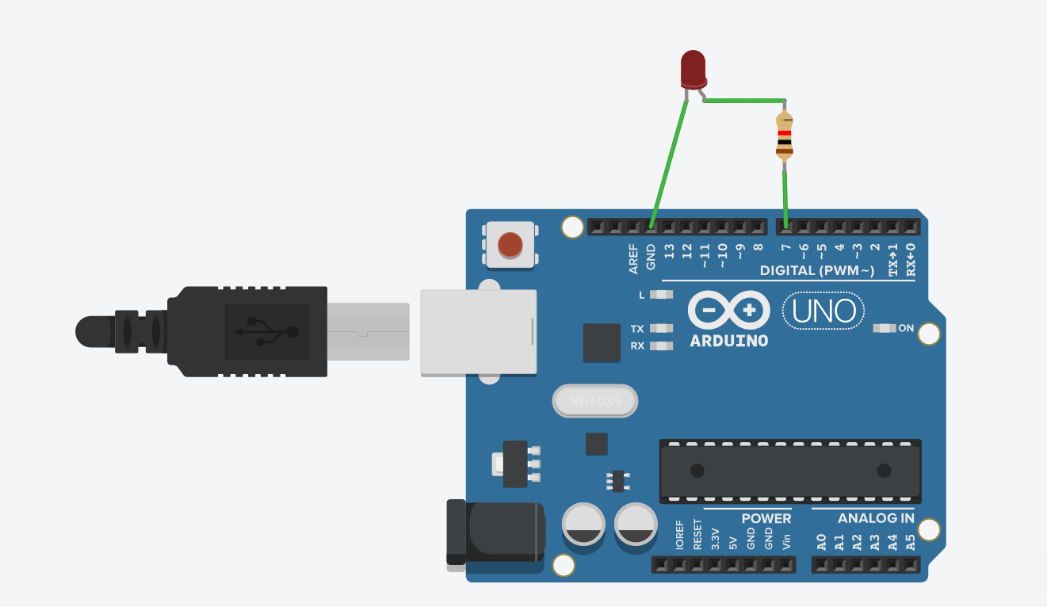

**Code :**

void setup()

{

pinMode(LED_BUILTIN, OUTPUT);

}

void loop()

{

digitalWrite(7, HIGH);

delay(1000); // Wait for 1000 millisecond(s)

digitalWrite(7, LOW);

delay(1000); // Wait for 1000 millisecond(s)

}

**Running Machine :**

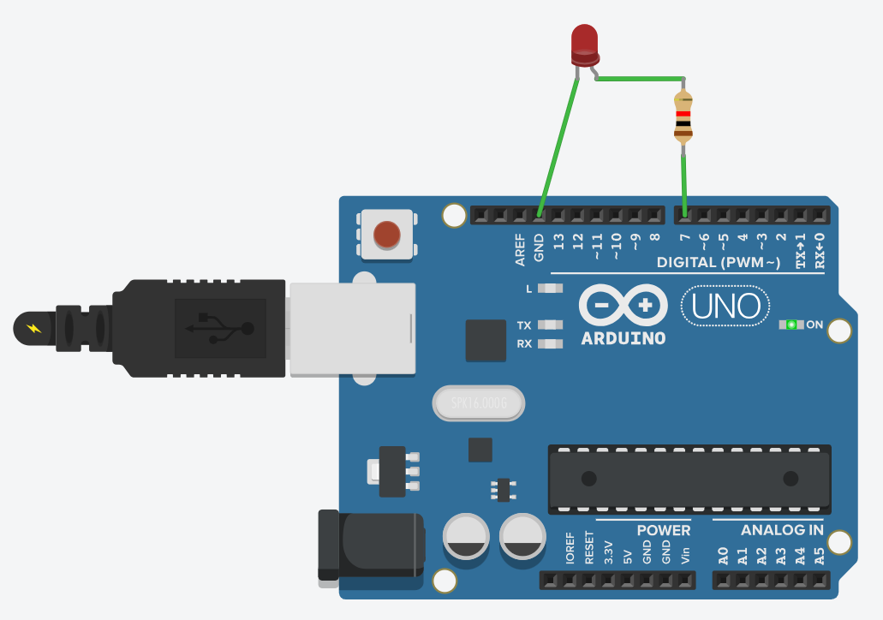

**Conclusion :**

Thus, Learnt how to Led to blink in the Proper way and using resistor and the ARDUINO.

**Practical No. 02**

**Title : To interface 3 LED’s with Arduino and write a program to blink 3 LEDs, one at a time, in a back and forth formation.**

**Aim : To blink 3 LEDs, one at a time, in a back and forth formation.**

**Circuits:**

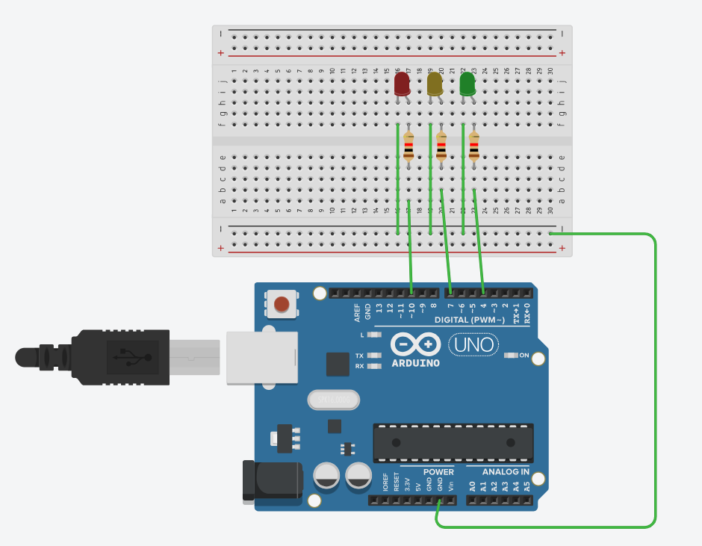

**Code:**

// C++ code

void setup()

{

pinMode(LED_BUILTIN, OUTPUT);

}

void loop()

{

digitalWrite(10, HIGH);

delay(1000); // Wait for 1000 millisecond(s)

digitalWrite(10, LOW);

delay(1000); // Wait for 1000 millisecond(s)

digitalWrite(7, HIGH);

delay(1000); // Wait for 1000 millisecond(s)

digitalWrite(7, LOW);

delay(1000);

digitalWrite(4, HIGH);

delay(1000); // Wait for 1000 millisecond(s)

digitalWrite(4, LOW);

delay(1000);

}

**Running Machine:**

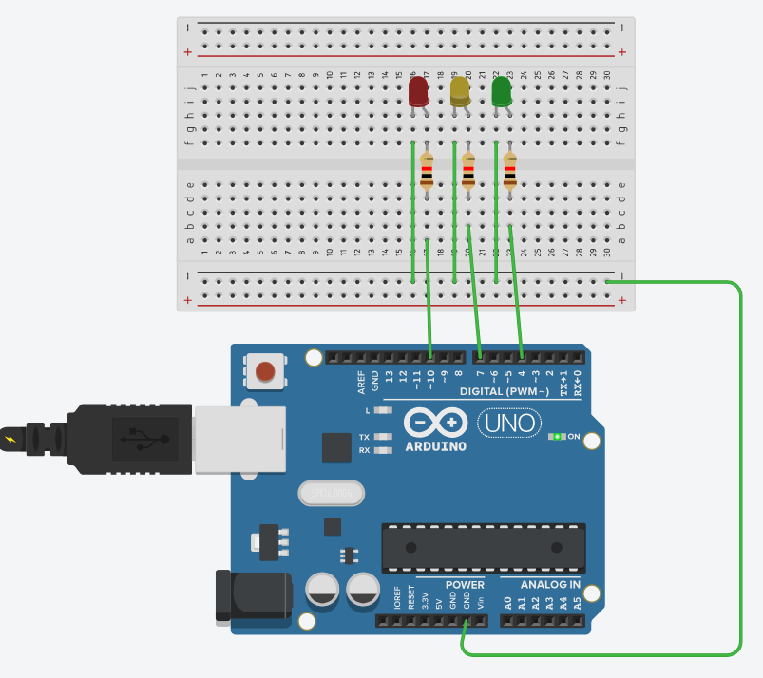

**Conclusion :**

Thus, Learnt How to blink 3 LEDs, one at a time, in a back and forth formation.

**Practical No. 03**

**Title : To interface Push button with Arduino and write a program to turn ON LED when push button is pressed.**

**Aim: To study how push button work and start LED(HIGH).**

**Circuits:**

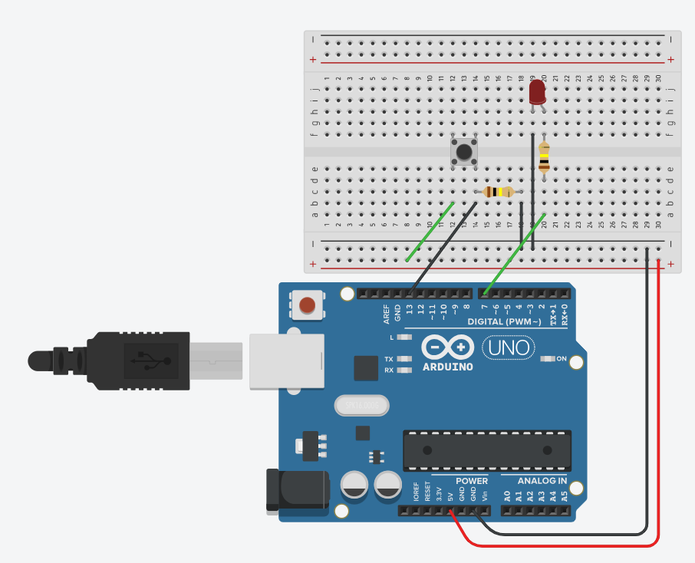

**Code:**

int button = 0;

void setup()

{

pinMode(13, INPUT);

pinMode(7, OUTPUT);

}

void loop()

{

button = digitalRead(13);

if(button == HIGH){

digitalWrite(7, HIGH);

}

else{

digitalWrite(7, LOW);

}

delay(10);

}

**Running Machine:**

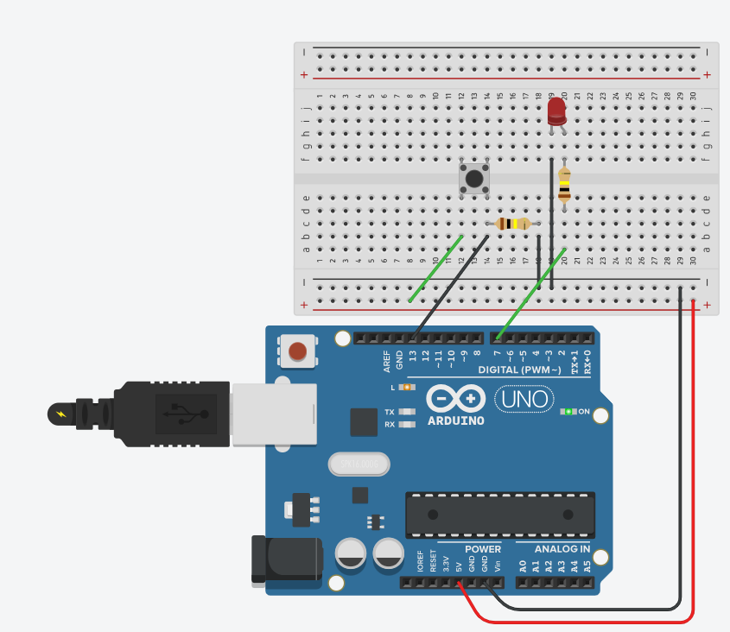

**Conclusion:**

Thus, to Learnt Push button with Arduino and write a program to turn ON LED when push button is pressed.

**Practical No. 04**

**Title:** **To interface Push button, Speaker/buzzer with Arduino and write a program to turn ON LED and generate a note or tone when push button is pressed.**

**Aim: To study turn ON LED and buzzer generate a note or tone when push button is pressed.**

**Circuits:**

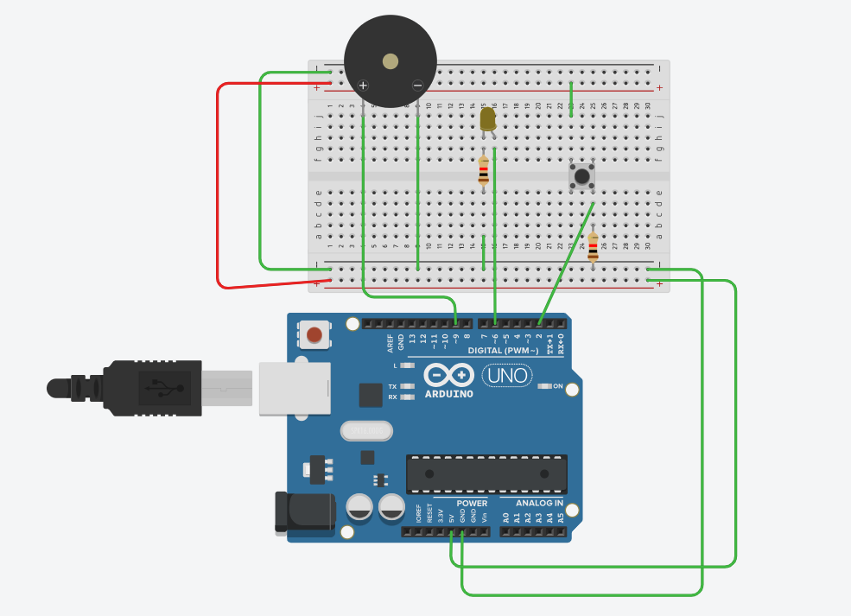

**Code:**

void setup()

{

pinMode(2, INPUT);

pinMode(6, OUTPUT);

pinMode(9, OUTPUT);

Serial.begin(9600);

}

void loop()

{

delay(1000); // Wait for 1000 millisecond(s)

if (digitalRead(2) == HIGH) {

digitalWrite(6, LOW);

digitalWrite(9, HIGH);

} else {

digitalWrite(9, LOW);

digitalWrite(6, HIGH);

}

Serial.println(digitalRead(2));

}

**Running Machines:**

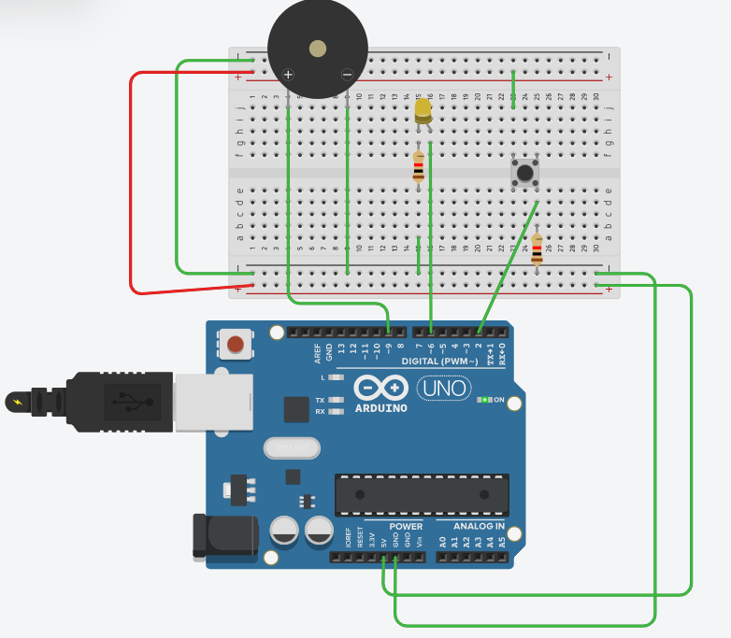

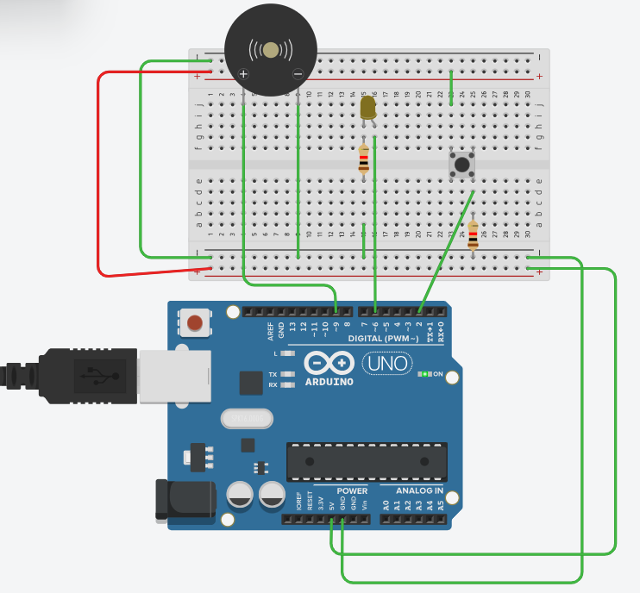

**Conclusion :**

Here we can learntturn ON LED and generate a note or tone when push button is pressed.

**Practical No. 05**

**Title : To interface 2 Push buttons, a Speaker with Arduino and write a program to turn ON LED and generate a 2 different notes on two button keyboard.**

**Aim : to turn ON LED and generate a 2 different notes on two button keyboard**

**Circuits:**

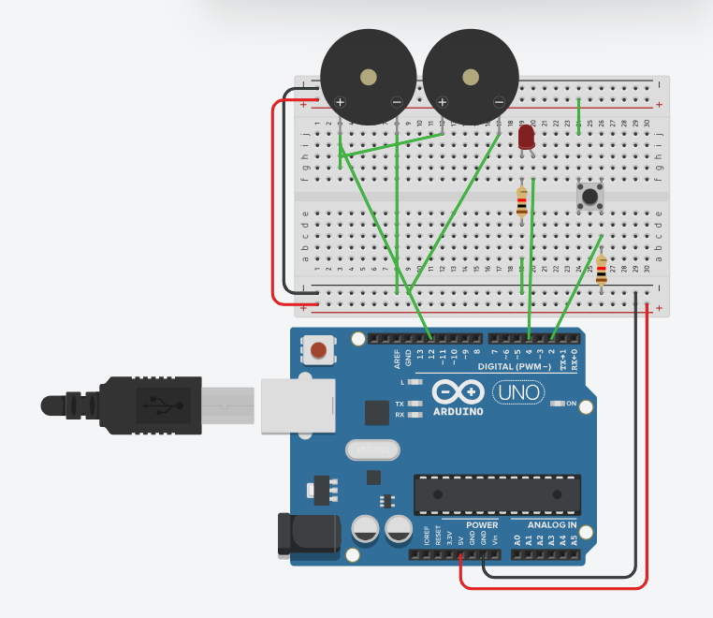

**Code:**

void setup()

{

pinMode(2, INPUT);

pinMode(4, OUTPUT);

pinMode(12, OUTPUT);

Serial.begin(9600);

}

void loop()

{

if (digitalRead(2) == HIGH) {

digitalWrite(4, HIGH);

digitalWrite(12, HIGH);

} else {

digitalWrite(4, LOW);

digitalWrite(12, LOW);

}

Serial.println(digitalRead(2));

delay(10); // Delay a little bit to improve simulation performance

}

**Running Machines:**

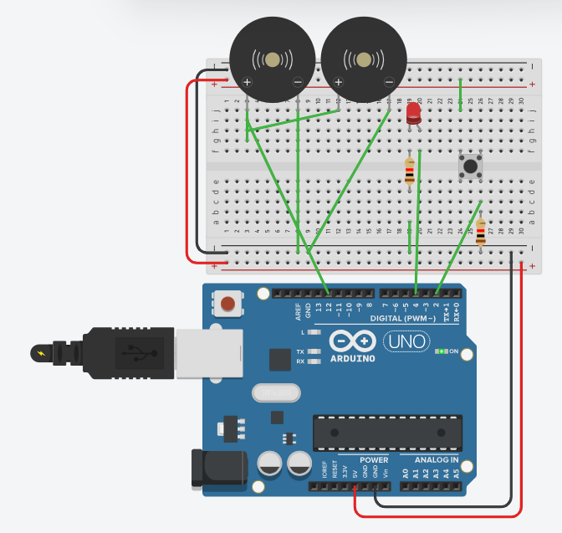

**Conclusion:**

Here we can learn 2 Push buttons, a Speaker with Arduino and write a program to turn ON LED and generate a 2 different notes on two button keyboard.