**Title: To interface 5 LED’s with Arduino and write a program to blink 5 LEDs, one at a time, in a back and forth formation.**

**Aim:** To blink 5 LEDs, one at a time, in a back and forth formation.

**Circuits:**

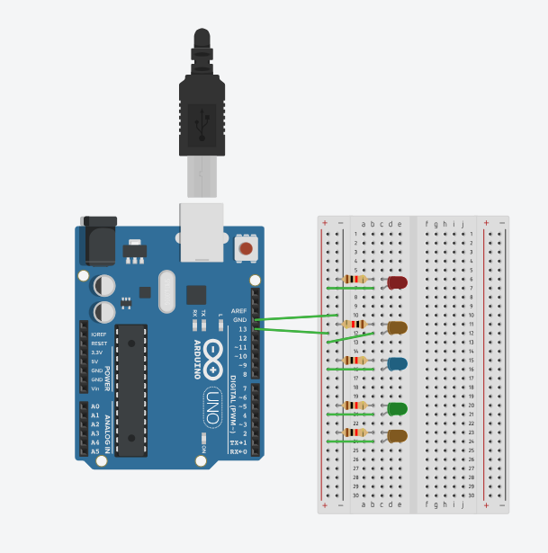

**Code:**

int bright = 0;

void setup()

{

pinMode(13, OUTPUT);

}

void loop()

{

for(bright = 0 ; bright <= 255; bright+=2){

digitalWrite(13,HIGH);

}

delay(150);

for(bright = 255 ; bright >= 0; bright-=2){

digitalWrite(13,LOW);

}

delay(50);

}

**Running Circuit:**

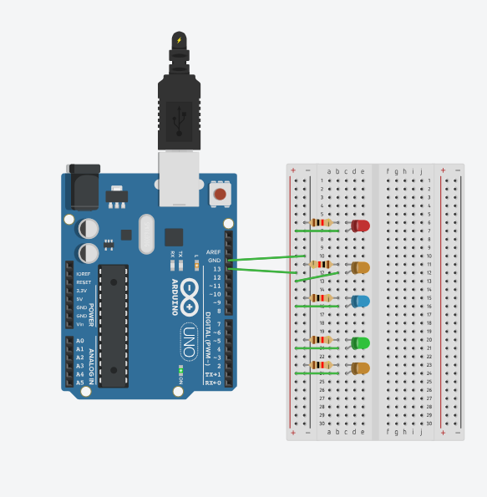

**Conclusion:**

Here we Learn To Blink the 5 LED’s at One By One.