**Matrix.cpp:**

#include<iostream>

using namespace std;

class Graph {

bool** adjMatrix;

int numVertices;

public:

Graph(int numVertices) {

this->numVertices = numVertices;

adjMatrix = new bool*[numVertices];

for (int i = 0; i < numVertices; i++) {

adjMatrix[i] = new bool[numVertices];

for (int j = 0; j < numVertices; j++)

adjMatrix[i][j] = false;

}

}

void addEdge(int i, int j) {

adjMatrix[i][j] = true;

adjMatrix[j][i] = true;

}

void removeEdge(int i, int j) {

adjMatrix[i][j] = false;

adjMatrix[j][i] = false;

}

void toString() {

for (int i = 0; i < numVertices; i++) {

cout << i << ": ";

for (int j = 0; j < numVertices; j++)

cout << adjMatrix[i][j] << " ";

cout << "\n";

}

}

~Graph() {

for (int i = 0; i < numVertices; i++)

delete[] adjMatrix[i];

delete[] adjMatrix;

}

};

int main() {

Graph g(4);

g.addEdge(0, 1);

g.addEdge(0, 2);

g.addEdge(1, 2);

g.addEdge(2, 0);

g.addEdge(2, 3);

g.toString();

return 0;

}

**Output:**



**DirectedGraph.cpp**

#include<iostream>

#include<conio.h>

#define size 5

using namespace std;

class graph{

public:

int i, j;

int wt, u, v, edges;

int graf[size][size];

graph();

void read(int, int, int);

void display();

void degree();

};

graph::graph() {

for (i = 0; i < size; i++) {

for (j = 0; j < size; j++) {

graf[i][j] = 0;

} }}

void graph::read(int u, int v, int wt) {

graf[u][v] = wt;

graf[v][u] = wt; // Assuming it's an undirected graph

}

void graph::display() {

cout << "\nGraph is:\n\n";

for (i = 0; i < size; i++) {

for (j = 0; j < size; j++) {

cout << "\t" << graf[i][j];

}

cout << endl << endl;

}}

void graph::degree() {

int in, out;

cout << "\nIndegrees & outdegrees of vertices are:\n\n";

for (i = 0; i < size; i++) {

in = 0;

out = 0;

for (j = 0; j < size; j++) {

if (graf[i][j] > 0) {

in++;

}

if (graf[j][i] > 0) {

out++;

} }

cout << "indegree of vertex " << i << " = " << in << endl;

cout << "outdegree of vertex " << i << " = " << out << endl << endl;

}}

int main() {

graph g;

g.read(2, 3, 1);

g.display();

g.degree();

getch();

return 0;

}

**Output:**

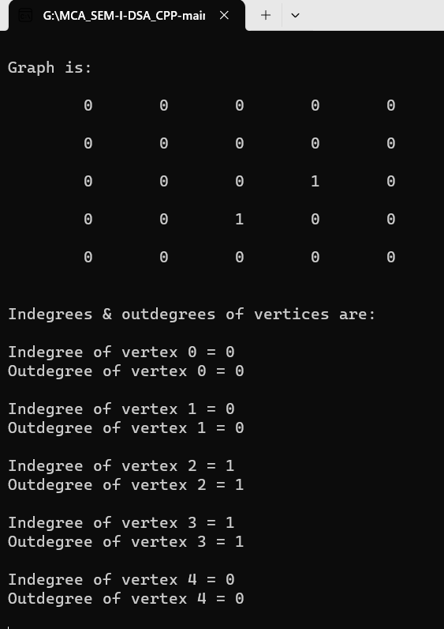

**Prims.cpp**

#include<iostream>

#include<conio.h>

#define size 4

using namespace std;

class graph {

public:

int i;

int j;

int wt, u, v, edges;

int graf[size][size];

graph();

void read(int, int, int);

void display();

void degree();

void prim(); // changed the function name from print() to prim()

};

graph::graph() {

for (i = 0; i < size; i++)

for (j = 0; j < size; j++)

graf[i][j] = 0;

}

void graph::read(int u, int v, int wt) {

graf[u][v] = wt;

graf[v][u] = wt;

}

void graph::display() {

cout << "\nGraph is:\n\n";

for (i = 0; i < size; i++) {

cout << i << ":";

for (j = 0; j < size; j++) {

cout << "\t" << graf[i][j];

}

cout << endl << endl;

}}

void graph::degree() {

int deg = 0;

cout << "\nDegrees of vertices are:\n\n";

for (i = 0; i < size; i++) {

deg = 0;

for (j = 0; j < size; j++) {

if (graf[i][j] > 0)

deg++;

}

cout << "Degree of vertex " << i << " = " << deg << endl;

}}

void graph::prim() {

int y, wt = 0, count = 0, min = 0;

int selected[size];

for (i = 0; i < size; i++) {

selected[i] = 0;

}

selected[0] = 1;

cout << "Selected nodes are:\n0";

while (count < size - 1) {

min = 9999;

for (i = 0; i < size; i++) {

if (selected[i] == 1) {

for (j = 0; j < size; j++) {

if (selected[j] == 0 && graf[i][j] != 0) {

if (min > graf[i][j]) {

min = graf[i][j];

y = j;

} } } } }

cout << " -> " << y;

selected[y] = 1;

wt = wt + graf[u][y];

count++;

}

cout << "\nWeight is: " << wt;

}

int main() {

graph g;

g.read(0, 1, 2);

g.read(0, 1, 7);

g.read(1, 9, 6);

g.read(1, 2, 5);

g.display();

g.degree();

g.prim(); // changed the function name from print() to prim()

getch();

return 0;

}

**Output:**

