**Practical No. 2**

**Exercise - Create an application to demonstrate file operations (Create, write, read,delete).**

**Implementation:**

**Program:**

var fs = require('fs'); //  inbuilt module  fs(File System)

// fs.writeFile( file, data, options, callback )

fs.writeFile('demo.txt','This  is  Demmo File.',function(err){

    if(err) {

        throw err;

    }

    console.log('File Created SuccessFully.');

})

**Terminal:**



// fs.readFile( filename, encoding, callback_function )

fs.readFile('demo.txt','utf8',function (err, data) {

    if(err) {

        throw err;

    }

    console.log('Read File!! ');

    console.log(data);

})

**Terminal:**

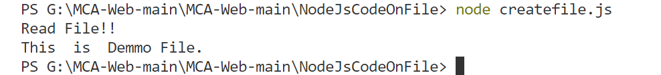

// fs.appendFile( path, data[, options], callback )

fs.appendFile('demo.txt',' This Data is Appended to File',

function(err){

    if(err) {

        throw err;

    }

    console.log('Appened Data to the File!!');

})

**Terminal:**



fs.readFile('demo.txt','utf8',function (err, data) {

    if(err) {

        throw err;

    }

    console.log('Read File!! ');

    console.log(data);

})

**Terminal:**



// fs.open( filename, flags, mode, callback )

fs.open('demo.txt', 'w+', function (err, data) {

    if (err) {

        return console.error(err);

    }

    console.log(data);

    console.log("File opened!!");

})

**Terminal:**



// fs.rename( oldPath, newPath, callback )

fs.rename('demo.txt','newname.txt',function(err){

    if(err){

        throw err;

    }

    console.log('File Renamed!!!!');

})

**Terminal:**



// fs.unlink(path, callback)

fs.unlink('newname.txt',function(err){

    if(err){

        throw err;

    }

    console.log('File Deleted!!!');

})

**Terminal:**

