# PRACTICAL NO :07

**DATA VISUALIZATION USING TABLEAU**

# Unit Structure :

* 1. Introduction
  2. Data Visualization
  3. Data Visualization and Big Data
  4. Types of Data Visualizations
  5. Common Data Visualization Use Cases
  6. Basic Data Visualization Principles
  7. Connecting to Data
  8. Tableau
  9. Custom SQL Queries Tableau
  10. Visualizing Treemaps Using Tableau
  11. Creating A Story with Tableau Public
  12. Saving and Publishing Your Tableau Public Workbook
  13. A Dashboard with Tableau
  14. Questions
  15. Quiz
  16. Video Lectures
  17. MOOCS
  18. References

# INTRODUCTION

There is an increased recognition that effectively visualizing data is important to anyone who works with and analyzes data. To that end, there has been an explosion in data analysis and data visualization tools over the past few years. Microsoft Excel continues to be the workhorse for their data visualization needs. There are certainly different strategies to creating some of these graphs, the approach presented here allows you to not only create those graphs, but also give you the techniques you can use elsewhere to create your own graphs.

# DATA VISUALIZATION

Data visualization is the representation of data through use of common graphics, such as charts, plots, infographics, and even animations. These visual displays of information communicate complex data relationships and data-driven insights in a way that is easy to understand.

Data visualization can be utilized for a variety of purposes, and it’s Data Visualization important to note that is not only reserved for use by data teams. Management also leverages it to convey

organizational structure and hierarchy while data analysts and data scientists use it to discover and explain patterns and trends. Harvard Business Review categorizes data visualization into four key purposes: idea generation, idea illustration, visual discovery, and everyday dataviz. We’ll delve deeper into these below:

Data visualization is commonly used to spur idea generation across teams. They are frequently leveraged during brainstorming or Design Thinking sessions at the start of a project by supporting the collection of different perspectives and highlighting the common concerns of the collective. While these visualizations are usually unpolished and unrefined, they help set the foundation within the project to ensure that the team is aligned on the problem that they’re looking to address for key stakeholders.

Data visualization for idea illustration assists in conveying an idea, such as a tactic or process. It is commonly used in learning settings, such as tutorials, certification courses, centers of excellence, but it can also be used to represent organization structures or processes, facilitating communication between the right individuals for specific tasks. Project managers frequently use Gantt charts and waterfall charts to illustrate workflows.

# Benefits of data visualization include the following:

* The ability to absorb information quickly, improve insights and make faster decisions;
* An increased understanding of the next steps that must be taken to improve the organization;
* An improved ability to maintain the audience's interest with information they can understand;
* An easy distribution of information that increases the opportunity to share insights with everyone involved;
* Eliminate the need for data scientists since data is more accessible and understandable; and
* An increased ability to act on findings quickly and, therefore, achieve success with greater speed and less mistakes.

# 7.2 DATA VISUALIZATION AND BIG DATA

The increased popularity of big data and data analysis projects have made visualization more important than ever. Companies are increasingly using machine learning to gather massive amounts of data that can be difficult and slow to sort through, comprehend and explain. Visualization offers a means to speed this up and present information to business owners and stakeholders in ways they can understand.

Big data visualization often goes beyond the typical techniques used in normal visualization, such as pie charts, histograms and corporate graphs. It instead uses more complex representations, such as heat maps and fever charts. Big data visualization requires powerful computer systems to collect raw data, process it and turn it into graphical representations that humans can use to quickly draw insights.

While big data visualization can be beneficial, it can pose several disadvantages to organizations. They are as follows:

* To get the most out of big data visualization tools, a visualization specialist must be hired. This specialist must be able to identify the best data sets and visualization styles to guarantee organizations are optimizing the use of their data.
* Big data visualization projects often require involvement from IT, as well as management, since the visualization of big data requires powerful computer hardware, efficient storage systems and even a move to the cloud.
* The insights provided by big data visualization will only be as accurate as the information being visualized. Therefore, it is essential to have people and processes in place to govern and control the quality of corporate data, metadata and data sources.

# 7.3 TYPES OF DATA VISUALIZATIONS

Individuals could utilize data visualization to present data in a more effective manner and companies turn to dashboards to report their performance metrics in real-time. Dashboards are effective data visualization tools for tracking and visualizing data from multiple data sources, providing visibility into the effects of specific behaviors by a team or an adjacent one on performance. Dashboards include common visualization techniques, such as:

**Tables**: This consists of rows and columns used to compare variables.

**Pie charts and stacked bar charts**: These graphs are divided into sections that represent parts of a whole.

**Line graphs and area charts**: These visuals show change in one or more quantities by plotting a series of data points over time. Line graphs utilize lines to demonstrate these changes while area charts connect data points with line segments, stacking variables on top of one another and using color to distinguish between variables.

**Histograms**: This graph plots a distribution of numbers using a bar chart representing the quantity of data that falls within a particular range.

**Scatter plots**: These visuals are beneficial in reveling the relationship between two variables, and they are commonly used within regression data analysis.

**Heat maps**: These graphical displays are helpful in visualizing behavioral data by location.

**Tree maps**: Display hierarchical data as a set of nested shapes, typically rectangles. Treemaps are great for comparing the proportions between categories via their area size.

**Population pyramids**: This technique uses a stacked bar graph to display the complex social narrative of a population.

# 7.4 COMMON DATA VISUALIZATION USE CASES

**Sales and marketing**. Research from the media agency Magna predicts that half of all global advertising dollars will be spent online by 2020. Data visualization makes it easy to see traffic trends over time as a result of marketing efforts.

**Politics**. A common use of data visualization in politics is a geographic map that displays the party each state or district voted for.

**Healthcare**. Healthcare professionals frequently use choropleth maps to visualize important health data. A choropleth map displays divided geographical areas or regions that are assigned a certain color in relation to a numeric variable.

**Scientists**. Scientific visualization, sometimes referred to in shorthand as SciVis, allows scientists and researchers to gain greater insight from their experimental data than ever before.

**Finance**. Finance professionals must track the performance of their investment decisions when choosing to buy or sell an asset.

**Logistics**. Shipping companies can use visualization tools to determine the best global shipping routes.

**Data scientists and researchers**. Visualizations built by data scientists are typically for the scientist's own use, or for presenting the information to a select audience.

**DATA VISUALIZATION TOOLS AND VENDORS** Data visualization tools can be used in a variety of ways. The most common use today is as a business intelligence (BI) reporting tool. Users can set up visualization tools to generate automatic dashboards that track company performance across key performance indicators (KPIs) and visually interpret the results. While Microsoft Excel continues to be a popular tool for data visualization, others have been created that provide more sophisticated abilities:

* IBM Cognos Analytics
* Qlik Sense and QlikView
* Microsoft Power BI
* Oracle Visual Analyzer
* SAP Lumira
* SAS Visual Analytics
* Tibco Spotfire
* Zoho Analytics
* D3.js
* Jupyter
* MicroStrategy
* Google Charts

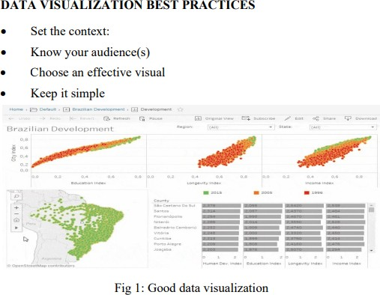

# 7.5 BASIC DATA VISUALIZATION PRINCIPLES

Three basic principles seem especially useful to guide your creation of better, more effective visualizations.

# Show the Data

People will read the graphs in your report, article, or blog post to better understand your argument.

# Reduce the Clutter

Cart clutter, the use of unnecessary or distracting visual elements, tends to reduce effectiveness of the graph. Clutter comes in many forms: dark or heavy gridlines; unnecessary tick marks, labels, or text; unnecessary icons or pictures; ornamental shading and gradients; and Data Visualization unnecessary dimensions.

# Integrate the Text and the Graph

Legends define or explain a series on a graph are often placed far away from the content—off to the right or below the graph.

Example

Prepare any type of chart using excel sheet. [ Using design tab, format tab and chart menu]

# 7.6 CONNECTING TO DATA

Visualizations depend on the data in them, and however aesthetically pleasing your visualization might be, it may be misleading or even wrong, unless the data has been formatted, aggregated, and properly represented. This session discusses the major elements of finding, cleansing, understanding, formatting, and aggregating data that you will need to understand in order to produce accurate visualizations that tell compelling stories, including the following elements:

* Where you can get publicly available data and how to use it
* What tables and databases are
* The data formats that Tableau Public connects to
* Databases, tables, dimensions, facts, and field formats and conventions
* Preparing data to load it into Tableau
* Connecting to the data from Tableau Public
* Using the data interpreter
* Pivoting fields

# Public data

The data sets that are publicly available or the ones that you have compiled on your own, are ideal for Tableau Public. Public data is readily available online. Tableau Public maintains a catalog of publicly available data. Much of this data is produced by various governments, economic groups, and sports fans, along with a link to, and a rating for each source. You can find it at [http://public.tableau.com/s/resources.](http://public.tableau.com/s/resources) The Google Public Data Explorer has a large collection of public data, including economic forecasts and global public health data. This tool is unique because it allows users to make simple visualizations from all the original data sources without having to investigate the source data, though most of it is available by linking available resources.

# Tables and databases

Data is stored in tables. A table is an array of items, and it can be as simple as a single word, letter, or number, or as complicated as millions (or more) of rows of transactions with timestamps, qualitative attributes (such as size or color), and numeric facts, such as the quantity of the purchased goods. Both a single text file of data and a worksheet in an excel workbook are tables. When grouped together in a method that has been designed to enable a user to retrieve data from them, they constitute a database. Typically, Data Visualization when we think of databases, we think of the Database Management Systems (DBMS) and languages that we use to make sense of the data in tables, such as Oracle, Teradata, or Microsoft's SQL Server. Currently, the Hadoop and NoSQL platforms are very popular because they are comparatively low-cost and can store very large sets of data, but Tableau Public does not enable a connection to these platforms.

Tableau Public is designed in such a way that it allows users in a single data connection to join tables of data, which may or may not have been previously related to each other, as long as they are in the same format.

The most common format of publicly available data is in a text file or a Character-Separated Values (CSV) file. CSV files are useful because they are simple. Many public data sources do allow data to be downloaded as Excel documents. The World Bank has a comprehensive collection, and we will demonstrate the connective capabilities of Tableau Public using one of its data products. Tables can be joined in Tableau Public by manually identifying the common field among the tables. Tableau Public connects to four different data sources, namely Access, Excel, text file (CSV or TXT), and OData; the first two data sources are bundled with Microsoft Office (in most cases), and the second two are freely available to everyone, regardless of the operating system that they are using.

# Connecting to the data in Tableau Public

Tableau Public has a graphical user interface (GUI) that was designed to enable users to load data sources without having to write code. Since the only place to save Tableau Public documents is in Tableau's Cloud, data sources are automatically extracted and packaged with the workbook. Connecting to data from a local file is illustrated as follows with detailed screenshots:

* 1. Click on the Connect to Data Link option from the Data menu.
  2. Select the data source type.
  3. Select the file or website to which you want to connect.
  4. For a Microsoft Access, Microsoft Excel, or a text file, determine whether the connection is to one table or multiple tables or it requires a custom SQL connection:
     + If the connection is to one table, select the table.
     + If the connection is to multiple tables, select the option for the connection to multiple tables and identify the join conditions. We will discuss this in detail in the next section.
     + Alternatively, you can type or paste a custom SQL.
  5. When all the selections have been made, click on Ok. We will connect to the World Bank's environment indicators. You can download this data, which is formatted either for Microsoft Excel or as a text file, at [www.worldbank.org.](http://www.worldbank.org/)

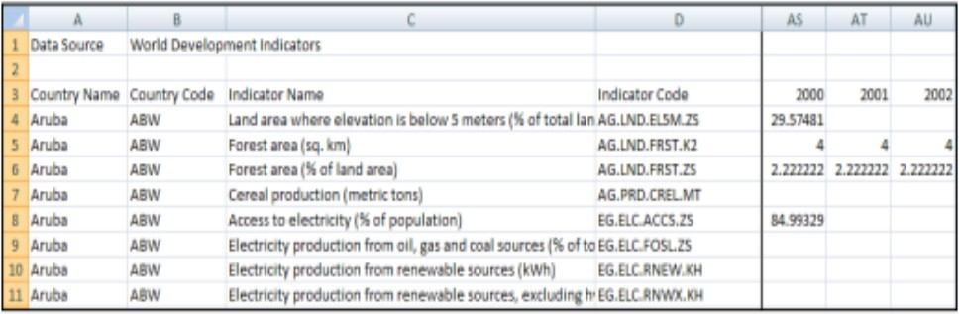

The data source user interface

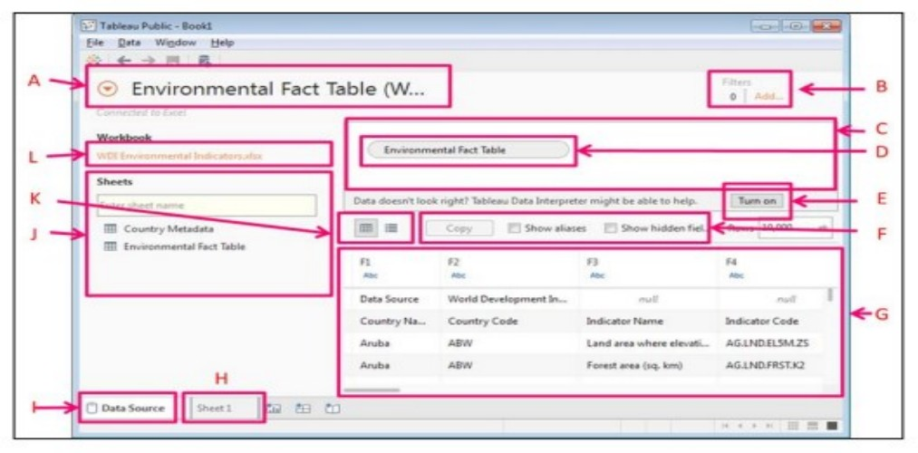Before loading data, let’s know the different parts of the data connection user interface.

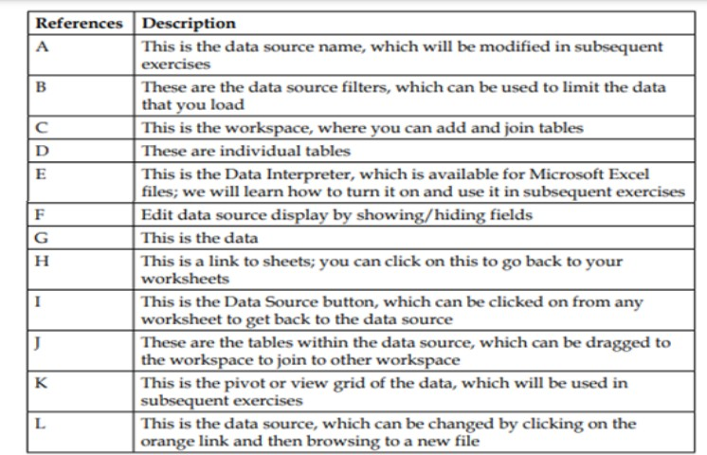

To load the file into Tableau Public, you can download the Tableau Public Data Visualization workbook by visiting https://public.tableau.com/profile/tableau.data. stories#!/.

1. Open a new instance of Tableau Public.
2. From the Connect pane, click on the data file type to which you'd like to connect. In this case, we are using an excel file.
3. Browse to the file to which you would like to connect.
4. Drag a table from the list of tables, which is a list of different worksheets in this case, along with the workbook onto the workspace.
5. Note that the values in the data source are now populating the space below the workspace, but at least with this data set, there is no complete set of field headers. We will edit the data source by using the data interpreter in the next exercise.

# Connecting to web-based data sources

The steps required to connect to OData are different from the steps required to connect to the previously mentioned sources because they involve web servers and network security. These steps are a subset of the steps in Desktop Professional that are used to connect to a server:

1. Enter the URL of the website.
2. Select the authentication method.
3. Establish the connection.
4. Name the data source.

In order to refresh a web-based data source, perform the following steps:

1. Right-click on the data source name in the data pane.
2. Click on Edit Connection.
3. In the previous dialog box, which will be populated with the connection parameters, click on the Connect button in step 3 of the preceding list.

# TABLEAU

Tableau is a visual analysis solution that allows people to explore and analyze data with simple drag and drop operations. It has a user-friendly interface that creates reports that look great right at the beginning. Tableau is a rapid BI Software.

**Great Visualizations:** Allows to connect to the data, visualize and creative interactive, sharable dashboards in a few clicks.

**Ease of use:** It’s easy enough that any excel user can learn it, but powerful enough to satisfy even the most complex analytical problems

**Fast:** We can create interactive dashboards, quick filters and calculations.

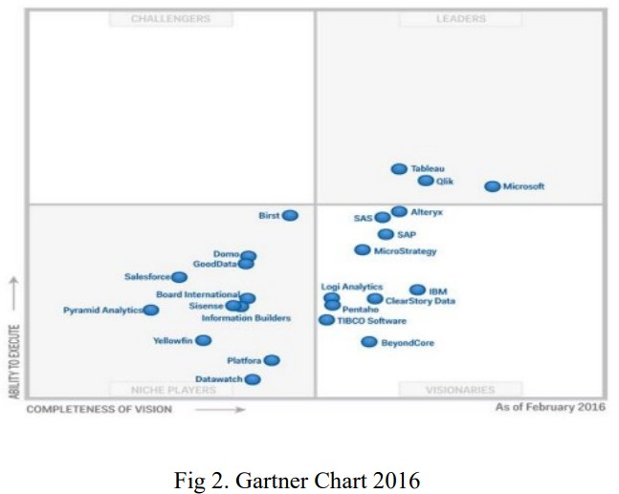**WHY TABLEAU?** As per Gartner survey “Tableau was chosen more often for functionality than any other vendor in the survey, with the highest product functionality scores”. “Tableau’s products often fill an unmet need in organizations that already have a BI standard “and are more frequently deployed than other interactive visualization vendors as a complementary capability to an existing BI platform.

Gartner positions tableau as “Leader”. Companies frequently cite that breadth and ease of use along with high business benefits as the primary reasons that they choose Tableau.

# Three main stages in Tableau

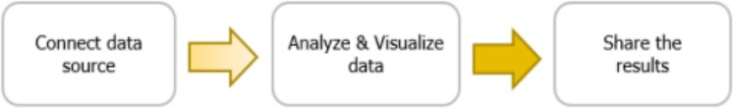

**Connect data source:** Connect Tableau to any data source like MS-Excel, MySQL, and Oracle. Tableau connects data in two ways: Live connect and Extract.

**Analyze & Visualize:** Analyze the data by filtering, sorting and Visualize Data Visualization the data using the relevant chart provided. Tableau automatically analyzes the data as follows: Dimensions: Tableau treats any field containing qualitative, categorical information as dimension. All dimensions are indicated by the “Blue” color.

**Measures:** Tableau treats any field containing numeric information as a measure. All measures indicated by “Green” color Tableau suggest the recommended charts based on the dimensions and measures.

**Share:** Tableau Dashboards can be shared as word documents, pdf files, images.

# Maps in Tableau

Tableau automatically assigns geographic roles with common geographically names, such as Country, State/Province, City etc. Fields with a geographic role will automatically generate longitude and latitude coordinates on a map view. Fields with assigned geographic roles will have a globe icon next to them. In Tableau, there are two types of maps to choose from when creating a visualization with geographic data:

* Symbol Maps and ❖ Filled Maps.

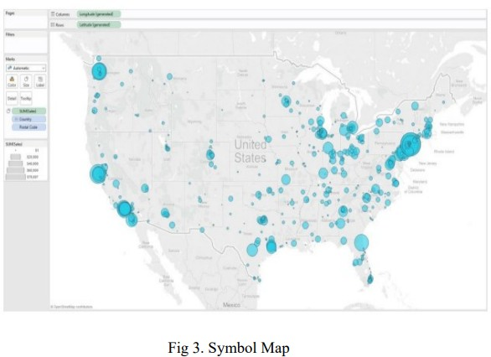**Symbol Maps:** These are simple maps that use a type of mark to represent a data point, such as a filled circle.

**Filled Maps:** Instead of displaying data points, filled maps uses shading on a country or state basis to indicate relationships.

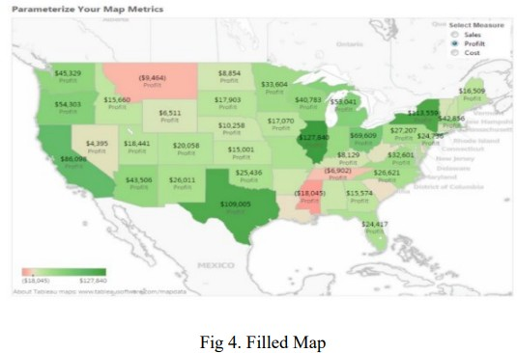

# CUSTOM SQL QUERIES TABLEAU

What is a Custom SQL Query? Tableau queries each data source using SQL that’s specific to the data type. Tableau allows the SQL used to query a data source to be customized in order to manipulate the joins, filters, and field lengths and types to produce a more accurate output.

Sample SQL query:

SELECT ['us states data 1$'].[State] AS [State], ['us states data 1$'].[Population] AS [Population], ['us states data 1$'].[Region] AS [Region] FROM ['us states data 1$'] UNION SELECT ['us states data 2$'].[State] AS [State], ['us states data 2$'].[Population] AS [Population], ['us states data 2$'].[Region] AS [Region] FROM ['us states data 2$'] UNION SELECT ['us states data 3$'].[State] AS [State], ['us states data 3$'].[Population] AS [Population], ['us states data 3$'].[Region] AS [Region] 163 FROM ['us states data 3$'] Data Visualization UNION SELECT ['us states data 4$'].[State] AS [State], ['us states data 4$'].[Population] AS [Population], ['us states data 4$'].[Region] AS [Region] FROM ['us states data 4$']

Steps to visualize using SQL in Tableau:

1. The following excel workbook consists of 4 sheets consisting of US population state wise. US population state wise.xlsx



1. Open Tableau and connect the Excel data as Open with Legacy Connection.

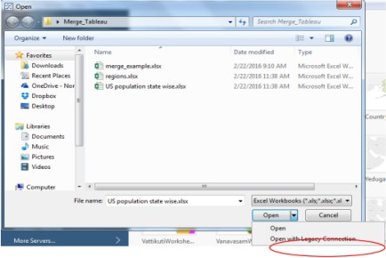

1. Now your Tableau window looks like this with an additional sheet named as New Custom SQL.

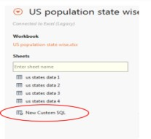

1. Click on New Custom SQL then you will be prompted to Edit Custom SQL as shown.

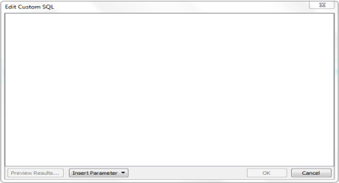

1. Now we need to write SQL query to perform union operation on the excel sheets and generate a combined sheet. Ex: SELECT [Sheet1$].[ID] AS [ID], [Sheet1$].[Type] AS [Type], [Sheet1$].[Value] AS [Value] FROM [Sheet1$] UNION ALL SELECT [Sheet2$].[ID] AS [ID], [Sheet2$].[Type] AS [Type], [Sheet2$].[Value] AS [Value] FROM [Sheet2$] The above SQL query performs union operation on two sheets namely Sheet1 and Sheet2 with ID, Type, and Value as their columns.
2. After writing the query click on Preview Results on the Edit Custom SQL window pane to check whether the query worked fine or not.
3. The resulting data should contain all the states, population and region name to which it belongs.
4. Click on the Tableau sheet to visualize the data.
5. Now you will see State, Region as Dimensions and Population as Measures.
6. Now visualize the data derived.

# Live data implementation Tableau

Live Data or Real-time data (RTD) denotes information that is delivered immediately after collection. There is no delay in the timeliness of the information provided. Real-time data is often used for navigation or tracking. A Web Map Service (WMS) is a standard protocol for serving georeferenced map images which a map server generates using data from a GIS database. A Web Map Service (WMS) produces an image (e.g. GIF, JPG) of geospatial data. Steps to implement live map using Tableau:

1. Open Tableau and connect the Excel data.
2. Drag and drop state Dimension in Detail menu provided in Marks window pane.
3. Now you can see Symbol map representing the states of United States. It looks as shown below

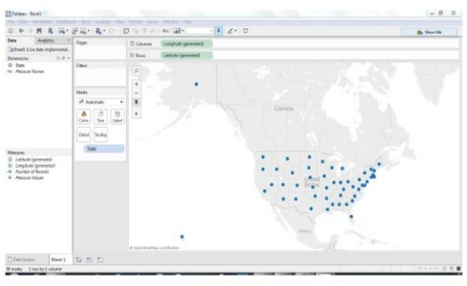

1. In this we will be using OGCWMS server to get the live geospatial data.
2. Click on Map item in the menu bar, then select Background Maps and select WMS Server as shown

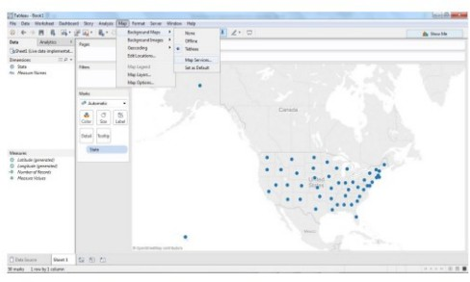

1. After clicking on Map Services you will be prompted a window as shown

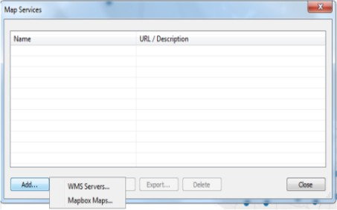

1. 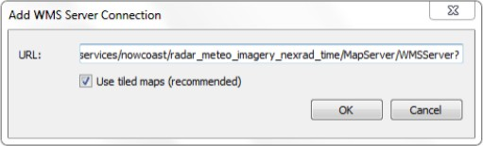Click on Add and select WMS Servers. After clicking on WMS Servers a window pane as shown below will be prompted to enter the URL of the server. <http://nowcoast.noaa.gov/arcgis/services/nowcoast/radar_meteo_ima> gery_nexrad_time/M apServer/WMSServer?
2. Now click on OK and then close the WMS server window pane and a map can be seen as shown

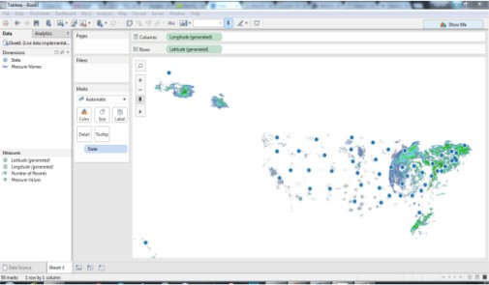

1. Change the map type to Filled map. Data Visualization
2. Change the color transparency to less than 20% so that the required map is visible.
3. Then required map looks like this

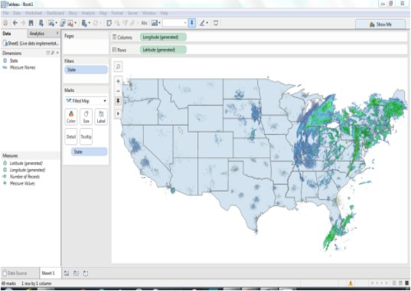

# VISUALIZING TREEMAPS USING TABLEAU

Tree map displays hierarchical data by using nested rectangles which together represent a whole. They were invented by Ben Shneiderman in 1992 as a way to visualize tree structures in a space-constrained layout. In a treemaps, each branch of a tree is a rectangle, which is tiled with smaller rectangles to represent sub-branches. This allows the viewer to easily see patterns that would be hard to spot in bar charts or area charts. The main benefits of tree maps are, they make efficient use of compact space. Treemaps are becoming popular in infographics and presentations, especially for data analysis that requires detailed views of many items. With this feature one can explore the data hierarchy effortlessly and simultaneously a decent level of estimation is also possible for quantitative aspects of information.

Steps to visualize Treemaps in Tableau:

1. The data is about the various products sold at a fashion store in the cities of different states of the united states
2. Start with opening tableau and connect the data, which is of type excel to Tableau
3. Click on sheet1 which is at the bottom of the page to visualize the data
4. Now to the left of the screen you can see a small window showing Dimensions and Measures. The dimensions of the data are state, city, store name, product, SKU number, year, quarter, month and week. The measures of the data are Quantity sold and sales revenue
5. You can also see rows and columns at the top of the page, now drag sales revenue from the measures and drop it in the rows section. You can see a bar chart with single bar showing sales revenues
6. Now drag states from the dimension to the column section, you can see a bar chart showing the sales revenues of different states
7. Now click on the Show Me button on the top right corner of the screen, you can see various maps suggested by the Tableau tool to visualize the data. The maps which are bright in color shows us that those maps are suitable to visualize the given data
8. Select the Tree Map by clicking it, you will see a Tree Map representing various states in green color with different shades
9. The rectangle which is large and bright represents the highest quantity according to sales revenue and similarly the smaller and lighter shade of the rectangles show less sales revenue
10. Now select the city tab from the dimension section and drop it on the Label in the Marks section. You can observe that the rectangles are split into even smaller rectangles according to the cities in each state
11. Now select the product from the dimension section and drop it on the Label in the Marks section. You can observe that the rectangles are split into even smaller rectangles according to the products.
12. Now select the Quantity sold tab from the dimension section and drop it on the Label in the Marks section. You can see the actual quantity sold of each product.

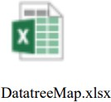

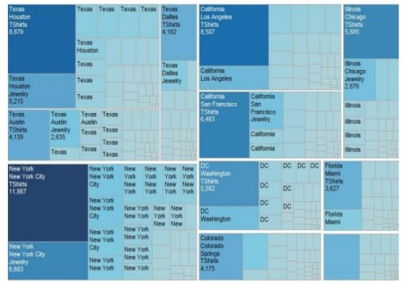

# Geographical map visualization using Tableau: Steps to visualize Filled Maps in Tableau:

1. Open Tableau and connect the excel sheet.
2. The data with states and their geographical data is shown in Tableau.
3. Drag and drop states onto columns and Total Area onto rows.
4. Drag and drop state onto color and total area onto tool tip.
5. 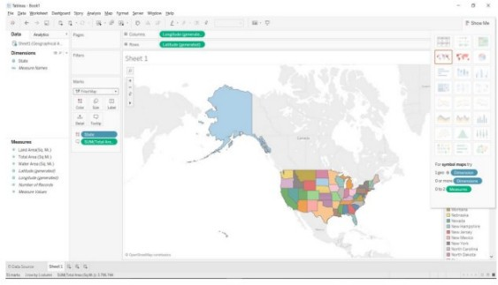Now select the filled map. Then the map is represented with the geographical data of each state as shown below.

Visualization of Combo and Gauge Charts using QlikView

1. For this we have taken two different datasets.

Dataset -1 (Cost_Student). Contains data which represents the amount spent by the countries, on a student per year for primary to secondary education and postsecondary education.

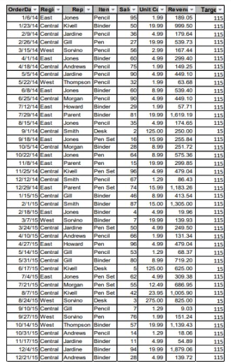Dataset - 2 (Sales_Rep). Contains data, which represents the sales made by the representatives of a stationary chain around the USA over particular dates.

1. Open QlikView. A QlikView getting started screen opens, now click on the New Document button on right below the corner of the Wizard.
2. A new Window opens up (Kind of pop up) close the pop up window. (Since it is an Auto chart generator, we do not want that wizard).
3. On closing the pop up, users will be able to see a Main blank sheet. Data Visualization Now has a quick look on to the toolbar.
4. Over the toolbar below to the selections labe1, click on the Edit Script icon (Icon looks like a pen on a paper).
5. A new Edit Script window opens up (We use this window to load an Excel file), bottom of the window under the Data from files Click Table Files button, and choose the saved Excel file, then click open.
6. A new File Wizard Type window opens up. Now select the Tables drop down and choose Cost_Student if it has not defaulted and click the Labels drop down and choose Embedded Labels. Click next until, next button disables (If it disables you on the final screen). Select checkbox load all and click finish.
7. On Finish you will be able to see Edit Script screen , with script added to load excel file(Script shown below) On Edit Script window toolbar below file , click the reload icon.It asks you save the file. LOAD * FROM [C:\Manusha\DataViz\DataViz-Qlik\QlikView_Dataset.xls] (biff, embedded labels, table is Cost_Per_Student$);
8. Now a sheet property window opens, please choose Country (Which works as a filter).
9. Right Click anywhere on the sheet, a window opens, choose New Sheet Object and select Table box. New window opens again, adds all the available fields and clicks apply. You will be able to see a table box with content the same as an excel sheet.
10. Right Click anywhere on the sheet, a window opens, choose New Sheet Object and select Chart. New window opens again, Select Combo Chart from chart type and click next.
11. Choose Country as dimension and click next now choose the expressions. • Expression 1 for bar chart Sum (PRSCIUSD), now click Add button to add one more expression Sum (PSCIUSD) and click finish.
12. Now we have seen the Combo Chart.
13. If you observe both pre-Secondary and post-secondary are on the same axis. Let us split them. Right click on the chart and choose the properties, and navigate to the Axes tab, Select Post-Secondary Expression and choose the position Right (Top) click apply and ok. You will see charts similar to below.

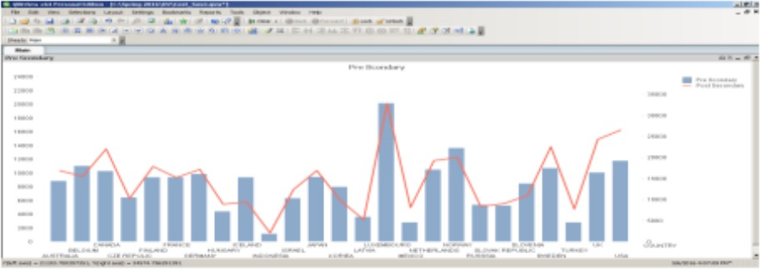

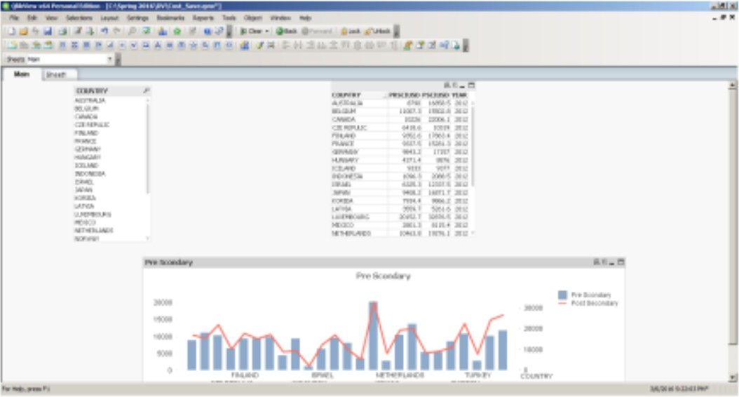

1. Now click on the layout shown in the toolbar and add a new sheet. A new sheet will open.
2. Repeat step 7 to step 12, in step 9 choose sales_Rep sheet and in step 11 Choose Rep to the filed display in list boxes.
3. Right Click anywhere on the sheet, a window opens, choose New Sheet Object and select Chart. New window opens again, Select Gauge from chart type and click next.
4. Gauge charts have no dimensions, so we do not select any dimension, and will be moving directly to expression.
5. Since we are calculating the performance, we add a division between sales and targets (Sum (sales)/sum (targets)), add label for expression (Sales Achieved) finish you will see a chart like below.

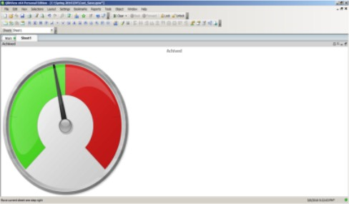

1. Let us make it more readable, right click, choose the properties, navigate to presentation, add a segment in segment setup (we can go with 2 segments as well for clear user readability we choose 3) and change the colors of each segment by choosing color band (Red, Yellow, Green).
2. Now look for the Show scale section left –below to segment setup add margin units a 4 and show labels on every major entry margin units 1 (Select the check box Show scale if it is not selected).
3. 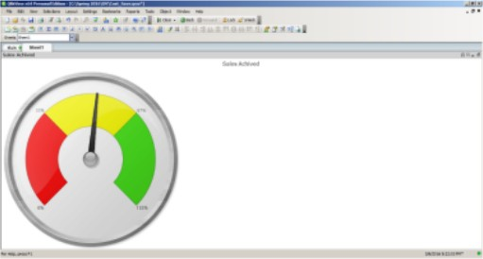Now Switch Data Visualization to Number tab since we are representing it in percentage select the radio button Fixed to and select the checkbox Show in percentage and click apply.
4. In order to see the needle value (Speedometer current value). Right click on the chart and select properties move to presentation tab and select Add button next to Text in Chart (located below right corner of the window) and add this formula(=num(Sum(Sales)/sum(Target),'##%') ),

and click apply, the value appears on the top left corner of the chart. Press CTL +SHIFT to drag the text anywhere in the chart. Final Gauge chart with data along with chart looks like below:

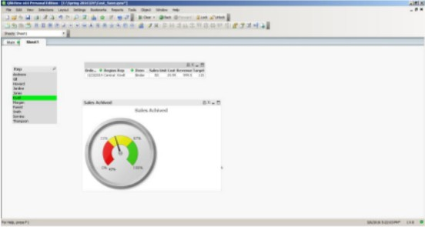

# 7.10 CREATING A STORY WITH TABLEAU PUBLIC

With Tableau public, you are able to organize your data in order to tell a meaningful story. This is beneficial when you are doing a presentation, creating an article, or uploading to a website, as it helps your audience understand your data. Stories are created through assembling the different worksheets and dashboards. We can highlight important data points, add text boxes and pictures to help convey our story. We will use our health expenditure worksheets to create a tailoring in story and illustrate the changes in Canada’s spending in a meaningful way. To begin, select “New Story” at the bottom right of your screen

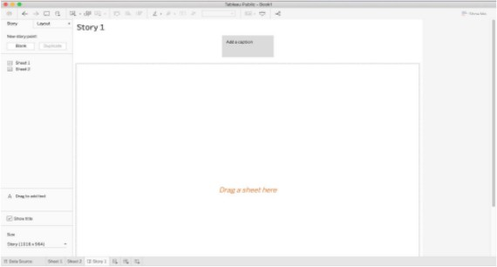

Drag “Sheet 1” and “Sheet 2” on to “Drag a sheet here”. We can rename each storyboard by clicking “Add a caption”. Rename Sheet 1 to “Provincial Health Expenditure in 2016”.

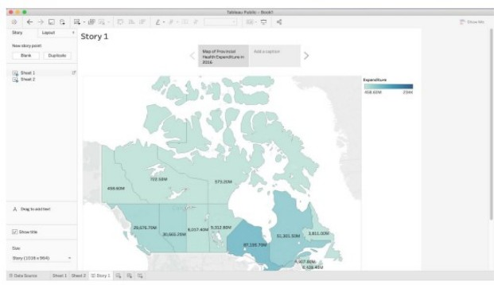

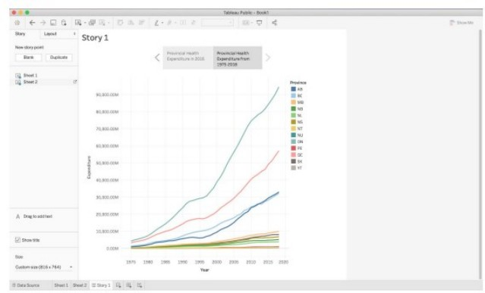Use the arrows located on the side of the caption field to navigate to Sheet 2. Click on “Add a caption” and rename Sheet 2 to “Provincial Health Expenditure from 1975-2018”.

In this story, we are going to narrow in and draw attention to the province Data Visualization or territory that is spending the most amount of money on health. Drag an additional copy of “Sheet 1” and drop it between the two existing sheets. Select “Add a caption” and rename it to “Ontario”.

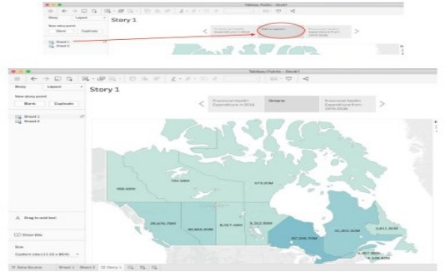

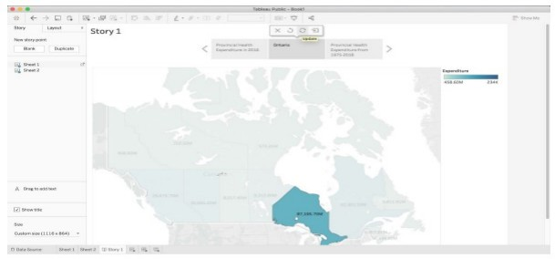On the map, click on the province Ontario and then navigate to the caption field and select “Update”. Your screen will show Ontario highlighted from the rest of Canada.

Select the right arrow to navigate to “Provincial Health Expenditure from 1975-2018”. Hover over the line representing Ontario and select the data point representing health expenditure during the year 2016. Then click “Update”.

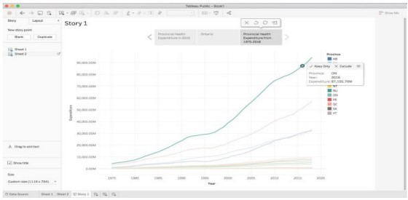

We can add a textbox to label the highlighted pointed by dragging “Drag to add text” on to the line graph. Write a key message in the textbox, such as “Ontario had the highest health expenditure in Canada in 2016, spending $87,195.70M”. Select “OK”.

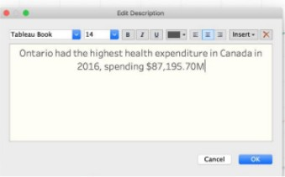

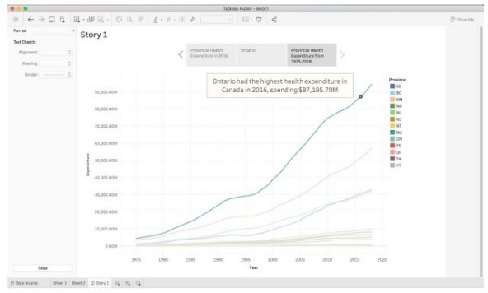You can edit the text box by selecting “More options” which will open a drop-down menu. Expand the text box by dragging the borders in order to show the full message.

We have now created a story with three sheets of how Ontario had the highest health expenditure in the year 2016. If you choose to add a dashboard, it will allow your audience to play with data. You can navigate between the story as shown below:

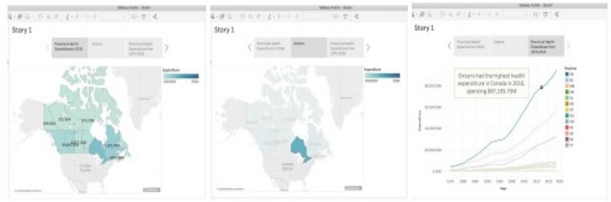

# SAVING AND PUBLISHING YOUR TABLEAU PUBLIC WORKBOOK

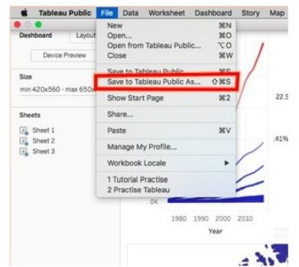Once satisfied with your workbook, which includes sheets, dashboards, and stories, you can publish it to the Tableau Public website. This is the only way to save your work when using Tableau Public, so make sure to do it if you wish to return to the workbook in the future. Once ready to publish, select the “Save to Tableau Public As…” option under the “File” tab.

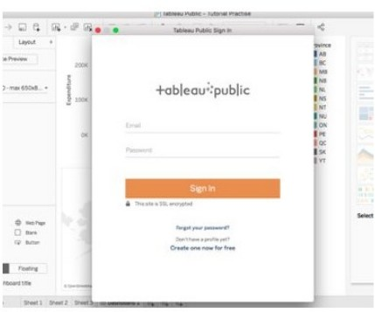From here, you will likely be prompted to log in to the Tableau Public website. You can create an account for free if you have not already.

Then, create a title for your workbook.

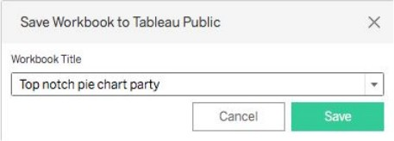

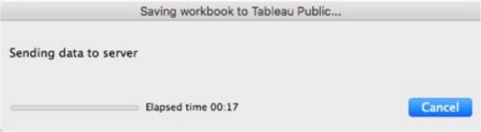Your workbook will then be uploaded to the Tableau Public server. This may take a couple minutes.

You will then be directed to the webpage on which your workbook is publicly available for download. Your workbook has now been published and saved! This page includes information on you, including a link to your Tableau Public profile, as well as additional information on the workbook. There are several options for making use of your work data visualizations that can be found at the bottom right of the workbook image. By clicking Share (A), you can get the code for embedding the workbook into a website or the link to find the workbook on tableau public. The Share button also gives you the option to share your work over email, Facebook, or Twitter. By clicking Download (B), you or any other Tableau Public users can download your workbook and make use of the data themselves.

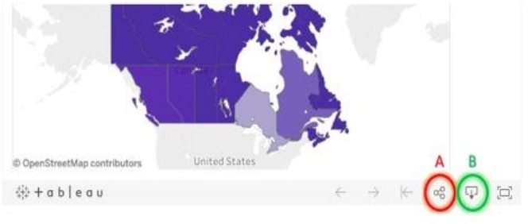

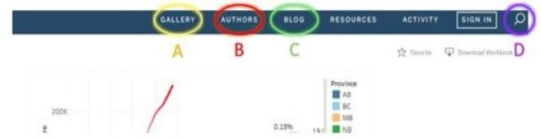On Tableau Public, all saved data visualizations are uploaded and available to all other users. This means you can use other users’ work for your website, presentations, or research as well. To search for interesting data, there is a search function (D) at the top right corner of the webpage, along with highlighted visualizations (A), authors (B), and blogs (C).

When you wish to access your published workbook, or any public Data Visualization workbooks you’ve downloaded, in the future, simply open the Tableau Public application and your workbooks will be there waiting for you!

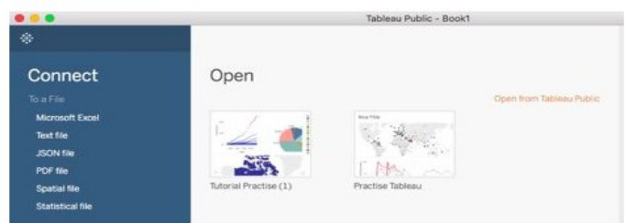

# A DASHBOARD WITH TABLEAU

Dashboards are a great way to combine your data visualizations and have them interact with one another. A lot of businesses use dashboards to keep up-to-date in real time about key performance indicators at a glance. In this example, we will combine just two of our data visualizations, the map and the line graph from the first section of the tutorial, but in reality, it can be used to combine much visualization at once.

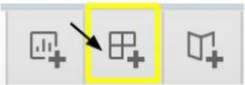The first step in creating your dashboard is to open up the Dashboard tab at the bottom of the screen:

After clicking this icon, your screen should open to this:



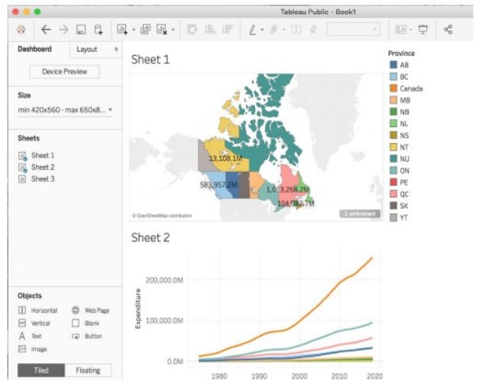This is your Dashboard Sheet. On the left side you can see that there is a list of the sheets you have made from your current data source. To build your dashboard, drag the sheet you want in to the centre where it says Drop sheets here. For our purposes, we will need to drag Sheet 1 and Sheet 2 where the map and line graph are saved. When you drag, you will notice an area of your screen will shade over where your graph will drop when you put it down. Organize your dashboard to look like the following:

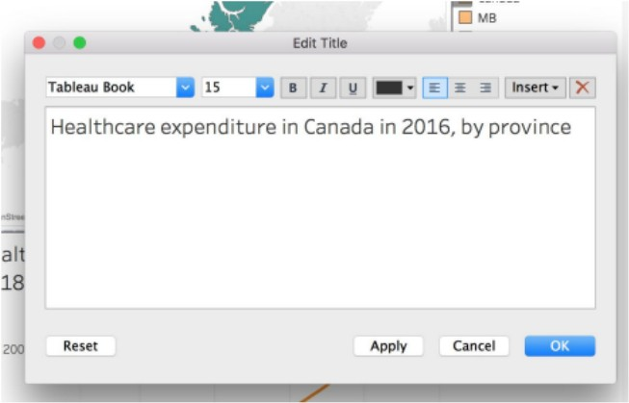Now to add titles to the graphs that were chosen, double click on the automatic titles generated based on the sheet name, and a new window should appear, type in a title that describes the graph like so:

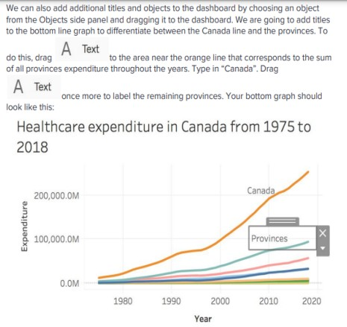

Now, to add an interactive layer between the graphs, we can choose a graph that can act as a filter to the other. We will choose the line graph to act as a filter to the map. To do this, click on the line graph and a grey sidebar should appear. From this bar, click the filter icon to use this graph as a filter:

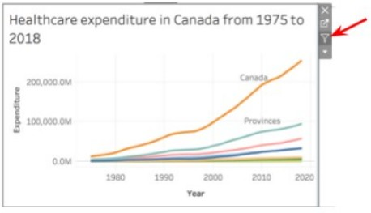

Now, when you click a given line, it will be highlighted on the above map:

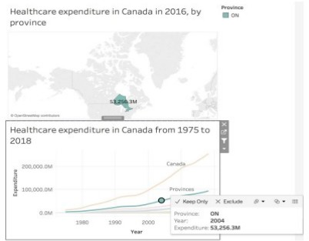

Congrats, now you have an interactive dashboard that is ready to be published or saved!

# QUESTIONS

1. What is data visualization in Tableau?
2. What is the difference between various BI tools and Tableau?
3. What are different Tableau products?
4. What is a parameter in Tableau?
5. Tell me something about measures and dimensions?
6. What are continuous and discrete field types?
7. What is aggregation and disaggregation of data?
8. What are the different types of joins in Tableau?
9. Tell me the different connections to make with a dataset?
10. What are the supported file extensions in Tableau?

# QUIZ

Uploaded on classroom

# VIDEO LECTURES

1. Tableau Full Course - Learn Tableau in 6 Hours | Tableau Training for Beginners | Edureka. [https://www.youtube.com/watch?v=aHaOIvR00So](http://www.youtube.com/watch?v=aHaOIvR00So)
2. Introduction to Tableau | How Tableau Works. [https://www.youtube.com/watch?v=gWZtNdMko1k](http://www.youtube.com/watch?v=gWZtNdMko1k)
3. Tableau Vs Excel. [https://www.youtube.com/watch?v=ozGYSLrAc5o](http://www.youtube.com/watch?v=ozGYSLrAc5o)
4. Tableau Tutorial | Tableau Full Course - Learn Tableau In 6 Hours | Great Learning. [https://www.youtube.com/watch?v=6mBtTNggkUk](http://www.youtube.com/watch?v=6mBtTNggkUk)
5. Tableau Expert Full Course | Tableau Training | Tableau Tutorial | Tableau Full Course | Simplilearn. [https://www.youtube.com/watch?v=DlBIhpDjhbY](http://www.youtube.com/watch?v=DlBIhpDjhbY)
6. Data Visualization with Tableau | Tableau Tutorial for Beginners in 2022 | Great Learning. [https://www.youtube.com/watch?v=](http://www.youtube.com/watch?v=WAXfRAI96YA)W[AXfRAI96](http://www.youtube.com/watch?v=WAXfRAI96YA)YA
7. Tableau Projects For Practice With Examples | Tableau Training For Beginners | Simplilearn. [https://www.youtube.com/watch?v=5uzB4z4iN0g](http://www.youtube.com/watch?v=5uzB4z4iN0g)

# MOOCS

* Data Visualization in Tableau. [https://www](http://www.udacity.com/course/data-visualization-in-tableau--).udacity[.com/course/data-visualization-in-tableau--](http://www.udacity.com/course/data-visualization-in-tableau--) ud1006
* Tableau Tutorial for Beginners. [https://www](http://www.udemy.com/course/tableau-tutorial-for-beginners/).udemy[.com/course/tableau-tutorial-for-beginners/](http://www.udemy.com/course/tableau-tutorial-for-beginners/) ❖ Tableau Certification Training Course. [https://www.edureka.co/tableau-certification-training?](http://www.edureka.co/tableau-certification-training)

# 7.17 REFERENCES

1. [https://www](http://www.techtarget.com/searchbusinessanalytics/definition/datavisualization).techtar[get.com/searchbusinessanalytics/definition/datavisualization](http://www.techtarget.com/searchbusinessanalytics/definition/datavisualization)
2. [https://www.ibm.com/cloud/learn/data-visualization](http://www.ibm.com/cloud/learn/data-visualization)
3. [https://www.tableau.com/learn/articles/data-visualization](http://www.tableau.com/learn/articles/data-visualization) 4.https://policyviz.com/wpcontent/uploads/woocommerce_uploads/2017/07/A-Guide-toAdvance d-Data-Visualization-in-Excel-2016-Final.pdf