**Practical No. 1**

**Remote Process Communication**

**Q.1 Write a java program to implement client server application using TCP.**

**Structure :**

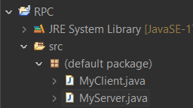

**Program :**

**MyServer.java**

import java.io.*;

import java.net.*;

public class MyServer{

public static void main(String[] args)

{

try{

//1. Open the Server Socket and Register service on port

ServerSocket ss =new ServerSocket(2222);

//2. Wait for the Client Request and accept a

Socket s=ss.accept();

DataInputStream in=new DataInputStream(System.in);

//3. Create I/O streams for communicating to the client

DataInputStream dis = new DataInputStream(s.getInputStream());

DataOutputStream dout=new DataOutputStream(s.getOutputStream());

//4. Perform communication with

String str=dis.readUTF()

System.out.println("message= "+str);

System.out.println("Enter a message for the Client...");

@SuppressWarnings("deprecation")

String str1 = in.readLine();

dout.writeUTF(str1);

//5. flush and close

dout.flush();

dout.close();

//6. Close

s.close();

ss.close();

}

catch(Exception e){

System.out.println(e);

}

}

}

**MyClient.java**

import java.io.*;

import java.net.*;

public class MyClient

{

public static void main(String[] args){

try{

//1. Create a Socket Object and Open your connection to a server at port

Socket s=new Socket("localhost",2222);

//2. Create I/O streams for communicating with the server.

// Get an output file handle from the socket

DataOutputStream dout=new DataOutputStream(s.getOutputStream());

// Get an input file handle from the socket and read the input

DataInputStream dis = new DataInputStream(s.getInputStream());

DataInputStream in = new DataInputStream(System.in);

System.out.println("Enter a message for the server...");

//3.Perform I/O or communication with the

@SuppressWarnings("deprecation")

String str = in.readLine();

dout.writeUTF(str);

String str1=dis.readUTF();

System.out.println("message= "+str1);

//4. flush and close

dout.flush();

dout.close();

dis.close();

//5. Close

s.close();

}

catch(Exception e){

System.out.println(e);

}

}

}

**Output :**

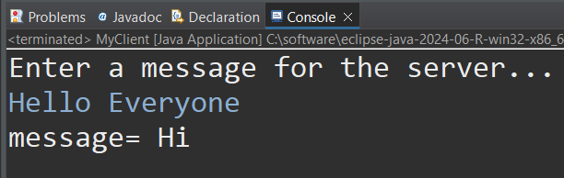

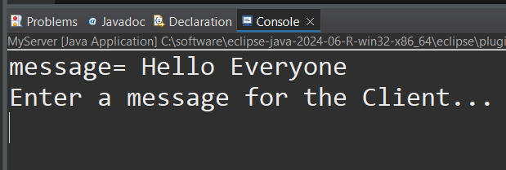

**Q.2 Develop a JAVA program for multi-client chat server using Socket.**

**Structure:**

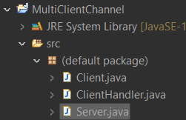

**Program:**

**Server.java**

import java.io.IOException;

import java.net.ServerSocket;

import java.net.Socket;

public class Server {

private ServerSocket serverSocket;

public Server(ServerSocket serverSocket) {

this.serverSocket = serverSocket;

}

public void startServer() {

try {

while(!serverSocket.isClosed()) {

Socket socket = serverSocket.accept();

System.out.println("A new client has connected!");

ClientHandler clientHandler = new ClientHandler(socket);

Thread thread = new Thread((Runnable) clientHandler);

thread.start();

}

}

catch (IOException e) {

// TODO: handle exception

System.out.println("Exception Occurs : " + e.getMessage());

e.printStackTrace();

}

}

public void closeServerSocket() {

try {

if(serverSocket != null) {

serverSocket.close();

}

}

catch(IOException e) {

e.printStackTrace();

}

}

public static void main(String[] args) throws IOException{

// TODO Auto-generated method stub

ServerSocket serverSocket = new ServerSocket(8867);

Server server = new Server(serverSocket);

server.startServer();

}

}

**ClientHandler.java**

import java.io.BufferedReader;

import java.io.BufferedWriter;

import java.io.InputStreamReader;

import java.io.OutputStreamWriter;

import java.net.Socket;

import java.util.ArrayList;

public class ClientHandler implements Runnable {

public static ArrayList<ClientHandler> clientHandlers = new ArrayList<>();

private Socket socket;

private BufferedReader bufferedReader;

private BufferedWriter bufferedWriter;

private String clientUserName;

@SuppressWarnings("unused")

private String messageToSend;

public ClientHandler(Socket socket) {

// TODO Auto-generated constructor stub

try {

this.socket = socket;

// res allocated

this.bufferedReader = new BufferedReader(new InputStreamReader(socket.getInputStream()));

this.bufferedWriter = new BufferedWriter(new OutputStreamWriter(socket.getOutputStream()));

this.clientUserName = bufferedReader.readLine();

clientHandlers.add(this);

broadcastMessage("Server : " + clientUserName + " has entered the chat guys!");

}

catch(Exception e) {

closeEverything(socket, bufferedReader, bufferedWriter);

}

}

@Override

public void run() {

String messageFromClient;

while(socket.isConnected()) {

try {

messageFromClient = bufferedReader.readLine();

broadcastMessage(messageFromClient);

}

catch(Exception e) {

closeEverything(socket, bufferedReader, bufferedWriter);

break;

}

}

}

public void broadcastMessage(String messageToSend) {

this.messageToSend = messageToSend;

for(ClientHandler clientHandler : clientHandlers) {

try {

if(!clientHandler.clientUserName.equals(clientUserName)) {

clientHandler.bufferedWriter.write(messageToSend);

clientHandler.bufferedWriter.newLine();

clientHandler.bufferedWriter.flush();

}

}

catch(Exception e) {

closeEverything(socket, bufferedReader,bufferedWriter);

}

}

}

public void removeClientHandler() {

clientHandlers.remove(this);

broadcastMessage("Server : " + clientUserName + " has left the Chat Guys!");

}

public void closeEverything(Socket socket, BufferedReader bufferedReader, BufferedWriter bufferedWriter) {

// Lefted 1 member

removeClientHandler();

try {

if(bufferedReader != null) {

bufferedReader.close();

}

if(bufferedWriter != null) {

bufferedWriter.close();

}

if(socket != null) {

socket.close();

}

}

catch (Exception e) {

// TODO: handle exception

e.printStackTrace();

}

}

}

**Client.java**

// when user start it

import java.io.BufferedWriter;

import java.io.IOException;

import java.io.InputStreamReader;

import java.io.OutputStreamWriter;

import java.io.BufferedReader;

import java.net.Socket;

import java.net.UnknownHostException;

import java.util.Scanner;

public class Client {

private Socket socket;

private BufferedReader bufferedReader;

private BufferedWriter bufferedWriter;

private String username;

public Client(Socket socket, String username) {

try {

this.socket = socket;

this.bufferedReader = new BufferedReader(new InputStreamReader(socket.getInputStream()));

this.bufferedWriter = new BufferedWriter(new OutputStreamWriter(socket.getOutputStream()));

this.username = username;

}

catch (Exception e) {

// TODO: handle exception

e.printStackTrace();

}

}

public void sendMessage() {

try {

bufferedWriter.write(username);

bufferedWriter.newLine();

bufferedWriter.flush();

Scanner sc = new Scanner(System.in);

while (socket.isConnected()) {

String messageToSend = sc.nextLine();

bufferedWriter.write(username + " : "+ messageToSend);

bufferedWriter.newLine();

bufferedWriter.flush();

}

sc.close();

}

catch (Exception e) {

// TODO: handle exception

e.printStackTrace();

}

}

public void listenForMessage() {

new Thread(new Runnable() {

@Override

public void run() {

// TODO Auto-generated method stub

String msgFromGroupChat;

while(socket.isConnected()) {

try {

msgFromGroupChat = bufferedReader.readLine();

System.out.println(msgFromGroupChat);

}

catch (Exception e) {

// TODO: handle exception

closeEverything(socket, bufferedReader, bufferedWriter);

e.printStackTrace();

}

}

}

}).start();

}

public void closeEverything(Socket socket, BufferedReader bufferedReader, BufferedWriter bufferedWriter) {

// Lefted 1 member

try {

if(bufferedReader != null) {

bufferedReader.close();

}

if(bufferedWriter != null) {

bufferedWriter.close();

}

if(socket != null) {

socket.close();

}

}

catch (Exception e) {

// TODO: handle exception

e.printStackTrace();

}

}

public static void main(String[] args) throws UnknownHostException, IOException {

// TODO Auto-generated method s

Scanner sc = new Scanner(System.in);

System.out.println("Enter your username for the group chat : ");

String username = sc.nextLine();

Socket socket = new Socket("localhost",8867);

Client client = new Client(socket, username);

client.listenForMessage();

client.sendMessage();

sc.close();

}

}

**Output:**

