**Practical No. 03**

**Solidity Programming**

**Q. 1 Write a solidity smart contract to display hello world message.**

**Code :**

**// Hello World Smart Contract**

**// SPDX-License-Identifier: MIT**

**pragma solidity >= 0.5.0 < 0.8.27;**

**contract HelloWorld {**

**function get()public pure returns (string memory str) {**

**str = "Hello World";**

**}**

**}**

**Output :**

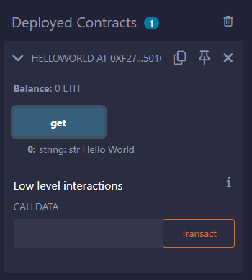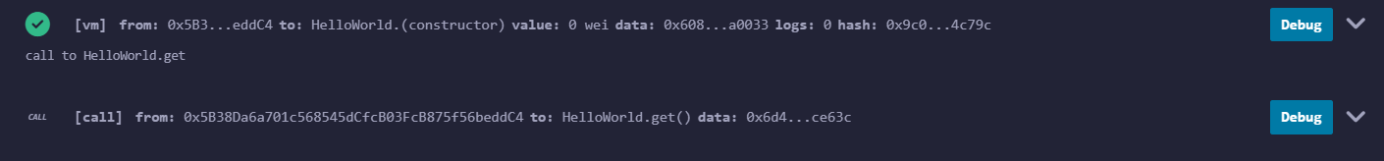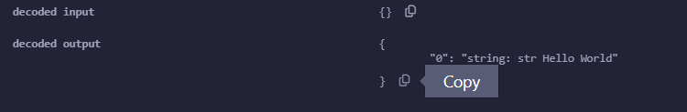

**Q. 2 Write a solidity smart contract to demonstrate state variable, local variable and global variable.**

**Code:**

**// SPDX-License-Identifier: MIT**

**pragma solidity >= 0.5.0 < 0.8.27;**

**contract DemonstrateFunction{**

**uint16 num = 10; // state variable**

**function getInput3(uint16 n1, uint16 n2) public returns (uint16){**

**num = 100;**

**return n1 + n2 + num;**

**}**

**function getInput2(uint16 n1, uint16 n2) public view returns (uint16){**

**return n1 + n2 + num;**

**}**

**function getInput(uint16 n1, uint16 n2) public pure returns (uint16){**

**return n1 + n2;**

**}**

**function getInfo() public returns (uint16){**

**return num += 11;**

**}**

**function getData() public view returns (uint16){**

**return num;**

**}**

**function getData01() public pure returns (uint16){**

**return 111;**

**}**

**}**

**Output:**

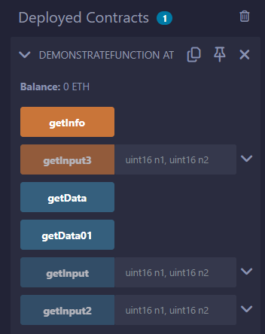

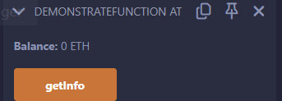

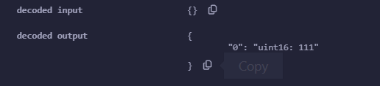

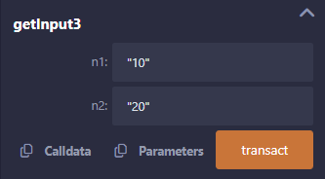

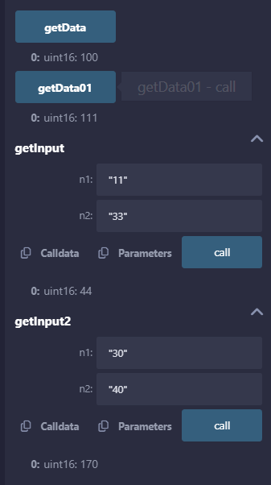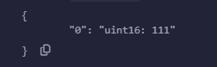

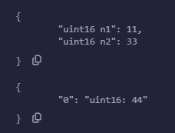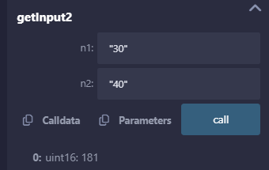

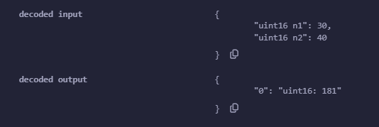

**Q.3 Write a solidity smart contract to demonstrate getter and setter methods.**

**Code :**

**// SPDX-License-Identifier: MIT**

**pragma solidity ^0.8.19;**

**contract StructureDemo1{**

**// structure like C program**

**struct Book{**

**string title;**

**string author;**

**uint book_id;**

**}**

**// variable object created**

**Book b1;**

**// setter method**

**function setBook() public {**

**b1=Book('Hello JS', 'Onkar', 101);**

**}**

**// add values to it**

**function enterBkDtls(string memory title, string memory auth, uint bid) public {**

**b1=Book(title, auth, bid);**

**}**

**// Getter method**

**function getBookDtls() public view returns(string memory,string memory,uint) {**

**return (b1.title,b1.author,b1.book_id);**

**}**

**}**

**Output :**

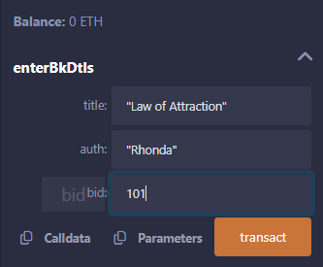

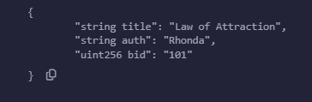

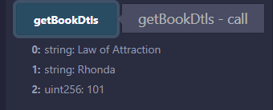

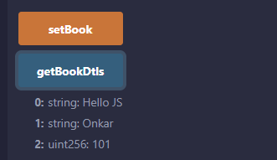

**Q.4 Write a solidity smart contract to demonstrate function modifier.**

**Code:**

**// SPDX-License-Identifier: MIT**

**pragma solidity >= 0.5.0 < 0.8.27;**

**contract ModifierDemo {**

**// We will use the modifier to limit the function changePrice to only the owner of the contract**

**address public owner;**

**uint price;**

**constructor() {**

**owner = msg.sender;**

**}**

**modifier onlyOwner{**

**require(msg.sender == owner, 'Only Owner is allowed to modify the price!');**

**_;   // Asterisk is used to indicate that this function will be executed even if there is an exception.**

**// This will allow us to do any other modification.**

**}**

**function changePrice(uint _price) public onlyOwner{**

**price=_price;**

**}**

**function viewPrice() public view returns (uint){**

**return price;**

**}**

**}**

**Output:**

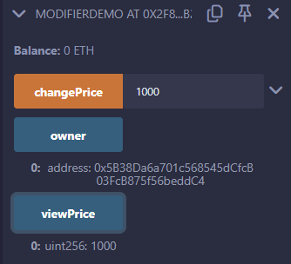

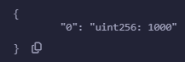

**Q.5 Write a Solidity program to demonstrate arrays Push operation and Pop operation.**

**Code:**

**// Push pop Array**

**// SPDX-License-Identifier: MIT**

**pragma solidity ^0.8.19;**

**contract PushPop {**

**uint[] data = [10, 20, 30, 40, 50];**

**function array_push() public returns(uint[] memory) {**

**data.push(60);**

**data.push(70);**

**data.push(80);**

**return data;**

**}**

**function array_pop() public returns (uint[] memory){**

**data.pop();**

**return data;**

**}**

**}**

**Output:**

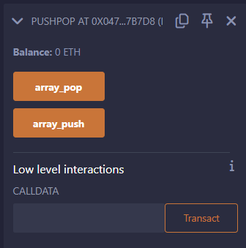

**Push Button Click:**

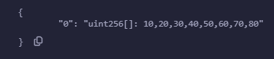

**Pop Button Click:**

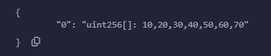

**Q.6 Write a Solidity program to demonstrate creating a fixed-size array and access array element.**

**Code:**

**// Demonstrate Array**

**// SPDX-License-Identifier: MIT**

**pragma solidity >= 0.5.0 < 0.8.27;**

**// create a Contract**

**contract FixedSizeArray {**

**// Declaring state variable of Array**

**uint[6] data1;**

**//Defining the functions**

**function array_example() public returns (int[5] memory, uint[6] memory){**

**int[5] memory data = [int(50), -63, 77, -28, 90];**

**// local variable type**

**data1 = [uint(10), 20, 30, 40, 50, 60];**

**return (data, data1); // Returning the values**

**}**

**}**

**Output:**

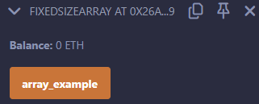

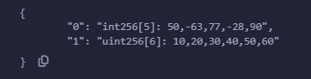

**Q.7 Write a Solidity program to demonstrate creating a dynamic array and accessing array element.**

**Code:**

**// Dynamic Smart Contract**

**// SPDX-License-Identifier: MIT**

**pragma solidity >= 0.5.0 < 0.8.27;**

**contract Types{**

**// dynamic array**

**int[] data1;**

**// static array**

**uint[] data = [10, 20, 30, 40, 50, 60];**

**function dynamic_array() public returns (uint[] memory, int[] memory) {**

**data1 = [int(-60), 70, 120, -120];**

**return (data, data1);**

**}**

**}**

**Output:**

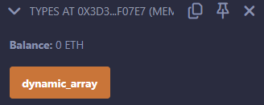

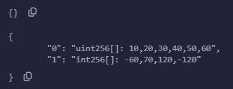

**Q.8 Write a solidity smart contract to demonstrate use of structure.**

**// SPDX-License-Identifier: MIT**

**pragma solidity ^0.8.19;**

**contract StructureDemo1{**

**// structure like C program**

**struct Book{**

**string title;**

**string author;**

**uint book_id;**

**}**

**// variable object created**

**Book b1;**

**// setter method**

**function setBook() public {**

**b1=Book('Hello JS', 'Onkar', 101);**

**}**

**// add values to it**

**function enterBkDtls(string memory title, string memory auth, uint bid) public {**

**b1=Book(title, auth, bid);**

**}**

**// Getter method**

**function getBookDtls() public view returns(string memory,string memory,uint) {**

**return (b1.title,b1.author,b1.book_id);**

**}**

**}**

**Output :**









**Q.9 Write a solidity smart contract to calculate percentage of marks obtained by students for six subjects in final examination.**

**Code:**

**// SPDX-License-Identifier: MIT**

**pragma solidity ^0.8.19;**

**contract StudentMarks {**

**struct Student {**

**uint256[6] marks; // Array to hold marks for six subjects**

**}**

**mapping(address => Student) private students;**

**// Function to set marks for a student**

**function setMarks(uint256[6] memory _marks) public {**

**require(_marks.length == 6, "Must provide marks for six subjects");**

**students[msg.sender].marks = _marks;**

**}**

**// Function to calculate the percentage of marks obtained**

**function calculatePercentage() public view returns (uint256) {**

**Student storage student = students[msg.sender];**

**uint256 totalMarks = 0;**

**uint256 maxMarks = 600; // Assuming each subject is out of 100**

**for (uint256 i = 0; i < 6; i++) {**

**totalMarks += student.marks[i];**

**}**

**// Calculate percentage**

**return (totalMarks * 100) / maxMarks;**

**}**

**}**

**Output:**

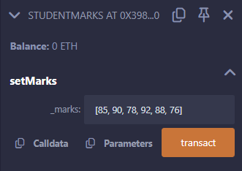

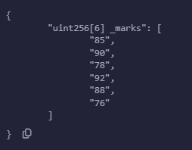

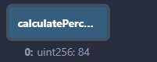

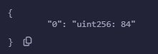

**Q.10 Write a solidity smart contract to find the factorial of entered number.**

**Code:**

**// SPDX-License-Identifier: MIT**

**pragma solidity ^0.8.19;**

**contract FactorialCalculator {**

**// Function to calculate factorial of a number**

**function factorial(uint16 n) public pure returns (uint16) {**

**require(n >= 0, "Input must be a non-negative integer");**

**if (n == 0) {**

**return 1; // Base case: 0! = 1**

**} else {**

**return n * factorial(n - 1); // Recursive case**

**}**

**}**

**}**

**Output:**

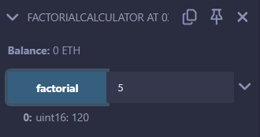

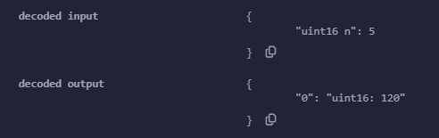

**Q.11 Write a solidity smart contract to check whether entered number is palindrome or not.**

**Code:**

**// SPDX-License-Identifier: MIT**

**pragma solidity ^0.8.19;**

**contract PalindromeChecker {**

**// Function to check if a number is a palindrome**

**function isPalindrome(uint256 n) public pure returns (bool) {**

**uint256 reversed = reverse(n);**

**return n == reversed;**

**}**

**// Function to reverse a number**

**function reverse(uint256 n) internal pure returns (uint256) {**

**uint256 reversed = 0;**

**while (n > 0) {**

**reversed = reversed * 10 + n % 10;**

**n /= 10;**

**}**

**return reversed;**

**}**

**}**

**Output:**

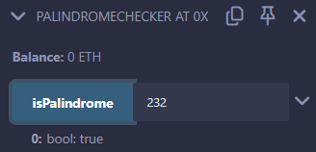

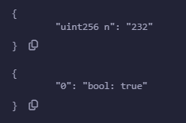

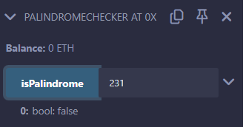

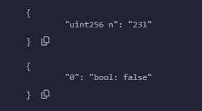

**Q.12 Write a solidity smart contract to generate Fibonacci Series up to given number.**

**Code:**

**// SPDX-License-Identifier: MIT**

**pragma solidity ^0.8.19;**

**contract FibonacciGenerator {**

**// Function to generate Fibonacci series up to a given number**

**function generateFibonacci(uint256 n) public pure returns (uint256[] memory) {**

**require(n > 0, "Input must be a positive integer");**

**uint256[] memory fibSequence = new uint256[](n);**

**fibSequence[0] = 0;**

**if (n == 1) {**

**return fibSequence;**

**}**

**fibSequence[1] = 1;**

**for (uint256 i = 2; i < n; i++) {**

**fibSequence[i] = fibSequence[i - 1] + fibSequence[i - 2];**

**}**

**return fibSequence;**

**}**

**}**

**Output:**

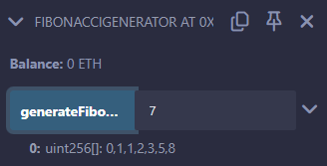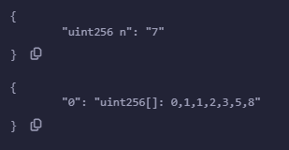

**Q.13 Write a solidity smart contract to check whether entered number is prime number or not.**

**Code:**

**// SPDX-License-Identifier: MIT**

**pragma solidity ^0.8.19;**

**contract PrimeChecker {**

**// Function to check if a number is prime**

**function isPrime(uint256 n) public pure returns (bool) {**

**require(n > 0, "Input must be a positive integer");**

**if (n == 1) {**

**return false; // 1 is not a prime number**

**}**

**for (uint256 i = 2; i * i <= n; i++) {**

**if (n % i == 0) {**

**return false; // n is divisible by i, so it's not prime**

**}**

**}**

**return true; // n is prime**

**}**

**}**

**Output:**

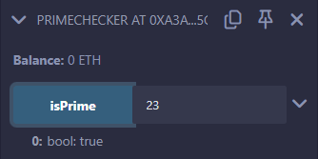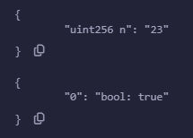

**Q.14 Write a solidity smart contract to create arithmetic calculator which includes functions for operations addition, subtraction, multiplication, division etc.**

**Code:**

**// SPDX-License-Identifier: MIT**

**pragma solidity ^0.8.19;**

**contract ArithmeticCalculator {**

**// Function to add two numbers**

**function add(uint256 a, uint256 b) public pure returns (uint256) {**

**return a + b;**

**}**

**// Function to subtract two numbers**

**function subtract(uint256 a, uint256 b) public pure returns (uint256) {**

**require(b <= a, "Subtraction result would be negative");**

**return a - b;**

**}**

**// Function to multiply two numbers**

**function multiply(uint256 a, uint256 b) public pure returns (uint256) {**

**return a * b;**

**}**

**// Function to divide two numbers**

**function divide(uint256 a, uint256 b) public pure returns (uint256) {**

**require(b > 0, "Division by zero is not allowed");**

**return a / b;**

**}**

**// Function to calculate modulus of two numbers**

**function modulus(uint256 a, uint256 b) public pure returns (uint256) {**

**require(b > 0, "Modulus by zero is not allowed");**

**return a % b;**

**}**

**// Function to calculate exponentiation of two numbers**

**function exponentiation(uint256 base, uint256 exponent) public pure returns (uint256) {**

**uint256 result = 1;**

**for (uint256 i = 0; i < exponent; i++) {**

**result *= base;**

**}**

**return result;**

**}**

**}**

**Output:**

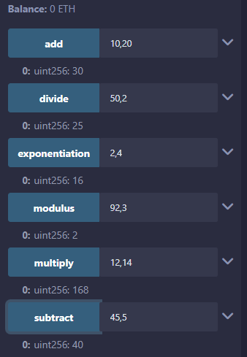

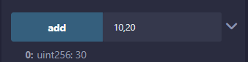 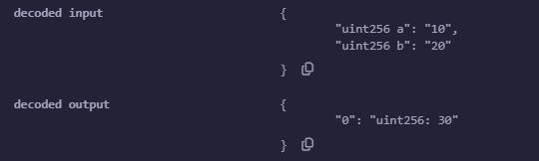

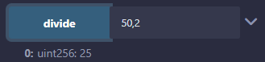 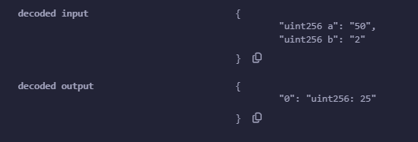

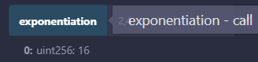 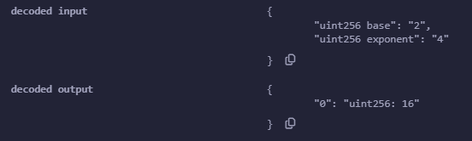

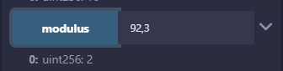 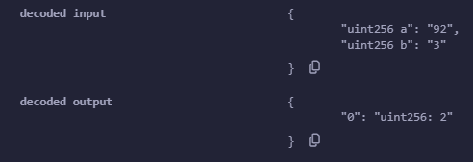

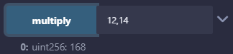 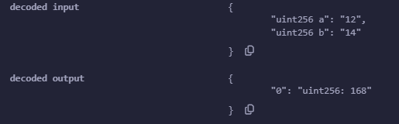

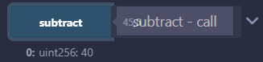 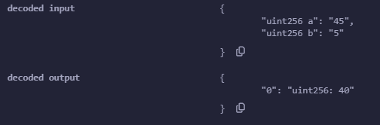

**Q.15 Write a solidity smart contract to demonstrate view function and pure function.**

**Code:**

**// SPDX-License-Identifier: MIT**

**pragma solidity ^0.8.19;**

**contract ViewAndPureFunctions {**

**// State variable to store a number**

**uint256 private storedNumber;**

**// Constructor to initialize the stored number**

**constructor(uint256 initialNumber) {**

**storedNumber = initialNumber;**

**}**

**// View function to get the stored number**

**function getStoredNumber() public view returns (uint256) {**

**return storedNumber;**

**}**

**// Pure function to add two numbers**

**function add(uint256 a, uint256 b) public pure returns (uint256) {**

**return a + b;**

**}**

**// Pure function to multiply two numbers**

**function multiply(uint256 a, uint256 b) public pure returns (uint256) {**

**return a * b;**

**}**

**}**

**Output:**

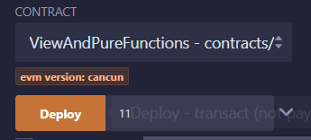

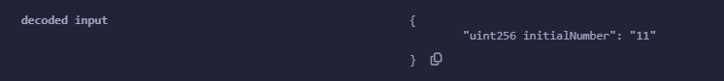

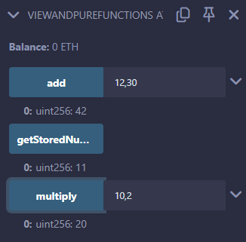

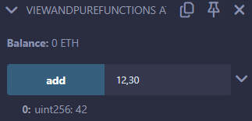

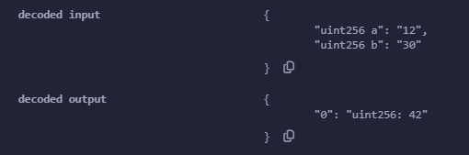

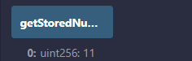

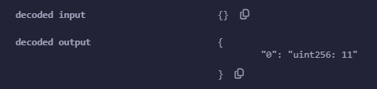

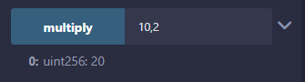

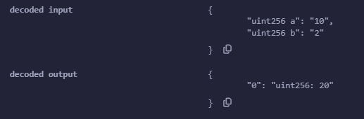

**Q.16 Write a solidity smart contract to demonstrate inbuilt mathematical functions.**

**Code:**

**// SPDX-License-Identifier: MIT**

**pragma solidity ^0.8.19;**

**contract MathematicalFunctions {**

**// Function to demonstrate addition**

**function add(uint256 a, uint256 b) public pure returns (uint256) {**

**return a + b;**

**}**

**// Function to demonstrate subtraction**

**function subtract(uint256 a, uint256 b) public pure returns (uint256) {**

**return a - b;**

**}**

**// Function to demonstrate multiplication**

**function multiply(uint256 a, uint256 b) public pure returns (uint256) {**

**return a * b;**

**}**

**// Function to demonstrate division**

**function divide(uint256 a, uint256 b) public pure returns (uint256) {**

**require(b > 0, "Division by zero is not allowed");**

**return a / b;**

**}**

**// Function to demonstrate modulus**

**function modulus(uint256 a, uint256 b) public pure returns (uint256) {**

**require(b > 0, "Modulus by zero is not allowed");**

**return a % b;**

**}**

**// Function to demonstrate exponentiation**

**function exponentiation(uint256 base, uint256 exponent) public pure returns (uint256) {**

**uint256 result = 1;**

**for (uint256 i = 0; i < exponent; i++) {**

**result *= base;**

**}**

**return result;**

**}**

**// Function to demonstrate absolute value**

**function absoluteValue(int256 a) public pure returns (uint256) {**

**return a >= 0 ? uint256(a) : uint256(-a);**

**}**

**// Function to demonstrate minimum value**

**function minimum(uint256 a, uint256 b) public pure returns (uint256) {**

**return a < b ? a : b;**

**}**

**// Function to demonstrate maximum value**

**function maximum(uint256 a, uint256 b) public pure returns (uint256) {**

**return a > b ? a : b;**

**}**

**}**

**Output:**

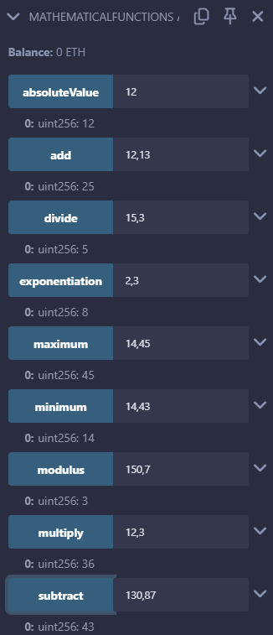

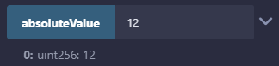 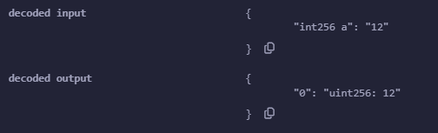

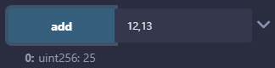 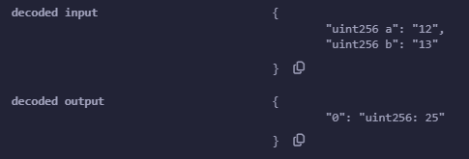

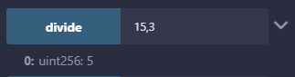 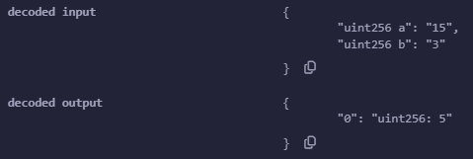

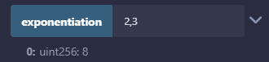 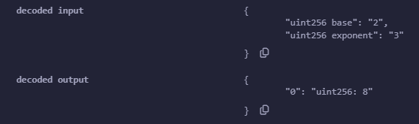

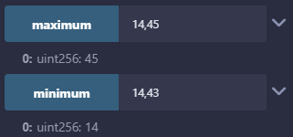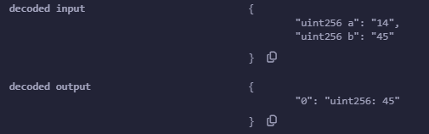

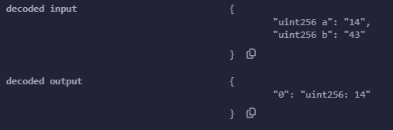

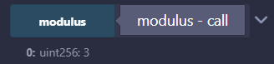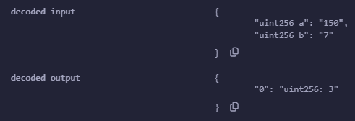

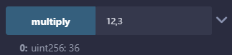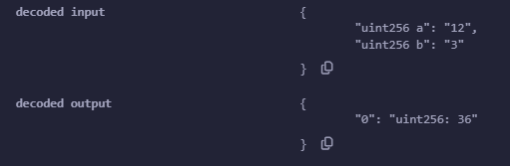

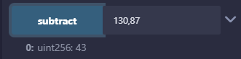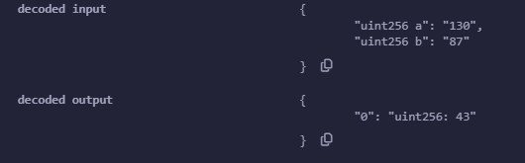

**Q.17 Write a solidity smart contract to demonstrate inheritance in contract.**

**Code:**

**// SPDX-License-Identifier: MIT**

**pragma solidity ^0.8.19;**

**contract Employee{**

**string internal name;**

**string internal age;**

**string internal sal;**

**constructor(string memory _name, string memory _age, string memory _sal){**

**name = _name;**

**age = _age;**

**sal = _sal;**

**}**

**function updateSalary (string memory _newSal) public {**

**sal = _newSal;**

**}**

**function updateAge (string memory _newAge) public {**

**age = _newAge;**

**}**

**function getEmployeeDetails() public view returns (string memory, string memory, string memory){**

**return (name,age,sal);**

**}**

**}**

**contract Manager is Employee {**

**string public department;**

**constructor(string memory _name, string memory _age, string memory _sal, string memory _dept) Employee (_name, _age, _sal) {**

**department = _dept;**

**}**

**function getManagerDetails() public view returns (string memory, string memory, string memory, string memory){**

**return (name, age, sal, department);**

**}**

**}**

**Output:**

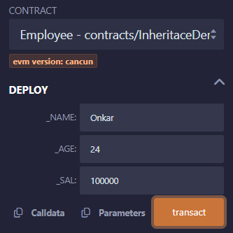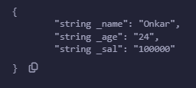

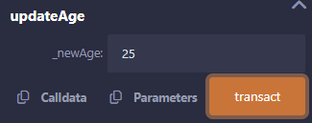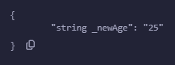

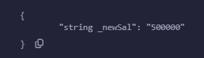

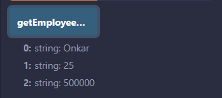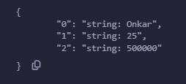

**Q.18 Write a solidity smart contract to demonstrate events.**

**Code:**

**// SPDX-License-Identifier: MIT**

**pragma solidity ^0.8.19;**

**contract EventDemo{**

**uint256 public data = 0;**

**event Increment(address owner);**

**function getValue(uint _a, uint _b) public returns (uint256){**

**emit Increment(msg.sender);**

**data = _a + _b;**

**return data;**

**}**

**}**

**Output:**

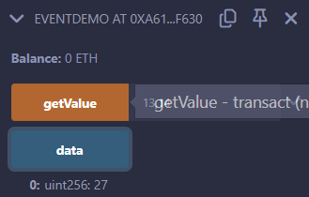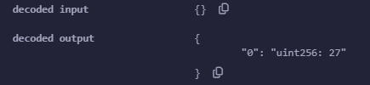

**Q.19 Write a solidity smart contract to demonstrate assert statement and revert statement.**

**Code:**

**// SPDX-License-Identifier: MIT**

**pragma solidity ^0.8.19;**

**contract AssertDemo {**

**uint public count;**

**function increment() public returns (uint) {**

**count += 1;**

**return count;**

**}**

**function decrement() public returns (uint) {**

**require(count > 0, "Count must be greater than zero");**

**count -= 1;**

**return count;**

**}**

**function checkCountInVarient() public view {**

**assert(count >= 1);**

**}**

**}**

**Output:**

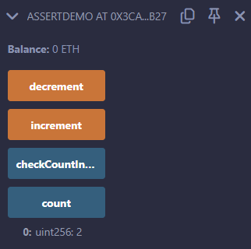

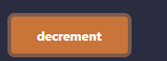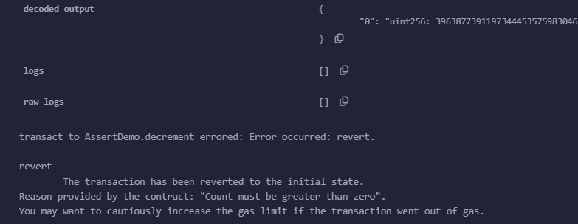

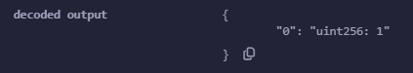



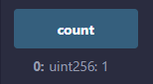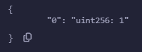

**Q.20 Write a solidity smart contract for Bank Account which provides operations such as check account balance, withdraw amount and deposit amount etc.**

**Code:**

**// SPDX-License-Identifier: MIT**

**pragma solidity ^0.8.19;**

**contract SimpleBank {**

**// State variable to store the balance**

**uint256 private balance;**

**// Constructor to initialize balance**

**constructor() {**

**balance = 0;**

**}**

**// Function to add (deposit) amount to the balance**

**function addAmount(uint256 amount) public {**

**balance += amount;**

**}**

**// Function to withdraw amount from the balance**

**function withdrawAmount(uint256 amount) public {**

**require(amount <= balance, "Insufficient balance");**

**balance -= amount;**

**}**

**// Function to check the remaining balance**

**function checkBalance() public view returns (uint256) {**

**return balance;**

**}**

**}**

**Output:**

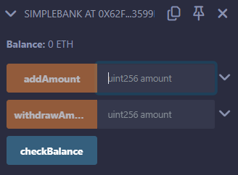

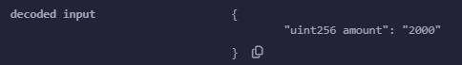

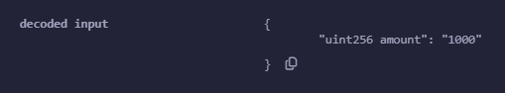

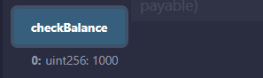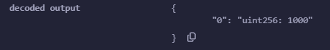

**Q.21 Write a program in solidity to create a structured student with Roll no, Name,Class, Department, Course enrolled as variables.**

**I) Add information of 5 students.**

**ii) Search for a student using Roll no**

**iii) Display all information**

**Code:**

**// SPDX-License-Identifier: MIT**

**pragma solidity ^0.8.19;**

**contract StudentInformation {**

**// Struct to represent a student**

**struct Student {**

**uint256 rollNo;**

**string name;**

**string class_;**

**string department;**

**string courseEnrolled;**

**}**

**// Mapping to store students by roll number**

**mapping(uint256 => Student) private students;**

**// Function to add a new student**

**function addStudent(uint256 rollNo, string memory name, string memory class_, string memory department, string memory courseEnrolled) public {**

**require(rollNo > 0, "Roll number must be greater than zero");**

**require(bytes(name).length > 0, "Name cannot be empty");**

**require(bytes(class_).length > 0, "Class cannot be empty");**

**require(bytes(department).length > 0, "Department cannot be empty");**

**require(bytes(courseEnrolled).length > 0, "Course enrolled cannot be empty");**

**students[rollNo] = Student(rollNo, name, class_, department, courseEnrolled);**

**}**

**// Function to search for a student by roll number**

**function searchStudent(uint256 rollNo) public view returns (Student memory) {**

**require(students[rollNo].rollNo > 0, "Student not found");**

**return students[rollNo];**

**}**

**// Function to display all student information**

**function displayAllStudents() public view returns (Student[] memory) {**

**uint256 count = 0;**

**for (uint256 i = 1; i <= 100; i++) {**

**if (students[i].rollNo > 0) {**

**count++;**

**}**

**}**

**Student[] memory allStudents = new Student[](count);**

**uint256 index = 0;**

**for (uint256 i = 1; i <= 100; i++) {**

**if (students[i].rollNo > 0) {**

**allStudents[index] = students[i];**

**index++;**

**}**

**}**

**return allStudents;**

**}**

**}**

**Output:**

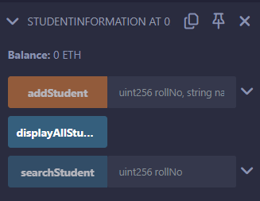

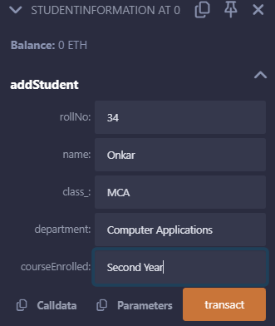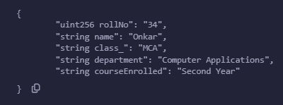

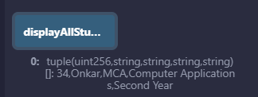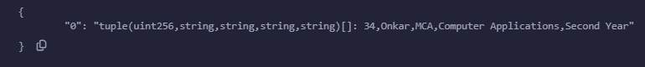

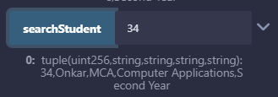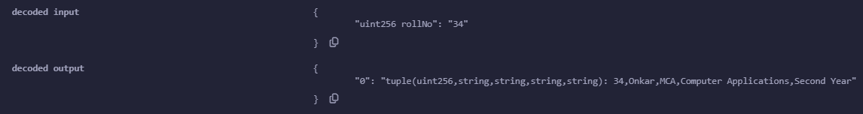

**Q.22 Create a structure Consumer with Name, Address, Consumer ID, Units and Amount as members. Write a program in solidity to calculate the total electricity bill according to the given condition:**

**For first 50 units Rs. 0.50/unit. For next 100 units Rs. 0.75/unit. For next 100 units Rs. 1.20/unit. For unit above 250 Rs. 50/unit. An additional surcharge of 20% is added to the bill. Display the information of 5 such consumers along with their units consumed and amount.**

**Code:**

**// SPDX-License-Identifier: MIT**

**pragma solidity ^0.8.19;**

**contract ElectricityBillCalculator {**

**// Struct to represent a consumer**

**struct Consumer {**

**string name;**

**string address_;**

**uint256 consumerID;**

**uint256 units;**

**uint256 amount;**

**}**

**// Mapping to store consumers by consumer ID**

**mapping(uint256 => Consumer) private consumers;**

**// Function to add a new consumer**

**function addConsumer(uint256 consumerID, string memory name, string memory address_, uint256 units) public {**

**require(consumerID > 0, "Consumer ID must be greater than zero");**

**require(bytes(name).length > 0, "Name cannot be empty");**

**require(bytes(address_).length > 0, "Address cannot be empty");**

**require(units >= 0, "Units cannot be negative");**

**uint256 amount = calculateBill(units);**

**consumers[consumerID] = Consumer(name, address_, consumerID, units, amount);**

**}**

**// Function to calculate the total electricity bill**

**function calculateBill(uint256 units) internal pure returns (uint256) {**

**uint256 amount;**

**if (units <= 50) {**

**amount = units * 50; // Rs. 0.50/unit**

**} else if (units <= 150) {**

**amount = 50 * 50 + (units - 50) * 75;**

**// Rs. 0.50/unit for first 50 units, Rs. 0.75/unit for next 100 units**

**} else if (units <= 250) {**

**amount = 50 * 50 + 100 * 75 + (units - 150) * 120;**

**// Rs. 0.50/unit for first 50 units, Rs. 0.75/unit for next 100 units, Rs. 1.20/unit for next 100 units**

**} else {**

**amount = 50 * 50 + 100 * 75 + 100 * 120 + (units - 250) * 150;**

**// Rs. 0.50/unit for first 50 units, Rs. 0.75/unit for next 100 units, Rs. 1.20/unit for next 100 units, Rs. 1.50/unit for units above 250**

**}**

**// Additional surcharge of 20%**

**amount = amount + (amount * 20 / 100);**

**return amount;**

**}**

**// Function to display the information of a consumer**

**function displayConsumer(uint256 consumerID) public view returns (Consumer memory) {**

**require(consumers[consumerID].consumerID > 0, "Consumer not found");**

**return consumers[consumerID];**

**}**

**// Function to display the information of all consumers**

**function displayAllConsumers() public view returns (Consumer[] memory) {**

**uint256 count = 0;**

**for (uint256 i = 1; i <= 100; i++) {**

**if (consumers[i].consumerID > 0) {**

**count++;**

**}**

**}**

**Consumer[] memory allConsumers = new Consumer[](count);**

**uint256 index = 0;**

**for (uint256 i = 1; i <= 100; i++) {**

**if (consumers[i].consumerID > 0) {**

**allConsumers[index] = consumers[i];**

**index++;**

**}**

**}**

**return allConsumers;**

**}**

**}**

**Output:**



