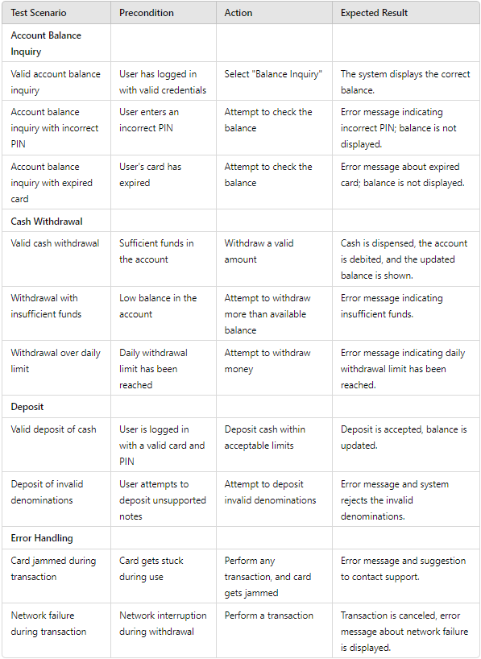

**Error Handling**

**Deposit**

**Cash Withdrawal**

**Account Balance Enquiry**

**Write test scenarios to verify the functionality of an ATM machine. Consider scenarios that**

**include account balance inquiries, cash withdrawals, deposits, and error handling.**

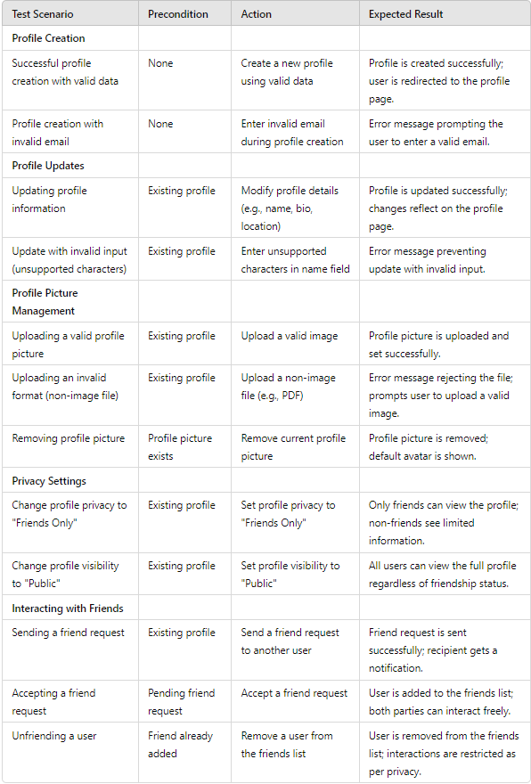

**Interacting with Friends**

**Privacy Settings**

**Profile Picture Management**

**Profile Updates**

**Profile Creation**

**Write test scenarios to validate the functionality of a Facebook user profile. Include scenarios**

**for creating and updating a profile, uploading and managing profile pictures, privacy settings,**

**and interacting with friends.**