**Sequential Search:**

Implementation of the Sequential Search (Linear Search) in C++ Language.

**Code:**

#include<iostream>

using namespace std;

int linearSearch(int arr[],int size,int key){

for (int i = 0; i < size; i++)

{

if(arr[i]==key){

return i;

}

}

return -1;

}

int main(){

int n;

cout << "\nEnter the Size of the Array: ";

cin >> n;

int arr[n];

cout << "\nEnter the elements from the Array: ";

for(int i=0;i<n;i++){

cin >> arr[i];

}

cout<<"\n Enter Key:";

int key;

cin>>key;

cout << "\n Check Location of the if its Founded: " << linearSearch(arr, n, key);

return 0;

}

**Output:**

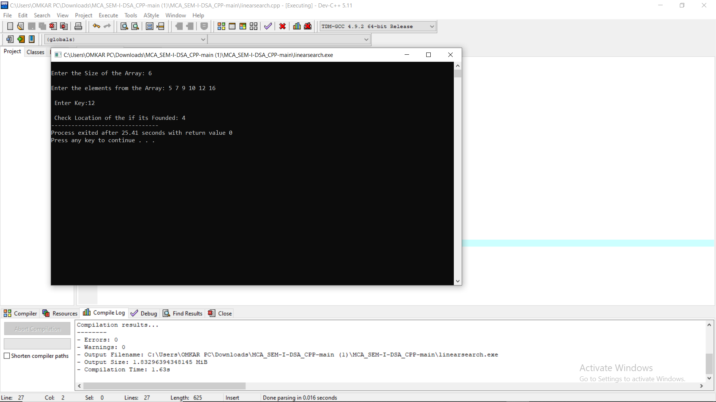

**Binary Search:**

Implementation of the Binary Search in C++ Language.

**Code:**

#include<iostream>

using namespace std;

int binarysearch(int arr[],int size,int key){

int start=0;

int end=size-1;

int mid=start+(end-start)/2;

while(start<=end){

if(arr[mid]==key){

return mid;

}

if(key>arr[mid])//goto right

{

start=mid+1;

}

else if(key<arr[mid])//goto left

{

end=mid-1;

}

mid=start+(end-start)/2;

}

return -1;

}

int main()

{

int n;

cout << "\nEnter the Size of the Array: ";

cin >> n;

int arr[n];

cout << "\nEnter the elements from the Array: ";

for(int i=0;i<n;i++){

cin >> arr[i];

}

cout<<"\n Enter Key:";

int key;

cin>>key;

int Eindex=binarysearch(arr, n, key);

cout<<"\n Index of is "<<Eindex;

return 0;

}

**Output:**

