

# A PROJECT REPORT ON

**FOOD GRAIN MANAGEMENT SYSTEM**

# Submitted in partial fulfillment for Degree of

**MASTER OF COMPUTER APPLICATION**

# By

**Siddhivinayak Sanjay Thorat Gayatri Manohar More Tanuja Kailas Tabib**

# Under the guidance of

**<Name of Internal Guide> (Department of MCA)**

# Submitted to

**Department of MCA**

**FINOLEX ACADEMY OF MANAGEMENT AND TECHNOLOGY, RATNAGIRI**



**FINOLEX ACADEMY OF MANAGEMENT AND TECHNOLOGY, RATNAGIRI**

# This is to certify that the project report titled:

**FOOD GRAIN MANAGEMENT SYSTEM**

# Carried out by student of MCA Submitted By:

**Siddhivinayak Sanjay Thorat Gayatri Manohar More Tanuja Kailas Tabib**

# In partial fulfillment of the award for degree of

**MASTER OF COMPUTER APPLICATION**

# From Mumbai University

**And is/are the bonafide records of the work done by him/her/them during the Semester II of A.Y 2022-2023**

**Internal Guide HOD**

**(<Name of Internal Guide>) (Prof. Tejas V. Joshi)**

# ABSTRACT

The foundation of my project is the food grain management system. Nutritional food items must be delivered to children in a pandemic condition. The company delivers nutritious food to underprivileged children, malnourished youngsters, and pregnant mothers. During the lockdown, the company also feeds these food grains to pupils at the school.

This is a government project, and the company receives food grains from them. This food is weighed, put into packets, and supplied to the appropriate schools and nurseries. The company manually keeps track of all data records. As a result, my project entails the automation of all business processes. Stock records, billing for distributed stock, and distribution chalans are all included in this project's data. I am working on a software that will allow me to conveniently organize and save all of this data. Admins may access all data in one place with this software.

# ACKNOWLEDGEMENT

I wish to express my sincere thanks to The Principal Dr. P. P. Kulkarni, Vice Principal Dr. A. M. Kulkarni, Information Technology Department Coordinator Dr. V. V. Bhide, and HOD of Department of Information Technology Mrs. M. A. Sahasrabuddhe for their support and for the facilities they have made available. I would also like to express my sincere gratitude to everyone for supporting me throughout my project. First, I will thank my guides, Mrs. M. A. Sahasrabuddhe and V. S. Pandit for their enthusiasm, patience, insightful comments, helpful information, practical advice and unceasing ideas that have helped me tremendously at all times.

I am also grateful to the staff of Department of Information Technology for their consistent support and assistance. Finally, last but by no means least; I would thank my parents for their guidance and support on every step of mine, also to everyone in the Department of Information Technology, GJC it was great sharing premises with all of you during last three years. Thanks for all your encouragement.

# TABLE OF CONTENT

|  |  |  |
| --- | --- | --- |
| Sr no | Content | Page No |
| **1** | **Introduction** | 1 |
|  | 1.1 Background | 1 |
|  | 1.2 Objectives | 1 |
|  | 1.3 Purpose, Scope and Applicability | 2 |
| **2.** | **Survey Of Technologies** | 3 |
|  | 2.1 Existing Systems and its Limitations | 3 |
|  | 2.2 Proposed System | 3 |
| **3.** | **Requirements and Analysis** | 4 |
|  | 3.1 Requirement Specifications | 4 |
|  | 3.2 Planning And Scheduling – Gantt Chart | 4 |
|  | 3.3 Hardware Requirements | 5 |
|  | 3.4 Software Requirements | 5 |

|  |  |  |
| --- | --- | --- |
| Sr no | Content | Page No |
|  | 3.5 Preliminary Product Description | 5 |
|  | 3.6 ER And UML Diagrams | 6 |
| **4.** | **System Design** | 13 |
|  | 4.1 Modules | 13 |
|  | 4.2 Data Design | 14 |
|  | 4.3 User Interface Design | 19 |
|  | 4.4 Test Cases Design | 28 |
| **5.** | **Conclusion** | 33 |
| **6.** | **Bibliography** | 34 |

**TABLE OF FIGURES**

|  |  |  |
| --- | --- | --- |
| **Sr. No.** | **Figures** | **Page No.** |
| 1. | Fig 1: Planned Gantt Chart | 4 |
| 2. | Fig 2: Actual Gantt Chart | 5 |
| 3. | Fig 3: ER Diagram | 6 |
| 4. | Fig 4: Use Case Diagram of Beet, Anganwadi and Scheme | 7 |
| 5. | Fig 5: Use Case Diagram of Packaging | 7 |
| 6. | Fig 6: Use Case Diagram of PackInfo | 8 |
| 7. | Fig 7: Use Case Diagram of Chalan | 8 |
| 8. | Fig 8: Class Diagram | 9 |
| 9. | Fig 9: Sequence Diagram of Beet, Anganwadi Beneficiaries | 10 |
| 10. | Fig 10: Sequence Diagram of Items, Scheme | 10 |
| 11. | Fig 11: Sequence Diagram of Stock, Packaging & Packet Stock | 11 |
| 12. | Fig 12: Sequence Diagram of challan | 11 |
| 13. | Fig 13: Deployment Diagram A | 12 |
| 14. | Fig 14: Deployment Diagram B | 12 |
| 15. | Fig 15: Signup Page | 19 |
| 16. | Fig 16: Signin Page | 19 |
| 17. | Fig 17: Dashboard page | 20 |
| 18. | Fig 18: Stock item UI | 20 |
| 19. | Fig 19: Stock Incoming Stock UI | 21 |

|  |  |  |
| --- | --- | --- |
| **Sr. No.** | **Figures** | **Page No.** |
| 20. | Fig 20: Stock Stock UI | 21 |
| 21. | Fig 21: Packaging Scheme Entry UI | 22 |
| 22. | Fig 22: Packaging Packet Stock UI | 22 |
| 23. | Fig 23: Packaging Daily Packaging UI | 23 |
| 24. | Fig 24: Beet page UI | 23 |
| 25. | Fig 25: Anganwadi page UI | 24 |
| 26. | Fig 26: Distribution Excel | 24 |
| 27. | Fig 27: Anganwadi Excel | 25 |
| 28. | Fig 28: Beet Excel | 25 |
| 29. | Fig 29: Anganwadi Challan | 26 |
| 30. | Fig 30: 3-6 Challan | 27 |

* 1. Background

# INTRODUCTION

During this pandemic, delivery of nutritional food items to the children’s is necessary. Company provides healthy food to necessary children’s, malnutritional children’s and pregnant women. In this lockdown situation, company also provides this food grains to school students.

This is Government project and they provide food grains to the company. This food grains are weighed, packed in packets and then distributed to respective schools and nursery. This all data of activities taken in the Company is very vast and complicated so it’s difficult to save it manually. So, our project is automation of all the business task.

This project data contains stock record, billing of distributed stock, chalan of distribution. We are developing a software in which all this data record can be managed and saved easily. Using this software admin can access all the data at one place.

* 1. Objectives
     + Our project can store data, update and view records.
     + Manage the information of stock, chalan.
     + To convert all manual process into computerized process.
     + To find any data in single click.
     + To generate chalan.
     + To generate all stock details into bill report.
     + You can easily export PDF for chalan and bill reports.
  2. Purpose, Scope, Applicability
     1. Purpose

The purpose is to build an easy, interactive and user-friendly system that will reduce the efforts of manual data collection. This will allow admin to store record of stock, packaging and chalan. The admin of this system will be the only one to be allowed to edit the entered data.

* + 1. Scope

Our project’s major goal is to store and update data while also allowing admins to access records. Currently, the scope of the purposed system is limited to the management of the system.

# SURVEY OF TECHNOLOGIES

* 1. Existing System and its limitations:

Initially, data collecting was carried out by hand. They must manually keep track of stock, number of packets, and packaging details. All of the calculations have to be done by hand. They were storing chalan details in excel sheets and printing chalan books individually after that.

Limitations:

* + - Manually written records were difficult to manage.
    - Making chalans separately was expensive, and printing them was difficult as well.
    - Calculating by hand was quite difficult.
  1. Proposed System and its Advantages:

The current system will have a user-friendly interface and simple forms that will make data entry simple and straightforward. The current system will have a user-friendly interface and simple forms that will make data entry simple and straightforward. All of the massive records will be kept here, and it will be simple to find any data at any moment. Any data will be easier to calculate.

Advantages:

* + - Easy and convenient
    - Without any complicated operations, the entered data can be viewed.
    - Calculation becomes less difficult.

# REQUIREMENTS AND ANALYSIS

* 1. Problem Definition

Create a web-based system that allows admins to access all entered data, which will be stored in a database in the background and processed and analyzed for future work.

* 1. Requirements Specification –
     + Simple forms should allow users to submit data into the system.
     + Bulk upload of data using .xlsx files should made possible.
     + Modification and Chalan Making.
  2. Planning and Scheduling – Gantt chart

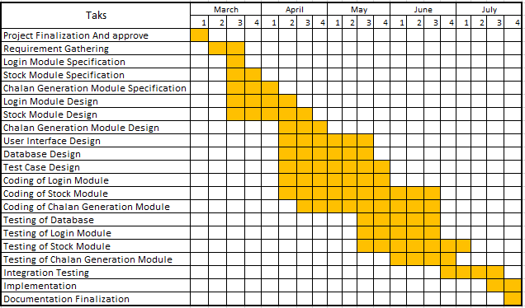

Fig 1: Actual Gantt Chart

* 1. Software and Hardware Requirements User Side:

A PC with sufficient network connection and a Browser. We recommend using Desktop or Laptop.

Developer Side:

A PC with proper network connection, also ASP.NET, Microsoft SQL Server Management System, installed and a web server for hosting preferred a virtual private one.

* 1. Preliminary Product Description

According to the functionality, the system is divided into three modules. Login module, Stock module, and Chalan generation module are the three modules. All of the modules are accessible to only admin. All the primary details will be entered and a login will be created. Login Module will consist of a login screen. After successful login the page will redirected to the dashboard. Dashboard contains different functions like stock, records, chalan generation etc. Stock module will contain different functions like add stock, check stock etc.

* 1. Diagrams ER Diagram:

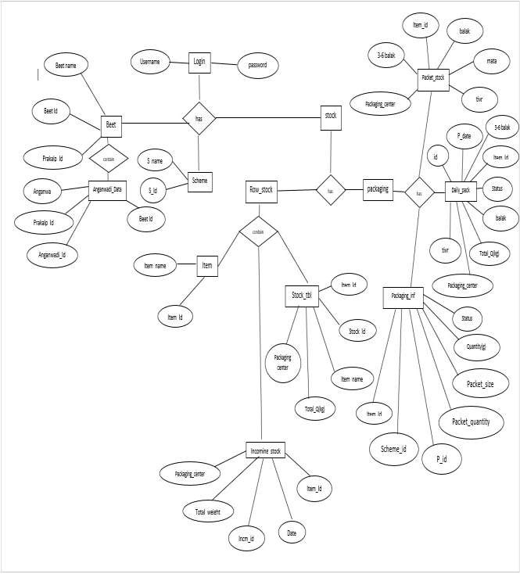

Fig 3: ER Diagram

Usecase Diagram

Beet, Anganwadi and Scheme

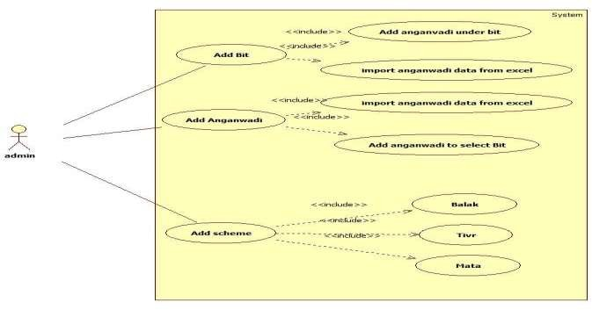

Fig 4: Use Case Diagram of Beet, Anganwadi and Scheme

Packaging

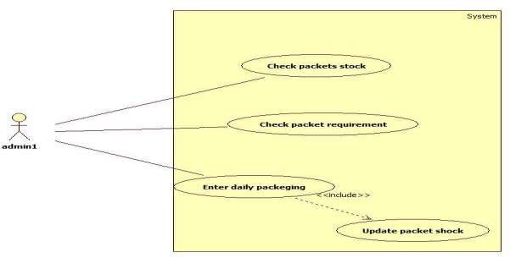

Fig 5: Use Case Diagram of Packaging

PackInfo

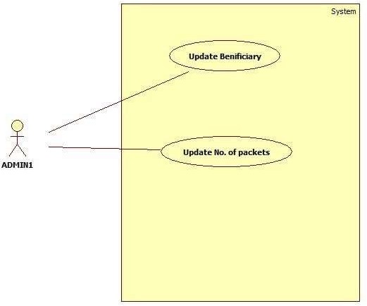

Fig 6: Use Case Diagram of PackInfo

Chalan

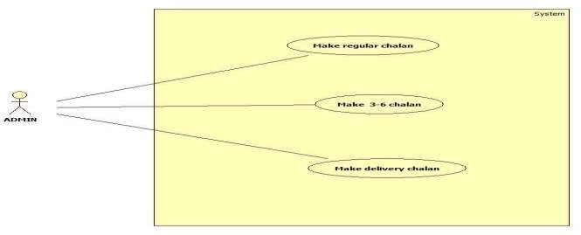

Fig 7: Use Case Diagram of Chalan

Class Diagram

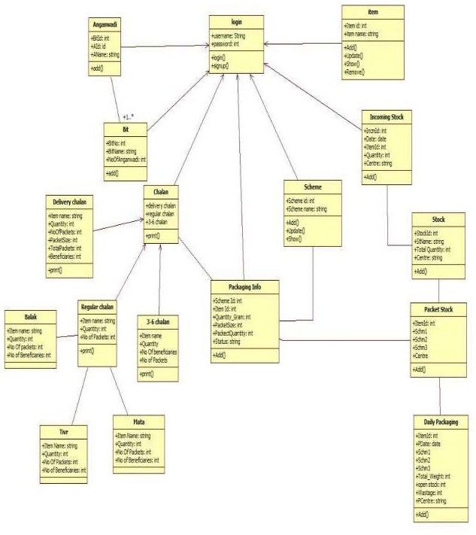

Fig 8: Class Diagram

Sequence Diagram:

Beet, Anganwadi Beneficiaries:

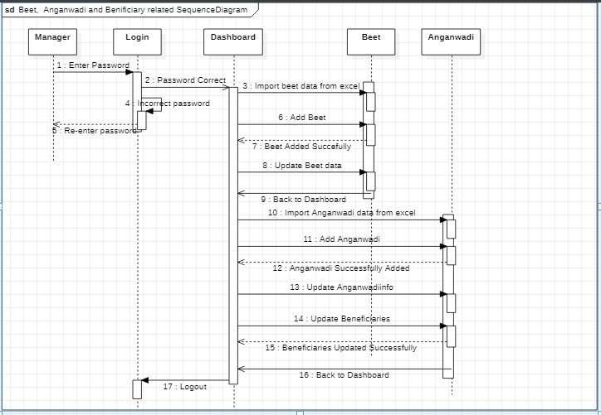

Fig 9: Sequence Diagram of Beet, Anganwadi Beneficiaries Items,

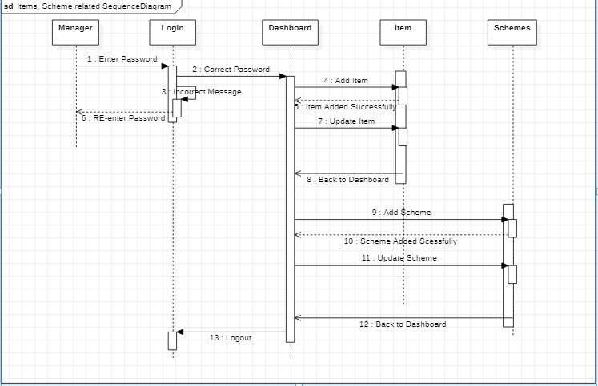Scheme:

Fig 10: Sequence Diagram of Items, Scheme

Stock, Packaging, Packet Stock:

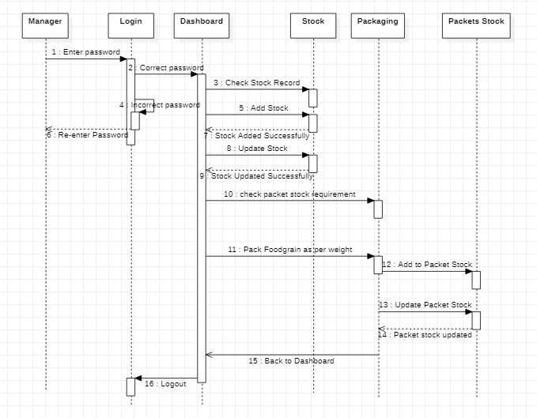

Fig 11: Sequence Diagram of Stock, Packaging & Packet Stock Challan:

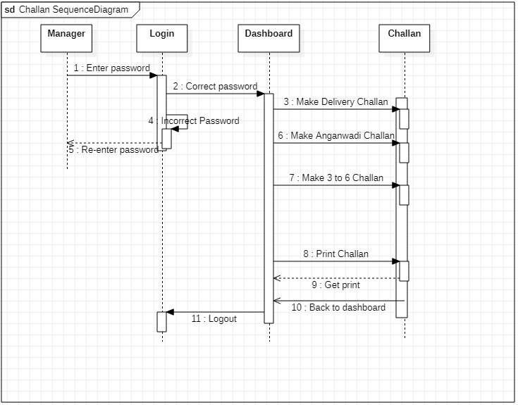

Fig 12: Sequence Diagram of challan

Deployment Diagram:

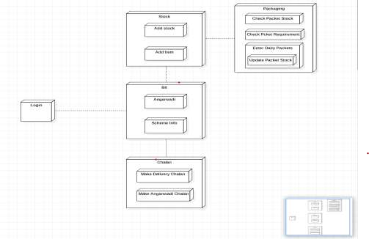

Fig 13: Deployment Diagram A

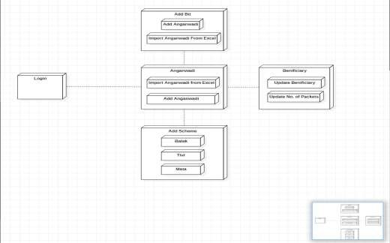

Fig 14: Deployment Diagram B

# SYSTEM DESIGN

* 1. Basic Modules

The system is basically divided into three modules as per the functionality they are as follows:

Module 1: Login Module

This will consist of a login screen. Here, admin can log into the system using username and password.

Module 2: Stock Module

This will consist of two types of stock that are Raw stock and Packaging stock. In this module add stock, check stock, etc. functions are given as per requirement.

Module 3: Chalan Generation

This module will generate 3types of chalan that are Regular chalan, 3-6 chalan, Delivery chalan. These chalans have their own purpose. These chalans act as a report.

* 1. Data Design (Database tables and database diagram) 1.Login table

|  |  |  |  |
| --- | --- | --- | --- |
| Column name | Description | Type | Constraints |
| Username | Enter username of admins | Varchar(MAX) | Not null |
| Password | Set password | Varchar(MAX) | Not null |

1. Items

|  |  |  |  |
| --- | --- | --- | --- |
| Column Name | Description | Type | Constraints |
| Item Id | ID of items | int | Primary key |
| Item name | Name of Items | nvarchar(MAX) | Not null |

1. Incoming Stock

|  |  |  |  |
| --- | --- | --- | --- |
| Column Name | Description | Type | Constraints |
| Incm Id | ID of items | int | Primary key |
| Date | Date of Coming stock | Date | Not null |
| Item id | ID of items | int | Foreign key |
| Quantity (kg) | Quantity of items | float | Not null |
| Packaging Center | Name of the Packaging Center | nvarchar(MAX) | Not null |

1. Stock Table

|  |  |  |  |
| --- | --- | --- | --- |
| Column Name | Description | Type | Constraints |
| Stock Id | ID of Stocks | int | Primary key |
| Item Id | Id of items | int | Foreign key |
| Total Quantity (kg) | Total Quantity of items | float | Not null |
| Packaging Center | Name of the Packaging Center | nvarchar(MAX) | Not null |

1. Scheme

|  |  |  |  |
| --- | --- | --- | --- |
| Column Name | Description | Type | Constraints |
| Scheme Id | ID of Scheme | int | Primary key |
| Scheme name | Name of Scheme | nvarchar(MAX) | Not null |

1. Packaging Info

|  |  |  |  |
| --- | --- | --- | --- |
| Column Name | Description | Type | Constraints |
| Packaging ID |  | int | Primary key |
| Scheme Id | ID of Scheme | int | Foreign key |
| Item Id | ID of items | int | Not null |
| Quantity in gram | Quantity of items in gram | nvarchar(MAX) | Not null |
| Packet Size | Size of packet | float | Not null |
| Packet Quantity | Each packet Quantity | int | Not null |
| Status | Availability of Items | nvarchar(MAX) | Not null |

1. Packet Stock

|  |  |  |  |
| --- | --- | --- | --- |
| Column name | Description | Type | Constraints |
| Item Id | ID of items | Varchar(MAX) | Primary key |
| Scheme1 |  | Varchar(MAX) | Not null |
| Scheme2 |  | Varchar(MAX) | Not null |
| Scheme3 |  | Varchar(MAX) | Not null |
| Packaging Center | Name of the Packaging Center | Varchar(MAX) | Not null |

1. Daily Packaging

|  |  |  |  |
| --- | --- | --- | --- |
| Column name | Description | Type | Constraints |
| ID |  | int | Primary Key |
| Item Id | ID of items | int | Not null |
| Packaging _date | Date of packaging | date | Not null |
| Balak |  | int | Null |
| Tivr |  | int | Null |
| 3-6 balak |  | int | Null |
| Mata |  | int | Null |
| Total Quantity |  | float | Null |
| Wastage |  | float | Null |
| Packaging Center | Name of the Packaging Center | nvarchar(MAX) | Not null |

1. Prakalp

|  |  |  |  |
| --- | --- | --- | --- |
| Column name | Description | Type | Constraints |
| Prakalp ID |  | int | Primary key |

|  |  |  |  |
| --- | --- | --- | --- |
| Prakalp Name | Name of Prakalp | Nvarchar(MAX) | Not null |

1. Bit data

|  |  |  |  |
| --- | --- | --- | --- |
| Column name | Description | Type | Constraints |
| Prakalp ID |  | int | Primary key |
| Bit Id | Id of Bits | int | Primary key |
| Bit Name | Name of bit | nvarchar(MAX) | Not null |

1. Anganwadi data

|  |  |  |  |
| --- | --- | --- | --- |
| Column name | Description | Type | Constraints |
| Prakalp No |  | int |  |
| Bit Id | Id of Bits | int | Primary Key |
| Anganwadi Id | Id of anganwadi | int | Primary Key |
| Anganwadi Name | Name of anganwadi | nvarchar(MAX) | Not null |

1. Distribution Info

|  |  |  |  |
| --- | --- | --- | --- |
| Column name | Description | Type | Constraints |
| ID |  | int | Not null |
| Prakalp |  | nvarchar(MAX) | Not null |
| Anganwadi |  | nvarchar(MAX) | Not null |
| Month |  | nvarchar(MAX) | Not null |
| Balak |  | nvarchar(MAX) | Not null |
| Tivr |  | int | Null |
| 3-6 Balak |  | int | Null |
| Mata |  | int | Null |

|  |  |  |  |
| --- | --- | --- | --- |
| Status |  | nvarchar(MAX) | Not null |
| Chalan |  | nvarchar(MAX) | Null |

1. Distribution Details

|  |  |  |  |
| --- | --- | --- | --- |
| Column name | Description | Type | Constraints |
| ID |  | int | Not null |
| Prakalp ID |  | int | Not null |
| Bit No |  | int | Not null |
| Month |  | nvarchar(MAX) | Not null |
| Year |  | nvarchar(MAX) | Not null |
| Balak Benefeciaries |  | int | Null |
| Tivr Benefeciaries |  | int | Null |
| 3-6 balak Benefeciaries |  | int | Null |
| Mata Benefeciaries |  | int | Null |

4..3 User Interface Design

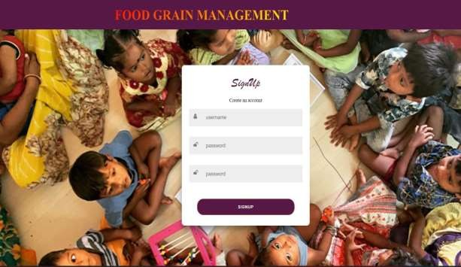

Fig 15: Signup Page

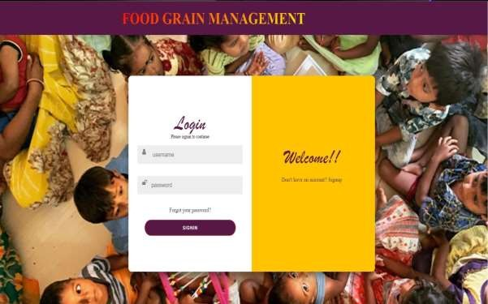

Fig 16: Signin Page



Fig 17: Dashboard page

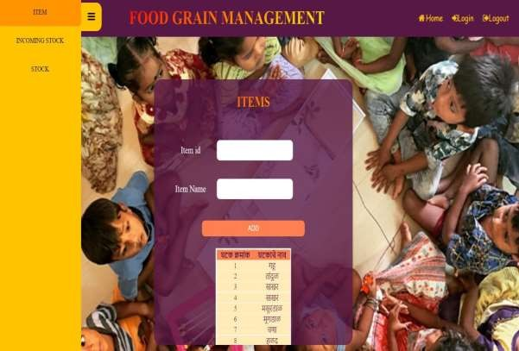

Fig 18: Stock_item UI

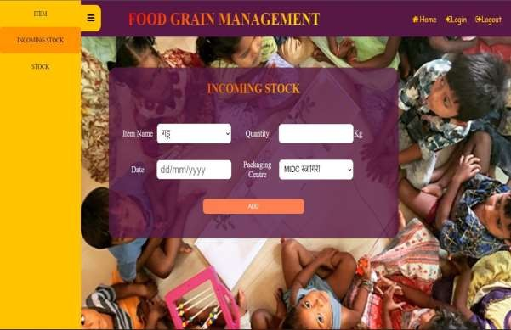

Fig 19: Stock_Incoming Stock UI

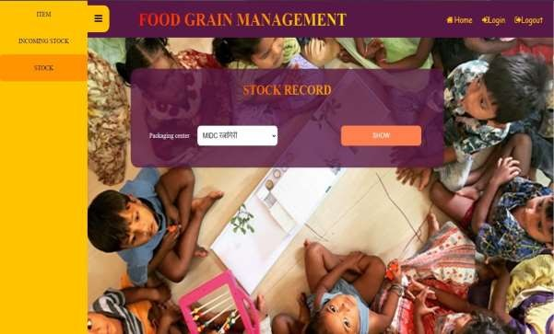

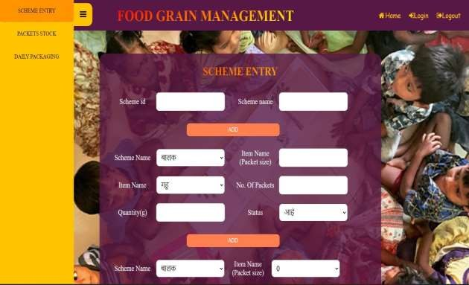Fig 20: Stock_Stock UI

Fig 21: Packaging Scheme Entry UI

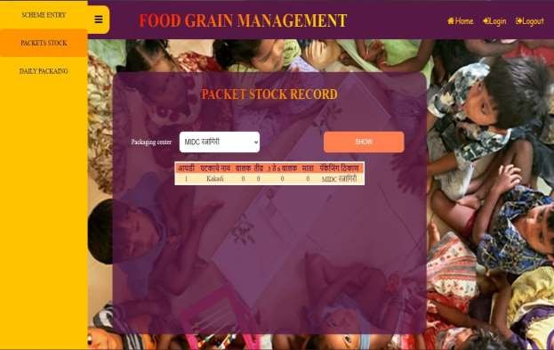

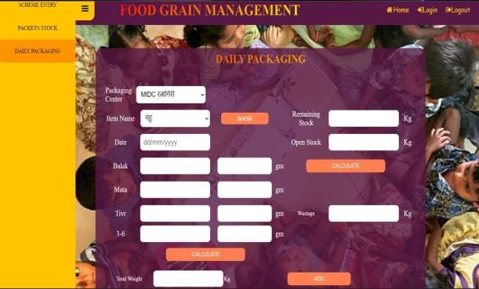Fig 22: Packaging Packet Stock UI

Fig 23: Packaging Daily Packaging UI

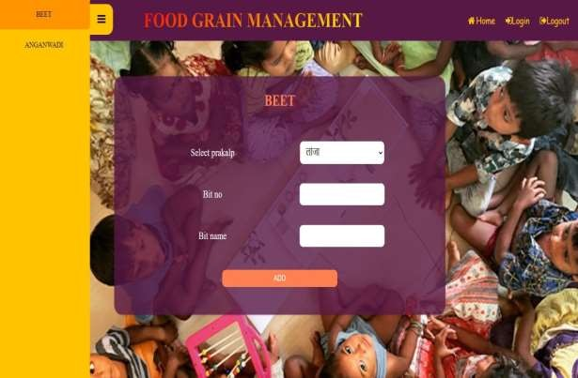

Fig 24: Beet page UI

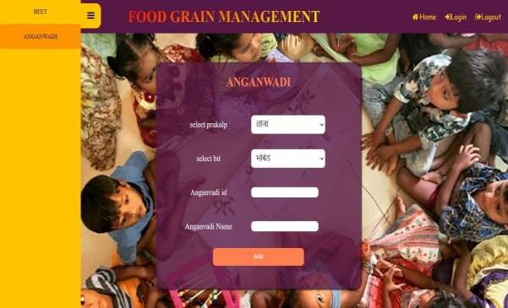

Fig 25: Anganwadi page UI

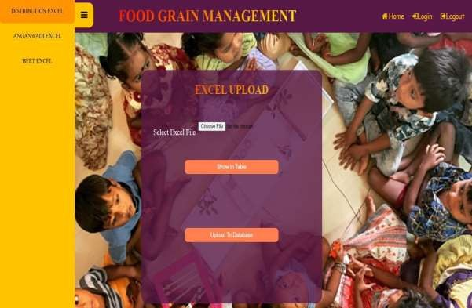

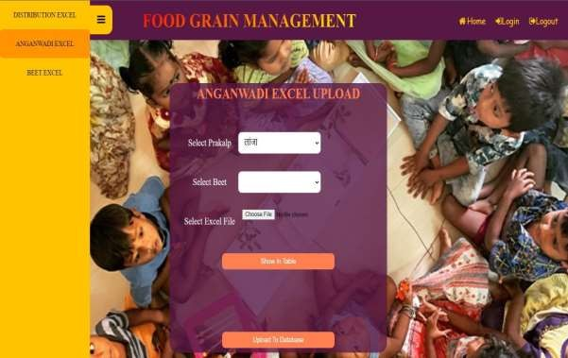Fig 26: Distribution Excel

Fig 27: Anganwadi Excel

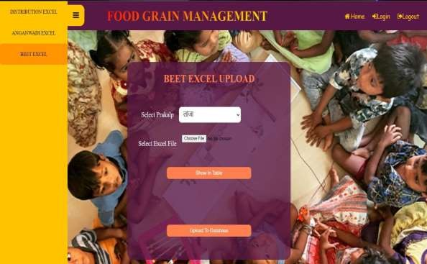

Fig 28: Beet Excel

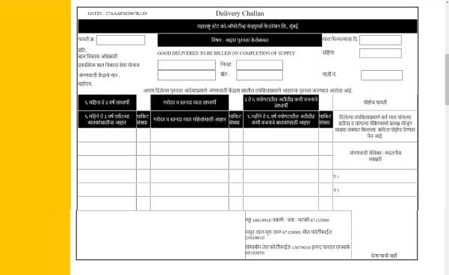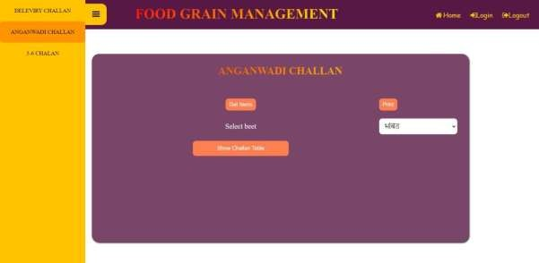

Fig 29: Anganwadi Challan

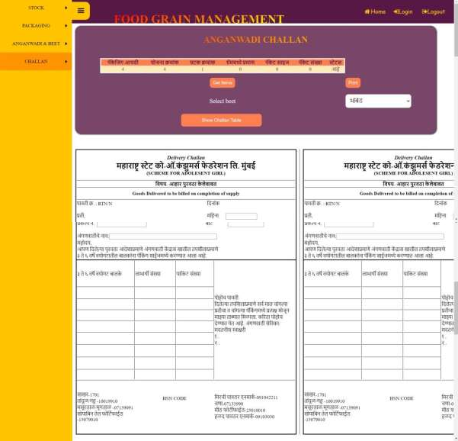

Fig 30: 3-6 Challan

4.4 Test Cases

1. **Login Form**

|  |  |  |  |  |
| --- | --- | --- | --- | --- |
| Sr.  No. | Possible Inputs | Expected Result | Actual Result | Result (pass/fail) |
| 1. | Valid Username and correct Password | Login Success Message and Redirect to dashboard | Login Success Message and Redirect to dashboard | pass |
| 2. | Valid Username and incorrect Password | Login Failure Message and Reload login Page | Login Failure Message and Reload login Page | pass |
| 3. | Invalid Username and correct Password | Login Failure Message and Reload login Page | Login Failure Message and Reload login Page | pass |
| 4. | Invalid Username and incorrect Password | Login Failure Message and Reload login Page | Login Failure Message and Reload login Page | Pass |

1. **Item**

|  |  |  |  |  |  |
| --- | --- | --- | --- | --- | --- |
| Sr.  No. | Operation Title | Possible Inputs | Expected Result | Actual Result | Result (pass/fail) |
| 1. | Add new item | Enter item id and item name and click on Add button | Items entered Successfully | Items entered Successfully | pass |

1. **Incoming Stock**

|  |  |  |  |  |  |
| --- | --- | --- | --- | --- | --- |
| Sr.  No. | Operation Title | Possible Inputs | Expected Result | Actual Result | Result (pass/fail) |
| 1. | Stock Update | Select item name and packaging center and click on Update button | Stock updated of selected packaging center for respective item name | Stock updated of selected packaging center for respective item name | pass |
| 2. |  |  |  |  |  |

1. **Stock**

|  |  |  |  |  |  |
| --- | --- | --- | --- | --- | --- |
| Sr.  No. | Operation Title | Possible Inputs | Expected Result | Actual Result | Result (pass/fail) |
| 1. | Unpacked Table | Select packaging center and click on Add button | Show unpacked stock according to selected packaging center | Show unpacked stock according to selected packaging center | pass |

1. **Scheme entry**

|  |  |  |  |  |  |
| --- | --- | --- | --- | --- | --- |
| Sr.  No. | Operation Title | Possible Inputs | Expected Result | Actual Result | Result (pass/fail) |
| 1. | New Scheme Add | Enter Scheme id and Scheme Name and click on Add button | Scheme added Successfully | Scheme added Successfully | pass |

|  |  |  |  |  |  |
| --- | --- | --- | --- | --- | --- |
| Sr.  No. | Operation Title | Possible Inputs | Expected Result | Actual Result | Result (pass/fail) |
| 2. |  | Select Scheme Name, Item Name and Status and Enter Item Name with Packet size, Quantity and No. of Packets And click on Add Button | Enter packets successfully | Enter packets successfully | pass |
| 3. | Scheme Update (Yes/No) | Select Scheme Name , Item Name with Packet size and Status and click on Update button | Scheme updated of selected scheme name , status and item name | Scheme updated of selected scheme name , status and item name | pass |

1. **Packet stock**

|  |  |  |  |  |  |
| --- | --- | --- | --- | --- | --- |
| Sr.  No. | Operation Title | Possible Inputs | Expected Result | Actual Result | Result (pass/fail) |
| 1. | Packed Stock | Select packaging center and click on show button | Show packed stock according to selected packaging center | Show unpacked stock according to selected packaging center | pass |

1. **Daily packaging**

|  |  |  |  |  |  |
| --- | --- | --- | --- | --- | --- |
| Sr.  No. | Operation Title | Possible Inputs | Expected Result | Actual Result | Result (pass/fail) |
| 1. | Showing | Select | Show quantity in | Show quantity in | Pass |
|  | Packet | packaging | gram of all | gram of all |  |
|  | Quantity (in | center and item | schemes | schemes |  |
|  | gram) | name and click |  |  |  |
|  |  | on the button |  |  |  |
|  |  | show |  |  |  |
| 2. | Total Weight | Insert no of | Total weight | Total weight | Pass |
|  |  | packed packets to their respective  schemes and | display in kg successfully | display in kg successfully |  |
|  |  | calculate total |  |  |  |
|  |  | weight |  |  |  |
| 3. | Wastage | Insert | Wastage display | Wastage display | Pass |
|  |  | remaining | in kg | in kg |  |
|  |  | stock and open | successfully | successfully |  |
|  |  | stock and |  |  |  |
|  |  | calculate |  |  |  |
|  |  | wastage |  |  |  |
| 4. | Adding above details | Click on add button | All entries stored to database successfully | All entries stored to database successfully | Pass |

1. **Beet**

|  |  |  |  |  |  |
| --- | --- | --- | --- | --- | --- |
| Sr.  No. | Operation Title | Possible Inputs | Expected Result | Actual Result | Result (pass/fail) |
| 1. | New Beet | Select prakalp | Entries added | Entries added | Pass |
|  |  | and enter beet | sucessfully | sucessfully |  |
|  |  | no & beet |  |  |  |
|  |  | name and click |  |  |  |
|  |  | on add button |  |  |  |

1. **Anganwadi**

|  |  |  |  |  |  |
| --- | --- | --- | --- | --- | --- |
| Sr.  No. | Operation Title | Possible Inputs | Expected Result | Actual Result | Result (pass/fail) |
| 1. | New | Select prakalp | Entries added | Entries added | Pass |
|  | Anganwadi | and select beet | sucessfully | successfully |  |
|  |  | name & Enter |  |  |  |
|  |  | anganwadi id |  |  |  |
|  |  | and Enter |  |  |  |
|  |  | anganwadi |  |  |  |
|  |  | name click on |  |  |  |
|  |  | add button |  |  |  |

# CONCLUSION

This project was actually a great opportunity for growth of myself and I enjoyed every single period of work. The task took more time to the different parts of the project development and gave its genuine understanding. The struggle and challenges faced by me during the project development was life learning and will always be our actual guide for future. I had put all my best to perform the project.

The project is running effectively and agreeably to satisfy the clients expectations.

During the task advancement I truly understood the betterments and facilities those might have been given to upgrade the venture. I look at them as future improvements.

# BIBLIOGRAPHY

1. [https://www.c-sharpcorner.com](https://www.c-sharpcorner.com/)
2. [https://www.stackoverflow.com](https://www.stackoverflow.com/)
3. [https://www.w3school.com](https://www.w3school.com/)
4. [https://www.aspsnippets.com](https://www.aspsnippets.com/)
5. [https://www.codeproject.com](https://www.codeproject.com/)