**Name: Onkar Kempana Nandanwade Roll No: 45**

**Class : TY CSE Batch : T2**

**Title: -** Design a student registration form which contains all the registration details and after registration display success page which should display all the entered details. And also design login form, home page and logout form using servlet.

**Program:-**

import javax.servlet.*;

import javax.servlet.http.*;

import java.io.*;

import java.sql.*;

public class StudentHttpServlet extends HttpServlet

{

public void doPost(HttpServletRequestreq,HttpServletResponse res)

throws IOException ,ServletException

{

res.setContentType("text/html");

PrintWriter pw = res.getWriter();

int stdrollno =Integer.parseInt(req.getParameter("stdrollno"));

String stdname= req.getParameter("stdname");

String stdcourse= req.getParameter("course");

String stdclass =req.getParameter("class");

pw.println("<html>");

pw.println("<head>");

pw.println("<title>Record</title>");

pw.println("</head>");

pw.println("<body bgcolor='#4BB543'>");

pw.println("</br>");

pw.println("<h1> Details Entered: </h1>");

pw.println("<h2><span style='padding-left:50px'>Student RollNo = "+stdrollno+"</span></h2>");

pw.println("<h2><span style='padding-left:50px'>Student Name = "+stdname+"</span></h2>");

pw.println("<h2><span style='padding-left:50px'>Course = "+stdcourse+"</span></h2>");

pw.println("<h2><span style='padding-left:50px'>Year = "+stdclass+"</span></h2>");

pw.println("</body>");

pw.println("</html>");

}

}

Web.xml

<servlet>

<servlet-name>StudentHttpServlet</servlet-name>

<servlet-class>StudentHttpServlet</servlet-class>

</servlet>

<servlet-mapping>

<servlet-name>StudentHttpServlet</servlet-name>

<url-pattern>/StudentHttpServlet</url-pattern>

</servlet-mapping>

StudentRegistartion.html

<!doctype html>

<html>

<head>

<title>Student Registration</title>

<!-- Bootstrap CSS -->

<link rel="stylesheet" href="https://cdn.jsdelivr.net/npm/bootstrap@4.5.3/dist/css/bootstrap.min.css" integrity="sha384-TX8t27EcRE3e/ihU7zmQxVncDAy5uIKz4rEkgIXeMed4M0jlfIDPvg6uqKI2xXr2" crossorigin="anonymous">

<style>

header{

background-color:black;

height:60px;

padding-top:20px;

margin-bottom:50px;

}

nav ul{

display: flex;

justify-content: center;

align-items: center;

margin-right: 74px;

}

nav ul li{

list-style: none;

}

nav ul li a{

text-decoration: none;

padding: 15px;

color:white;

font-weight: bold;

}

nav ul li a:hover {

background-color: white;

color: black;

border-radius: 20px;

transition: all 0.5s ease-in-out;

opacity: 1;

}

</style>

</head>

<body>

<header>

<nav>

<ul>

<li><a href="/Student/Home.html">Home</a></li>

<li><a href="/Student/StudentRegistration.html">Student Registration</a></li>

<li><a href="/Student/StudentLogin.html">Login</a></li>

<li><a href="/Student/StudentLogout.html">Logout</a></li>

</ul>

</nav>

</header>

<div class="container">

<form autocomplete="off" onsubmit="return validate()" action="/StudentHttpServlet" method="post">

<h1>Student Registration</h1>

<table>

<tr>

<td><label>Roll Number</label></td>

<td><input type="number" name="stdrollno" min="0" class="form-control" id="stdrollno" ></td>

</tr>

<tr>

<td><label>Student Name</label></td>

<td><input type="text" name="stdname" class="form-control" id="stdname" ></td>

</tr>

<tr>

<td><label>Course</label></td>

<td>

<input type="radio" value="Computer Science" name="course" id="course">CSE <br/>

<input type="radio" value="Mechanical" name="course" id="course">ME <br/>

<input type="radio" value="Electrical" name="course" id="course">EE <br/>

<input type="radio" value="Electronics" name="course" id="course">E&TC<br/>

</td>

</tr>

<tr>

<td><label>Class</label></td>

<td>

<select name="class" id="class" class="form-control">

<option>First Year</option>

<option>Second Year</option>

<option>Third Year</option>

<option>Fourth Year</option>

</select>

</td>

</tr>

<tr>

<td><input type="submit" class="btnbtn-success" value="Submit" name="action" ></td>

<td><input type="reset" class="btnbtn-info" value="Clear" name="" ></td>

</tr>

</table>

</form>

</div>

<script src="https://code.jquery.com/jquery-3.5.1.slim.min.js" integrity="sha384-DfXdz2htPH0lsSSs5nCTpuj/zy4C+OGpamoFVy38MVBnE+IbbVYUew+OrCXaRkfj" crossorigin="anonymous"></script>

<script src="https://cdn.jsdelivr.net/npm/bootstrap@4.5.3/dist/js/bootstrap.bundle.min.js" integrity="sha384-ho+j7jyWK8fNQe+A12Hb8AhRq26LrZ/JpcUGGOn+Y7RsweNrtN/tE3MoK7ZeZDyx" crossorigin="anonymous"></script>

<script>

function validate()

{

var rollno=document.getElementById("stdrollno").value;

var stdname=document.getElementById("stdname").value;

var course=document.getElementById("course").value;

var stdclass=document.getElementById("class").value;

var msg="Please enter\n";

if(rollno=="" || rollno==null)

{

msg+='Rollno\n';

}

if(stdname=="" || stdname==null)

{

msg+='Name\n';

}

if(course=="" || course==null)

{

msg+='Course\n';

}

if(stdclass=="" || stdclass==null)

{

msg+='Class\n';

}

if(msg!="Please enter\n"){

alert(msg);

return false;

}

console.log("hii");

}

</script>

</body>

</html>

StudentLogin.html

<!doctype html>

<html lang="en">

<head>

<!-- Required meta tags -->

<meta charset="utf-8">

<meta name="viewport" content="width=device-width, initial-scale=1, shrink-to-fit=no">

<!-- Bootstrap CSS -->

<link rel="stylesheet" href="https://cdn.jsdelivr.net/npm/bootstrap@4.5.3/dist/css/bootstrap.min.css" integrity="sha384-TX8t27EcRE3e/ihU7zmQxVncDAy5uIKz4rEkgIXeMed4M0jlfIDPvg6uqKI2xXr2" crossorigin="anonymous">

<title>Student Login</title>

<style>

header{

background-color:black;

height:60px;

padding-top:20px;

margin-bottom:50px;

}

nav ul{

display: flex;

justify-content: center;

align-items: center;

margin-right: 74px;

}

nav ul li{ list-style: none; }

nav ul li a{

text-decoration: none;

padding: 15px;

color:white;

font-weight: bold;

}

nav ul li a:hover {

background-color: white;

color: black;

border-radius: 20px;

transition: all 0.5s ease-in-out;

opacity: 1;

}

</style>

</head>

<body>

<header>

<nav>

<ul>

<li><a href="/Student/Home.html">Home</a></li>

<li><a href="/Student/StudentRegistration.html">Student Registration</a></li>

<li><a href="/Student/StudentLogin.html">Login</a></li>

<li><a href="/Student/StudentLogout.html">Logout</a></li>

</ul>

</nav>

</header>

<div class="container">

<h1>Student Login Registeration</h1>

<form method="post">

<dl>

<dt>UserName</dt>

<dd><input type="text" placeholder="Enter UserName" name="uname" class="form-control"></dd>

<dt>Password</dt>

<dd><input type="password" placeholder="Enter Password" name="pwd" class="form-control"></dd>

</dl>

<button type="submit" class="btnbtn-success" name="submit">Submit</button>

<button type="reset" class="btnbtn-secondary" >Clear</button>

</form>

</div>

<!-- Optional JavaScript; choose one of the two! -->

<!-- Option 1: jQuery and Bootstrap Bundle (includes Popper) -->

<script src="https://code.jquery.com/jquery-3.5.1.slim.min.js" integrity="sha384-DfXdz2htPH0lsSSs5nCTpuj/zy4C+OGpamoFVy38MVBnE+IbbVYUew+OrCXaRkfj" crossorigin="anonymous"></script>

<script src="https://cdn.jsdelivr.net/npm/bootstrap@4.5.3/dist/js/bootstrap.bundle.min.js" integrity="sha384-ho+j7jyWK8fNQe+A12Hb8AhRq26LrZ/JpcUGGOn+Y7RsweNrtN/tE3MoK7ZeZDyx" crossorigin="anonymous"></script>

</body>

</html>

StudentLogout.html

<html>

<head>

<title>LogOut</title>

<link rel="stylesheet" href="https://cdn.jsdelivr.net/npm/bootstrap@4.5.3/dist/css/bootstrap.min.css" integrity="sha384-TX8t27EcRE3e/ihU7zmQxVncDAy5uIKz4rEkgIXeMed4M0jlfIDPvg6uqKI2xXr2" crossorigin="anonymous">

<style>

header{

background-color:black;

height:60px;

padding-top:20px;

margin-bottom:50px;

}

nav ul{

display: flex;

justify-content: center;

align-items: center;

margin-right: 74px;

}

nav ul li{

list-style: none;

}

nav ul li a{

text-decoration: none;

padding: 15px;

color:white;

font-weight: bold;

}

nav ul li a:hover {

background-color: white;

color: black;

border-radius: 20px;

transition: all 0.5s ease-in-out;

opacity: 1;

}

</style>

</head>

<body>

<header>

<nav>

<ul>

<li><a href="/Student/Home.html">Home</a></li>

<li><a href="/Student/StudentRegistration.html">Student Registration</a></li>

<li><a href="/Student/StudentLogin.html">Login</a></li>

<li><a href="/Student/StudentLogout.html">Logout</a></li>

</ul>

</nav>

</header>

<div class="container">

<form method="POST" action="">

<button type="button" class="btnbtn-danger">Log Out</button>

</form>

</div>

<!-- Option 1: jQuery and Bootstrap Bundle (includes Popper) -->

<script src="https://code.jquery.com/jquery-3.5.1.slim.min.js" integrity="sha384-DfXdz2htPH0lsSSs5nCTpuj/zy4C+OGpamoFVy38MVBnE+IbbVYUew+OrCXaRkfj" crossorigin="anonymous"></script>

<script src="https://cdn.jsdelivr.net/npm/bootstrap@4.5.3/dist/js/bootstrap.bundle.min.js" integrity="sha384-ho+j7jyWK8fNQe+A12Hb8AhRq26LrZ/JpcUGGOn+Y7RsweNrtN/tE3MoK7ZeZDyx" crossorigin="anonymous"></script>

</body>

</html>

Home.html

<html>

<head>

<title>Home</title>

<link rel="stylesheet" href="https://cdn.jsdelivr.net/npm/bootstrap@4.5.3/dist/css/bootstrap.min.css" integrity="sha384-TX8t27EcRE3e/ihU7zmQxVncDAy5uIKz4rEkgIXeMed4M0jlfIDPvg6uqKI2xXr2" crossorigin="anonymous">

<style>

header{

background-color:black;

height:60px;

padding-top:20px;

margin-bottom:50px;

}

nav ul{

display: flex;

justify-content: center;

align-items: center;

margin-right: 74px;

}

nav ul li{

list-style: none;

}

nav ul li a{

text-decoration: none;

padding: 15px;

color:white;

font-weight: bold;

}

nav ul li a:hover {

background-color: white;

color: black;

border-radius: 20px;

transition: all 0.5s ease-in-out;

opacity: 1;

}

</style>

</head>

<body>

<header>

<nav>

<ul>

<li><a href="/Student/Home.html">Home</a></li>

<li><a href="/Student/StudentRegistration.html">Student Registration</a></li>

<li><a href="/Student/StudentLogin.html">Login</a></li>

<li><a href="/Student/StudentLogout.html">Logout</a></li>

</ul>

</nav>

</header>

<div class="container">

<form method="POST" action="">

<h1>Welcome to Home Page</h1>

</form>

</div>

<!-- Option 1: jQuery and Bootstrap Bundle (includes Popper) -->

<script src="https://code.jquery.com/jquery-3.5.1.slim.min.js" integrity="sha384-DfXdz2htPH0lsSSs5nCTpuj/zy4C+OGpamoFVy38MVBnE+IbbVYUew+OrCXaRkfj" crossorigin="anonymous"></script>

<script src="https://cdn.jsdelivr.net/npm/bootstrap@4.5.3/dist/js/bootstrap.bundle.min.js" integrity="sha384-ho+j7jyWK8fNQe+A12Hb8AhRq26LrZ/JpcUGGOn+Y7RsweNrtN/tE3MoK7ZeZDyx" crossorigin="anonymous"></script>

</body>

</html>

**Output: - Home page**

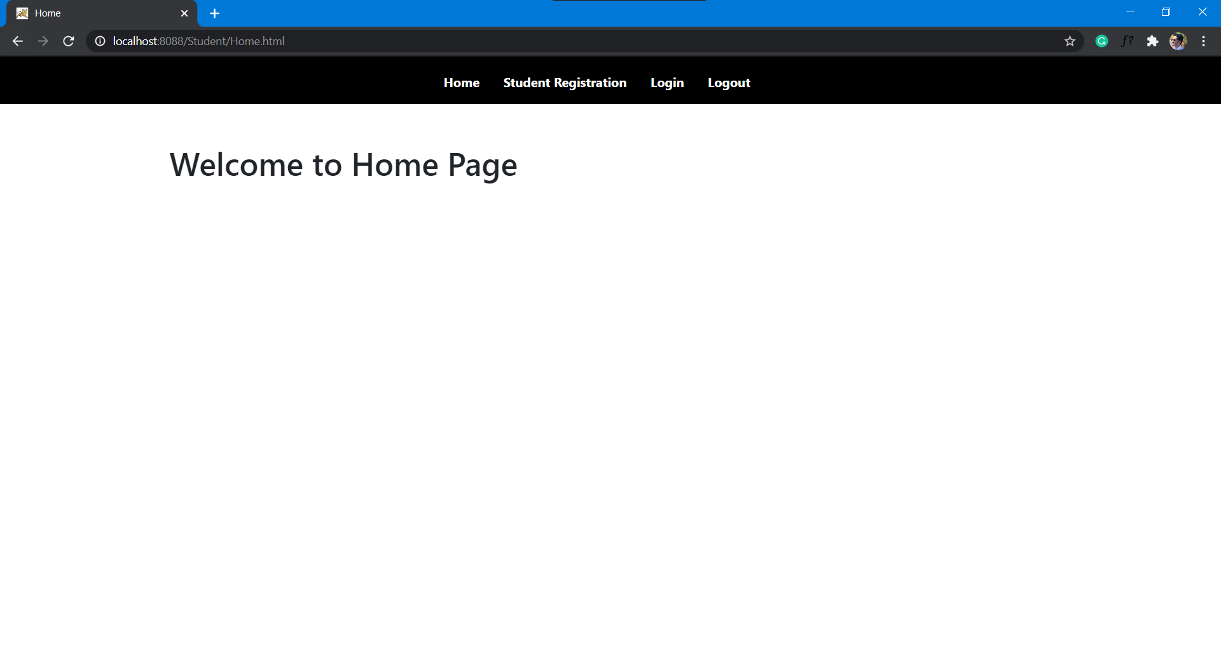

**Registration page**

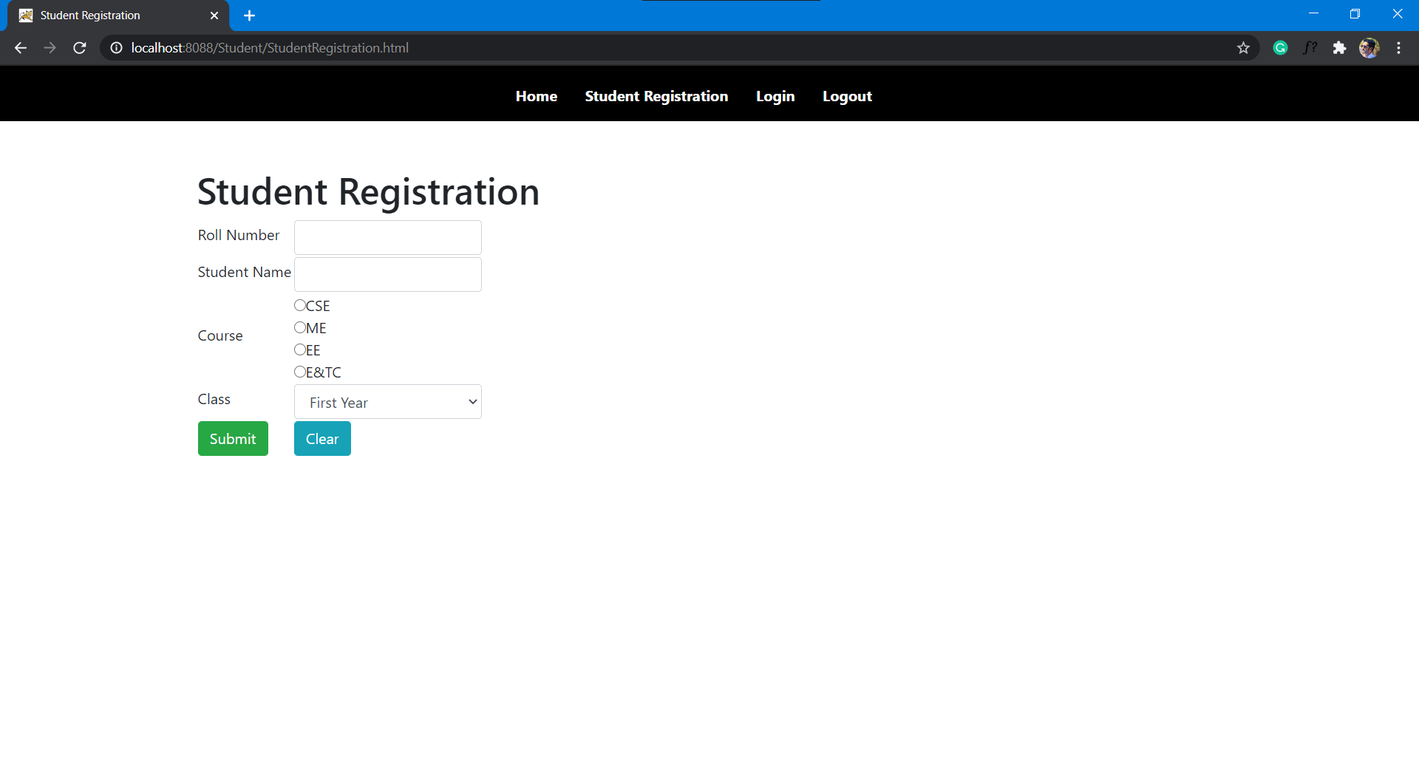

**Enter the user details**

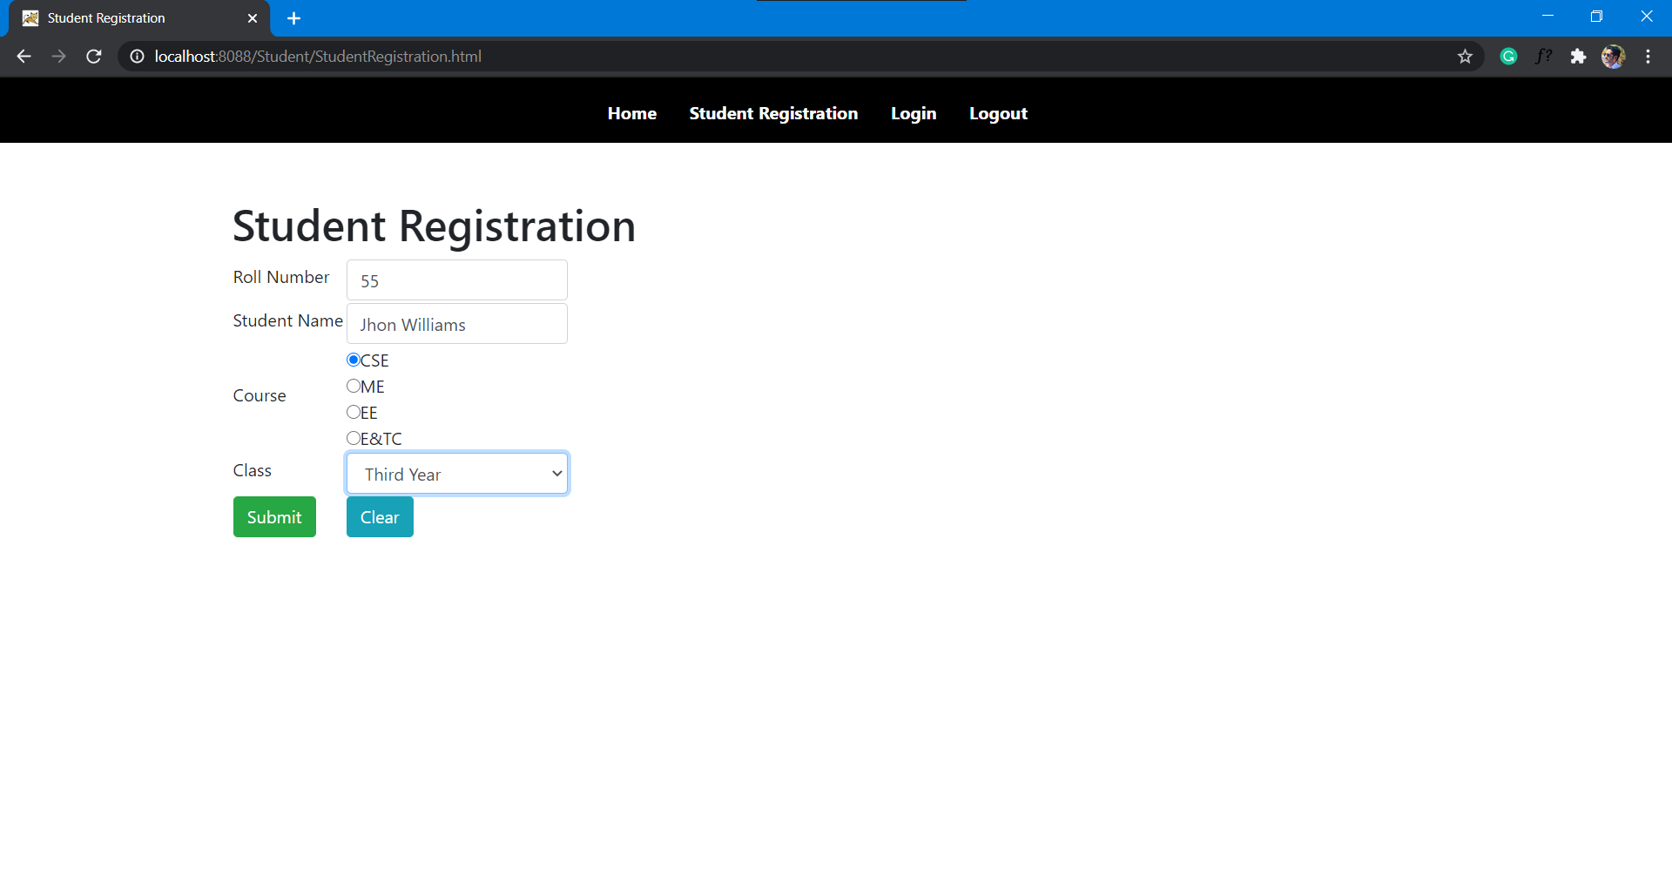

**After submitting the data**

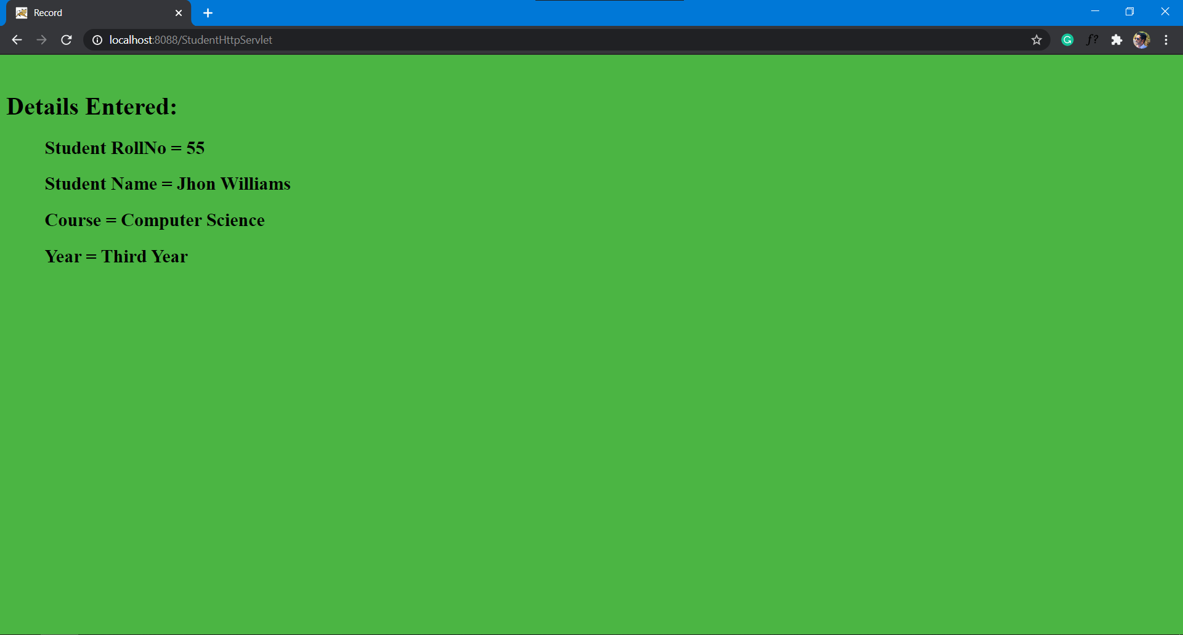

**Login page**

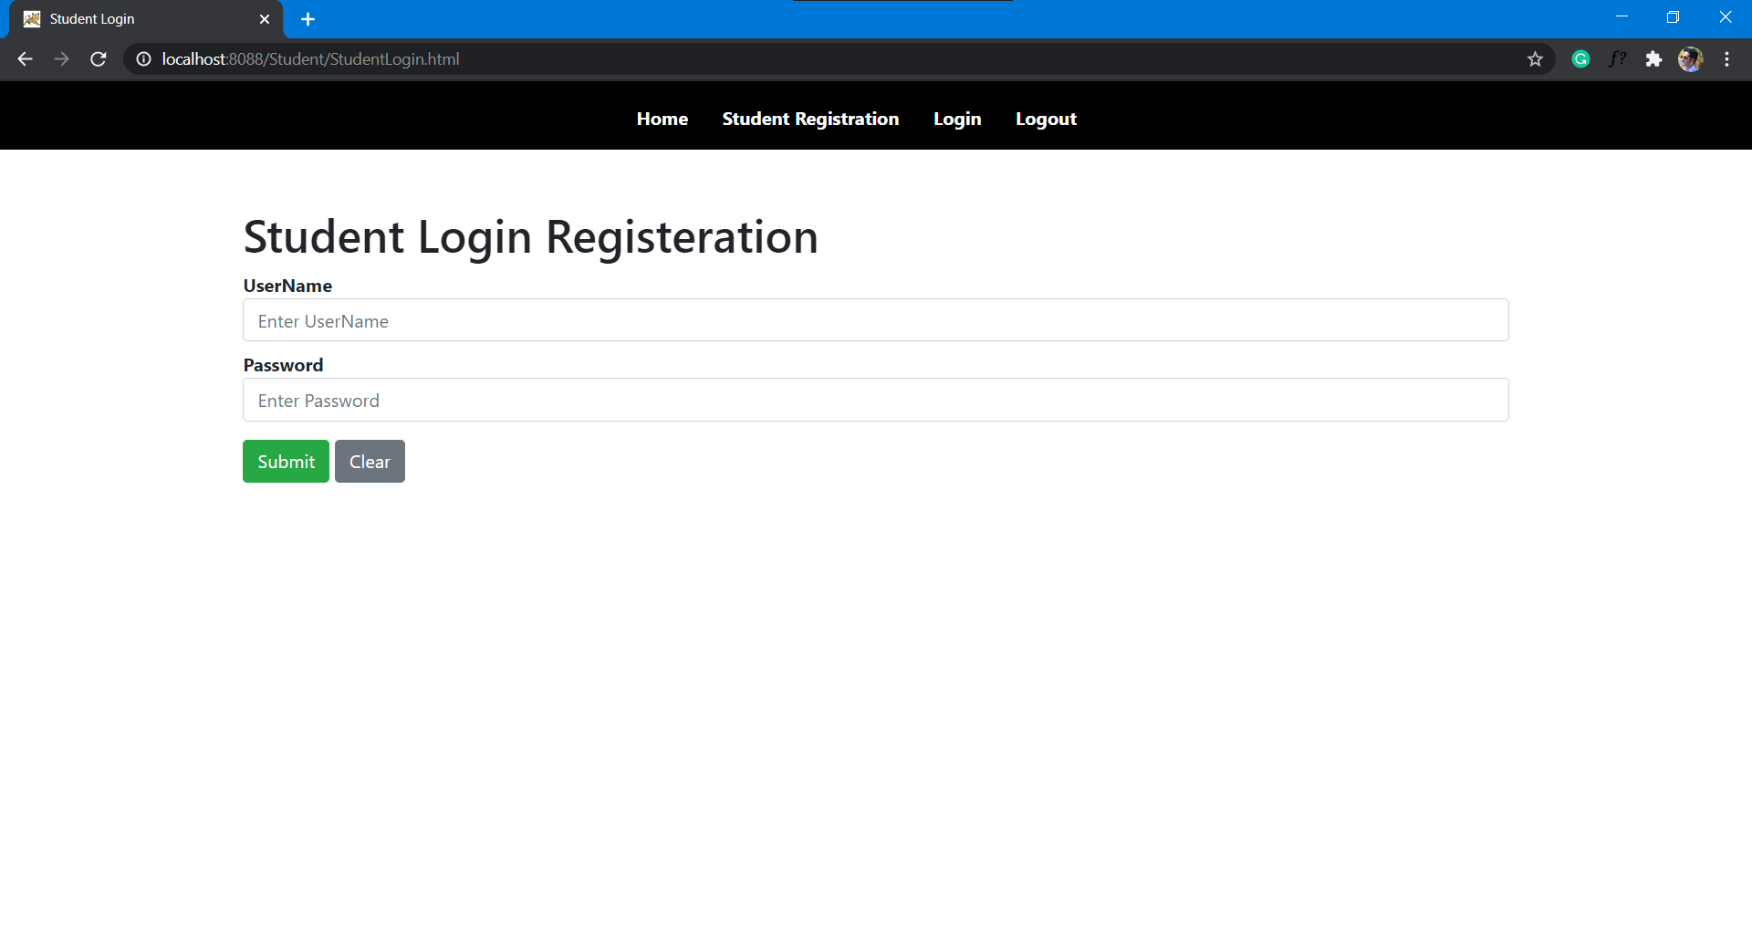

**Logout page**

