Merged Day 2 & Day 3 Report
AI Job Description Skill Extraction System
Day 2: Dataset Collection Summary
Dataset source: job description collection for AI/ML recruitment screening.
Relevant columns included: job_id, job_title, company, location, job_description, experience, education, salary, job_type, and text_length.
The dataset consisted of 13 job records collected across multiple companies and job roles.
Key quality checks: 1 missing salary value and 1 duplicate job record were identified during validation.
Day 3: Exploratory Data Analysis (EDA)
The EDA focused on understanding data quality, role distribution, location spread, description structure, and missing-value patterns.
The most frequent role was Data Scientist, followed by other technical positions such as Java Full Stack Developer, ML Engineer, AI Engineer, and Data Analyst.
The dataset had diverse job locations including Hyderabad, Bengaluru, Pune, Mumbai, Remote, and others.
Metric | Result
Total Jobs | 13
Unique Job Titles | 12
Missing Values | 1
Duplicate Records | 1
Average Description Length | 63.92
Minimum Length | 44
Maximum Length | 93
Figure 1: Top Job Titles
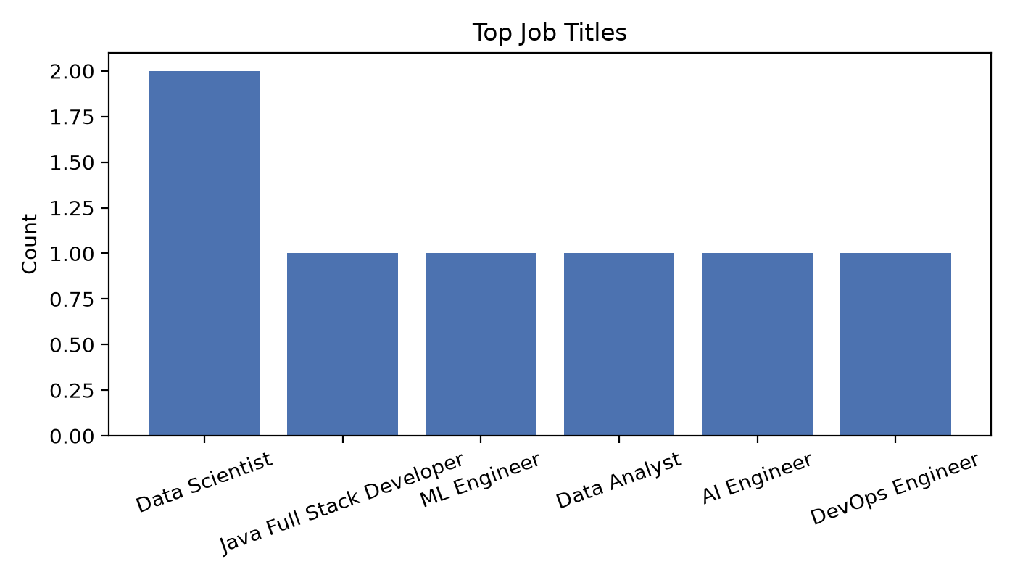
Figure 2: Jobs by Location
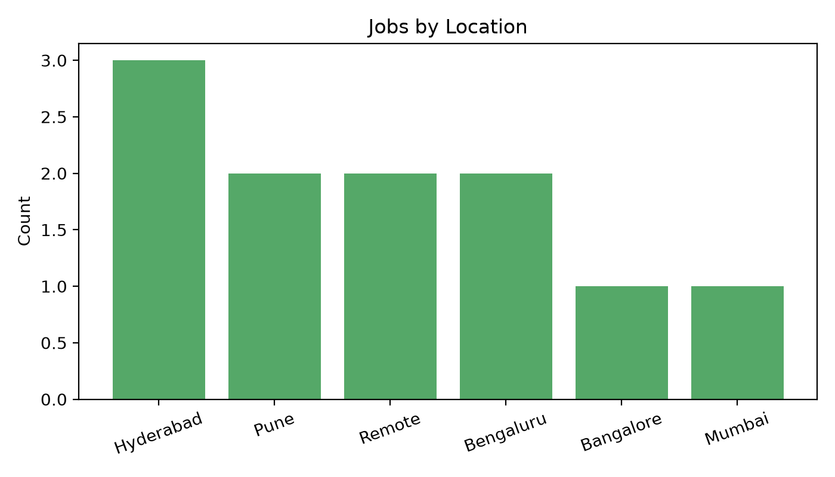
Figure 3: Description Length Distribution
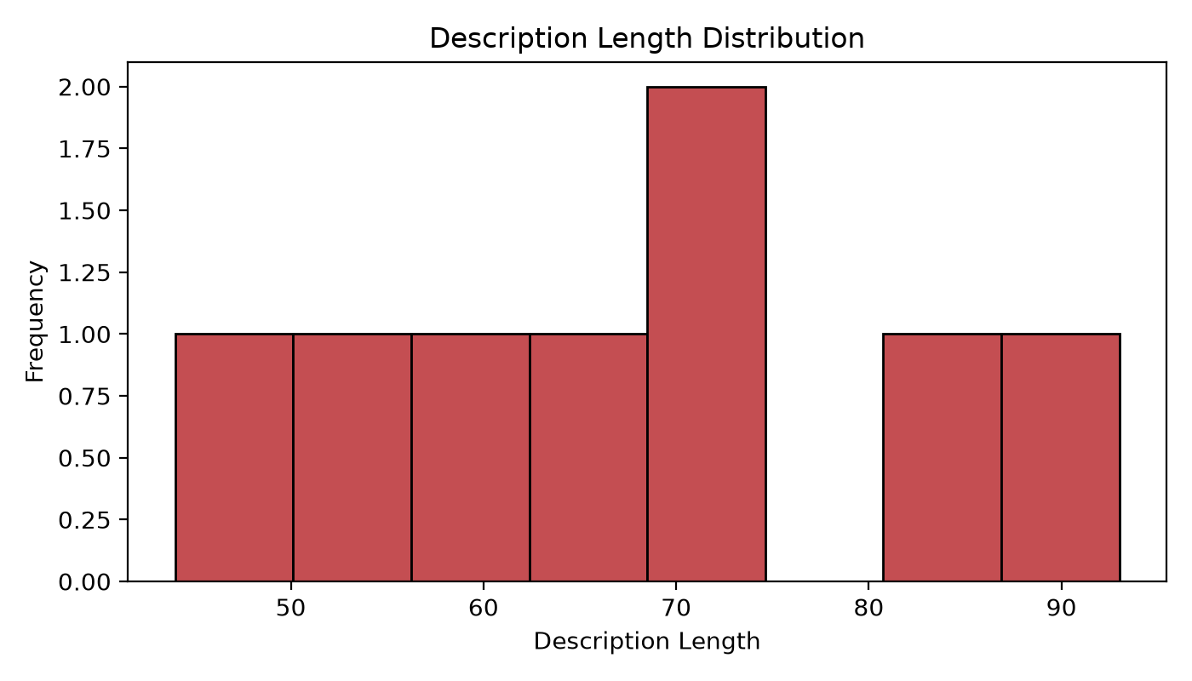
Figure 4: Missing Values
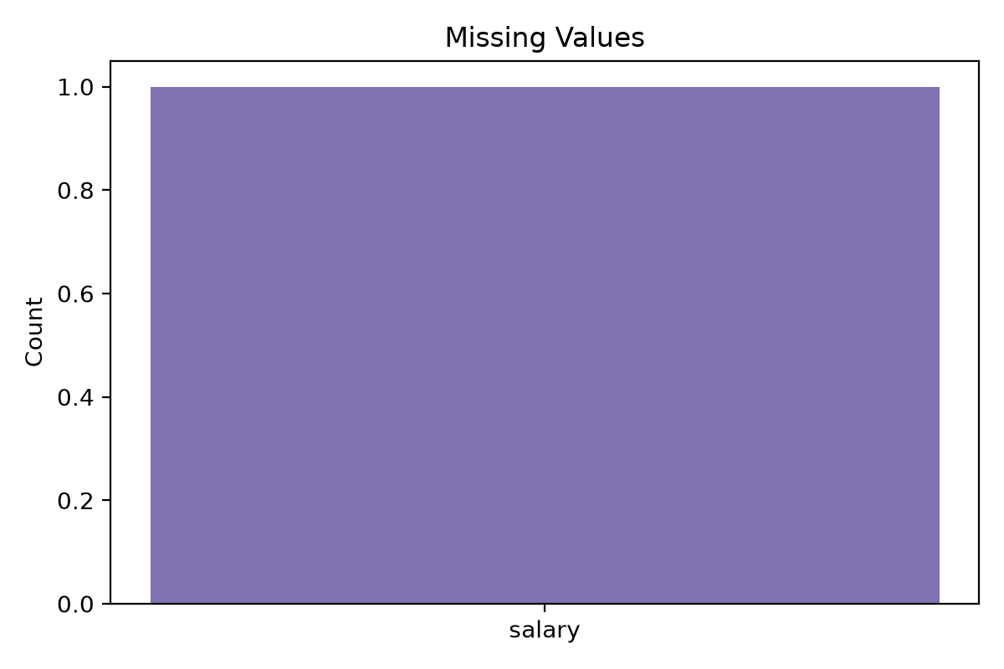
Figure 5: Top Companies
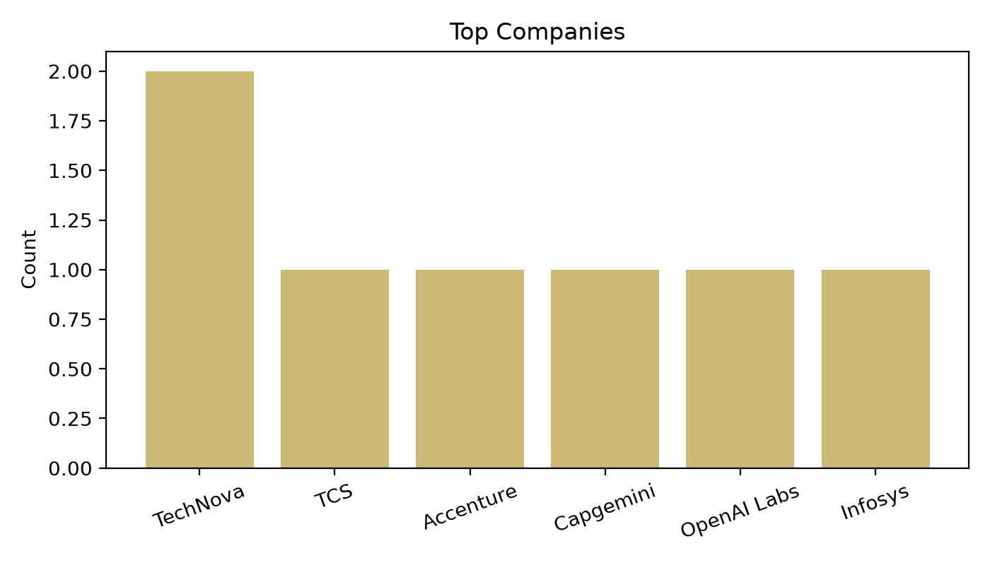
Conclusion
The merged report demonstrates important dataset characteristics, highlights quality issues, and provides a structured EDA summary suitable for submission in the internship project portfolio.

