# Amrutvahini College of Engineering, Sangamner Department of Electronics and Telecommunication

# Mini Project Synopsis

**Academic Year: 2022-23**

## Title: Ultrasonic Glasses For The Blind

**Aim: To design and develop a wearable device that utilizes ultrasonic sensors to detect obstacles and provide haptic feedback, allowing visually impaired or blind individuals to navigate their surroundings with greater independence and safety.**

**Objectives:**

* To detect obstacles within a range of at least 2 meters in front of the wearer, including objects at ground level, waist height, and head height.
* To provide haptic feedback to the wearer in real-time, alerting them to the presence and proximity of obstacles through vibrations.
* To be lightweight and comfortable to wear, affordable and accessible.

**Introduction:**

Ultrasonic glasses for the blind is an innovative technology that aims to assist blind or visually impaired individuals in navigating their environment. These glasses use ultrasonic waves to detect objects and obstacles in the wearer's surroundings and convert this information into haptic feedback, providing a clearer picture of their environment. This technology has the potential to improve the quality of life for individuals who are blind or visually impaired, allowing them to navigate unfamiliar environments with more confidence and independence. Additionally, ultrasonic glasses can offer a more discreet and less invasive alternative to traditional assistive devices such as canes or guide dogs. Guide dogs and white canes are major tools to support the visually impaired. However, the number of guide dogs is predominantly smaller than, the number of visually impaired persons [2]. With the continuous advancements in technology, ultrasonic glasses for the blind may become more accessible and widely available in the near future.

While ultrasonic glasses for the blind are still a relatively new technology, they are rapidly evolving. Newer versions of the glasses are becoming smaller, lighter, and more affordable. Advances in artificial intelligence and machine learning are also being incorporated into the technology, allowing the glasses to learn from the wearer's movements and adapt to their needs.

**Need of the Project:**

Blind and visually impaired individuals face significant challenges in navigating their surroundings. With the limitations and drawbacks of traditional assistive devices, such as canes and guide dogs, ultrasonic glasses use ultrasonic waves to detect objects and obstacles in the wearer's surroundings, providing a clearer picture of the environment. This can significantly improve the mobility and independence of blind and visually impaired individuals, allowing them to navigate unfamiliar environments with more confidence and ease.

**Related work:**

|  |  |  |  |
| --- | --- | --- | --- |
| **SR NO.** | **Research Paper** | **Positive Aspects** | **Limitations** |
| 1. | Automated Walk-in Assistant for the Blinds [1] | The proposed system consumes lower cost, lesser weight and simpler design. | But it uses an alarm which will produce noise pollution and disturbance to other people. |
| 2. | A Wearable Walking Support System to provide safe direction for the Blind [2] | It uses a vibration motor for haptic feedback. | As all components are assembled on eyewear, it becomes bulky. |
| 3. | Development of Glasses for Guiding Visually Impaired Using Ultrasonic Sensor and Microcontroller [3] | As all other components are assembled in a box, eyewear becomes lightweight. | But only one sensor is used which may not give accurate information. |
| 4. | A Unique Smart Eye Glass for Visually Impaired People [4] | As it has three sensors, so more accurate distance is calculated. | As it uses earphones, it cannot be used for deaf people. |
| 5. | Smart Guiding Glasses for Visually Impaired People in Indoor Environment [5] | The depth camera gives extra information about obstacle. | But the circuit is bulky as well as consumes large amount of power. |

## Component list:

1. **Arduino UNO Board:** Arduino UNO is an open-source, low cost, power efficient, high speed microcontroller board build using ATmega328P microcontroller. It has a type B USB port for power as well as code uploading purpose. It can be programmed using Arduino IDE.
2. **Ultrasonic Sensor(HC-SR04):** This economical sensor provides 2cm to 400cm of non-contact measurement functionality with a ranging accuracy that can reach up to 3mm. Each HC-SR04 module includes an ultrasonic transmitter, a receiver and a control circuit.
3. **Flat Vibration Motor (1034) Module:** It is a compact and efficient device used for haptic feedback in various electronic devices, including smartphones and wearables. It produces vibrations by rotating an eccentric weight around a motor shaft, creating a smooth and consistent tactile experience.
4. **Battery(9V):** A typical 9V battery is used to provide power to the whole system. It can provide power to the system up to 30 hours.
5. **Battery snap with DC jack:** It allows for easy and reliable connections between the battery and the device.
6. **Male to Female Jumper Wires:** They are used to connect the modules and sensors with each another.
7. **SPST switch:** It is used to power ON/OFF the whole system.

**Block diagram:**

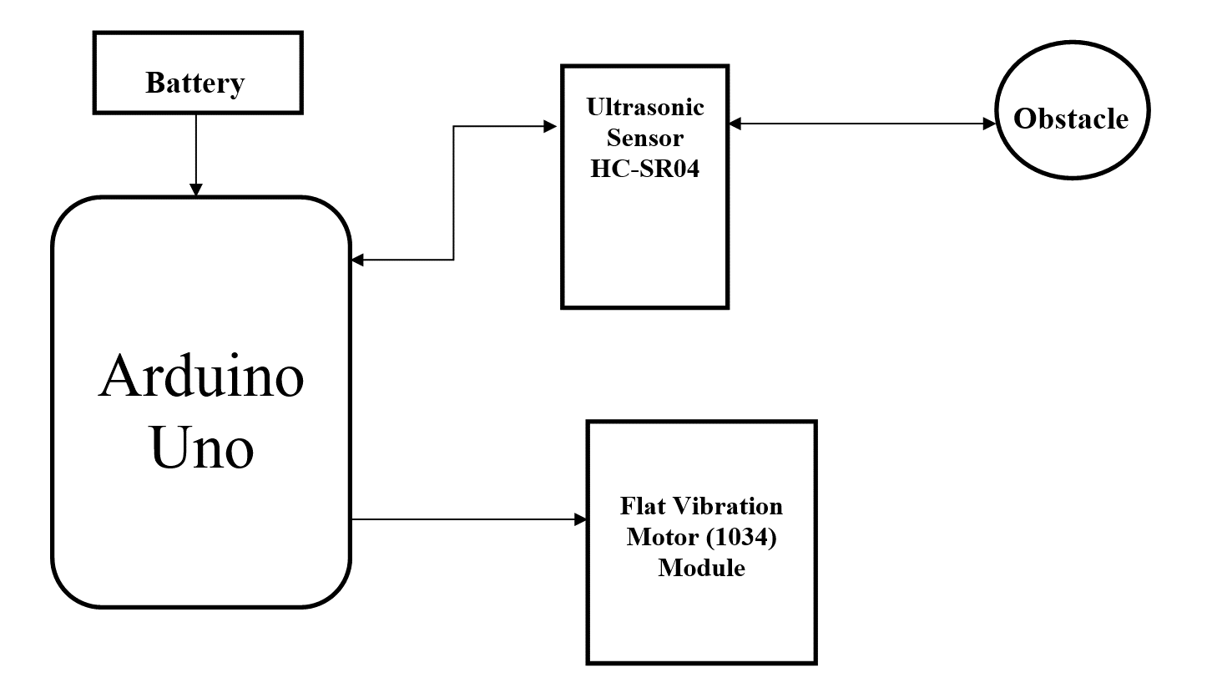

## Working:

Ultrasonic glasses for the blind are a wearable device designed to help people who are visually impaired or blind navigate their surroundings using ultrasonic sensors and a haptic vibration motor as the output device. The glasses work by emitting high-frequency sound waves from ultrasonic sensors, which bounce off objects in the environment and return to the sensors. The time taken for the sound waves to return to the sensors is used to determine the distance of the objects from the wearer. This information is then transmitted to a control unit i.e., Arduino Uno, which is usually located in a box which is placed in pocket of wearer. The control unit processes the data and sends signals to a haptic vibration motor located in the same box. The haptic vibration motor then generates vibrations that correspond to the distance and location of objects in the wearer's environment.

For example, if an object is very close to the wearer, the motor may generate a strong and rapid vibration, while a weaker and slower vibration may indicate an object that is further away. By feeling these vibrations, the wearer can gain a better understanding of their surroundings and avoid obstacles. Overall, ultrasonic glasses for the blind provide a valuable tool for people with visual impairments to navigate their surroundings and improve their independence and quality of life.

# Reference: (Minimum 6 recent papers published in international journals)

1. “Automated Walk-in Assistant for the Blinds” by Muhammad Sheikh Sadi, Saifuddin Mahmud, Md. Mostafa Kamal, Abu Ibne Bayazid. Published in 2014 in the IEEE International Conference on Electrical Engineering and Information & Communication Technology
2. “A Wearable Walking Support System to provide safe direction for the Blind” by Kataoka Hiroto, Harashima Katsumi. Published in 2019 in the IEEE 34th International Technical Conference on Circuits/Systems, Computers and Communications (ITC-CSCC)
3. “Development of Glasses for Guiding Visually Impaired Using Ultrasonic Sensor and Microcontroller” by Wawan Setiawan, Rasim, and Jajang Kusnendar. Published in 2014 in the Journal of Multidisciplinary Engineering Science and Technology (JMEST)
4. “A Unique Smart Eye Glass for Visually Impaired People” by Md. Razu Miah, Md. Sanwar Hussain. Published in 2018 in the IEEE International Conference on Advancement in Electrical and Electronic Engineering (ICAEEE)
5. “Smart Guiding Glasses for Visually Impaired People in Indoor Environment” by Jinqiang Bai, Shiguo Lian, Zhaoxiang Liu, Kai Wang, Dijun Liu. Published in 2017 in the IEEE Transactions on Consumer Electronics
6. “Ultrasonic Glasses for the Blind: A Portable Aid for Obstacle Detection” by P. Mehta, A. Thakur, and A. Sharma. Published in 2017 in the IEEE Sensors Journal.
7. “Development of Ultrasonic Glasses for Blind People Using an ATmega328 Microcontroller” by M. Sahin, A. Erol, and H. Koyuncu. Published in 2019 in the journal Journal of Intelligent & Robotic Systems.
8. “Ultrasonic Glasses for Visually Impaired: Human–Machine Interaction and Control System Design” by J. Geng, J. Fang, and J. Zhang. Published in 2021 in the IEEE Transactions on Instrumentation and Measurement.
9. “Ultrasonic Glasses for the Blind Using Raspberry Pi and Arduino” by M. Amor, A. Idoudi, and N. Bouden. Published in 2021 in the journal International Journal of Electrical and Computer Engineering (IJECE).
10. “Design and Implementation of Ultrasonic Glasses for the Blind Based on Wireless Sensor Network” by W. Zhang, C. Liao, and X. Huang. Published in 2021 in the IEEE International Conference on Artificial Intelligence and Computer Applications (ICAICA).

# Amrutvahini College of Engineering, Sangamner Department of Electronics and Telecommunication

**Mini Project Synopsis**

**Academic Year: 2022-23**

|  |  |  |
| --- | --- | --- |
| Name of Students | **Roll Number** | Sign |
| Sarthak Devidas Varade | 68 |  |
| Onkar Uttam Waman | 73 |  |
| Omkar Sunil Yelmame | 74 |  |

**Remark of Mini Project Guide:**

**Remark of Head of Department:**

|  |  |  |
| --- | --- | --- |
|  |  | **Dr. R. P. Labade** |
| **Mini Project Guide** | **Mini Project Coordinator** | **(Head, E&TC Department)** |