PROPOSAL
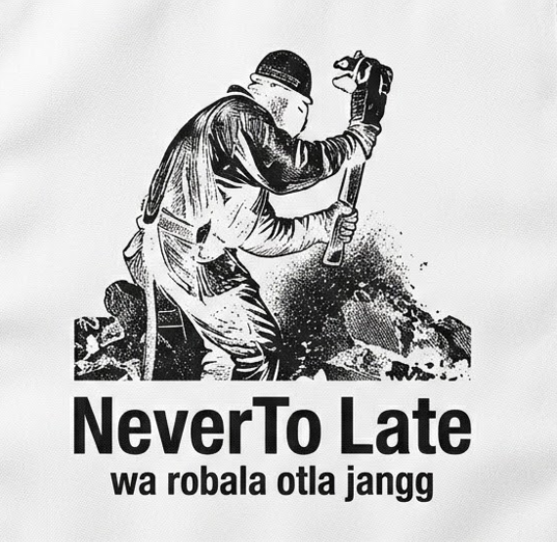  Neverto late  Wa robala otla jang.. | Name: Onkarabile skhosana  Student number: st10503620  Code: wede5020  subject name: web development

Table of Contents
Target Audience 2
Web site Goal 2
Languages to use 3
Site structure / Navigation Structure 3
Folder Structure 4
Current Website Analysis 5
Budget 6
Time Line 6
Web Site Structure 8
Index.hml 8
About.html 9
products.html 10
Enquiries.html 11
Contact.html 12

Target Audience
- My website is designed for young man adults, workers, and streetwear lovers between age 17 to 40. Meaning that we focus on individuals who appreciate local culture, and a bit of graphic apparel.
- Our clothes are created for hard working people who resonate with our brand message, “wa robala otla jangg” (“If you sleep, you will eat nothing”), meaning that you need to keep working for you to eat and its never too late to work.
- Lastly our target audience are online shoppers looking for durable, high quality local brand including:
- T-Shirts
- Hoodies
- Denim cloths
- Accessories

Web site Goals and Vision
The main goal of this project is to make a website for our retail clothing store which is NeverToLate. We’re designing this website to show how unique and authentic NeverToLate apparel is.
We want to make it easy for people to find us online, view our latest clothing collections, and make orders. We also want to make it easy to manage when people ask about sizing or product availability.
We want people to feel comfortable and inspired when they visit our website.
We have three main focuses we want to do with this website:
- First, we want more people to know about our NeverToLate clothing brand
- Second, we want to make it easy for our clients to view all our clothes’, to know what is available in stock, and contact us directly for orders.
- Lastly, we want to make a website that can grow with our retail business as we add new clothing drops.
We aim to develop a website that will act like a helper that's available all the time, meaning that we want to make sure that we develop a web site that functions for 24/7 without breaking, so customers can look at what we offer and get in touch with us anytime.

Languages to use
- We will be using HTML which is Hyper Text Markup Language to build the structure of our web site.
- CSS, Cascading Style Sheets. We will use CSS language to style our web site to change colours, backgrounds, fonts, alignments and also mainly to design our website to have a responsive design which it will automatically adjust its web page to fit on smart phones, tablets and desktop screen.
- Lastly, we will use a bit of JavaScript to enable our web site to have button’s, mouse movement navigations, video players, and a bit of animation.

Site structure / Navigation Structure
- Index.html
This will be our web site’s homepage featuring hero shoots, brand story, and clothing drops.
- About.html
On the about page will be our brand’s history, every detail about our brand. Full meaning of our slogan, our brand’s vision and act.
- Services.html
The services page will contain our product catalogues showcasing t-shirts, hoodies, denim, and caps with and pricing.
- Contact.html
Contact page will have details about the way you can contact use and the address of all our stores.

Folder Structure












NeverTo-Late-website
js_assets
css_assets
_private
heroShoot.png
logo.png
_images
enquirie.html
services.html
about.html
index.html

product.html

Current Website Analysis
The existing website functions primarily as a static online showcase with basic layout structures, lacking the dynamic tools required for a modern streetwear brand. Key limitations include:
- Customers are unable to select sizes, add items to a cart, or complete secure online checkouts directly on the site.
- Products are displayed without interactive previews, colour-swapping capabilities, or high-resolution zoom features.
- The site lacks automated support, order tracking systems, and direct customer profile management.
The New Website: A Next-Generation Game Changer
The objective of the new platform is to transform NeverToLate Apparel into a high-converting, fully integrated digital brand store. The upgraded platform introduces several game-changing features:
- Customers can view 360-degree product, seamlessly toggle between colourways (black, white, blue), and preview matching full-outfit combinations (hoodies, utility side bags, and headwear).
- Integration with secure local and international payment systems, instant cart management, and guest checkout options to eliminate purchasing friction.
- A dedicated user portal allowing customers to track order status, manage delivery addresses, and save favourite items to a Wishlist.
- High-impact urban aesthetic designs featuring integrated drop countdowns, and limited-edition release banners.

Budget
- Domain name registration (Host Africa) .co.za: R250 per year
- Web Hosting (South African Data System) Uncapped: R60 per month
- Maintenance and deployment: R0 (Manage my own website)
- Design Assets and stock graphics: R12500
Total Estimated: R15600

Time Line
Date | Phase | Description
27 July -30 July | Phase 1: Assignment planning | Decided on what languages to use  Defined website’s goal, target audience.
31 July – 02 August | Phase 2: Catering resources | 1. Planned responsive layout structure  2. Creating colour pallet and typography styles for the website  3. Structuring the website’s folder
03 August – 05 August | Phase 3: Development | 1. Build a HTML structure for all the web pages [ index, about,products,contact,  enquirers]  2. Developed responsive header, navigation bar, and contact info
06 August – 08 August | Phase 4: Adding content and first debug | 1. Adding the navigation links on the web pages for easy access across all the pages  2. Testing the websites behaviour on different devices of different screen size
09 August | Phase 5: Review before Submission | 1. Make sure that all the files are structures nicely  2. Perform a final test on all the web pages.  3. Finalize writing the proposal

Web Site Structure

Index.hml

NeverTo Late
Wa robala otla jangg
LOGO
LOGO
about
product
contact
enquiries
HERO SHOOT
PHOTO 1
TEXT

About.html

LOGO
NeverTo Late
Wa robala otla jangg
home
products
enquiries
LOGO
contact

History Story Text

Old Logo History Text
Old Logo

New Logo Story Text

New Logo

products.html

LOGO
LOGO
NeverTo Late
Wa robala otla jangg
About
Home

Enquiries
Contact

Text

Text

Text

PHOTO 4
PHOTO 5
PHOTO 6
Text

Text

Text

Text
Text
Text
PHOTO 3
PHOTO 2
PHOTO 1

Enquiries.html

LOGO
LOGO
NeverTo Late
Wa robala otla jangg
About
Home

Product
Contact

Text

Enquiries Form

Contact.html

Text

Text
Map
Map

LOGO
LOGO
NeverTo Late
Wa robala otla jangg
About
Home

Product
Contact

Reference

- Folder icon, icon archive[ Available online]
<https://www.iconarchive.com/show/flatastic-1-icons-by-custom-icon-design/folder-icon.html>
- Image icon, Icons [Available online]
< https://icons8.com/icon/114320/image >
- Html icon, Free SVG [ Available online]
< https://freesvg.org/1541611743 >

