Lenskart IPO: Clear Vision or Overpriced Illusion?
India’s leading eyewear brand Lenskart made its much-awaited stock market debut yesterday, marking one of the biggest IPOs of the year in the consumer-tech sector. The listing drew strong attention from investors, but it also reignited debates over valuation, profitability, and long-term investor risk..
Here are the financial highlights of Lenskart before listing of the IPO
Ahead of the IPO, Lenskart reported a significant financial turnaround:
- Revenue (FY25): ₹6,625 crore — up about 22% from ₹5,428 crore in FY24
- Net Profit (FY25): ₹297 crore — compared to a loss of ₹10 crore in FY24
Now, the surprising thing in this is that Lenskart was making losses for most of the years since it was started. But as the time approached for IPO listing it suddenly became a profitable company with profits 30 times the loss that they made last year. Moreover, out of the profit of ₹297 crore, ₹167 crore was related to the Owndays acquisition, which means the adjusted profit was only ₹130 crore.

But before discussing it further, let’s look more at the IPO structure.

IPO Structure and Details
●Total size: ₹7,278 crore
●Fresh Issue: ₹2,150 crore
●Offer for Sale(OFS) : ₹5,128 crore
●Price band: ₹382- ₹402 per share
●Minimum bid(lot size) :37 shares
A substantial Offer for Sale (OFS), allowing early investors and promoters to partially exit.The IPO received an enthusiastic response during the subscription period, driven by Lenskart’s strong brand recall and growing dominance in India’s eyewear market.
Business Saturation
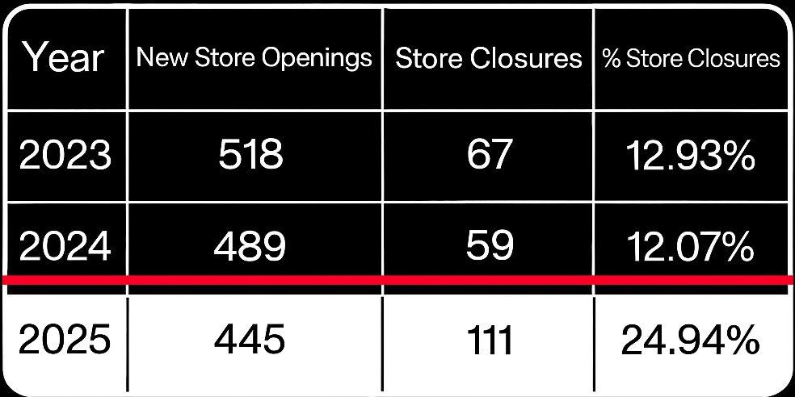
The data clearly shows a rising trend in store closures, reaching nearly 25% in 2025, signaling market saturation.Despite strong brand presence, Lenskart appears to be approaching its expansion ceiling within India.The decline in new store openings from 518 in 2023 to 445 in 2025 indicates slowing domestic growth potential.Increasing closures suggest that store performance and profitability are becoming harder to sustain in mature markets.This leaves Lenskart with only one option; to expand internationally to justify the given valuation in future.
Also, Lenskart has its market base in the organised sector in India, which is a very small portion of the whole eyewear market of India.

Valuation and P/E Ratio Debate
Despite its strong numbers, the IPO valuation raised eyebrows across the market. Analysts estimated Lenskart’s Price-to-Earnings (P/E) ratio at approximately 230×, placing it far above traditional retail or FMCG peers that typically trade at 40–70×. And this is exactly the thing which is not going well with investors.
The ratio implied that investors were paying heavily for future growth expectations rather than current earnings — a risky bet if profitability fails to scale accordingly.
Emergence of Smart and AR Glasses:
On the other hand, the eyewear industry is on the verge of disruption with global tech giants investing heavily in smart glasses and augmented reality (AR) eyewear — devices that integrate phone functionalities directly into lenses. As these hi-tech glasses evolve into mainstream consumer products, traditional optical retailers like Lenskart may face a sharp decline in demand for conventional eyewear, unless they innovate and adapt. This could redefine how consumers perceive eyewear altogether.
To stay relevant, Lenskart would need to pivot from retail expansion toward R&D and technology integration, partnering or developing its own line of smart eyewear — a shift that requires heavy investment and expertise.
Moreover, in the recent interview of Peyush Bansal with CNBC-TV, questions related to the high valuation and future expansions were avoided dimly. Even the questions related to strategy and the company’s new goals to achieve the market cap value were vaguely answered and thus raised concerns over the valuation of the company.
Conclusion
Lenskart’s IPO debut marked a milestone for India’s consumer and retail space — showcasing the country’s growing appetite for modern lifestyle brands. However, beneath the excitement lies a crucial investor takeaway: valuation must match performance.
The company’s strong brand and growth strategy give it a promising outlook, but the lofty valuation and high expectations make it a case where investors must look through the hype with a clear, cautious lens.

