Needs vs Wants

— The Foundation of Financial Literacy
In the journey toward financial freedom, one of the most important lessons to learn is the difference between needs and wants. This simple understanding can completely transform the way you handle money, save for the future, and achieve your goals.

What Are “Needs”?
Needs are the essentials — the things you must have to live a stable and secure life. They include:
- Food and water ●Basic healthcare and hygiene
- Shelter and clothing ●Education or necessary tools for earning
In short, needs are non-negotiable. Without them, day-to-day life becomes difficult or even impossible.

What Are “Wants”?
Wants are the things that make life more enjoyable — but you can live without them. Examples include:
- Eating out frequently ●Designer clothes
- Buying the latest phone or gadgets ●Vacations, entertainment, or luxury items
There’s nothing wrong with spending on wants — as long as your needs and savings come first.
Let’s understand the importance with simple example:-
Meet Ravi, a college student who receives ₹2000 from his parents at the beginning of every month as pocket money.
On the first day, he feels rich — like a king! He celebrates with his friends, eats out at cafés, buys new T-shirts, and even subscribes to a couple of OTT platforms.
For the first 15 days, life feels perfect — outings, parties, and zero worries about tomorrow.
But by the middle of the month, Ravi’s wallet starts to feel lighter. His money, which should have lasted 30 days, is almost gone.
Now comes the tough part.
He starts borrowing from friends, skips breakfast to save money, avoids the canteen, and even delays buying study materials. What began as fun turns into stress and compromise.
By the end of the month, Ravi realizes that his money didn’t vanish — it was simply spent on wants instead of needs.
If he had planned better — spending first on essentials like food, travel, and stationery, then saving a small amount — he could have enjoyed small treats without financial regret.

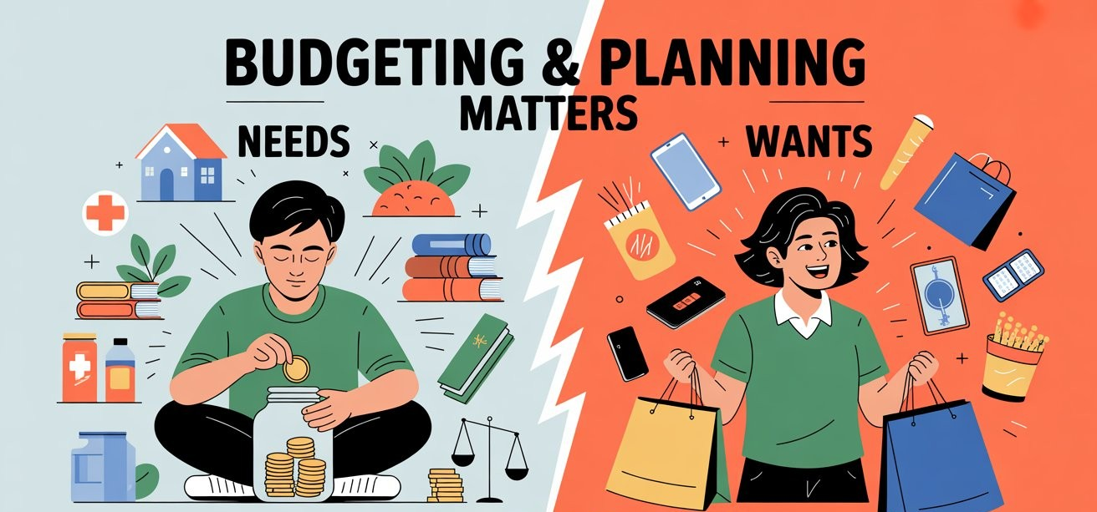

Smart Money Rule: Needs → Savings → Wants
Whenever you receive money — whether it’s a salary, allowance, or bonus — follow this simple order:
First, spend on your Needs.
Secure the basics that keep your life running smoothly.
Next, save for Future Needs.
Life is unpredictable. Savings protect you from emergencies, future education expenses, or retirement worries. Think of savings as "future needs" — not optional luxuries.
Finally, spend on Wants.
After meeting needs and setting aside savings, you can use the remaining amount for the things you enjoy. This approach lets you indulge guilt-free, knowing your essentials are secure.

Why This Matters
When you prioritize needs and savings over wants:
- You stay out of unnecessary debt.
- You build a safety net for the future.
- You develop self-control and financial discipline.
- You make conscious, not emotional, spending choices.

Final Thought
Financial literacy isn’t about earning more — it’s about managing what you have wisely.
So, the next time money comes your way, pause and ask yourself:

