IS THE AI BUBBLE READY TO EXPLODE?
The global financial markets are witnessing a sharp sell-off, and a growing number of analysts are pointing fingers at one of the hottest sectors of our time — Artificial Intelligence (AI). Since the launch of ChatGPT in late 2022, the AI industry has attracted massive attention, unprecedented investment, and sky-high valuations. Yet, as numbers begin to roll in, questions are emerging: Is the AI sector living up to the market’s expectations?

The AI Revolution: From ChatGPT to a Global Phenomenon
The journey of AI’s commercial explosion began with OpenAI’s ChatGPT, which transformed how people interact with technology. Within weeks of its launch, ChatGPT became the fastest-growing consumer application in history, hitting over 100 million users in just two months.
This success ignited a wave of investor enthusiasm — startups, tech giants, and chip manufacturers alike rushed to capitalize on the “AI gold rush.”
NVIDIA, AMD, Microsoft, and Google invested billions to integrate AI into their ecosystems. The promise was simple yet powerful: AI would redefine productivity, creativity, and automation, ushering in a new era of digital profitability.

When Numbers Tell a Different Story
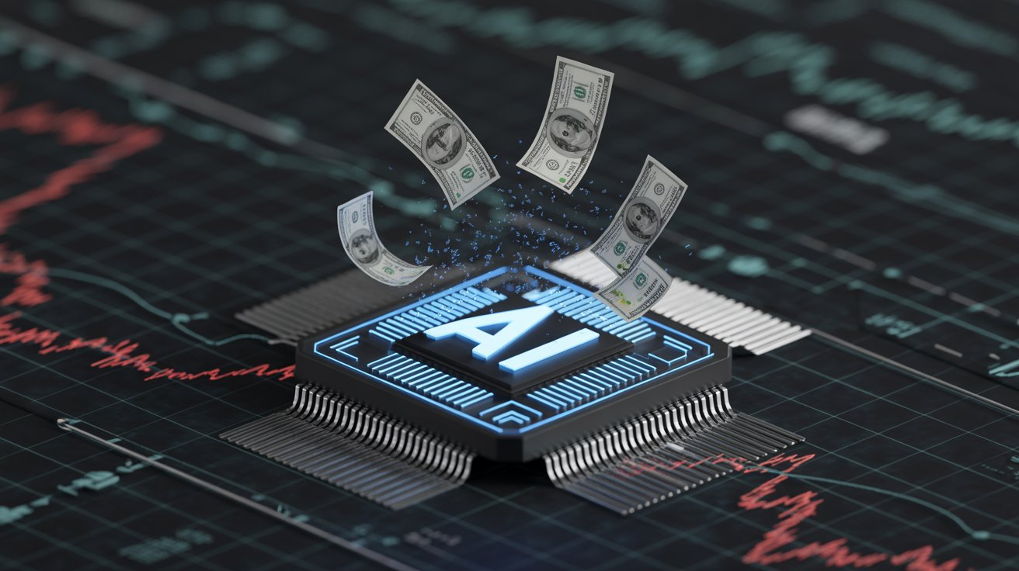
Take OpenAI, for example — the company at the heart of the AI revolution:
OpenAI reported a net loss of $13.5 billion in the first half of 2025, with $7.8 billion in operating losses and $2.5 billion in cash burn during the same period. Its operational costs were primarily driven by $6.7 billion in research and development expenses, along with significant spending on sales and marketing and stock-based compensation. Despite enormous investments and high demand for AI services, OpenAI’s expenses have far outpaced its revenues. The company’s projected spending could exceed US $129 billion by 2029, raising questions about how sustainable this growth truly is.

AI Sector: A Case of Over-Expectations
The excitement surrounding AI has led to soaring valuations — not just for OpenAI, but across the sector.Investors, driven by the promise of limitless innovation, have poured trillions into AI-related equities. However, as the global sell-off suggests, the sector is not keeping pace with the financial returns the market expected.
Companies in the AI domain are often revenue-light but capital-heavy — investing billions in computing power, research, and infrastructure before profits can materialize. While the technology itself continues to evolve rapidly, the business models remain experimental, and monetization is slower than anticipated.In simpler terms: AI is still a long-term story, but many investors are expecting short-term miracles.

A Market Correction or a Healthy Reality Check?
Analysts describe the current downturn not as the end of AI’s promise, but as a reality check.The hype cycle that once propelled AI stocks to historic highs is now being tested by real-world economics — costs, competition, and regulation.
NVIDIA, the biggest AI chip supplier, has seen fluctuating stock prices despite record demand.Startups boasting “AI” in their names raised billions in early rounds but are now struggling to secure follow-on funding.Tech giants are trimming AI budgets and demanding clearer returns on investment.In short, the AI narrative remains powerful, but the financial execution is under pressure.

The Road Ahead: Balancing Innovation with Realism
AI is undoubtedly one of the most transformative technologies of the century. Its influence across education, healthcare, finance, and creative industries is undeniable. Yet, the market must remember that innovation takes time to translate into consistent profits.Investors need to separate true innovators from trend followers, focusing on companies with clear revenue streams, scalable products, and strong infrastructure.The ongoing market correction may actually be healthy — cooling unrealistic expectations and paving the way for more sustainable growth.
Conclusion: The AI Story Isn’t Over — It’s Just Evolving
The AI revolution, launched by ChatGPT, was never just a fad — it marked the beginning of a new digital epoch.But like every major technological shift, its economic reality will take years to stabilize. The current mismatch between market investment and tangible financial output is a natural phase of adjustment.Know that AI is not failing — it’s maturing.The next few years will determine whether this hype transforms into a truly self-sustaining industry, or becomes another cautionary tale of over-enthusiasm.

