IPO – Initial Public Offering
An Initial Public Offering (IPO) marks a significant milestone in a company’s journey — the moment it opens its doors to public investors. Through an IPO, a private company offers its shares to the general public for the first time, allowing investors to become part-owners of the business. For investors, IPOs present exciting opportunities to invest in companies at an early stage of their public life. However, as with all investments, IPOs come with potential rewards and risks that must be carefully evaluated.

IPO as an Investment Option
Investing in an IPO allows individuals to purchase shares directly from the company before they are listed on the stock exchange.
For many investors, this offers a chance to : Participate early in the growth story of a promising company.Benefit from price appreciation if the stock performs well post-listing.
Diversify investment portfolios with exposure to new and expanding industries.
However, IPO investments can also be volatile, especially in the initial trading days, so a clear understanding of fundamentals is essential.
Things to Consider Before Investing in an IPO
Before investing in an IPO, investors should study the company’s financial health, revenue trends, profit margins, and debt levels using the RHP. It is also important to compare the IPO’s price band with similar companies and understand the broader industry outlook to judge long-term potential. Evaluating the credibility of promoters and the strength of the management team further helps in assessing future stability.
Investors must also check how the company plans to utilize the IPO funds—whether for expansion, debt repayment, or acquisitions. Market conditions at the time of listing play a major role in short-term performance, with bullish markets often boosting gains. Additionally, understanding the allotment process and lock-in rules helps investors make informed and balanced IPO decisions.

Types of IPOs
There are two main types of IPO issues:
- Fixed Price Issue:
The company fixes the price of its shares before the issue opens. Investors know the exact price they’ll pay while applying.
- Book Building Issue:
A price range (known as the price band) is offered. Investors bid within this range, and the final price is determined after analyzing all bids.

What Companies Do with IPO Funds
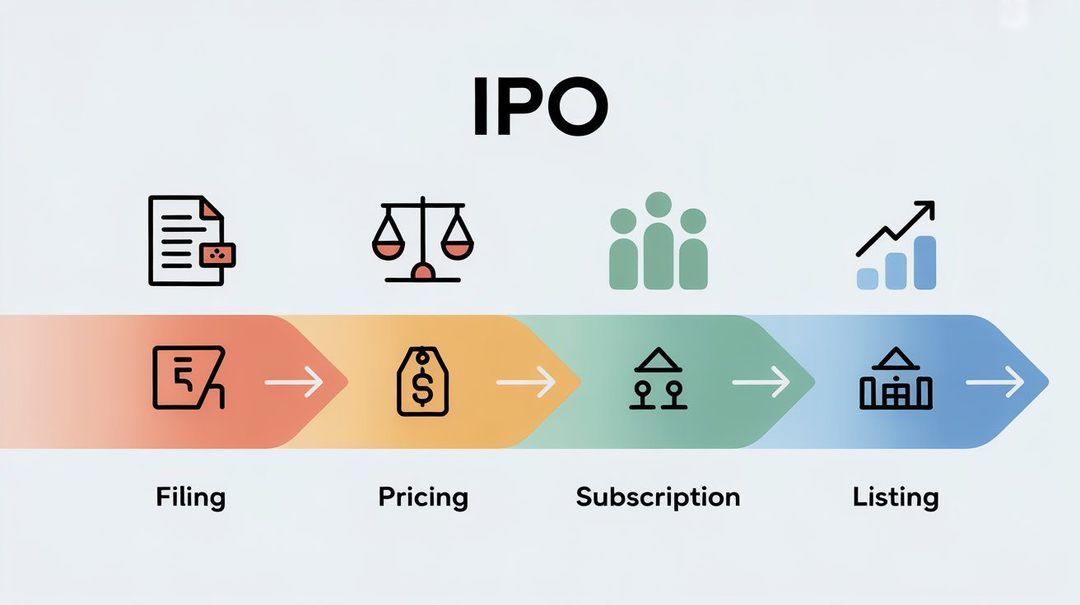
Companies launch IPOs primarily to raise capital for various strategic purposes, such as:
Business Expansion, Setting up new branches, manufacturing units, or entering new markets.Research and Development (R&D), Developing innovative products and technologies.Debt Repayment, Reducing existing financial liabilities to strengthen the balance sheet.Brand Building, Enhancing visibility and trust among investors and consumers.Liquidity for Promoters, Allowing early investors or founders to partially sell their stakes.

Examples of Large Companies That Launched Successful IPOs
- Reliance Industries (1977): One of India’s most successful IPOs, now a conglomerate leading multiple industries.
- Infosys (1993): Launched at a small scale, its IPO marked the beginning of India’s IT revolution.
- Zomato (2021): A milestone in India’s startup ecosystem, attracting global investor interest.
- LIC (2022): India’s largest-ever IPO, raising over ₹21,000 crore.
- Nykaa (2021): A strong example of a digital-first brand achieving market success post-listing.

Advantages of Investing in IPOs
Opportunity to invest early in high-growth companies.Potential for listing gains and long-term capital appreciation.Transparent process regulated by SEBI (Securities and Exchange Board of India).Helps investors diversify their portfolios with new industry entrants
.
Risks Associated with IPOs
Market Volatility: Prices may fluctuate sharply after listing.Limited Historical Data: Newly listed companies often lack long-term financial records.Overhyped Valuations: Investor enthusiasm can sometimes inflate prices beyond realistic value.Liquidity Risks: Not all IPOs perform well or maintain trading volume post-listing.

Conclusion
An IPO is both a milestone for companies and an opportunity for investors. While it opens the gateway to potential profits, it also demands careful analysis and patience. Investors should focus on understanding the business model, management quality, and long-term potential rather than chasing short-term gains.
Ultimately, a well-researched IPO investment can become a rewarding part of one’s financial growth journey.

