Software Architecture and Design Specification
Project: Online Bookstore
Version: 1.1
Authors: Varchas – PES2UG24CS575; Uditi Mourya – PES2UG24CS565; Vrinda Venugopal M – PES2UG24CS601
Date: 12-09-2026
Status: Draft

Revision History
Version | Date | Author | Change Summary
1.0 | 08-09-2026 | Varchas, Uditi Mourya, Vrinda Venugopal M | INITIAL SRS DRAFT
1.1 | 12-09-2026 | Varchas, Uditi Mourya, Vrinda Venugopal M | Initial SAD draft derived from SRS Version 1.0

Approvals
Role | Name | Signature/Date

1. Introduction

1.1 Purpose
This Software Architecture and Design Specification (SAD) describes the logical architecture and design of Version 1.1 of the Online Bookstore. It translates the system’s functional, security, performance, usability, reliability, scalability, and other requirements into architectural components, responsibilities, interactions, and design views.
The document defines the selected technology stack, database, system architecture, component responsibilities, interactions, security considerations, API design, and other key aspects required for the implementation and maintenance of the Online Bookstore.

1.2 Scope
The SAD covers the architecture and design of the web-based Online Bookstore:
• Customer registration, login, authentication, authorization, and profile management.
• Book catalogue browsing, search, filtering, sorting, and book details.
• Shopping cart management and checkout with delivery information.
• Online payment processing through an external payment gateway/API.
• Order creation, order viewing, order tracking, and eligible order cancellation.
• Inventory management and prevention of purchases when stock is insufficient.
• Administrator management of books, pricing, categories, inventory, and customer orders.
• Security controls, transaction consistency, performance, scalability, reliability, usability, maintainability, and portability.
Physical warehouse operations, book publishing, physical delivery operations, banking infrastructure, and internal implementation of third-party payment or courier services are outside the project scope, as stated in the SRS.

1.3 Audience
The intended audience is the development team, system designers, testing/QA team, administrators, customers, and project evaluators. The document is also useful for maintenance and future design work where the existing requirements provide sufficient guidance.

1.4 Definitions
Term | Definition
Online Bookstore | Web-based system that allows customers to browse, purchase, and track books online.
Customer | Registered user who can browse books, manage a cart, place orders, make payments, and track purchases.
Administrator | Authorized user responsible for managing books, inventory, catalogue information, and customer orders.
Book Catalogue | Collection of books available for purchase, including title, author, ISBN, category, price, description, and availability.
Inventory | Records representing the quantity of each book currently available for purchase.
Shopping Cart | Temporary collection of books selected by a customer before purchase.
Checkout | Process of reviewing cart items, providing delivery details, and proceeding with payment and order placement.
Order | Confirmed request made by a customer to purchase one or more books.
Order ID | Unique identifier assigned to an order for identification and tracking.
Payment Gateway | Service that securely processes online payment transactions and communicates the payment result.
RBAC | Role-Based Access Control; restricts system functionality according to the user's assigned role.
API | Application Programming Interface used for communication and data exchange between software components.

2. Document Overview

2.1 How to use this document
The document first presents the architectural goals and stakeholders, then describes the logical components and their responsibilities. It next explains the chosen architecture representation, technology and data-store constraints, risks, requirement traceability, and security architecture. The design section then covers the purchase and administrative interaction flows, logical interfaces, error handling, UX considerations, and open issues.
The UML-style diagrams included here are design views derived from the actors, entities, system components, and activity/sequence flows explicitly described in the SRS.

2.2 Related Documents
• Software Requirements Specification for Online Bookstore, Version 1.0, Team 16, dated September 8, 2026.
• Online Bookstore Project Proposal, the primary reference for project objectives, scope, features, user roles, and functional requirements.
• Software Engineering Course Materials, PES University, for requirements engineering, UML modelling, and software quality attributes.
• IEEE Std 830-1998, the basis for organizing the Software Requirements Specification.

3. Architecture

3.1 Goals & Constraints
The architecture is designed as a web-based application consisting of a user interface, application logic, database management system, and supporting services for authentication, order processing, payment, and inventory management.
Goal / Constraint | Design implication
Secure access | Authentication, authorization, password protection, secure sessions, and HTTPS/TLS must protect protected functions and sensitive data.
Transaction integrity | Order, payment, and inventory processing must avoid duplicate orders and inconsistent records.
Responsive performance | Search/catalogue responses target 2 seconds under normal load; checkout processing excluding external payment time targets 3 seconds.
Scalability | The design must support at least 100,000 catalogue titles and horizontal scaling of application servers.
Reliability | The system targets at least 99% uptime and must support rollback/recovery behaviour for third-party service failure.
Cross-device access | The web interface must work across desktop, tablet, and mobile screen sizes and modern browsers.
External dependencies | Payment processing depends on a third-party payment gateway/API; delivery tracking is assumed to be handled externally.

3.2 Stakeholders & Concerns
Stakeholder | Primary concerns
Customer | Simple browsing/search, secure authentication, cart and checkout, payment, order confirmation, tracking, and eligible cancellation.
Administrator | Secure access to book, catalogue, pricing, inventory, and customer-order management.
Payment Service | Secure payment request/response exchange and reliable payment result communication.
Development / QA Team | Clear module responsibilities, traceability to requirements, testability, maintainability, and error handling.
Project Evaluators | Conformance of the implemented system with the SRS functional and non-functional requirements.

3.3 Component (UML) Diagram
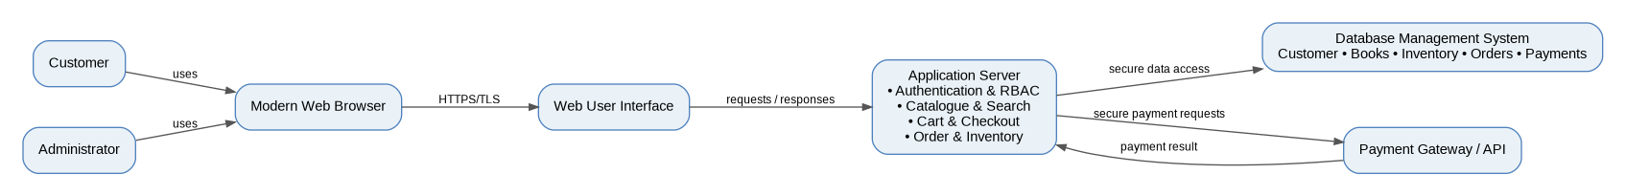
Figure 1. Logical component view derived from the Online Bookstore SRS.
The component view consists of the main system elements and their interactions: customers and administrators access the system through a web interface using modern browsers, while the application server handles business logic and communicates with the database and payment gateway/API.

3.4 Component Descriptions
Component | Responsibility derived from SRS
Web User Interface | Provides registration/login, catalogue browsing/search/filtering, book details, cart, checkout, payment interaction, order viewing/tracking, and administrator interfaces.
Application Server | Handles application/business logic, user requests, authentication/authorization, order processing, inventory updates, and communication between the interface, database, and payment service.
Authentication & Access Control | Validates customer/administrator credentials and enforces role-based access to protected functions. Passwords must not be stored in plain text.
Catalogue & Search | Provides browsing, search by title/author/category/ISBN, filtering, sorting, and book details.
Cart & Checkout | Maintains selected books, item quantities, removal/update operations, delivery information, and order summary before payment.
Order & Inventory Management | Creates unique Order IDs for confirmed purchases, maintains order status, updates stock after successful purchases, and prevents purchases when stock is insufficient.
Database Management System | Stores and retrieves customer accounts, book details, inventory, shopping carts, payment records, and order records, with referential integrity and consistency.
Payment Gateway / API | External service that securely processes online payment transactions and returns payment success/failure information.

3.5 Chosen Architecture Pattern and Rationale
A layered logical architecture is used for the system, with React.js forming the frontend layer and Node.js with Express.js providing the backend and REST API layer. MySQL is used as the database layer, while supporting modules handle authentication, catalogue, cart, checkout, payment, order, inventory, and administrative functions.
The architecture follows a modular design to ensure clear separation of responsibilities, easier maintenance, and flexibility for future enhancements.

3.6 Technology Stack & Data Stores
The SRS specifies technology-level constraints rather than specific products. Therefore, the following are the supported design facts:
Area | Specified by SRS
Client | Modern web browsers on desktops, laptops, tablets, and smartphones.
Application layer | Backend/application server handling business logic and system requests.
Database | A database management system for customer, book, inventory, cart, payment, and order information.
External payment | Payment Gateway/API accessed using secure API communication such as HTTPS.
Communication security | HTTPS with TLS for client/server and sensitive external-service communication; secure database connections where supported.
Specific programming language / framework | React.js (Frontend), Node.js + Express.js (Backend), REST API
Specific DBMS product | MySQL

3.7 Risks & Mitigations
Risk identified from SRS | Mitigation / design response
Payment gateway or third-party service failure | Roll back the transaction, notify the customer, and prevent corruption of order or inventory records.
Insufficient stock | Check stock at checkout and do not confirm an order when requested quantity exceeds available stock.
Duplicate payment/order requests | Validate external responses and maintain transaction consistency so failed requests do not create duplicate orders.
Unauthorized administrative access | Require authentication and enforce RBAC for administrator-only operations.
Sensitive data exposure | Use HTTPS/TLS, secure password hashing, session security, and avoid storing raw payment credentials.
Database or system failure | Use automated backups and restore service/data to the most recent consistent backup point.

3.8 Traceability to Requirements
The following mapping connects SRS sections/requirement identifiers to the logical design components. The SRS does not assign FR identifiers to its functional requirements, so section numbers are used where appropriate.
SRS requirement | Design component / view
5.1 Customer Account Management | Web UI + Authentication & Access Control + Application Server
5.2 Book Catalogue and Search | Web UI + Catalogue & Search + Database
5.3 Shopping Cart | Web UI + Cart & Checkout + Database
5.4 Checkout and Delivery | Web UI + Cart & Checkout + Application Server
5.5 Payment Processing / SEC-7 | Application Server + Payment Gateway/API
5.6 Order Management | Order Management + Database
5.7 Inventory Management / BR-1 | Order & Inventory Management + Database
5.8 Administrator Management / SEC-8 | Administrator UI + Authentication & Access Control + Application Server
5.9 Order Tracking and Status / BR-2 | Order Management + Web UI + Database
5.10 Security and Access Control / SEC-1 to SEC-6 | Authentication & Access Control + HTTPS/TLS + Application Server
PERF-1 to PERF-4 | Application Server + Database + Web UI
SCAL-1 to SCAL-3 | Application Server + Database architecture
REL-1 to REL-4 | Application Server + Database + external-service error handling
USE-1 to USE-4 | Web User Interface
MAIN-1 to MAIN-3 | Modular application components + logging
PORT-1 to PORT-2 | Web User Interface / browser-responsive design

3.9 Security Architecture
The security architecture emphasizes confidentiality, integrity, accountability, secure authentication, role-based authorization, secure communication, session security, and protection of payment data.
Security requirement | Architectural control
SO-1 Confidentiality | Protect customer credentials, delivery information, and payment-related information through access control, secure storage practices, and HTTPS/TLS.
SO-2 Integrity and Accountability | Restrict modifications to authorized users and retain relevant activity records for traceability.
SEC-1 Secure Authentication | Authentication required before protected functions; administrator functions restricted to authorized administrators.
SEC-2 Password Protection | Passwords stored only using an appropriate secure password-hashing mechanism.
SEC-3 Authorization and Access Control | RBAC separates customer functions from administrator functions.
SEC-4 Secure Communication | HTTPS/TLS for credentials, customer data, checkout, payment requests, and other sensitive data.
SEC-5 Data and Transaction Integrity | Validate inputs and coordinate order, payment, and inventory operations to prevent duplicate/inconsistent records.
SEC-6 Session Security | Secure authenticated sessions and invalidate the session on logout.
SEC-7 Payment Data Protection | Avoid unnecessary storage of sensitive payment credentials; rely on the payment service's secure mechanisms.
SEC-8 Administrative Activity Protection | Only authenticated and authorized administrators can modify books, prices, inventory, and customer orders.

4. Design

4.1 Design Overview
The Online Bookstore is organized around a web interface, an application server, a database management system, and the external payment gateway/API. Within the application server, responsibilities are logically separated into authentication/access control, catalogue/search, cart/checkout, order/inventory management, and administrator operations.

4.2 UML Sequence Diagrams
The following sequence views are derived from the SRS activity and sequence descriptions. They show the logical interactions needed for the specified flows and do not introduce concrete implementation APIs.
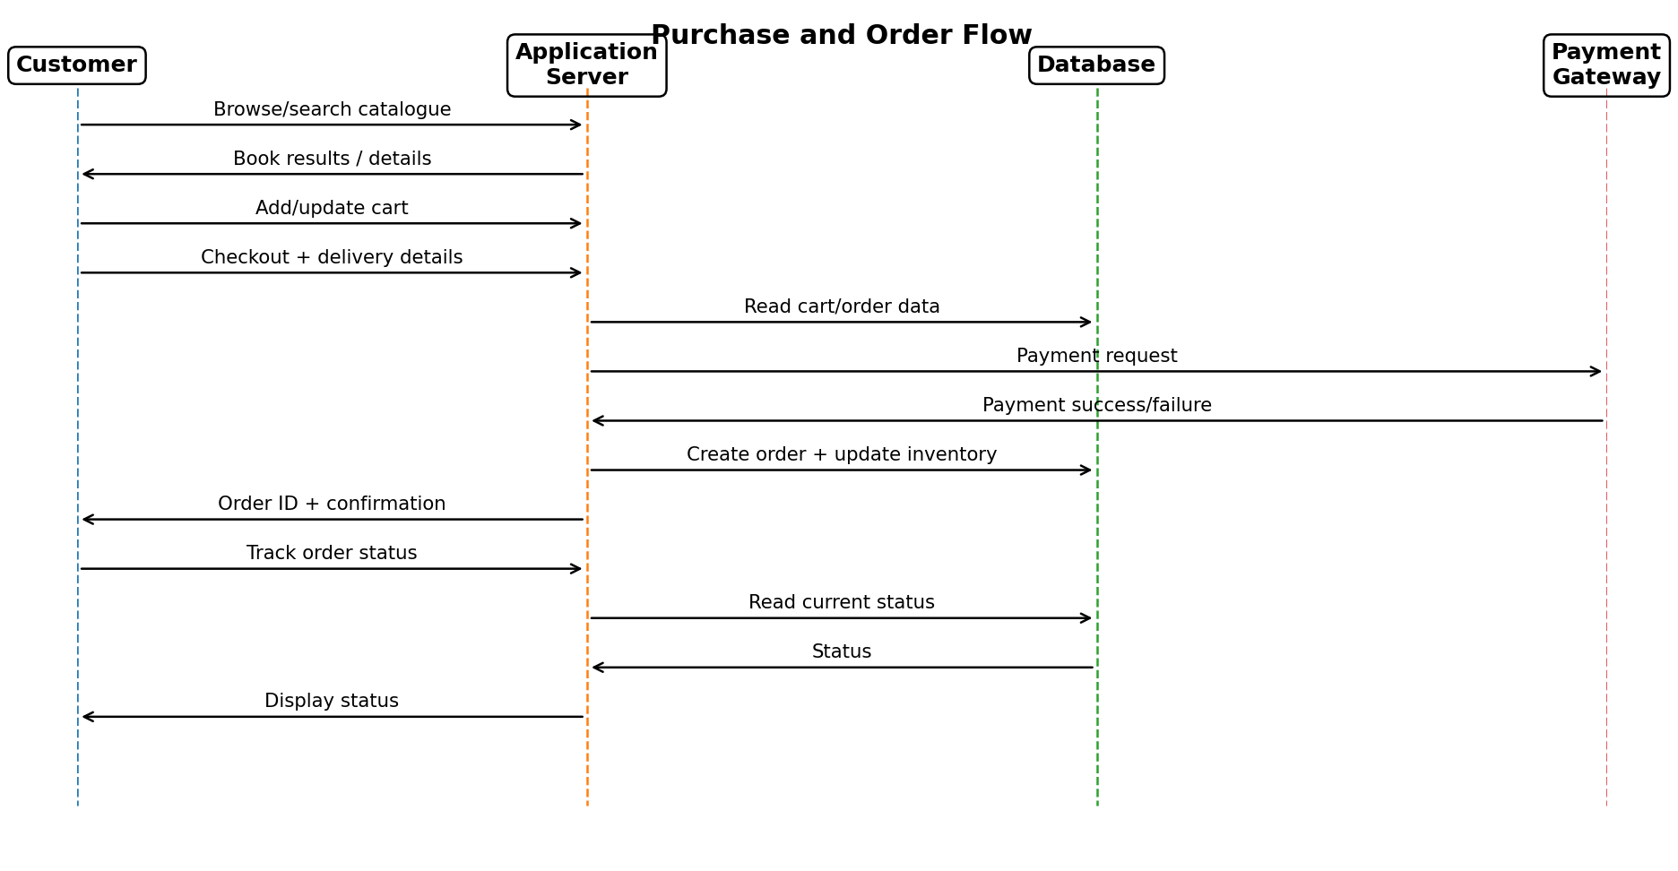
Figure 2. Purchase, payment, order creation, inventory update, and tracking flow.
The purchase flow follows the SRS sequence description: the customer interacts with the web interface; the application server validates requests, accesses the database, communicates with the payment gateway/API, and then updates order and inventory records after successful payment. Failed communication or payment must not create duplicate orders or inconsistent records.
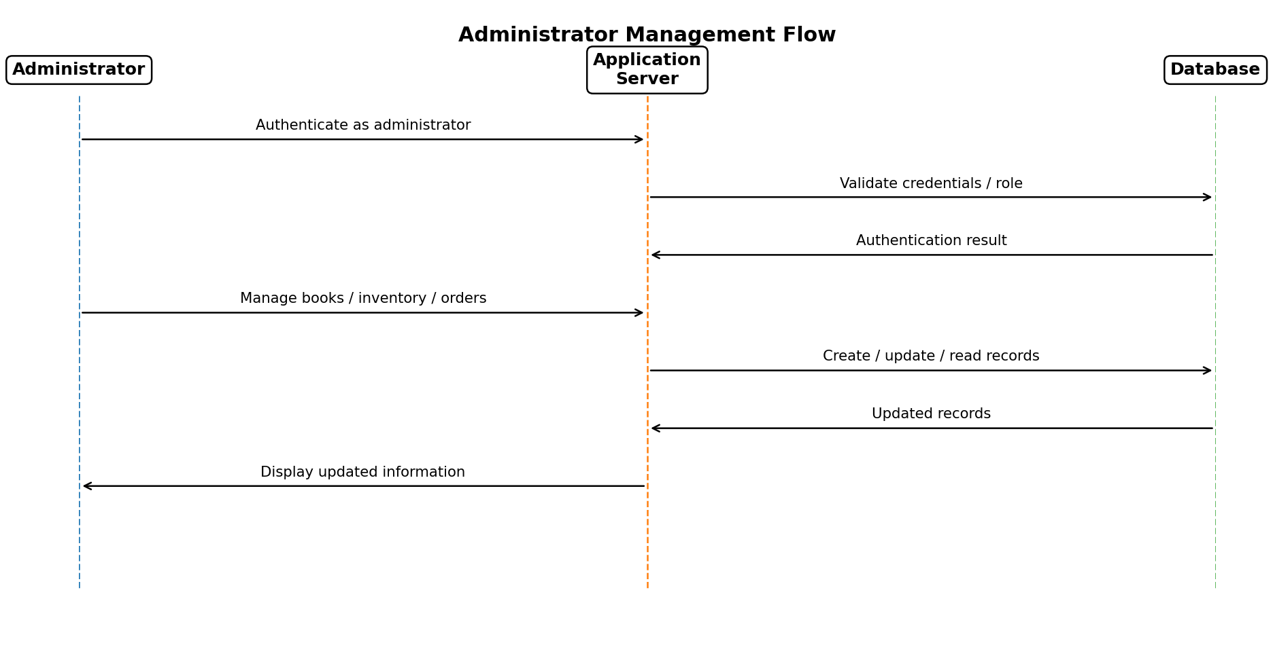
Figure 3. Administrator authentication and management flow.
The administrator flow follows the SRS activity model: authenticate as administrator → manage books/catalogue or review customer orders → update inventory or order status → maintain stock and transaction consistency → save updated records.

4.3 API / Logical Interface Design
The system uses communication between the web interface, application server, MySQL database, and payment gateway/API. The following are defined as logical interfaces, while specific endpoint names, HTTP methods, request schemas, and response schemas will be finalized during implementation.
Interface | Direction | Purpose | Logical data exchanged
Web UI ↔ Application Server | Bidirectional | Customer/admin requests and responses for authentication, catalogue, cart, checkout, orders, tracking, and administration. | Credentials, search/filter criteria, book/cart data, delivery information, order information, status and validation results.
Application Server ↔ Database | Bidirectional | Persistent storage and retrieval of system data. | Customer accounts, books, catalogue data, inventory quantities, cart data, payments, and orders.
Application Server ↔ Payment Gateway/API | Bidirectional | Secure payment processing and verification. | Payment request and payment success/failure result.
Application Server ↔ External logistics provider | Not specified as an internal API | Delivery/courier tracking is assumed to be handled externally and is outside internal implementation. | Tracking information, where applicable, through the external provider.

Concrete endpoint definitions and payload schemas are open implementation items.

4.4 Error Handling, Logging & Monitoring
Area | Design response
Input validation | Validate incomplete, invalid, or incorrect user input and show clear, non-technical messages.
Payment failure | Do not confirm the order; handle the failure/communication problem without corrupting order or inventory records.
Communication failure | Handle failures gracefully and inform the customer; failed requests must not produce duplicate orders.
Stock failure | Prevent checkout confirmation when sufficient stock is unavailable.
Logging | Log significant errors and administrative actions without exposing sensitive customer data in logs.
Monitoring | The SRS requires logging/monitoring support where implemented; reliability/performance measures include uptime, response time, and transaction consistency.

4.5 UX Design
The interface design follows the SRS usability and external-interface requirements:
• Responsive web interface for desktops, laptops, tablets, and smartphones.
• Clear menus, buttons, search options, and navigation controls.
• Customers should be able to locate and view a book's details within 3 clicks from the homepage.
• Clear, non-technical validation and error messages.
• Consistent layout, terminology, and interaction patterns across customer and administrator pages.
• Administrator tasks should be learnable through in-app guidance and labels without external training.
• Text, controls, labels, and error messages should be presented clearly for users with different levels of technical familiarity.

4.6 Open Issues & Next Steps
The following items are not specified in the SRS and therefore should be finalized during detailed implementation design:
• Define concrete REST/API endpoint names, HTTP methods, request/response schemas, and authentication token/session implementation.
• Define the exact payment gateway provider and integration contract.
• Define deployment topology and infrastructure configuration needed to meet the stated performance, scalability, availability, backup, and recovery targets.
• Define the external logistics/tracking integration if order tracking depends on an external provider.

5. Appendices

5.1 Glossary
Term | Meaning
API | Application Programming Interface.
CRUD | Create, Read, Update, and Delete operations.
DBMS | Database Management System.
ISBN | International Standard Book Number used to identify a book/edition.
NFR | Non-Functional Requirement.
RBAC | Role-Based Access Control.
SAD | Software Architecture and Design Specification.
SRS | Software Requirements Specification.
TLS | Transport Layer Security used with HTTPS for secure communication.
UML | Unified Modeling Language used for modelling system structure and behaviour.

5.2 References
• Software Requirements Specification for Online Bookstore, Version 1.0, Team 16, September 8, 2026.
• Online Bookstore Project Proposal.
• Software Engineering Course Materials, PES University.
• IEEE Std 830-1998 for SRS organization.

5.3 Tools
The UML diagrams and documentation for this SAD are created using draw.io for architectural and UML modelling, and Microsoft Word for documentation and formatting. These tools are used to represent the system architecture, component interactions, domain model, and sequence flows clearly.

