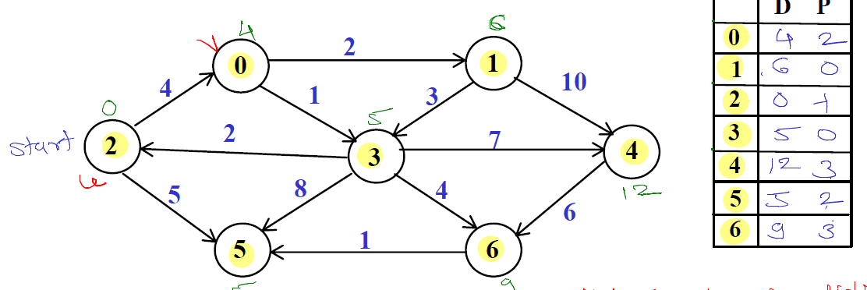

insert into nodes values(0,'',1,2);

insert into nodes values(1,'',3,2);

insert into nodes values(2,'',0,1);

insert into nodes values(3,'',2,1);

insert into nodes values(4,'',4,1);

insert into nodes values(5,'',1,0);

insert into nodes values(6,'',3,0);

insert into edges values (default, 4, 0,2);

insert into edges values (default, 2, 1,0);

insert into edges values (default, 10, 4,1);

insert into edges values (default, 5, 5,2);

insert into edges values (default, 1, 5,6);

insert into edges values (default, 6, 6,4);

insert into edges values (default, 2, 2,3);

insert into edges values (default, 7, 4,3);

insert into edges values (default, 1, 3,0);

insert into edges values (default, 4, 6,3);

insert into edges values (default, 8, 5,3);

insert into edges values (default, 3,3,1);