Software Architecture and Design Specification
Project: Online Internship and Placement Preparation Portal
Version | 1.3
Authors | Architecture & Design Lead: Kavana P G. v1.3 revision: Namitha R (Team T1: Namitha R, Manu Kudukundi, Kavana P G, Koushik)
Date | 12-11-2026
Status | Implementation-aligned baseline: updated after Sprints 1–3 to match the delivered code, SRS v1.1 and Software Test Plan v3.1.
Document ID | SAD-OIPP-1.3 (Document 3 of 3: SRS, Test Plan, Architecture & Design)

Revision History
Version | Date | Author | Change Summary
1.0 | 28-09-2026 | Architecture & Design Lead | First complete release: architecture, component diagram, pattern and ADRs, security architecture, traceability, sequence diagrams, API design, error handling, UX and open issues.
1.1 | 29-09-2026 | Architecture & Design Lead | Consistency update: aligned NFRs with the 5-NFR SRS baseline, changed performance target to 3 seconds, added SR-05 traceability, clarified component ownership and removed obsolete NFR references.
1.2 | 29-09-2026 | Architecture & Design Lead | Synchronised all test-case IDs (Sections 3.8.1, 3.8.2, 3.9.1) with the official SRS Requirements Traceability Matrix (TC-AUTH-xx, TC-INT-xx, TC-APP-xx, TC-TEST-xx, TC-PROG-xx, TC-PERF-xx, TC-ADM-xx, TC-SEC-xx, TC-DATA-xx, TC-UX-xx); aligned NFR-05 wording with the SRS; clarified that UC-01–UC-15 is this document’s own numbering of the SRS’s named use cases.
1.3 | 12-11-2026 | Namitha R (Team T1) | Aligned with the implementation, SRS v1.1 and Test Plan v3.1 (deviations D-01–D-16): table of contents; Figures 1–4 redrawn; 3 implemented endpoints and 4 error codes added; technology versions, data model, cascade-delete rules and NFR-01 test reference updated; open issues in 4.6 closed; footer version and document ID fixed.

Approvals
Role | Name | Signature/Date
Architecture & Design Lead (Member 3) | Kavana P G
SRS & Requirements Lead (Member 1)
Test Plan Lead (Member 2)
UML, Security & Integration Lead (Member 4)
Course Instructor / Reviewer | Prof Vadiraja

Table of Contents
1. Introduction
1.1 Purpose
1.2 Scope
1.3 Audience
1.4 Definitions
2. Document Overview
2.1 How to use this document
2.2 Related Documents
3. Architecture
3.1 Goals & Constraints
3.2 Stakeholders & Concerns
3.3 Component (UML) Diagram
3.4 Component Descriptions
3.5 Chosen Architecture Pattern and Rationale
3.6 Technology Stack & Data Stores
3.7 Risks & Mitigations
3.8 Traceability to Requirements
3.9 Security Architecture
4. Design
4.1 Design Overview
4.2 UML Sequence Diagrams
4.3 API Design
4.4 Error Handling, Logging & Monitoring
4.5 UX Design
4.6 Resolved Issues & Next Steps
5. Appendices
5.1 Glossary
5.2 References
5.3 Tools

1. Introduction

1.1 Purpose
This document specifies the architecture and design of the Online Internship and Placement Preparation Portal (the “Portal”). It follows the golden rule of the project baseline: the SRS defines what the system must do, this document defines how the system is organised to do it, and the Test Plan defines how it is verified. Traceability connects all three.
The document describes the architectural views (component view, layered pattern, data and security views) and the design views (sequence diagrams, API design, error handling, logging and monitoring, UX design). It is structured after IEEE 42010 (architecture description) and IEEE 1016 (software design description).
Version 1.3 brings the document in line with the delivered implementation (Sprints 1–3), SRS v1.1 and Software Test Plan v3.1. Every place where the code differs from version 1.2 is recorded in docs/DEVIATIONS.md (D-01–D-16) and is now reflected here.

1.2 Scope
This specification covers the following in-scope capabilities of the Portal, grouped by the baseline modules:
Module | Name | Capabilities covered
M1 | Authentication | Student registration, login, authentication and role-based authorization
M2 | Internship Management | View, search/filter and view details of internships; admin add/edit/delete
M3 | Internship Application Management | Submit application, view own applications, prevent invalid and duplicate applications
M4 | Aptitude Test Management | List tests, take test, submit answers, evaluate, store and display results; admin manage tests/questions
M5 | Progress Tracking | Record completed tests and relevant activities; display preparation progress
M6 | Performance Analysis | Analyse aptitude-test performance and present it to the student
M7 | Admin Management | Administrator access; manage internship and aptitude-test data

Out of scope (per the project baseline): conducting real company interviews, guaranteeing selection, automatic hiring decisions, recruiter/company-side features and any feature not documented in the source-of-truth file. No recruiter or company actor exists in this architecture.

1.3 Audience
Developers (implementation of components and APIs), QA engineers (derivation of test cases and traceability), security reviewers, the course instructor/evaluators, and future maintenance teams. Team members responsible for the SRS and Test Plan use this document to keep all three deliverables consistent.

1.4 Definitions
Term | Meaning
ADR | Architecture Decision Record – a short record of an architectural decision, its context and consequences
API | Application Programming Interface – here, the REST/JSON interface between frontend and backend
CRUD | Create, Read, Update, Delete operations
FR / NFR | Functional Requirement / Non-Functional Requirement (IDs from the SRS, e.g. FR-06, NFR-02)
JWT | JSON Web Token – signed token issued at login and sent with each protected request
ODM | Object-Document Mapper – library that maps application objects to MongoDB documents
RBAC | Role-Based Access Control – permissions granted by role (student, admin)
REST | Representational State Transfer – resource-oriented HTTP API style
RTM | Requirements Traceability Matrix
SO / SR | Security Objective / Security Requirement (IDs from the SRS, e.g. SO-01, SR-03)
SPA | Single-Page Application – the React frontend
SRS / STP | Software Requirements Specification / Software Test Plan
STRIDE | Threat model categories: Spoofing, Tampering, Repudiation, Information disclosure, Denial of service, Elevation of privilege
TLS / HTTPS | Transport Layer Security / HTTP over TLS – encrypted transport between browser and server
UC | Use Case – UC-01 to UC-15 are this document’s numbering of the use cases named in the SRS (see 3.8)
UML | Unified Modeling Language

2. Document Overview

2.1 How to use this document
This document provides the architectural deliverables required by the mini-project: UML component and sequence diagrams, architecture decision records, threat model, API design, error handling and traceability. Readers can navigate as follows:
If you need… | Read
The big picture and pattern | 3.3 Component Diagram, 3.4 Component Descriptions, 3.5 Architecture Pattern and ADRs
Technologies and data | 3.6 Technology Stack and Data Stores
Risk, requirement and security coverage | 3.7 Risks, 3.8 Traceability, 3.9 Security Architecture
Runtime behaviour | 4.2 UML Sequence Diagrams
Implementation contracts | 4.3 API Design, 4.4 Error Handling, Logging and Monitoring
User interface structure | 4.5 UX Design
How the open issues were decided | 4.6 Resolved Issues and Next Steps

Identifier conventions used throughout: FR-xx / NFR-xx / SR-xx / SO-xx (SRS), UC-xx (use cases), M1–M7 (modules), SD-x (sequence diagrams), ADR-xx (decisions), R-xx (risks), TC-xx (Test Plan test cases).

2.2 Related Documents
Document | Relationship
SRS v1.1 (Document 1, docs/OIPP_SRS_v1.1.docx) | Source of FR-01–FR-16, NFR-01–NFR-05, SO-01–SO-02, SR-01–SR-05, the named use cases numbered UC-01–UC-15 in this document, and the test-case IDs (TC-AUTH-xx, TC-INT-xx, TC-APP-xx, TC-TEST-xx, TC-PROG-xx, TC-PERF-xx, TC-ADM-xx, TC-SEC-xx, TC-DATA-xx, TC-UX-xx) used in Section 3.8
Software Test Plan v3.1 (Document 2, docs/OIPP_Software_Test_Plan_v3_Final.docx) | Uses the same test-case IDs and the traceability in Section 3.8 and the interfaces in Section 4.3
Team Source-of-Truth baseline | Defines scope, actors, modules, requirement IDs and the rule “change the baseline first”. This document is consistent with it
RTM | The requirement-to-component-to-API-to-test chain is given in Section 3.8
Implementation deviations (docs/DEVIATIONS.md) | Records every difference between the code and the SRS/SAD/Test Plan (D-01–D-16); all are reflected in this version
Test reports (docs/reports/) | Unit Test, System Validation, Code Coverage and Branch Coverage reports that verify the design in this document

3. Architecture

3.1 Goals & Constraints

Architectural goals
ID | Goal | Description | Source
G1 | Functional completeness | Every functional requirement is assigned a primary owning component and may depend on other components through defined interfaces. | FR-01–FR-16
G2 | Security | Protect student, application and result data; restrict protected and administrative functions to authenticated and authorised users | SO-01, SO-02, SR-01–SR-05, NFR-02–03
G3 | Data integrity | Application and test-result data remain correct and consistent (no duplicate applications, scores computed only on the server) | NFR-04
G4 | Performance | Normal requests complete within the response-time limit. Target: 95% of normal requests within 3 seconds under normal load. | NFR-01
G5 | Usability | Clear navigation between internship, test, progress and analysis functions. | NFR-05
G6 | Modularity and maintainability | Each module can be understood, changed and tested independently; new features are added without restructuring the system | Team constraint

Constraints
ID | Constraint | Impact on architecture
C1 | Web-based system | Browser-based frontend served over HTTPS; no native client
C2 | Team of 4, mini-project timeline | Simple, well-understood architecture; no distributed infrastructure
C3 | Only technologies actually used by the team may be documented | Stack in 3.6 is the JavaScript/MERN-style stack in the baseline; any change requires updating this document first
C4 | No external recruiter/company integration | No third-party integration components; Portal is self-contained
C5 | Passwords never stored in plain text | Salted password hashing in the Authentication component (SR-03)
C6 | A student must never see another student’s data | Ownership checks enforced on the server for every student-specific query (SR-04)
C7 | Academic deployment environment | Single deployment of frontend, API and database; high-availability clustering is not required

3.2 Stakeholders & Concerns
Stakeholder | Concerns | Addressed in
Student | Secure account, private data, easy navigation, accurate scores, clear errors, quick responses | 3.9 Security, 4.5 UX, 4.4 Errors, G3, G4
Administrator | Safe and simple management of internships, tests and questions; access restricted to admins | 3.4 Admin Component, 3.9 RBAC, 4.3 Admin APIs
Developers | Modularity, clear component boundaries, unambiguous API contracts, consistent technology | 3.4, 3.5, 3.6, 4.1, 4.3
QA / Test team | Testable requirements, traceability from requirement to test case, defined error behaviour | 3.8 Traceability, 4.3, 4.4
Security reviewer | Threat coverage, authentication and authorization design, protection of stored data | 3.9 Security Architecture
Course instructor / evaluators | Completeness against required IEEE deliverables, correctness of diagrams, consistency across documents | Whole document, 3.8
Maintenance team | Extensibility, logging and monitoring, documented decisions | 3.5.1 ADRs, 4.4, 4.6

3.3 Component (UML) Diagram
Figure 1 shows the UML component view of the Portal. The Frontend calls the Backend/API Layer over REST/JSON; the API Layer routes each request to the component that owns the module (M1–M7); all components persist data through the Database. Purple dashed arrows are dependencies between components; their numbers 1–6 appear in the figure and are explained in the table below. Component names and key operations match the implemented modules in server/src/modules.
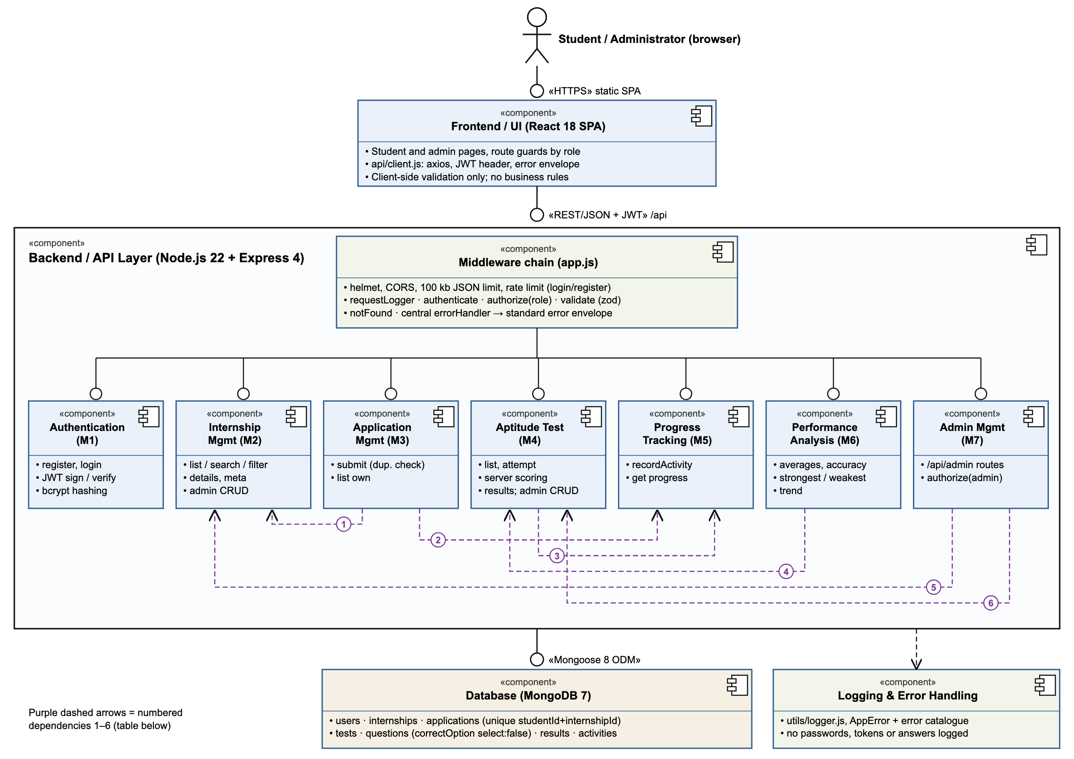
Figure 1: UML component diagram of the Online Internship and Placement Preparation Portal
No. | Dependency (client → supplier) | Reason
1 | Application Management → Internship Management | Checks that the internship exists and is open before accepting an application (FR-06)
2 | Application Management → Progress Tracking | Records an “internship applied” activity (FR-12)
3 | Aptitude Test → Progress Tracking | Records a “test completed” activity after evaluation (FR-12)
4 | Performance Analysis → Aptitude Test | Reads stored results (and question categories) to compute analysis (FR-14)
5 | Admin Management → Internship Management | Delegates add/update/remove of internship listings (FR-15)
6 | Admin Management → Aptitude Test | Delegates create/update/remove of tests and questions (FR-16)

3.4 Component Descriptions
The ten components required by the baseline are described below. Provided interfaces are exposed as REST endpoints (Section 4.3); required interfaces are calls to other components or the Database.
Component | Responsibility and key operations | Depends on | Requirements
Frontend / UI (React SPA) | Renders student and admin screens; captures input; performs basic client-side validation; stores the JWT and {name, role} in sessionStorage (key oipp_auth) for the browser session; guards routes by role (ProtectedRoute); shows API success and error messages, including field-level messages from VALIDATION_ERROR details. Contains no business rules and never computes scores. | Backend / API Layer | NFR-05
Backend / API Layer (Node.js + Express) | Single entry point for all requests (app.js). Applies the middleware chain (helmet security headers, CORS restricted to CLIENT_ORIGIN, 100 kb JSON limit, rate limiting on login/register, request logging, authentication, authorization, zod validation), routes to components, converts errors into the standard error response (errorHandler, notFound) and writes logs. | All functional components | NFR-01, NFR-02, NFR-03
Authentication Component (M1) | register(name, email, password): validates and creates a student account with a hashed password. login(email, password): verifies credentials and issues a signed JWT with user id and role. Provides authenticate and authorize(role) middleware used by every protected route. | Database | FR-01, FR-02, SR-01, SR-02, SR-03
Internship Management Component (M2) | listInternships(filters, role), getMeta() (distinct categories and locations for the filter dropdowns), getInternship(id, user), and for admins createInternship, updateInternship, deleteInternship (adminInternships.* files). Supports keyword search on title or company and filtering by category/location; students see only open internships. Deleting an internship also deletes its applications (D-06). | Database | FR-03, FR-04, FR-05
Application Management Component (M3) | submitApplication(studentId, internshipId): verifies internship exists and is open, rejects duplicates, stores the application, triggers activity recording. listApplications(studentId): returns only the caller’s own applications. | Internship Mgmt, Progress Tracking, Database | FR-06, FR-07, NFR-04, SR-04
Aptitude Test Component (M4) | listTests(studentId), getTestForAttempt(testId) (questions without correct answers), evaluateSubmission(studentId, testId, answers) (server-side scoring, category scores), listResults(studentId), getResult(studentId, resultId). Admin test and question operations live in adminAptitude.* files; deleting a test deletes its questions but keeps results for history (D-06). | Progress Tracking, Database | FR-08, FR-09, FR-10, FR-11, NFR-04
Progress Tracking Component (M5) | recordActivity(studentId, type, refId) called internally after applications and completed tests; getProgress(studentId) returns completed tests, applications submitted and recent activities. | Database | FR-12, FR-13
Performance Analysis Component (M6) | getAnalysis(studentId): computed on demand from stored results – number of attempts, average, best and latest percentage, per-category accuracy, strongest and weakest category and score trend (last 20 results). The calculations are pure functions in analysis.utils.js (D-13). Implemented inside the Node.js backend; no separate Python service. | Aptitude Test (results), Database | FR-14
Admin Management Component (M7) | Admin-only access to internship listings and aptitude tests/questions under /api/admin. Every route uses authenticate and authorize('admin'). The routers sit next to the module they manage (internships/adminInternships.*, aptitude/adminAptitude.*; D-10, D-15) and are mounted under /api/admin. Admin write actions are logged with the admin’s user id. | Internship Mgmt, Aptitude Test | FR-15, FR-16, NFR-03, SR-02, SR-05
Database (MongoDB) | Persistent storage of users, internships, applications, tests, questions, results and activities. Enforces uniqueness (e.g. one application per student per internship) through indexes. Accessed only by the API layer. | – | NFR-04
Logging & Error Handling (cross-cutting) | Central error-handling middleware (errorHandler, notFound), AppError with the error catalogue in utils/errors.js, and utils/logger.js, used by all API components (Section 4.4). | – | Design consideration (cross-cutting; no separate NFR)

3.5 Chosen Architecture Pattern and Rationale
Chosen pattern: three-layer (layered) architecture – Presentation Layer → Application/API Layer → Data Layer – with the API layer organised as a modular monolith (one deployable Node.js application containing the modules M1–M7). Each layer may only call the layer directly beneath it; the browser never accesses the database.
Layer | Components | Responsibility
Presentation | Frontend / UI (React SPA) | User interaction, display, input validation for convenience, navigation
Application / API | Backend/API Layer, M1–M7 components, cross-cutting logging and error handling | Business rules, authentication, authorization, validation, scoring, analysis, orchestration
Data | Database (MongoDB) | Durable storage, uniqueness and integrity constraints

Rationale
- Separation of concerns: UI, business logic and data can be developed and tested independently by different team members.
- Security: all authorization and validation sit in the API layer, which is the only trusted entry point to the data (SO-01, SO-02).
- Fit for scale and team: the Portal has two roles and seven modules; a layered modular monolith is simple to build, deploy and demonstrate within the project timeline.
- Traceability and testability: each requirement maps to one component and API operation, so test cases map directly to interfaces.
- Matches the implementation: the pattern reflects the actual technology stack (React → Express → MongoDB) and is not aspirational.
Alternatives considered
Alternative | Advantages | Reason not chosen
Microservices | Independent scaling and deployment per module | Excessive operational complexity (service discovery, distributed data, deployment) for two roles and seven small modules
Two-tier (browser talks directly to database) | Fewer moving parts | Cannot enforce authorization, hides no business logic and exposes data; violates SR-02 and SR-04
Server-rendered monolith with mixed UI/logic | Single codebase | Weaker separation of concerns and harder to test the API independently of the UI

3.5.1 Architecture Decision Records (ADRs)
ID | Decision | Rationale | Consequences / trade-offs
ADR-01 | Use a three-layer architecture | Clear separation of concerns, single trusted API entry point | Slight overhead of an API hop for every operation
ADR-02 | Build the backend as a modular monolith (not microservices) | Simple deployment and debugging; suitable for project scale | Modules share one process; scaling is per application, not per module
ADR-03 | Use MongoDB document store | Flexible documents for tests with embedded options and result category scores; matches the baseline stack | Referential integrity is enforced by the application and unique indexes, not foreign keys
ADR-04 | Stateless JWT authentication with RBAC (roles: student, admin) | No server session storage; role carried in the signed token; simple middleware | Tokens must be short-lived and transmitted only over HTTPS; logout is client-side token removal
ADR-05 | Hash passwords with a salted adaptive algorithm (bcrypt, via the bcryptjs library, 10 rounds) | Satisfies SR-03; resists offline guessing | Slightly higher CPU cost at login and registration
ADR-06 | Expose a REST/JSON API under /api | Simple, testable, matches React fetch calls and the baseline endpoint list | Multiple round trips for composite screens
ADR-07 | Evaluate tests and compute analysis on the server, inside the backend (no separate Python service) | Prevents score tampering and answer leakage; avoids a second runtime | A separate analytics service can be introduced later without changing the API contract

3.6 Technology Stack & Data Stores
The stack below is the one used in the implementation; versions are taken from server/package.json and client/package.json.
Layer | Technology | Purpose
Frontend | JavaScript, React 18 SPA built with Vite 5, react-router-dom 6, axios 1.x, recharts 2.x (analysis charts), plain CSS with design tokens | Student and admin user interface, route guards by role
Backend / API | Node.js 22 LTS, Express 4.21 (CommonJS) | REST API, middleware chain, business logic of M1–M7
Security libraries | jsonwebtoken 9, bcryptjs 2.4 (10 salt rounds), helmet 8, cors 2, express-rate-limit 7, zod 3 (request validation) | Token issue/verification, password hashing, HTTP hardening, rate limiting, input validation
Data access | Mongoose 8 ODM | Schema validation, parameterised queries, indexes
Database | MongoDB 7 (local Community Server or Atlas free tier) | Persistent data store
Transport | HTTPS (TLS) for a deployed instance; HTTP on localhost for local development (D-01) | Encrypted browser-to-server communication
Analysis | Implemented in Node.js (module M6) | Performance analysis; Python is not used in this baseline
Testing | Jest 29, Supertest 7, mongodb-memory-server 10 (server); Vitest 2 and Testing Library (client); Postman/Newman | Unit, integration and API tests named after Test Plan IDs
CI | GitHub Actions (.github/workflows/ci.yml) | Runs server and client tests and the client build on every pull request

Deployment view. The browser loads the static React build over HTTPS and calls the Express API on the same host or an allowed origin. The API connects to MongoDB over a private connection; the database port is not exposed to end users. Secrets (JWT signing key, database URI) are supplied through environment variables (server/.env, validated by config/env.js at startup), never committed to source control; only .env.example is in git.

3.6.1 Logical data store design
Collections as implemented by the Mongoose models in server/src/models. Relationships are by stored identifiers; all collections have createdAt/updatedAt timestamps.
Collection | Key fields | Notes and constraints
users | _id, name (2–80), email, passwordHash, role (student | admin) | Unique index on email; passwordHash has select:false and is stored only as a bcrypt hash (SR-03)
internships | _id, title, company, location, category, description, deadline, status (open | closed) | Indexes on category, location and (status, deadline); keyword search uses an escaped, case-insensitive match on title or company (FR-04)
applications | _id, studentId, internshipId, status, appliedAt | Unique compound index (studentId, internshipId) prevents duplicates (NFR-04)
tests | _id, title, category, description, durationMinutes (1–180) | Created and edited only by admins; deleting a test deletes its questions (D-06)
questions | _id, testId (indexed), text, options[2–6], correctOption, category, marks (1–10) | correctOption has select:false and is never returned by student endpoints
results | _id, studentId, testId, score, totalMarks, percentage, categoryScores[{category, score, total}], submittedAt | Written once per submission by the server; index (studentId, submittedAt); kept when a test is deleted
activities | _id, studentId, type (TEST_COMPLETED | INTERNSHIP_APPLIED), refId, createdAt | Index (studentId, createdAt); feeds progress tracking (FR-12, FR-13)

3.7 Risks & Mitigations
ID | Risk | Likelihood | Impact | Mitigation
R-01 | A student accesses another student’s applications or results | Medium | High | Student id is taken from the verified JWT, never from the request body; every student-specific query filters by it (SR-04)
R-02 | Compromised or weak stored credentials | Low | High | Salted bcrypt hashes only; password minimum length; no passwords in logs (SR-03)
R-03 | Non-admin calls an administrative function | Medium | High | RBAC middleware on all /api/admin routes; admin role is set only in the database (SR-02)
R-04 | Correct answers leaked to the client, allowing cheating | Medium | Medium | Attempt endpoint excludes correctOption; scoring only on the server
R-05 | Duplicate or inconsistent applications/results | Medium | Medium | Unique compound index, server-side validation, single write of a result per submission (NFR-04)
R-06 | Injection or malformed input | Medium | High | Schema validation, sanitisation and ODM parameterised queries; reject unknown fields
R-07 | Database or server failure makes the Portal unavailable | Low | High | Central error handler returns a generic 500 message; health check and logging; regular database backups
R-08 | Slow responses as results and activities grow | Low | Medium | Indexes on studentId, pagination on list endpoints, analysis computed from a bounded set of results (NFR-01)
R-09 | Stolen JWT reused by an attacker | Low | High | Short token lifetime, HTTPS only, tokens not written to logs
R-10 | Documents, diagrams and implementation drift apart | Medium | Medium | Change the source-of-truth baseline first; final consistency check by the Integration Lead

3.8 Traceability to Requirements
The chain used is Requirement → Use Case → Architecture Component → API/Design → Test Case. SD-1 = Login, SD-2 = Internship Application, SD-3 = Aptitude Test attempt and evaluation (Section 4.2). Test-case IDs follow the naming convention of the SRS’s own Requirements Traceability Matrix (Document 1, Section 8): TC-AUTH-xx, TC-INT-xx, TC-APP-xx, TC-TEST-xx, TC-PROG-xx, TC-PERF-xx, TC-ADM-xx, TC-SEC-xx and TC-DATA-xx / TC-UX-xx, so that this document and the SRS/Test Plan reference the same test cases. Use-case labels UC-01–UC-15 are this document’s own numbering of the use cases shown, by name, in the SRS’s UML use-case diagram (Document 1, Section 7); the SRS diagram does not itself assign numeric IDs.

3.8.1 Functional requirements
FR | Use case | Component | API / design element | Diagram | Test case
FR-01 | UC-01 | Authentication (M1) | POST /api/register | 4.3 | TC-AUTH-01
FR-02 | UC-02 | Authentication (M1) | POST /api/login | SD-1 | TC-AUTH-02
FR-03 | UC-03 | Internship Mgmt (M2) | GET /api/internships | 4.3 | TC-INT-01
FR-04 | UC-04 | Internship Mgmt (M2) | GET /api/internships?search=&category=&location=, GET /api/internships/meta | 4.3 | TC-INT-02
FR-05 | UC-05 | Internship Mgmt (M2) | GET /api/internships/:id | 4.3 | TC-INT-03
FR-06 | UC-06 | Application Mgmt (M3) | POST /api/applications | SD-2 | TC-APP-01
FR-07 | UC-07 | Application Mgmt (M3) | GET /api/applications | 4.3 | TC-APP-02
FR-08 | UC-08 | Aptitude Test (M4) | GET /api/tests | 4.3 | TC-TEST-01
FR-09 | UC-09 | Aptitude Test (M4) | GET /api/tests/:id, POST /api/tests/:id/submit | SD-3 | TC-TEST-02
FR-10 | UC-09 | Aptitude Test (M4) | Server-side evaluation in submit | SD-3 | TC-TEST-03
FR-11 | UC-10 | Aptitude Test (M4) | GET /api/results, GET /api/results/:id | SD-3 | TC-TEST-04
FR-12 | UC-06, UC-09 | Progress Tracking (M5) | Internal recordActivity (no public endpoint) | SD-2, SD-3 | TC-PROG-01
FR-13 | UC-11 | Progress Tracking (M5) | GET /api/progress | 4.3 | TC-PROG-02
FR-14 | UC-12 | Performance Analysis (M6) | GET /api/analysis | 4.3 | TC-PERF-01
FR-15 | UC-13 | Admin Mgmt (M7) → M2 | POST/PUT/DELETE /api/admin/internships | 4.3 | TC-ADM-01
FR-16 | UC-14, UC-15 | Admin Mgmt (M7) → M4 | /api/admin/tests (GET, POST, PUT, DELETE), /api/admin/tests/:id/questions, /api/admin/questions/:qid | 4.3 | TC-ADM-02

Example chain: FR-06 → UC-06 Apply for Internship → Application Management Component → POST /api/applications → Internship Application Sequence Diagram (SD-2) → TC-APP-01.
Note: TC-PERF-01 identifies the FR-14 performance-analysis test. The NFR-01 response-time measurement is referenced as “NFR-01 (response time)”, as in SRS v1.1 and the test reports (D-12).

3.8.2 Non-functional requirements
NFR | Architectural realisation | Component / section | Test case
NFR-01 | Stateless API, indexed queries, pagination, analysis on bounded data; response-time target defined in G4 | API layer, Database (3.6.1) | NFR-01 (response time; server/scripts/perf-test.js)
NFR-02 | authenticate middleware on every student-specific route | M1, API layer (3.9) | TC-SEC-01
NFR-03 | authorize(admin) middleware on all /api/admin routes | M1, M7 (3.9) | TC-SEC-02
NFR-04 | Unique compound index, server-side validation, server-side scoring, single result write | M3, M4, Database (3.6.1) | TC-DATA-01
NFR-05 | Role-based dashboards and direct, consistent navigation between internships, applications, aptitude tests, progress and performance analysis | Frontend (4.5) | TC-UX-01

3.9 Security Architecture

3.9.1 Security objectives and their architectural realisation
Objective | Requirement | Architectural mechanism | Validation
SO-01 Protect user information | SR-03 Password protection | Salted bcrypt hash stored in users.passwordHash; plain text never stored or logged | TC-SEC-03
SO-01 Protect user information | SR-04 Protected student data | Student id derived from JWT; queries on applications, results, progress and analysis filtered by it; other students’ records return 404 | TC-SEC-04
SO-02 Protect authentication and administrative access | SR-05 Backend/API authorization | Authorization middleware validates role and ownership on protected API routes; frontend route hiding is not relied upon for security. | TC-SEC-05
SO-02 Protect authentication and administrative access | SR-01 Authentication | authenticate middleware verifies JWT signature and expiry before protected routes | TC-SEC-01
SO-02 Protect authentication and administrative access | SR-02 Authorization | authorize(admin) middleware; frontend admin routes hidden from students (defence in depth, not relied upon) | TC-SEC-02

3.9.2 Trust boundaries and security mechanisms
- Untrusted zone – browser: anything sent by the client (body, query, headers, token) is treated as untrusted input and validated on the server.
- Trusted zone – API layer: the only component that talks to the database; enforces authentication, authorization, validation and business rules.
- Protected zone – database: reachable only from the API layer; contains only password hashes, never plain-text passwords.
- Transport: HTTPS/TLS for all traffic of a deployed instance (local development uses HTTP on localhost, D-01); JWT sent in the Authorization: Bearer header.
- Hardening: helmet security headers, CORS restricted to CLIENT_ORIGIN, 100 kb request body limit, rate limiting of /api/login and /api/register to 20 requests per 15 minutes per IP (429 TOO_MANY_REQUESTS).
- Secrets: JWT signing key and database URI in environment variables; never in source control or logs.
- Error hygiene: generic error messages to users; stack traces and internal details only in server logs (4.4).

3.9.3 Threat model (STRIDE)
Threat | Portal-specific scenario | Mitigation | Component
Spoofing | Attacker logs in as a student or forges a token | bcrypt verification, JWT signature and expiry check, login rate limiting, identical error for unknown email and wrong password | M1
Tampering | Student alters test answers after the fact, changes a score, or edits another user’s application via a crafted request | Score computed only on the server; results and applications are insert-only for students; ownership checks; input validation | M3, M4
Repudiation | A user denies submitting an application or test | Timestamped application, result and activity records; request log with user id and request id | M3, M4, M5
Information disclosure | Reading other students’ results; leaking correct answers; leaking stack traces or password hashes | Ownership filters; attempt endpoint omits correctOption; API never returns passwordHash; generic error responses; HTTPS | API layer, M4
Denial of service | Flooding login or list endpoints | Rate limiting, pagination, body size limit, database indexes | API layer
Elevation of privilege | Student calls admin endpoints; registration used to create an admin | RBAC middleware on admin routes; registration always creates role = student; admin accounts created only by seeding/database | M1, M7

3.9.4 Access control matrix
Function group | Public | Student | Admin | Endpoints
Register and login | Yes | Yes | Login only | /api/register, /api/login
Browse and view internships | No | Yes | Yes | /api/internships…
Applications (own only) | No | Yes | No | /api/applications
Aptitude tests, results (own only) | No | Yes | No | /api/tests…, /api/results…
Progress and analysis (own only) | No | Yes | No | /api/progress, /api/analysis
Manage internships, tests, questions | No | No | Yes | /api/admin/…

4. Design

4.1 Design Overview
The Portal is designed as layered modules for separation of concerns and easier maintenance. Inside the backend, every module (M1–M7) follows the same internal structure, which keeps the code uniform and testable:
routes – maps HTTP method + path to a controller, attaches middleware
controllers – reads the request, calls a service, builds the HTTP response
services – business rules (validation of rules, scoring, analysis, duplicates)
models – database schemas and queries (data layer access)
Request processing pipeline (same for every protected request):
- Security headers, CORS check, JSON body parsing and size limit
- authenticate: verify JWT signature and expiry, attach userId and role to the request
- authorize(role): allow or reject by role (admin routes only)
- Input validation of body, query and path parameters
- Controller → service → model (database)
- Response sent in the standard envelope; any thrown error goes to the central error handler
Design principles: single responsibility per component; stateless API; server is the only source of truth for scores, roles and ownership; consistent JSON response format; no business logic in the frontend.
Standard success envelope:
{ "success": true, "data": { ... } }
Paginated list responses (GET /api/internships) return data as { items, page, limit, total } with page ≥ 1 and limit 1–50 (default 10).

4.2 UML Sequence Diagrams
Three sequence diagrams cover flows specific to the Portal: the authentication flow (security-critical), the internship application flow and the aptitude test flow. SD-2 and SD-3 are the two baseline diagrams (Student → Frontend → Backend/API → Database → … → Student); the component and middleware participants (including Progress Tracking, M5, which records activities) are shown to make the design traceable to Figure 1. Messages are numbered; every error code shown is the one the implementation returns. Alternative paths (errors) are modelled with alt fragments.

SD-1: User Login (FR-02, SR-01)
Actors | Student or Administrator
Precondition | The user has a registered account
Postcondition | On success a signed JWT (1 hour) is returned, stored in sessionStorage and the user is redirected to the student or admin dashboard; on failure nothing is issued. Invalid input returns 400 VALIDATION_ERROR and too many attempts return 429 TOO_MANY_REQUESTS
Components | Frontend, Backend/API Layer, Authentication (M1), Database

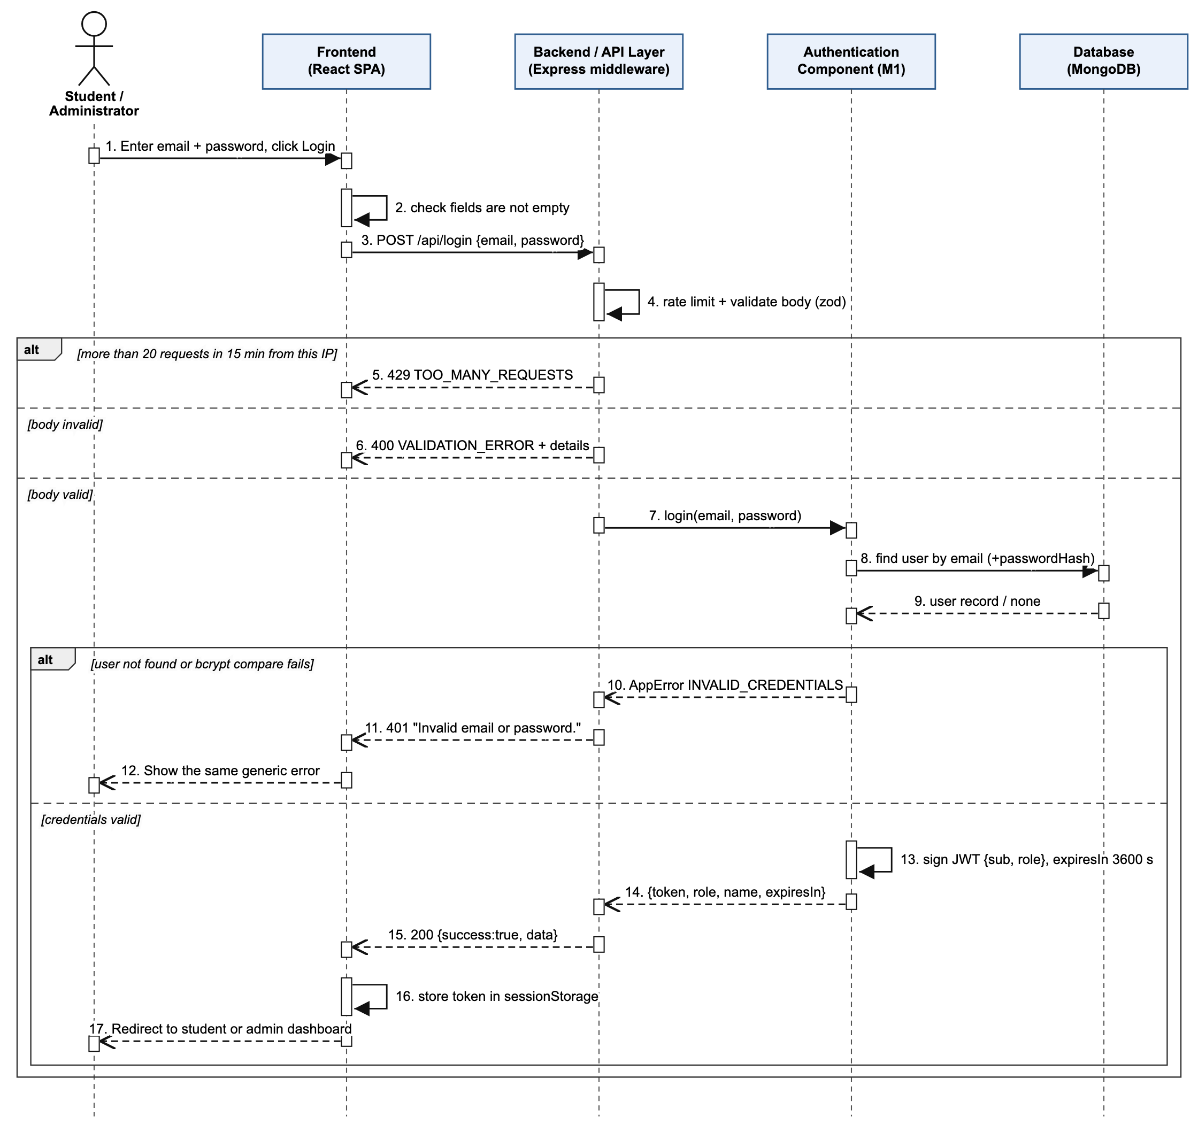
Figure 2: Sequence diagram SD-1 – User Login

SD-2: Internship Application (FR-06, FR-12, SR-01, SR-04)
Actors | Student
Precondition | The student is logged in and viewing the details of an internship
Postcondition | A single application with status “Submitted” exists for the student and internship, and an activity is recorded; duplicates and invalid applications are rejected with a clear message
Components | Frontend, Backend/API Layer (auth middleware), Application Management (M3), Progress Tracking (M5), Database

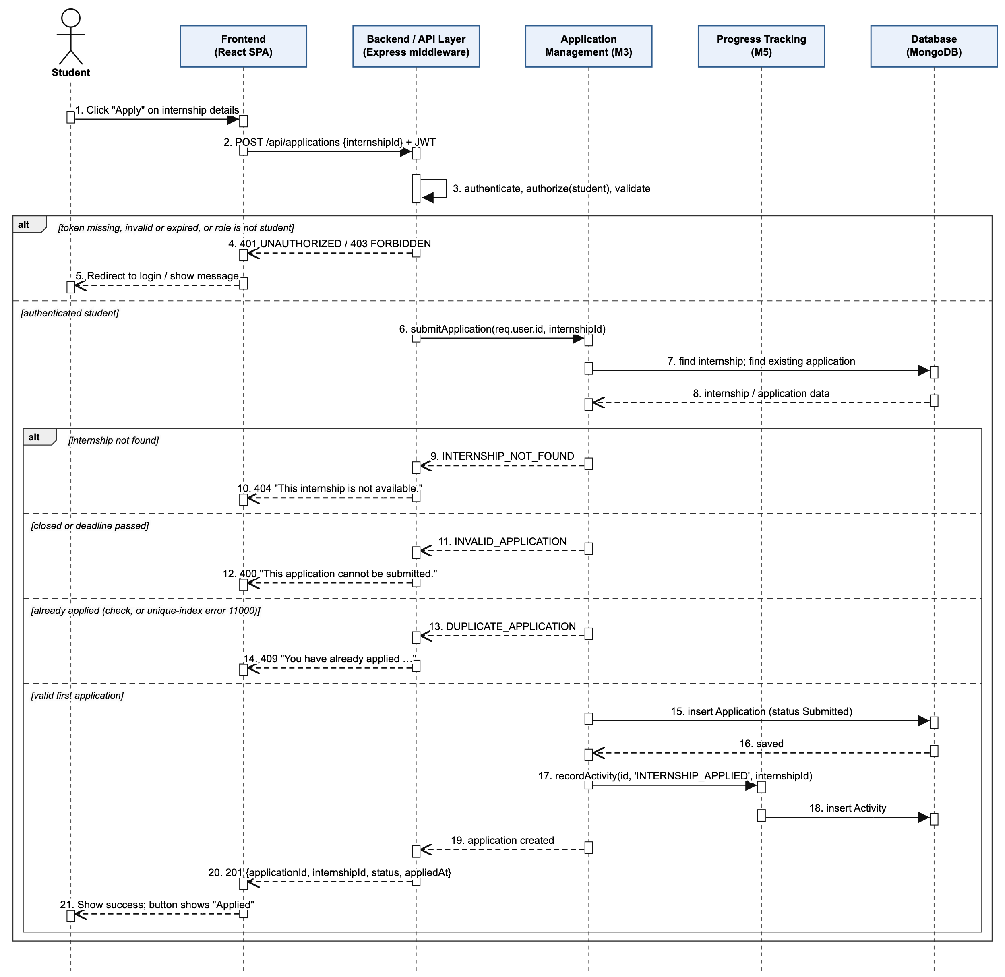
Figure 3: Sequence diagram SD-2 – Internship Application

SD-3: Aptitude Test Attempt and Evaluation (FR-09, FR-10, FR-11, FR-12)
Actors | Student
Precondition | The student is logged in and at least one aptitude test exists
Postcondition | The test is evaluated on the server, a result is stored and shown to the student, and a “test completed” activity is recorded; correct answers are never sent to the client
Components | Frontend, Backend/API Layer (auth middleware), Aptitude Test (M4), Progress Tracking (M5), Database

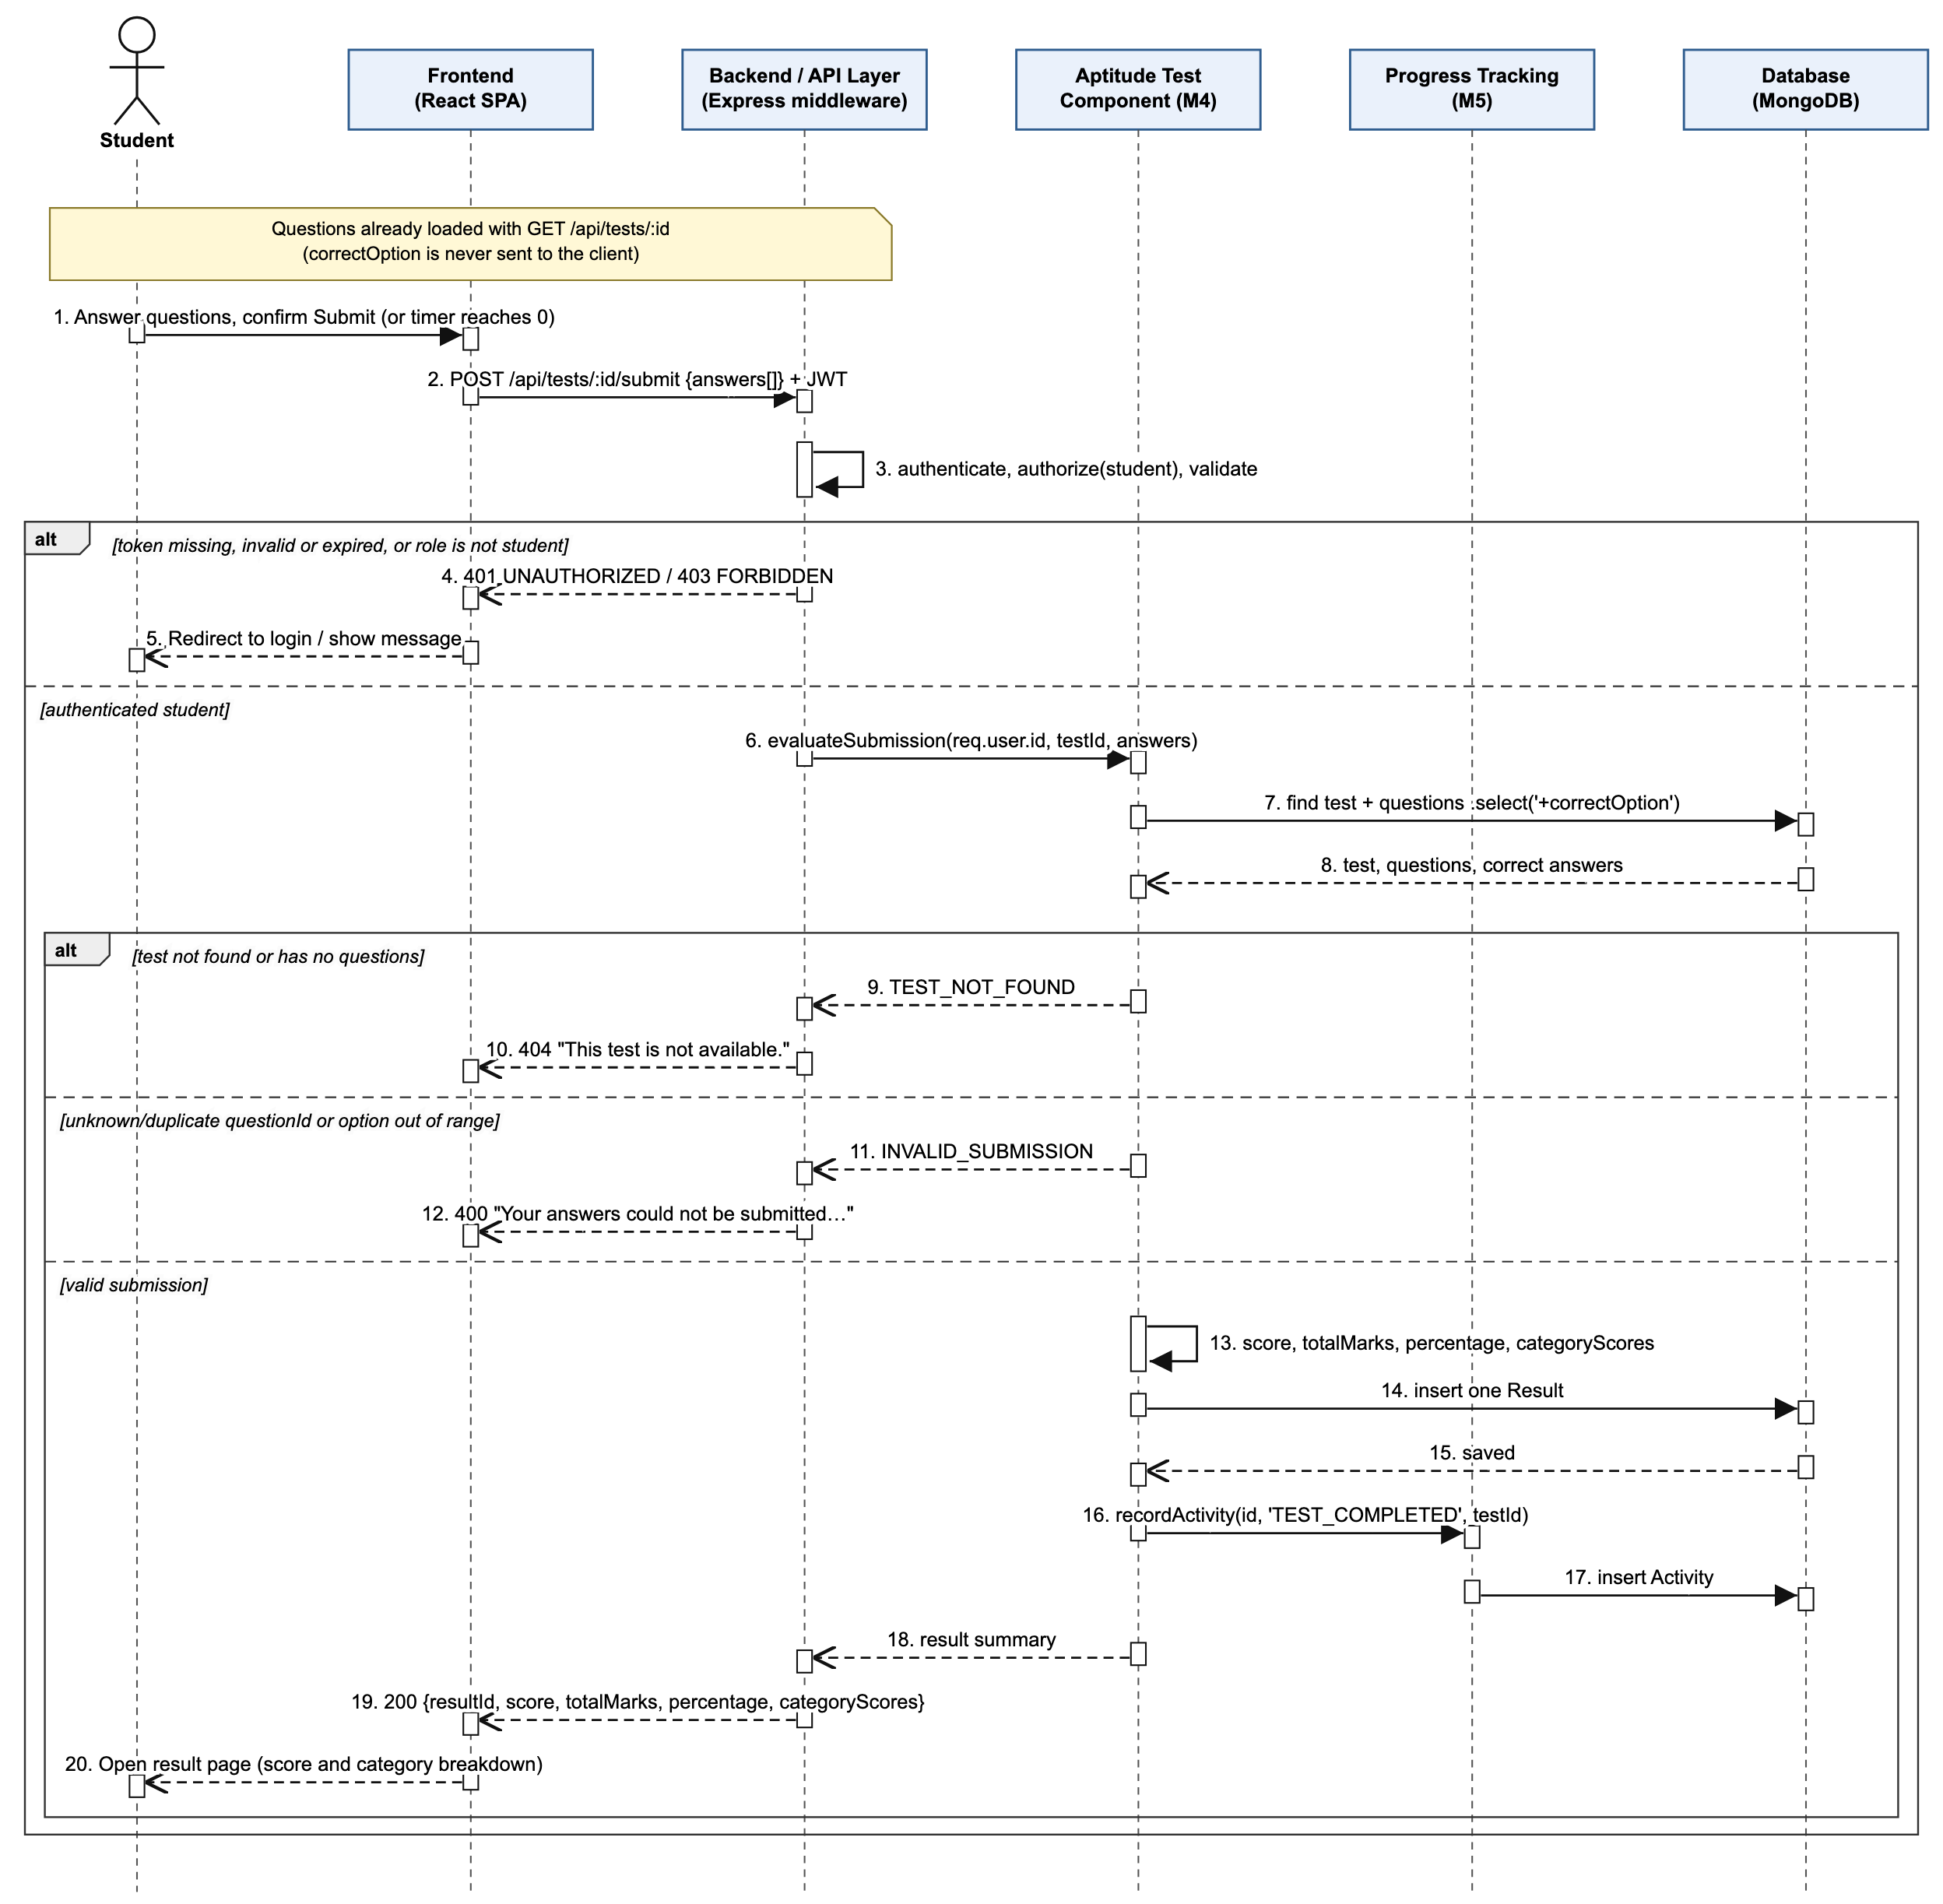
Figure 4: Sequence diagram SD-3 – Aptitude Test attempt and evaluation

4.3 API Design

4.3.1 Conventions
- Base path /api; JSON request and response bodies; HTTPS for a deployed instance (D-01).
- Protected endpoints require the header Authorization: Bearer <JWT>. The user id and role come from the verified token, never from the request body.
- Success responses use { "success": true, "data": … }; errors use the standard error format in 4.4.
- HTTP status codes: 200 OK, 201 Created, 400 Bad Request, 401 Unauthorized, 403 Forbidden, 404 Not Found, 409 Conflict, 429 Too Many Requests, 500 Internal Server Error.
- GET /api/internships supports page (default 1) and limit (default 10, maximum 50); the other lists are small per-student arrays.

4.3.2 Endpoint summary
Endpoints marked ✱ extend the original baseline table (needed for FR-09, FR-11, FR-15 and FR-16); they are recorded in the source-of-truth file and implemented (D-02). Endpoints marked ✱✱ were added during implementation (D-03, D-04). All 26 endpoints are implemented and tested.
Method | Endpoint | Purpose | Access | Requirement
POST | /api/register | Register student | Public | FR-01
POST | /api/login | Authenticate user | Public | FR-02
GET | /api/internships | List/search/filter internships | Authenticated | FR-03, FR-04
GET | /api/internships/meta ✱✱ | Category and location values for the filter dropdowns | Authenticated | FR-04
GET | /api/internships/:id | Internship details | Authenticated | FR-05
POST | /api/applications | Submit application | Student | FR-06
GET | /api/applications | Own applications | Student | FR-07
GET | /api/tests | Available tests | Student | FR-08
GET | /api/tests/:id ✱ | Test questions for an attempt | Student | FR-09
POST | /api/tests/:id/submit | Submit answers and evaluate | Student | FR-09, FR-10
GET | /api/results | Own results | Student | FR-11
GET | /api/results/:id ✱ | One own result | Student | FR-11
GET | /api/progress | Preparation progress | Student | FR-13
GET | /api/analysis | Performance analysis | Student | FR-14
POST | /api/admin/internships ✱ | Add internship | Admin | FR-15
PUT | /api/admin/internships/:id ✱ | Update internship | Admin | FR-15
DELETE | /api/admin/internships/:id ✱ | Remove internship | Admin | FR-15
GET | /api/admin/tests ✱✱ | All tests with question count | Admin | FR-16
GET | /api/admin/tests/:id ✱✱ | Test with all questions, including correctOption | Admin | FR-16
POST | /api/admin/tests ✱ | Create test | Admin | FR-16
PUT | /api/admin/tests/:id ✱ | Update test | Admin | FR-16
DELETE | /api/admin/tests/:id ✱ | Remove test | Admin | FR-16
POST | /api/admin/tests/:id/questions ✱ | Add question to test | Admin | FR-16
PUT | /api/admin/questions/:qid ✱ | Update question | Admin | FR-16
DELETE | /api/admin/questions/:qid ✱ | Remove question | Admin | FR-16
GET | /api/health ✱ | Health check for monitoring (returns status only) | Public | NFR-01

4.3.3 Interface definitions
Detailed interface definitions are given for five components: Authentication, Internship Management, Application Management, Aptitude Test and Performance Analysis, plus a representative administrative operation.
A. Authentication Component (M1) – Register
Endpoint | /api/register
Method | POST
Access | Public
Validation | name 2–80 characters; email valid format and unique (stored lower-case); password 8–72 characters; unknown fields are rejected. Role is always set to student by the server.
Errors | 400 VALIDATION_ERROR – missing/invalid fields (with details per field); 409 EMAIL_EXISTS – email already registered; 429 TOO_MANY_REQUESTS

Request body:
{ "name": "Asha K", "email": "asha@example.com", "password": "********" }
Success response:
201 Created
{ "success": true, "data": { "userId": "…", "name": "Asha K", "email": "asha@example.com", "role": "student" } }
A. Authentication Component (M1) – Login
Endpoint | /api/login
Method | POST
Access | Public
Behaviour | Compares the supplied password with the stored hash; returns a signed JWT containing user id and role, with an expiry time
Errors | 400 VALIDATION_ERROR – missing email or password; 401 INVALID_CREDENTIALS – “Invalid email or password” (same message for unknown email and wrong password); 429 TOO_MANY_REQUESTS – more than 20 attempts in 15 minutes

Request body:
{ "email": "asha@example.com", "password": "********" }
Success response:
200 OK
{ "success": true, "data": { "token": "<JWT>", "role": "student", "name": "Asha K", "expiresIn": 3600 } }
B. Internship Management Component (M2) – List / search / filter
Endpoint | /api/internships
Method | GET
Access | Authenticated (student or admin)
Query parameters | search (case-insensitive keyword in title or company), category (exact, case-insensitive), location (partial), page, limit – all optional. Students see only open internships; results are sorted by deadline
Errors | 401 UNAUTHORIZED – missing/invalid token; 400 VALIDATION_ERROR – invalid query parameter (for example limit above 50)

Success response:
200 OK
{ "success": true, "data": { "items": [ { "id": "…", "title": "…", "company": "…", "location": "…", "category": "…", "deadline": "2026-11-30", "status": "open" } ], "page": 1, "limit": 10, "total": 24 } }
B. Internship Management Component (M2) – Internship details
Endpoint | /api/internships/:id
Method | GET
Access | Authenticated
Errors | 400 INVALID_REQUEST – malformed id; 401 UNAUTHORIZED; 404 INTERNSHIP_NOT_FOUND (students also receive 404 for a closed internship)

Success response:
200 OK
{ "success": true, "data": { "id": "…", "title": "…", "company": "…", "location": "…", "category": "…", "description": "…", "deadline": "…", "status": "open", "hasApplied": false, "deadlinePassed": false } }
C. Application Management Component (M3) – Submit application
Endpoint | /api/applications
Method | POST
Access | Student
Behaviour | Checks that the internship exists and is open, rejects a second application by the same student, stores the application with status “Submitted” and records an activity (SD-2)
Errors | 400 INVALID_APPLICATION – malformed or unknown body fields (D-14), internship closed or deadline passed; 401 UNAUTHORIZED; 403 FORBIDDEN – caller is not a student; 404 INTERNSHIP_NOT_FOUND; 409 DUPLICATE_APPLICATION

Request body:
{ "internshipId": "…" }
Success response:
201 Created
{ "success": true, "data": { "applicationId": "…", "internshipId": "…", "status": "Submitted", "appliedAt": "2026-09-28T10:15:00Z" } }
C. Application Management Component (M3) – View own applications
Endpoint | /api/applications
Method | GET
Access | Student (own records only)
Errors | 401 UNAUTHORIZED; 403 FORBIDDEN

Success response:
200 OK
{ "success": true, "data": [ { "applicationId": "…", "internshipId": "…", "internshipTitle": "…", "company": "…", "location": "…", "status": "Submitted", "appliedAt": "…" } ] }
D. Aptitude Test Component (M4) – Get test for attempt
Endpoint | /api/tests/:id
Method | GET
Access | Student
Behaviour | Returns questions and options only; correct answers are never included
Errors | 401 UNAUTHORIZED; 403 FORBIDDEN – caller is not a student; 404 TEST_NOT_FOUND (also when the test has no questions)

Success response:
200 OK
{ "success": true, "data": { "id": "…", "title": "…", "category": "…", "description": "…", "durationMinutes": 30, "questions": [ { "id": "…", "text": "…", "options": ["A","B","C","D"], "category": "Quantitative", "marks": 1 } ] } }
D. Aptitude Test Component (M4) – Submit answers
Endpoint | /api/tests/:id/submit
Method | POST
Access | Student
Behaviour | Validates the submission, scores it on the server, stores the result, records a “test completed” activity (SD-3)
Errors | 400 INVALID_SUBMISSION – unknown or duplicate question id, malformed answers or option out of range; 401 UNAUTHORIZED; 403 FORBIDDEN; 404 TEST_NOT_FOUND – unknown test or test without questions

Request body:
{ "answers": [ { "questionId": "…", "selectedOption": 2 } ] }
Success response:
200 OK
{ "success": true, "data": { "resultId": "…", "testId": "…", "score": 8, "totalMarks": 10, "percentage": 80, "categoryScores": [ { "category": "Quantitative", "score": 4, "total": 5 } ] } }
D. Aptitude Test Component (M4) – Results
Endpoints | GET /api/results (list own results), GET /api/results/:id (one own result)
Access | Student (own records only)
Errors | 401 UNAUTHORIZED; 404 RESULT_NOT_FOUND (also returned when the result belongs to another student, to avoid disclosing its existence)

Success response:
200 OK
{ "success": true, "data": [ { "resultId": "…", "testId": "…", "testTitle": "…", "score": 8, "totalMarks": 10, "percentage": 80, "submittedAt": "…" } ] }
E. Performance Analysis Component (M6) – Get analysis
Endpoint | /api/analysis
Method | GET
Access | Student (own data only)
Behaviour | Computes analysis from the student’s stored results. If no results exist, returns attempts: 0 and a message instead of an error
Errors | 401 UNAUTHORIZED; 500 SERVER_ERROR

Success response:
200 OK
{ "success": true, "data": { "attempts": 3, "averagePercentage": 72, "bestPercentage": 80, "latestPercentage": 80, "categoryPerformance": [ { "category": "Quantitative", "correctMarks": 7, "totalMarks": 9, "accuracy": 78 } ], "strongestCategory": "Verbal", "weakestCategory": "Logical", "trend": [ { "date": "2026-09-10", "testTitle": "…", "percentage": 60 } ] } }
F. Progress Tracking Component (M5) – Get progress
Endpoint | /api/progress
Method | GET
Access | Student (own data only)
Errors | 401 UNAUTHORIZED; 500 SERVER_ERROR

Success response:
200 OK
{ "success": true, "data": { "testsAvailable": 8, "testsCompleted": 3, "totalAttempts": 5, "applicationsSubmitted": 2, "completionPercentage": 38, "recentActivities": [ { "type": "TEST_COMPLETED", "refId": "…", "label": "…", "at": "…" } ] } }
G. Admin Management Component (M7) – Add internship (representative)
Endpoint | /api/admin/internships
Method | POST
Access | Admin only
Behaviour | Validates and stores a new listing. PUT /api/admin/internships/:id and DELETE /api/admin/internships/:id follow the same access rule; DELETE also removes the internship’s applications (D-06); the test and question endpoints under /api/admin behave analogously. The deadline must be today or later
Errors | 400 VALIDATION_ERROR; 401 UNAUTHORIZED; 403 FORBIDDEN_ADMIN_ONLY – caller is not an admin; 404 INTERNSHIP_NOT_FOUND (update/delete); QUESTION_NOT_FOUND / TEST_NOT_FOUND for the test endpoints

Request body:
{ "title": "…", "company": "…", "location": "…", "category": "…", "description": "…", "deadline": "2026-11-30", "status": "open" }
Success response:
201 Created
{ "success": true, "data": { "id": "…", "title": "…", "status": "open" } }

4.4 Error Handling, Logging & Monitoring

4.4.1 Error handling strategy
Error occurs
-> Backend identifies/handles error (validation, service rule, or unexpected)
-> Appropriate HTTP status and standard error body returned
-> Frontend displays a clear, user-facing message
- Expected errors (validation, not found, duplicate, unauthorized) are raised by services with an error code; the central error handler maps them to HTTP status codes.
- Unexpected errors are logged in full on the server and returned to the user as a generic message; internal details, stack traces and database messages are never exposed.
- The frontend shows the message field to the user and uses code to decide behaviour (for example, redirect to login on UNAUTHORIZED).
Standard error format:
{ "success": false, "error": { "code": "DUPLICATE_APPLICATION", "message": "You have already applied for this internship." } }
For VALIDATION_ERROR the error also contains details: [ { "field": "email", "message": "…" } ]. The frontend shows each message under its form field (toFieldErrors in client/src/api/client.js); nested paths such as options.1 map to the top-level field.

4.4.2 Error catalogue
Covers every error case required by the project baseline plus four codes added during implementation (D-05). The central errorHandler maps AppError to its status, zod errors to 400 VALIDATION_ERROR, Mongoose CastError and malformed or oversized JSON to 400 INVALID_REQUEST, and anything else to 500 SERVER_ERROR (full stack logged only on the server).
Error case | HTTP | Code | User-facing message | Raised by
Invalid login credentials | 401 | INVALID_CREDENTIALS | Invalid email or password. | M1
Missing/invalid registration information | 400 | VALIDATION_ERROR | Please correct the highlighted fields. | M1
Email already registered | 409 | EMAIL_EXISTS | An account with this email already exists. | M1
Internship not found | 404 | INTERNSHIP_NOT_FOUND | This internship is not available. | M2, M3
Invalid internship application | 400 | INVALID_APPLICATION | This application cannot be submitted. | M3
Duplicate application | 409 | DUPLICATE_APPLICATION | You have already applied for this internship. | M3
Test not found | 404 | TEST_NOT_FOUND | This test is not available. | M4
Invalid test submission | 400 | INVALID_SUBMISSION | Your answers could not be submitted. Please try again. | M4
Result not found / not owned | 404 | RESULT_NOT_FOUND | Result not found. | M4
Unauthorized access (no/invalid token) | 401 | UNAUTHORIZED | Please log in to continue. | M1 middleware
Admin-only function accessed by a student | 403 | FORBIDDEN_ADMIN_ONLY | You do not have permission to perform this action. | M1 middleware
Invalid API request (malformed id/parameters/JSON) | 400 | INVALID_REQUEST | The request could not be understood. | API layer
Student-only function accessed by an admin | 403 | FORBIDDEN | You do not have permission to perform this action. | M1 middleware
Question not found (admin) | 404 | QUESTION_NOT_FOUND | This question does not exist. | M4 / M7
Unknown API route | 404 | NOT_FOUND | Resource not found. | API layer (notFound)
Too many login or registration attempts | 429 | TOO_MANY_REQUESTS | Too many attempts. Please wait and try again. | API layer (rate limiter)
Database/server failure | 500 | SERVER_ERROR | Something went wrong. Please try again later. | API layer

4.4.3 Logging
- What is logged: timestamp, request id, method, path, status code, duration, user id (identifier only), error code, and full stack trace for 5xx errors (server logs only).
- Never logged: passwords, password hashes, JWTs, correct answers or other sensitive information.
- Levels: info for normal requests, warn for rejected requests (401, 403, 409, failed logins), error for 5xx and unexpected failures.
- Security-relevant events (failed logins, admin actions, access-denied) are logged to support repudiation handling (3.9.3); admin create, update and delete actions are logged at info level with the admin’s user id.

4.4.4 Monitoring
Metric | Purpose
Response time per endpoint (p95) | Verify the response-time target of NFR-01 (G4)
Error rate (4xx / 5xx) | Detect failing components and abuse; supports operational monitoring.
Failed login count per period | Detect brute-force attempts (SO-02)
Database connectivity via /api/health | Detect outages early; the endpoint returns only { status: "ok", db: "up" | "down" }
Test submission failure rate | Detect problems in the most critical write path (SD-3)

4.5 UX Design
The UI is a role-based single-page application. After login, students land on a dashboard with five cards linking directly to Internships, My Applications, Aptitude Tests, Progress and Analysis (NFR-05); administrators land on an admin dashboard with Manage Internships and Manage Tests.
Screen | Actor | API used | Requirement
Register / Login | All | /api/register, /api/login | FR-01, FR-02
Student Dashboard | Student | /api/progress (summary) | NFR-05
Internship list with search and filters | Student | GET /api/internships | FR-03, FR-04
Internship details with Apply button | Student | GET /api/internships/:id, POST /api/applications | FR-05, FR-06
My Applications | Student | GET /api/applications | FR-07
Test list | Student | GET /api/tests | FR-08
Take test and submit | Student | GET /api/tests/:id, POST /api/tests/:id/submit | FR-09
Result and score | Student | GET /api/results, /api/results/:id | FR-10, FR-11
Progress | Student | GET /api/progress | FR-13
Performance Analysis | Student | GET /api/analysis | FR-14
Admin Dashboard, Manage Internships, Manage Tests and Questions | Admin | /api/admin/… | FR-15, FR-16

UX principles applied
- Clear navigation (NFR-05): the student navigation bar always shows Dashboard, Internships, My Applications, Aptitude Tests, Results, Progress, Analysis and Logout; the admin bar shows Admin Dashboard, Manage Internships, Manage Tests and Logout.
- Clear feedback: success and error messages from the API are shown near the action, and validation messages appear under each form field; every data screen also has an empty state; loading indicators for requests; confirmation before deleting internships, tests or questions.
- Accessibility: readable font sizes and contrast, labelled form fields, keyboard-operable controls, and no information conveyed by colour alone.
- Responsive layout for common desktop and mobile browser widths as a design consideration.
- Test-taking: one question at a time, a progress indicator, a countdown timer that submits automatically at zero, and a confirmation step before final submission. Analysis uses a line chart for the trend and a bar chart for category accuracy (recharts).

4.6 Resolved Issues & Next Steps
These items correspond to the “must be finalized by the team” list of the baseline. All of them were decided during implementation (Sprints 1–3); the table records the decision and no issue remains open.
Open issue | Decision as implemented | Status
Exact technology stack and versions | Node.js 22, Express 4.21, Mongoose 8, MongoDB 7, React 18, Vite 5 (3.6) | Closed
Measurable response-time target (NFR-01) | 95% of requests within 3 seconds; measured with server/scripts/perf-test.js (250 requests, 10 at a time) – met | Closed
Supported browsers (design consideration) | Current Chrome, Edge and Firefox; layout checked at 360 px and 1440 px | Closed
Authentication implementation | JWT (1 hour, payload {sub, role}) with bcryptjs (10 rounds); token kept in sessionStorage (ADR-04, ADR-05) | Closed
Student-visible application status | Only “Submitted” is used | Closed
Performance-analysis metrics | Average, best, latest, per-category accuracy, strongest/weakest category, trend of the last 20 results | Closed
Exact admin capabilities | Add/update/remove internships, tests and questions (FR-15, FR-16); deleting an internship removes its applications (D-06); no application review | Closed
Use of Python | Not used; analysis is inside the Node.js backend (ADR-07) | Closed
Final endpoint names and extra endpoints (✱) | As in 4.3.2, including three endpoints added during implementation (D-03, D-04) | Closed
Database schema | As in 3.6.1 (Mongoose models in server/src/models) | Closed

Next steps
- Keep this document, SRS v1.1 and Software Test Plan v3.1 consistent; record any further code change in docs/DEVIATIONS.md first and then update the affected document.
- Re-run the NFR-01 response-time test on a deployed HTTPS instance (D-01).
Future enhancements (out of current scope): application status workflow reviewed by admins, email notifications, internship recommendations based on test performance, password reset.

5. Appendices

5.1 Glossary
Term | Definition
Internship listing | An internship opportunity posted by an administrator, with title, company, location, category, description, deadline and status
Application | A student’s request for a specific internship; unique per student and internship
Aptitude test | A set of multiple-choice questions used for preparation
Result | The stored outcome of one test attempt: score, total marks and category scores
Activity | A recorded preparation event (test completed, internship applied) used for progress tracking
Progress | Summary of a student’s completed tests, applications and recent activities
Performance analysis | Derived information (averages, per-category accuracy, trend) computed from a student’s results
Category score | Score obtained within one question category, such as quantitative or verbal
Baseline / source of truth | The team file that defines scope, requirement IDs and decisions; changed first before any document
Modular monolith | A single deployable application internally divided into independent modules
ADR, API, JWT, RBAC, REST, STRIDE, TLS | See Section 1.4

5.2 References
- ISO/IEC/IEEE 42010:2011, Systems and software engineering – Architecture description (IEEE 42010).
- IEEE 1016-2009, Software Design Descriptions.
- ISO/IEC/IEEE 29148, Requirements engineering (SRS structure and requirement quality).
- OWASP Top 10 and OWASP Application Security Verification Standard (ASVS).
- NIST SP 800-160, Systems Security Engineering.
- RFC 7519, JSON Web Token (JWT); RFC 9110, HTTP Semantics.
- OMG Unified Modeling Language (UML) Specification 2.5.1.
- Project documents: Team Source-of-Truth baseline; SRS v1.1; Software Test Plan v3.1; docs/DEVIATIONS.md; test reports in docs/reports/.

5.3 Tools
- Diagram generation: Figures 1–4 (v1.3) drawn as SVG in UML 2.5 notation and exported to PNG; editable equivalents can be redrawn in PlantUML or draw.io using them as the reference.
- API documentation and testing: Postman collection docs/api/OIPP.postman_collection.json (run with Newman) based on Section 4.3.
- Document authoring: Microsoft Word; version control for source and documents.

