Software Requirements Specification (SRS)
Online Internship and Placement Preparation Portal (OIPP)
Field | Value
Project | Online Internship and Placement Preparation Portal
Version | 1.1
Authors | Team T1: Namitha R, Manu Kudukundi, Kavana P G, Koushik
Date | 12-11-2026
Status | Academic Mini-Project. Revised after the Part-3 review; submitted for approval

Revision history
Version | Date | Author | Change summary | Approval
1.0 | 28-09-2026 | Team T1 | SRS with diagrams embedded (Deliverable-1). | Submitted
1.1 | 12-11-2026 | Team T1 | IEEE 830 introduction sub-sections (1.1–1.5) and references added; FRs grouped under the correct feature sections; NFR-01 test load defined and its test reference corrected; use case diagram updated (Administrator → Login); template text and placeholders removed; RTM statuses updated after testing. | Pending (see Approvals)

Approvals
Role | Name | Signature / Email | Date
Course Coordinator / Faculty Reviewer | Prof Vadiraja
SRS and Requirements Lead | Namitha R

Revision history
Approvals
1. Introduction
1.1 Purpose
1.2 Scope
1.3 Definitions, acronyms and abbreviations
1.4 References
1.5 Overview
2. Overall description
2.1 Product perspective
2.2 Product functions
2.3 User classes and characteristics
2.4 Operating environment
2.5 Design and implementation constraints
2.6 Assumptions and dependencies
3. External interface requirements
3.1 User interfaces
3.2 Hardware interfaces
3.3 Software interfaces
3.4 Communications interfaces
4. System features (detailed)
4.1 Authentication and Access Control
4.2 Internship and Application Management
4.3 Aptitude Tests, Progress and Performance
4.4 Administrator Management
4.5 Requirement Verification
5. Non-functional requirements (detailed)
5.1 Security
6. Quality attributes & Acceptance tests
7. UML Use-Case Diagram
7.1 UML Use-Case diagram
8. Requirements Traceability Matrix (RTM)

1. Introduction

1.1 Purpose
This document is the Software Requirements Specification (SRS) for the Online Internship and Placement Preparation Portal. It defines the functional, non-functional, interface, security, and verification requirements used as the baseline for development and testing.
Intended audience: developers, QA/testers, project team members, instructors, and assessment evaluators.

1.2 Scope
The portal covers student registration and login, internship discovery and applications, aptitude tests, result viewing, preparation progress, performance analysis, and administrator management of internships and aptitude tests/questions. It excludes actual company interviews, guaranteed internship or placement selection, automatic hiring decisions, and recruiter/company access unless separately approved.

1.3 Definitions, acronyms and abbreviations
Term | Meaning
SRS | Software Requirements Specification
FR | Functional Requirement
NFR | Non-Functional Requirement
SO / SR | Security Objective / Security Requirement
RTM | Requirements Traceability Matrix
UI | User Interface
API | Application Programming Interface
UML | Unified Modeling Language
MERN | MongoDB, Express.js, React, Node.js

1.4 References
- IEEE Std 830-1998, IEEE Recommended Practice for Software Requirements Specifications.
- Online Internship and Placement Portal Source of Truth (team baseline).
- Software Architecture and Design Specification (SAD) v1.2.
- Software Test Plan and Test Case Document v3.1 (OIPP-STP-003).
- Software Engineering Mini-Project Deliverables, Part-1 to Part-3.

1.5 Overview
Section 2 describes the product, its users, environment and constraints. Section 3 gives the external interfaces. Section 4 lists the functional requirements by feature and Section 5 the non-functional and security requirements. Section 6 gives the acceptance criteria, Section 7 the UML use case diagram and Section 8 the traceability matrix.
The project baseline requires at least 15 functional requirements, 5 non-functional requirements, 2 security objectives and 5 security requirements. This SRS defines 16 FRs (FR-01 to FR-16), 5 NFRs (NFR-01 to NFR-05), 2 security objectives (SO-01, SO-02) and 5 security requirements (SR-01 to SR-05).

2. Overall description

2.1 Product perspective
The portal is a web-based application using the MERN technology baseline. React provides the presentation layer, Node.js and Express.js provide the application/API layer, and MongoDB provides persistent storage.

2.2 Product functions
- Student registration and login
- Internship listing, search/filter, details, and applications
- Aptitude-test access, submission, scoring, and result viewing
- Preparation progress tracking and performance analysis
- Administrator management of internship listings and aptitude tests/questions

2.3 User classes and characteristics
- Student: basic web-browser knowledge; uses internships, applications, aptitude tests, results, progress, and performance analysis.
- Administrator: authorized user who maintains internship and aptitude-test information.

2.4 Operating environment
Web browser, network connectivity, React frontend, Node.js/Express.js backend, and MongoDB database.

2.5 Design and implementation constraints
The system shall be a web application using the MERN baseline. Protected information requires authentication and authorization. Normal operation requires network connectivity. Development is subject to the academic project schedule.

2.6 Assumptions and dependencies
- Administrator accounts are created by the project team (seed data), not through public registration.
- A MongoDB database (local or hosted) is available to the backend.
- Users have a modern web browser and network access to the deployed portal.

3. External interface requirements

3.1 User interfaces
Registration and login; internship listing/search/filter/details; internship application; aptitude-test question and submission; results, progress and performance analysis; administrator management; clear error messages without sensitive internal details.

3.2 Hardware interfaces
No dedicated hardware interface is required. Users access the portal through standard computing devices and web browsers.

3.3 Software interfaces
The React frontend shall communicate with the Node.js/Express.js backend through APIs. The backend shall communicate with MongoDB for persistent storage.

3.4 Communications interfaces
The web client shall communicate with backend APIs using HTTP/HTTPS. The deployed system shall use HTTPS for protected communication.

4. System features (detailed)
Each requirement below includes acceptance criteria and a reference test case. IDs follow the project FR-## format.

4.1 Authentication and Access Control
Description: Provide student registration and authenticated access for students and administrators; restrict administrator-only functions to authorized administrators.
Req ID | Requirement (shall...) | Type | Priority | Source / Stakeholder | Acceptance criteria / Test case ref | Comments / Dependencies
FR-01 | The system shall allow a new student to register for an account using the required registration information. | Functional | High | Student | Valid registration data creates a student account. Test: TC-AUTH-01 | Requires registration information.
FR-02 | The system shall allow a registered student or administrator to log in using valid credentials. | Functional | High | Student / Administrator | Valid credentials create an authenticated session. Test: TC-AUTH-02 | Protected functions depend on authentication.

4.2 Internship and Application Management
Description: Provide internship discovery, search/filter, details, application submission, and application viewing for students.
Req ID | Requirement (shall...) | Type | Priority | Source / Stakeholder | Acceptance criteria / Test case ref | Comments / Dependencies
FR-03 | The system shall display available internship listings to authenticated students. | Functional | High | Student | Available listings are displayed. Test: TC-INT-01 | Depends on internship listing data.
FR-04 | The system shall allow students to search and filter internship listings using supported criteria. | Functional | High | Student | A supported criterion returns matching listings. Test: TC-INT-02 | Depends on internship listing data.
FR-05 | The system shall display the details of a selected internship. | Functional | Medium | Student | Selecting a listing displays its stored details. Test: TC-INT-03 | Depends on selected internship.
FR-06 | The system shall allow an authenticated student to submit an application for an available internship. | Functional | High | Student | A valid application is stored against the student and internship. Test: TC-APP-01 | Requires authenticated student.
FR-07 | The system shall allow an authenticated student to view their submitted internship applications. | Functional | High | Student | The student sees only their submitted applications. Test: TC-APP-02 | Requires authorization.

4.3 Aptitude Tests, Progress and Performance
Description: Provide available aptitude tests, test submission and evaluation, result viewing, progress recording and display, and performance analysis based on recorded results.
Req ID | Requirement (shall...) | Type | Priority | Source / Stakeholder | Acceptance criteria / Test case ref | Comments / Dependencies
FR-08 | The system shall display aptitude tests available to students. | Functional | High | Student | Available tests are listed. Test: TC-TEST-01 | Depends on stored tests.
FR-09 | The system shall allow a student to start, answer, and submit an available aptitude test. | Functional | High | Student | Answers can be submitted and the attempt is recorded. Test: TC-TEST-02 | Requires available test.
FR-10 | The system shall calculate the student's aptitude-test score using the defined evaluation rules after submission. | Functional | High | Student | Calculated score follows the defined answer-evaluation rules. Test: TC-TEST-03 | Depends on correct-answer rules.
FR-11 | The system shall allow a student to view the result of a completed aptitude test. | Functional | High | Student | Completed test result is displayed. Test: TC-TEST-04 | Requires stored result.
FR-12 | The system shall record completed aptitude-test activity and other defined preparation activities for progress tracking. | Functional | Medium | Student | Completed activities are stored with the student record. Test: TC-PROG-01 | Requires activity records.
FR-13 | The system shall display a student's recorded preparation progress. | Functional | Medium | Student | Recorded progress is displayed to the authenticated student. Test: TC-PROG-02 | Depends on recorded activities.
FR-14 | The system shall provide performance analysis based on the student's recorded aptitude-test results. | Functional | Medium | Student | Analysis is derived from stored test results. Test: TC-PERF-01 | Depends on stored results.

4.4 Administrator Management
Description: Authorized administrators maintain internship listings and create, update, and remove aptitude tests and questions.
Req ID | Requirement (shall...) | Type | Priority | Source / Stakeholder | Acceptance criteria / Test case ref | Comments / Dependencies
FR-15 | The system shall allow an authorized administrator to add, update, and remove internship listings. | Functional | High | Administrator | Authorized changes are persisted; unauthorized users are denied. Test: TC-ADM-01 | Requires administrator authorization.
FR-16 | The system shall allow an authorized administrator to create, update, and remove aptitude tests and questions. | Functional | High | Administrator | Authorized changes are persisted; unauthorized users are denied. Test: TC-ADM-02 | Requires administrator authorization.

4.5 Requirement Verification
Requirements are verified through the acceptance criteria and test-case references in the tables above. All high-priority requirements shall be implemented and tested.

5. Non-functional requirements (detailed)
NFRs below are measurable and tied to test cases. IDs follow the project NFR-## format.
Req ID | Requirement | Category | Priority | Acceptance criteria / Measurement
NFR-01 | For normal portal operations under the expected test load, defined as 250 requests sent 10 at a time (about 10 concurrent users) to the main portal functions against a seeded database, the system shall return a successful response within 3 seconds for at least 95% of measured requests. | Performance | High | ≥95% of measured requests ≤3 seconds, with no errors, measured with the project performance script. Test: NFR-01 (response time)
NFR-02 | The system shall require authentication before access to student-specific applications, test results, progress, or performance information. | Security | High | Unauthenticated access is denied. Test: TC-SEC-01
NFR-03 | The system shall deny administrator functions to authenticated users without administrator authorization. | Security | High | Student account cannot access administrator functions. Test: TC-SEC-02
NFR-04 | The system shall keep application and test-result records associated with the correct student and internship/test. | Data Integrity | High | Record ownership and association remain correct. Test: TC-DATA-01
NFR-05 | The system shall provide direct navigation from the student dashboard to internships, applications, aptitude tests, progress, and performance analysis. | Usability | Medium | All listed destinations are directly reachable. Test: TC-UX-01

5.1 Security
5.1.1 Security Objectives
- SO-01: Protect student account, application, test-result, progress, and performance information from unauthorized access.
- SO-02: Ensure only authenticated and authorized users can access protected student and administrative functions.
5.1.2 Security Requirements
Req ID | Requirement (shall...) | Type | Priority | Acceptance criteria / Test case ref
SR-01 | The system shall require authentication before protected student-specific information is accessed. | Security | High | Unauthenticated access is rejected. Test: TC-SEC-01
SR-02 | The system shall restrict administrative functions to authorized administrator accounts. | Security | High | Student account is denied administrator functions. Test: TC-SEC-02
SR-03 | The system shall not store user passwords in plain text. | Security | High | Stored password representation is not plain text. Test: TC-SEC-03
SR-04 | The system shall prevent a student from accessing another student's application, test-result, progress, or performance information through normal application functions. | Security | High | Cross-student access is rejected. Test: TC-SEC-04
SR-05 | The system shall validate authorization on protected backend/API operations, not only through frontend controls. | Security | High | Direct unauthorized API request is rejected. Test: TC-SEC-05

6. Quality attributes & Acceptance tests
- Exit criteria for acceptance: all high-priority functional requirements are implemented and verified, no critical NFR failures occur, and the RTM contains the corresponding test references.
- Acceptance test suites: authentication, internship/application, aptitude test, progress/performance, performance, security, and usability tests.

7. UML Use-Case Diagram

7.1 UML Use-Case diagram
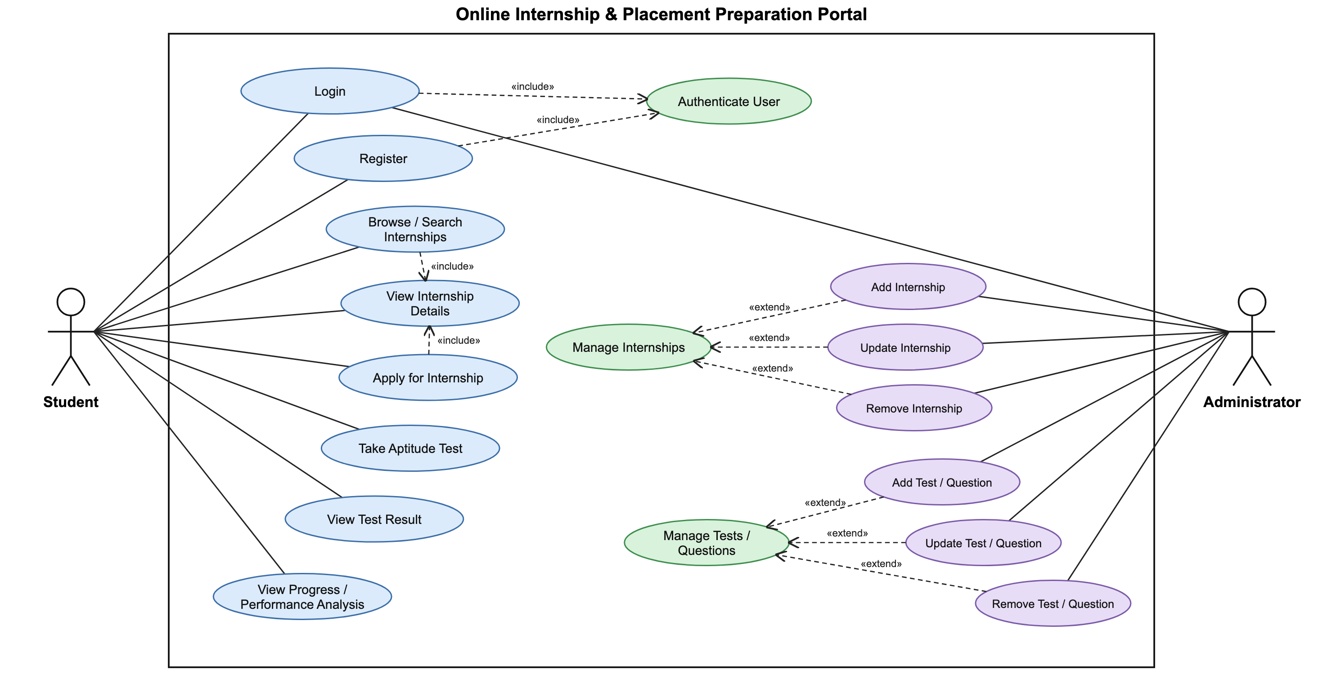
Figure 1: Student and Administrator use cases for the Online Internship and Placement Preparation Portal.
Actors. Student and Administrator. Both log in (FR-02); only students register (FR-01).
Relationships. Register and Login «include» Authenticate User. Browse/Search Internships and Apply for Internship «include» View Internship Details. Add, Update and Remove Internship «extend» Manage Internships; Add, Update and Remove Test/Question «extend» Manage Tests/Questions.

8. Requirements Traceability Matrix (RTM)
Status: N = not yet tested, P = passed, A = accepted by the reviewer. Statuses reflect the test execution of 06-11-2026 (Software Test Plan v3.1 and the System Validation Report).
Req ID | Requirement short | Section ref / Design spec | Module | Test case(s) | Status (N/P/A) | Comments
FR-01 | Register student | 4.1 / Authentication | Authentication | TC-AUTH-01 | P
FR-02 | Login | 4.1 / Authentication | Authentication | TC-AUTH-02 | P
FR-03/04/05 | Internship discovery/details | 4.2 / Internship | Internship Module | TC-INT-01/02/03 | P
FR-06/07 | Applications | 4.2 / Application | Application Module | TC-APP-01/02 | P
FR-08/09/10/11 | Aptitude tests/results | 4.3 / Aptitude | Test Module | TC-TEST-01/02/03/04 | P
FR-12/13 | Progress | 4.3 / Progress | Progress Module | TC-PROG-01/02 | P
FR-14 | Performance analysis | 4.3 / Performance | Analysis Module | TC-PERF-01 | P
FR-15 | Manage internships | 4.4 / Administration | Admin Module | TC-ADM-01 | P | Defect S3-D1 found and fixed
FR-16 | Manage tests/questions | 4.4 / Administration | Admin Module | TC-ADM-02 | P | Defect S3-D1 found and fixed
NFR-01 | Response time target | 5 / Performance | WebUI / API | NFR-01 (response time) | P | 100% within 3 s
NFR-02/03 | Access control | 5 / Security | Auth/Authorization | TC-SEC-01/02 | P
NFR-04 | Data integrity | 5 / Data Integrity | Database/API | TC-DATA-01 | P
NFR-05 | Dashboard navigation | 5 / Usability | Frontend | TC-UX-01 | P
SR-01..05 | Security controls | 5.1.2 / Security | Auth/Authorization | TC-SEC-01..05 | P

