System Validation Report
Online Internship and Placement Preparation Portal (OIPP)
Mini-Project Deliverables Part-3, item 2(b)(ii).
Item | Value
Report identifier | OIPP-SVR-001
Test plan | OIPP-STP-003, Software Test Plan and Test Case Document v3.1
Build tested | main at commit 569fa35 plus the Sprint-3 tests (S3-03); application code unchanged since a63dc42
Date executed | 06-11-2026
Prepared by | Team T1
Status | Final

1. Summary
2. Test Environment
3. Approach
4. Results by Test Case
5. Detailed Results
TC-AUTH-01
TC-AUTH-02
TC-INT-01
TC-INT-02
TC-INT-03
TC-APP-01
TC-APP-02
TC-TEST-01
TC-TEST-02
TC-TEST-03
TC-TEST-04
TC-PROG-01
TC-PROG-02
TC-PERF-01
TC-ADM-01
TC-ADM-02
TC-SEC-01
TC-SEC-02
TC-SEC-03
TC-SEC-04
TC-SEC-05
TC-DATA-01
TC-UX-01
6. NFR-01 Response Time
7. API System Test (Postman / Newman)
8. Defects and Observations
8.1 Defect S3-D1 (open, medium)
8.2 Observations
9. Variances from the Test Plan
10. Conclusion
Approvals
Appendix A. Screenshots

1. Summary
The complete system was validated against Test Plan v3.1 on 06-11-2026: the React client, the Express API and a real standalone MongoDB 7 database, seeded with the project seed script. Each test case was executed by following its numbered Test Steps in Google Chrome and checking each Expected Result in the user interface, the API response and the database.
Activity | Result
Test cases executed | 24 of 24 (23 functional/security/usability cases in Chrome, plus NFR-01)
Test case results | 22 pass; TC-ADM-01 and TC-ADM-02 fail on one expected result each (defect S3-D1)
Validation checks | 84 checks: 81 passed, 2 failed, 1 observation
Postman collection (Newman) | 36 of 36 requests and 47 of 47 assertions passed
NFR-01 response time | 250 requests, 100% within 3 s, p95 163.03 ms, 0 errors
Security validation (Test Plan §5.1) | 6 of 6 checks passed
Pending steps from the Test Plan | TC-TEST-02 steps 7–8 (timer auto-submit, leave-page warning) executed and passed
Defects found | 1 open: S3-D1 (medium). The four earlier defects stay fixed
Observations | 2 (Section 8): one Test Plan correction (applied in v3.1), one low-priority usability note

Conclusion: the system meets the SRS requirements covered by the Test Plan, with one open medium defect: the admin forms do not show validation messages under each field (S3-D1). Invalid admin input is still rejected, so data and security are not affected. No critical or high defect is open, so the Test Plan exit criteria are met; S3-D1 should be fixed before the final demonstration.

2. Test Environment
Item | Value
Build | main at commit 569fa35 plus the Sprint-3 tests (S3-03); application code unchanged since a63dc42
API server | node src/server.js, NODE_ENV=development (rate limiter active), port 5000
Client | Vite dev server on http://localhost:5173, proxying /api to port 5000
Database | MongoDB 7.0.25 Community Server, standalone (no replica set), port 27018, isolated database oipp_sysval; seeded with npm run seed before each phase
Browser | Google Chrome (headless) at 1440 × 900 and 360 × 800
Execution | Steps driven through Chrome with Playwright 1.48 so the run is repeatable; API checks with HTTP requests; database checks with mongosh
API tool | Newman 6.2.1 with docs/api/OIPP.postman_collection.json
Accounts | Seeded: admin@oipp.test, ravi@oipp.test, asha@oipp.test, meera@oipp.test; new students registered during the run

3. Approach
- For each test case, the numbered steps in Test Plan §13.3 were followed in order, using the listed Test Parameters.
- Each Expected Result was checked where it is visible: on screen (text, redirects, dialogs, charts), in the API response (status, error code, fields) and, for data rules, directly in MongoDB.
- A screenshot was saved for the key screen of each test case (Appendix A; all 44 in docs/reports/evidence/screens).
- Login and register share a limit of 20 requests per 15 minutes per IP. The run was split into phases with a server restart between them so the limit did not affect other test cases; the limit itself was tested last, on a fresh server (TC-SEC-05).
- Testing used a standalone MongoDB, unlike the automated tests, to confirm behaviour on the database the team runs locally.

4. Results by Test Case
Test case | Requirement | Checks | Passed | Result | Evidence
TC-AUTH-01 | FR-01 | 7 | 7 | Pass | 4 screenshot(s)
TC-AUTH-02 | FR-02, NFR-02 | 8 | 8 | Pass | 4 screenshot(s)
TC-INT-01 | FR-03 | 2 | 2 | Pass | 1 screenshot(s)
TC-INT-02 | FR-04 | 4 | 4 | Pass | 2 screenshot(s)
TC-INT-03 | FR-05 | 4 | 4 | Pass | 3 screenshot(s)
TC-APP-01 | FR-06, FR-12, NFR-04 | 2 | 2 | Pass | 1 screenshot(s)
TC-APP-02 | FR-07 | 3 | 2 | Pass (1 observation) | 2 screenshot(s)
TC-TEST-01 | FR-08 | 3 | 3 | Pass | 1 screenshot(s)
TC-TEST-02 | FR-09 | 6 | 6 | Pass | 4 screenshot(s)
TC-TEST-03 | FR-10, FR-12, NFR-04 | 3 | 3 | Pass | API / database
TC-TEST-04 | FR-11, SR-04 | 4 | 4 | Pass | 3 screenshot(s)
TC-PROG-01 | FR-12 | 2 | 2 | Pass | 1 screenshot(s)
TC-PROG-02 | FR-13, SR-04 | 5 | 5 | Pass | 2 screenshot(s)
TC-PERF-01 | FR-14 | 5 | 5 | Pass | 3 screenshot(s)
TC-ADM-01 | FR-15, NFR-03 | 5 | 4 | Fail (S3-D1) | 4 screenshot(s)
TC-ADM-02 | FR-16, NFR-03 | 6 | 5 | Fail (S3-D1) | 3 screenshot(s)
TC-SEC-01 | SR-01, NFR-02 | 2 | 2 | Pass | API / database
TC-SEC-02 | SR-02, NFR-03 | 3 | 3 | Pass | API / database
TC-SEC-03 | SR-03 | 1 | 1 | Pass | API / database
TC-SEC-04 | SR-04 | 1 | 1 | Pass | API / database
TC-SEC-05 | SR-05 | 3 | 3 | Pass | API / database
TC-DATA-01 | NFR-04 | 1 | 1 | Pass | API / database
TC-UX-01 | NFR-05 | 4 | 4 | Pass | 4 screenshot(s)
NFR-01 | NFR-01 | 1 | 1 | Pass | Section 6

5. Detailed Results
Each row is one check, in the order executed. "Step" refers to the numbered Test Steps of the test case in Test Plan §13.3.

TC-AUTH-01
Step | Expected | Actual | Status
Steps 1-3: register with valid details | Account created; redirected to /login with a success message | Redirected to /login; alert "Registration successful! Please sign in with your credentials."; stored { email: 'sv.student.1793979979420@oipp.test', role: 'student' } | Pass
Step 4: submit the empty form | A message under each field; no request sent | Full Name: "Full name is required"; Email: "Email address is required"; Password: "Password is required (min 8 characters)" | Pass
Step 4: password "short" (under 8 characters) | Message under Password; no request sent | Password: "Password must be at least 8 characters" | Pass
Step 4: name "A" and email "abc" (checked by the server) | 400 VALIDATION_ERROR shown under Full Name and Email | Full Name: "Name must be at least 2 characters."; Email: "A valid email address is required."; still on /register | Pass
Step 4 (API): name "A", email "abc", 7- and 73-character passwords | 400 VALIDATION_ERROR with field details | 400 VALIDATION_ERROR [name]; 400 VALIDATION_ERROR [email]; 400 VALIDATION_ERROR [password]; 400 VALIDATION_ERROR [password] | Pass
Step 5: register the same email in different case | 409 EMAIL_EXISTS shown | Message "An account with this email already exists." shown | Pass
Step 6: POST /register with role "admin" | Rejected or created as student; never admin | 400 VALIDATION_ERROR; admin users with that email: 0 | Pass

TC-AUTH-02
Step | Expected | Actual | Status
Steps 1-2: student login | Lands on /dashboard; session stored in sessionStorage (oipp_auth) | URL /dashboard; oipp_auth { token, user: { name: Ravi M, role: student } } | Pass
Step 8: open /login while signed in | Redirect to own dashboard | Redirected to /dashboard | Pass
Step 3: log out | Session cleared; back on /login | URL /login; oipp_auth=null | Pass
Step 4: admin login | Lands on /admin | Redirected to /admin | Pass
Step 5: wrong password and unknown email | Same 401 INVALID_CREDENTIALS message for both | Both show "Invalid email or password." | Pass
Step 6: submit the empty login form | A message under each field | Email: "Email is required"; Password: "Password is required" | Pass
Step 7: open /analysis while signed out | Redirect to /login | Redirected to /login | Pass
API: token contents | JWT has sub, role and exp = iat + 3600 | sub present, role=student, exp-iat=3600s | Pass

TC-INT-01
Step | Expected | Actual | Status
Steps 1-2: student opens Internships | Only open internships, nearest deadline first | 8 listings, all open, sorted by deadline=true | Pass
Steps 3-5: pagination, admin view, no token | Correct page totals; admin sees closed too; 401 without token | page 2: 3 items of 8; admin total 10 (2 closed) vs student 8; no token 401 UNAUTHORIZED | Pass

TC-INT-02
Step | Expected | Actual | Status
Step 2: search by title in mixed case | Case-insensitive match on title or company | "BACKEND": 1 result(s); company "datanest": 1 | Pass
Step 2: search "c++" and "zzzz" | "c++" handled safely; "zzzz" shows empty state | "c++": 200 with 0 results; "zzzz": "No internships found" shown | Pass
Steps 3-6: category, partial location, combined, clear, dropdowns | Filters narrow results; Clear filters resets; dropdowns list distinct values | category (any case) 1; location "beng" 2; combined 1; meta 6 categories, 6 locations; after Clear filters 8 cards shown | Pass
Step 7: limit=51 and unknown parameter | 400 VALIDATION_ERROR | limit=51: 400 VALIDATION_ERROR; foo=1: 400 VALIDATION_ERROR | Pass

TC-INT-03
Step | Expected | Actual | Status
Step 1: open an internship card | Full details shown | Details page shows "Machine Learning Intern", DataNest, description and deadline | Pass
Step 2: reopen after applying | hasApplied true | hasApplied=true | Pass
Step 3: open a past-deadline internship | "Deadline passed" notice; Apply not available | Notice shown; Apply disabled=true; API apply 400 INVALID_APPLICATION | Pass
Steps 4-5: malformed id, unknown id, closed internship | 400; 404 with friendly message; closed 404 for student and 200 for admin | malformed 400 INVALID_REQUEST; unknown 404 INTERNSHIP_NOT_FOUND ("This internship is not available." shown); closed: student 404 INTERNSHIP_NOT_FOUND, admin 200 | Pass

TC-APP-01
Step | Expected | Actual | Status
Steps 1-2: click Apply and confirm | Application submitted; button shows "Applied"; activity recorded | hasApplied was false; button now "Applied"; INTERNSHIP_APPLIED activities for it: 1 | Pass
Steps 3-6: duplicate, closed, unknown, malformed, extra field, admin, no token | 409, 400, 404, 400, 400, 403, 401 | duplicate: 409 DUPLICATE_APPLICATION; closed: 400 INVALID_APPLICATION; unknown: 404 INTERNSHIP_NOT_FOUND; malformed: 400 INVALID_APPLICATION; extra: 400 INVALID_APPLICATION; admin: 403 FORBIDDEN; noToken: 401 UNAUTHORIZED | Pass

TC-APP-02
Step | Expected | Actual | Status
Steps 1-2: open My Applications | Only own applications, newest first, all columns | Meera sees "Machine Learning Intern" with company, location, status and date; Ravi's list (2) newest first=true | Pass
Step 3: admin deletes an applied internship | Test Plan expects "Internship removed" | Applications before 1, after 0. Deleting through the admin page also deletes its applications (D-06), so "Internship removed" cannot appear through the UI. | Observation
Step 4: student with no applications | Empty state with link to Internships | "No applications yet" with a Browse internships link | Pass

TC-TEST-01
Step | Expected | Actual | Status
Steps 1-2: open Aptitude Tests | Tests with questions, sorted by title, with count, marks, duration and attempts | 3 tests sorted by title=true; all have questionCount, totalMarks, durationMinutes, attempts (Ravi: 0/1/1) | Pass
Step 4: empty test hidden; admin and no-token calls | Empty test not listed; 403; 401 | "AAA Empty Test" listed=false; admin 403 FORBIDDEN; no token 401 UNAUTHORIZED | Pass
Step 3: attempts increase after a submission | attempts + 1 | attempts 0 -> 1 | Pass

TC-TEST-02
Step | Expected | Actual | Status
Steps 1-2: start a test and read the instructions | Instructions screen with description and Begin button | Instructions and Begin button shown | Pass
Steps 3-4: answer, Next, Previous, palette | Answer kept when moving back; palette marks answered questions | Answer kept=true; palette shows Question 1 (Answered); jump to Q3 ok=true | Pass
Steps 5-6: submit with unanswered questions and confirm | Dialog shows correct unanswered count; result page opens | Dialog: "Submit Test You have 4 unanswered questions. Are you sure you want to submit? Keep Reviewing Submit Test" (expected 4 unanswered); redirected to the result page | Pass
Step 9: unknown, empty and malformed test ids; no answer key | 404 TEST_NOT_FOUND; 404; 400 INVALID_REQUEST; no correctOption | unknown 404 TEST_NOT_FOUND; empty 404 TEST_NOT_FOUND; malformed 400 INVALID_REQUEST; correctOption in response=false | Pass
Step 8: try to leave the page during a test | Browser shows a leave-page warning | Dialog type "beforeunload"; after choosing to stay, still on the test page=true | Pass
Step 7: let the timer reach 0 | Test submits automatically and the result opens | Auto-submitted 59s after the timer screenshot (1-minute test); result page shows 50%, 1/2 marks (one of two questions answered correctly) | Pass

TC-TEST-03
Step | Expected | Actual | Status
Step 1: all-correct, all-wrong, half-correct, two unanswered | score/total/percentage match hand calculation | all correct 7/7=100%; all wrong 0/7=0%; half 4/7=57% (expected 4/7); two unanswered 5/7=71% (expected 5/7); categoryScores returned; correctOption in responses=false | Pass
Step 3: invalid answer sets | Each 400 INVALID_SUBMISSION; nothing saved | unknownId: 400 INVALID_SUBMISSION; duplicateId: 400 INVALID_SUBMISSION; minusOne: 400 INVALID_SUBMISSION; fraction: 400 INVALID_SUBMISSION; outOfRange: 400 INVALID_SUBMISSION; results before/after 5/5 | Pass
Steps 4-5: one Result and one activity per valid submission; retake | Counts match submissions | Meera: 5 valid submissions (1 UI + 4 API) -> 5 results, 5 TEST_COMPLETED activities; each retake added a new result | Pass

TC-TEST-04
Step | Expected | Actual | Status
Steps 1-2: results list and detail | Newest first; detail shows percentage, score, date, category bars | 5 results newest first=true; detail shows percentage, score/total, date, category rows, Retake and View analysis (TC-TEST-04-detail.png) | Pass
Step 3: another student opens this result | 404 RESULT_NOT_FOUND; existence not revealed | Asha: 404 RESULT_NOT_FOUND, identical to a non-existent id; page shows "Result not found." | Pass
Step 5-6: malformed id; no token; admin | 400; 401; 403 on results and submit | malformed 400 INVALID_REQUEST; no token 401 UNAUTHORIZED; admin list 403 FORBIDDEN; admin submit 403 FORBIDDEN | Pass
Step 4: result of a deleted test | Result kept; "Test removed"; Retake hidden | Detail shows "Test removed"; Retake links: 0 | Pass

TC-PROG-01
Step | Expected | Actual | Status
Steps 1-2: apply, reopen Progress | applicationsSubmitted 1; timeline shows the internship | applicationsSubmitted 1; timeline shows "Backend Developer Intern" | Pass
Step 3: complete a test, reopen Progress | testsCompleted, totalAttempts and completion increase | testsCompleted 1, totalAttempts 1, completion 33% of 3 tests | Pass

TC-PROG-02
Step | Expected | Actual | Status
Step 1: new student opens Progress | All counts 0, 0%, empty state linking to /tests | testsAvailable 3, completed 0, attempts 0, applications 0, 0%; empty state with link to /tests | Pass
Step 2: retake a completed test | Attempt added; completed unchanged | testsCompleted 1, totalAttempts 2; empty test "AAA Empty Test" not counted (testsAvailable 3) | Pass
Step 3: latest 10 activities, newest first | At most 10, newest first | Meera has 5 activities; 6 shown, newest first=true | Pass
Step 4: delete a completed test and an applied internship | "Removed item"; completion never above 100% | labels: Removed item; testsCompleted 0, totalAttempts 2, completion 0% | Pass
Step 5 / TC-SEC-04: admin, no token, other student data | 403; 401; only caller data | admin 403 FORBIDDEN; no token 401 UNAUTHORIZED; Asha's progress shows 0 attempts despite other students' activity | Pass

TC-PERF-01
Step | Expected | Actual | Status
Step 1: student with no results | Message "Take your first aptitude test..." with link | attempts 0; message "Take your first aptitude test to see your performance analysis." and a Take a test link | Pass
Steps 2-3: Ravi's analysis matches hand calculation | Values match stored results | attempts 2, average 79% (calc 79), best 86% (calc 86), latest 71% (calc 71); 3 category accuracies match; strongest Logical, weakest Quantitative; trend 2 points | Pass
Step 4: charts at 1440 px | Both charts drawn; no sideways scroll | 4 charts drawn; horizontal overflow 0px | Pass
Step 4: charts at 360 px | Both charts drawn; no sideways scroll | 4 charts drawn; horizontal overflow 0px | Pass
Step 5: admin and no token | 403; 401 | admin 403 FORBIDDEN; no token 401 UNAUTHORIZED | Pass

TC-ADM-01
Step | Expected | Actual | Status
Steps 1-2: add an internship | Created; table refreshes with success alert | Row "Data Analyst Intern SV" added; alert "Internship created successfully.  ×" | Pass
Step 3: edit the title | Updated row shown | Row shows the edited title | Pass
Step 5: save title "A" with a past deadline | Rejected; 400 VALIDATION_ERROR with field messages | API 400 VALIDATION_ERROR on [title, deadline]; nothing saved (0); the page shows one alert "Please correct the highlighted fields." and 0 field-level messages. Defect S3-D1. | Fail
Step 4: delete an internship that has applications | Deleted with its applications after confirming | "Data Science Intern" deleted after confirm dialog; applications left for it: 0 (had 1) | Pass
Steps 6-7: malformed/unknown ids, student, no token; admin logging | 400; 404; 403 FORBIDDEN_ADMIN_ONLY; 401; info log with admin id | malformed 400 INVALID_REQUEST; unknown 404 INTERNSHIP_NOT_FOUND; student 403 FORBIDDEN_ADMIN_ONLY; no token 401 UNAUTHORIZED; 5 info log lines with adminId for internship changes | Pass

TC-ADM-02
Step | Expected | Actual | Status
Step 1: add a test | Created; listed | "Logical Reasoning SV" listed with 0 questions | Pass
Step 2: question shows its correct answer | The selected option is marked "Correct Answer" | 1 option marked: "Yes — Correct Answer" | Pass
Steps 3-4: invalid correctOption, removing the correct option, missing title, whitespace, unknown field | 400 VALIDATION_ERROR with field details | correctOption 5: 400 VALIDATION_ERROR; options cut below correct option: 400 VALIDATION_ERROR; missing title: 400 VALIDATION_ERROR; whitespace title: 400 VALIDATION_ERROR; unknown field: 400 VALIDATION_ERROR (valid edit to option 4: 200) | Pass
Step 5: delete the question (UI), then a test with results | Question removed; test deleted; student results kept | Question deleted via confirm dialog; test "Mixed Placement Mock Test" deleted on standalone MongoDB (200); questions left 0; results 1 -> 1 | Pass
Step 6: unknown/malformed ids; all 8 endpoints as student and without token | 404/400; 403 FORBIDDEN_ADMIN_ONLY; 401 | unknown test 404 TEST_NOT_FOUND; unknown question 404 QUESTION_NOT_FOUND; malformed 400 INVALID_REQUEST; student on 8 endpoints: 403 FORBIDDEN_ADMIN_ONLY; no token: 401 | Pass
Steps 3-4: server validation error shown on the Manage Tests and Manage Questions forms | 400 VALIDATION_ERROR with field messages | Manage Tests: verified in a component test with the API mocked to return VALIDATION_ERROR with a title detail: the summary "Please correct the highlighted fields." is shown, the field message is not, 0 field errors. Manage Questions: the same code path (no field errors are passed to its form fields), confirmed by code inspection. Invalid data is rejected by the API (step 3-4 API check above). Defect S3-D1. | Fail

TC-SEC-01
Step | Expected | Actual | Status
Step 1: signed-out access to protected pages | Each redirects to /login | /dashboard, /tests, /results, /admin all redirected to /login | Pass
Steps 2-3: every protected route with no/bad tokens | 401 UNAUTHORIZED in the error envelope | 70 of 70 requests (7 token cases x 10 routes) returned 401 UNAUTHORIZED | Pass

TC-SEC-02
Step | Expected | Actual | Status
Step 1: student opens admin pages | Redirect to /dashboard | /admin, /admin/internships, /admin/tests redirected to /dashboard | Pass
Step 3 (UI): admin opens student pages | Redirect to /admin | /tests, /results, /applications redirected to /admin | Pass
Steps 2-4: student on admin APIs, admin on student APIs, forged role | 403 FORBIDDEN_ADMIN_ONLY; 403 FORBIDDEN; forged role rejected | student->admin: 403 FORBIDDEN_ADMIN_ONLY, 403 FORBIDDEN_ADMIN_ONLY; admin->student: 403 FORBIDDEN, 403 FORBIDDEN; forged admin role (signed with the real secret): 403 FORBIDDEN_ADMIN_ONLY | Pass

TC-SEC-03
Step | Expected | Actual | Status
Steps 1-3: stored hash and responses | bcrypt hash stored; no password data in responses | 6 users: all bcrypt $2x$10$ hashes=true, plain text=false; password data in register/login/error responses=false; in server log=false | Pass

TC-SEC-04
Step | Expected | Actual | Status
Steps 1-3: cross-student access and studentId in body | Own records only; 404; 400 VALIDATION_ERROR and nothing saved | shared results between Ravi and Asha: 0; Asha opening Ravi's result: 404 RESULT_NOT_FOUND; Asha's applications 0; submit with Ravi's studentId: 400 VALIDATION_ERROR, Ravi's results 2 -> 2; Asha's analysis attempts 0 | Pass

TC-SEC-05
Step | Expected | Actual | Status
Steps 1-3: malformed JSON, oversized body, malformed id, unknown field, headers, CORS | Safe 400s; no internals; headers set; foreign origin refused | malformed JSON 400 INVALID_REQUEST; 110 kb body 400 INVALID_REQUEST; malformed id 400 INVALID_REQUEST; unknown field 400 VALIDATION_ERROR; internals leaked=false; CSP set=true, nosniff=nosniff, X-Powered-By=null; CORS for evil.example -> Access-Control-Allow-Origin http://localhost:5173 | Pass
Step 4: 21 login requests from one IP within 15 minutes | Requests 1-20 processed; 21st 429 TOO_MANY_REQUESTS | requests 1-20: 401 INVALID_CREDENTIALS; request 21: 429 TOO_MANY_REQUESTS | Pass
Step 4: register after the limit | Also limited (shared limiter) | register 429 TOO_MANY_REQUESTS with the standard error envelope | Pass

TC-DATA-01
Step | Expected | Actual | Status
Steps 1-4: concurrent duplicates, direct duplicate insert, valid/invalid submission, cascade | One record; index rejects duplicate; one result; no orphans | 5 parallel applications -> statuses 201,409,409,409,409, stored 1; direct duplicate insert -> error 11000; valid submit 200, invalid 400 INVALID_SUBMISSION, results stored 1; orphan applications after deleting the internship: 0 | Pass

TC-UX-01
Step | Expected | Actual | Status
Steps 1-2: each dashboard card | Opens Internships, My Applications, Aptitude Tests, Progress, Analysis | All 5 cards opened the right page: Browse Internships, My Applications, Aptitude Tests, Preparation Progress, Performance Analysis | Pass
Step 3: navbar items and active link | 8 student items; active link bold and underlined | Navbar: Dashboard | Internships | My Applications | Aptitude Tests | Results | Progress | Analysis | Logout; active "Progress" weight 700, underline | Pass
Step 4: mobile menu at 360 px | Menu opens; closes after link click and on Escape | opened=true; after link click=false; after Escape=false, focus on "Toggle navigation menu"; overflow 0px | Pass
Steps 5-6: admin navbar and logout | 4 admin items; logout clears session | Admin navbar: Admin Dashboard | Manage Internships | Manage Tests | Logout; session after logout=null; console errors during walkthrough: 0 | Pass

6. NFR-01 Response Time
npm run perf was run against the seeded standalone database (250 requests, concurrency 10, the same workload as the 30-10-2026 Atlas run in docs/perf/nfr-01-results.json). Target: at least 95% of requests within 3 seconds.
Endpoint group | Count | Avg ms | p95 ms | Max ms | Errors
POST /login | 10 | 302.4 | 526.97 | 526.97 | 0
GET /internships | 24 | 97.93 | 213.28 | 254.41 | 0
GET /internships?search=software | 24 | 6.42 | 11.12 | 14.48 | 0
GET /internships?category=Software%20Development | 24 | 4.34 | 5.42 | 5.73 | 0
GET /internships?location=Bengaluru | 24 | 4.91 | 6.48 | 6.64 | 0
GET /internships/:id | 24 | 4.85 | 5.77 | 5.84 | 0
GET /applications | 24 | 4.55 | 5.85 | 5.86 | 0
GET /tests | 24 | 3.24 | 4.85 | 5.18 | 0
GET /results | 24 | 5.87 | 7.74 | 8.29 | 0
GET /progress | 24 | 10.33 | 14.76 | 14.85 | 0
GET /analysis | 24 | 6.74 | 12.92 | 13.59 | 0
Overall | 250 |  | 163.03 |  | 0

Result: 100% of requests within 3000 ms (target 95%). Pass. The local database has no network delay, so these times are lower than the Atlas run (slowest request 825.92 ms there), which also passed.

7. API System Test (Postman / Newman)
The full Postman collection was run against the live system. All 36 requests returned the expected status and all 47 assertions passed.
Request | Method and path | Status
Health check | GET /api/health | 200
Register student | POST /api/register | 201
Login as student (Ravi) | POST /api/login | 200
Login as second student (Asha) | POST /api/login | 200
Login as admin | POST /api/login | 200
Login with wrong password | POST /api/login | 401
Create internship | POST /api/admin/internships | 201
Update internship | PUT /api/admin/internships/:id | 200
List internships (search + filters) | GET /api/internships | 200
Filter options (meta) | GET /api/internships/meta | 200
Internship details | GET /api/internships/:id | 200
Apply for internship | POST /api/applications | 201
Apply again (duplicate) | POST /api/applications | 409
My applications | GET /api/applications | 200
List tests (admin) | GET /api/admin/tests | 200
Create test | POST /api/admin/tests | 201
Update test | PUT /api/admin/tests/:id | 200
Add question | POST /api/admin/tests/:id/questions | 201
Update question | PUT /api/admin/questions/:id | 200
Get test with answers (admin) | GET /api/admin/tests/:id | 200
List tests | GET /api/tests | 200
Open test for attempt | GET /api/tests/:id | 200
Submit answers | POST /api/tests/:id/submit | 200
My results | GET /api/results | 200
Result detail | GET /api/results/:id | 200
My progress | GET /api/progress | 200
My performance analysis | GET /api/analysis | 200
TC-SEC-01 no token | GET /api/results | 401
TC-SEC-01 tampered token | GET /api/tests | 401
TC-SEC-02 student calls admin endpoint | POST /api/admin/tests | 403
TC-SEC-03 login response has no password data | POST /api/login | 200
TC-SEC-04 other student's result | GET /api/results/:id | 404
TC-SEC-05 malformed JSON | POST /api/tests/:id/submit | 400
Delete question | DELETE /api/admin/questions/:id | 200
Delete test | DELETE /api/admin/tests/:id | 200
Delete internship | DELETE /api/admin/internships/:id | 200

8. Defects and Observations

8.1 Defect S3-D1 (open, medium)
Item | Value
Found in | TC-ADM-01 step 5; the same behaviour in TC-ADM-02 steps 3–4
Steps | As admin, open Manage Internships, click + Add Internship, enter title "A" and deadline 01/01/2020, click Create Internship
Expected | The request is rejected and a message appears under Title and under Application Deadline (CLAUDE.md §9: "field-level messages from details")
Actual | The request is rejected (400 VALIDATION_ERROR with details for title and deadline; nothing saved), but the page shows only the alert "Please correct the highlighted fields." and no field is highlighted (Appendix A, Figure 13)
Scope | ManageInternshipsPage, ManageTestsPage and ManageQuestionsPage: none of them passes the error details to its form fields. Register and Login do (TC-AUTH-01, TC-AUTH-02 pass)
Impact | Usability: the admin is told to correct highlighted fields but cannot see which ones. No effect on data or security
Suggested fix | Keep a field-error map from err.details and pass it to each FormField error prop, as RegisterPage does; add a client test for each page

8.2 Observations
ID | Test case | Observation | Impact | Action
OBS-1 | TC-APP-02 step 3 | Test Plan v3.0 expected "Internship removed" after the admin deletes an applied internship. Deleting through the admin page also deletes its applications (deviation D-06), so the student's list no longer shows the application. "Internship removed" can only appear if an internship is removed outside the admin page; the automated test covers it by deleting the internship directly. | None on the system; the expected result in v3.0 was inconsistent with D-06. | Corrected in Test Plan v3.1.
OBS-2 | TC-PERF-01 | The score trend chart labels points by date only, so two results on the same day show the same label (Appendix A, Figure 15). | Low; values and order are correct. | Optional: include the time or the test title in the axis label or tooltip.

The four defects found earlier in the project (SEC-D1, SEC-D2, S1-D1, S2-D1) were re-checked and stay fixed: the rate limiter applies (TC-SEC-05), test and internship deletes work on a standalone MongoDB (TC-ADM-01, TC-ADM-02), and the Analysis page fits 360 px (TC-PERF-01).

9. Variances from the Test Plan
- Steps were driven through Chrome by an automation script rather than clicked by hand, so that every step is recorded and the run can be repeated. Every check reads the same screens a tester would see.
- On review, four on-screen checks (TC-AUTH-01 step 4, TC-AUTH-02 step 6, TC-ADM-01 step 5, TC-ADM-02 step 2) were found to match label text rather than the message itself. They were re-run with exact assertions on the error elements; Section 5 contains only the re-run results. The re-run found defect S3-D1.
- The TC-ADM-02 form-message check was made in a component test (API mocked) and by code inspection, not in the browser.
- For TC-TEST-02 step 7, a one-minute test was created by the admin so that the timer could run out within the run; the seeded tests last 20 to 30 minutes.
- For TC-INT-03 step 3, an open internship with a past deadline was inserted directly into the database, because the seed data has none.

10. Conclusion
22 of 24 test cases pass on the complete system. All six security checks pass, NFR-01 is met, and the two TC-TEST-02 steps that were pending in Test Plan v3.0 have been executed and pass. TC-ADM-01 and TC-ADM-02 fail on one expected result each because of S3-D1: the admin forms do not show validation messages under the fields. Every other expected result in those two test cases passes, and invalid admin input is always rejected. When S3-D1 is fixed, steps TC-ADM-01 step 5 and TC-ADM-02 steps 3–4 should be re-run.

Approvals
Role | Name | Signature / Date
Member 2: Test Plan Lead | Manu Kudukundi
Member 1: SRS and Requirements Lead | Namitha R
Member 3: Architecture and Design Lead | Kavana P G
Member 4: UML, Security and Integration Lead | Koushik
Faculty Reviewer | Prof Vadiraja

Appendix A. Screenshots
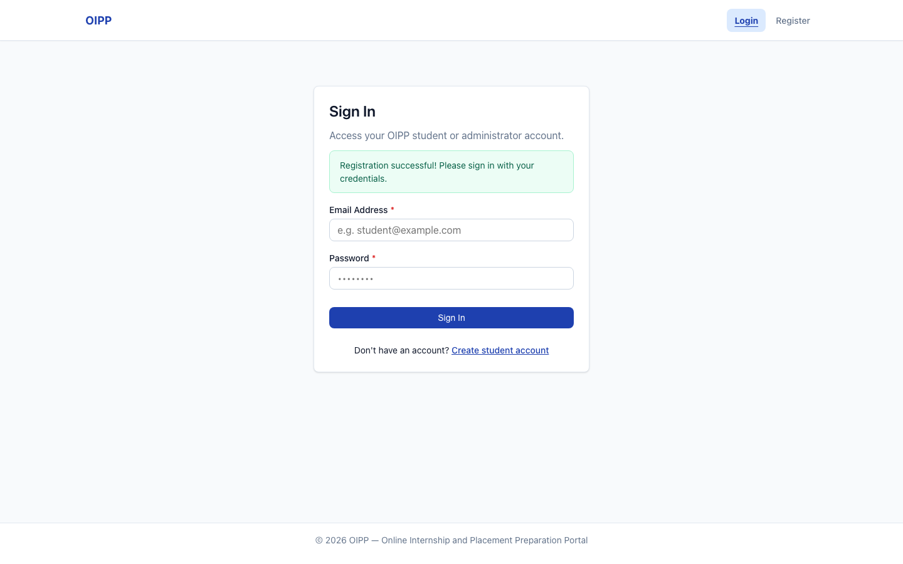
Figure 1. TC-AUTH-01: registration succeeded, redirected to Sign In
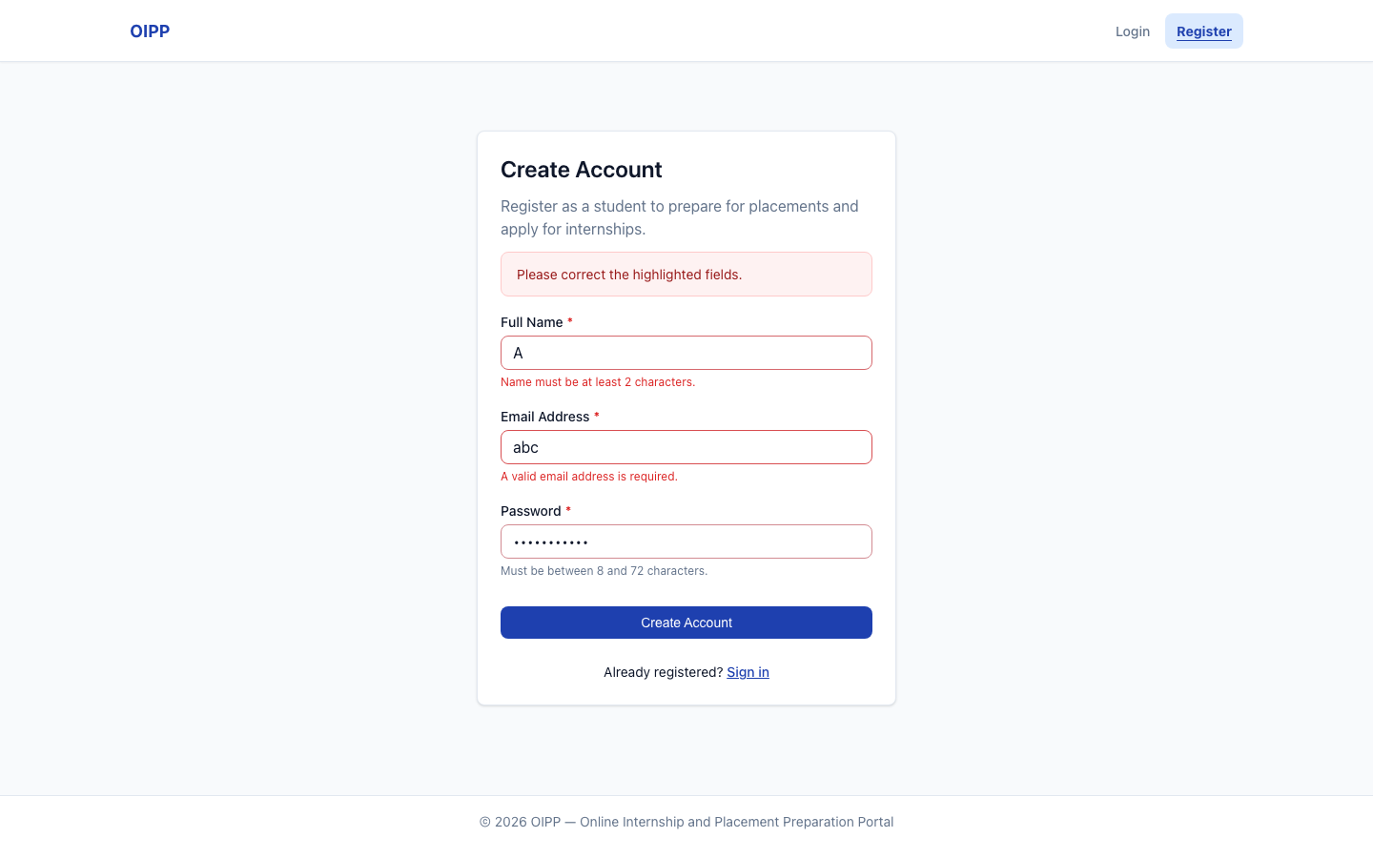
Figure 2. TC-AUTH-01: server validation messages under Full Name and Email
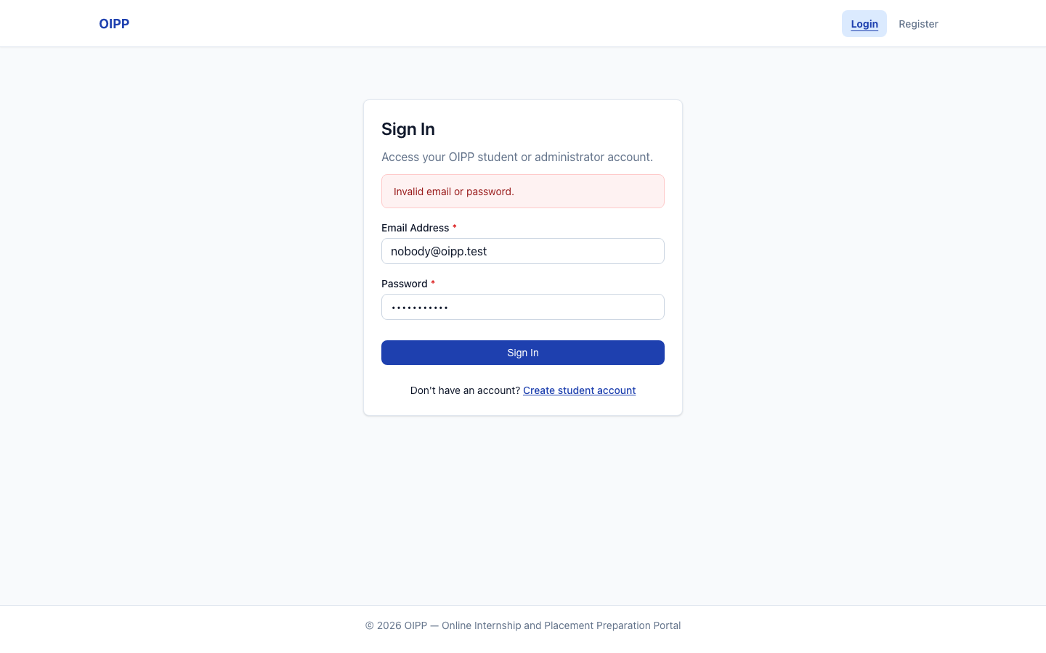
Figure 3. TC-AUTH-02: wrong password and unknown email show the same message
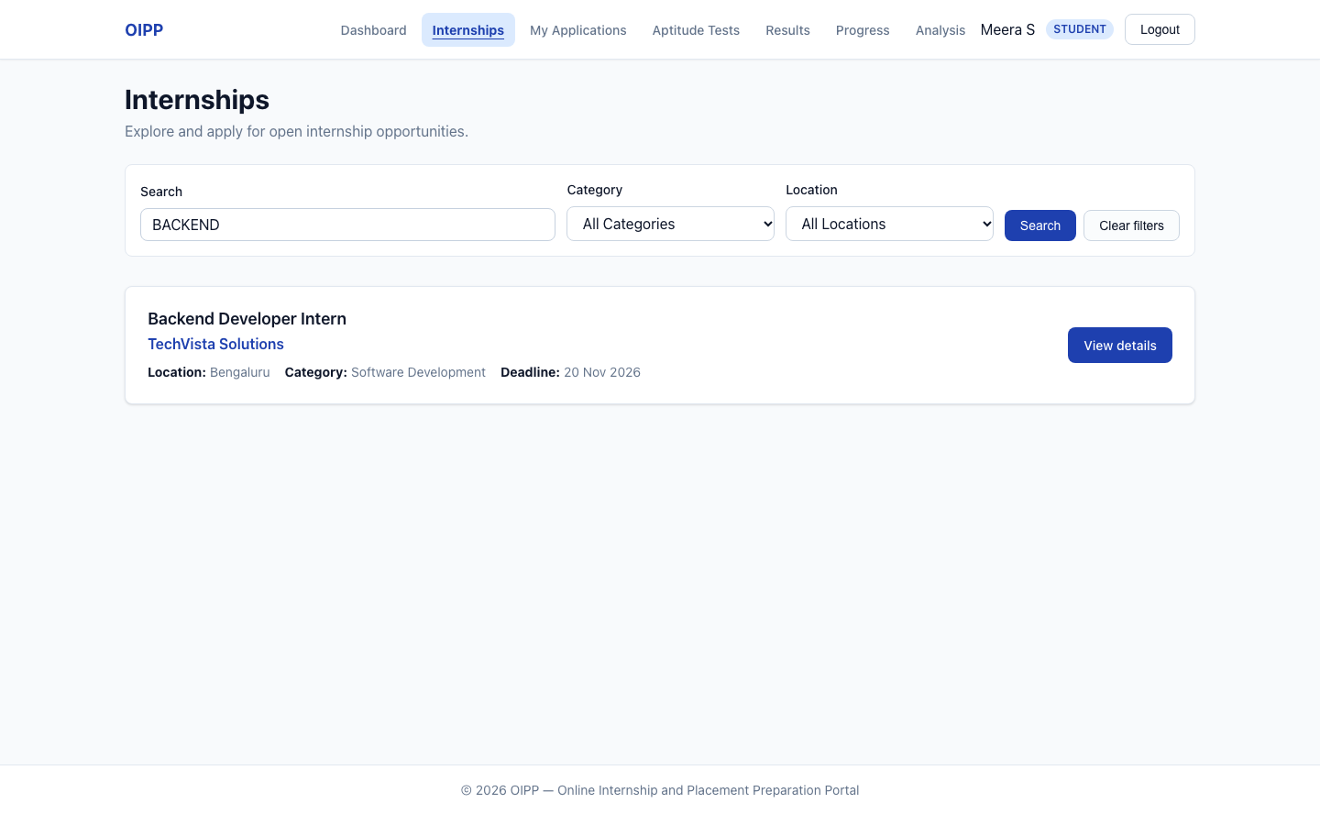
Figure 4. TC-INT-02: case-insensitive search
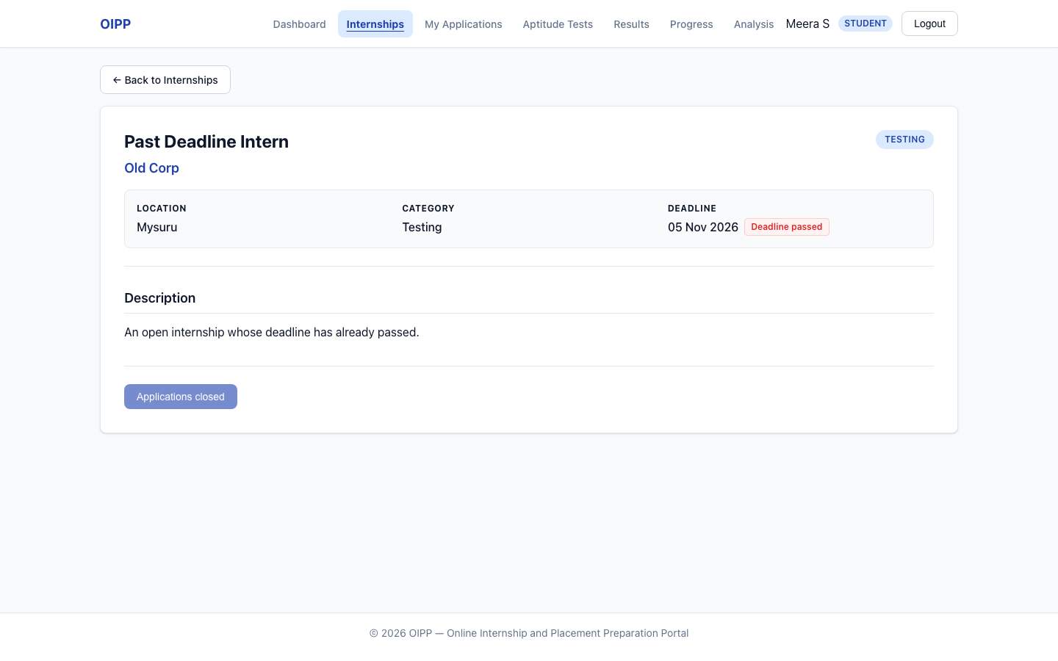
Figure 5. TC-INT-03: open internship past its deadline; Apply unavailable
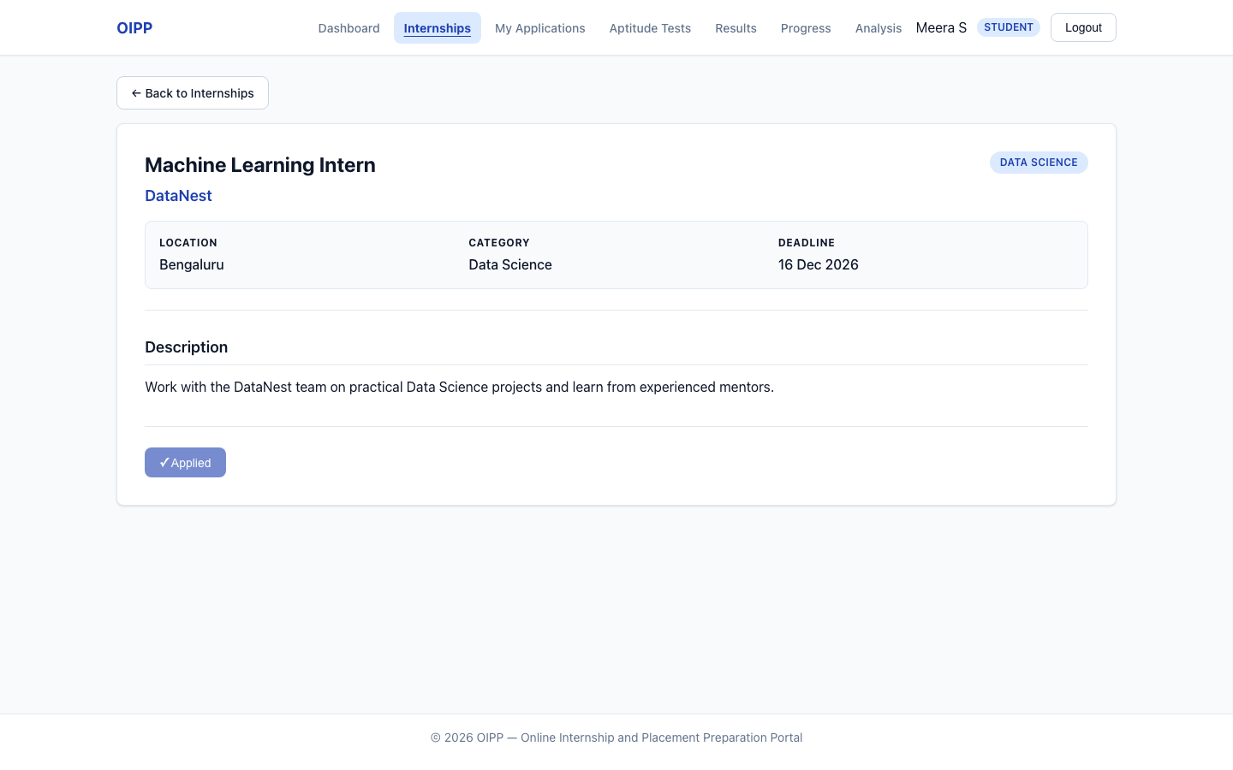
Figure 6. TC-APP-01: application submitted; button shows Applied
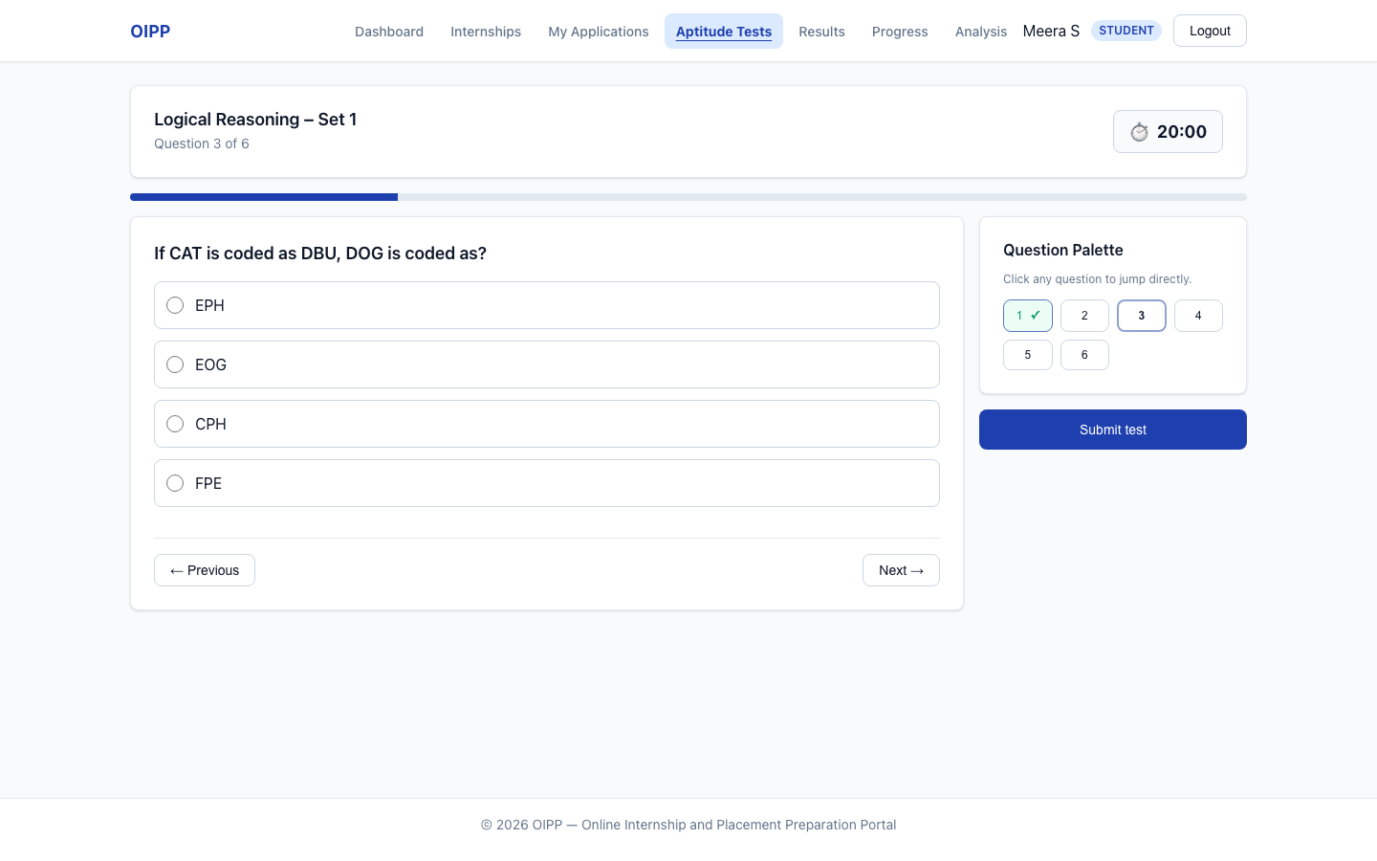
Figure 7. TC-TEST-02: one question at a time, palette and timer
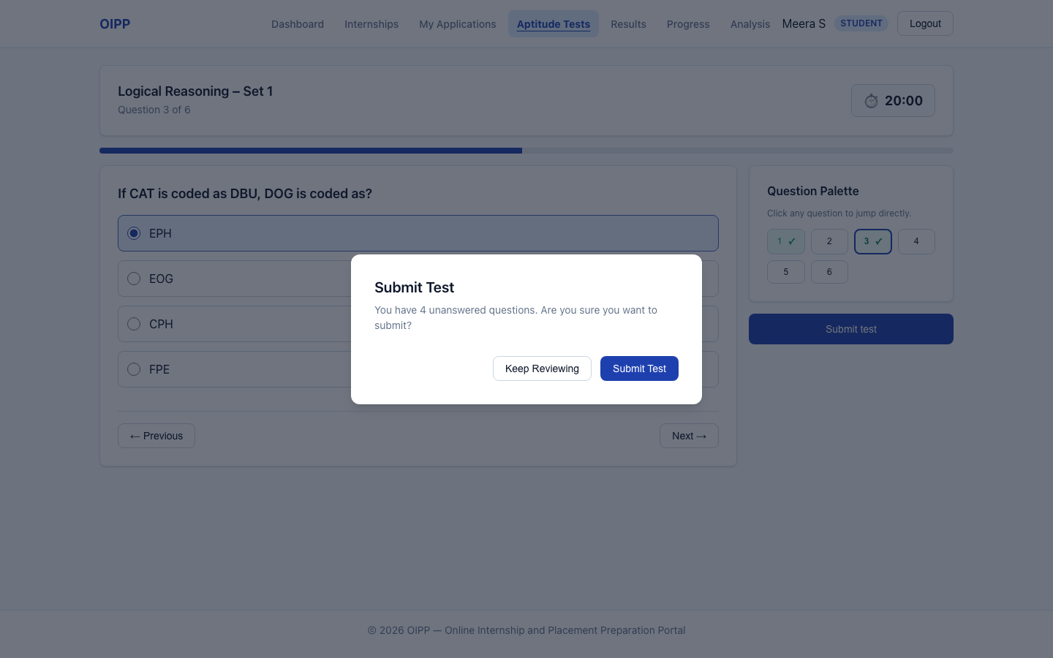
Figure 8. TC-TEST-02: confirm dialog with the unanswered count
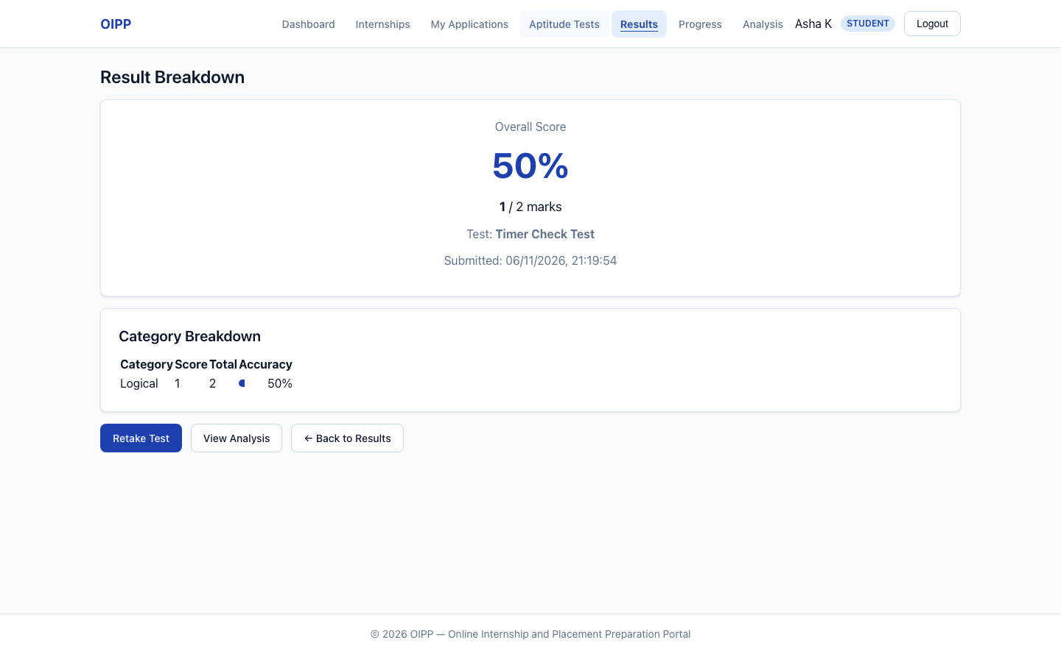
Figure 9. TC-TEST-02 step 7: result after the timer auto-submitted
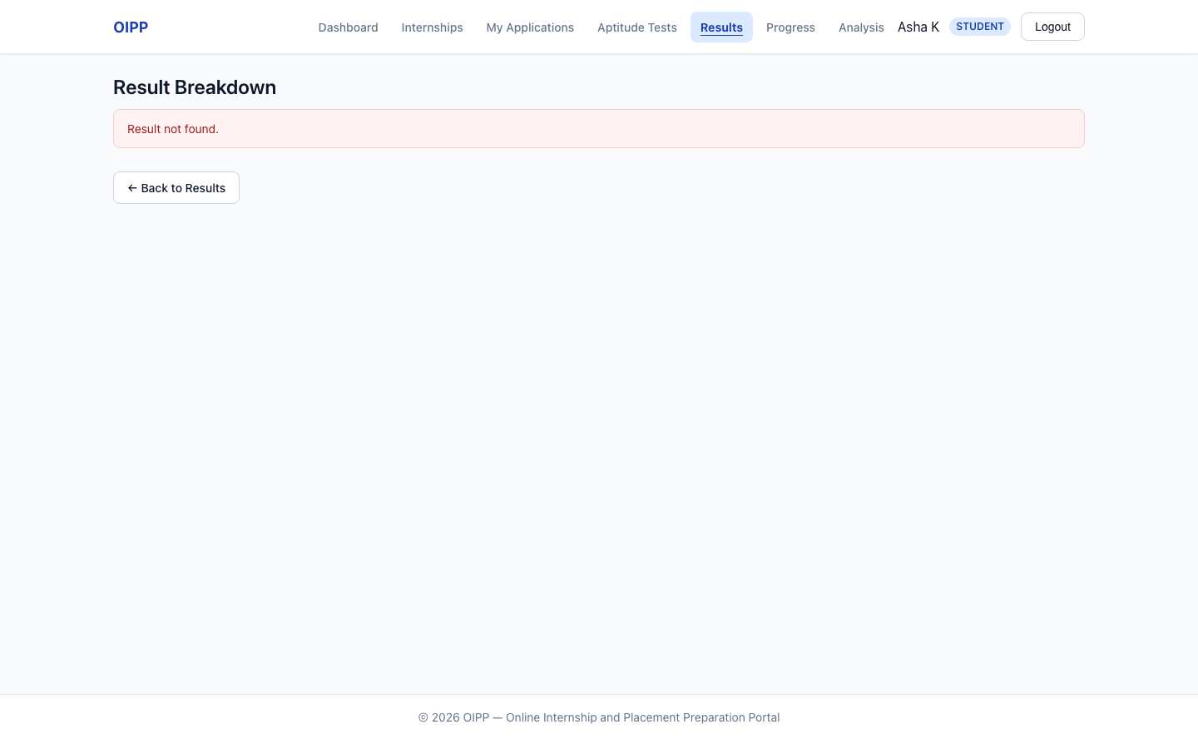
Figure 10. TC-TEST-04: another student's result is not found
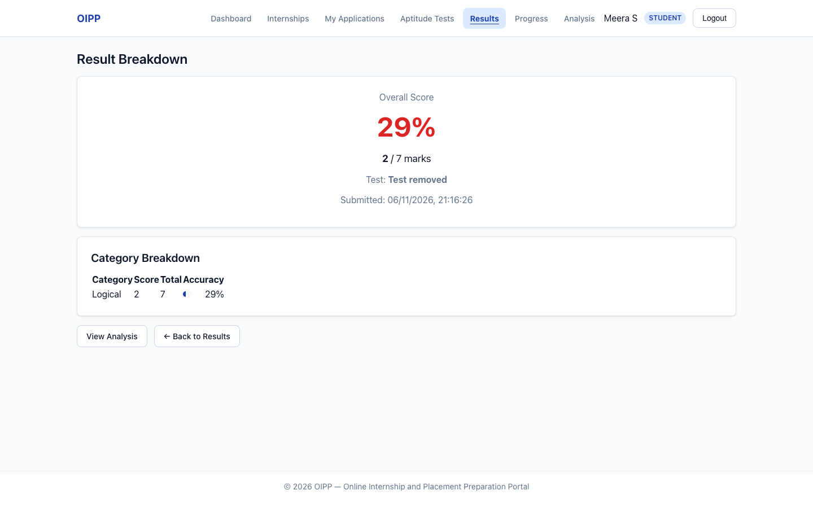
Figure 11. TC-TEST-04: result kept after its test was deleted; Retake hidden
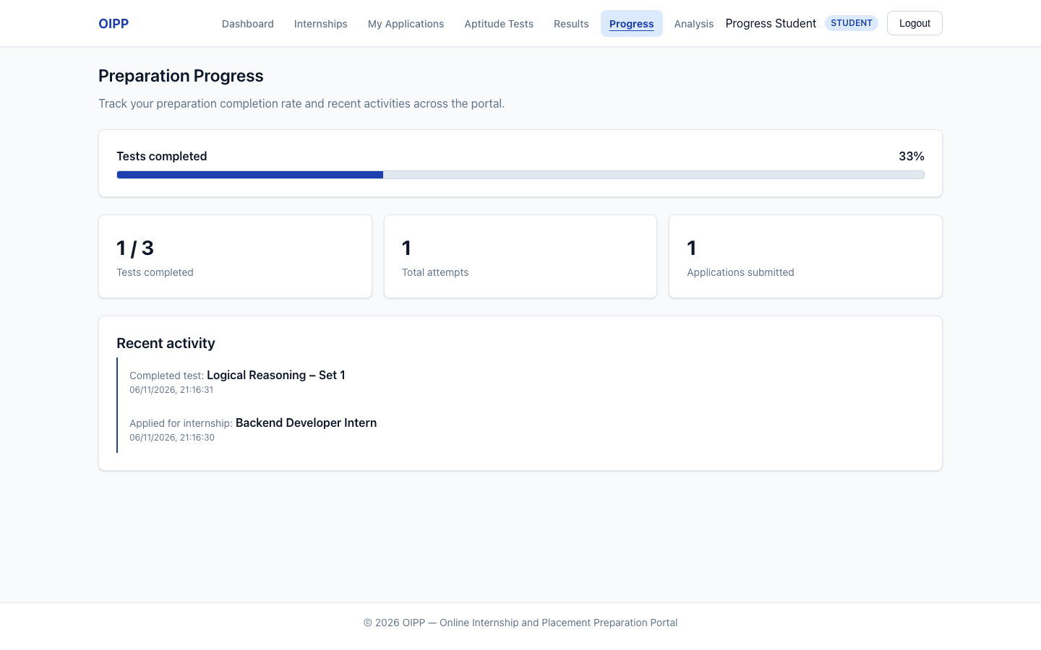
Figure 12. TC-PROG-01: progress after applying and completing a test
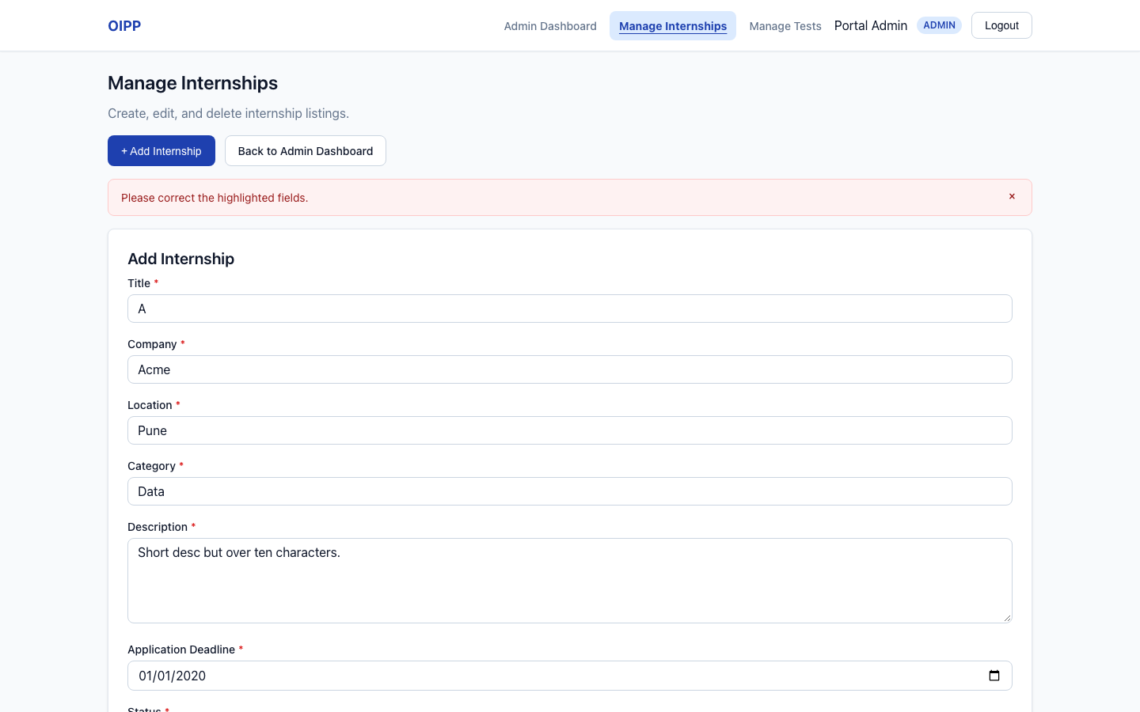
Figure 13. Defect S3-D1: invalid data rejected, but only a summary alert; no field is highlighted
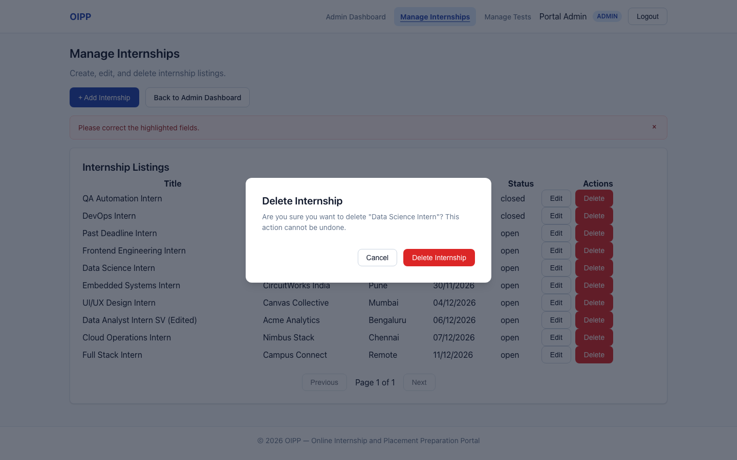
Figure 14. TC-ADM-01: delete confirmation
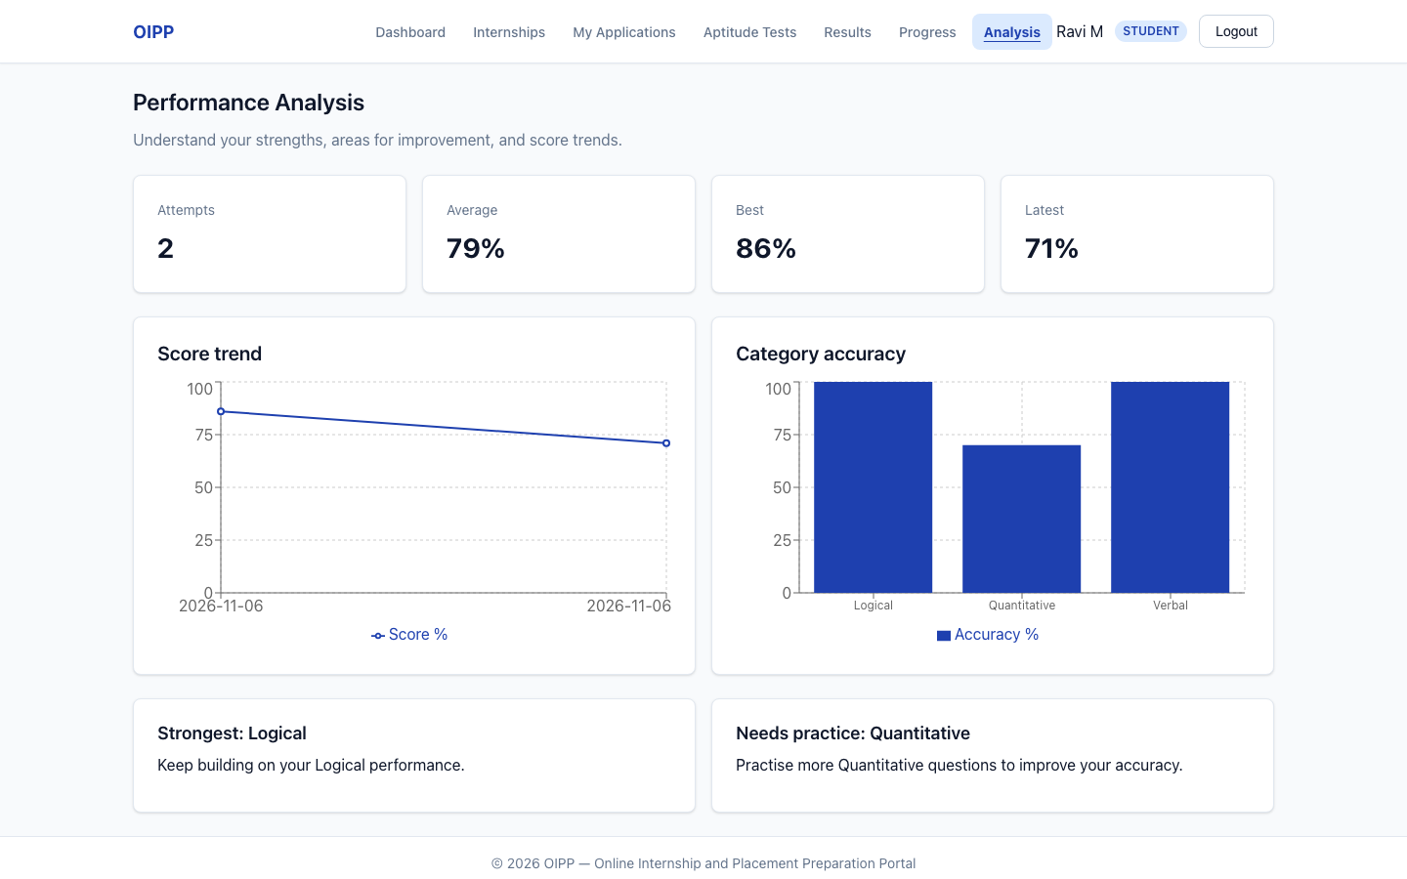
Figure 15. TC-PERF-01: analysis at 1440 px
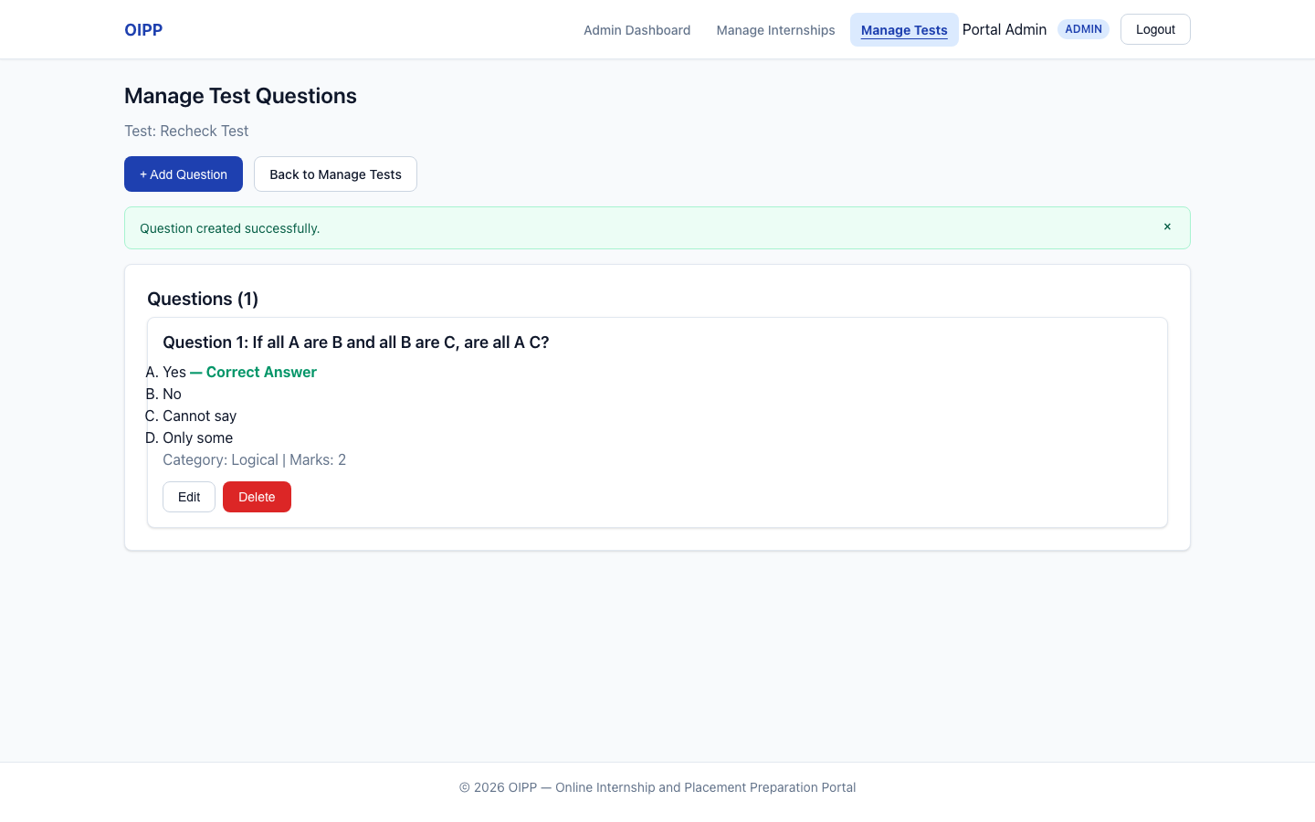
Figure 16. TC-ADM-02: question with its correct answer
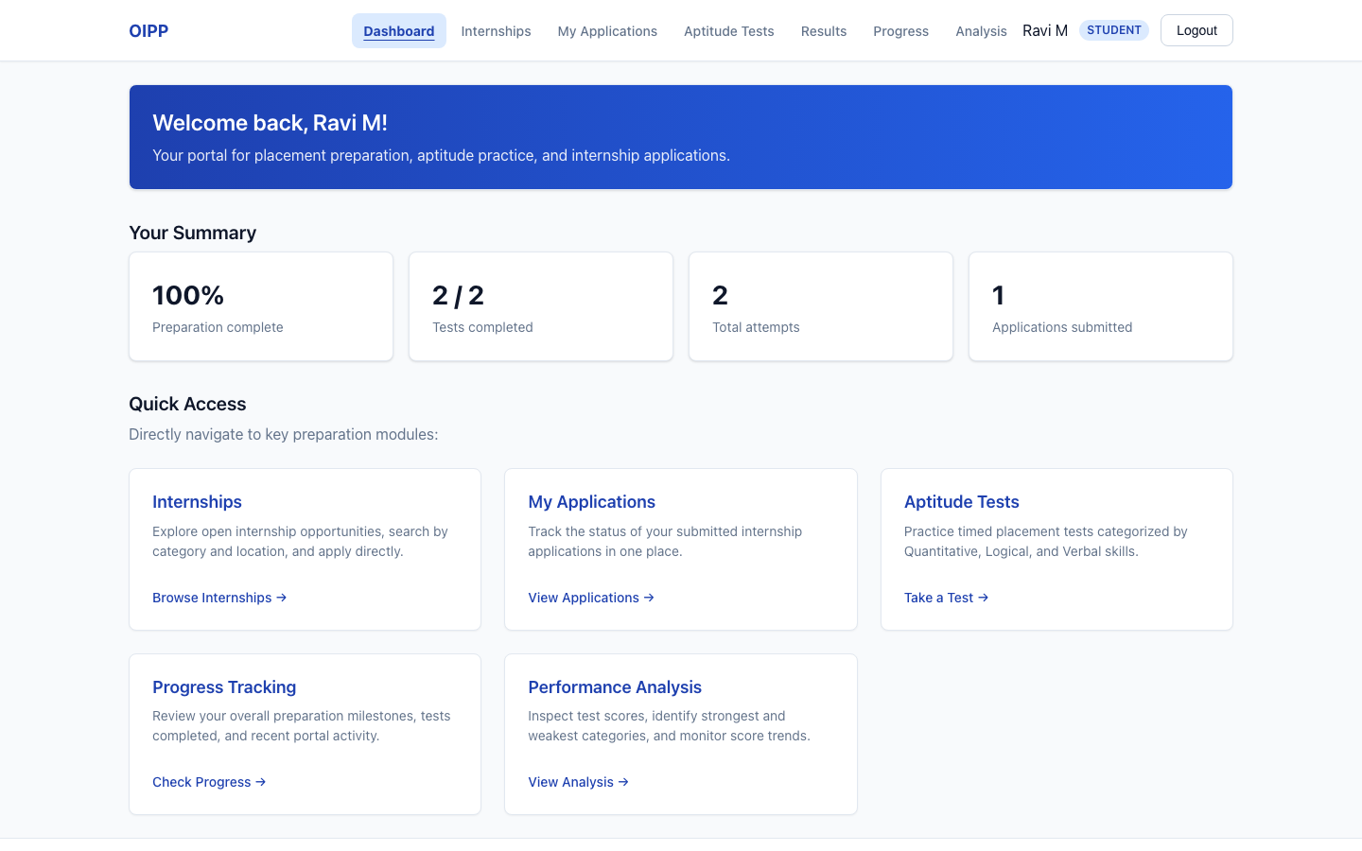
Figure 17. TC-UX-01: student dashboard cards
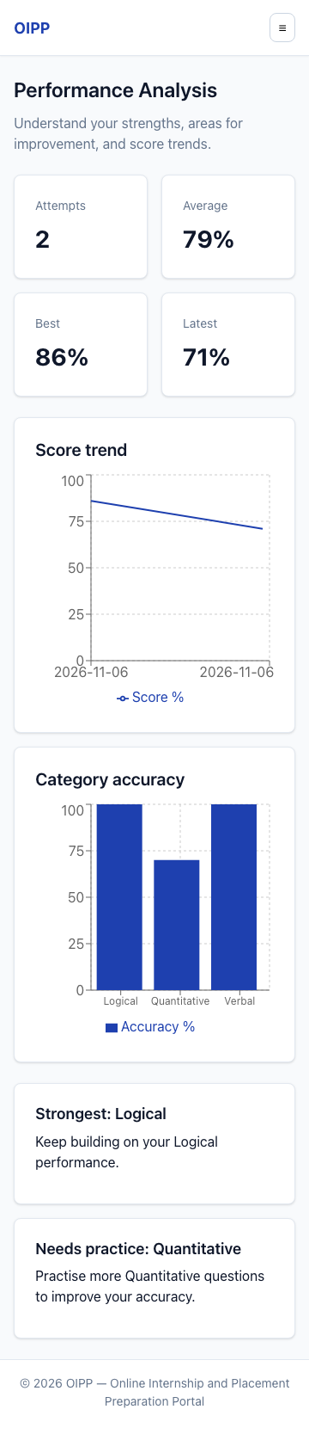
Figure 18. TC-PERF-01: analysis at 360 px, no sideways scrolling
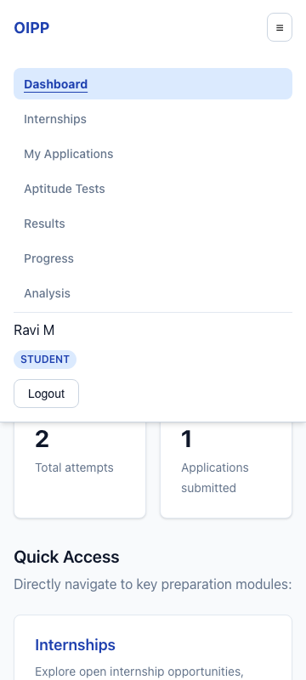
Figure 19. TC-UX-01: mobile menu at 360 px

