MINI PROJECT

(2021-2022)

Quickzzy Online Quiz System
Report


Institute of Engineering & Technology

Team Members

TANYA GOYAL

(181500754)

MANSI VERMA

(181500372)

DIYA GUPTA

(181500228)

DIKSHA KHANDELWAL

(181500217)

Supervised By

MR. ANAND GUPTA

TECHNICAL TRAINER

Department of Computer Engineering &Websites

i


Department of Computer Engineering and Applications GLA University, Mathura

17 km. Stone NH#2, Mathura-Delhi Road, P.O.
Chaumuha, Mathura – 281406

Declaration

I hereby declare that the work which is being presented in the Mini Project “Ouickzzy”, in partial fulfillment of the requirements for Mini project Lab is an authentic record of my own work carried under the supervision of Mr. Anand Gupta, Technical Trainer.

Mansi Verma

Tanya Goyal

Diksha Khandelwal

Diya Gupta

ii

Department of Computer Engineering and Applications GLA University, Mathura

17 km. Stone NH#2, Mathura-Delhi Road, P.O
Chaumuha, Mathura – 281406

Certificate

This is to certify that the project entitled “Quickzzy” carried out in Mini Project – I I Lab is a bonafide work done by Mansi Verma (181500372), Tanya Goyal (181500754), Diksha Khandelwal (181500217), Diya Gupta (181500228) submitted in partial fulfillment of the requirements for the award of the degree Bachelor of Technology (Computer Science & Engineering).

Signature of Supervisor:

Name of Supervisor: Mr. Anand Gupta

Date:22/04/2021

iii

ACKNOWLEDGEMENT

It gives us a great sense of pleasure to present the report of the B. Tech Mini Project undertaken during B. Tech. Third Year. This project in itself is an acknowledgment to the inspiration, drive and technical assistance contributed to it by many individuals. This project would never have seen the light of the day without the help and guidance that we have received.

Our heartiest thanks to Dr. (Prof). Anand Singh Jalal, Head of Dept., Department of CEA for providing us with an encouraging platform to develop this project, which thus helped us in shaping our abilities towards a constructive goal.

We owe special debt of gratitude to Mr. Anand Gupta, Technical Trainer, for his constant support and guidance throughout the course of our work. His sincerity, thoroughness and perseverance have been a constant source of inspiration for us. He has showered us with all his extensively experienced ideas and insightful comments at virtually all stages of the project & has also taught us about the latest industry-oriented technologies.

We also do not like to miss the opportunity to acknowledge the contribution of all faculty members of the department for their kind guidance and cooperation during the development of our project. Last but not the least, we acknowledge our friends for their contribution in the completion of the project.

Mansi Verma

Tanya Goyal

Diksha Khandelwal

Diya Gupta

iv

Abstract

Online Quiz System “Quickzzy” is a web-based examination system where quiz is taken online i.e. through the internet or intranet using computer system. The purpose of Online Quiz System is to take Semester Quizzes in an efficient manner and no time wasting for checking the paper. The main objective of Online Quiz is to efficiently evaluate the candidate through a fully automated system that not only saves lot of time but also gives fast results. Teachers can administer quizzes using the Online Quiz System.The system will show result after the examination is finished. A teacher has control in the question bank and is supposed to make schedule for the quiz. The system carries out the examination and auto-grading for multiple choice questions which is fed into the system. Administrative control of the whole system is provided.
The main objective of the project on MCQ Quiz Applications is to manage the details of Students, Examinations, Marks, Courses, Papers. It manages all the information about Students, Results, Papers,Students. The project is totally built at administrative end and thus only the administrator is guaranteed the access. The purpose of the project is to build an application program to reduce the manual work for Marks, Courses, Papers.

Online Quiz System is an intelligent prototype developed as a multiple choice question examination system which is built as a Web based application scalable to run on both intranet and internet. Online Quiz System is intelligent enough and equipped with a level of automation to guide the students to get proficiency/become subject matter experts by taking the tests. It ensures that students will have the Mock Tests for practice, and can get the results displayed in their panel. The Online Quiz System is designed for three major roles. Those are: An administrator who controls all the level of roles and creates the tests. An instructor should be able to create test questions and manage tests. A student who is an end user for the tests. The main objective of the Online Quiz System is to efficiently evaluate the student using a fully automated system that not only saves a lot of time but also gives fast results. Technologies used to develop this website are HTML, CSS, and JavaScript for client side validation, php for dynamic content update. SQL Server is used as a data base server for this application.

Online Quiz System will help the university, to establish a collaborative online exam environment to conduct quiz/tests for their regular, as well as distant students, in an effective manner. It facilitates a user-friendly environment and reduces manual intervention as well as time. The core underlying automation of the Online Quiz System will generates questions and options on the fly basis and captures the answers from students into the database.

v

Table of Contents

Declaration --------------------------------------------------------------------ii
Certificate --------------------------------------------------------------------iii
Acknowledgement ----------------------------------------------------------iv
Abstract------------------------------------------------------------------------v

- Introduction

1.1 Objective--------------------------------------------------------------2-3

- SoftwareRequirementAnalysis

2.1 Definitation------------------------------------------------------------3-5

2.2 Tools Used------------------------------------------------------------6-10

2.3 Development Tools------------------------------------------------10-14

2.4 UseCase Diagram------------------------------------------------------15

2.5 DFD Diagram----------------------------------------------------------15

2.6 Requirement------------------------------------------------------------16

- Project Design and their Screenshots---------------------------17-29

- Implementation----------------------------------------------------------

- References/Bibliography----------------------------------------------30

Introduction

Online Examination System refers to service as conduct online examination or test. It will use for students progress evaluation using modern computer technology. It replaced the paperwork and overcome the outcomes of traditional way of examinations using paper or pen.It is web based platform can be used by Admin at any remote location. Online Examination System is fully developed automated system is to efficiently evaluate the candidate progress that not only save the time of Examination Controller and also gives fast result. The Administrator of the system has authority to propose tests or papers. It is cost effective and time effective.The candidate can login through proposed computer with their Enrollment number matching the details to the student’s database, then they can take the exam. Candidate can give their course’s examination in a specific duration and in specific number of questions. Online Examination System is a technology-driven way to simplify examination activities like defining exam patterns with question banks, defining exam timer, objective/ subjective question sections, conducting exams using the computer or mobile devices in a paperless manner.Online Examination System is a cost-effective, scalable way to convert traditional pen and paper-based exams to online and paperless mode.Candidates can appear for the exam using any desktop, laptop, or mobile device with a browser. Exam results can be generated instantly for the objective type of questions. It can simplify overall examination management and result in generation activity.
The ‘MCQ Quiz Application’ project will be developed to overcome the time consuming problem of manual system. Apart from that in current system, checking the answer sheets after taking test, waste the examiners time, so this application will check the correct answer and save the examiner time and carry the examination in an effective manner. The users which are use this system don’t need to high computing knowledge and also system will inform them while entering invalid data.
Functionalities of the project will be as following:

Able the examiners to punch the MCQ questions online;
Able the users to solve the questions online;
Examiners can manage the information regarding exam;
Correct answers will be evaluated by system;
Users can see their result after submitting the test;

1.1Objective

The main objective of the project on MCQ Quiz Applications is to manage the details of Students, Examinations, Marks, Courses, Papers. It manages all the information about Students, Results, Papers,Students. The project is totally built at administrative end and thus only the administrator is guaranteed the access. The purpose of the project is to build an application program to reduce the manual work for Marks, Courses, Papers.The main aim of Online Quiz System Project is to facilitate a user friendly environment of Blue book implementation and reduces the manual effort. The manual procedure used for conducting exam is time consuming process and error prone due to human limitations. The System purpose is to completely automate the old manual procedure of conducting exam to Online Web Based Examination System. The purpose of the project is to build an application to reduce the manual work for managing the MCQ quiz and we will follow to achieve these objectives in this project.

To create an appropriate platform for best managing of MCQ test;

To overcome the time consuming issues and taking MCQ tests;

To release the marks of the test taker as soon as possible;

To manage the information of different tests.

Operational Definition:

Online Examination System refers to service as conduct online examination or test. It will use for students progress evaluation using modern computer technology.The main aim of this project is to manage the details of students, examinations, marks, courses and papers in a good manner. The performance of the application will be fully control by administrator and administrator can guaranty any one to access.

Hypothesis:

This project has helped us in getting a clearer understanding of real world application development. It has provided us a deeper insight into connecting databases with servers. The entire learning outcome of this project has proved to be immensely beneficial for our future application development.

2.1 DEFINITIONS

ADMIN :

The Administrator application, also known as the Back-end, Admin Panel or Control Panel, is the interface where administrators and other site officials with appropriate privileges can manipulate the look of a Quickzzy online quiz portal. In our website we have the admin pannel where admin can add, edit, delete, view quiz.

USER:

Client End: The functions of the Client End are: To instruct the users who want to register ,Provide proper interface to sign-in, login, and test.

Visual Code:

Microsoft Visual Studio is an integrated development environment (IDE) from Microsoft. It is used to develop computer programs, as well as websites, web apps, web services and mobile apps. Visual Studio uses Microsoft software development platforms such as Windows API, Windows Forms, Windows Presentation Foundation, Windows Store and Microsoft Silverlight. It can produce both native code and managed code.

Visual Studio includes a code editor supporting IntelliSense (the code completion component) as well as code refactoring. The integrated debugger works both as a source-level debugger and a machine-level debugger. Other built-in tools include a code profiler, forms designer for building GUI applications, web designer, class designer, and database schema designer. It accepts plug-ins that enhance the functionality at almost every level—including adding support for source control systems (like Subversion and Git) and adding new toolsets like editors and visual designers for domain-specific languages or toolsets for other aspects of the software development lifecycle (like the Team Foundation Server client: Team Explorer).

Visual Studio supports 36 different programming languages and allows the code editor and debugger to support (to varying degrees) nearly any programming language, provided a language-specific service exists. Built-in languages include C,[6] C++, C++/CLI, Visual Basic C#, F#, JavaScript, Typescripts, XML, XSLT, HTML, and CSS. Support for other languages such as Python,Ruby, Node.js, and M among others is available via plug-ins. Java (and J#) were supported in the past.

Visual Studio includes a code editor supporting IntelliSense (the code completion component) as well as code refactoring. The integrated debugger works both as a source-level debugger and a machine-level debugger. Other built-in tools include a code profiler, forms designer for building GUI applications, web designer, class designer, and database schema designer. It accepts plug-ins that enhance the functionality at almost every level—including adding support for source control systems (like Subversion and Git) and adding new toolsets like editors and visual designers for domain-specific languages or toolsets for other aspects of the software development lifecycle (like the Team Foundation Server client: Team Explorer).
The most basic edition of Visual Studio, the Community edition, is available free of charge.

WEB BROWSER :

"A web browser, or simply 'browser,' is an application used to access and view websites. Web Browser is a software application for accessing the information on the World Wide Web. It is the function of the web browser to retrieve the information requested by the user from any website.
A web browser is not the same thing as a search engine, though the two are often confused.For a user, a search engine is just a website, such as google.com, that stores searchable data about other websites. But to connect to a website's server and display its web pages, a user needs to have a web browser installed on their device. The most popular browsers are Chrome, Firefox, Safari, Internet Explorer, and Edge

BOOTSTRAP:

Bootstrap is a free and open-source front-end web framework. It contains HTML and CSS-based design templates for typography, forms, buttons, navigation and other interface components, as well as optional JavaScript extensions. Unlike many earlier web frameworks, it concerns itself with front-end development only. Bootstrap is the most popular CSS Framework for developing responsive and mobile-first websites.
Bootstrap is a potent front-end framework used to create modern websites and web apps. It's open-source and free to use, yet features numerous HTML and CSS templates for UI interface elements such as buttons and forms. Bootstrap also supports JavaScript extensions.
It includes HTML and CSS based design templates for typography, forms, buttons, tables, navigation, modals, image carousels etc. Here are some additional reasons to use Bootstrap: Bootstrap's responsive CSS adjusts to phones, tablets, and desktops.

MYSQL :

MySQL is an open source relational database management system (RDBMS). Its name is a combination of "My", the name of co-founder Michael Widenius's daughter, and "SQL", the abbreviation for Structured Query Language.

MySQL is free and open-source software under the terms of the GNU General Public License, and is also available under a variety of proprietary licenses. MySQL was owned and sponsored by the Swedish company MySQL AB, which was bought by Sun Microsystems (now Oracle Corporation).In 2010, when Oracle acquired Sun, Widenius forked the open-source MySQL project to create MariaDB.

MySQL is a component of the LAMP web application software stack (and others), which is an acronym for Linux, Apache, MySQL, Perl/PHP/Python. MySQL is used by many database-driven web applications, including Drupal, phpBB, and Word Press. MySQL is also used by many popular websites, including Google (though not for searches), Facebook, Twitter YouTube.

MySQL is written in C and C++. Its SQL parser is written in Yacc, but it uses a home-brewed lexical analyzer.MySQL works on many system platforms, including AIX, BSDi, FreeBSD, HP-UX,, i5/OS, IRIX, Linux, mac OS, Microsoft Windows, OS/2 Warp, QNX, Oracle, SCO Open Server, SCO Unix Ware, Sanos and Tru64. A port of MySQL to OpenVMS also exists.

The MySQL server software itself and the client libraries use dual-licensing distribution. They are offered under GPL version 2, or a proprietary license.

Support can be obtained from the official manual. Free support additionally is available in different IRC channels and forums. Oracle offers paid support via its MySQL Enterprise
products. They differ in the scope of services and in price. Additionally, a number of third party organizations exist to provide support and services, including MariaDB and Percona.

MySQL has received positive reviews, and reviewers noticed it "performs extremely well in the average case" and that the "developer interfaces are there, and the documentation (not to mention feedback in the real world via Web sites and the like) is very, very good". It has also been tested to be a "fast, stable and true multi-user, multi-threaded Sql database server".

2.2 Technology Used:

HTML

Hypertext Markup Language (HTML) is the standard markup language for creating web pages and web application. With Cascading Style Sheets (CSS) and JavaScript, it forms a triad of cornerstone technologies for the World Wide Web.

Web Browser receive HTML documents from a web server or from local storage and render the documents into multimedia web pages. HTML describes the structure of a web page semantically and originally included cues for the appearance of the document.

HTML Elements are the building blocks of HTML pages. With HTML constructs, images and other objects such as interactive forms may be embedded into the rendered page. HTML provides a means to create structured documents by denoting structural semantics for text such as headings, paragraphs, lists, links, quotes and other items. HTML elements are delineated by tags, written using angle brackets. Tags such as <img/> and <input/>directly introduce content into the page. Other tags such as <p> surround and provide information about document text and may include other tags as sub-elements. Browsers do not display the HTML tags, but use them to interpret the content of the page.

HTML can embed programs written in a scripting language such as JavaScript, which affects the behavior and content of web pages. Inclusion of CSS defines the look and layout of content. The World Wide Web Consortium (W3C), maintainer of both the HTML and the CSS standards, has encouraged the use of CSS over explicit presentational HTML since 1997.

HTML code ensures the proper formatting of text and images so that your Internet browsermay display them as they are intended to look. Without HTML, a browser would not know how to display text as elements or load images or other elements. HTML also provides a basic structure of the page, upon which Cascading Style Sheets are overlaid to change its appearance. One could think of HTML as the bones (structure) of a web page, and CSS as its skin (appearance).

CSS (Cascading Style Sheets)

Cascading Style Sheets, fondly referred to as CSS, is a simple design language intended to simplify the process of making web pages presentable.

CSS handles the look and feel part of a web page. Using CSS, you can control the color of the text, the style of fonts, the spacing between paragraphs, how columns are sized and laid out, what background images or colors are used, layout designs,variations in display for different devices and screen sizes as well as a variety of other effects.

CSS is easy to learn and understand but it provides powerful control over the presentation of an HTML document. Most commonly, CSS is combined with the markup languages HTML or XHTML.

Advantage Of CSS

CSS saves time − You can write CSS once and then reuse same sheet in multiple HTML pages. You can define a style for each HTML element and apply it to as many Web pages as you want.

Pages load faster − If you are using CSS, you do not need to write HTML tag attributes every time. Just write one CSS rule of a tag and apply it to all the occurrences of that tag. So less code means faster download times.

Easy maintenance − To make a global change, simply change the style, and all elements in all the web pages will be updated automatically.

Superior styles to HTML − CSS has a much wider array of attributes than HTML, so you can give a far better look to your HTML page in comparison to HTML attributes.

Multiple Device Compatibility − Style sheets allow content to be optimized for more than one type of device. By using the same HTML document, different versions of a website can be presented for handheld devices such as PDAs and cell phones or for printing.

BOOTSTRAP

Bootstrap is a free and open front-end framework for designing websites and web applications. It contains HTML - and CSS -based design templates for typography, forms, buttons, navigation and other interface components, as well as optional JavaScript extensions. Unlike many earlier web frameworks, it concerns itself with front end development only.

Bootstrap is the second most-starred project on GitHub, with more than 129,000 stars. Bootstrap comes with several JavaScript components in the form of jQuery plugins. They provide additional user interface elements such as dialog boxes, tool-tips, and carousels. They also extend the functionality of some existing interface elements, including for example an auto-complete function for input fields. In version 1.3, the following JavaScript plugins are supported: Modal, Dropdown, Scrollspy, Tab, Tool tip, Popover, Alert, Button, Collapse, Carousel and Typeahead.

Getting Started with Bootstrap Basics

Bootstrap is available in two forms; as a precompiled version, and as a source code version. The source code version uses the Less CSS preprocessor, but if you are more into Sass, there is an official Sass port of Bootstrap also available. To make it easier to make use of CSS vendor prefixes, Bootstrap uses Autoprefixer.

The source code version comes styles source code written in Less (or Sass), all the JavaScript, and accompanying documentation. This allows more ambitious designers and developers to change and customize, at their will, all the provided styles, and to build their own version of Bootstrap. But if you are not familiar with Less (or Sass), or you are just not interested in changing the source code, don’t worry. You can just use the precompiled vanilla CSS. All the styles can be overridden later by using custom styles.

JAVA SCRIPT (JS)

JavaScript often abbreviated as JS, is a high-level, interpreted programming language that conforms to the ECMAScript specification. It is a programming language that is characterized as dynamic, weakly typed, prototype-based and multi-paradigm.

Alongside HTML and CSS, JavaScript is one of the core technologies of the World Wide Web. JavaScript enables interactive web pages and is an essential part of web applications. The vast majority of websites use it, and major web browsers have a dedicated JavaScript engine to execute it.

As a multi-paradigm language, JavaScript supports event-driven, functional, and imperative (including object-oriented and prototype-based) programming styles. It has APIs for working with text, arrays, dates, regular expressions, and the DOM, but the language itself does not include any I/O, such as networking, storage, or graphics facilities. It relies upon the host environment in which it is embedded to provide these features.

Initially only implemented client-side in web browsers, JavaScript engines are now embedded in many other types of host software, including server-side in web servers and databases, and in non-web programs such as word processors and PDF

software, and in runtime environments that make JavaScript available for writing mobile and desktop applications, including desktop widgets.

The terms Vanilla JavaScript and Vanilla JS refer to JavaScript not extended by any frameworks or additional libraries. Scripts written in Vanilla JS are plain JavaScript code.

Although there are similarities between JavaScript and Java, including language name, syntax, and respective standard libraries, the two languages are distinct and differ greatly in design. JavaScript was influenced by programming languages such as Self and Scheme.

JQUERY

jQuery is a JavaScript library designed to simplify HTML DOM tree traversal and manipulation, as well as event handling, CSS animation, and Ajax. It is free, open-source software using the permissive MIT License. Web analysis indicates that it is the most widely deployed JavaScript library by a large margin.

Jquery syntax is designed to make it easier to navigate a document, select DOM elements, create animations, handle events, and develop Ajax applications. jQuery also provides capabilities for developers to create plug-ins on top of the JavaScript library. This enables developers to create abstractions for low-level interaction and animation, advanced effects and high-level, themeable widgets. The modular approach to the jQuery library allows the creation of powerful dynamic web pages and Web applications.

The set of jQuery core features—DOM element selections, traversal and manipulation—enabled by its selector engine (named "Sizzle" from v1.3), created a new "programming style", fusing algorithms and DOM data structures. This style influenced the architecture of other JavaScript frameworks like YUI v3 and Dojo, later stimulating the creation of the standard Selectors API

Microsoft and Nokia bundle jQuery on their platforms. Microsoft includes it with Visual Studio for use within Microsoft's ASP.NET AJAX and ASP.NET MVC frameworks while Nokia has integrated it into the Web Run-Time widget development platform.

FONT AWESOME

Font Awesome is a font and icon toolkit based on CSS and LESS. It was made by Dave Gandy for use with Twitter Bootstrap, and later was incorporated into the BootstrapCDN. Font Awesome has a 20% market share among those websites which use third-party Font Scripts on their platform, ranking it second place after Google Fonts.

Font Awesome is the most popular way to add font icons to your website. Font Awesome icons are created using scalable vectors, so you can use high quality icons that work well on any screen size.

Font Awesome Free is free, open source, and GPL friendly. You can use it for commercial projects, open source projects, or really almost whatever you want. Font Awesome gives you scalable vector icons that can instantly be customized — size, color, drop shadow, and anything that can be done with the power of CSS.

2.3 DEVELOPMENT TOOLS :-

PHP :-

PHP is a server-side scripting language. That is used to develop Static websites or Dynamic websites or Web applications. PHP stands for Hypertext Pre-processor, that earlier stood for Personal Home Pages.
- PHP scripts can only be interpreted on a server that has PHP installed.
- The client computers accessing the PHP scripts require a web browser only.
- A PHP file contains PHP tags and ends with the extension ".php".
PHP means - Personal Home Page, but it now stands for the recursive backronym PHP: Hypertext Preprocessor.
PHP code may be embedded into HTML code, or it can be used in combination with various web template systems, web content management system and web frameworks.

Php Syntax

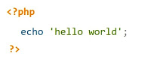
A PHP file can also contain tags such as HTML and client side scripts such as JavaScript.
HTML is an added advantage when learning PHP Language. You can even learn PHP without knowing HTML but it’s recommended you at least know the basics of HTML.
Database management systems DBMS for database powered applications.
For more advanced topics such as interactive applications and web services, you will need JavaScript and XML.
The flowchart diagram shown below illustrates the basic architecture of a PHP web application and how the server handles the requests.
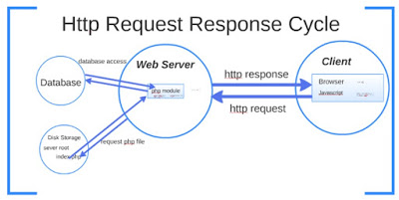
Why use PHP?
You have obviously heard of a number of programming languages out there; you may be wondering why we would want to use PHP as our poison for the web programming. Below are some of the compelling reasons.
- PHP is open source and free.
- Short learning curve compared to other languages such as JSP, ASP etc.
- Large community document

Most web hosting servers support PHP by default unlike other languages such as ASP that need IIS. This makes PHP a cost effective choice.
- PHP is regular updated to keep abreast with the latest technology trends.
- Other benefit that you get with PHP is that it’s a server side scripting language; this means you only need to install it on the server and client computers requesting
for resources from the server do not need to have PHP installed; only a web browser would be enough.

PHP has in built support for working hand in hand with MySQL; this doesn’t mean you can’t use PHP with other database management systems. You can still use PHP with
- Postgres
- Oracle
- MS SQL Server
- ODBC etc.

PHP is cross platform; this means you can deploy your application on a number of different operating systems such as windows, Linux, Mac OS etc.

Use PHP for & Market share
In terms of market share, there are over 20 million websites and application on the internet developed using PHP scripting language.
This may be attributed to the points raised above;
The diagram below shows some of the popular sites that use PHP.
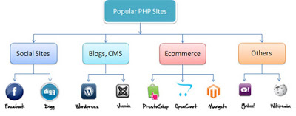

PHP File Extensions
File extension and Tags In order for the server to identify our PHP files and scripts, we must save the file with the “.php” extension. Older PHP file extensions include
- .phtml
- .php3
- .php4
- .php5
- .phps
The PHP tags themselves are not case-sensitive, but it is strongly recommended that we use lower case letter. The code below illustrates the above point.
<?php … ?>
We will be referring to the PHP lines of code as statements. PHP statements end with a semi colon (;). If you only have one statement, you can omit the semi colon. If you have more than one statement, then you must end each line with a semi colon. For the sake of consistency, it is recommended that you always end your statement(s) with a semi colon. PHP scripts are executed on the server. The output is returned in form of HTML.
Advantages of PHP :-

- Most important advantage of PHP is that it’s open source and freed from cost. It are often downloaded anywhere and readily available to use for event of web applications.
- It is platform independent. PHP based applications can run on any OS like UNIX, Linux and windows, etc.
- Application can easily be loaded which are based on PHP and connected to database. it’s mainly used due to its faster rate of loading over slow internet and speed than another programming language.
- It has less learning curve, because it is straightforward and straightforward to use. If a private knows C programming can easily work on PHP.
- It is more stable from a few years with assistance of providing continuous support to various versions.
- It helps in reusing an equivalent code and no got to write lengthy code and sophisticated structure for event of web applications.
- It helps in managing code easily.
- It has powerful library support to use various function modules for data representation.
- Phps built-in database connection modules help in connecting database easily reduce trouble and time for development of web applications and content based sites.
- Popularity of PHP gave rise to various community of developers, a fraction of which may be potential candidates for hire.
- Flexibility makes PHP ready to effectively combine with many other programming languages in order that the software package could use foremost effective technology for every particular feature.

Disadvantages of PHP :

- It is not that secure due to its open-source, because the ASCII text file are often easily available.
- It is not suitable for giant content-based web applications.
- It has a weak type, which can cause incorrect data and knowledge to user.
- PHP frameworks got to learn to use PHP built-in Functionalities to avoid writing additional code.
- Using more features of PHP framework and tools cause poor performance of online applications.
- PHP don’t allow change or modification in core behavior of online applications.
- The PHP frameworks aren’t an equivalent in behavior so does their performance and features.
- While PHP may be a powerful tool supported by an out sized community and plentiful reference documentation, there are easier programming languages for web apps.
- It is widely believed by the developers that PHP features a poor quality of handling errors. PHP lacks debugging tools, which are needed to look for errors and warnings. PHP has less number of debugging tools in comparison to other programming languages.
- It’s highly tough to manage because, it’s not competent modular. It already imitates the features of Java language.

DATABASE PLATFORM - MySQL

MySQL is an open-source relational database management system (RDBMS). Its name is a combination of "My", the name of co-founder Michael Widenius's daughter and "SQL", the abbreviation for Structured Query Language. The MySQL development project has made its source code available under the terms of the GNU General Public License, as well as under a variety of proprietary agreements.

MySQL is an open source relational database management system (RDBMS) Its name is a combination of "My", the name of co-founder Michael Widenius's daughter, and "SQL", the abbreviation for Structured Query Language.

MySQL is free and open-source software under the terms of the GNU(General Public License), and is also available under a variety of proprietary licenses.

MySQL was owned and sponsored by the Swedish company MySQL AB, which was bought by Sun Microsystems (now Oracle Corporation).In 2010, when Oracle acquired Sun, Widenius forked the open-source MySQL project to create MariaDB.

MySQL is a component of the LAMP web application software stack (and others), which is an acronym for Linux, Apache, MySQL, Perl/PHP/Python. MySQL is used by many database-driven web applications, including Drupal, Joomla, phpBB, and WordPress. MySQL is also used by many popular websites, including Google (though not for searches), Facebook, Twitter, Flickr,and YouTube.

2.4 UseCase Diagram :-

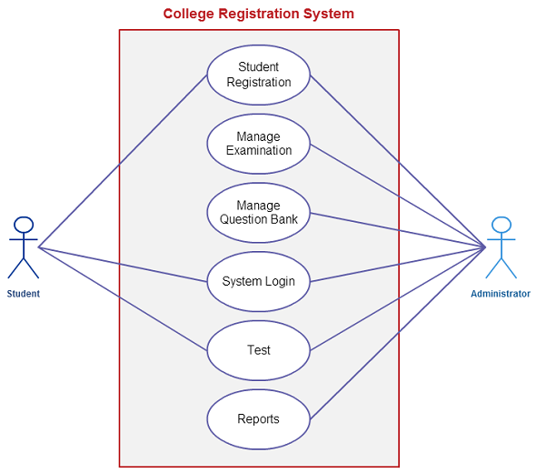

2.5 DFD

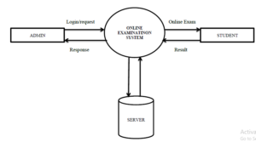

Level 0 DFD diagram

2.6 Hardware Requirements:

Server Side:
- Operating System:Windows,MAC
- Processor: Pentium 3.0 GHz or higher
- Hard Drive: 10 GB or more
- RAM: 256 Mb or more

Client Side:
- Operating System: Windows 9x or above, MAC or UNIX.
- Processor: Pentium III or 2.0 GHz or higher.
- RAM: 256 Mb or more

2.6 Software requirements

- Client Side: HTML, Web Browser, Windows
- Web Server: HTML, Windows XP

PROJECT DESIGN & Their Screenshots

For designing and implementing of Online MCQ Quiz application we used HTML, CSS,
JavaScript and SQL Server with the context of Java and JSP. Following pages have been designed using HTML, CSS, Bootstrap and JavaScript to handle the defined objective of this project.

- Index: This the first page which user observe after running the project. This page will able the user to select the type of Login or Sign up. Selecting “Login or Sign up as Teacher” will direct the user to Teacher Login or Sign up Page and selecting “Login or Sign up as Student” will direct the user to Student Login or Sign up Page.

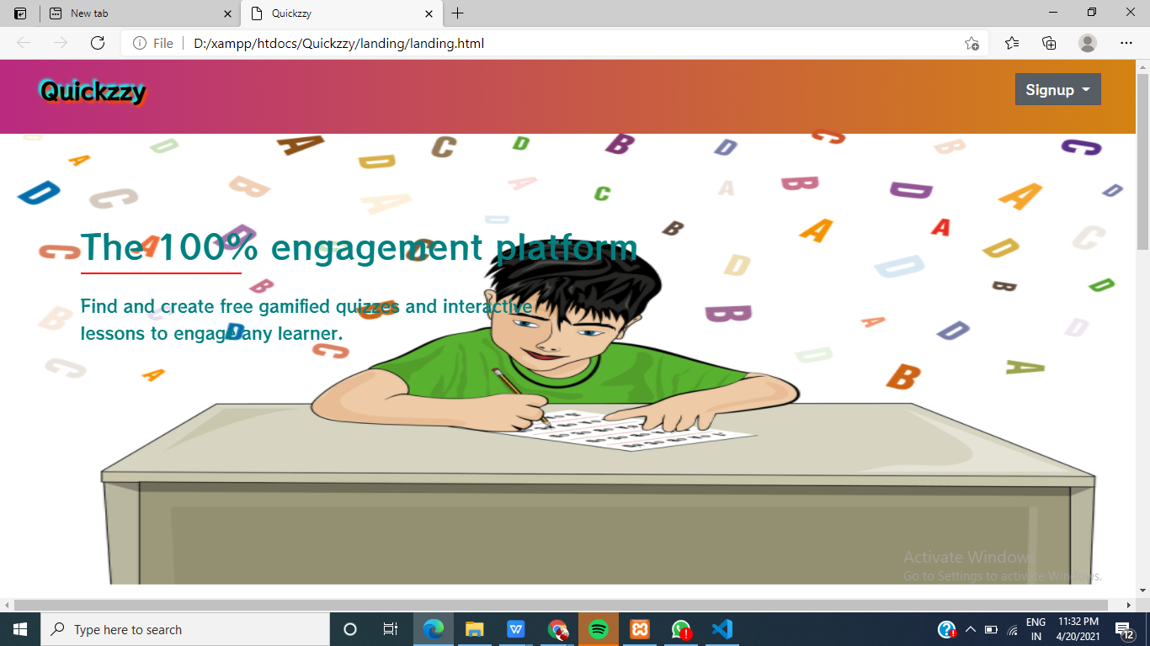

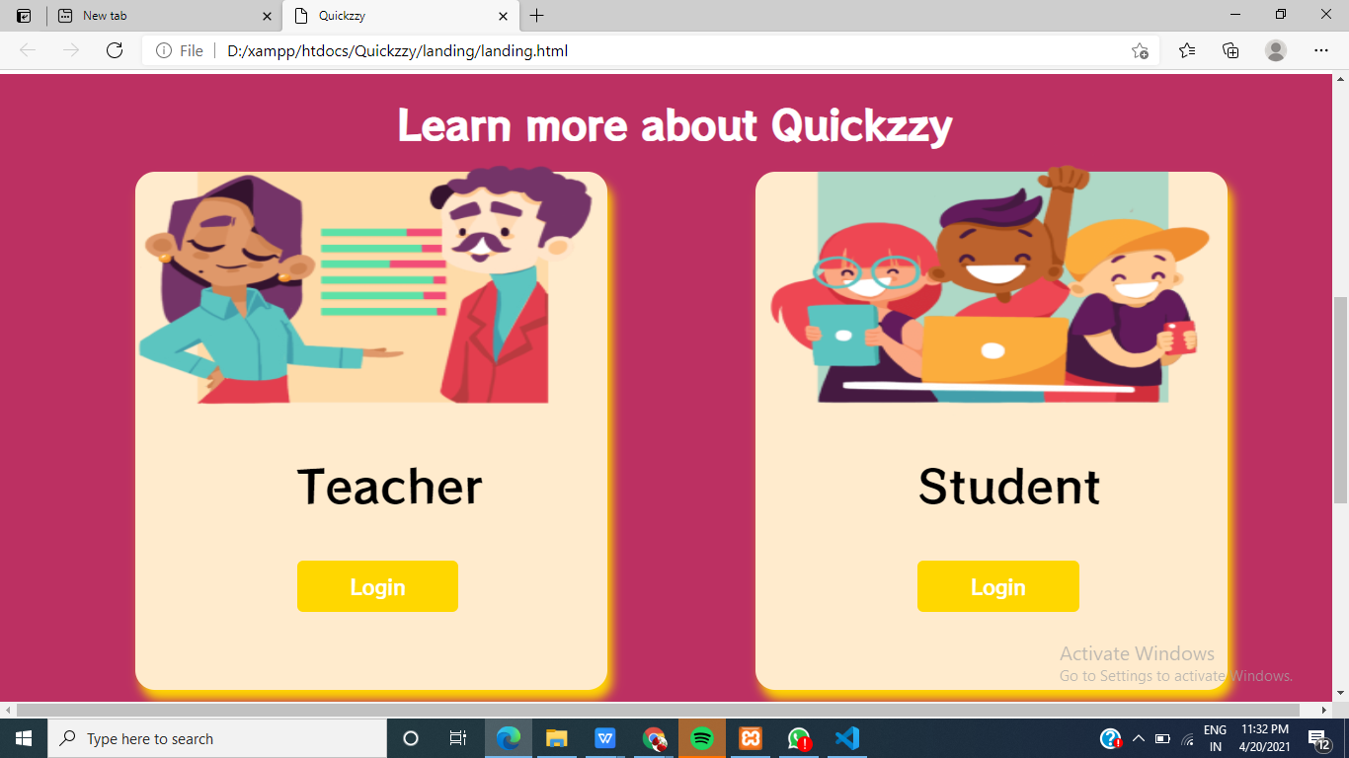

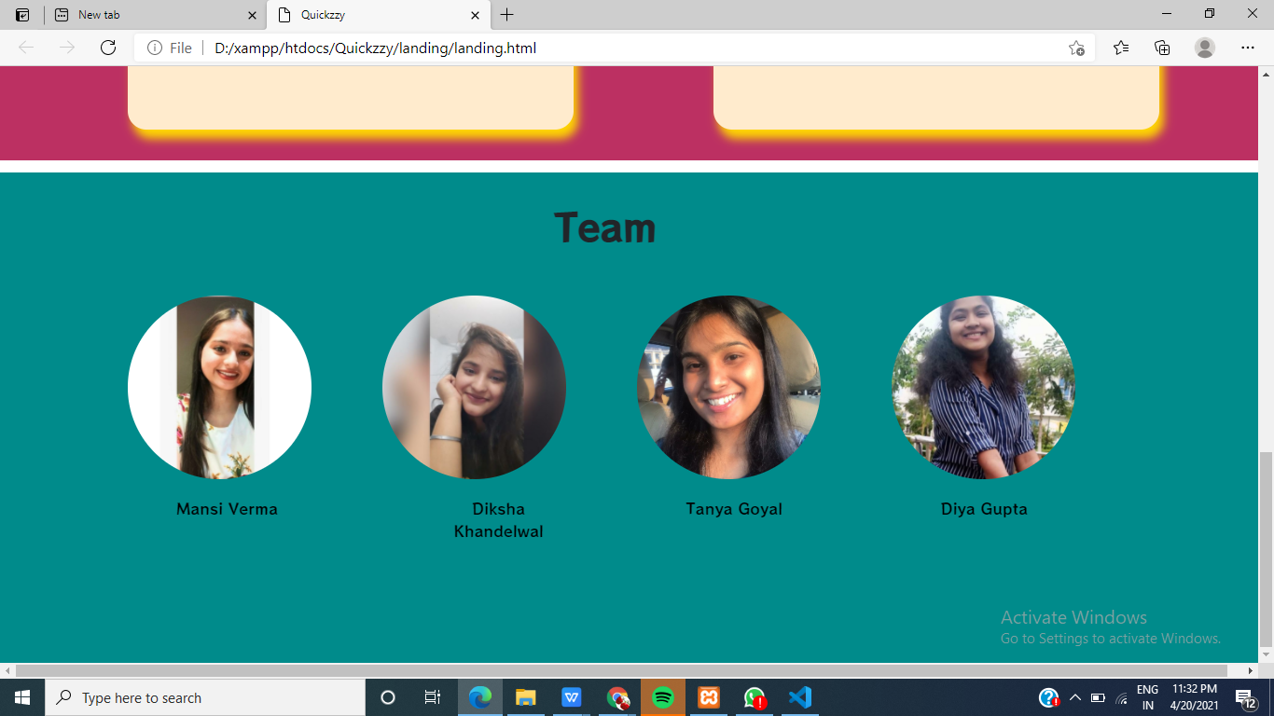

To design and implement this project we plan that the project support to different types of users apart from its administrative part. When project is run for the first time it allowed the user to select as who he/she wants to login in the system. Project support login as teacher and login as student. If a user who is student, try to login as teacher system will allow them and vice versa. User who add as teacher in system will be able to punch test and questions to system and also will be

able to observe the result of the student which attempt tests. User who login to system as student will be able to select a particular test and attempt questions depend on this test. After attempting the test and submitting that user will receive a message that you have attempt the test successfully and if the user tries to attempt the same test, system will not allow him/her. Also a user which login to system as student will be able to observe the result of test he/she attempt.

To conclude introduction, we have use these modules to follow the objectives of our project and each of these modules have logical connections to other modules which they are depend.

- Index: Which allow users to select their type of login or sign up to system;

- Teacher Login or Sign up: Able the teachers to Sign up to system with a valid user name and password. If a teacher is successfully login to system, he/she will have access to following pages:

- Teacher Dashboard: Which have information about Online MCQ Quiz and issues support by this system for the teachers.

- Add Quiz: Which able the teacher to punch a test and after entering the test name and clicking on ‘Submit to Enter Questions’, teacher will be able to add.
questions to the particular test.
- Students Marks: Which able the teacher to observe the result of all student who
have attempt the tests;

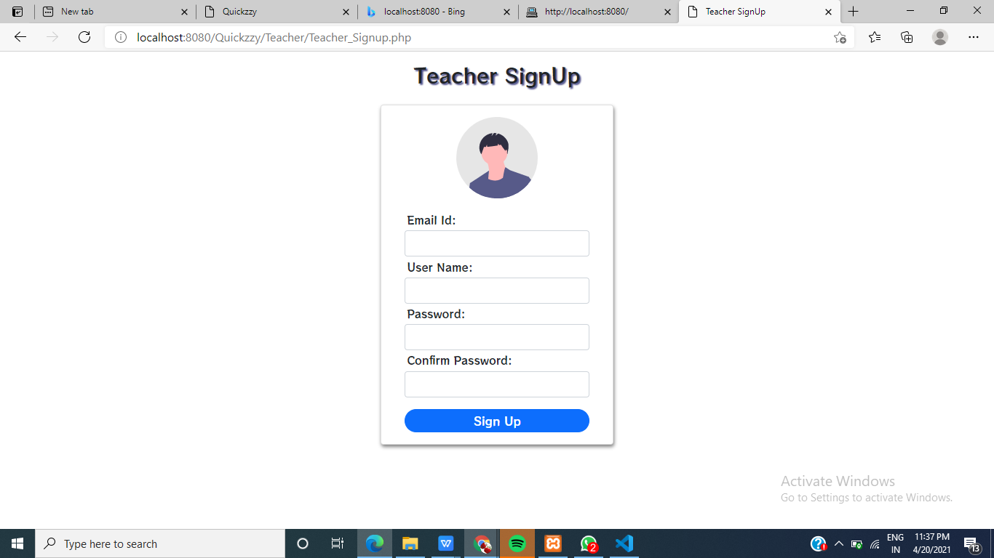

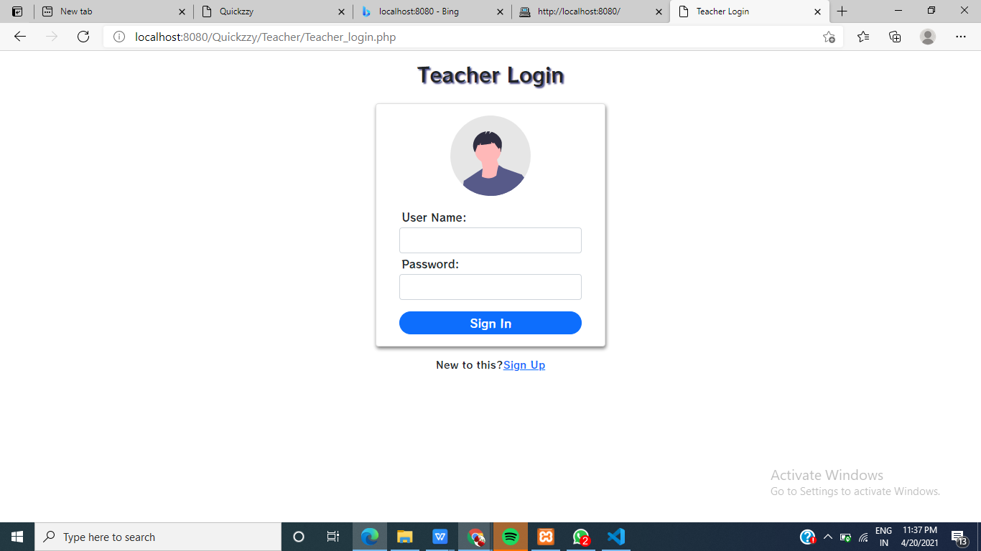

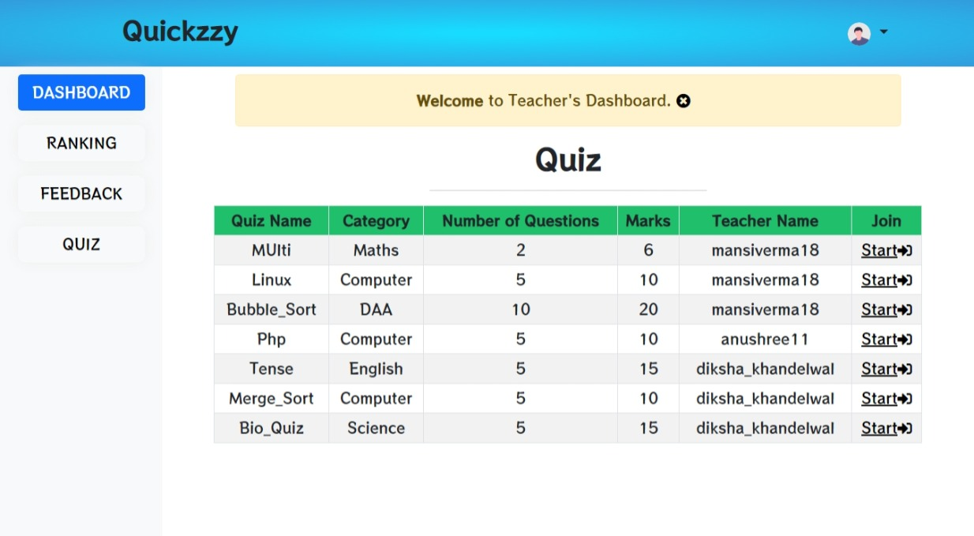

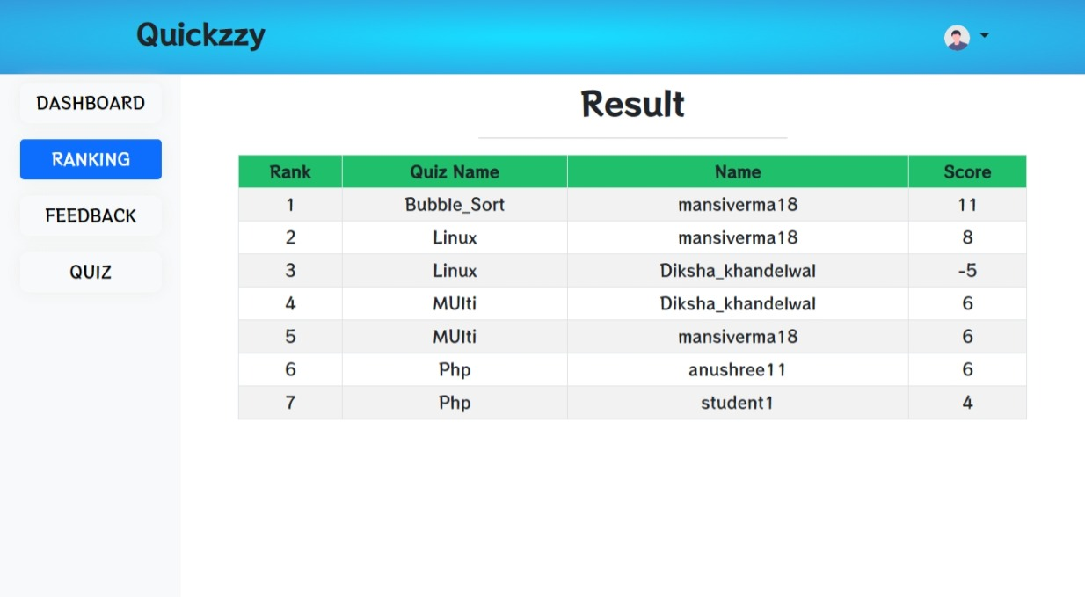

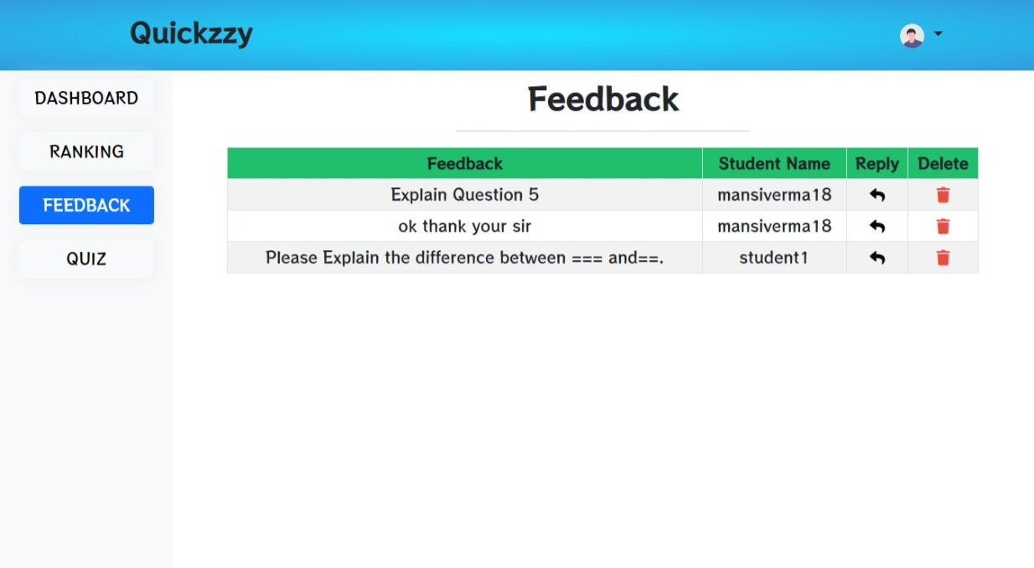

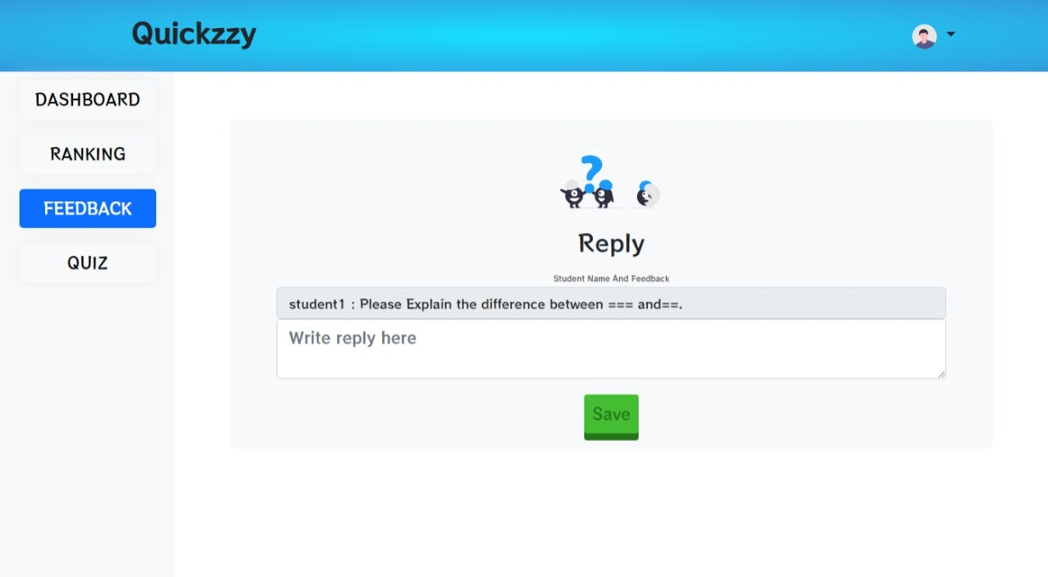

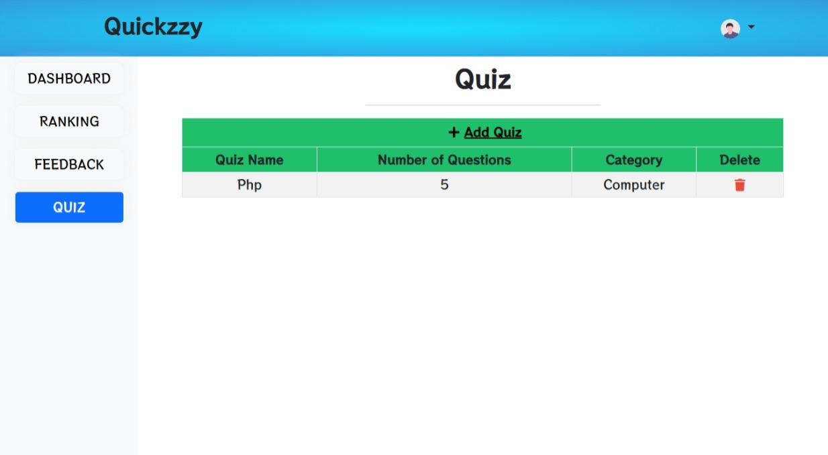

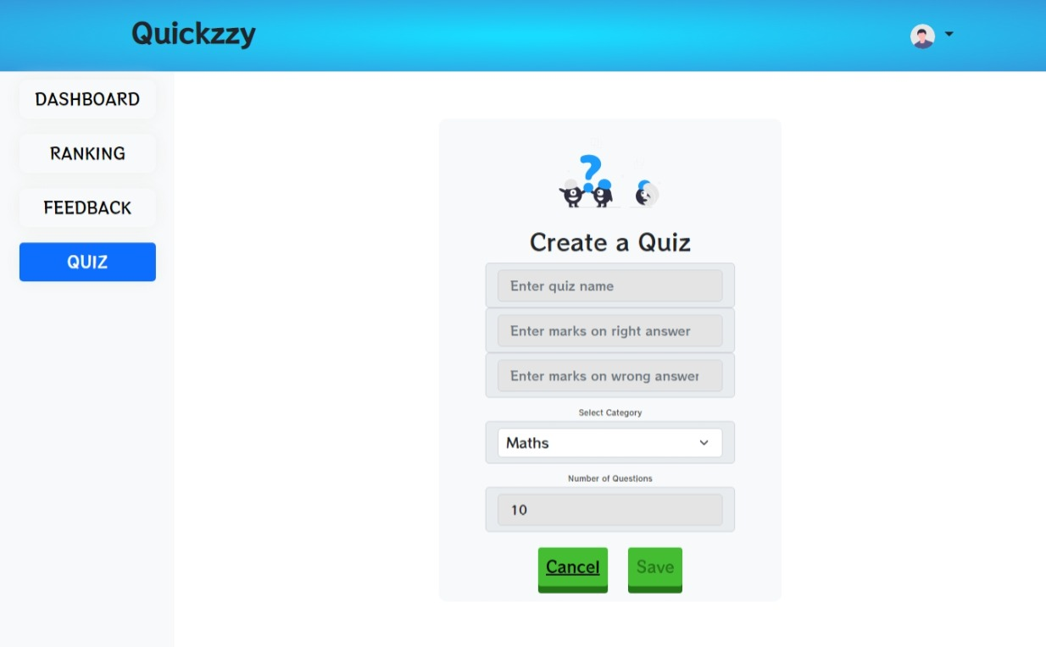

- Student Login: Able the students to Sign up to system with a valid user name and password. If student is successfully login to system, he/she will have access to following pages:

- Student Dashboard: Which have information about Online MCQ Quiz and issues support by this system for students.

- Attempt Test: Which able the student to select a particular test for attempting from the existing test in system from drop down list and after clicking on ‘go to the selected test’, the questions of selected test will be displayed for the student to attempt. Than student will be able to attempt the questions and after submitting, student will receive a message that test is successfully attempt.

- Marks: Which able the particular students to have access to result of the test
which he/she attempt.

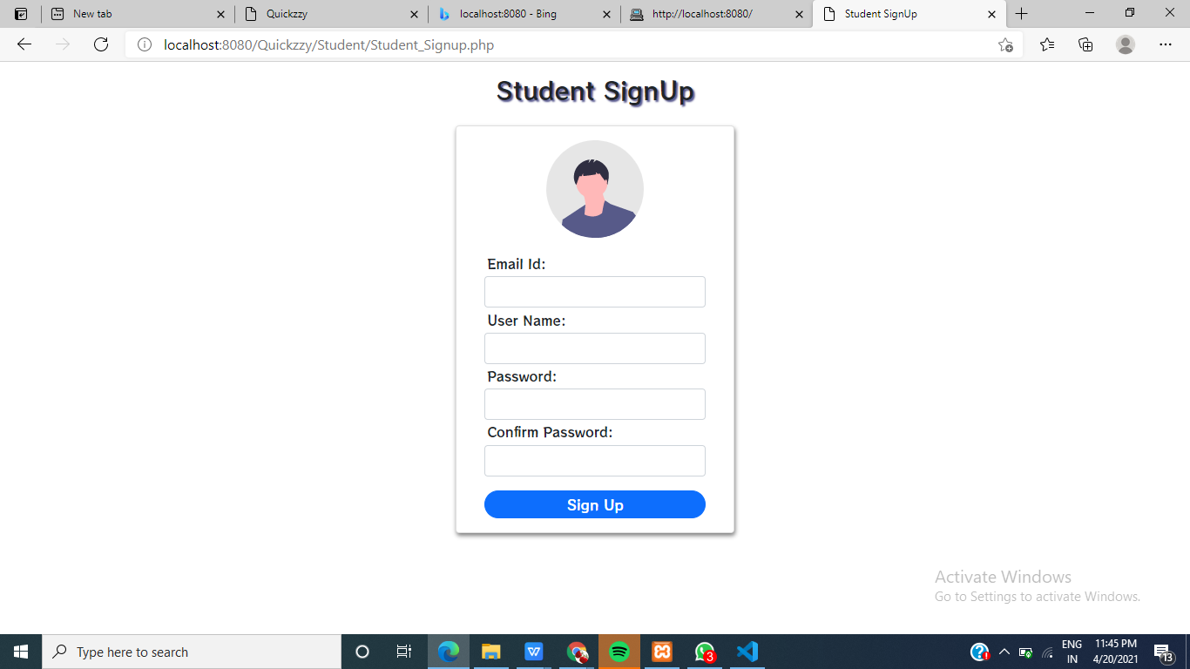

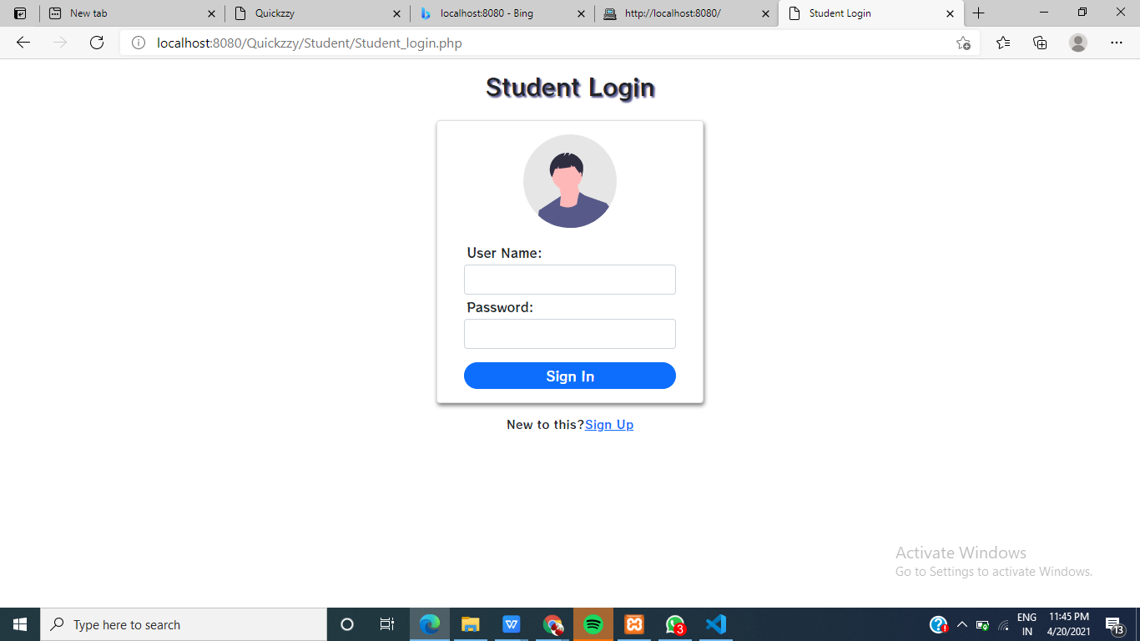

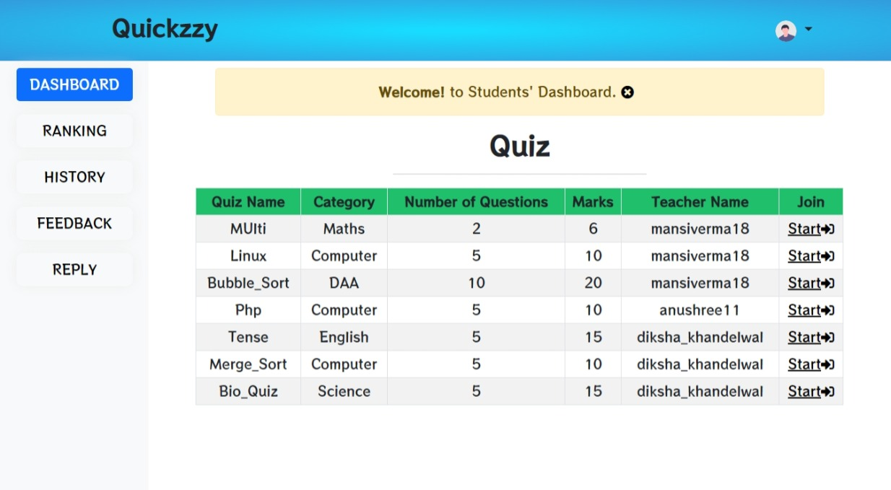

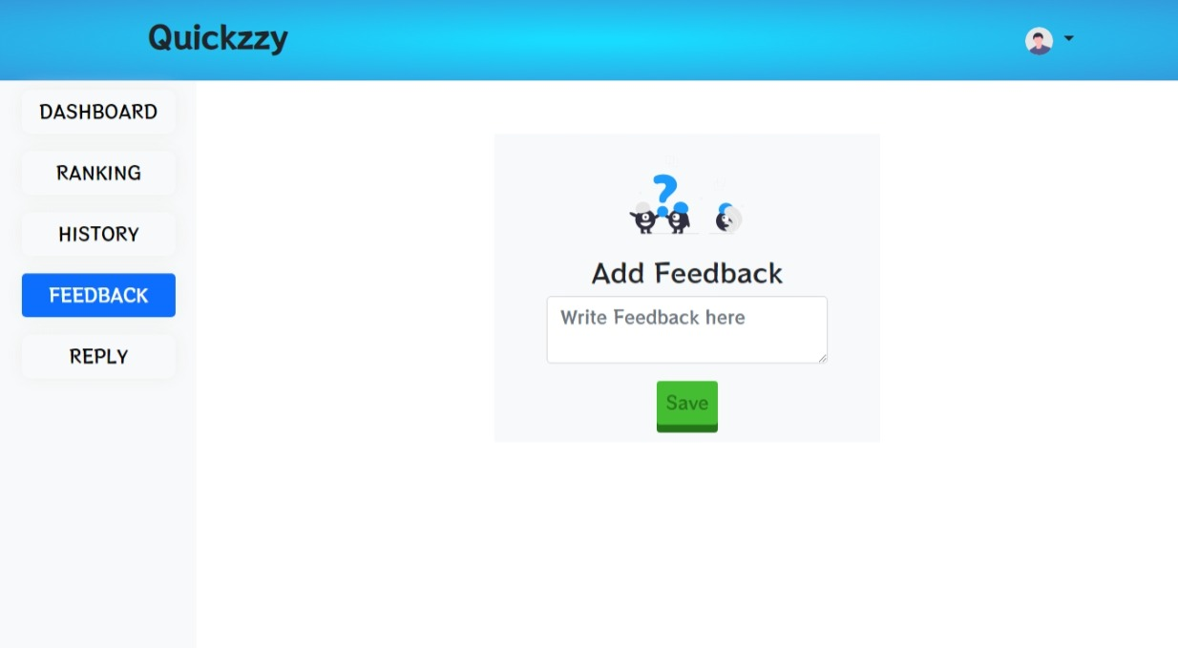

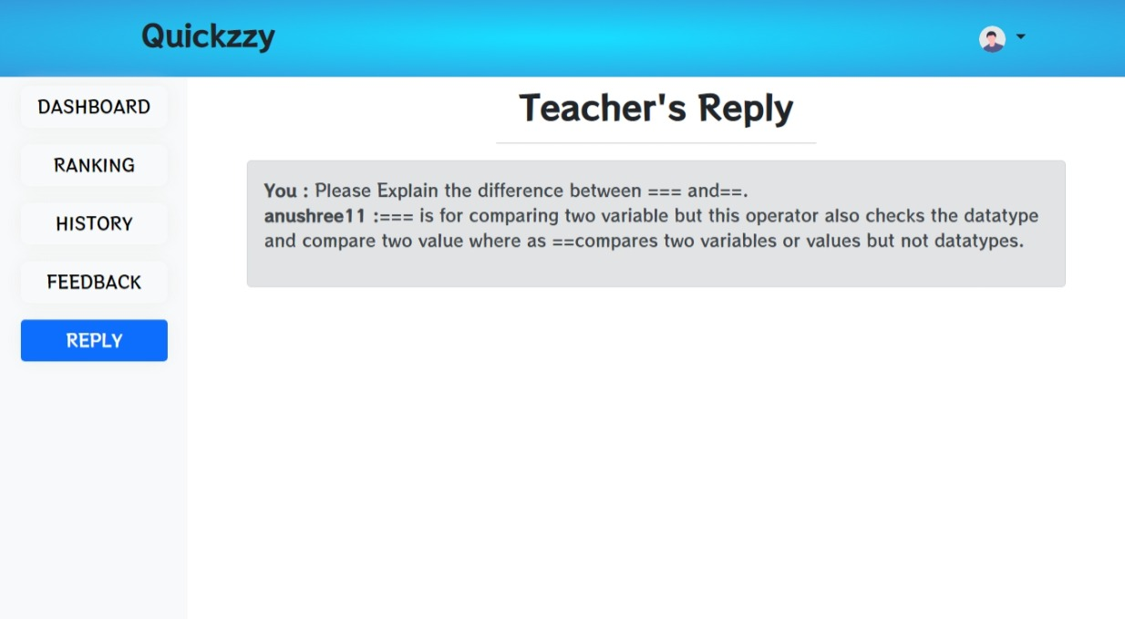

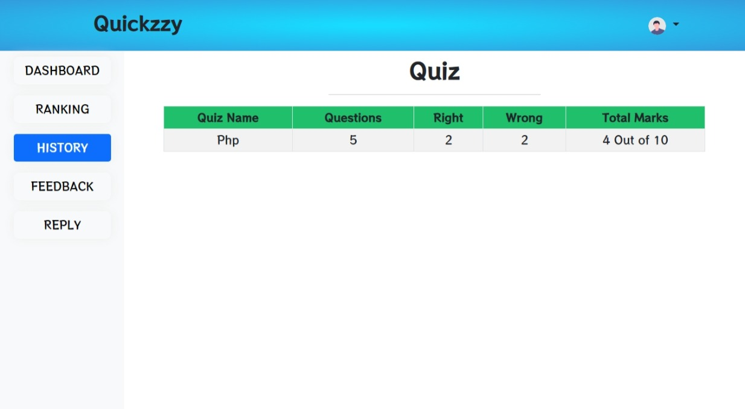

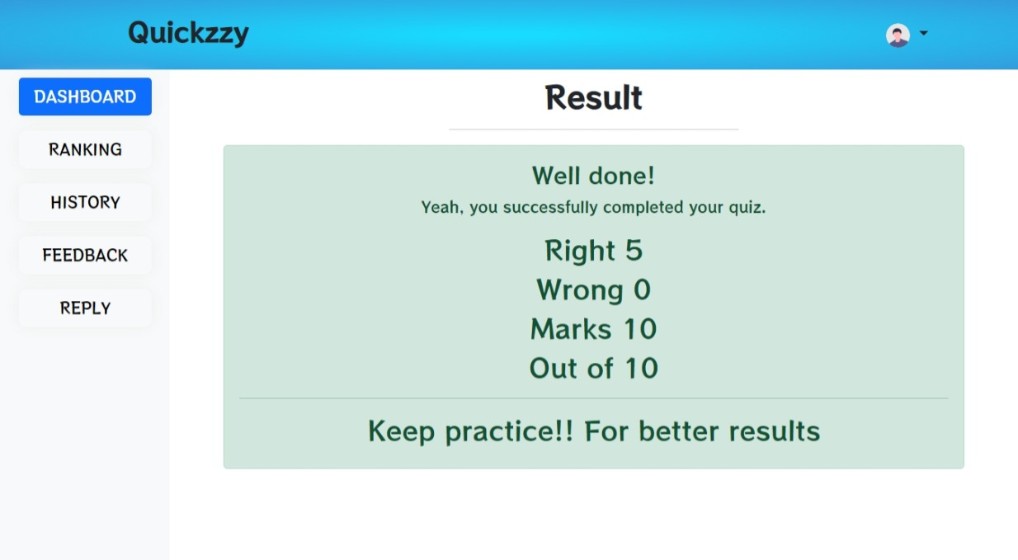

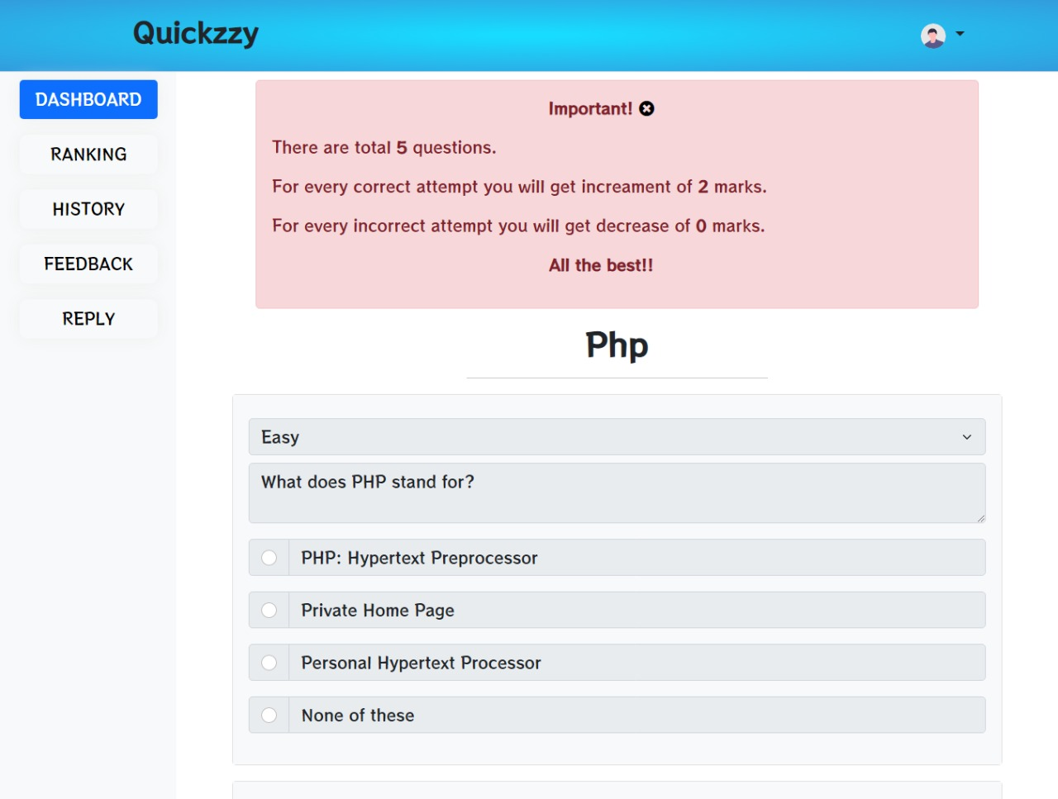

REFERENCES

