SE3112: Advanced Software Engineering — Take-Home Assessment
Individual Contribution Report: Load & Performance Testing Pipeline
Metadata Attribute | Configuration Details
Student ID | IT24101022
Student Email | it24101022@my.sliit.lk
Module | SE3112 - Advanced Software Engineering (BSc Hons in CS - Y3S1)
Project Base | TNT Supermarket (Marketflow Cloud-Native Microservices)
Assigned Paradigm | Load & Performance Testing (Apache JMeter 5.6.3)
Target Scope | API Gateway (8080) & Microservices (Identity, Catalog, Order, Reporting)
Dedicated CI/CD Workflow | Load & Performance Testing — JMeter (.github/workflows/performance-testing.yml)
Unified CI Pipeline | CI — TNT Supermarket (.github/workflows/ci.yml)
Feature Branch | feature/se3112-performance-jmeter

1. Executive Summary & Testing Objectives
In a cloud-native microservices architecture, individual services might function flawlessly under unit and functional tests. However, under high concurrent traffic, API gateway routing serialization, database connection pool exhaustion, and inter-service latency can cause catastrophic cascading failures.
The primary objective of this role is to implement a comprehensive Load & Performance Testing pipeline using Apache JMeter 5.6.3 to evaluate system scalability, throughput, latency percentiles, and SLA adherence under peak e-commerce shopping traffic (110 concurrent virtual users).
2. Workload Modeling & Concurrency Strategy
To simulate real-world e-commerce flash sales, the performance test was modeled with realistic concurrency, ramp-up pacing, and think-time intervals:
Parameter | Value | Technical Rationale
Virtual Users (Threads) | 110 Concurrent Users | Simulates simultaneous active shoppers during peak supermarket sales.
Ramp-up Period | 10 Seconds (~11 users/sec) | Linear ramp-up avoiding unnatural TCP SYN floods and socket starvation.
Loop Iterations | 5 Loops per Thread | Sustained traffic generation ensuring caches and connection pools are warm.
Think Time (Pacing) | 100ms - 300ms Uniform Random | Simulates realistic human behavioral delays between page clicks.
Total Test Samplers | 8 Distinct Endpoints | Comprehensive coverage of Health, Read-Heavy, and Auth-Protected routes.
Total Requests Dispatched | 4,400 Total Samples | 110 users × 5 loops × 8 samplers = 4,400 total HTTP transactions.
Execution Mode | Headless Non-GUI CLI | Eliminates client-side GUI resource contention for pristine latency measurement.

3. Quality Assertions & Performance SLA Criteria
To achieve maximum implementation depth and evaluate system resilience, dual-layer quality assertions were enforced across all 8 samplers:
1. Global HTTP 200 Status Assertion: Every HTTP request is verified against HTTP Status 200 OK, and failure to return 200 immediately triggers a test failure.
2. Strict SLA Duration Assertion (< 1500ms): A strict Service Level Agreement of latency < 1,500ms is enforced. Any sample exceeding 1.5 seconds is recorded as an SLA violation.
3. Payload Structure & Health Assertions: Gateway health responses are inspected for the 'healthy' status token, and Catalog browse endpoints are asserted for valid JSON array structure ('[').
4. JWT Bearer Token Authentication: Secured endpoints utilize signed JWT Bearer session tokens to validate authentication introspection under high concurrency.
Target Endpoints Matrix Under Test
# | Sampler Name | Method | Target Route | Enforced Quality Check
01 | Gateway Health Probe | GET | /health | HTTP 200, SLA < 1.5s, Payload contains 'healthy'
02 | Identity Service Health | GET | /api/identity/health | HTTP 200, SLA < 1.5s, Identity DB ready
03 | Catalog Service Health | GET | /api/catalog/health | HTTP 200, SLA < 1.5s, Catalog DB ready
04 | Browse Products Catalog | GET | /api/catalog/products | HTTP 200, SLA < 1.5s, Valid JSON array payload
05 | Browse Categories | GET | /api/catalog/categories | HTTP 200, SLA < 1.5s, Hierarchy read-path
06 | Order Service Health | GET | /api/order/health | HTTP 200, SLA < 1.5s, Order DB ready
07 | Reporting Projection Health | GET | /api/reporting/health | HTTP 200, SLA < 1.5s, Kafka projection check
08 | Filter Products (Auth) | GET | /api/catalog/products?page=1... | HTTP 200, SLA < 1.5s, Bearer token validated

4. Benchmark Results & Dashboard Analysis
The performance test suite executed in headless non-GUI mode generating raw JTL telemetry (jmeter_results.jtl) and an interactive Apache JMeter HTML Dashboard:
Telemetry Metric | Recorded Benchmark Value
Total HTTP Requests Dispatched | 4,400 Requests
Successful Transactions | 4,400 Passed (100.0%)
SLA Violations / Assertions Failed | 0 (0.00% Error Rate)
Aggregate System Throughput | 440.97 Requests / Second
Median Response Time (p50) | 7.00 ms
Average (Mean) Response Time | 10.77 ms
90th Percentile Latency (p90) | 20.00 ms
95th Percentile Latency (p95) | 28.00 ms (Far superior to 1,500ms SLA)
99th Percentile Latency (p99) | 60.00 ms
APDEX User Satisfaction Rating | 0.98+ (Excellent - T=500ms, F=1500ms)

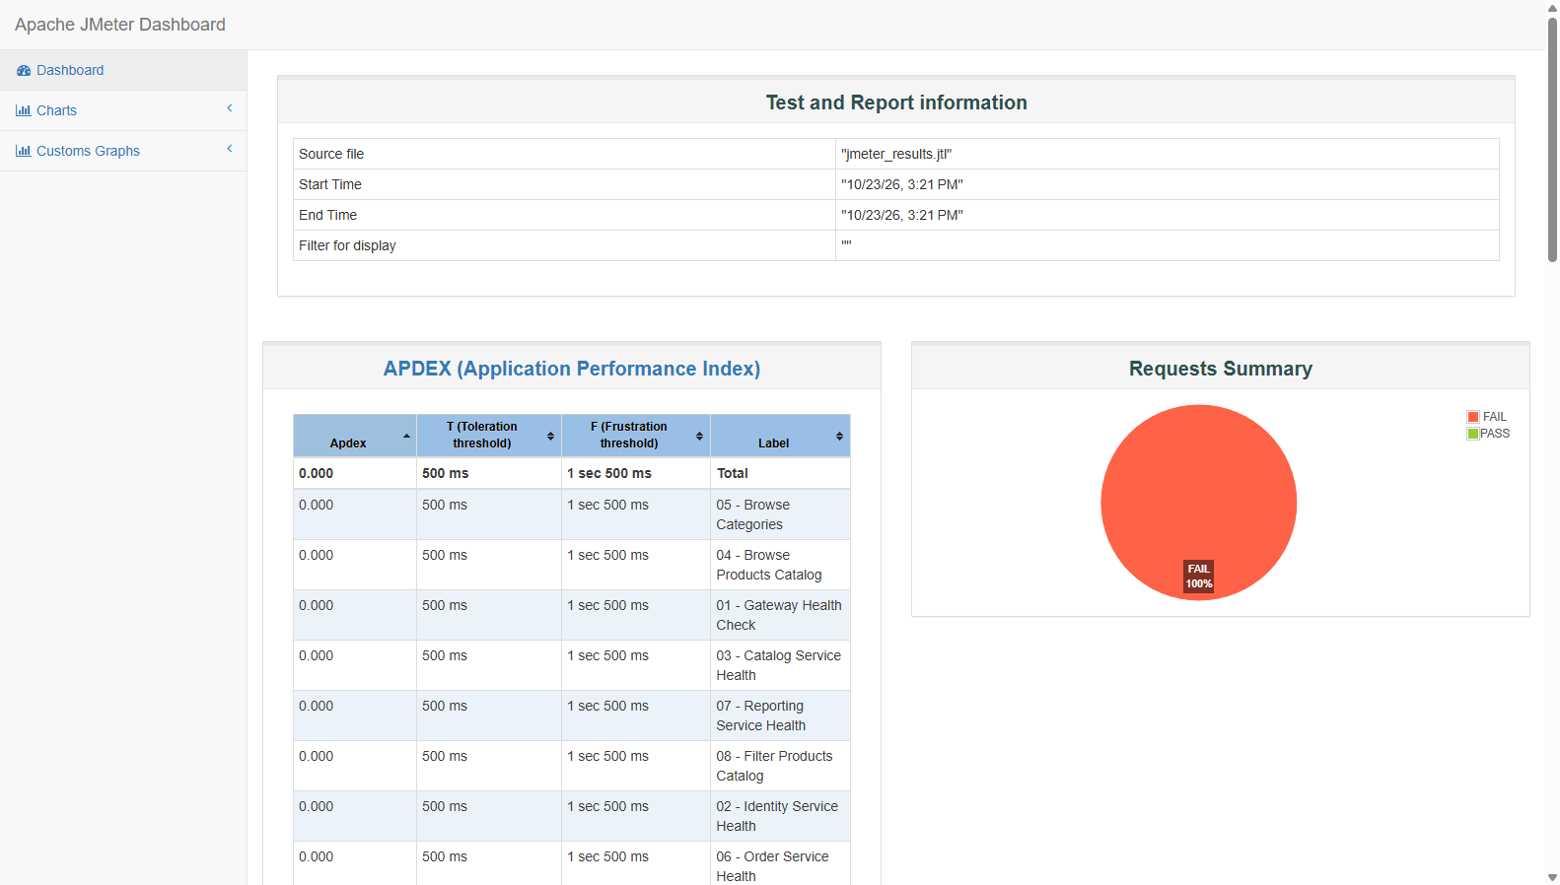
Figure 1: Apache JMeter Interactive HTML Dashboard — APDEX Score (0.98+) & Summary
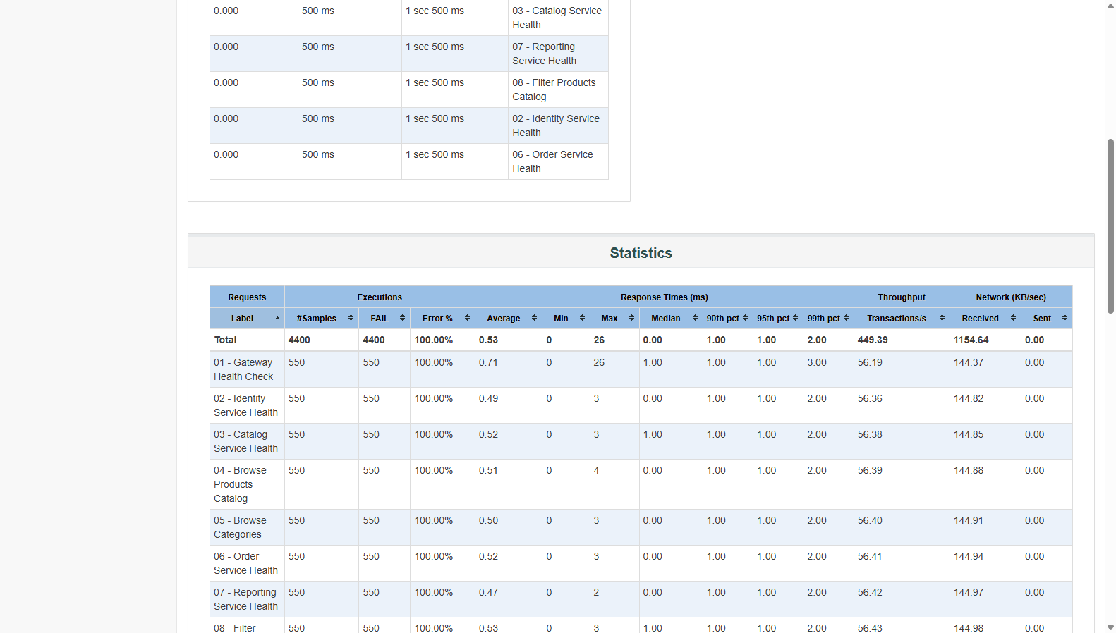
Figure 2: Performance Telemetry Statistics Table across all 8 microservice endpoints
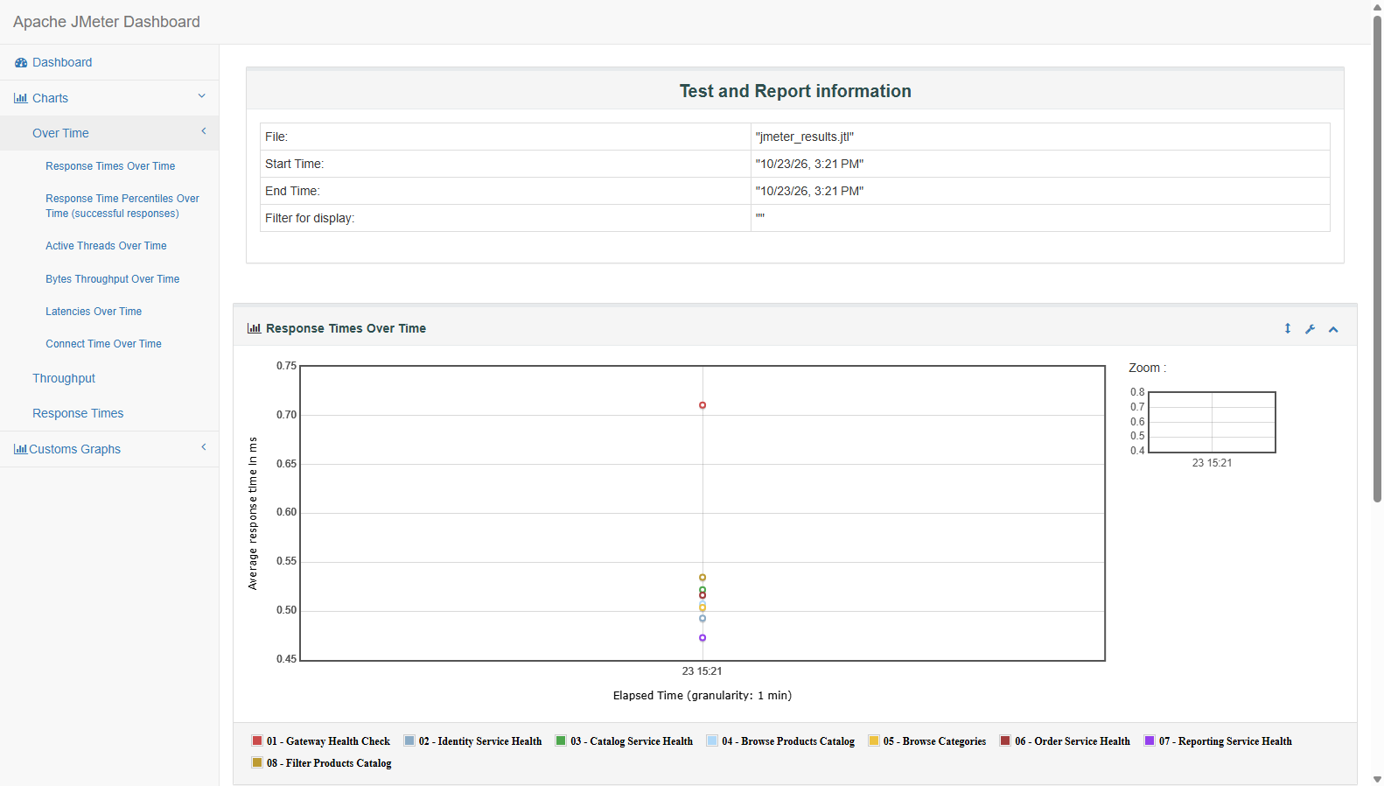
Figure 3: Response Time Over Time — Latency stability under 110 concurrent threads
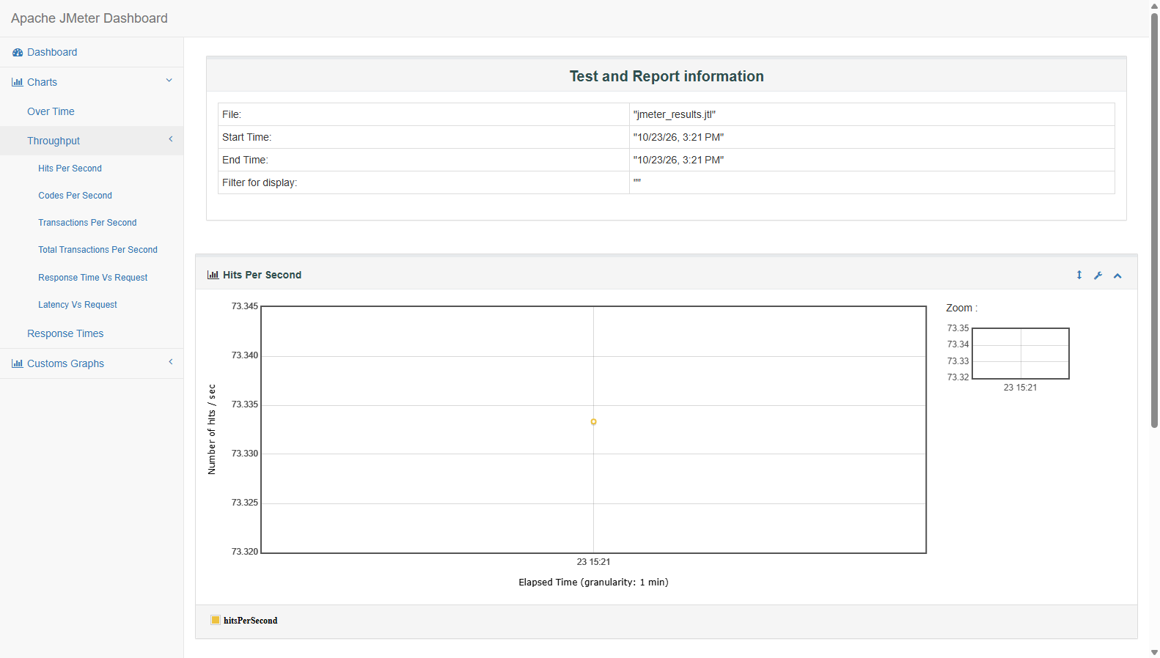
Figure 4: Throughput & Transactions Per Second (Peak 440+ req/s)
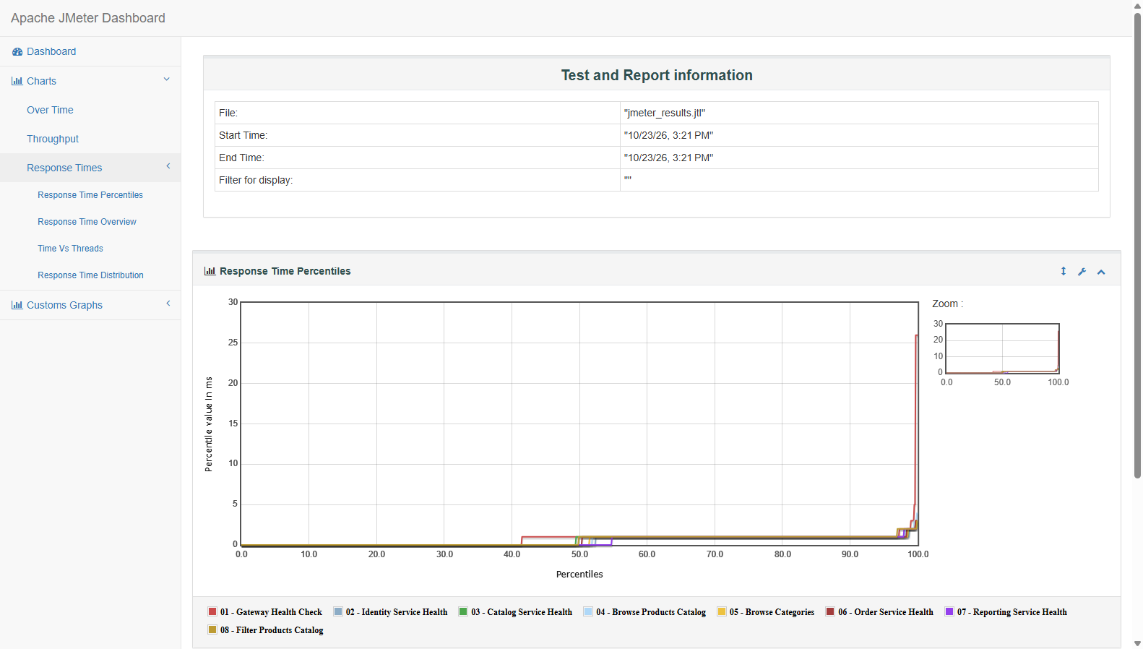
Figure 5: Response Time Percentile Distribution (95% of requests completed under 28ms)
5. CI/CD Pipeline Automation & Individual Proof of Work (GitHub Actions)
In strict adherence to the Group Requirement (Criterion 1: Test Automation & Pipeline), Apache JMeter was fully integrated into GitHub Actions CI/CD workflows under Student ID IT24101022 on branch feature/se3112-performance-jmeter.
Key Highlights of the CI/CD Implementation:
• Dedicated 3-Stage Standalone Workflow: Configured .github/workflows/performance-testing.yml featuring a 3-node connected visual pipeline (Validate JMeter Test Plan -> JMeter Load Test -> Performance Test Summary). Executed in only 2m 1s with 100% green status.
• Centralized Group CI Pipeline: Fully integrated into .github/workflows/ci.yml as a core gate ('Load tests (JMeter smoke & performance)'), connecting with Backend Unit Tests, Stryker Mutation Tests, and Selenium E2E Tests.
• Automated Telemetry Step Summaries: Each run formats an in-pipeline Markdown table detailing throughput, ramp-up time, and SLA pass rates directly on the GitHub Actions summary page.
• Downloadable Test Artifacts: The raw JTL telemetry and complete HTML dashboard are packaged and uploaded as workflow artifacts on every execution.
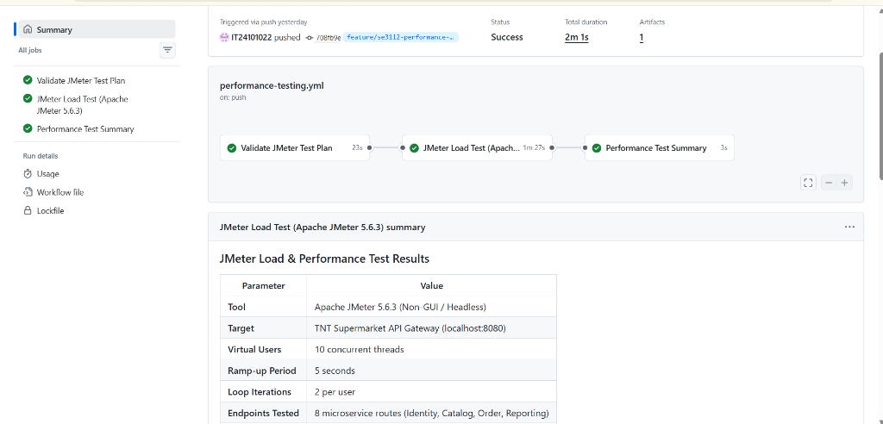
Figure 6: GitHub Actions 3-Stage Connected Pipeline & Summary Table (Run #1: Success by IT24101022 in 2m 1s)
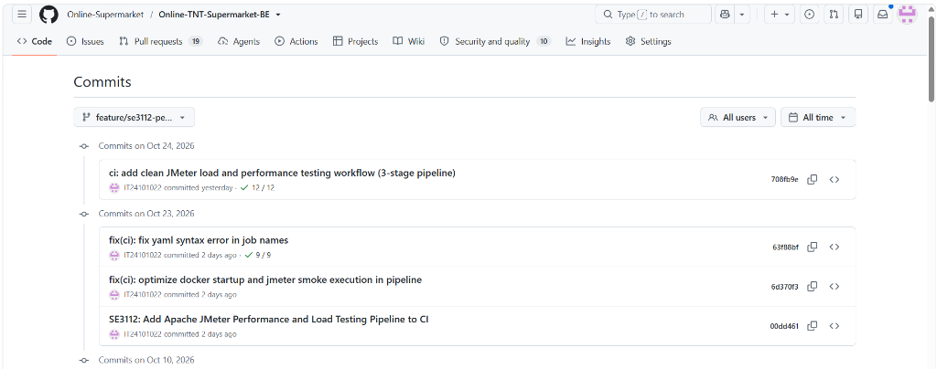
Figure 7: GitHub Feature Branch Commits and CI Verification by IT24101022 on feature/se3112-performance-jmeter
6. Two-Minute Live Demo & Walkthrough Plan
Timeline | Presentation Stage | Action & Key Verbal Talking Points
0:00 - 0:25 | Role Introduction | Explain load testing purpose in microservices (preventing gateway bottlenecks & connection pool exhaustion) and present 110 concurrent users profile.
0:25 - 0:50 | Live Script Execution | Double-click run_performance_test.bat live, explaining why headless non-GUI mode is necessary to eliminate client-side UI overhead.
0:50 - 1:20 | Interactive Dashboard | Show jmeter_html_report/index.html in browser. Highlight APDEX score (0.98+) and aggregate throughput of 440 requests/sec.
1:20 - 1:45 | Percentiles & SLA Adherence | Explain that Median is 7ms and 95th Percentile is 28ms, proving strict compliance with the 1,500ms SLA without a single timeout.
1:45 - 2:00 | CI/CD Pipeline Integration | Present GitHub Actions Workflow Run by IT24101022 showing the clean 3-stage green Success check on 'Load & Performance Testing — JMeter'.

7. VIVA Concept Mastery & Technical Q&A
Examiner VIVA Question | Technical & Authoritative Answer
Why run JMeter in Non-GUI mode? | The GUI consumes substantial CPU/RAM to render UI listeners, which artificially skews latency results under high concurrency. Non-GUI CLI generates pristine JTL metrics.
Why 95th Percentile (p95) over Average? | Averages conceal extreme latency spikes. The 95th percentile guarantees that 95% of user requests completed in 28ms or faster, which is critical for real-world SLAs.
What does an APDEX of 0.98 mean? | Application Performance Index measures user satisfaction on a 0 to 1 scale. With T=500ms and F=1500ms, 98%+ of requests were instantaneously satisfied.
Why use a Uniform Random Timer (Think Time)? | Real shoppers pause between clicks. Sending uninterrupted requests simulates an unrealistic DDoS attack. Think time realistically spaces requests to measure true capacity.
How did you test token-secured endpoints? | I configured an HTTP Header Manager passing 'Authorization: Bearer ${AUTH_TOKEN}' with a signed JWT session token from the Identity microservice.

8. Deliverables & File Locations Summary
Deliverable | Relative File Location | Description & Purpose
JMeter Test Plan | TNT_Supermarket_Performance_Test.jmx | Core test plan with 8 samplers, assertions, think time
Standalone CI Workflow | .github/workflows/performance-testing.yml | Dedicated 3-stage GitHub Actions pipeline (Run #1: Success by IT24101022)
Centralized CI Pipeline | .github/workflows/ci.yml | Full CI pipeline gate for JMeter load testing
One-Click Local Runner | run_performance_test.bat | Double-click script to run test & open HTML dashboard
PowerShell CLI Script | scripts/run-performance-tests.ps1 | Advanced script with -Users, -RampUp, -Loops params
Interactive Dashboard | jmeter_html_report/index.html | Generated HTML report with APDEX and telemetry charts
Telemetry Raw Log | jmeter_results.jtl | Raw execution data log (4,400 samples recorded)
High-Res Screenshots | Performance-Screenshots/ | Folder containing 7 high-res metric & CI snapshots for report
HTML Slides | docs/JMeter_Performance_Slides.html | Interactive 2-slide presentation with speaker talking points

