The main Home and Landing Page has several comments to make it clear that this is an assistive tool for the Therapist and that the session is “Clinician-led”:
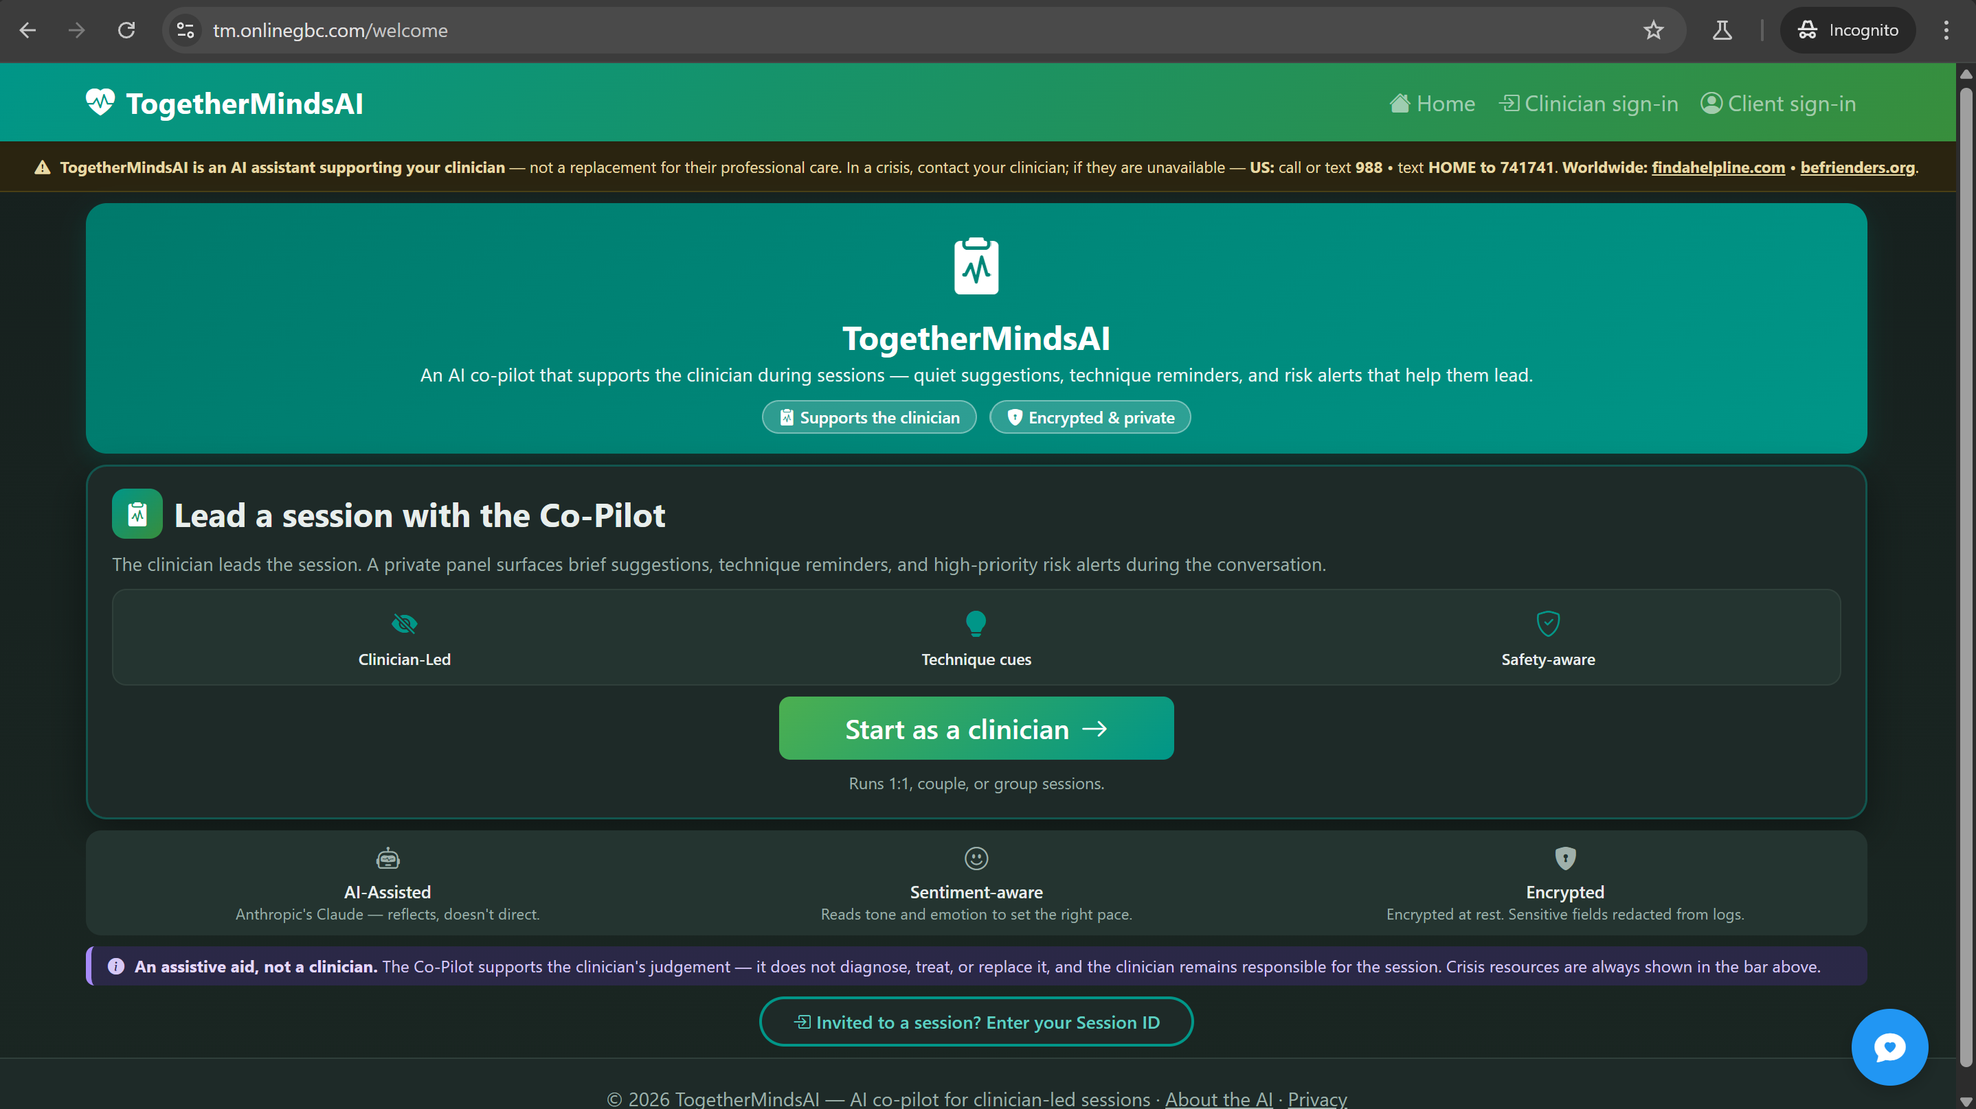

Disclaimer before client joins
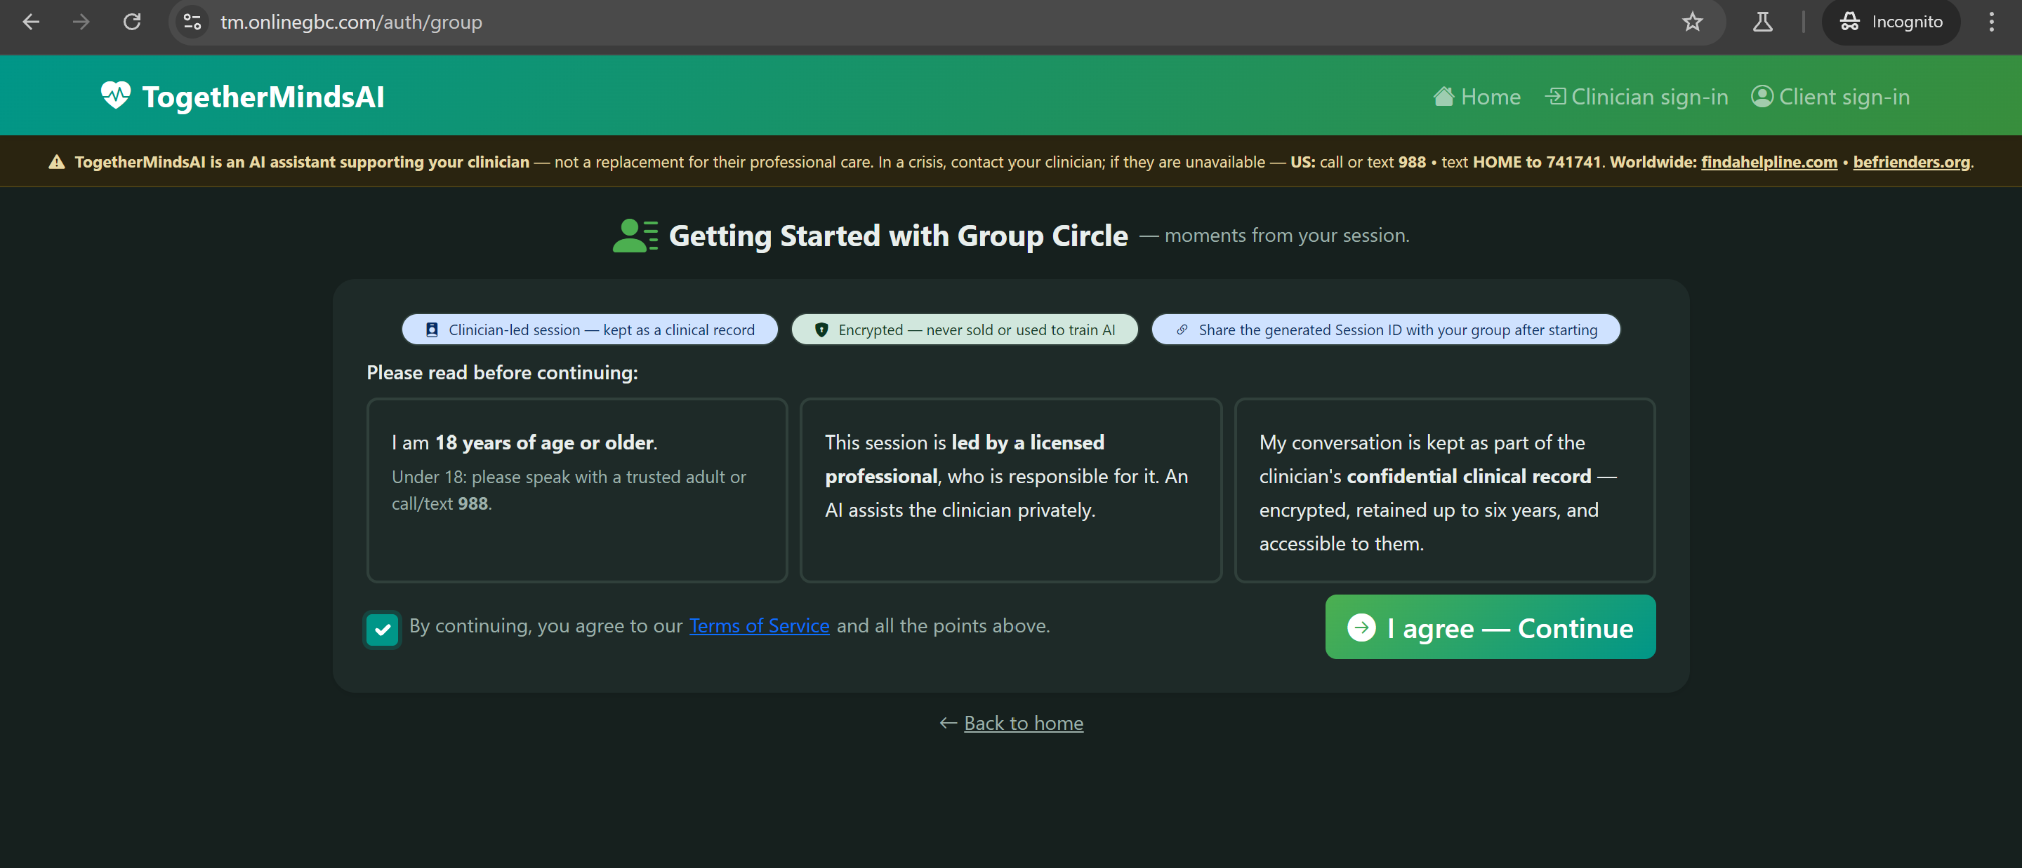

Yet another disclaimer:
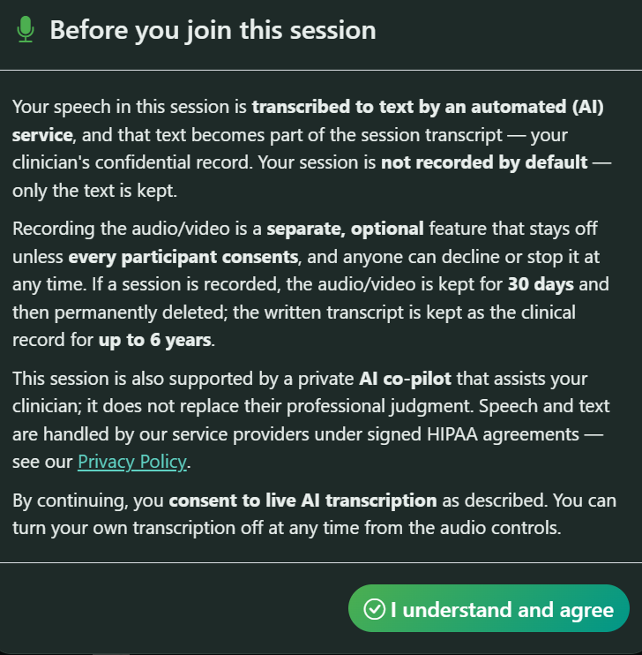

Full Privacy policy: https://tm.onlinegbc.com/privacy
Full Terms of Service: https://tm.onlinegbc.com/tos

