BNSI use-case: Experimental OJAs statistics

Introduction

The Bulgarian use-case on web scraping of OJAs for producing experimental statistical outputs is being done as part of an ESSNet on BDII, WPB. This work started in the beginning of 2019 and the BNSI still continue to work on it, even after the end of the ESSnet project. Our ambitions are to improve our initial findings and to produce statistical indicators as such that can serve to enrich the job vacancy statistics or to measure the on-line labour by demand side.
This paper focuses on the OJAs results achieved so far from BNSI team and some main challenges in using OJAs for official statistics purposes from the beginning of the project till August 2020.
In general, BNSI is interested in producing experimental statistics about the OJAs as new statistics derived from the big data sources (job portals) and as complementary statistics for on-line labour market to the regular JVS as well.
In order to be methodologically correct, the following main considerations and assumptions must be taken into account when producing the experimental OJAs statistics:
- The traditional JVS takes account of job vacancies declared by employers at the end of each quarter (according to a European Regulation) i.e. definition of a concept “job vacancy” can be understood as the vacant position within an enterprise that the enterprise is trying to fill. The concept “job vacancy” is different from the concept “job advertisement” and is not possible to produce job vacancy statistics via simple counting the number of job advertisements;
- An “on-line job advertisement” (OJA) is defined as the unstructured text on a job portal, job boards etc. websites consisting information about a given job vacancy. It means that there is a clear distinction between OJV and OJA: an OJA is only indicates the existence of a job vacancy within an enterprise or a recruitment agency. In many cases, an OJA contains more than one job vacancy although there is cases where relationship between OJA and OJV is one-to-one. Vice-versa – a job vacancy could be advertised on a number of different job portals;
- The distribution by characteristics covers only those OJAs, where the relevant characteristics were found during the scraping process;
- The OJAs experimental statistics can not replace the traditional JVS. It still needed and the challenge is how to integrate data from different sources in order to produce statistics that are most useful for labour market policies.
- OJAs home data
Data Sources
Data from OJAs are a very rich data source. They provide almost real-time information on the types of jobs, where jobs are located and some other important characteristics of job vacancy.
BNSI used the extracted OJAs from the two biggest Internet job-portals in Bulgaria: www.jobs.bg and www.zaplata.bg to produce experimental statistical.
These two jobs portals publish daily almost 95% of the total number of OJAs from all job portals in Bulgaria and this makes them sufficiently representative to produce OJAs experimental statistics. Therefore, the BNSI decided not to scrape the other small jobs portals to save effort and resources.
For the purposes of analyzing the COVID-19 lockdawn situation, the administrative daily data on registered unemployment has been received from National Employment Agency.
Methodology
The total number of weekly/monthly/quarterly OJAs for the reference period is calculated from the sum of the newly daily published on www.jobs.bg and www.zaplata.bg. Duplicate advertisements on both portals are removed before the OJAs are encoded and classified.
The OJAs indicators do not reflect the total number of job advertisements on the Bulgarian labor market as it does not include jobs advertised through other channels – enterprises websites, social media, newspapers or through informal communications such as word of mouth. In addition, it is possible that some vacant job positions are not advertised at all.
The following experimental indicators for OJAs by weeks/months/quarters for the period were produced:
- Number of OJAs and change (flow)
- Number of OJAs and change by Educational_level (flow)
- Number of OJAs and change by Full_and_part_time_work (flow)
- Number of OJAs and change by Permanent and temporary job (flow)
- Number of OJAs and change by NACE 2.0 Level 1 (flow)
- Number of OJAs by NUTS 3 (flow)
- Number of OJAs by average salary (flow)
BNSI is doing OJAs experimental statistics in four main steps, which are performed in daily, weekly monthly or quarterly basis. The steps are executed automatically with scheduled Python scripts.

Step 1: Scraping
BNSI is doing scraping of OJAs on daily basis. During the scraping, we are saving OJAs that are published only yesterday, i.e. the day before the real scraping. We are using Python’s Scrapy library with custom written spiders. They are using configuration files in JSON format with instructions what to be scraped and from where. A log file is written during the scraping. The spiders are saving the scraped data in CSV files by days. The CSV files have 26 columns of semi-structured information.
Step 2: Validation
BNSI is doing validation step daily on the scraped CSV file with yesterday OJAs data by Python script. The validation step is checking whether the obtained OJAs records are well structured, i.e. dose the column contains expected data or not. In addition, the script is transforming date column in the same pattern. Then the script is saving the OJA records without errors in CSV files by days.
Step 3: Encoding
BNSI is doing encoding step daily on the all validated CSV files with OJAs data by Python script. First, the script de duplicates all records by all columns and keeps only the first record. Then the script de duplicates all records by date, OJA publisher (employer), populated place, country and OJA title and keeps only the first record. Then the script encodes the OJA by the following characteristics:
- Educational levels;
- Permanent or temporary work;
- Full or part time work;
- Country codes;
- Min. and Max. Salary
- NUTS 3 levels – from populated places classification and OJA populated place;
- Enterprise’s ID code (Statistical Business Register code) – full string comparison of OJA publisher and SBR enterprise name;
- NACE 2 codes – from enterprise’s identification code and SBR NACE information.
The script is saving the encoded OJAs data in two CSV files:
- All OJAs records;
- OJAs records placed in Bulgaria.
The NACE code has been assigned only for employers who encoded from SBR with ID code. The sub-population of OJAs encoded to NACE is around 45% of the total number of OJAs population.
Step 4: Experimental statistics and statistical indicators
BNSI is calculating experimental OJAs statistics according to the list of indicators, mentioned above.
Results
The experimental data for OJAs are available on the Intranet site of BNSI, under the dedicated Experimental statistics section and on the WPB wiki page:
https://webgate.ec.europa.eu/fpfis/mwikis/essnetbigdata/index.php/WPB_Experimental_statistics

- First results: May - July 2019 (testing phase)

The original number of OJAs extracted for the period from the two sites totaled 195,950. After clearing duplicate records (by comparing all OJAs variables and secondary de-duplication by date, company, city, country and job) 181 059 OJAs records were finally received i.e., 7.6% duplicate records have been deleted.
Obtained data on OJAs by districts of the country offered by the employers show that the largest number is in the districts of Bourgas (4727), Varna (6434), Plovdiv (5654) and Sofia (25462). It can be said that the large number of online vacancies in these areas is logical, given that they contain the largest cities of the country which are industrial and administrative centers. The majority of the country's population is concentrated there compared to the other 24 districts. Some exceptions are observed in Veliko Tarnovo district - 1293 OJVs, Blagoevgrad - 1134, Rousse - 1540 and Stara Zagora - 1577 OJVs. In contrast to the areas mentioned above, a four-digit number for the number of job vacancies in these four areas can also be considered as a temporary phenomenon, since the observed period is too short.
For the correctness of the analytical comparisons by the country districts (NUTS 3), a series of indicators was calculated, as the number of OJAs is related to the number of population, work force, employed and unemployed by the country districts (Table 1).

Table 1: Number of OJVs and main proportions (in ‰) for the period May - July 2019
NUTS 3 | Monthly Mean | Population to Mountly mean | Workforce to Mountly mean | Employed to Mountly mean | Unemployed to Mountly mean
Blagoevgrad | 1134 | 4 | 6 | 8 | 155
Burgas | 4727 | 12 | 19 | 26 | 468
Dobrich | 726 | 4 | 7 | 10 | 105
Gabrovo | 534 | 5 | 9 | 12 | 254
Haskovo | 682 | 3 | 5 | 7 | 227
Kardzhali | 249 | 2 | 3 | 4 | 119
Kyustendil | 343 | 3 | 5 | 7 | 191
Lovech | 353 | 3 | 5 | 8 | 71
Montana | 251 | 2 | 3 | 6 | 33
Pazardzhik | 948 | 4 | 6 | 9 | 182
Pernik | 503 | 4 | 7 | 10 | 123
Pleven | 949 | 4 | 7 | 10 | 114
Plovdiv | 5654 | 8 | 14 | 19 | 496
Razgrad | 260 | 2 | 4 | 6 | 50
Ruse | 1540 | 7 | 12 | 16 | 291
Shumen | 752 | 4 | 7 | 10 | 77
Silistra | 207 | 2 | 3 | 5 | 40
Sliven | 492 | 3 | 5 | 7 | 63
Smolyan | 164 | 2 | 3 | 3 | 30
Sofia | 677 | 3 | 5 | 6 | 967
Sofia (stolitsa) | 25462 | 19 | 30 | 37 | 1768
Stara Zagora | 1577 | 5 | 9 | 11 | 464
Targovishte | 281 | 3 | 4 | 6 | 49
Varna | 6434 | 14 | 22 | 31 | 677
Veliko Tarnovo | 1293 | 5 | 9 | 13 | 223
Vidin | 199 | 2 | 4 | 7 | 27
Vratsa | 429 | 3 | 5 | 8 | 68
Yambol | 421 | 4 | 6 | 9 | 100
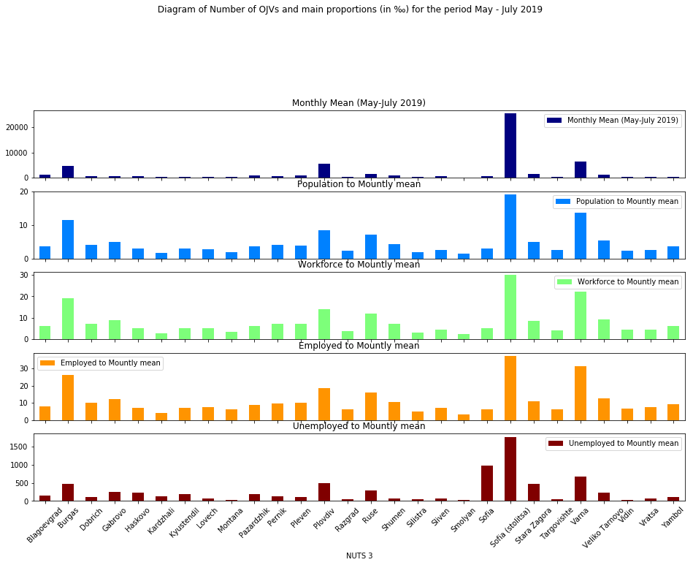

Most interesting is the indicator - OJAs offered per 1000 unemployed people under NUTS3 for the period May-July 2019. For example, there are 1768 OJVs offered to 1000 unemployed people in Sofia – the capital. The high number of job vacancies shows that employers are looking for skilled workers for their businesses. For the other larger districts the same data are as follows per 1000 unemployed: Sofia district - 967; Burgas - 468; Varna - 677; Plovdiv - 496. In regions, where the population is relatively smaller, OJVs per 1 000 unemployed are: Veliko Tarnovo - 223; Gabrovo - 254; Dobrich - 105; Kardzhali - 119; Kyustendil - 191; Pazardzhik - 182; Pernik - 123; Pleven - 114; Haskovo - 227. In the smallest districts, OJVs per 1000 people unemployed are as follows: Shumen - 77; Yambol - 100; Vidin 27; Vratsa - 68; Lovech - 71; Montana - 33; Silistra - 40; Sliven - 63; Smolyan - 30; Targovishte - 49. It should be noted that the population factor (total, working age, employed and unemployed), as a whole, is important, but it is also ranked by a number of other factors and reasons characterizing each of the 28 areas of the country. This means that the geographical position of the district, the communications that have been built, as well as a number of socio-demographic and economic factors that determine the employment potential of the population, respectively for the offered number of online vacancies, are important for the dimension of each indicator.
Another interesting indicator from Table 1 is the ratio of OJVs offered per 1,000 employees. In the districts with the largest cities of the country there is also an increase in the available vacancies per 1000 people employed. For Sofia - the capital these are 37, Plovdiv - 19, Burgas - 26 and Varna - 31 offered OJVs. In other areas of the country, this indicator has relatively lower values. For the period considered, there are few online jobs available per 1000 people employed, which can be explained by the increased demand and job finding, which is the result of the favorable for work summer season. These two indicators are directly relevant to the labor market. In this sense, they characterize and focus on the aggregates of the population that are directly related to OJAs for searcing of labour force.
The data on other ratios between the number of OJVs and the population, respectively relative to the working population in the districts of the country, show smaller values. They reflect in a more generalized way the processes of the labor market, as they are tailored to the size of the districts, and especially to the size of the district cities. This makes them fairly comparable, but with relatively less relevant information on the current situation on the labor market and its changes.
The main conclusion from the data is that, under other things being equal, the demand and supply of job vacancies in the labor market strive for balance. In the larger areas of the country more jobs are offered online. Obviously, the demand and supply are the highest there, but the requirements of the employers are also higher in terms of the skills of workers (see Table 2).

Table 2: Distribution of OJAs by Educational level and NUTS 3
Educational level | Higher | Primary | Secondary
NUTS 3
Blagoevgrad | 117 | 1 | 61
Burgas | 246 | 17 | 217
Dobrich | 41 | 0 | 55
Gabrovo | 56 | 0 | 54
Haskovo | 54 | 1 | 44
Kardzhali | 28 | 0 | 19
Kyustendil | 25 | 0 | 27
Lovech | 46 | 1 | 32
Montana | 29 | 0 | 15
Pazardzhik | 87 | 1 | 80
Pernik | 35 | 2 | 49
Pleven | 80 | 2 | 68
Plovdiv | 493 | 11 | 453
Razgrad | 30 | 0 | 21
Ruse | 144 | 2 | 116
Shumen | 84 | 0 | 59
Silistra | 19 | 0 | 18
Sliven | 43 | 1 | 29
Smolyan | 15 | 0 | 11
Sofia | 63 | 1 | 94
Sofia (stolitsa) | 2259 | 87 | 1662
Stara Zagora | 133 | 2 | 99
Targovishte | 31 | 0 | 18
Varna | 458 | 6 | 368
Veliko Tarnovo | 121 | 1 | 115
Vidin | 13 | 0 | 9
Vratsa | 32 | 0 | 24
Yambol | 37 | 0 | 34

The distribution of the offered OJVs by districts of the country and degrees of education over the observed period indicates that specialists with higher and secondary education are most in demand. This indicates that the innovative approaches to work in most businesses in the country require skilled labor. Obviously, the competition and prosperity of businesses, nationally and internationally, dictates to employers the need to seek and hire individuals with more knowledge and skills. This situation is well expressed in the largest regions of the country: Sofia - the capital, Plovdiv, Varna and Burgas.

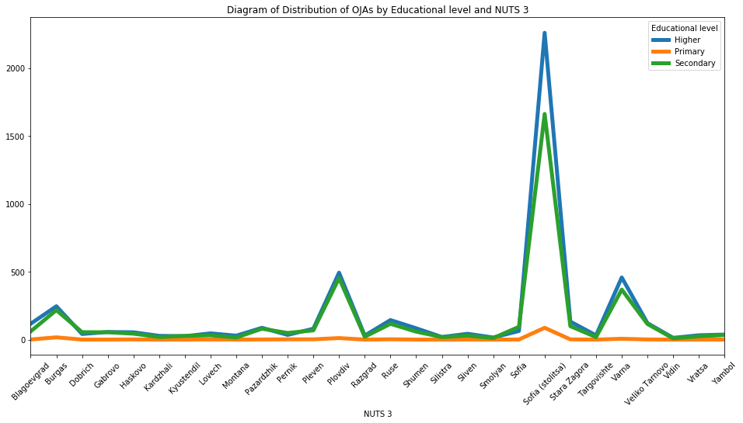
Another feature of OJVs is the type of working time, with 95% of all advertisements being offered at the national level for the May-July 2019 period are for full time jobs.
From the total number of OJAs for the period May-July 2019, for only 70 937 OJAs (or 40% of all) we have found the economic sector of employers offering online job vacancies according to the NACE Rev. 2. This is done by comparing the name of the employer from the advertisement in the job portals to the company name from the statistical business register. In this way, the economic activity from the register was joined to a job advertisement (Table 3).

Table 3: Distribution of OJAs by NUTS 3 and NACE Level 1 for the period May-July 2019
NACE Level 1 | C | D | E | F | G | H | I | J | L | M | N | S
NUTS 3
Blagoevgrad | 94 | 6 | 1 | 25 | 196 | 30 | 147 | 14 | 25 | 28 | 19 | 0
Burgas | 169 | 6 | 3 | 123 | 587 | 70 | 672 | 31 | 92 | 76 | 139 | 2
Dobrich | 86 | 5 | 1 | 15 | 107 | 21 | 72 | 4 | 9 | 11 | 14 | 0
Gabrovo | 88 | 5 | 0 | 8 | 79 | 16 | 17 | 1 | 6 | 2 | 12 | 0
Haskovo | 73 | 2 | 3 | 10 | 110 | 17 | 47 | 1 | 1 | 11 | 14 | 0
Kardzhali | 26 | 2 | 1 | 7 | 24 | 6 | 32 | 2 | 1 | 10 | 5 | 0
Kyustendil | 20 | 3 | 0 | 9 | 39 | 16 | 22 | 2 | 0 | 24 | 9 | 0
Lovech | 65 | 1 | 2 | 3 | 40 | 10 | 20 | 7 | 4 | 3 | 3 | 0
Montana | 27 | 2 | 0 | 5 | 43 | 8 | 34 | 2 | 1 | 7 | 7 | 0
Pazardzhik | 119 | 2 | 6 | 43 | 99 | 46 | 54 | 6 | 6 | 12 | 24 | 0
Pernik | 44 | 7 | 1 | 20 | 65 | 28 | 26 | 5 | 7 | 5 | 24 | 0
Pleven | 143 | 8 | 0 | 30 | 131 | 32 | 49 | 4 | 5 | 12 | 24 | 0
Plovdiv | 538 | 8 | 8 | 136 | 707 | 160 | 312 | 57 | 60 | 131 | 302 | 0
Razgrad | 23 | 4 | 0 | 6 | 35 | 13 | 11 | 5 | 1 | 2 | 3 | 0
Ruse | 219 | 7 | 0 | 17 | 209 | 58 | 84 | 24 | 7 | 18 | 52 | 2
Shumen | 104 | 7 | 2 | 34 | 119 | 22 | 20 | 4 | 6 | 7 | 31 | 1
Silistra | 15 | 2 | 0 | 3 | 49 | 5 | 20 | 5 | 0 | 2 | 1 | 0
Sliven | 54 | 2 | 0 | 10 | 73 | 12 | 41 | 0 | 2 | 6 | 26 | 0
Smolyan | 36 | 0 | 0 | 3 | 22 | 9 | 15 | 3 | 0 | 4 | 5 | 0
Sofia | 124 | 6 | 0 | 9 | 86 | 13 | 14 | 2 | 2 | 7 | 28 | 0
Sofia (stolitsa) | 978 | 47 | 52 | 546 | 2586 | 499 | 1086 | 738 | 243 | 784 | 1069 | 11
Stara Zagora | 139 | 5 | 1 | 59 | 213 | 52 | 109 | 23 | 12 | 21 | 48 | 2
Targovishte | 16 | 4 | 0 | 5 | 43 | 12 | 8 | 4 | 2 | 5 | 4 | 0
Varna | 331 | 20 | 11 | 145 | 886 | 137 | 839 | 80 | 100 | 166 | 206 | 1
Veliko Tarnovo | 165 | 9 | 0 | 17 | 191 | 34 | 110 | 14 | 13 | 22 | 18 | 0
Vidin | 9 | 2 | 0 | 5 | 33 | 9 | 19 | 1 | 0 | 5 | 3 | 0
Vratsa | 43 | 4 | 0 | 32 | 48 | 26 | 10 | 5 | 4 | 10 | 10 | 0
Yambol | 37 | 2 | 0 | 8 | 64 | 10 | 20 | 4 | 2 | 4 | 3 | 0

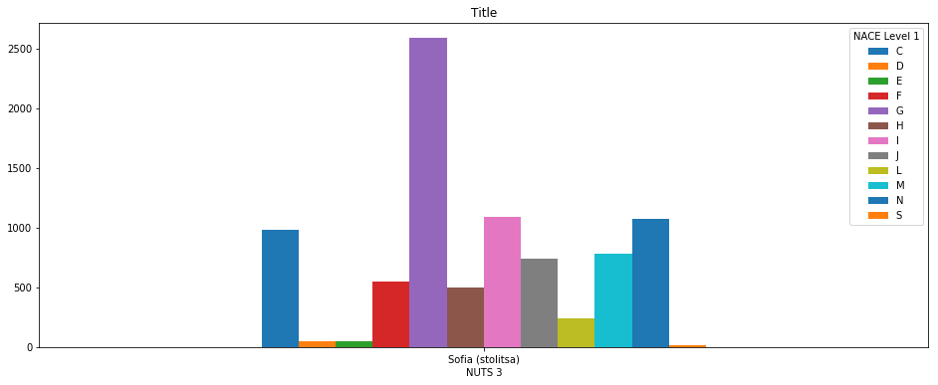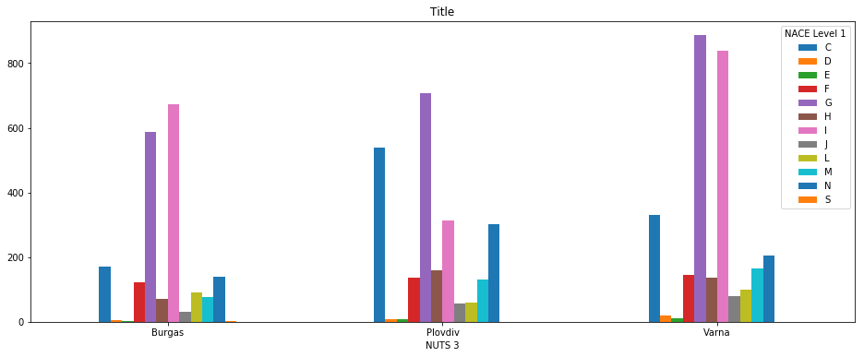

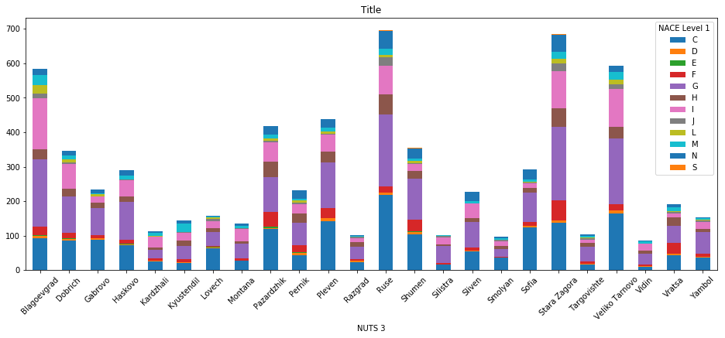

The graphic presentation of the calculated results is the following:

- Daily number of newly posted OJVs

by NUTS 3
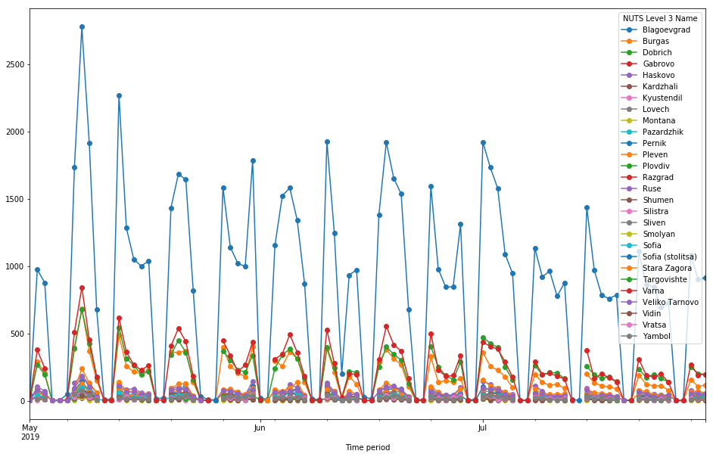

by NACE Level 1:
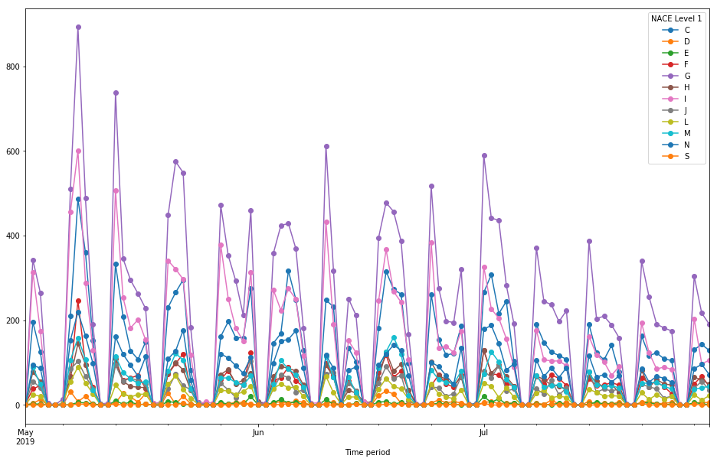

The trends shown in the graphs above present a relatively constant pattern, with the number of daily new advertisements declines in the summer months and particularly in July.

- Daily average newly posted OJVs within month
By NUTS3:

Table 4: Number of OJV advertisements by NUTS Level 3 and time period
Time period | 2019-05 | 2019-06 | 2019-07
NUTS 3
Blagoevgrad | 1279 | 1051 | 1073
Burgas | 6174 | 4585 | 3422
Dobrich | 874 | 684 | 619
Gabrovo | 606 | 460 | 537
Haskovo | 715 | 664 | 667
Kardzhali | 300 | 222 | 226
Kyustendil | 338 | 360 | 331
Lovech | 370 | 327 | 361
Montana | 274 | 241 | 237
Pazardzhik | 1023 | 938 | 882
Pernik | 591 | 460 | 458
Pleven | 1098 | 841 | 908
Plovdiv | 6460 | 5271 | 5230
Razgrad | 266 | 261 | 252
Ruse | 1783 | 1381 | 1455
Shumen | 812 | 743 | 701
Silistra | 200 | 210 | 210
Sliven | 527 | 499 | 451
Smolyan | 190 | 155 | 146
Sofia | 768 | 655 | 609
Sofia (stolitsa) | 27912 | 24617 | 23856
Stara Zagora | 1795 | 1452 | 1483
Targovishte | 324 | 276 | 244
Varna | 7661 | 6183 | 5457
Veliko Tarnovo | 1492 | 1231 | 1156
Vidin | 269 | 169 | 158
Vratsa | 464 | 423 | 400
Yambol | 517 | 383 | 364
By NACE Level 1:
Table 5: Number of OJAs by NACE Level 1 and Time period
 | 2019-05 | 2019-06 | 2019-07
NACE Level 1
C | 4293 | 3721 | 3487
D | 238 | 168 | 120
E | 92 | 85 | 98
F | 1575 | 1231 | 1326
G | 8158 | 6591 | 6232
H | 1410 | 1374 | 1368
I | 5650 | 4260 | 3126
J | 1171 | 971 | 1014
L | 763 | 672 | 583
M | 1557 | 1478 | 1259
N | 2359 | 2048 | 2064
S | 19 | 22 | 18
- Experimental OJAs statistics: July 2019 – August 2020
The weekly data is present here only graphically, because of the huge size of the tables. The monthly OJAs data are presented in table and graphically, the quarterly data is presented only in table format.

- Number of OJAs and change (flow) 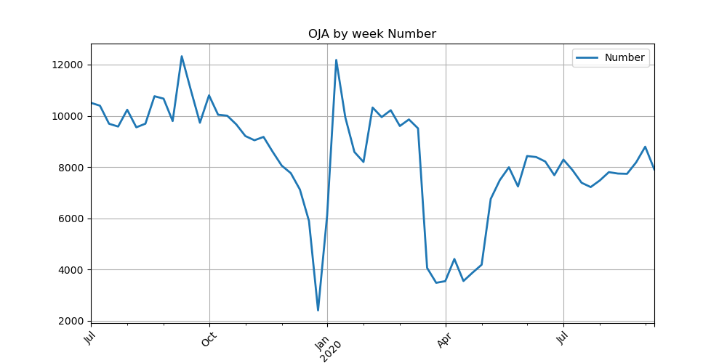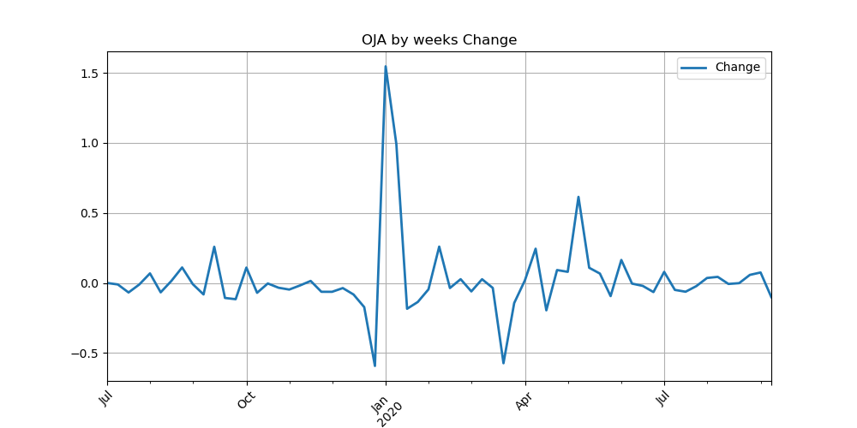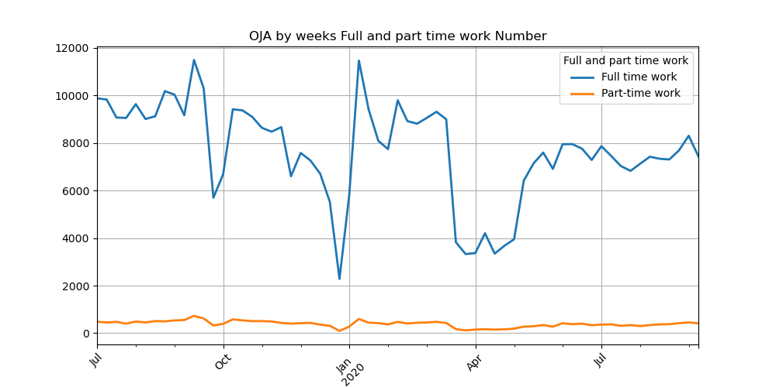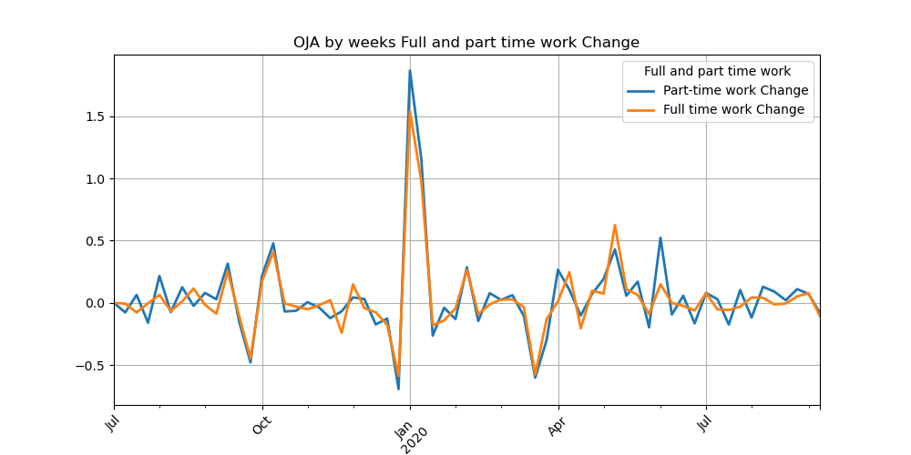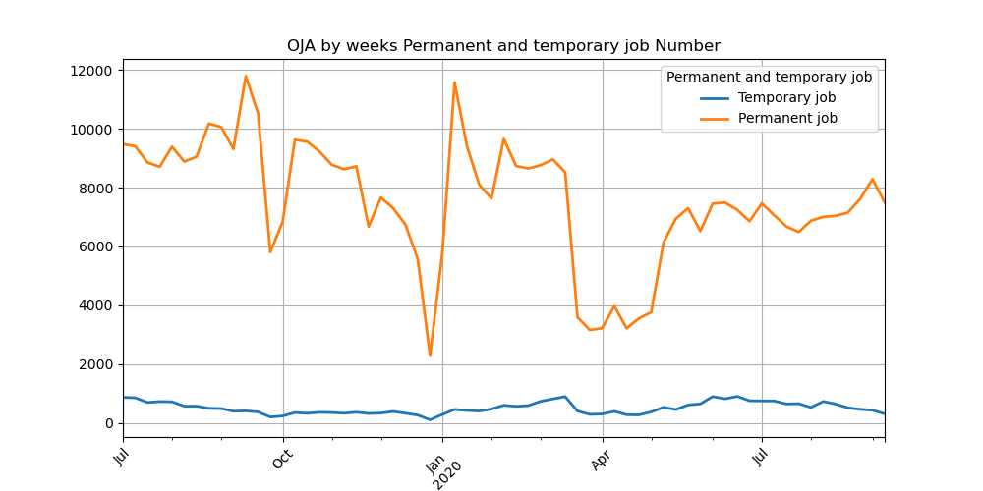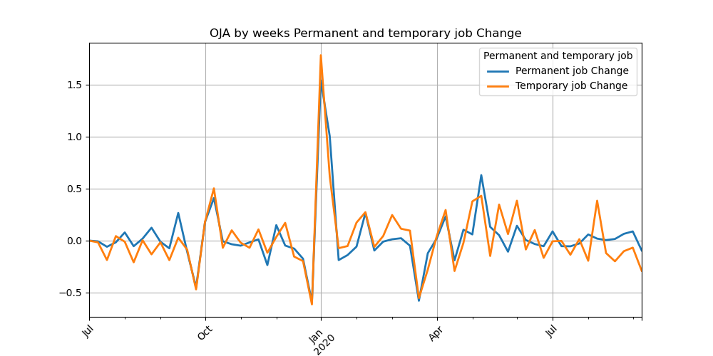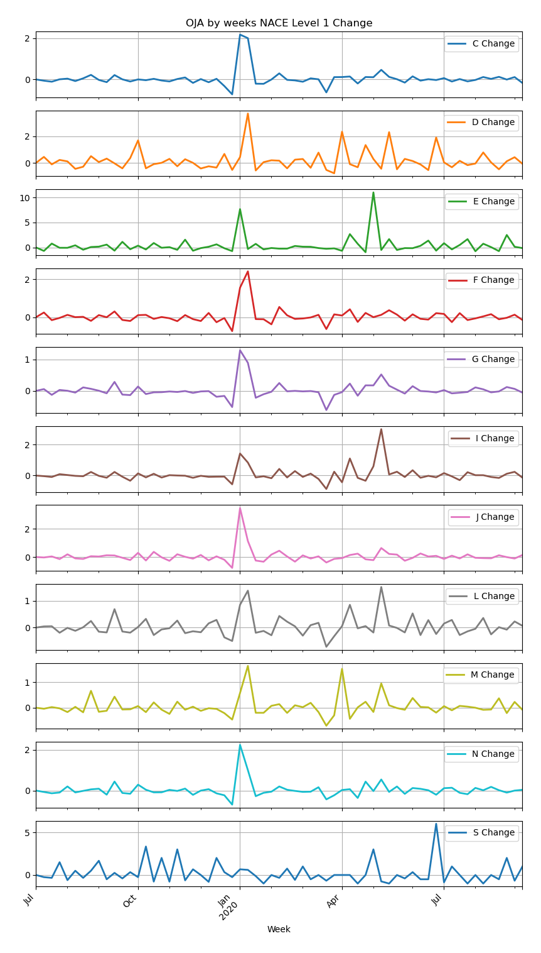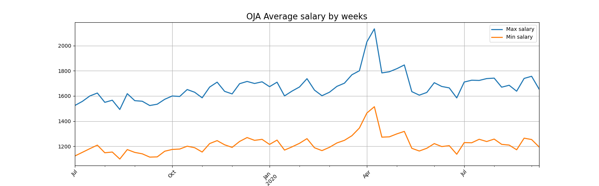

Table 1: OJAs by months (country level)
Table 2: OJAs by quarters (country level)
Month | OJAs (number) | Change
2019-07 | 46628 | 0
2019-08 | 44441 | -0,0469
2019-09 | 45528 | 0,024459
2019-10 | 45517 | -0,00024
2019-11 | 36413 | -0,20001
2019-12 | 24712 | -0,32134
2020-01 | 43474 | 0,759226
2020-02 | 40103 | -0,07754
2020-03 | 28364 | -0,29272
2020-04 | 18068 | -0,363
2020-05 | 29530 | 0,634381
2020-06 | 36384 | 0,232103
2020-07 | 34547 | -0,05049
2020-08 | 33683 | -0,02501
Quarter | Number | Change
2019Q3 | 136597 | 0
2019Q4 | 106642 | -0,21929
2020Q1 | 111941 | 0,04969
2020Q2 | 83982 | -0,24977

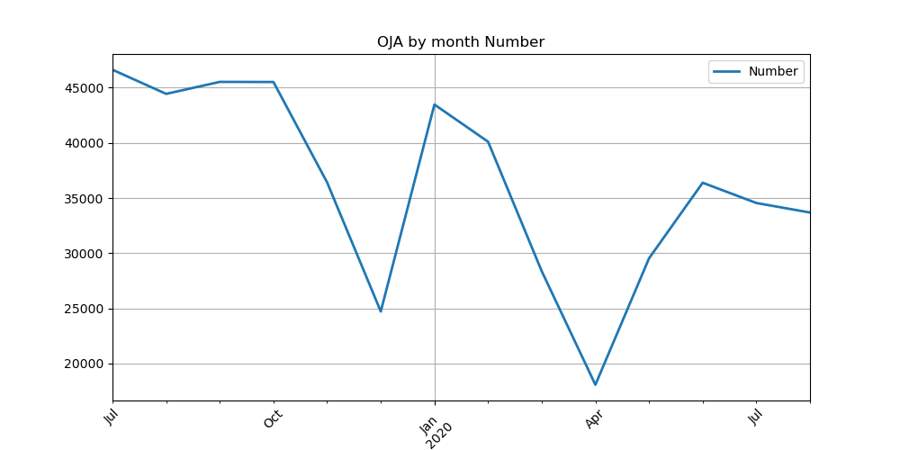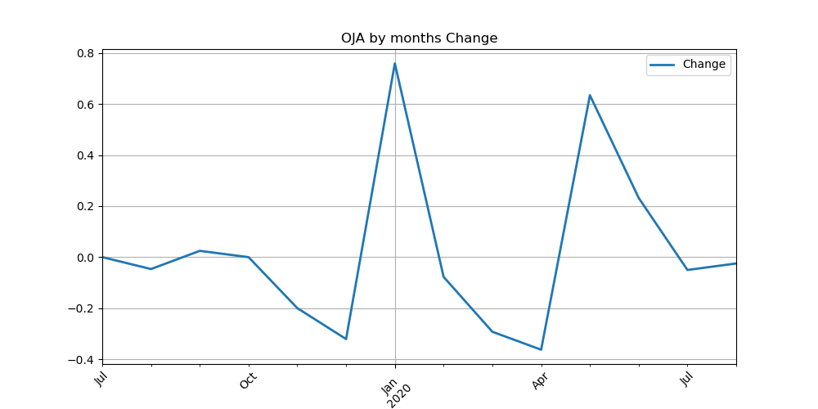
- Number of OJAs and change by Educational level (flow)

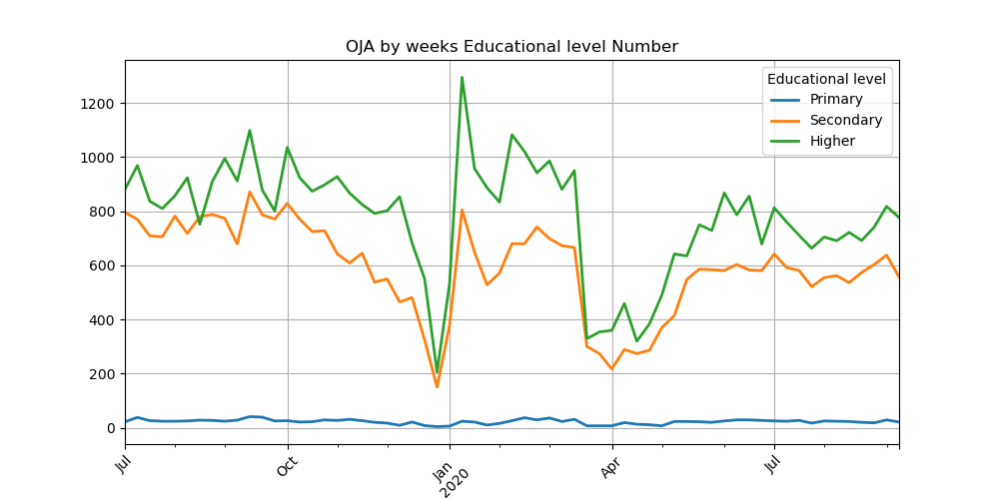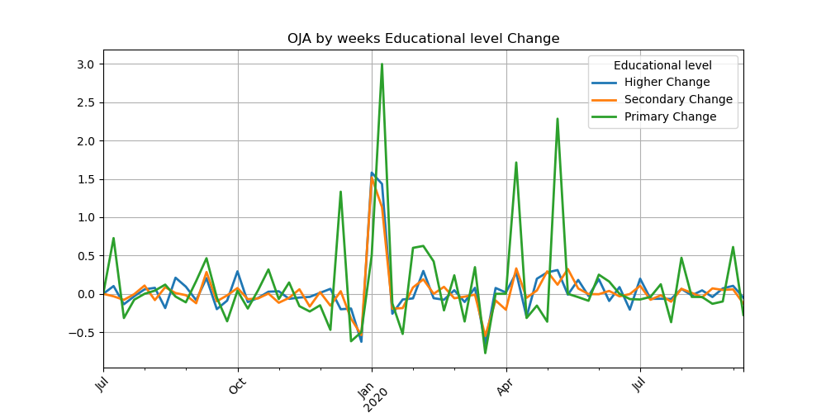

Table 3: OJAs by months and by Educational level
Month | Higher education | Primary education | Secondary education | Higher Change | Primary Change | Secondary Change
2019-07 | 4029 | 126 | 3471 | 0 | 0 | 0
2019-08 | 3903 | 112 | 3352 | -0,03127 | -0,11111 | -0,0342841
2019-09 | 3930 | 140 | 3280 | 0,006918 | 0,25 | -0,0214797
2019-10 | 4256 | 117 | 3396 | 0,082952 | -0,16429 | 0,03536585
2019-11 | 3453 | 94 | 2470 | -0,18867 | -0,19658 | -0,2726737
2019-12 | 2439 | 44 | 1513 | -0,29366 | -0,53191 | -0,3874494
2020-01 | 4359 | 76 | 2839 | 0,787208 | 0,727273 | 0,87640449
2020-02 | 4032 | 128 | 2801 | -0,07502 | 0,684211 | -0,013385
2020-03 | 2661 | 71 | 2005 | -0,34003 | -0,44531 | -0,2841842
2020-04 | 1861 | 54 | 1326 | -0,30064 | -0,23944 | -0,33865
2020-05 | 2761 | 88 | 2152 | 0,483611 | 0,62963 | 0,622926
2020-06 | 3554 | 125 | 2627 | 0,287215 | 0,420455 | 0,220725
2020-07 | 3285 | 103 | 2608 | -0,07569 | -0,176 | -0,00723
2020-08 | 3049 | 90 | 2433 | -0,07184 | -0,12621 | -0,0671

Table 4: OJAs by quarters and by Educational level
Quarter | Higher | Primary | Secondary | Higher Change | Primary Change | Secondary Change
2019Q3 | 11862 | 378 | 10103 | 0 | 0 | 0
2019Q4 | 10148 | 255 | 7379 | -0,1445 | -0,3254 | -0,26962
2020Q1 | 11052 | 275 | 7645 | 0,089082 | 0,078431 | 0,036048
2020Q2 | 8176 | 267 | 6105 | -0,26022 | -0,02909 | -0,20144

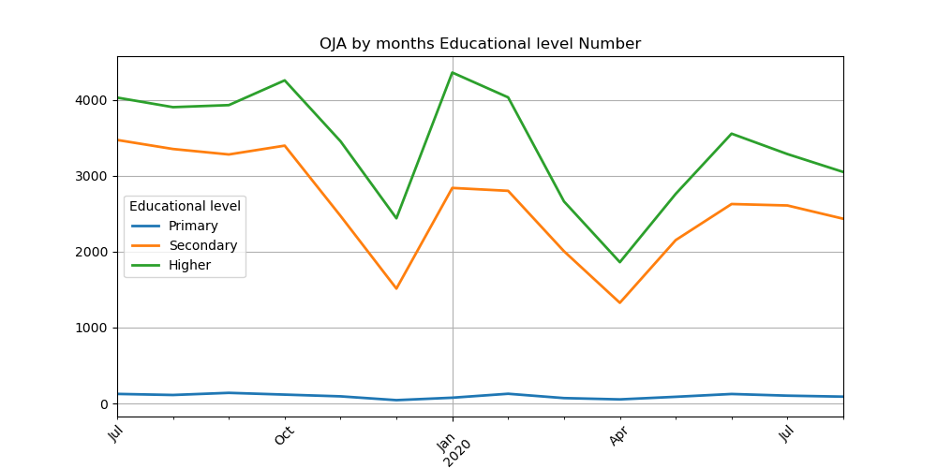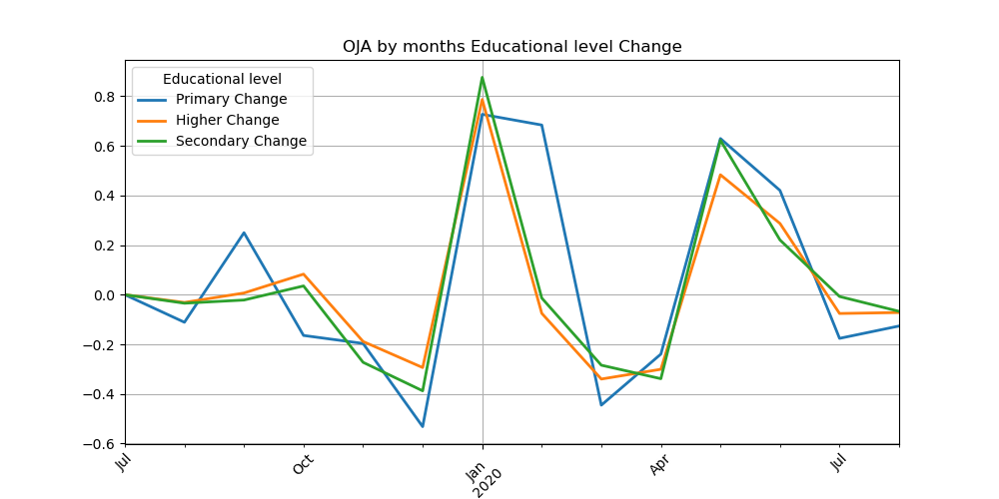

- Number of OJAs and change by Full and part time work (flow)

Table 5: OJAs by months and by Full and part time work
Month | Full time work | Part-time work | Full time work Change | Part-time work Change
2019-07 | 43898 | 2137 | 0 | 0
2019-08 | 41901 | 2165 | -0,045491822 | 0,01310248
2019-09 | 37577 | 2297 | -0,103195628 | 0,060969977
2019-10 | 40833 | 2397 | 0,086648748 | 0,043535046
2019-11 | 32787 | 1814 | -0,197046507 | -0,243220693
2019-12 | 23233 | 1288 | -0,29139598 | -0,289966924
2020-01 | 41061 | 2028 | 0,767356777 | 0,574534161
2020-02 | 36592 | 1774 | -0,10883807 | -0,125246548
2020-03 | 26859 | 1254 | -0,265987101 | -0,293122886
2020-04 | 17120 | 768 | -0,362597267 | -0,387559809
2020-05 | 28124 | 1186 | 0,642757009 | 0,544270833
2020-06 | 34404 | 1732 | 0,223296828 | 0,460370995
2020-07 | 32837 | 1492 | -0,045547029 | -0,138568129
2020-08 | 31865 | 1613 | -0,029600755 | 0,081099196
Table 6: OJAs by quarters and by Full and part time work
Quarter | Full time work | Part-time work | Full time work Change | Part-time work Change
2019Q3 | 123376 | 6599 | 0 | 0
2019Q4 | 96853 | 5499 | -0,21498 | -0,16669
2020Q1 | 104512 | 5056 | 0,079079 | -0,08056
2020Q2 | 79648 | 3686 | -0,23791 | -0,27097

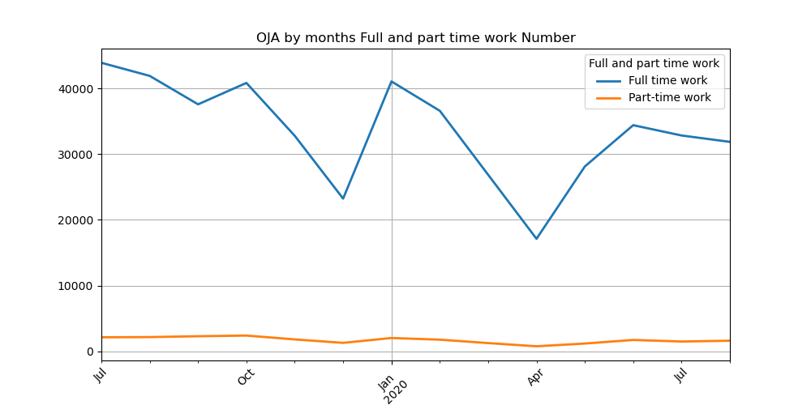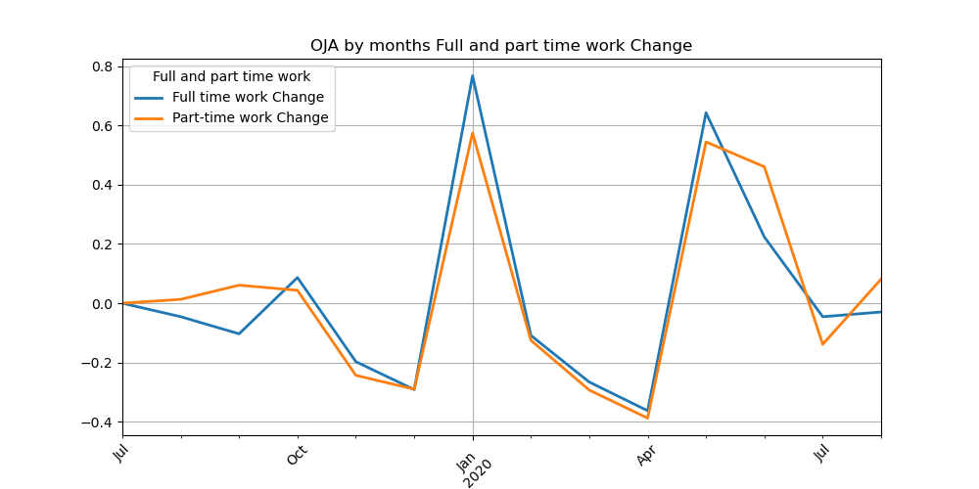
- Number of OJAs and change by Permanent and temporary job (flow)
Table 7: OJAs by months and by Permanent and temporary job
Month | Permanent job | Temporary job | Permanent job Change | Temporary job Change
2019-07 | 42361 | 3598 | 0 | 0
2019-08 | 41640 | 2355 | -0,01702 | -0,34547
2019-09 | 38406 | 1389 | -0,07767 | -0,41019
2019-10 | 41606 | 1525 | 0,08332 | 0,097912
2019-11 | 33153 | 1379 | -0,20317 | -0,09574
2019-12 | 23306 | 1164 | -0,29702 | -0,15591
2020-01 | 41057 | 1927 | 0,761649 | 0,655498
2020-02 | 35808 | 2474 | -0,12785 | 0,283861
2020-03 | 25573 | 2484 | -0,28583 | 0,004042
2020-04 | 16335 | 1499 | -0,36124 | -0,39654
2020-05 | 26952 | 2229 | 0,649954 | 0,486991
2020-06 | 32353 | 3685 | 0,200393 | 0,653208
2020-07 | 31234 | 2969 | -0,03459 | -0,1943
2020-08 | 30899 | 2441 | -0,01073 | -0,17784

Table 8: OJAs by quarters and by Permanent and temporary job
Quarter | Permanent job | Temporary job | Permanent job Change | Temporary job Change
2019Q3 | 122407 | 7342 | 0 | 0
2019Q4 | 98065 | 4068 | -0,19886 | -0,44593
2020Q1 | 102438 | 6885 | 0,044593 | 0,692478
2020Q2 | 75640 | 7413 | -0,2616 | 0,076688

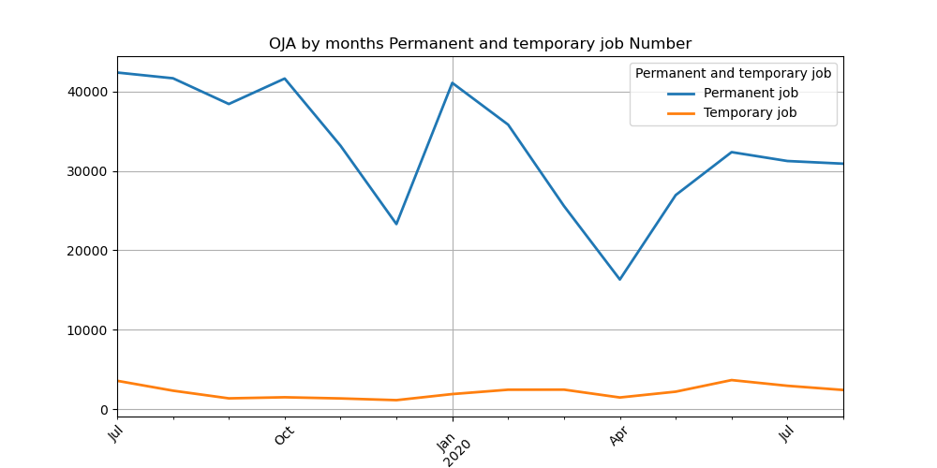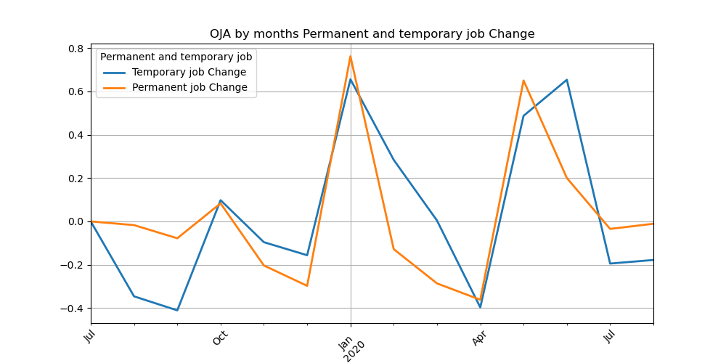

- Number of OJAs and change by NACE 2.0 Level 1 (flow)

Table 9: OJAs by months and by NACE Level 1
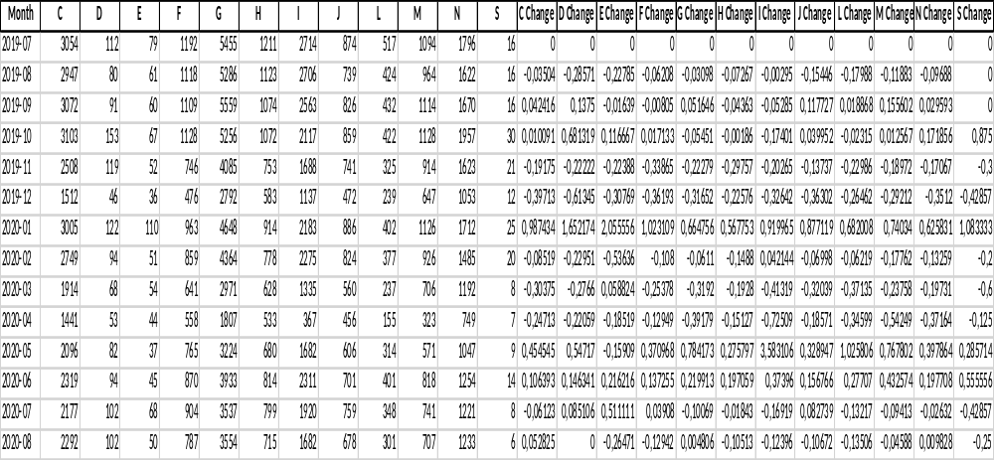

Table 9: OJAs by quarters and by NACE Level 1
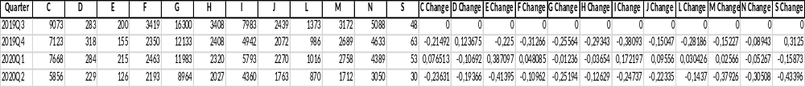
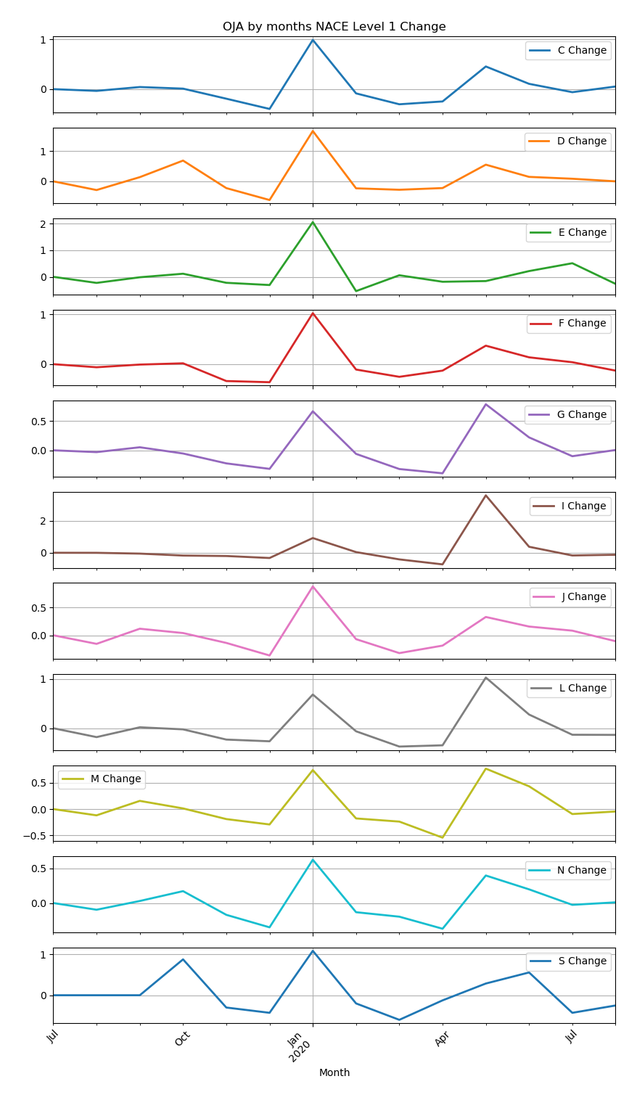

- Number of OJAs by NUTS 3 (flow)

Table 10: OJAs by months and NUTS 3
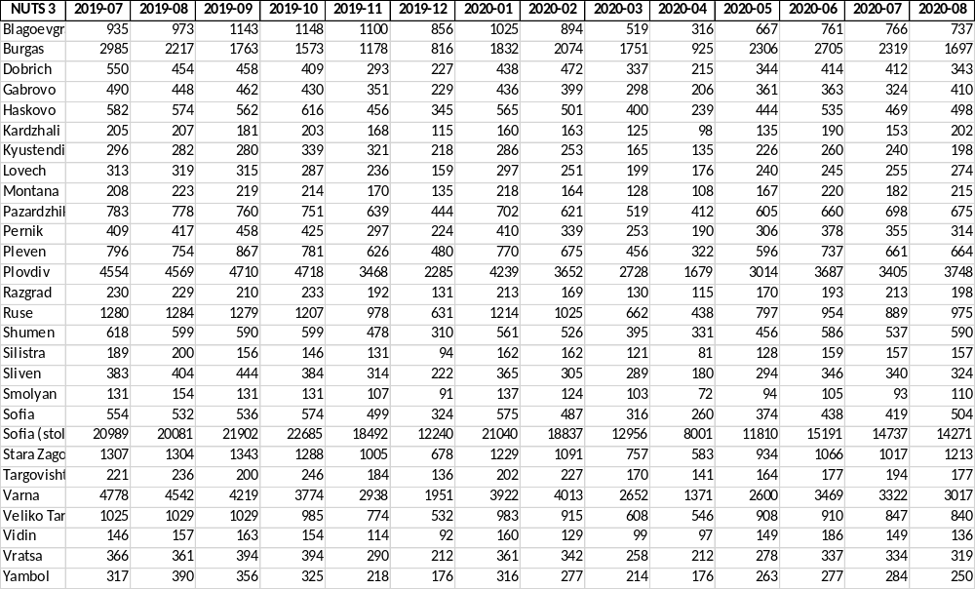

Table 11: OJAs by quarters and NUTS 3
NUTS 3 | 2019Q3 | 2019Q4 | 2020Q1 | 2020Q2
Blagoevgrad | 3051 | 3104 | 2438 | 1744
Burgas | 6965 | 3567 | 5657 | 5936
Dobrich | 1462 | 929 | 1247 | 973
Gabrovo | 1400 | 1010 | 1133 | 930
Haskovo | 1718 | 1417 | 1466 | 1218
Kardzhali | 593 | 486 | 448 | 423
Kyustendil | 858 | 878 | 704 | 621
Lovech | 947 | 682 | 747 | 661
Montana | 650 | 519 | 510 | 495
Pazardzhik | 2321 | 1834 | 1842 | 1677
Pernik | 1284 | 946 | 1002 | 874
Pleven | 2417 | 1887 | 1901 | 1655
Plovdiv | 13833 | 10471 | 10619 | 8380
Razgrad | 669 | 556 | 512 | 478
Ruse | 3843 | 2816 | 2901 | 2189
Shumen | 1807 | 1387 | 1482 | 1373
Silistra | 545 | 371 | 445 | 368
Sliven | 1231 | 920 | 959 | 820
Smolyan | 416 | 329 | 364 | 271
Sofia | 1622 | 1397 | 1378 | 1072
Sofia (stolitsa) | 62972 | 53417 | 52833 | 35002
Stara Zagora | 3954 | 2971 | 3077 | 2583
Targovishte | 657 | 566 | 599 | 482
Varna | 13539 | 8663 | 10587 | 7440
Veliko Tarnovo | 3083 | 2291 | 2506 | 2364
Vidin | 466 | 360 | 388 | 432
Vratsa | 1121 | 896 | 961 | 827
Yambol | 1063 | 719 | 807 | 716

- Number of OJAs by average salary (flow)

Table 12: OJAs by monthly average min and max salary
Month | Min salary | Max salary | Min salary Change | Max salary Change
2019-07 | 1162,52 | 1570,8 | 0 | 0
2019-08 | 1145,02 | 1560,71 | -0,02 | -0,01
2019-09 | 1130,35 | 1546,5 | -0,01 | -0,01
2019-10 | 1182,74 | 1615,94 | 0,05 | 0,04
2019-11 | 1216,05 | 1658,52 | 0,03 | 0,03
2019-12 | 1253,96 | 1710,69 | 0,03 | 0,03
2020-01 | 1207,99 | 1654,44 | -0,04 | -0,03
2020-02 | 1201,13 | 1654,02 | -0,01 | 0
2020-03 | 1272,71 | 1736,99 | 0,06 | 0,05
2020-04 | 1355,86 | 1902,18 | 0,07 | 0,1
2020-05 | 1210,37 | 1676,89 | -0,11 | -0,12
2020-06 | 1188,71 | 1655,72 | -0,02 | -0,01
2020-07 | 1248,46 | 1738,42 | 0,05 | 0,05
2020-08 | 1223,78 | 1698,62 | -0,02 | -0,02

Table 13: OJAs by quarterly average min and max salary
Quarter | Min salary | Max salary | Min salary Change | Max salary Change
2019Q3 | 1146,1 | 1559,42 | 0 | 0
2019Q4 | 1210,97 | 1652,91 | 0,06 | 0,06
2020Q1 | 1222,28 | 1675,7 | 0,01 | 0,01
2020Q2 | 1232,03 | 1715,78 | 0,01 | 0,02
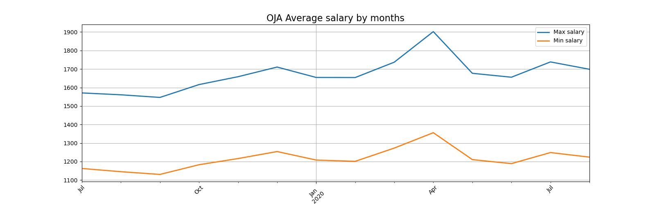
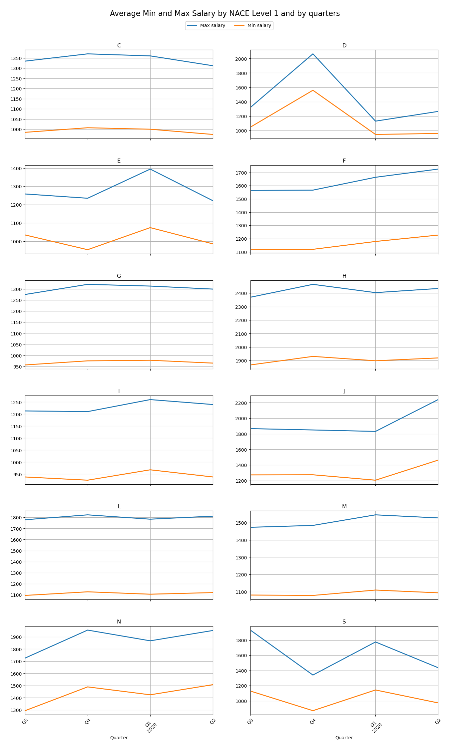

On the base of ESQRS for big data sources, we designed the quality report in the ESQRS for OJAs home data (July 2019 – August 2020). This ESQRS report is intended mainly for the producer of experimental statistics for big data sources and could be also served as a metadata explaining how the OJAs is produced.
The filled ESQRS for OJAs experimental Bulgarian data is include as an Annex to this document.
- COVID OJAs statistics

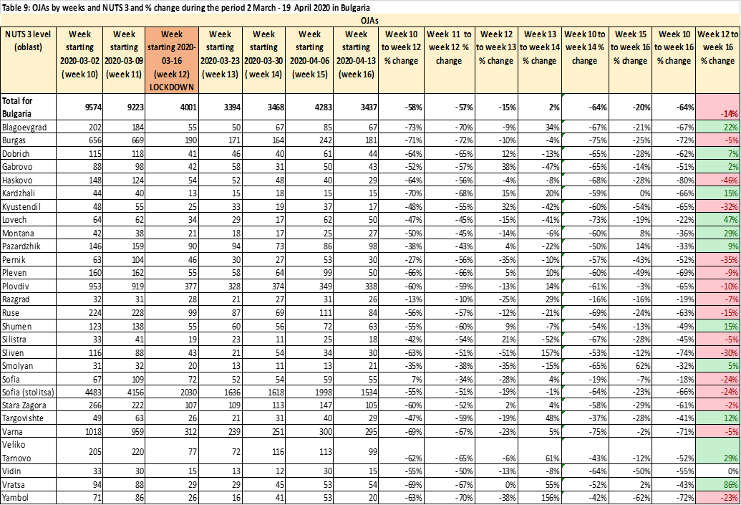

The Table above shows certain aspects of employers' newly published OJAs by weeks (for the period 3rd February 2020 to 19th April 2020 for 28 regions in Bulgaria by NUTS). The surveyed period includes the week of March related to the government's announcement of a lockdown in connection with COVID-19. Data on the number of jobs announced in week 12 (starting 16 March 2020) was considered as a baseline in calculating a series of ratios showing the effect of lockdown on of employers' decisions to publish OJAs.
Data show that after the critical week, the number of OJAs declined dramatically from the previous two weeks in March. The decrease is relatively lower in Sofia compared to other regional cities in the country. Four weeks after quarantine, there was a slight downward trend in tension. This means that OJAs are gradually increasing, but they still cannot reach supply levels in the pre-quarantine period and the change is still negative. It can be concluded that the labor market is currently tight and job vacancies in job platforms remain weak.

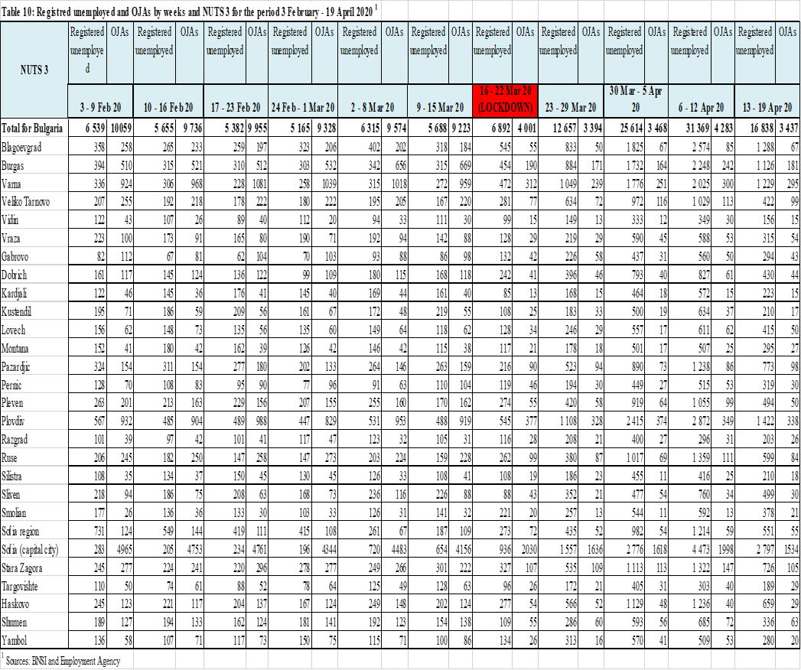

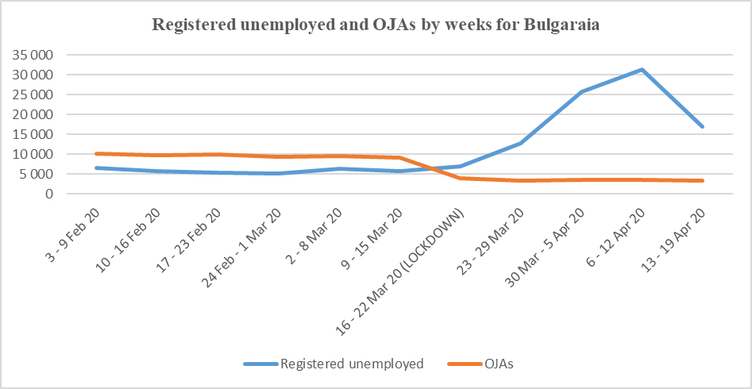

Table 10 and its graphics show clearly the trend that before the lockdown the ratio between the unemployed registered at the Employment Agency and the offered online job vacancies is in favour of the offered jobs at the labour market. During the critical week of March (lockdown) a sharp change is noticed whereby the number of the registered unemployed increases drastically and the ratio between them and the supply of job vacancies is negative. The curve of the unemployed is steep upwards during the first two weeks after announcing the lockdown and starts descending downwards during the first two weeks of April. This shows that the gap between the labour supply and demand decreases but still has not reached its normal levels before the lockdown period.

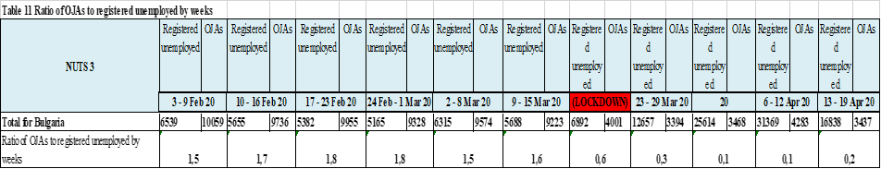

The data of the next Table 11 show that before the lockdown period more than one job advertisement corresponded per each registered unemployed. After the critical moment this trend changed – less than one job advertisement corresponds per each unemployed. This change in the labour market situation by equal other conditions illustrates a characteristic period when only within approximately four months of 2020 the demand and supply of labour force change their directions. Thus for example after a process of increased demand of labour force by 20th March 2020 a comparatively drastic change followed and the supply of labour force increased at the labour market.
- CEDEFOP data for Bulgaria (July 2018 – June 2019)
The CEDEFOP scraped five sources for Bulgaria for the period July 2018 – June 2019. One of them is an administrative source (National Employment Agency), one is general advertisements’ portal and three – are pure job portals. The BG_JOBS and BG_ZAPLATA are the two biggest job portals in Bulgaria. These two portals are scraped regularly by the BNSI also.
It is clear (see Table 1) that the data in the beginning is incomplete and probably testable (July – December 2018). Therefore, we prefer to make the conclusions in this report mainly for the period January - June 2019.
The biggest share of OJAs has BG_JOBS with 82.4%), then the second BG_ZAPLATA - 10.2%. The other three – have less than 8% share from total number of OJAs for the whole period.

Table1: Total number of OJAs by job portals 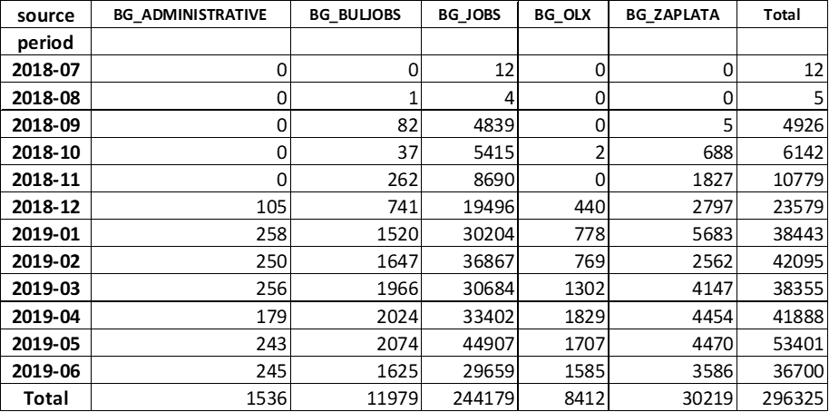

The biggest number of jobs are announced in May 2019, which could be explained with the beginning of the summer touristic season and need for seasonal workers.
Table 2: Daily OJAs for the month of May 2019 for BG_JOBS and BG_ZAPLATA
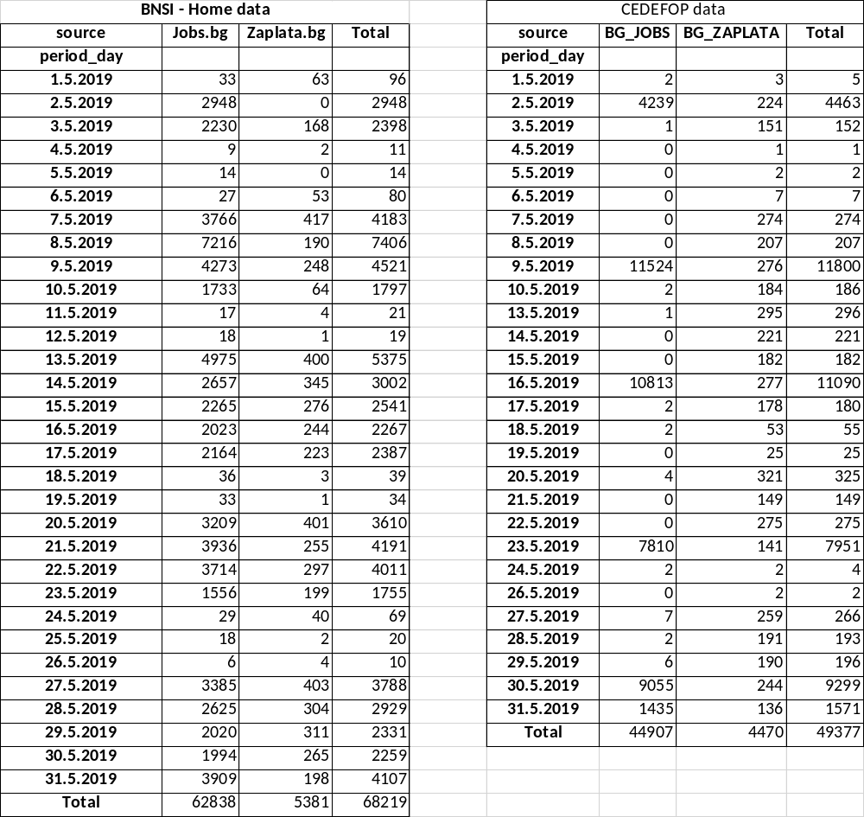

The table 2 shows that for two job portals in May 2019, the BNSI scraped around 28% more OJAs than CEDEFOP. All home data are de-duplicated by the following variables: publish_date, employer, populated place, country, job_title. But we don’t know how the CEDEFOP data was de-duplicated. The difference could be explained that CEDEFOP did not scrape for some days during the mount May 2019.
In the table 3 for June 2019, the difference becomes even more – 41%. We can assume, that the BNSI uses better scraper or the CEDEFOP cleans and de-duplicate data in better way.

Table 3: Daily OJAs for the month of June 2019 for BG_JOBS and BG_ZAPLATA
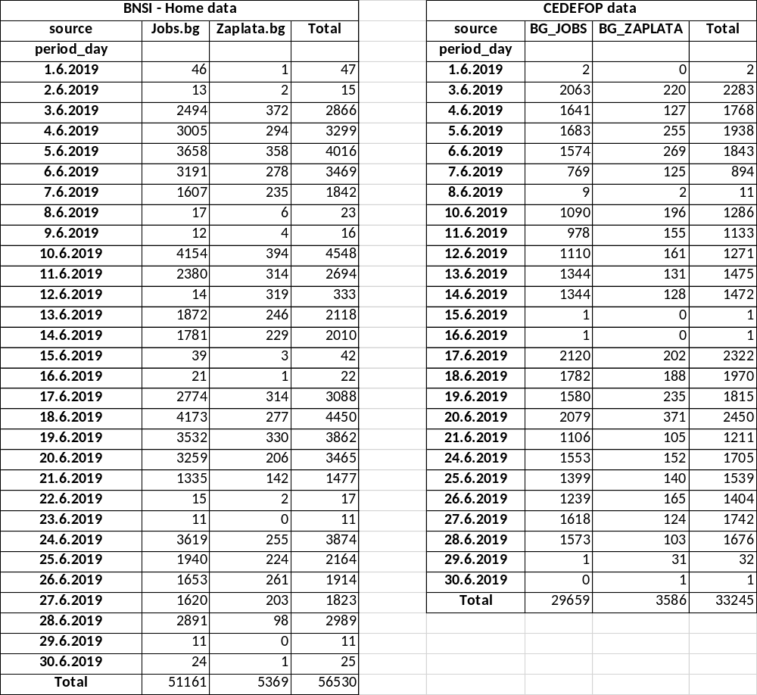

Table 4: OJAs by administrative regions (NUTS 2) and ESCO_level1 for the period for the period July 2018 – June 2019 (average values of daily OJAs)
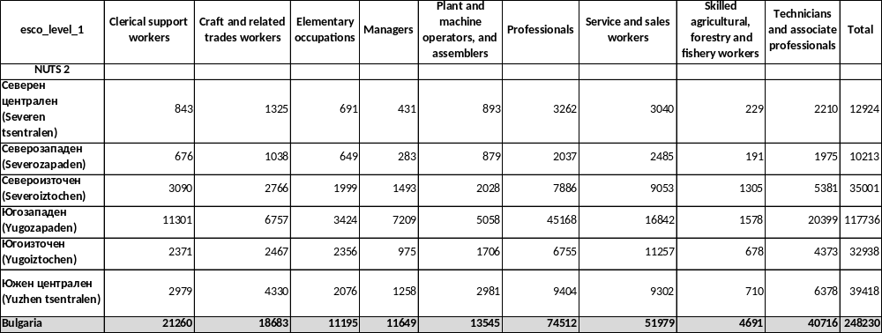

As we expected, almost half of OJAs – 47% are in the Yugozapaden region, where the capital Sofia is. In addition, 62% from total manager’s positions are announced in the Yugozapaden region. The OJAs for professionals, technicians and associate professionals and clerical support workers are also more than 50% from total number in the capital region.
Table 5: OJAs by administrative regions (NUTS 2) and by category economic sectors for the period July 2018 – June 2019
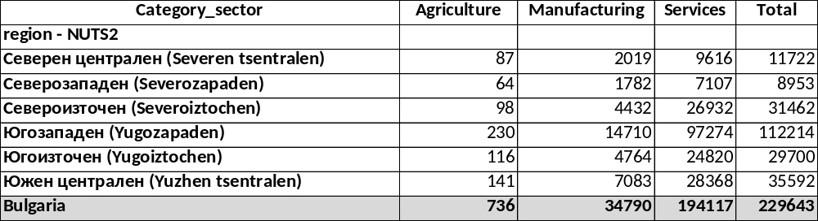

It seems that Bulgarian economy based on services as 84, 5 % from all OJVs for the whole period are in that economic sector. The small number of ads in agriculture sector could be explained through the manner that job vacancies are announced - most likely locally, from mouth to mouth, without the use of online job portals.
Figure 1: Total amount of OJAs by salary and ESCO level 1 for the whole period (CEDEFOP data)
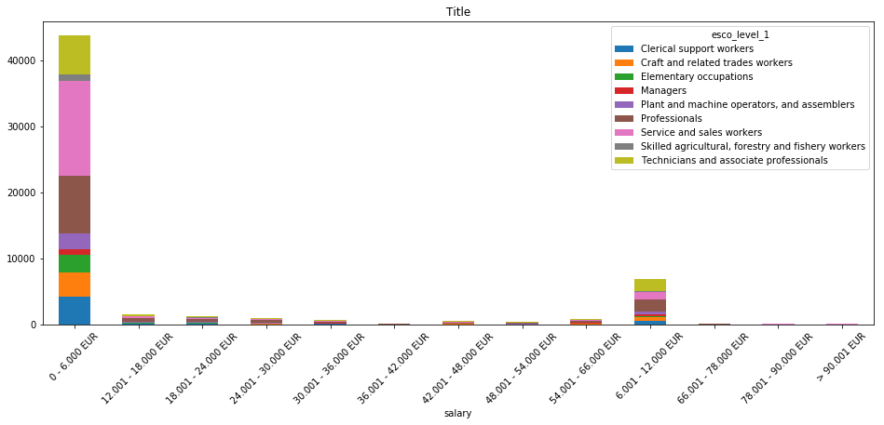

Figure 1 shows that most OJAs offer up to € 6,000 annual salary. In this income group, the professions sought are mainly in the service and sales workers group and professionals group according to ESCO level 1 classification. All other cases distributed in higher pay scales are almost insignificant, which is an indicator of the low cost of labor in Bulgaria.
In CEDEFOP data, there is a lack of information about the employer and thus it is not possible to determine from which economic sector the demand for a profession is coming. This would also be a constrain for correctly comparison with JV survey data.
For the project’s purposes, the BNSI obtained training data set from the National Employment Agency. The received data are for the period May-July 2019 and were compared to CEDEFOP and home scraped data. Unfortunately, the comparison makes a huge difference between the three datasets - e.g. by the Employment Agency for May and June 2019, 2 175 OJAs were announced with 6 310 OJVs, but CEDEFOP data shows that only 488 OJAs were scraped from administrative source over the same period (if we assumed that the BG_Administrative source is the National Employment Agency). Since the difference is almost 5 times, it cannot be explained only by the difference between OJV and OJA concepts.
The first comparison shows that although highly structured, the data from National Employment Agency are not correctly comparable for following main reasons:
- The basic concept is a JV (Employment Agency), not JA;
- These are just the JVs that employers voluntarily submit to the Employment Agency. In the Bulgarian reality, employers prefer to advertise their job vacancies mostly in online job portals, as it is faster and more convenient for them;
- From the moment when a job vacancy is declared in the Regional Labor Office until its actual publication on the Employment Agency's Internet portal, there is a certain lag of time, i.e. we can't say that these JVs are actual in real time.

Conclusions:

The results from OJAs home data raise some important questions about the OJVs data and whether and how it should be used for official statistics. While in this report (BNSI results) has shown that it is feasible to produce experimental estimates of OJAs, there is a still conceptual difference between them and the official JV estimates. It is therefore clear that experimental OJAs data could not be replace the official statistical indicators for JV. Unfortunately, OJAs experimental data give only a partial “picture” of overall labour market demand. It therefore seems that the role of OJAs data within official statistics is more likely to be as the basis for producing supplementary indicators. These could include indicators of local labour market demand (as shown above) and/or indicators of occupations and skills. It would be better not to measuring only absolute numbers of OJAs, but also would be more useful for measuring their change over time.
To conclude, it is important to have in mind the significant differences between ESS countries in terms of the OJVs landscape. Thus, what is feasible in one country may not necessarily be reproducible in others.

The population number is relevant for the end of 2019 according to data from the current demographic statistics.
The data are from the survey of the work force for 2019.
The data are from the survey of the work force for 2019.

