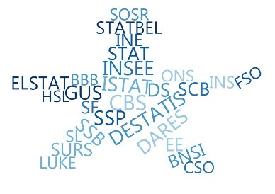

ESSnet Big Data II

Grant Agreement Number: 847375-2018-NL-BIGDATA
https://webgate.ec.europa.eu/fpfis/mwikis/essnetbigdata
https://ec.europa.eu/eurostat/cros/content/essnetbigdata_en

Workpackage WPB
Implementation – Online Job Vacancies

Exploratory analysis of CEDEFOP data
for Germany, 09.2020 (DE)
Prepared by:
Jakob de Lazzer

Date of present version: 21. September 2020

Workpackage Leader:
Tomaž Špeh (SURS, SI)
e-mail address: tomaz.speh@gov.si
mobile phone: +38651672116

Contents
1 Data overview 4
1.1 Country definition 4
1.2 Multiple samples 4
2 Current CEDEFOP data version (V5) 4
2.1 Webscraping coverage 5
2.2 Location of jobs 9
2.3 Staffing agencies 9
2.4 Contract type 10
2.5 Pseudo-stocks 10
2.6 Missing attributes 14
3 CEDEFOP data version V4 15
3.1 Dates and times of observations 15
3.2 Webscraping coverage 16
3.3 Location of jobs 19
3.4 Duplicates 19
3.5 Staffing agencies 21
3.6 Contract type 21
3.7 Pseudo-stocks 21
3.8 Missing attributes 23

Figures
Figure 1: CEDEFOP dataset V5: number of job ads by web-scraping month 5
Figure 2: CEDEFOP dataset V5: accumulated number of job ads by web-scraping day 5
Figure 3: CEDEFOP dataset V5: share of job ads by source (top 30) 7
Figure 4: CEDEFOP dataset V5: ads collected by source and month 7
Figure 5: CEDEFOP dataset V5: monthly development of top 3 sources of the whole period 8
Figure 6: CEDEFOP dataset V5: share of job ads by site (top 30) 8
Figure 7: Stock at time t: example of three active job ads 11
Figure 8: CEDEFOP dataset V5: Job ads/vacancies for CEDEFOP-OJA (pseudo-stocks) and JVS 13
Figure 9: CEDEFOP dataset V5: job ads/vacancies for CEDEFOP-OJA (pseudo-stocks) and FEA open vacancies 13
Figure 10: CEDEFOP dataset V4: number of job ads by web-scraping month 15
Figure 11: CEDEFOP dataset V4: accumulated number of job ads by web-scraping day 16
Figure 12: CEDEFOP dataset V4: ads collected by source and month 17
Figure 13: CEDEFOP dataset V4: monthly development of top 3 sources of the whole period 17
Figure 14: CEDEFOP dataset V4: ads collected by site and month 18
Figure 15: CEDEFOP dataset V4: share of duplicates by web-scraping month 20
Figure 16: CEDEFOP dataset V4 Job ads/vacancies for CEDEFOP-OJA (pseudo-stocks) and JVS 22
Figure 17: CDEDEFOP dataset V4: job ads/vacancies for CEDEFOP-OJA (pseudo-stocks ) and FEA open vacancies 22
Figure 18: CEDEFOP dataset V4: pseudo-stocks of CEDEFOP-OJA, by valid period 23

Tables
Table 1: Number of observations in the different CEDEFOP dataset versions V1, V4 and V5 4
Table 2: CEDEFOP dataset V5: location of jobs posted on websites (sources) in Germany 9
Table 3: CEDEFOP dataset V5: contract type 10
Table 4: CEDEFOP dataset V5: variables and their missings 14
Table 5: CEDEFOP dataset V4: Location of jobs posted on websites (sources) in Germany 19
Table 6: CEDEFOP dataset V4: contract type 21
Table 7: CEDEFOP dataset V4: variables and their missings before and after deduplication 23

Data overview

Country definition

Data for Germany refers to all observations in the CEDEFOP database for which $sourcecountry== DE$. This means that these job ads were posted on websites (sources) in Germany.

Multiple samples
The EU DataPlatform contains multiple sets of CEDEFOP data. We designate them the version number by which they are accessible on the EU Dataplatform: V1, V4 and V5. While V4 and V5 have, so far, been constant in their composition, V1 initially only covered the timeframe July 2018 to March 2019. By now, V1 extends to December 2019. Table 1 shows the dates and dimensions of the different datasets.
These datasets differ dramatically in their size, both absolute and relative to the covered timeframe. Each new version changed all previous data retroactively. Because the actual collection of job ads can’t change retroactively, the different versions of the data must be caused by changes in the processing pipeline.
The most obvious differences between versions concern the share of distinct observations relative to the number of duplicates. CEDEFOP classifies duplicates by assigning the same identifier to each observation in the group (variable: general_id).
Table 1: Number of observations in the different CEDEFOP dataset versions V1, V4 and V5
Dataset version | Dates covered | Time period | No. of observations |  | Distinct observations
 |  |  | in total of the whole time period | average per month | in total of the whole time period | average per month
V1 | 07_2018 – 12_2019 | 6 M | 17 mio | 2,8 | 14 mio | 2,3
V4 | 07_2018 – 03_2020 | 9 M | 44 mio | 4,9 | 16 mio | 1,8
V5 | 07_2018 – 06_2020 | 12 M | 156 mio | 13,0 | 17 mio | 1,4

Current CEDEFOP data version (V5)

This dataset is the most recent one, which covers the timeframe until June 2020. It is by far the largest dataset, with 156 million observations for Germany alone. However, most of these observations are duplicates, as designated by CEDEFOP.
Ressources of the Dataplatform are insufficient for working directly with such a large dataset. Therefore, for all subsequent results, only one observation of each group of duplicates is used.

Webscraping coverage
The frequency of scraped job ads varies by month and also by day of scraping.
Figure 1: CEDEFOP dataset V5: number of job ads by web-scraping month
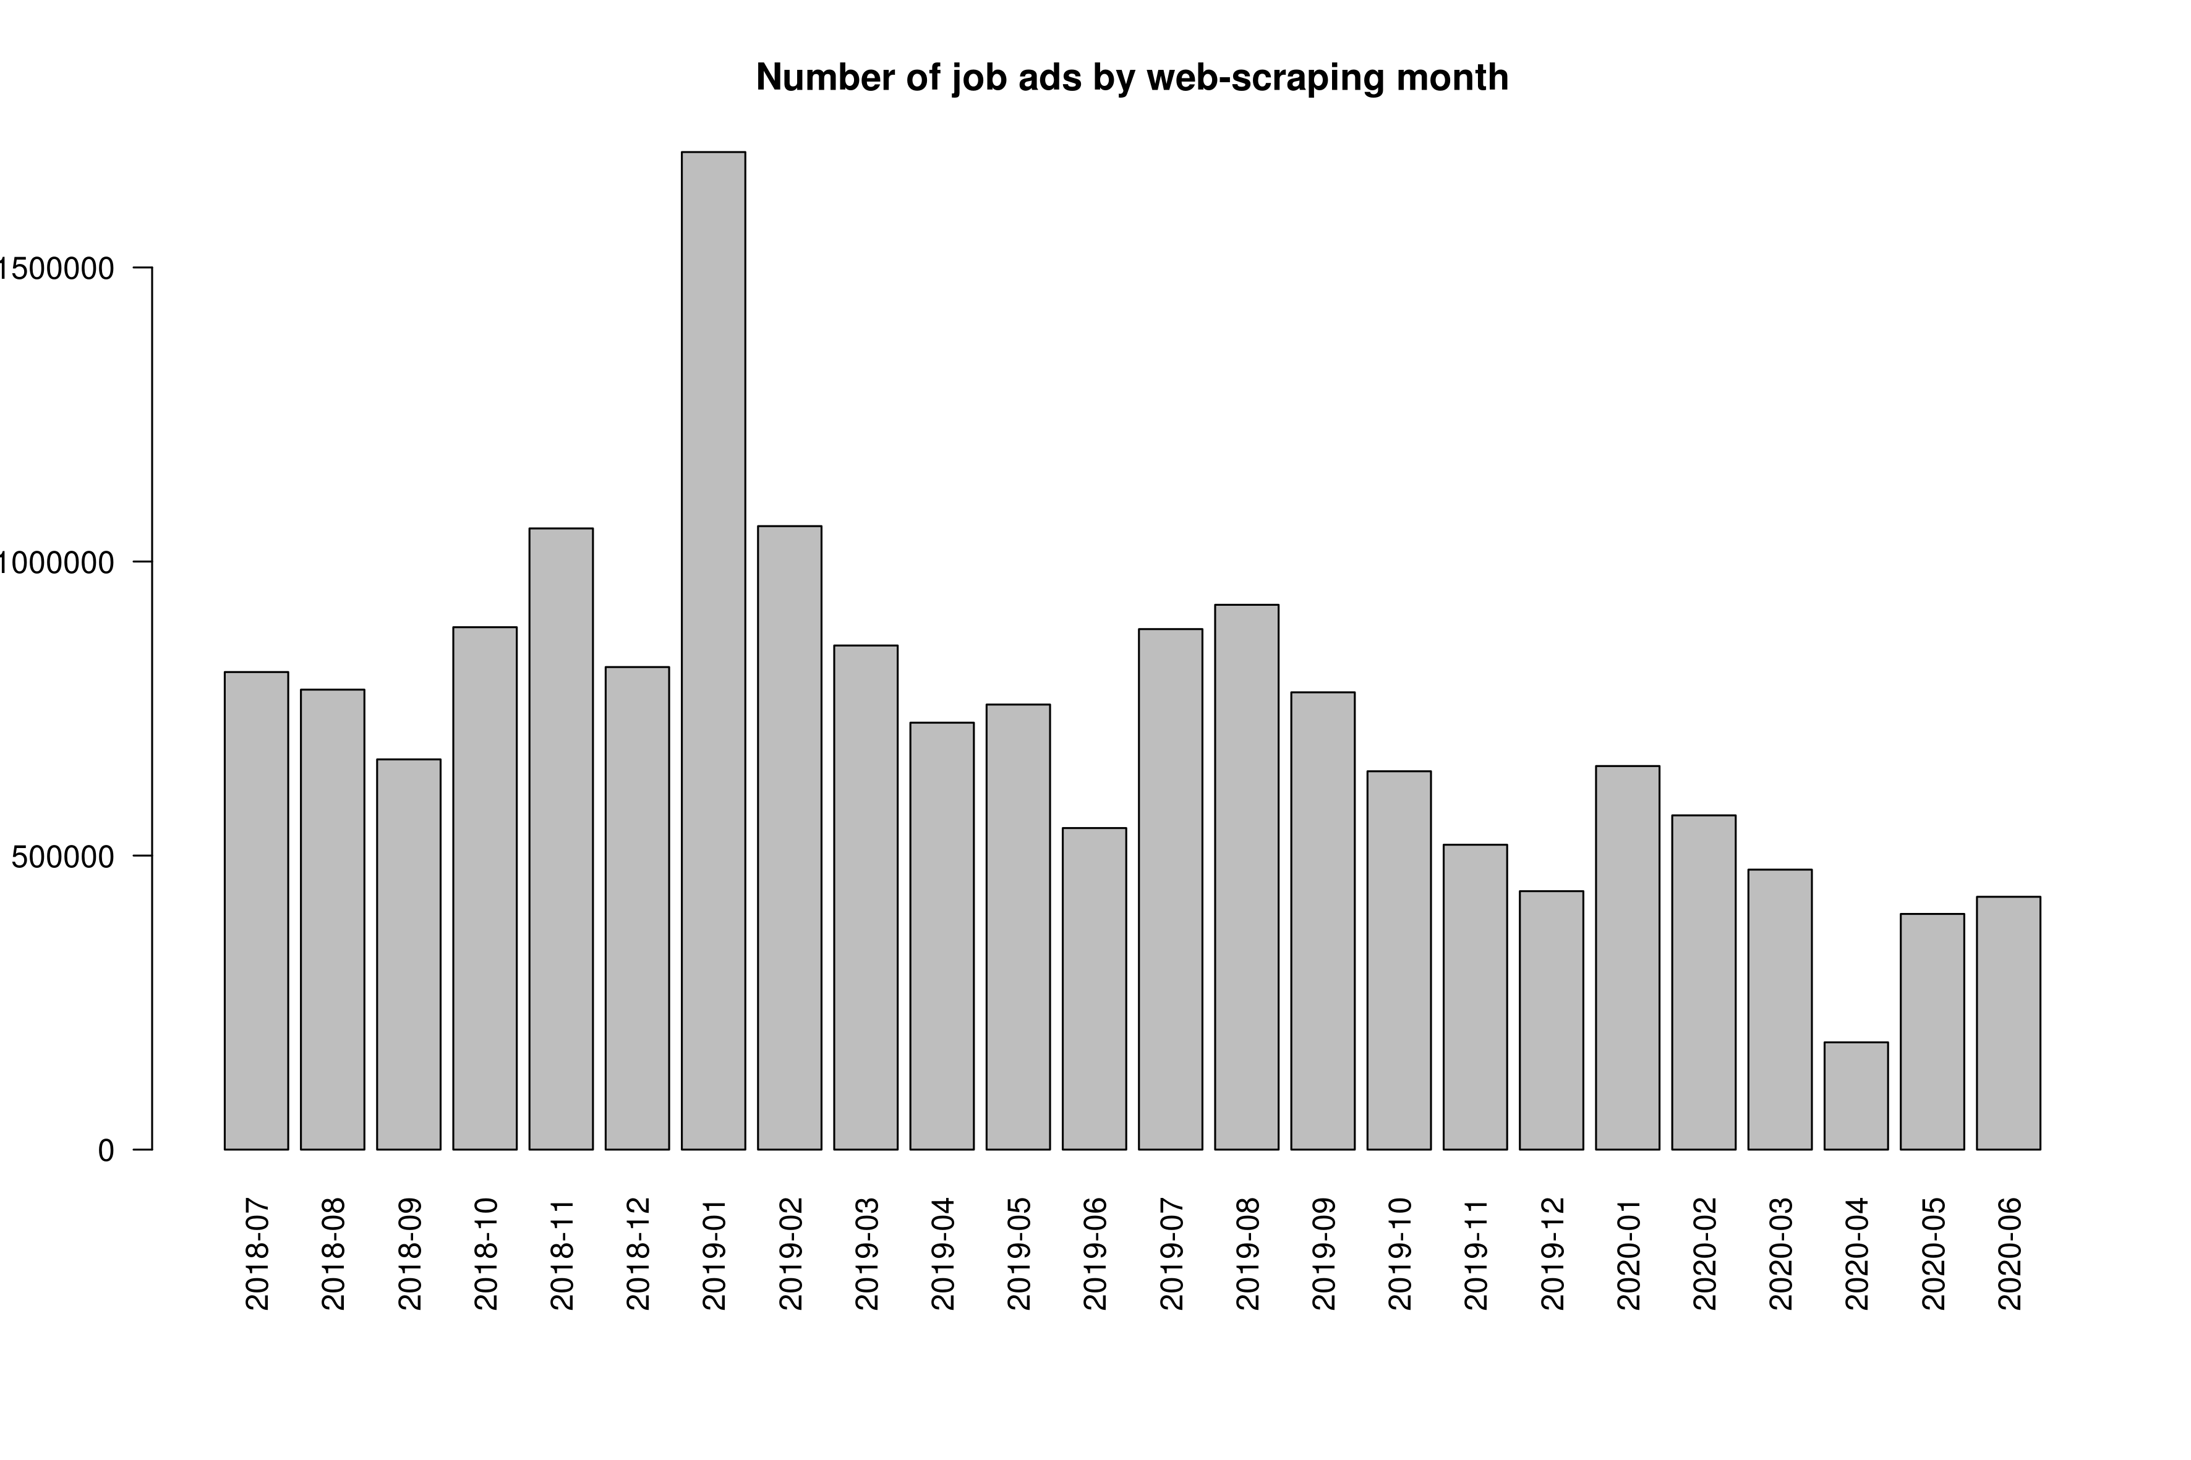
Figure 2: CEDEFOP dataset V5: accumulated number of job ads by web-scraping day
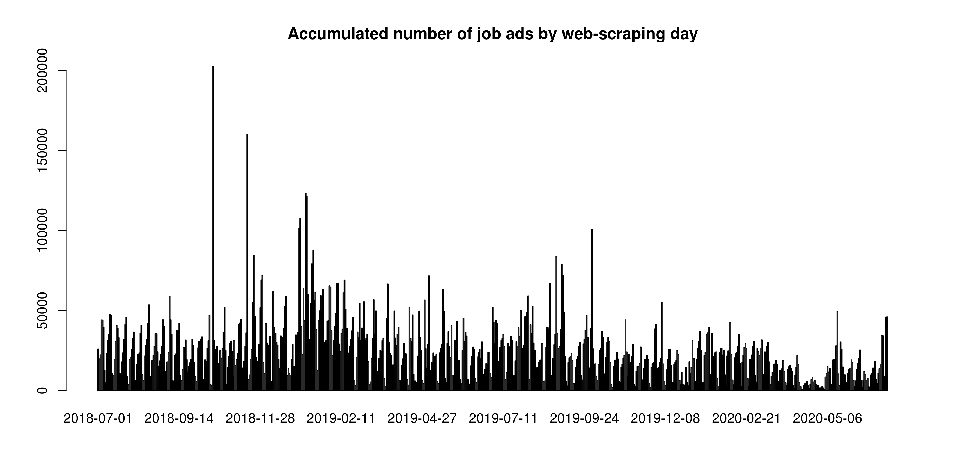
Sources and Sites
The number of job ads collected from the different sources is very uneven (Figure 3). In part, this reflects the size of the respective job portal. But is it also a symptom of inconsistent coverage of sources over time.
Not all sources were collected every day. Most sources display large day-to-day variations in the number of collected job ads. Some sources have gaps in coverage of single days up to more than a month (Figure 4). Note that data collection for several sources, e.g. DE_BACKINJOB, JOOBLE stopped completely after 01.2019.
The amount of total job ads collected, and the amount collected of each source varies dramatically over time. Figure 5 shows the share of the three largest sources, Arbeitsagentur, Xing and Adzuna, out of the total number of job ads collected each month. The total number of collected job ads has an immense peak in January 2019 and, on average, declines afterwards. The effect of the COVID-19 crisis is visible in a sharp drop in job ads for April 2020. Job ads recover in May and June 2020, although they remain at a level equivalent to the lowest number of ads scraped in the previous year.
The contribution of each major source is not stable over time and exhibits massive shifts. The share of non-duplicate ads collected from each source is roughly constant within each year, but shows large breaks between years. For instance, Adzuna makes up ~20% of all ads for every single month in 2018, but ~10% per month in 2019. In each month of 2020, Adzuna only accounts for 2-3% of all collected ads. Similarly, Xing contributes ~12% of ads per month in 2018, 15% in 2019 and ~30% in 2020.
These breaks are clearly artificial, because there is no reason to assume that the share of job ads posted on each platform exhibits such pronounced breaks at the same, specific points in time. This pattern is even more peculiar because earlier datasets (V4) don’t exhibit such clear breaks between calendar years (Figure 13).
We also observe increasing concentration in the number of sources towards the end of the observation period. By 2020, Arbeitsagentur and Xing together account for more than 80% of all job ads collected, in contrast with only about one third of all ads in 2018.
The distribution of sites (locations on the internet from which the job ads originate) is also very uneven. Figure 6 shows how the share of sites mostly reflects the share of sources.
Figure 3: CEDEFOP dataset V5: share of job ads by source (top 30)
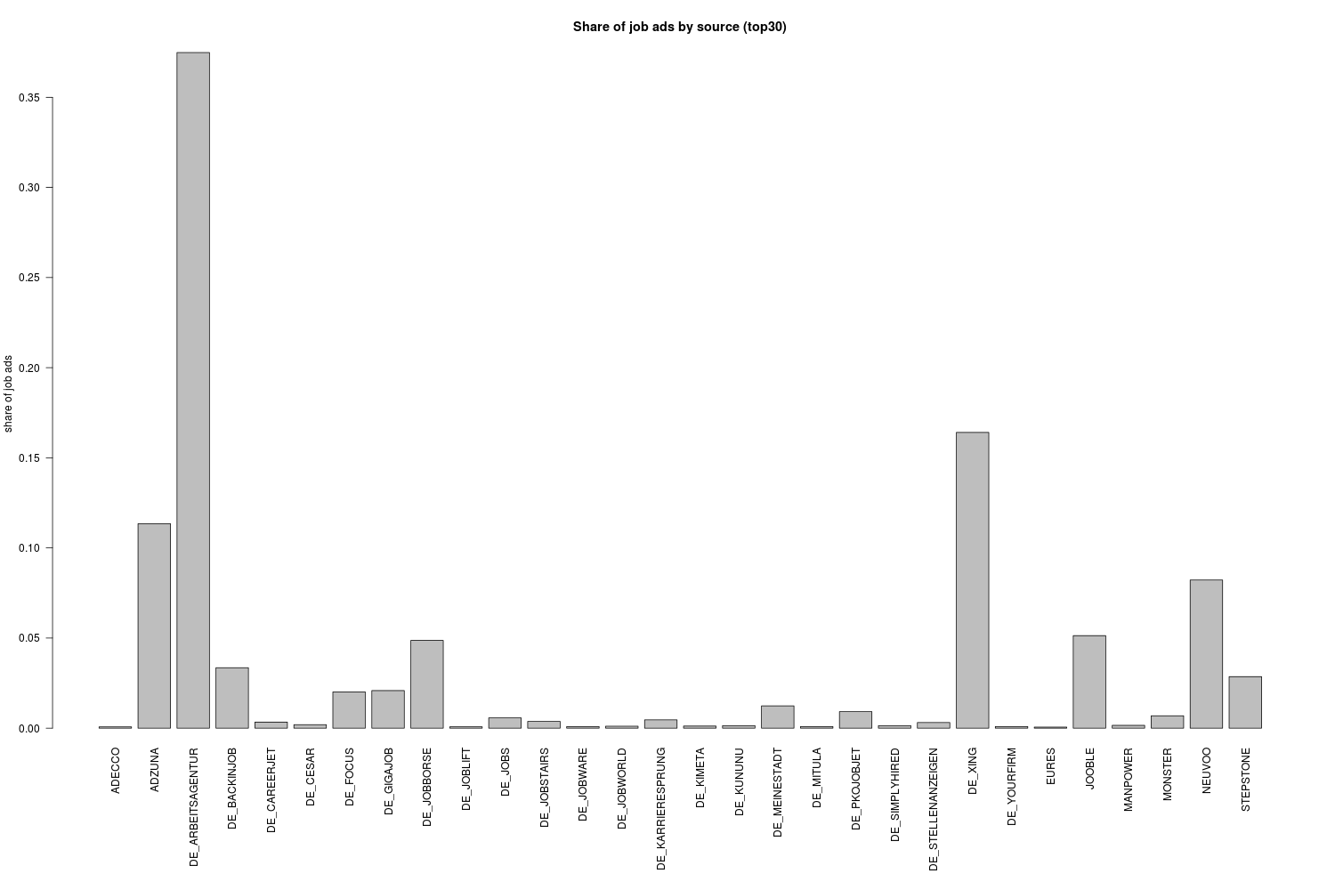

Figure 4: CEDEFOP dataset V5: ads collected by source and month
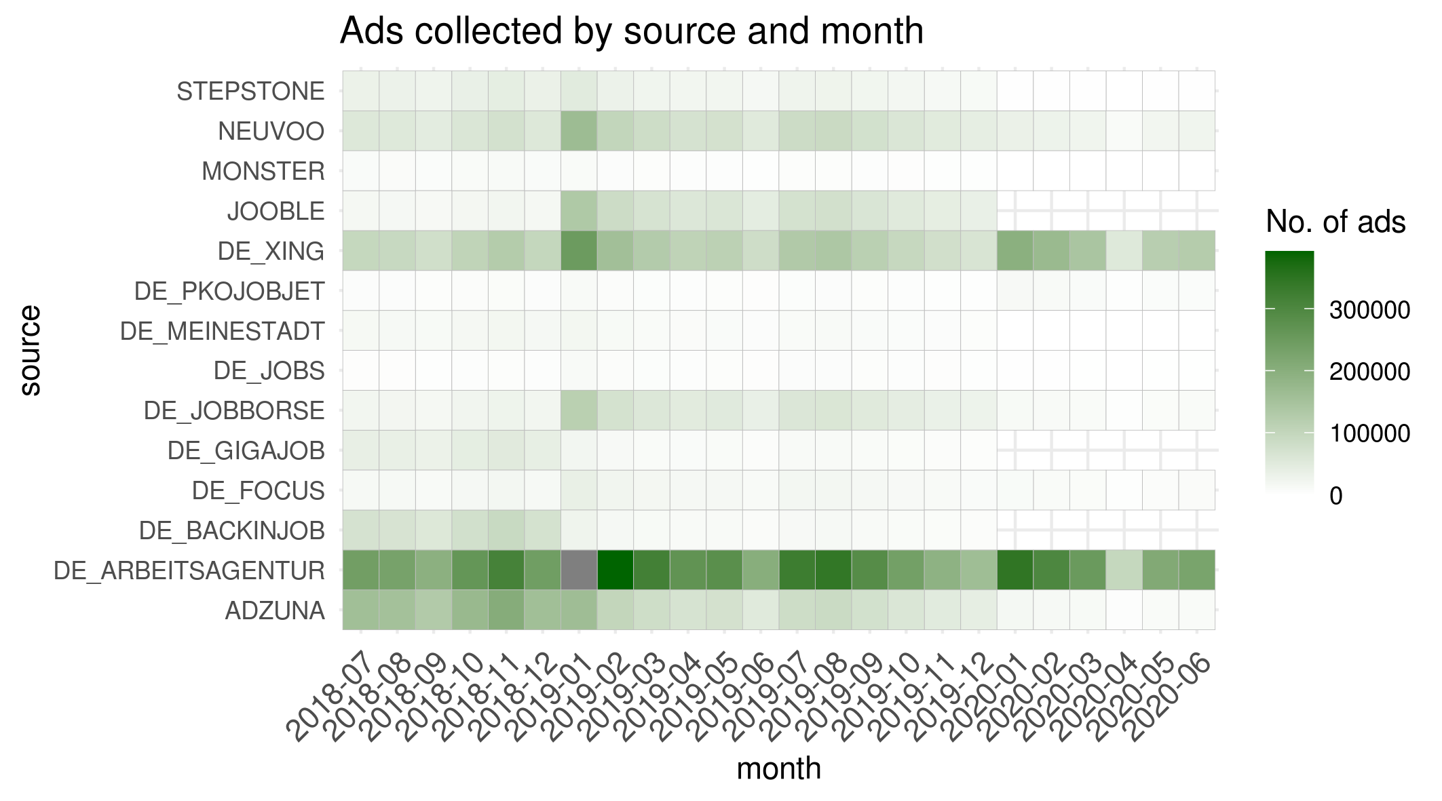

Figure 5: CEDEFOP dataset V5: monthly development of top 3 sources of the whole period
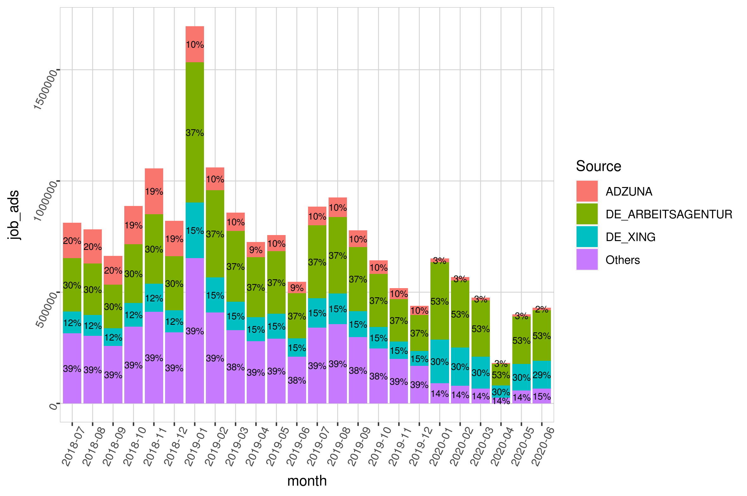

Figure 6: CEDEFOP dataset V5: share of job ads by site (top 30)
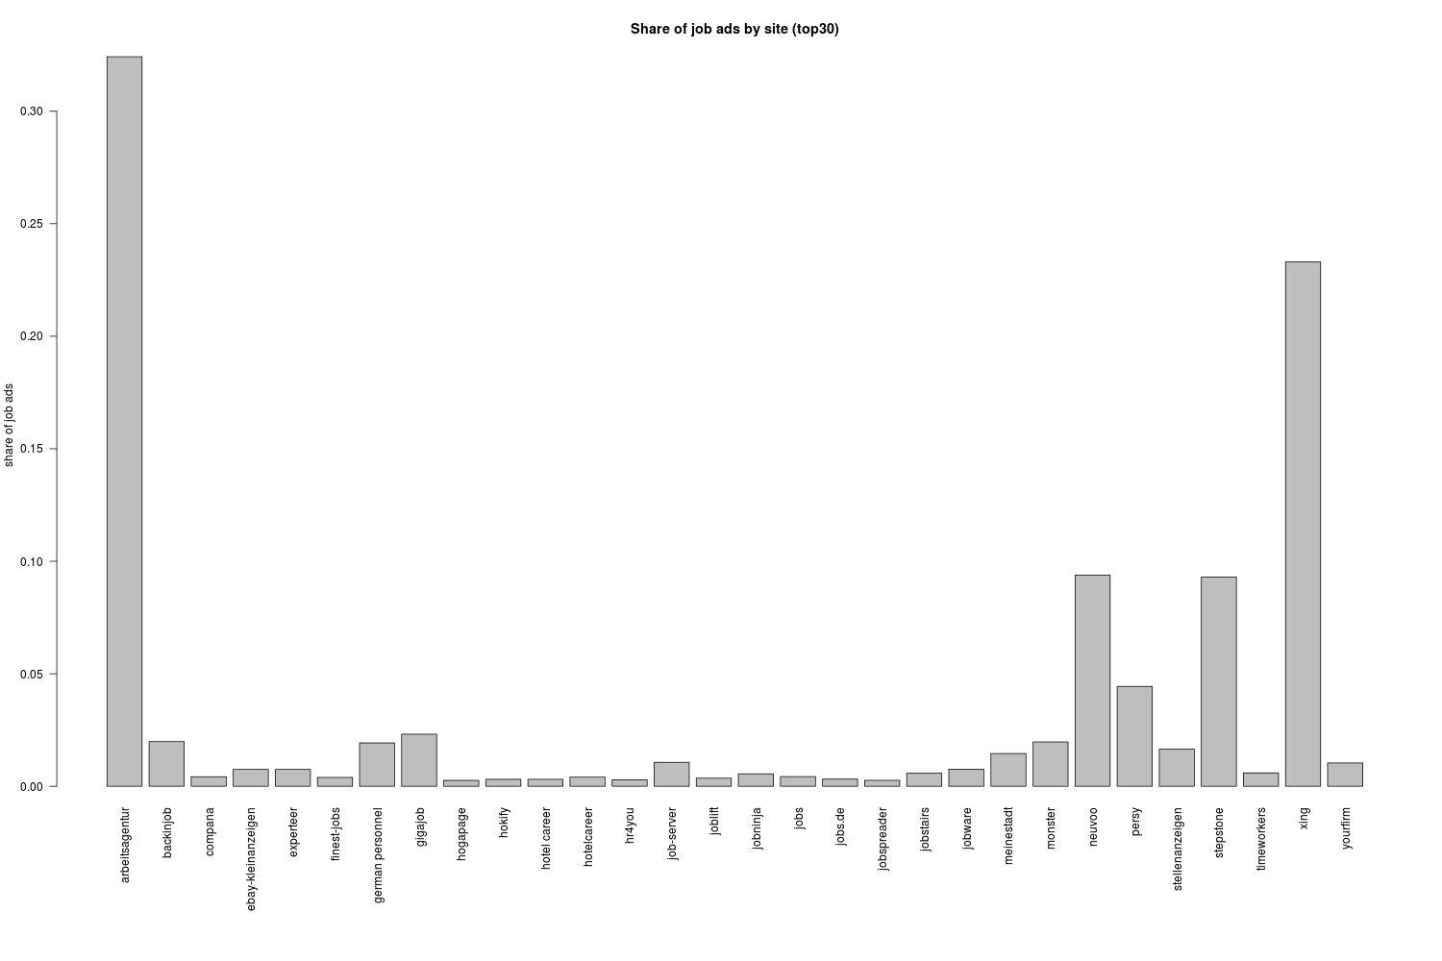

Location of jobs
Not all jobs in the sample, for which the source country is Germany, are located in Germany (country == DEUTSCHLAND). Next to jobs in Germany, German job portals primarily advertise jobs in Austria, the UK and the Netherlands (Table 2).
However, there seem to be some geographic consistency issues with the sourcecountry variable. When sourcecountry is set to DE the sample also contains job ads from various sources outside of Germany. These sources include, for instance, FR_METEOJOB, CH_GIGAJOB or NL_JOBBIRD.
Table 2: CEDEFOP dataset V5: location of jobs posted on websites (sources) in Germany
Country | Frequency
Germany | 16,966,266
Austria | 305,102
United Kingdom | 114,072
Netherlands | 46,573
France | 35,377
Belgium | 30,062
Bulgaria | 16,323
Italy | 8,562
Romania | 6,764
Spain | 6,371
Portugal | 5,363
Ireland | 3,913
Slovakia | 3,784
Hungary | 3,096
Luxembourg | 3,046
Greece | 2,335
Estonia | 1,619
Croatia | 1,477
Finland | 1,172
Sweden | 904
Slovenia | 836
Malta | 796
Poland | 624
Cyprus | 511
Denmark | 381
Czech Republic | 295
Lithuania | 233
Latvia | 48
Total | 17,565,905

Staffing agencies
We filter out job ads by staffing agencies, because it is unclear if they represent a real job vacancy and also because they might easily be duplicates of job ads by the employers themselves. Because there is no direct way of identifying ads by staffing companies, we filter by company name. Using a filter list of specific terms common to staffing agency names and of names of individual staffing companies. Names of staffing agencies, not covered by common terms, are collected from industry websites and Google search results.

Contract type
The type of contracts are classified by CEDEFOP, with the majority classified as temporary. In subsequent analysis, we exclude job ads classified as internships, because the presence or absence of ads for internships is not indicative of the state of the labour market
Table 3: CEDEFOP dataset V5: contract type
Contract type | Job Ads | Share
Internship | 3073755 | 23.4%
Permanent | 3413177 | 25.9%
Self Employment | 2579119 | 19.6%
Temporary | 4091649 | 31.1%

Pseudo-stocks
In order to evaluate total labor demand based on online job ads (OJA), we need to know if OJA data refers to the stock of vacancies at a point in time or to the inflow of new vacancies relative to the previous period. However, CEDEFOP data represent neither the flow nor the stock of online job vacancies. If it was flow data, we would see a large initial stock on which to base the flows of ads. This is not the case, as evident from Figure 2, which shows the daily frequency counts of job ads collected in Germany. If it were stocks, we would expect to observe similar stocks of observations every day, with gradual changes. This is also not the case, as there are large day-to-day fluctuations in the numbers of ads collected.
The data layout and descriptive material from CEDEFOP hint at an unstructured approach to collecting OJA -data by scraping new ads whenever there happen to be resources available. Therefore, the counts of job ads cannot be directly compared with other measures of labour demand. CEDEFOP job ads can’t be interpreted as a time-series unless converted to stock data.
In order to address this issue, we generate pseudo-stocks from CEDEFOP data which are an approximation to the underlying stock of job ads. The idea behind pseudo-stocks is the following:
The idea behind pseudo-stocks is the following: At a given point in time (T), we consider a job ad to be valid if it hasn’t expired yet and was posted a maximum number of days before T. Expiration of a job ad is determined by the variable expire_date. Preliminary analysis of other sources indicates that job ads stay relevant for roughly 30 days on average. The number of all job ads which are considered at time T is the pseudo-stock of active job ads at time T. Figure 7 illustrates this approach.
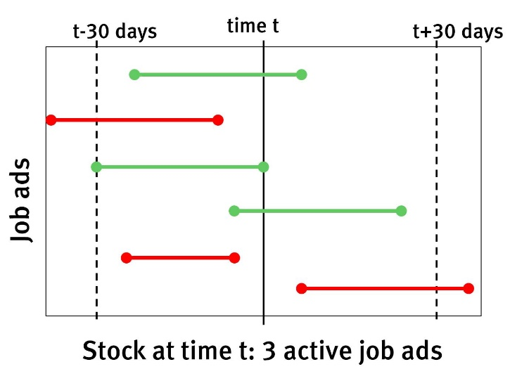
Figure 7: Stock at time t: example of three active job ads
This approach has the advantage that it can account for gaps in scraping coverage as long as the missing ads are scraped at some point within the assumed validity period.
One drawback of this approach is that for the length of the first validity period in the observed timeframe too few valid vacancies are available. Therefore, assuming 30 days of validity, pseudo-stocks are only useful from the 01.08.2018 onward.
We calculate daily pseudostocks of CEDEFOP OJAs and take the average over each quarter, in order to obtain quarterly pseudostocks. In Figure 8 and Figure 9 we compare these quarterly pseudostocks with quarterly results from the German JVS.
The German JVS quantifies two types of vacancies, general vacancies which are to be filled at some indeterminate point in the future and urgent vacancies which are to be filled immediately.
The number of pseudo-stock job ads lies substantially below general vacancies in the JVS. This is also the case if we only consider JVS positions which are to be filled immediately. We consider urgent vacancies to be a better equivalent to OJA than general vacancies, since the publication of OJA indicates that the recruitment process has started and the position is to be filled within a certain timeframe.
OJAs capture only a subset of all vacancies, therefore we expect accurately measured OJA stocks to be lower than JVS vacancies, which is borne out in the results. Another reason why OJA stocks are likely to lie below JVS stocks is the fact that multiple vacancies can be covered by a single job ad. This line of reasoning assumes that deduplication of web scraped job ads is (mostly) successful.
However, there is a substantial divergence in the development over time between OJA data and JVS vacancies. While JVS vacancies are relatively stable throughout the year 2019, this is not true for the pseudostocks of CEDEFOP OJAs. Those rise from 47-thousand in the third quarter of 2018, to 74-thousand at the start of 2019. An increase of more than 50% over 9 months. After a sharp drop in the second quarter of 2019, pseudostocks continue dropping until they reach an all-time low of 13-thousand in the fourth quarter of 2019. In the first quarter of 2020, pseudostocks rise again to 37-thousand, before dropping to 15-thousand in the second quarter. This last drop coincides with the start of the COVID-19 crisis in Germany.
However, the dramatic drop in valid job ads in Q4 2019 does not have any underlying economic events. There is also a large discrepancy between the number of collected job ads (Figure 1), and the pseudostock of job ads for this period (Figure 8). Job ads in Q4 2019 are lower than in the previous and the following quarter, but they don’t drop to an all-time low.
It needs to be stated clearly that the seven quarters for which CEDEFOP data is available is too short a timeframe to compare long-term trends in CEDEFOP and JVS results. However, it is clear that quarter-to-quarter variations are vastly different for both datasources. Three explanations for the observed differences are possible:
First, CEDEFOP OJA data is about job ads, while the JVS represents vacancies. If the number of vacancies per job ad was fluctuating strongly over time, discrepancies between OJA and JVS could be caused by this factor. However, research by the University of Zürich indicates that the average number of vacancies per online job ad is stable over time, at roughly 1.2.
Second, the online job market may be more volatile than the numbers of vacancies reported in the JVS. While increased volatility is likely, we have shown in Section 2 that there is also huge volatility in webscraping coverage of sources. It is therefore not possible, at the moment, to disentangle volatility in data collection from volatility in the underlying job market.
Which leads to the third possible reason for the observed discrepancies. Webscraping coverage of job ad sources in CEDEFOP data is spotty and unreliable, as illustrated by Figure 4 and Figure 5. Which might lead to strong quarter-to-quarter variations in pseudo-stock levels. Additionally, removal of duplicate observations is likely not perfect, which means that the share of duplicates will, to some extent, increase with the number of sources. Because the number of sources which are scraped effectively by Cedefop varies over time, the share of duplicates also varies in a similar way.

Figure 8: CEDEFOP dataset V5: Job ads/vacancies for CEDEFOP-OJA (pseudo-stocks) and JVS
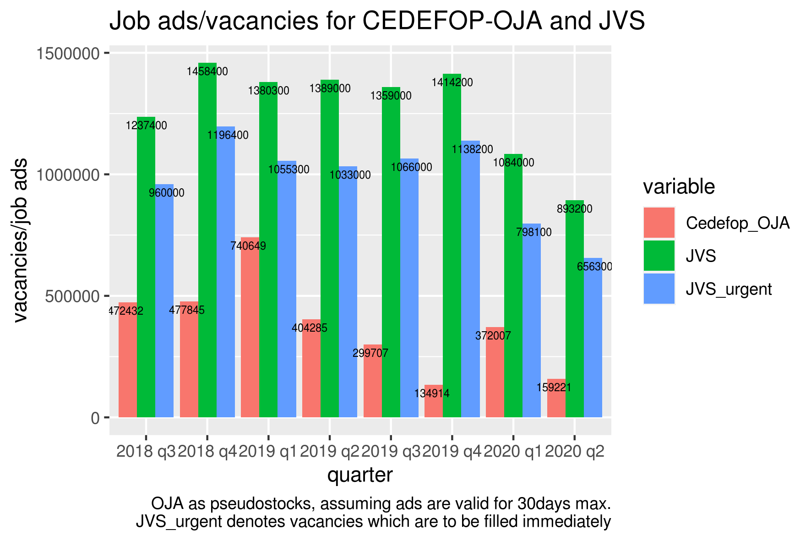
Figure 9: CEDEFOP dataset V5: job ads/vacancies for CEDEFOP-OJA (pseudo-stocks) and FEA open vacancies
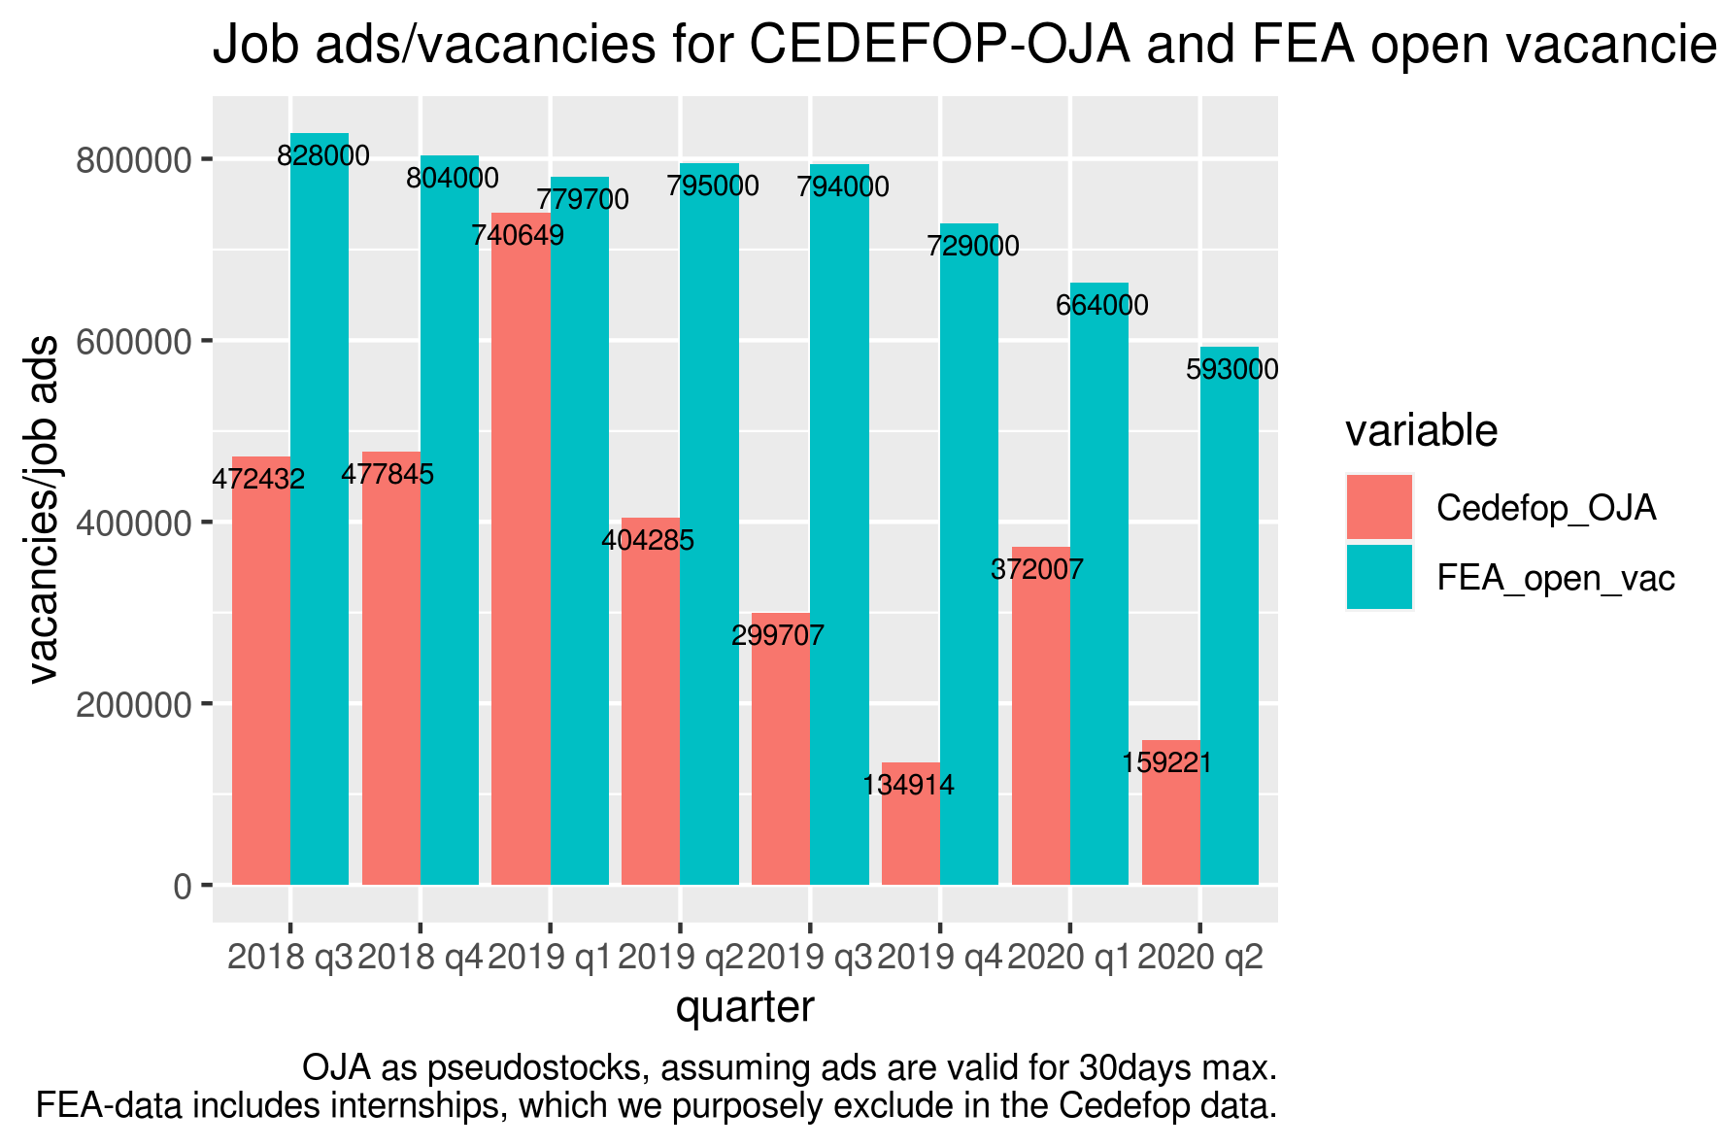

Missing attributes
Table 4 shows the counts and shares of missing attributes by variable in the Cedefop V5 dataset. Due to the issues described in the leading paragraph of Section 2, this is the dataset without duplicated observations.
Table 4: CEDEFOP dataset V5: variables and their missings
variable | short description | share | na_count
general_id |  | 0 | 0
grab_date |  | 0 | 0
year_grab_date |  | 0 | 0
month_grab_date |  | 0 | 0
day_grab_date |  | 0 | 0
expire_date |  | 0 | 0
year_expire_date |  | 0 | 0
month_expire_date |  | 0 | 0
day_expire_date |  | 0 | 0
lang |  | 0 | 0
idesco_level_4 |  | 0 | 0
esco_level_4 |  | 0 | 0
idesco_level_3 |  | 0 | 0
esco_level_3 |  | 0 | 0
idesco_level_2 |  | 0 | 0
esco_level_2 |  | 0 | 0
idesco_level_1 |  | 0 | 0
esco_level_1 |  | 0 | 0
idcity |  | 0,38 | 6,665,861
city |  | 0,38 | 6,665,753
idprovince | NUTS-III | 0,21 | 3,681,880
province |  | 0,21 | 3,681,056
idregion | NUTS-II | 0,18 | 3,161,335
region |  | 0,18 | 3,161,601
idmacro_region | NUTS-I | 0,17 | 2,983,964
macro_region |  | 0,17 | 2,983,969
idcountry |  | 0 | 0
country |  | 0 | 0
idcontract |  | 0,25 | 4,408,205
contract |  | 0,25 | 4,408,205
ideducational_level |  | 0,01 | 214,770
educational_level |  | 0,01 | 214,770
idsector |  | 0,01 | 137,969
sector |  | 0,01 | 137,969
idmacro_sector |  | 0,01 | 137,969
macro_sector |  | 0,01 | 137,969
idcategory_sector |  | 0,01 | 137,969
category_sector |  | 0,01 | 137,969
idsalary |  | 0,9 | 15,821,285
salary |  | 0,9 | 15,821,285
idworking_hours |  | 0,26 | 4,525,280
working_hours |  | 0,26 | 4,525,280
idexperience |  | 0,7 | 12,298,492
experience |  | 0,7 | 12,298,492
source_category |  | 0 | 0
sourcecountry |  | 0 | 0
source |  | 0 | 0
site |  | 0 | 0
companyname |  | 0,14 | 2,447,019

CEDEFOP data version V4
This dataset covers the timeframe from July 2018 to March 2020. It contains 44383960 observations in total.
With this dataset, due to the manageable size, we did include the duplicated observations for the analysis in Sections 3.1 to 3.3.

Dates and times of observations
The frequency of scraped job ads varies by month and also by day of scraping, as shown in Figure 10 and Figure 11. Note that the number of scraped ads per month and per day differs from the pattern we observe in the most recent V5 dataset (compare Figure 1 and Figure 2).
Figure 10: CEDEFOP dataset V4: number of job ads by web-scraping month

Figure 11: CEDEFOP dataset V4: accumulated number of job ads by web-scraping day

Webscraping coverage
As with the most recent V5 dataset, not all sources were collected every day (Figure 4 and Figure 12).
However, in contrast with the pattern observed in V5, the share of individual sources does not exhibit sharp breaks between years (Figure 13). On the other hand, shares fluctuate more strongly within years. For instance, Adzuna makes up 30% of all ads in September 2018, but only 3% in March 2020. Similarly, Xing fluctuates between 30% and 4% of all job ads.
The increasing concentration to smaller numbers of sources, observed in V5, is also present in V4. By 2020, Arbeitsagentur and Xing together account for more than 80% of all job ads collected, in contrast with only about one third of all ads in 2018.
Collection of ads was not consistent over sites, either (Figure 14).

Figure 12: CEDEFOP dataset V4: ads collected by source and month
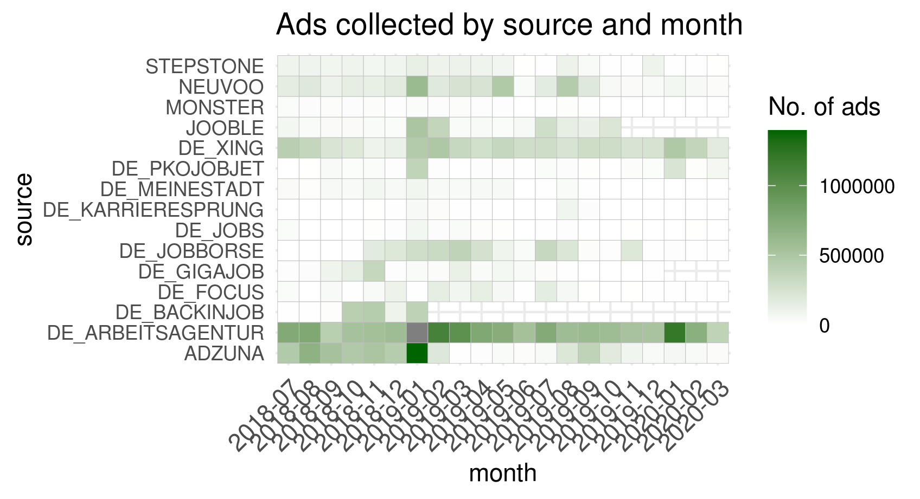

Figure 13: CEDEFOP dataset V4: monthly development of top 3 sources of the whole period
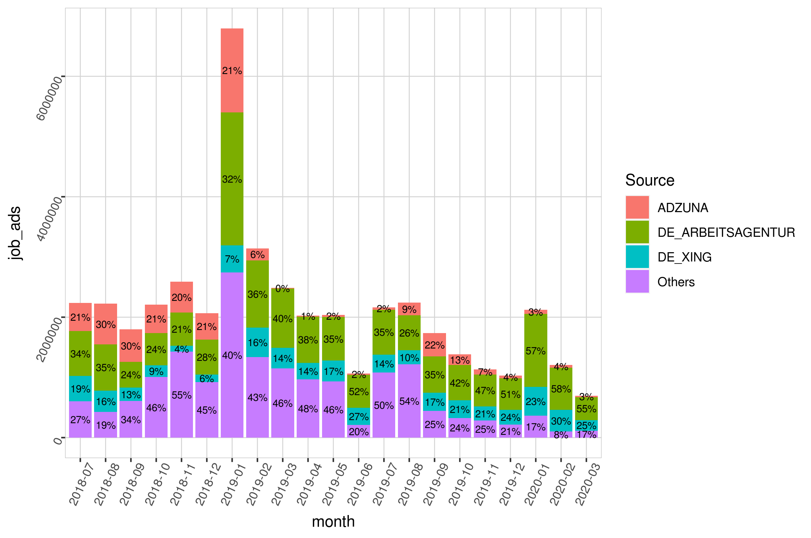
Figure 14: CEDEFOP dataset V4: ads collected by site and month
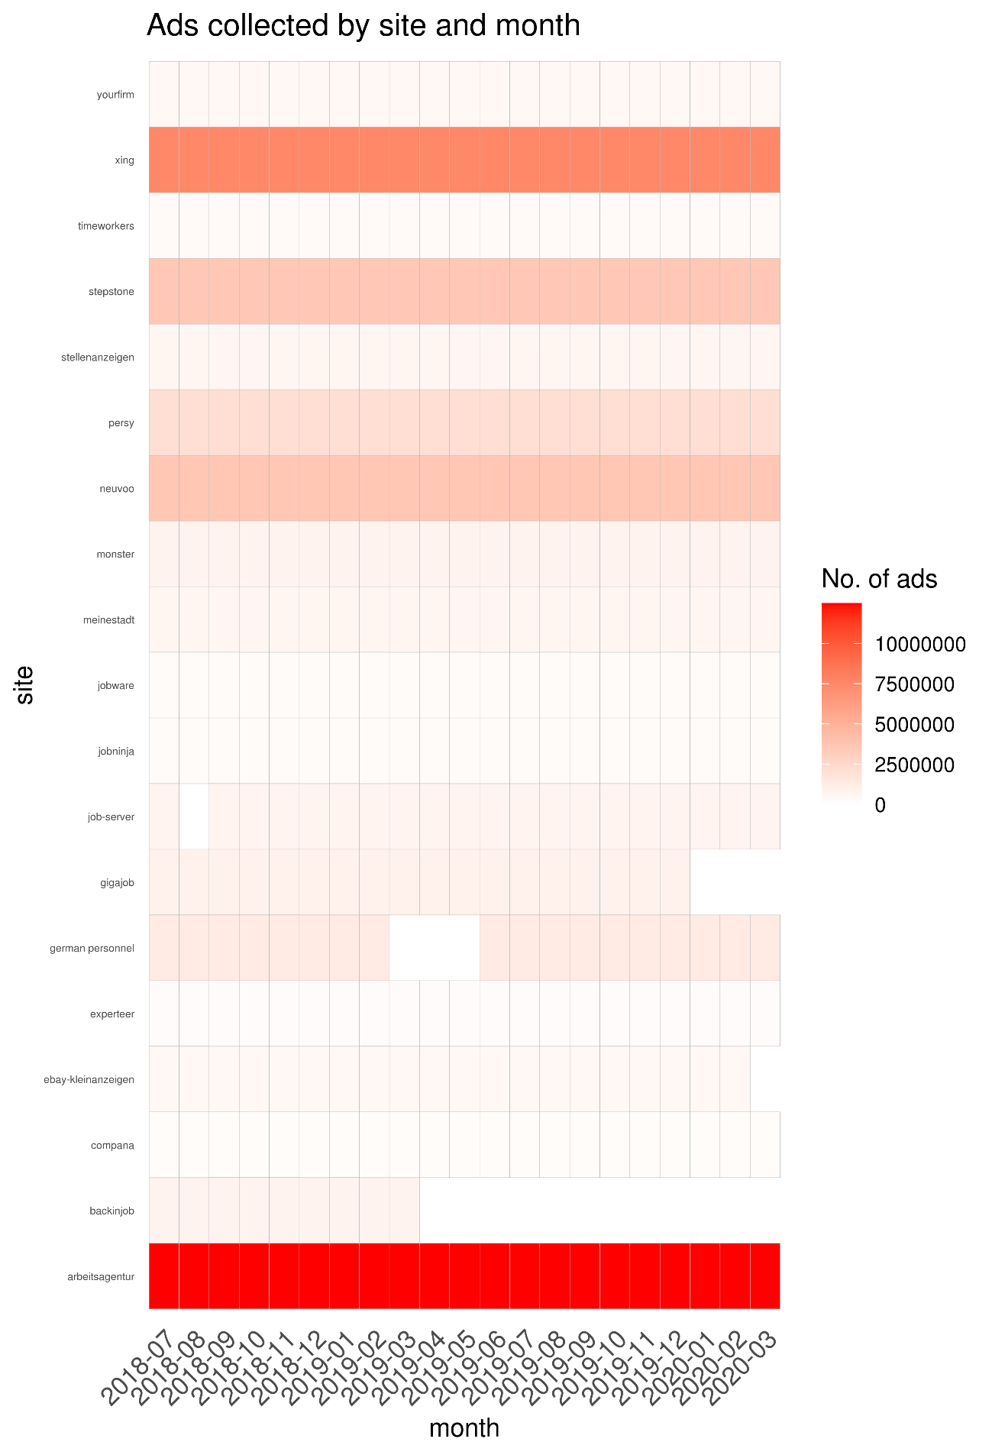

Location of jobs

Just as in the V5 dataset, not all job ads in the V4 sample, for which the source country is Germany, are located in Germany (country == DEUTSCHLAND). Next to jobs in Germany, German job portals primarily advertise jobs in Austria, the UK and the Netherlands (Table 5).
Table 5: CEDEFOP dataset V4: Location of jobs posted on websites (sources) in Germany
Country | Frequency
Germany | 43,090,384
Austria | 585,172
United Kingdom | 281,424
Netherlands | 111,139
France | 96,598
Belgium | 64,574
Bulgaria | 37,996
Portugal | 19,231
Italy | 18,592
Romania | 14,047
Spain | 13,103
Ireland | 7,862
Slovakia | 7,829
Hungary | 6,850
Luxembourg | 6,034
Greece | 3,830
Croatia | 3,445
Estonia | 3,013
Finland | 2,922
Sweden | 2,534
Slovenia | 1,789
Poland | 1,473
Cyprus | 1,087
Malta | 1,022
Denmark | 769
Czech Republic | 649
Lithuania | 478
Latvia | 114
Total | 44,383,960

Duplicates
Of the 44383960 observations for Germany in the V4 dataset, 16341879 are distinct (not duplicates). Which means that they have a unique “general_id”. CEDEFOP assigns the same general_id to all observations which it classifies as duplicates of each other. The share of such duplicates is therefore 63% of all observations.
Observations classified as “duplicates” in V4 by CEDEFOP can differ in their content. Typically, of a group of “duplicate” observations only one has a non-missing entry for the variable “companyname”. However, this is a pattern unique to the V4 dataset and does not hold for V5.
The share of duplicates is relatively consistent over time, with the exception of January 2019, January 2020 and March 2020. During the first two months, the share of duplicates was unusually high, exceeding 75%. In March 2020, the share was very low, with only 29% of observations classified as duplicates.
For subsequent analysis, we keep only one observation per group of duplicates. The observation with the least number of missing column entries is kept.
Figure 15: CEDEFOP dataset V4: share of duplicates by web-scraping month

Staffing agencies
As with the V5 dataset, we filter out job ads by staffing agencies. Filtering of staffing agencies leaves 15030950 of the 16341879 unique observations.

Contract type
Table 6: CEDEFOP dataset V4: contract type
Contract type | Job Ads (in thousand)
Internship | 2769
Permanent | 3008
Self Employment | 2298
Temporary | 3468

Pseudo-stocks
We have calculated pseudostocks for the V4 dataset in the same way we apply to the V5 dataset, as described in Section 2.5.
As in V5, the number of pseudo-stock job ads lies substantially below general vacancies in the JVS (Figure 16). This is also the case if we only consider JVS vacancies which are to be filled immediately (Figure 17).
A major difference between the two datasets is apparent in the pseudostock of job ads for the third and fourth quarters of 2019 (Figure 8). V4 pseudostocks for Q3 2019 are 59000, for Q4 2019 they are 42900. In contrast, pseudostocks for V5 are 29900 for Q3 2019 and 13000 for Q4 2019. This means that the stock of ads in V4 is twice that of V5 in Q3 and more than 2.5 times that of V5 in Q4.
Because both dataset are based on the same raw webscraping data, discrepancies on this scale are evidence of systematic changes in the data preparation pipeline between the two versions.
Figure 16: CEDEFOP dataset V4 Job ads/vacancies for CEDEFOP-OJA (pseudo-stocks) and JVS
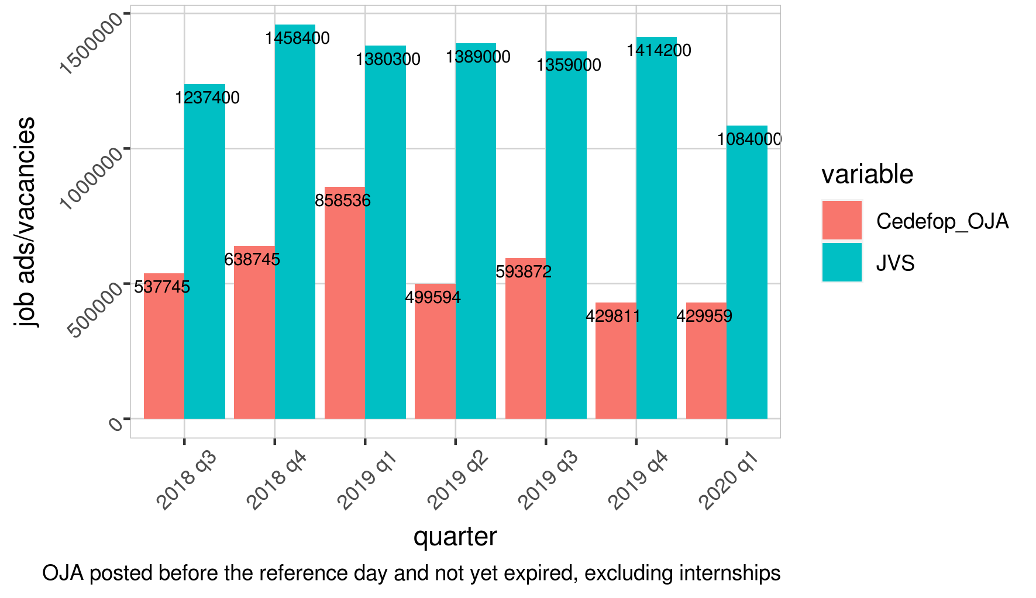

Figure 17: CDEDEFOP dataset V4: job ads/vacancies for CEDEFOP-OJA (pseudo-stocks ) and FEA open vacancies
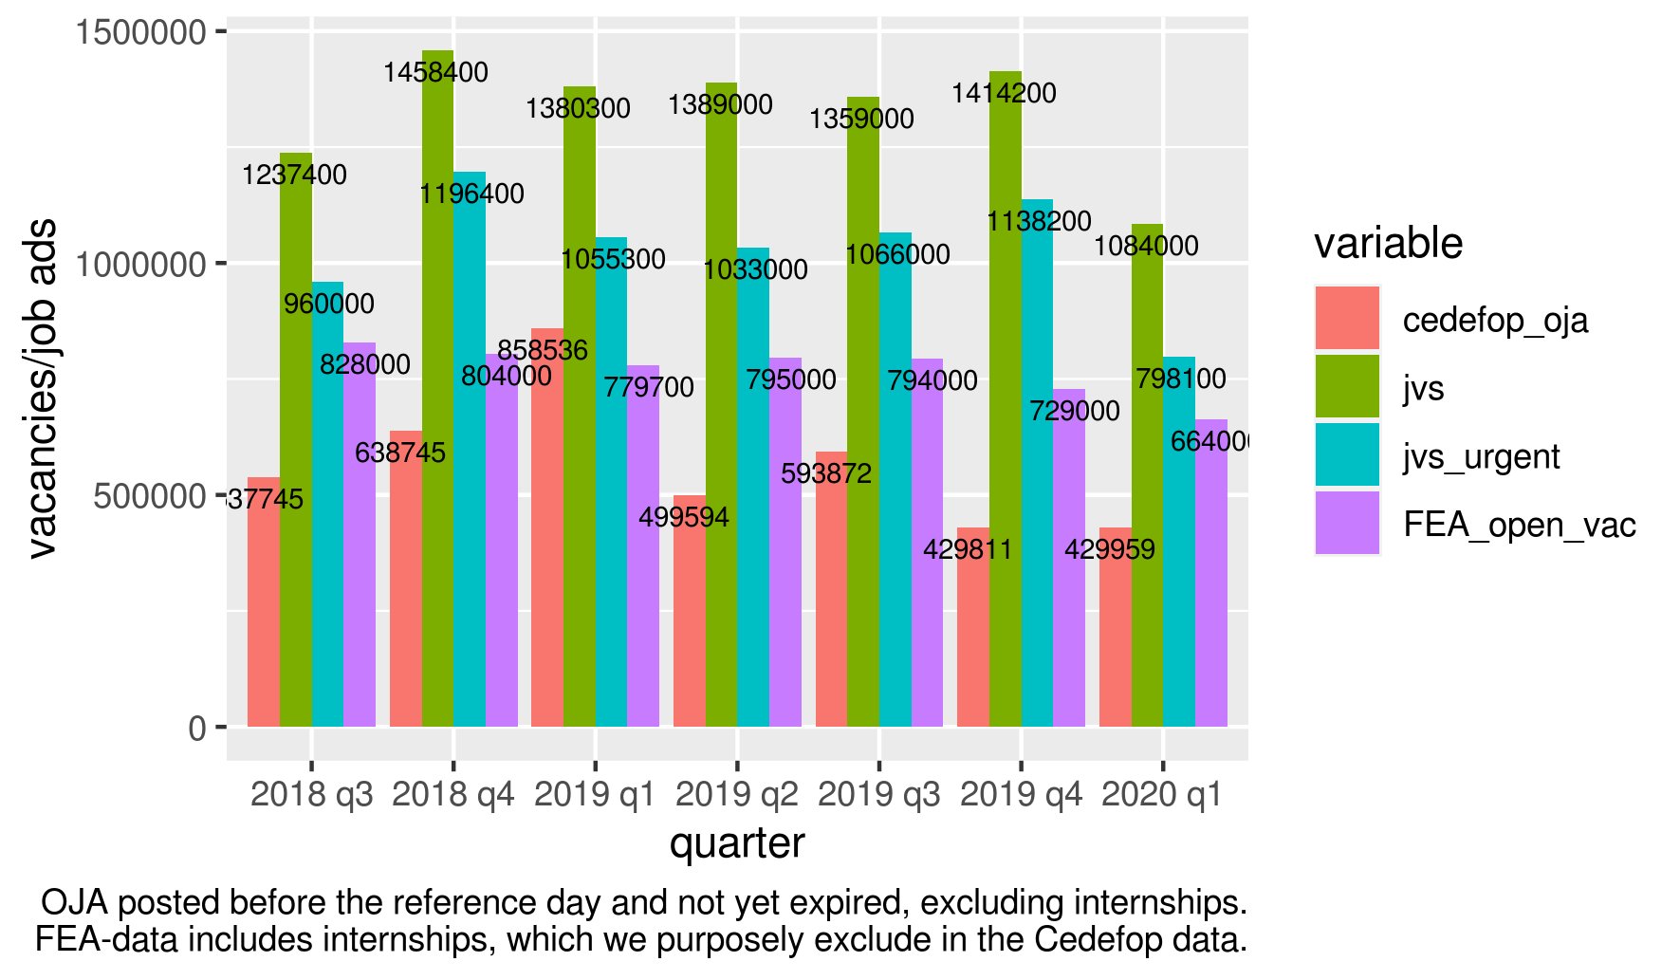

Figure 18: CEDEFOP dataset V4: pseudo-stocks of CEDEFOP-OJA, by valid period
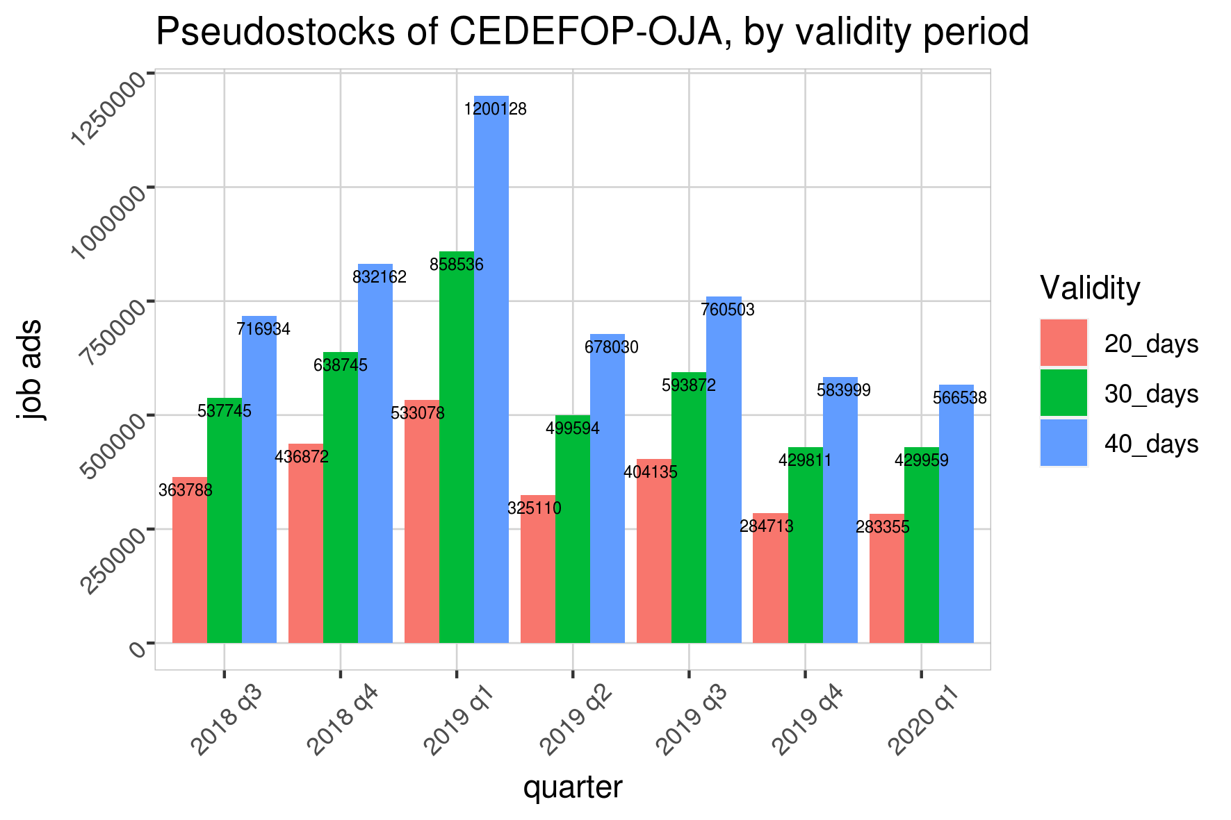

Missing attributes
Table 7 shows the counts and shares of missings by variable in the Cedefop V4 dataset without any cleaning or deduplication applied to the data. On the other hand it shows also the counts and shares of missing attributes after having dropped all observations marked as duplicates and cleaned some data inconsistencies. Most notable, there are no observations left with missing company names.
Table 7: CEDEFOP dataset V4: variables and their missings before and after deduplication
variable | short description | missings before deduplication |  | missings after deduplication
variable | short description | share | na_count | share | na_count
general_id |  | 0 | 0 | 0 | 0
grab_date |  | 0 | 0 | 0 | 0
year_grab_date |  | 0 | 0 | 0 | 0
month_grab_date |  | 0 | 0 | 0 | 0
day_grab_date |  | 0 | 0 | 0 | 0
expire_date |  | 0 | 0 | 0 | 0
year_expire_date |  | 0 | 0 | 0 | 0
month_expire_date |  | 0 | 0 | 0 | 0
day_expire_date |  | 0 | 0 | 0 | 0
lang |  | 0 | 0 | 0 | 0
idesco_level_4 |  | 0 | 0 | 0 | 0
esco_level_4 |  | 0 | 0 | 0 | 0
idesco_level_3 |  | 0 | 0 | 0 | 0
esco_level_3 |  | 0 | 0 | 0 | 0
idesco_level_2 |  | 0 | 0 | 0 | 0
esco_level_2 |  | 0 | 0 | 0 | 0
idesco_level_1 |  | 0 | 0 | 0 | 0
esco_level_1 |  | 0 | 0 | 0 | 0
idcity |  | 0,4 | 17,826,370 | 0,37 | 4,544,825
city |  | 0,4 | 17,826,370 | 0,37 | 4,544,835
idprovince | NUTS-III | 0,28 | 12,548,265 | 0,25 | 3,126,591
province |  | 0,28 | 12,547,968 | 0,25 | 3,126,667
idregion | NUTS-II | 0 | 0 | 0 | 0
region |  | 0 | 0 | 0 | 0
idmacro_region | NUTS-I | 0,19 | 8,308,139 | 0,16 | 1,931,199
macro_region |  | 0,19 | 8,308,139 | 0,16 | 1,933,844
idcountry |  | 0 | 0 | 0 | 0
country |  | 0 | 0 | 0 | 0
idcontract |  | 0,23 | 10,350,950 | 0,28 | 3,487,448
contract |  | 0,23 | 10,350,950 | 0,28 | 3,487,448
ideducational_level |  | 0,01 | 617,085 | 0,01 | 155,468
educational_level |  | 0,01 | 617,085 | 0,01 | 155,468
idsector |  | 0,01 | 408,194 | 0,01 | 79,043
sector |  | 0,01 | 408,194 | 0,01 | 79,043
idmacro_sector |  | 0,01 | 408,194 | 0,01 | 79,043
macro_sector |  | 0,01 | 408,194 | 0,01 | 79,043
idcategory_sector |  | 0,01 | 408,194 | 0,01 | 79,043
category_sector |  | 0,01 | 408,194 | 0,01 | 79,043
idsalary |  | 0,91 | 40,229,901 | 0,91 | 11,122,712
salary |  | 0,91 | 40,229,901 | 0,91 | 11,122,712
idworking_hours |  | 0,26 | 11,320,891 | 0,24 | 2,916,232
working_hours |  | 0,26 | 11,320,891 | 0,24 | 2,916,232
idexperience |  | 0,72 | 31,969,378 | 0,7 | 8,555,438
experience |  | 0,72 | 31,969,378 | 0,7 | 8,555,438
source_category |  | 0 | 0 | 0 | 0
sourcecountry |  | 0 | 0 | 0 | 0
source |  | 0 | 0 | 0 | 0
site |  | 0 | 0 | 0 | 0
companyname |  | 0,11 | 4,792,833 | 0 | 0

As shown in Figure 10, we also perform the same analysis with validity periods of 20 days and 40 days, in order to ensure robustness of the chosen timeframe. The results scale almost linearly with the length of the validity period. See also ESSnet WP 1.
Compare Sacchi, S. 2008, Methodische Grundlagen Stellenmarkt-Monitor Schweiz, Universität Zürich.

