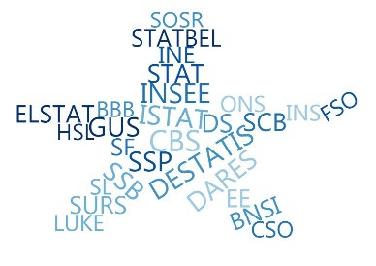

ESSnet Big Data II

Grant Agreement Number: 847375-2018-NL-BIGDATA
https://webgate.ec.europa.eu/fpfis/mwikis/essnetbigdata
https://ec.europa.eu/eurostat/cros/content/essnetbigdata_en

Workpackage WPB
Implementation – Online Job Vacancies

CEDEFOP exploratory analysis 07.2020 (DE)
Prepared by:
Jakob de Lazzer

Date of present version: September 2020

Workpackage Leader:
Tomaž Špeh (SURS, SI)
e-mail address: tomaz.speh@gov.si
mobile phone: +38651672116

Sample size, country identification and timeframe

Data for Germany refers to all observations in the BDTI Cedefop database for which $sourcecountry== DE$. 44383960 observations total.
43090384 of those are ads for jobs located in Germany (country == DEUTSCHLAND):
Country | Frequency
ÖSTERREICH | 585172
UNITED KINGDOM | 281424
NEDERLAND | 111139
FRANCE | 96598
BELGIQUE-BELGIË | 64574
БЪЛГАРИЯ (BULGARIA) | 37996
PORTUGAL | 19231
ITALIA | 18592
ROMÂNIA | 14047
ESPAÑA | 13103
IRELAND | 7862
SLOVENSKO | 7829
MAGYARORSZÁG | 6850
LUXEMBOURG | 6034
ΕΛΛΑΔΑ (ELLADA) | 3830
HRVATSKA | 3445
EESTI | 3013
SUOMI / FINLAND | 2922
SVERIGE | 2534
SLOVENIJA | 1789
POLSKA | 1473
ΚΥΠΡΟΣ (KYPROS) | 1087
MALTA | 1022
DANMARK | 769
ČESKÁ REPUBLIKA | 649
LIETUVA | 478
LATVIJA | 114
Total | 44383960

However, there seem to be some geographic consistency issues between sourcecountry and source. When sourcecountry is set to DE the sample also contains job ads from various sources outside of Germany. These sources include, for instance, FR_METEOJOB, CH_GIGAJOB or NL_JOBBIRD.

Dates and times of observations
All observations were collected between 01.07.18 and 31.03.20. The frequency of scraped job ads varies by month and also by day of scraping.
Figure 1 monthly
Figure 2 daily

Coverage of sources and sites in data collection

Not all sources were collected every day. Most sources display large day-to-day variations in the number of collected job ads. Some sources have gaps in coverage of single days up to more than a month (Figure 3). Note that data collection for several sources, e.g. DE_BACKINJOB, stopped prematurely after 01.2019.
The amount of total job ads collected, and the amount collected of each source varies dramatically over time. Figure 4 shows the share of the three largest sources, Arbeitsagentur, Xing and Adzuna, out of the total number of job ads collected each month. The total number of collected job ads has an immense peak in January 2019 and declines steadily afterwards, reaching its lowest state in March 2020. The contribution of each major source fluctuates wildly over time. For instance, Adzuna makes up 30% of all ads in September 2018, but only 3% in March 2020. Similarly, Xing fluctuates between 30% and 4% of all job ads. We also observe increasing concentration of sources towards the end of the observation period. By 2020, Arbeitsagentur and Xing together account for more than 80% of all job ads collected, in contrast with only about one third of all ads in 2018.
Figure 3
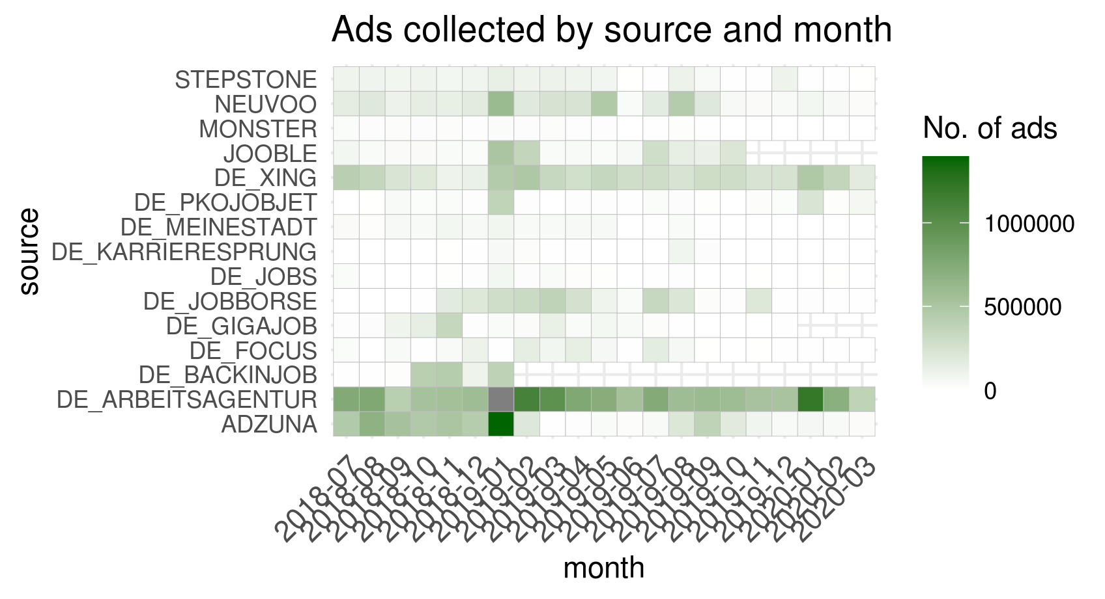

Figure 4 Ads collected from the 3 largest sources
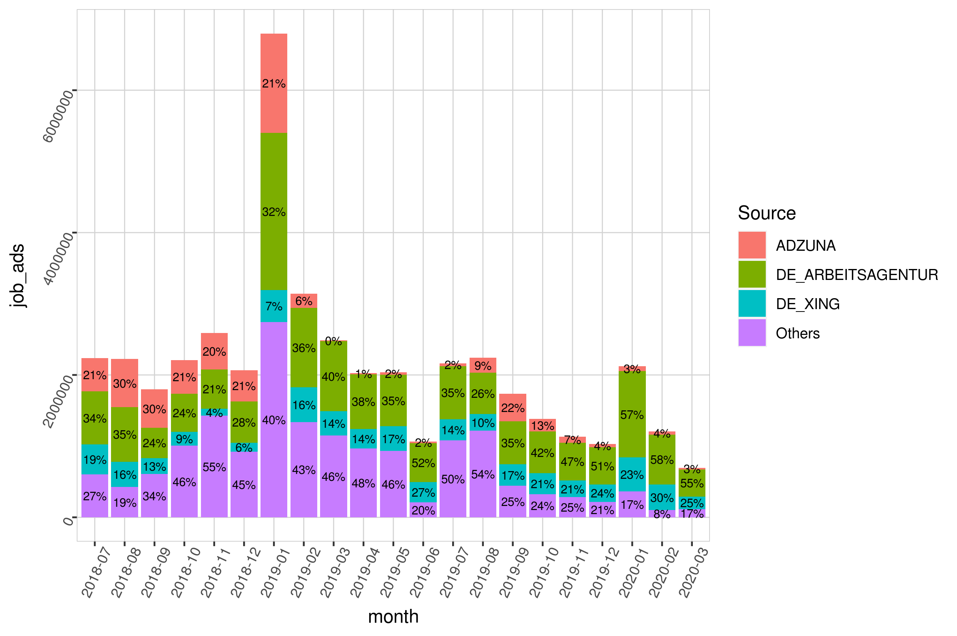
Nor were ads from every site consistently collected (Table 2, Figure 4)
Figure 5
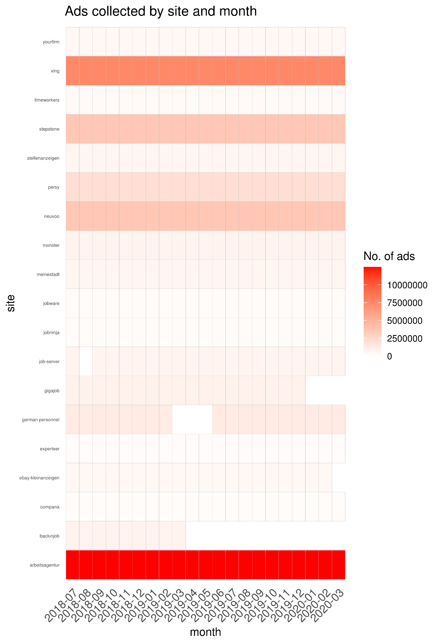

Deduplication and filtering

Duplicates
Of the 44383960 observations for Germany, 16341879 are distinct (not duplicate) observations. Which means that they have a unique “general_id”. CEDEFOP assigns the same general_id to all observations which it classifies as duplicates of each other. The share of such duplicates is therefore 63% of all observations.
Observations classified as “duplicates” by CEDEFOP can differ in their content. Typically, of a group of “duplicate” observations only one has a non-missing entry for the variable “companyname”.
The share of duplicates is relatively consistent over time, with the exception of January 2019, January 2020 and March 2020. During the first two months, the share of duplicates was unusually high, exceeding 75%. In March 2020, the share was very low, with only 29% of observations classified as duplicates.
For subsequent analysis, we keep only one observation per group of duplicates. The observation with the least number of missing column entries is kept.
Figure 6

Staffing agencies
We filter out job ads by staffing agencies, because it is unclear if they represent a real job vacancy and also because they might easily be duplicates of job ads by the employers themselves. Because there is no direct way of identifying ads by staffing companies, we filter by company name. Using a filter list of specific terms common to staffing agency names and of names of specific staffing companies. Filtering by this list leaves 15030950 of those 16341879.

Contract type
The type of contracts are classified by CEDEFOP, with the majority classified as temporary. In subsequent analysis, we exclude job ads classified as internships.
Table 1
Contract type | Job Ads (in thousand)
Internship | 2769
Permanent | 3008
Self Employment | 2298
Temporary | 3468

Pseudo-stocks
In order to evaluate total labor demand based on online job ads (OJA), we need to know if OJA data refers to the stock of vacancies at a point in time or to the inflow of new vacancies relative to the previous period. However, CEDEFOP data represent neither the flow nor the stock of online job vacancies. If it was flow data, we would see a large initial stock on which to base the flows of ads. This is not the case, as evident from Figure 2, which shows the daily frequency counts of job ads collected in Germany. If it were stocks, we would expect to observe similar stocks of observations every day, with gradual changes. This is also not the case, as there are large day-to-day fluctuations in the numbers of ads collected.
The data layout and descriptive material from CEDEFOP hint at an unstructured approach to collecting oja-data by scraping new ads whenever there happen to be resources available. Therefore, the counts of job ads cannot be directly compared with other measures of labour demand. CEDEFOP job ads can’t be interpreted as a time-series unless converted to stock data.
In order to address this issue, we explore the possibility of generating pseudo-stocks from CEDEFOP data which are an approximation to the underlying stock of job ads. The idea behind pseudo-stocks is the following:
The idea behind pseudo-stocks is the following: At a given point in time (T), we consider a job ad to be valid if it hasn’t expired yet and was posted a maximum number of days before T. Expiration of a job ad is determined by the variable expire_date. Preliminary analysis of other sources indicates that job ads stay relevant for roughly 30 days on average. The number of all job ads which are considered at time T is the pseudo-stock of active job ads at time T. Figure 7 illustrates this approach.
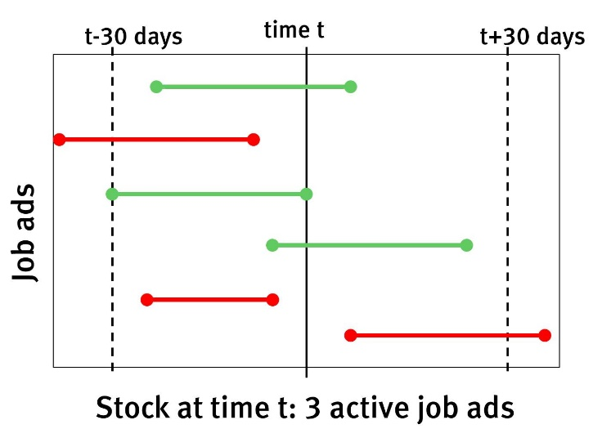
Figure 7
This approach has the advantage that it can account for gaps in scraping coverage as long as the missing ads are scraped at some point within the assumed validity period.
One drawback of this approach is that for the length of the first validity period in the observed timeframe too few valid vacancies are available. Therefore, assuming 30 days of validity, pseudo-stocks are only useful from the 01.08.2018 onward.
In order to ease the comparison with JVS, we take the average of pseudo-stocks over the last month of each quarter (Figure 6). In any given quarter, the pseudostock of job ads is much lower than
The German JVS quantifies two types of vacancies, general vacancies which are to be filled at some indeterminate point in the future and urgent vacancies which are to be filled immediately.
The number of pseudo-stock job ads lies substantially below general vacancies in the JVS. This is also the case if we only consider JVS vacancies which are to be filled immediately. We consider urgent vacancies to be a better equivalent to OJV ads than general vacancies, since the publication of OJV ads indicates that the recruitment process has started and the position is to be filled within a fixed timeframe.
OJVs capture only a subset of all vacancies, therefore we expect accurately measured OJV stocks to be lower than JVS vacancies, which is borne out by the results.
However, there is a substantial divergence in the development over time between OJA data and JVS vacancies. While JVS vacancies are relatively stable throughout the year 2019, this is not true for the pseudostocks of CEDEFOP OJAs. Those rise from 54-thousand in the third quarter of 2018, to 85-thousand at the start of 2019. An increase of more than 50% over 9 months. After a sharp drop in the second quarter of 2019, pseudostocks remain at a relatively low level until the start of 2020.
It needs to be stated clearly that the seven quarters for which CEDEFOP data is available is too short a timeframe to compare long-term trends in CEDEFOP and JVS results. However, it is clear that quarter-to-quarter variations are vastly different for both datasources. Three explanations for the obseved differences are possible:
First, CEDEFOP OJA data is about job ads, while the JVS represents vacancies. If the number of vacancies per job ad was fluctuating strongly over time, discrepancies between OJA and JVS could be caused by this factor. However, research by the University of Zürich indicates that the average number of vacancies per online job ad is stable over time, at roughly 1.2.
Second, the online job market may be more volatile than the numbers of vacancies reported in the JVS. While increased volatility is likely, we have shown in Section 2 that there is also huge volatility in webscraping coverage of sources. It is therefore not possible, at the moment, to disentangle volatility in data collection from volatility in the underlying job market.
Which leads to the third possible reason for the observed discrepancies. Webscraping coverage of job ad sources in CEDEFOP data is spotty and unreliable, as illustrated by Figure 3 and Figure 4. Which might lead to strong quarter-to-quarter variations in pseudostock levels. Additionally, removal of duplicate observations is likely not perfect, which means that the share of duplicates will, to some extent, increase with the number of sources. Because the number of sources which are scraped effectively by Cedefop varies over time, the share of duplicates also varies in a similar way.

Figure 8
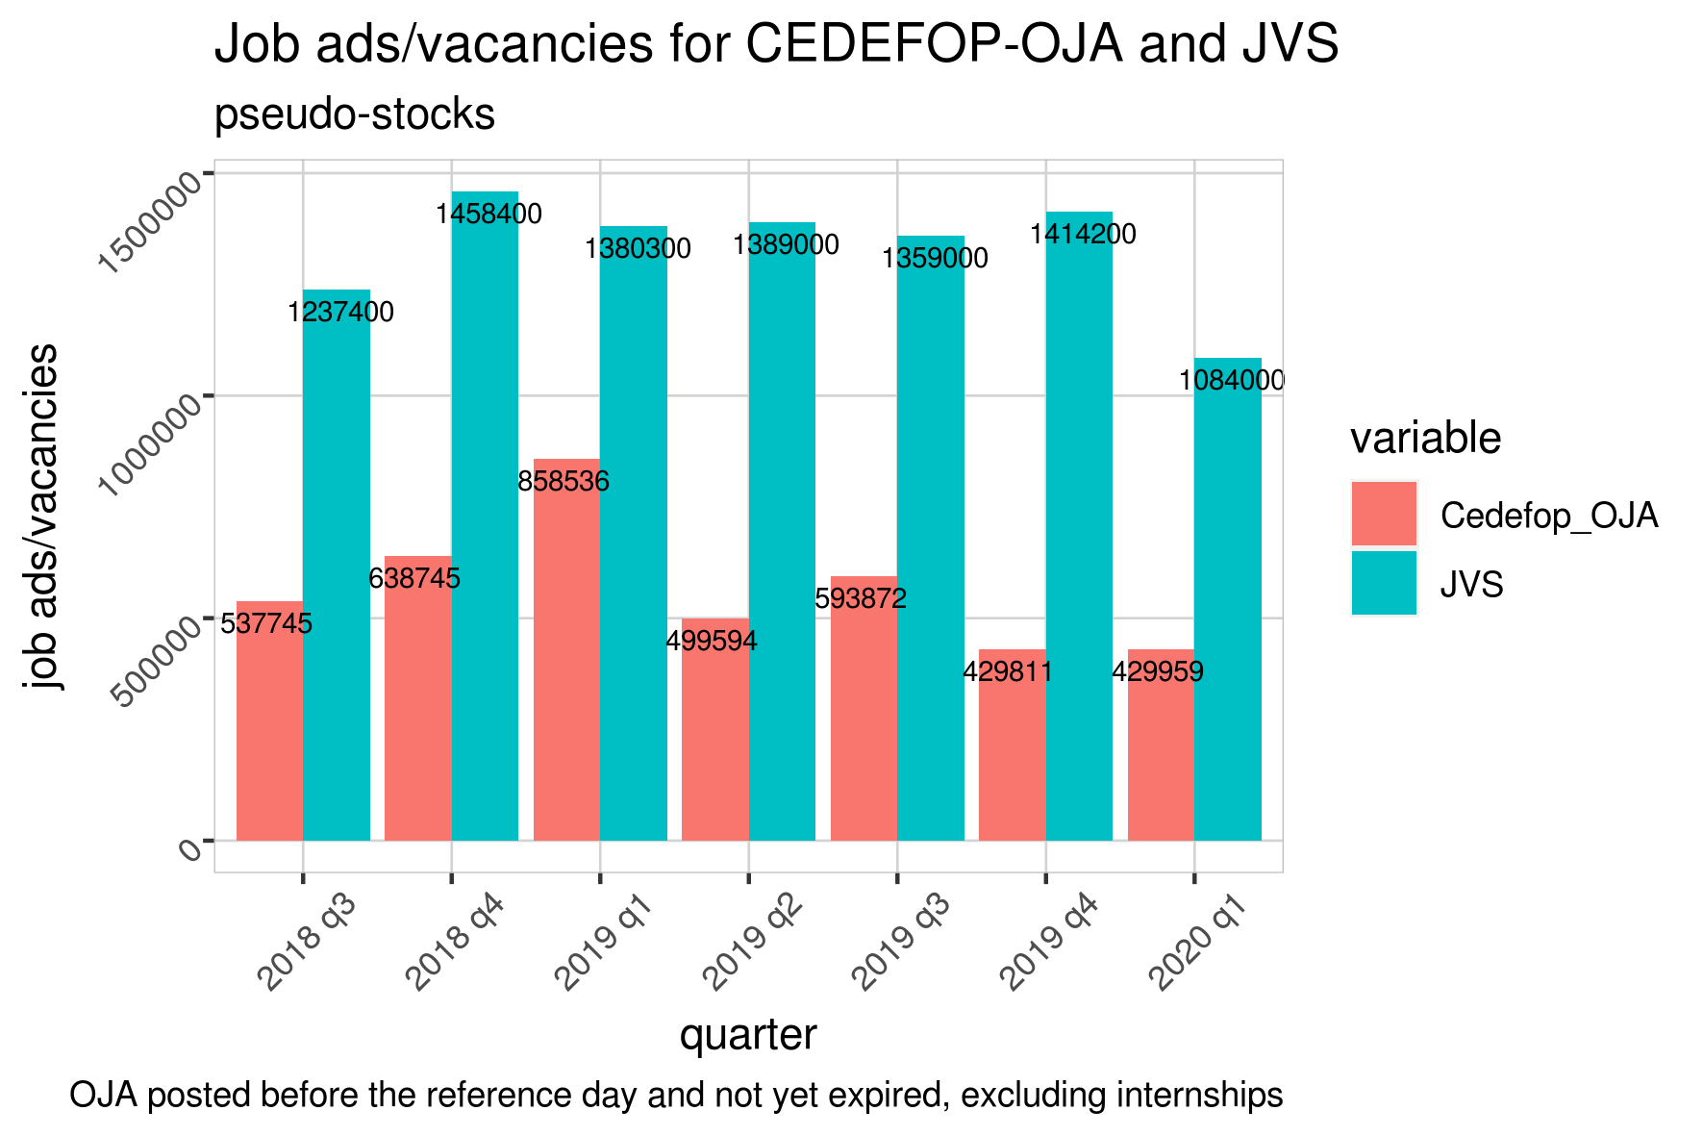
Figure 9
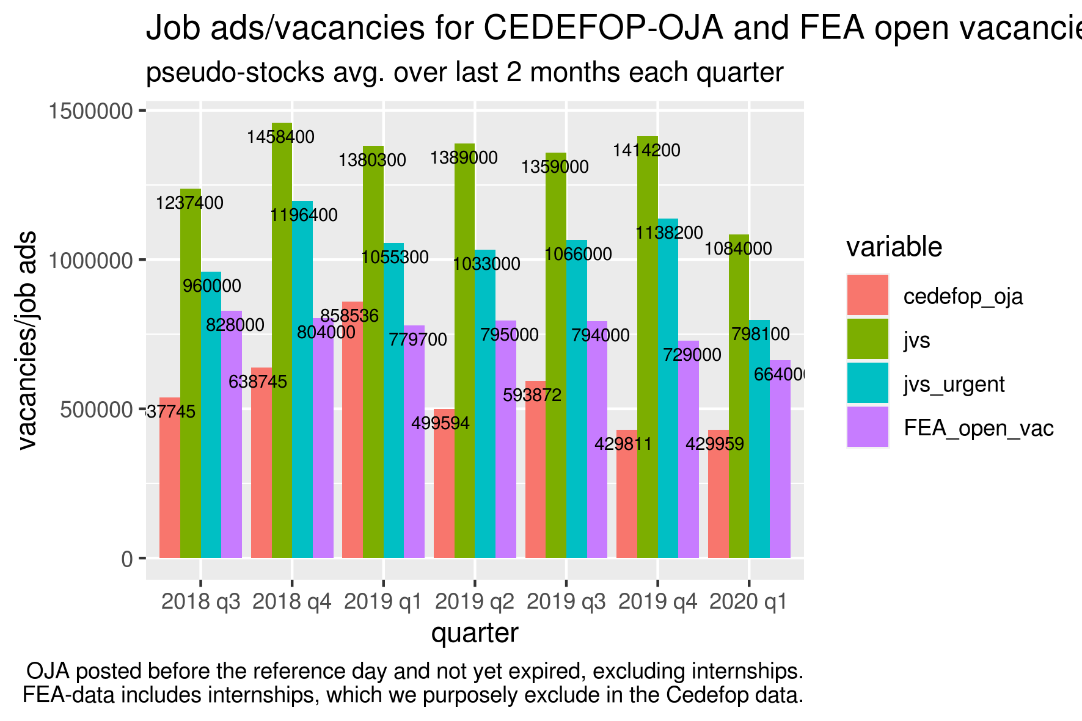
Figure 10
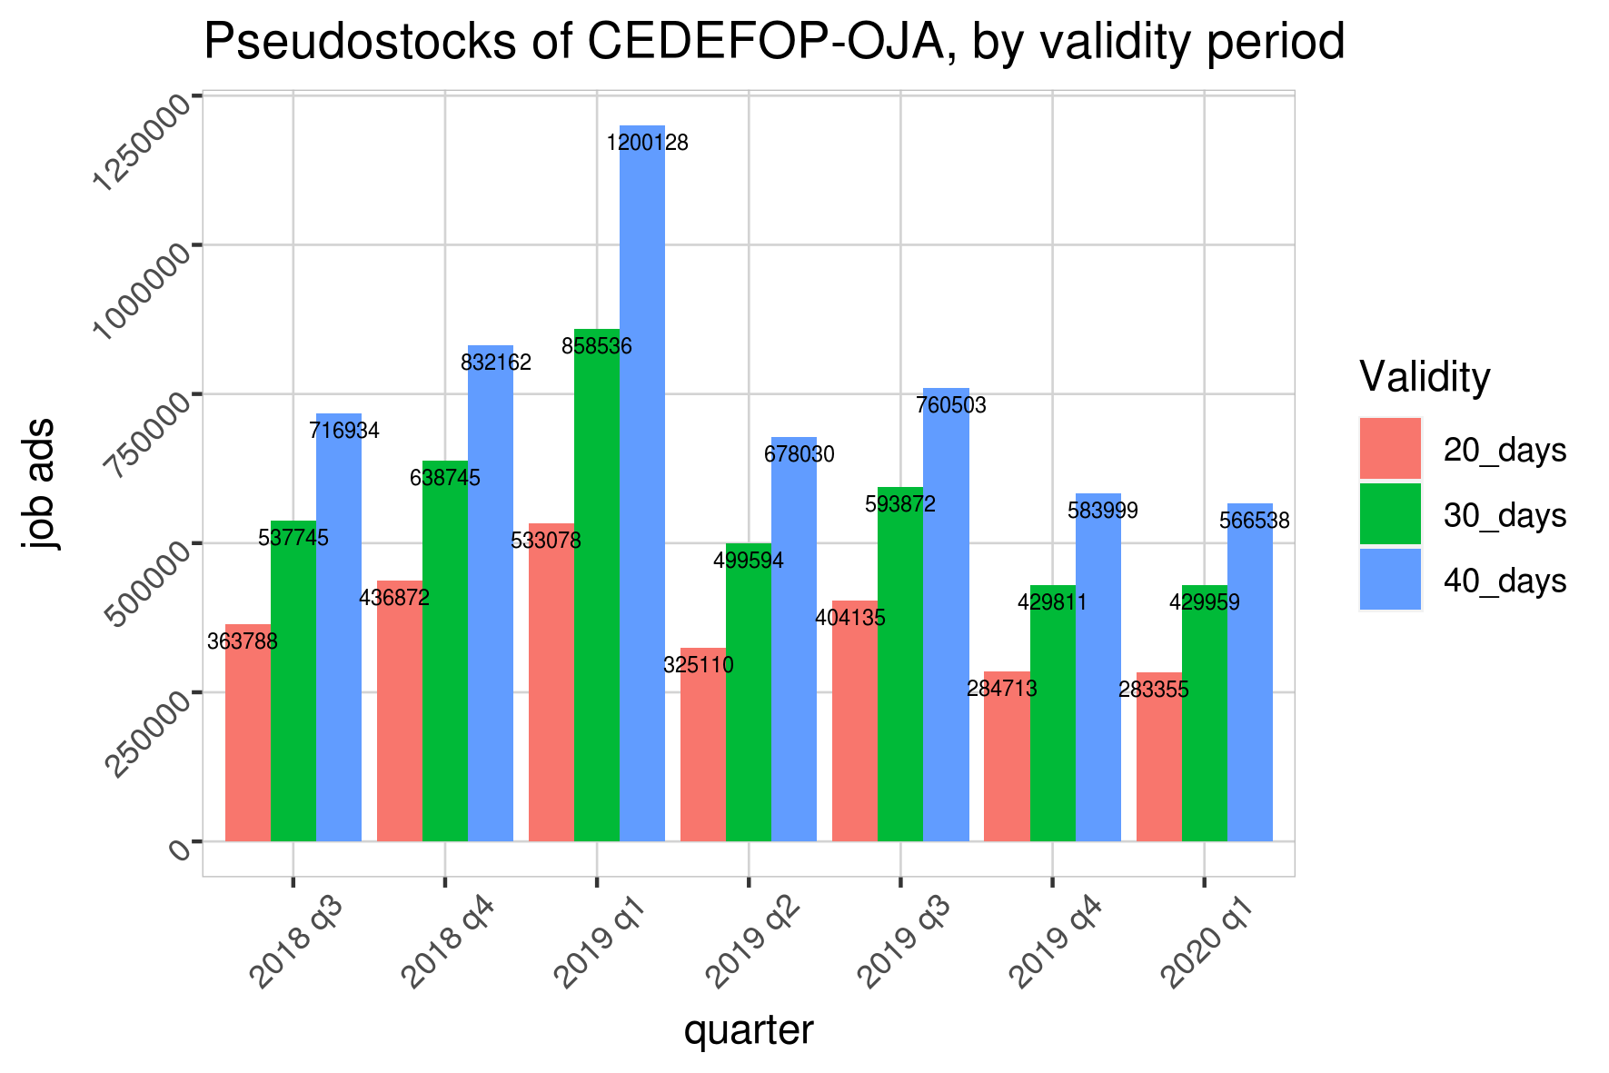

Missing attributes

Missings before deduplication
Table 2 shows the counts and shares of missings by variable in the raw Cedefop dataset without any cleaning or deduplication applied to the data.
Table 2 Missing attributes of the dataset before data cleaning and deduplication
variable | share | na_count
general_id | 0 | 0
grab_date | 0 | 0
year_grab_date | 0 | 0
month_grab_date | 0 | 0
day_grab_date | 0 | 0
expire_date | 0 | 0
year_expire_date | 0 | 0
month_expire_date | 0 | 0
day_expire_date | 0 | 0
lang | 0 | 0
idesco_level_4 | 0 | 0
esco_level_4 | 0 | 0
idesco_level_3 | 0 | 0
esco_level_3 | 0 | 0
idesco_level_2 | 0 | 0
esco_level_2 | 0 | 0
idesco_level_1 | 0 | 0
esco_level_1 | 0 | 0
idcity | 0,4 | 17826370
city | 0,4 | 17826370
idprovince | 0,28 | 12548265
province | 0,28 | 12547968
idregion | 0 | 0
region | 0 | 0
idmacro_region | 0,19 | 8308139
macro_region | 0,19 | 8308139
idcountry | 0 | 0
country | 0 | 0
idcontract | 0,23 | 10350950
contract | 0,23 | 10350950
ideducational_level | 0,01 | 617085
educational_level | 0,01 | 617085
idsector | 0,01 | 408194
sector | 0,01 | 408194
idmacro_sector | 0,01 | 408194
macro_sector | 0,01 | 408194
idcategory_sector | 0,01 | 408194
category_sector | 0,01 | 408194
idsalary | 0,91 | 40229901
salary | 0,91 | 40229901
idworking_hours | 0,26 | 11320891
working_hours | 0,26 | 11320891
idexperience | 0,72 | 31969378
experience | 0,72 | 31969378
source_category | 0 | 0
sourcecountry | 0 | 0
source | 0 | 0
site | 0 | 0
companyname | 0,11 | 4792833

Missings after deduplication

Table 3 shows the counts and shares of missing attributes after having dropped all observations marked as duplicates and cleaned some data inconsistencies. Most notable, there are no observations left with missing company names.
Table 3 Missings after deduplication
variable | share | na_count
general_id | 0 | 0
grab_date | 0 | 0
year_grab_date | 0 | 0
month_grab_date | 0 | 0
day_grab_date | 0 | 0
expire_date | 0 | 0
year_expire_date | 0 | 0
month_expire_date | 0 | 0
day_expire_date | 0 | 0
lang | 0 | 0
idesco_level_4 | 0 | 0
esco_level_4 | 0 | 0
idesco_level_3 | 0 | 0
esco_level_3 | 0 | 0
idesco_level_2 | 0 | 0
esco_level_2 | 0 | 0
idesco_level_1 | 0 | 0
esco_level_1 | 0 | 0
idcity | 0,37 | 4544825
city | 0,37 | 4544835
idprovince | 0,25 | 3126591
province | 0,25 | 3126667
idregion | 0 | 0
region | 0 | 0
idmacro_region | 0,16 | 1931199
macro_region | 0,16 | 1933844
idcountry | 0 | 0
country | 0 | 0
idcontract | 0,28 | 3487448
contract | 0,28 | 3487448
ideducational_level | 0,01 | 155468
educational_level | 0,01 | 155468
idsector | 0,01 | 79043
sector | 0,01 | 79043
idmacro_sector | 0,01 | 79043
macro_sector | 0,01 | 79043
idcategory_sector | 0,01 | 79043
category_sector | 0,01 | 79043
idsalary | 0,91 | 11122712
salary | 0,91 | 11122712
idworking_hours | 0,24 | 2916232
working_hours | 0,24 | 2916232
idexperience | 0,7 | 8555438
experience | 0,7 | 8555438
source_category | 0 | 0
sourcecountry | 0 | 0
source | 0 | 0
site | 0 | 0
companyname | 0 | 0

As shown in Figure 10, we also perform the same analysis with validity periods of 20 days and 40 days, in order to ensure robustness of the chosen timeframe. The results scale almost linearly with the length of the validity period. See also ESSnet WP 1.
Compare Sacchi, S. 2008, Methodische Grundlagen Stellenmarkt-Monitor Schweiz, Universität Zürich.

