Guideline for the ONLINE S3 toolbox

1.2 Stakeholder Engagement

ONLINE S3 – 710659 – Guidelines for the pilot experimentation phase



Content

Background and rationale 3

Description of the application 4

Benefits to key actors and stakeholders 5

Key issues and requirements 6

A STEP-BY-STEP GUIDE 7

Further information 7

**Figures**

Figure 1 Rational behind this ONLINE S3 application 4

Figure 2 Overview of this ONLINE S3 application 5

Figure 3 Benefits to stakeholders when using this ONLINE S3 application 6

Figure 4 Key issues when using this ONLINE S3 application 7

**HISTORY OF CHANGES**

|  |  |  |  |
| --- | --- | --- | --- |
| **Version** | **Date** | **Contributing partner** | **Summary of changes** |
| Version 0.1 | 2016-10-07 | RIM | Structure of the document, elaboration of required information as a template for all tools |
| Version 1.0 | 2017-08-06 | AALTO | First version of Stakeholder Engagement application guideline |
|  |  |  |  |
|  |  |  |  |

**DISCLAIMER**

The opinion stated in this report reflects the opinion of the ONLINE S3 consortium and not the opinion of the European Commission.

**ACKNOWLEDGEMENT**

This document has been elaborated within the framework of the ONLINE S3 project, which has received funding from the European Union’s Horizon 2020 research and innovation programme under grant agreement No. 710659.

## Background and rationale

Online deliberation tools are historically not that common in the RIS3 processes. However, the regions that have applied similar tools experienced increased level of stakeholder engagement with relatively low costs. The Stakeholder engagement tool seeks to seize this phenomenon.

Stakeholder engagement has been done via working groups, online surveys and interviews. While these methods are also important they lack openness and opportunity for open initiative from the stakeholders.

Stakeholder engagement tool enables widely inviting stakeholders to collaborate and letting them share and comment on regional issues. This way, stakeholders may participate proactively and bring forward their specific viewpoints.

Figure 1 Rationale behind ONLINE S3 Stakeholder Engagement application

## Description of the application

The Stakeholder Engagement tool enables regional RIS3 facilitators to engage stakeholders and get feedback on the RIS3 process from them. The tool allows registered users to set up regional folders and upload documents for online deliberation with the region’s stakeholders.

Beside the comments and input from stakeholders, there is also a voting mechanism in the application. Thus, stakeholders may vote up and down the ideas and documents, which provides the facilitators also a quick way to see which posts have gotten most interest from the stakeholders.

The application allows creation of consideration areas for each individual use case, such as for regional implementation of RIS3 strategies. Each region can have any number of users and administrators collaborating in the area.

Within each area, any number of different categories can be created to divide the discussion into smaller topics

Figure 2 Overview of ONLINE S3 Stakeholder Engagement application

## Benefits to key actors and stakeholders

Figure 3 illustrates the key benefits Stakeholder engagement tool provides to stakeholders of a region conducting the RIS3 process. Firstly, it facilitates greater stakeholder engagement and enables greater and more open stakeholder engagement. Secondly, the tool allows stakeholders and facilitators to deliberate issues and ideas together. Thus, stakeholders’ opinions matter and they get the feeling of having impact on regional policy-making. Lastly, the Stakeholder engagement tool promotes long term collaboration and refinement of regional issues and ideas. At its best, this establishes a long term relationship and collaboration between stakeholders and policy-makers.

Figure 3 Benefits to stakeholders when using ONLINE S3 Stakeholder Engagement application

## Key issues and requirements

The tool enables users to create discussion boards and upload ideas and documents to be commented and voted on.

Figure 4 Key issues when using this ONLINE S3 application

## A STEP-BY-STEP GUIDE

**Logging in**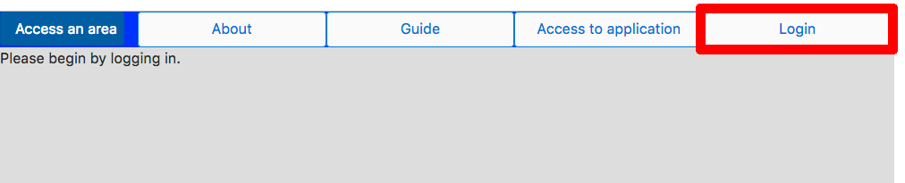

1. Select Login from the upper corner, and enter your login details or create a new account from the prompt that opens.

**JOINING AN AREA WITH AN INVITE CODE**

1. From the area menu select “Join an area” 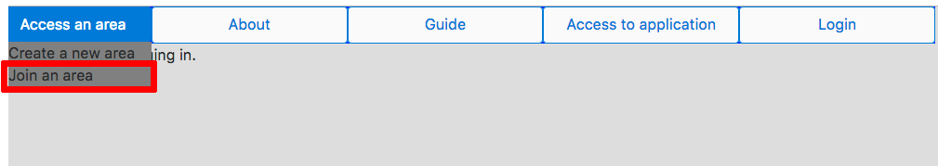
2. Enter the invitation key you have received from an administrator of the area. You will be granted access to contribute to the conversation in the area.

**PARTICIPATING IN DISCUSSION**

1. Select an area to participate in from the area menu
2. Select a category you want to comment on from the available options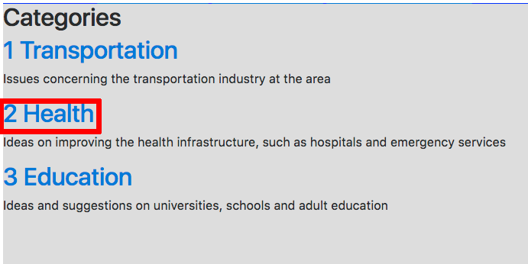
3. Post a new comment from the input fields at the bottom of the page, or reply to an existing comment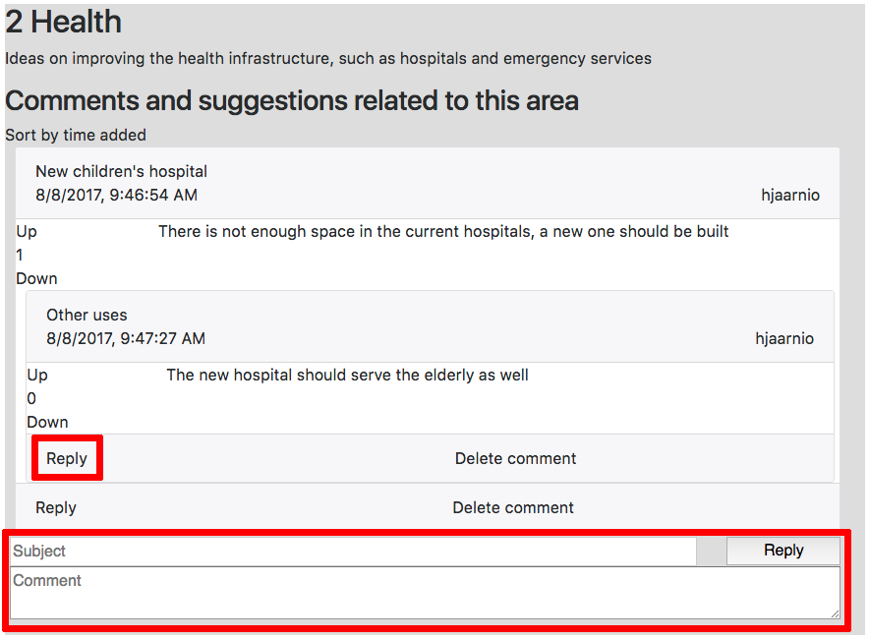
4. Vote comments you find to be of particular quality up, and vote down comments you don’t feel contribute to the conversation

**CREATING AN AREA FOR A REGION**

1. Click the area menu from the upper left corner, and from the menu select “Create a new area”. These areas are meant for the use of individual regions or smaller interest areas.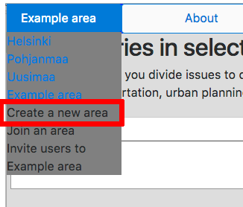
2. Enter the name for your area in the popup that opens, and click Add

**INVITING USERS AND ADMINISTRATORS TO COLLABORATE IN AN AREA**

1. From the area menu select “Invite users to [YOUR AREA NAME]”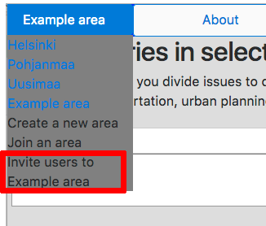
2. Copy the invite code for users from the popup, and share it with your target audience, for example by e-mail.
3. Copy the invite code for administrators of your area, and share it with people you trust to govern the discussion in your area.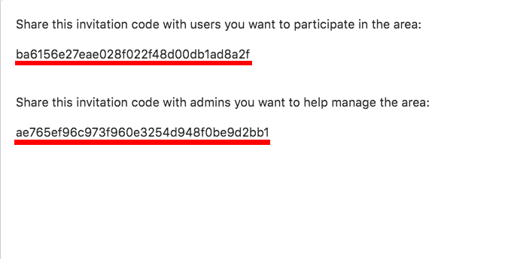

**CREATING CATEGORIES OF DISCUSSION TOPICS**

1. Select an area you are an administrator of from the area menu
2. Fill in the title of the category and a description of the kind of discussion you want to happen in the category 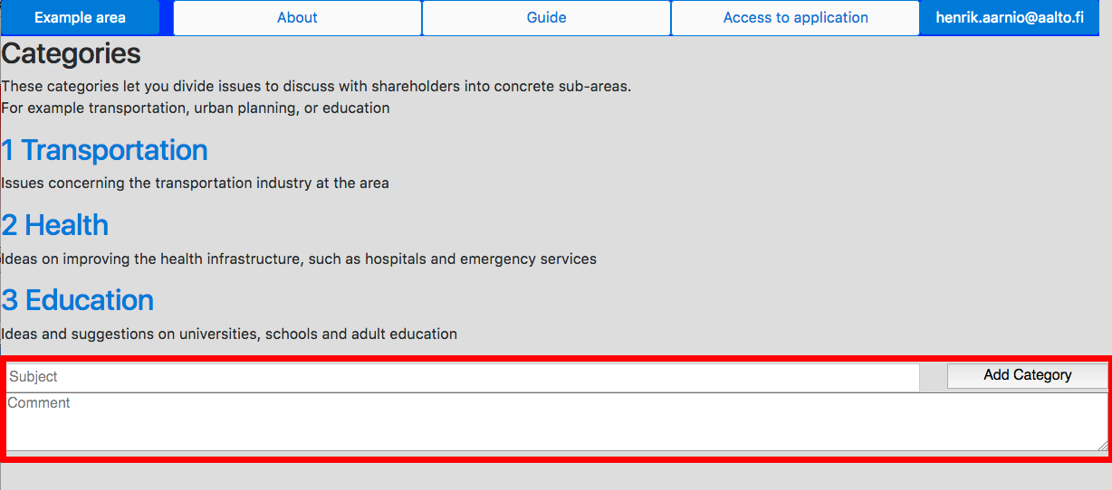

## Further information