**ONLINE S3 PROJECT**

**PLATFORM CONCEPT**

|  |  |
| --- | --- |
| **Project Reference Number** | 710659 - Online S3 |
| **Work package** | WP3 |
| **Nature** | Concept plan |
| **Dissemination Level** | Confidential, only for member of the consortium (including the Commission Services) |
| **Document Version** | V0.2 |

|  |  |
| --- | --- |
| **Editor(s)** | Aalto University (WP3 Leader) |
| **Contributors** | Antti Heliste |
| **Reviewers** | Timo Nyberg  Mona Roman |

|  |  |  |  |
| --- | --- | --- | --- |
| **Version** | **Date** | **Reason** | **Edited by** |
| V0.1 | 30.12.2016 | Initial version | Aalto/Antti |
| V0.2 | 2.1.2017 | Revision | Aalto/Timo |
|  |  |  |  |

## Definitions

|  |  |
| --- | --- |
| Step | The six steps in the creation of RIS3 strategies described in the RIS3 guide. |
| Method | Steps consist of methods that deal with certain areas of a step, for example, entrepreneurial discovery process. |
| Application/Tool | Tools and applications are programs that help in conducting a method. |
| Platform | The Online S3 platform website that will host/link the tools and guidance for RIS3. |

Contents

Definitions 2

Introduction 4

Context and problem 4

Design considerations 6

User categories 6

Stakeholders 8

Goals and objectives 9

Use cases 10

Requirements and conditions 12

System Capabilities 12

System Conditions 13

Platform structure 14

Discussion 21

## Introduction

This document describes the initial concept behind the Online S3 platform. It starts from the analysis of the context, possible users and stakeholders and then seeks to formulate the initial concept of the platform. The purpose of this document is to raise a discussion on the platform requirements and design. It is crucial that the project partners have a consensus at least on the following questions, even though they may seem trivial at this point of the project:

* Which problem are we solving?
* How will our platform solve the problem?
* Who are the users and stakeholders and what are their requirements/needs?
* What are the initial requirements and design for the platform?

Once a sufficient consensus on the previous questions has been reached, the document can be transformed into the platform design document that will describe the platform in more detail, especially from the technical point of view.

### Context and problem

In the EU, smart specialisation strategies have become a significant policy instrument that guides a large amount of R&D&I investment. Every region in the EU is required to create and implement a smart specialisation strategy in order to receive funding from the ERDF. However, there are several problems in the formulation, revision and implementation of these strategies. First, many of the strategies created by regions do not follow the basic concepts of smart specialisation. This is likely due to lack of clear information on smart specialisation and guidance in the strategy formulation. Second, there is a lack of tools and/or a lack of information about suitable tools for the formulation, revision and implementation of smart specialisation strategies. This limits the amount of analysis and methods applied in the strategies, thus, affecting the quality and efficiency of the strategies.

The Online S3 project seeks to address these two problems by creating an e-policy platform that contains supporting tools and guidance for the formulation and revision of smart specialisation strategies. These tools are available for all the six steps of the smart specialisation strategy process. They can either be existing tools created by third parties or new tools created by the project team. By providing regional policymakers with these tools, they can conduct more analyses and use diverse methods more effectively. Additionally, the guidance given alongside the tools makes the whole process, each step, and method easier to comprehend and to conduct. Overall, **the platform should help policymakers to create, implement and revise more efficient smart specialisation strategies with less effort**. This benefits both policymakers and their regions.

## Design considerations

Before trying to formulate the concept or list the requirements for the platform, several aspects need to be considered. This includes the analysis of different user categories, stakeholders, goals, objectives and use cases.

### User categories

The platform has multiple types of user categories with different needs and interests:

* Regional policymakers in the EU
* Consultants
* Academics
* Platform admins

#### **Regional policymakers in the EU**

Regional policymakers involved in formulating, implementing and revising smart specialisation strategies are the main user category of the platform. Their requirements for the platform are more important than those of other groups. Currently, they face many difficulties throughout the strategy process. First, there is little practical guidance for policymakers on how to formulate, implement, monitor and revise a smart specialisation strategy. Instead, an overwhelming amount of less practical academic literature is available. Second, the lack of suitable tools or lack of information about the tools makes it difficult to conduct many methods or analyses. Overall, policymakers have a clear need to create more efficient strategies with less effort.

Needs:

* Formulate, implement, monitor, and revise effective smart specialisation strategies efficiently
  + To receive funding from the EU
    - To increase regional competitiveness

Requirements for the platform:

* Guidance on the RIS3, steps and methods to make their purpose more understandable
  + Must be clearer and more practical than the academic literature
* Tools for each method to make them easier to conduct
* Easy to use platform

**Other possible users**

The platform can have many other possible users than just the regional policymakers. These users may be either involved in creating smart specialisation strategies or are just interested in them, for example, for academic purposes. Even though the platform is not targeted for them, they should also be considered in the development of the platform.

Consultants are sometimes hired to assist in creating smart specialisation strategies. Even though they are interested in smart specialisation just because of the business opportunity, they still share the same interest as the regional policymakers: to create effective smart specialisation strategies with optimised effort. Therefore, it is likely that our platform will support their work as well.

Academics may also be involved in creating smart specialisation strategies and share a similar interest as the regional policymakers and consultants. However, academics may also be interested in the platform for research purposes. The platform will be used by many users and it could be used to gather data on user activity. These data could be valuable to the researchers as they could tell who are creating smart specialisation strategies on the platform and how they are creating them.

**Admins**

The platform will also have admins that will be responsible for maintaining the site. Most likely, the level of their technical skills and knowledge about the S3 will vary. This has to be kept in mind when designing the admin side of the platform. The admins will have at least the following responsibilities:

1. Keeping the platform operational. This requires reliable technical implementation that is easy to comprehend and manage by the admins.
2. Developing and updating the content on the platform. This will require a clearly defined plan for the development and a system that would optimally allow anyone with little technical knowledge to update some parts of the site.
3. Managing users. This includes, for example, removing and adding users, and accessing some of their information. In addition, user activity could be tracked for development and academic purposes. This will require a good user management system with suitable tracking options.
4. Assisting users when needed. The guidance given on the platform might not be enough in all cases and therefore admins should be able to answer questions regarding the platform or S3 – or at least find a person or source that can.

### Stakeholders

In addition to the users, other stakeholders involved in the project need to be considered as well. Stakeholders have different expectations of the platform and they can influence the project in different ways. The following stakeholders are the key stakeholders:

* European Commission (relationship by contract)
* Project partners (developers)
* IPTS/JRC (possible collaboration / possible future maintainer/developer)

**European Commission**

European Commission is involved in this project through a legal contract: the project team is obliged to deliver an online platform that fulfils the requirements laid out in the grant agreement or/and is accepted by the Commission. This raises the question: what kind of platform is accepted by the Commission? In other words, can we, for example, use or link to tools on the platform that are not created by us? These kinds of questions need to be answered in the development process.

**Project partners**

Project partners are the actual developers of the platform. Their contribution to the development is described in the grant agreement of the project and in internal agreements. Overall, the project has 12 partners of which four, Aalto, URENIO, Intelspace, and IIL, are involved in the technical development of the platform. Consensus among the partners, especially the technical partners, on the platform design and development is crucial for the success of the project. However, differences in opinions will likely arise during the development. Therefore, a structured way of communicating and resolving conflicts is needed. Some resolution methods are defined in the grant agreement but project partners should find together ways to communicate effectively.

**IPTS/JRC**

The IPTS/JRC is an EU organisation that runs the official S3 platform. Their platform contains much information on the S3 but it does not feature that many tools for the development and implementation of smart specialisation strategies. However, the IPTS has the resources to develop its platform much longer than our project can. Therefore, our project seeks to collaborate with the IPTS in several ways. First, we seek to make our tools easily integrable into the IPTS platform. This way the IPTS can take the tools it wants from us and to develop them further even after our project’s ending. Second, we seek advice and feedback from the IPTS on the platform during the development. The IPTS has lots of professionals who understand smart specialisation. They can give us valuable feedback during the development process.

### Goals and objectives

The major goal of the Online S3 platform is to provide tools and guidance that effectively support the development and implementation of smart specialisation strategies. These tools should be carefully selected and developed iteratively based on the feedback from the users.

Another important goal is to make the platform as simple as possible in two aspects: usability and technical implementation. For usability, this means that each tool, method, step, etc. should be easy to understand and to apply in practice. In addition, the platform should be easy to navigate, i.e., the user should easily understand the structure of the platform and be able to find the suitable step, tool, etc. when needed. For technical implementation, this means that the technology behind the platform should be kept as simple as possible and the use of ready solutions and external applications should be encouraged. Overall, the platform should be easy to maintain after the project.

The third goal is to make the tools easily integrable into the official S3 platform by JRC/IPTS. This means that each tool should be built so that it can function completely independently or can be easily modified to function in that way.

### Use cases

**C:\Users\Heliste\AppData\Local\Microsoft\Windows\INetCacheContent.Word\Onlines3usecase.png**

Based on the previous analyses, the above use case diagram was created. It presents how different users will use the platform for different purposes. The diagram does not yet present all the possible use cases but it will still help to understand the platform requirements and structure.

In the diagram the users were combined into two groups: the users and the admins. The users are the people using the platform for creating, implementing and revising the smart specialisation strategies. They can either be signed in to the platform or not. Their main activities boil down to two tasks that can be done on the platform: reading guidance and using a tool. First, reading guidance means the act of studying material on the platform that will help to conduct the whole process, step, method, etc. This material can be distributed across different pages. Second, using a tool means the act of using an online application on the platform. The results of these tools could be then exported for further analysis. Tools can also be used on external sites or on the users’ own computers.

The users can also register for the platform. This includes the basic activities of registering, logging in, deleting account and editing account information. Registered users have benefits over the non-registered users, such as the ability to save their results/progress.

The admins are the people responsible for maintaining the platform. They have multiple activities on the platform. First, they can manage accounts and view their information. User information could be used for example to send emails to the users, for example, regarding the platform or S3. Second, the admins can track user activity for site development and research purposes. For example, the tracking could reveal which tool are applied more commonly and thus encourage the development of the less used ones. Third, the admins can manage content on the website. This includes managing the material (text, images, appearance) and the tools and keeping them up-to-date.

## Requirements

Based on all the previous discussions and some internal agreements within the project team, we can start to list of some the general system requirements and conditions for the platform. General system requirements refer to the general requirements determined by the previous analyses of users, stakeholders and goals. These requirements divide into two types: system capabilities and system conditions. System capabilities are features we would like to see on the platform and system conditions refer to predetermined decisions that will affect the development of the platform.

### System Capabilities

**Functional:**

* Effective guidance and tools for RIS3
* Available on the Internet
* Accessible at least through desktop browsers
* Login and user account management
  + Login
  + Register
  + Restore password
  + Edit account information
  + Delete account
  + Ability to save progress/results?
* User management system
  + Adding and removing users
  + View, edit and export some of the user information
* User tracking system
  + Track user activity on the system and collect (anonymised?) data
  + Export data for further analysis
* Content management system
  + Manage content and tools
* Use of ready technologies in the implementation
* Independent tools
  + Easily integrable into the JRC platform

**Non-functional:**

* Simple and easy-to-use
  + More understandable than academic literature
  + Easy to maintain system
* Good uptime
  + The platform should be accessible almost always
* Up-to-date content
  + Content should be updated constantly
* Visually attractive

### System Conditions

* Technology agreed in the technical meeting:
  + MySQL
  + Apache
  + Wordpress
  + Apps
    - PhP, Python, JavaScript
  + Appearance:
    - Bootstrap
* Grant agreement conditions
  + ?
* The platform must comply with national and EU regulation

## platformStructure.pngPlatform structure

The picture above represents a draft of the platform structure. The boxes represent pages on the website and the arrows the logical hierarchy of those pages. The structure is still very crude and it will be adjusted as many design questions become answered. However, we have sought to design a structure that is simple and fulfils the needs of the user. The following chapters explain in more detail about each page. You can also test the demo at: <http://softwarebusinesslab.fi/onlines3/>.

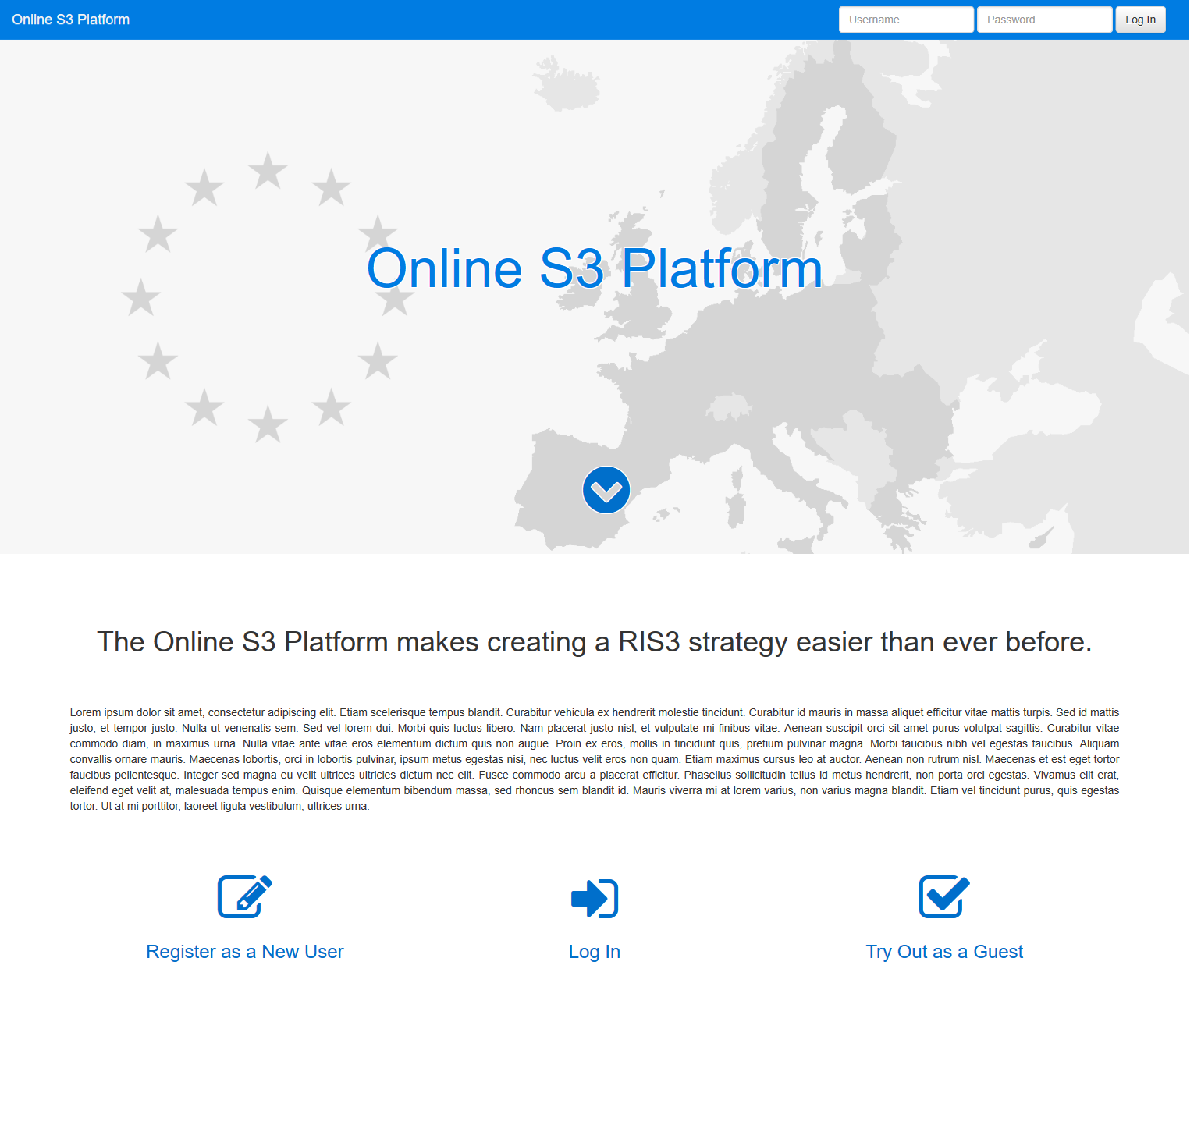**Front page**

The front page of the website is kept as simple as possible. Its purpose is to greet the user and to briefly explain what the platform is about and how it can the user. The user is given options to register, login and to try out the platform as a guest. The last option is important include since many users may not even bother to test platform if they first have to register.

**Login and register pages**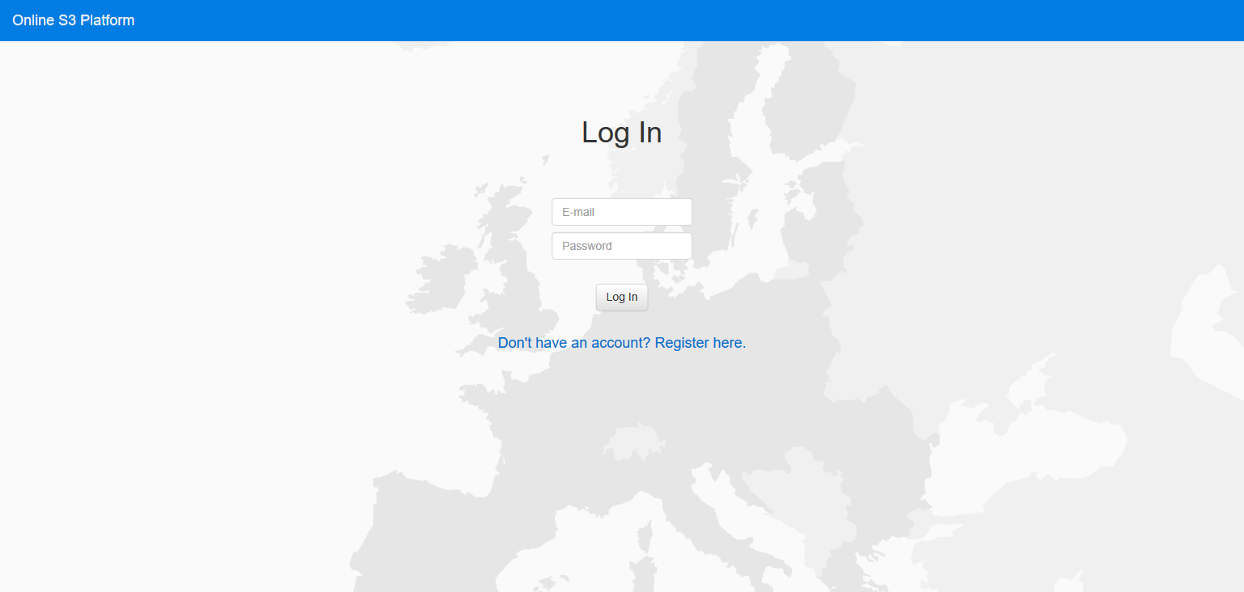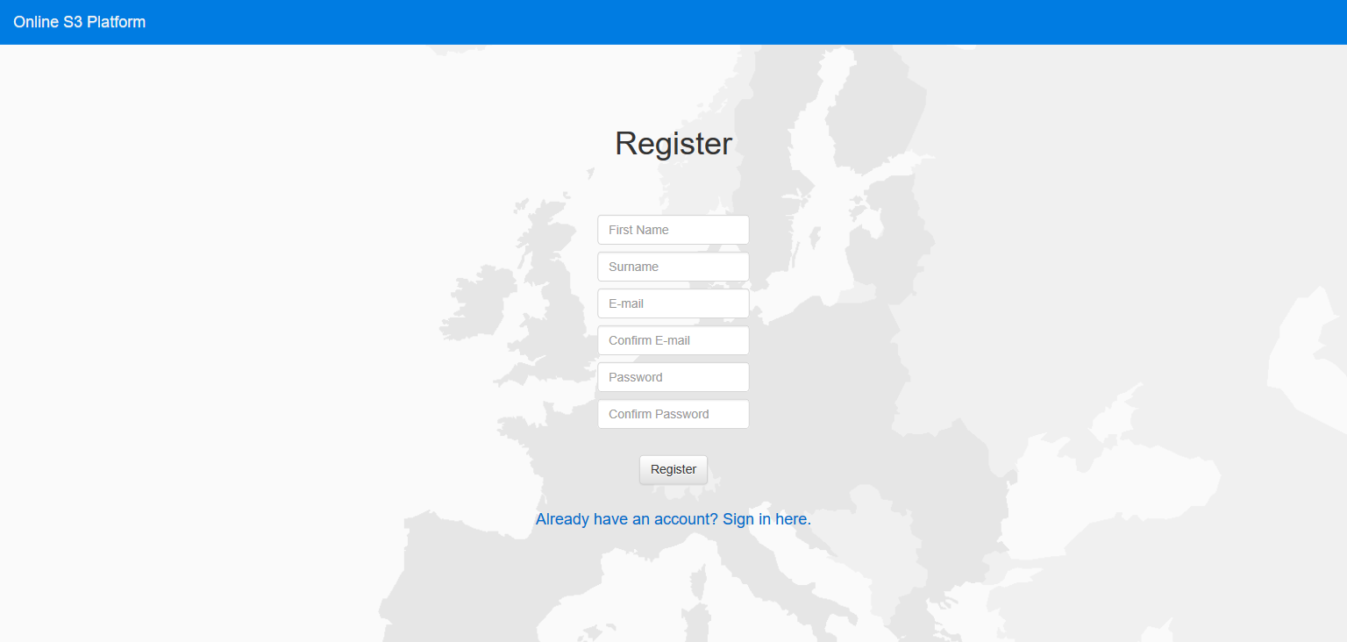

The login and register pages are quite straightforward; they will ask for credentials and user information. However, a decision on the suitable login options to be used and required user information has to be made. For now, we suggest the following:

Login

* Email
* Password

Registration

* First and last name
* Email
* Password

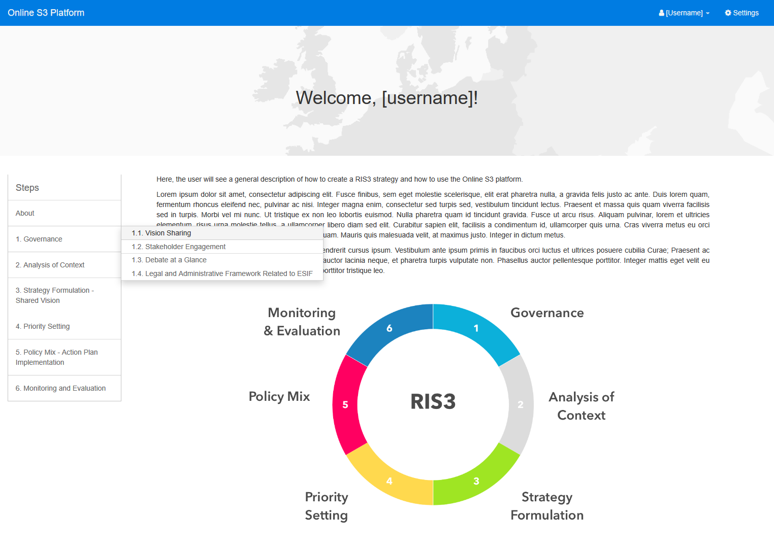**Front view**

From the front page, the user arrives to the front view of the platform. The purpose of this page is to introduce the concept of RIS3 and to tell about the steps and the process. However, a crucial design question has to be answered: how much guiding information and in what format should be given on this page - and on other pages? This will affect the design of many pages.

In addition to the information content, the user can see a menu bar on the left side. This includes links to all the step views and all the individual methods/tools. This menu can be seen throughout the platform and its purpose is to make navigation easy. Additionally, on the top bar the user can see their name, logout link and settings link.

**Step view**

A step view exists for each step of RIS3. It will show information about the step and list the methods involved in the step with a link and a short description. The methods can also be reached through the side menu bar. The design question about the information content should be again answered when designing this page.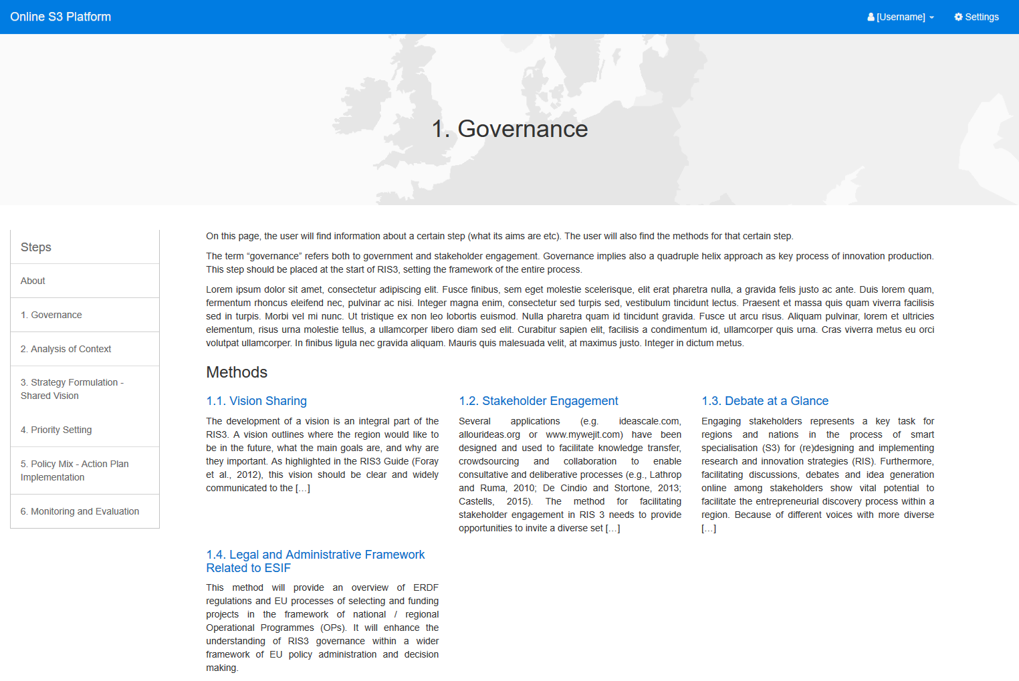

**Method / tool view**

The method / tool view contains information a method and the suitable tools for implementing them. The tools can either be embedded into the site or be just linked in the text. For presenting the embedded applications, we see two options:

1. 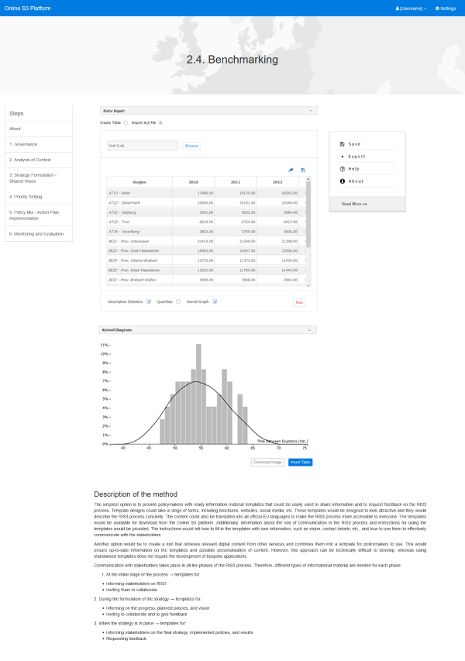Tool hosted alongside a long guiding text on the same page.

Figure Tool hosted alongside guiding text, Option 1

1. 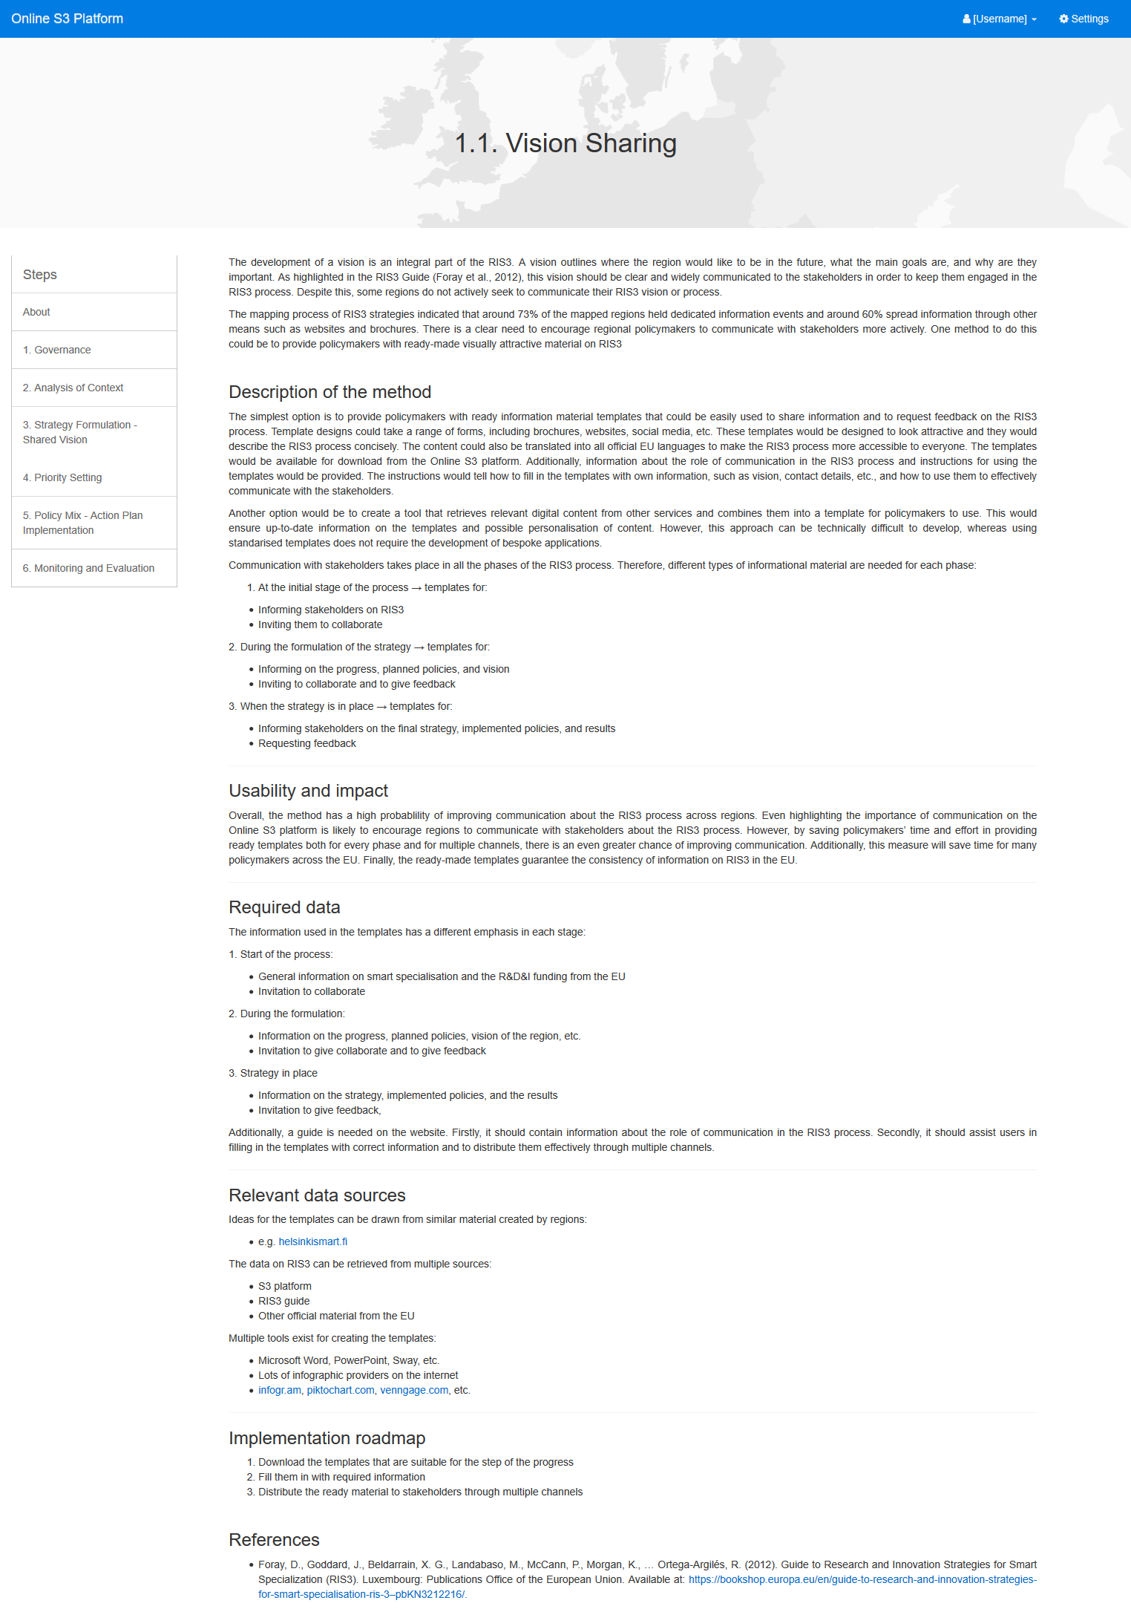Tool and guiding text hosted on separate pages. Only short instructions or/and a help button are given on the tool page.

Figure 2 - Guiding text on a separate page, Option 2

A choice between these options should be made or a better solution should be developed. Ultimately, it will largely depend on the amount of guidance we want to give on the platform. If there will be much guidance, we would recommend putting the application and text on separate pages. Nevertheless, the appearance of each tool can be quite freely decided by its developers, as long as they follow the Application Style Guide.

If there is no embeddable tool, only a guiding text, for example with links to files or/and external tools, is given. Creating method / tool pages like this is much easier than those with embedded tools.

## Discussion

We would like to receive comments especially regarding the four questions presented at the start of this document:

* Which problem are we solving?
* How will our platform solve the problem?
* Who are the users and stakeholders and what are their requirements/needs?
* What are the initial requirements and design for the platform?

In addition, we would like to hear about possible important aspects that should be considered when designing the platform. The idea is that with the help of the feedback we can develop this document and the platform design further and finally produce the platform design document that can be used for the technical implementation of the platform.