**Mini Project**

**Calculator Application Using Kivy Module**

**TASK**  : Build Calculator Application with Python kivy for Android:

**Tools** : 1) Python 3.9.7

2) Pycharm

**Library** : kivy - 2.1.0

**Theory**  :

* Kivy is a free and open source Python framework or library for developing mobile apps and other multi-touch application software with a natural user interface.
* It can run on Android, iOS, Linux, macOS, and Windows.
* The applications made using kivy will similar across all the platforms but it also means that the applications fell or look will differ from any native application.
* It is not built-in library. So, we need to install kivy on our computer.
* To install Kivy, we need Python pre-installed. Kivy not comes with Python.
* We can install kivy module/library using the pip command.

**Advantages :**

* Based on Python, which is the extremely powerful given it’s library rich nature.
* Write code once and use it across all devices.
* Easy to use widgets built with multi-touch support.
* Performs better than HTML5 cross-platform alternatives.

**Disadvantages :**

* Non-native looking User Interface.
* Bigger package size (because Python interpreter needs to be included).
* Lack of community support (Kivy Community isn’t particularly large).
* Lack of good examples and documentation.
* Better and more community rich alternates available if only focusing on Mobile Cross-platform devices i.e React Native.

**Installation** :

Step 1 : Open up a terminal or command prompt and run - **pip install Kivy**

**Steps :**

Creating a kivy application :

* Import the kivy module & all necessary methods from kivy Module.
* Inherit kivy’s App class which represents the window for our widgets.
* Create a build() method, which will show the content of the widgets.
* Add one or more widgets in your application as per your requirements.
* And at last calling its run() method.

**Conclusion**

Using Kivy, I have implemented Calculator for Android. Kivy is a graphical user interface opensource Python library that allows you to develop multi-platform applications on Windows, macOS, Android, iOS, Linux, and Raspberry-Pi. User can use this application to perform the calculations on Android.

**Snapshot :**

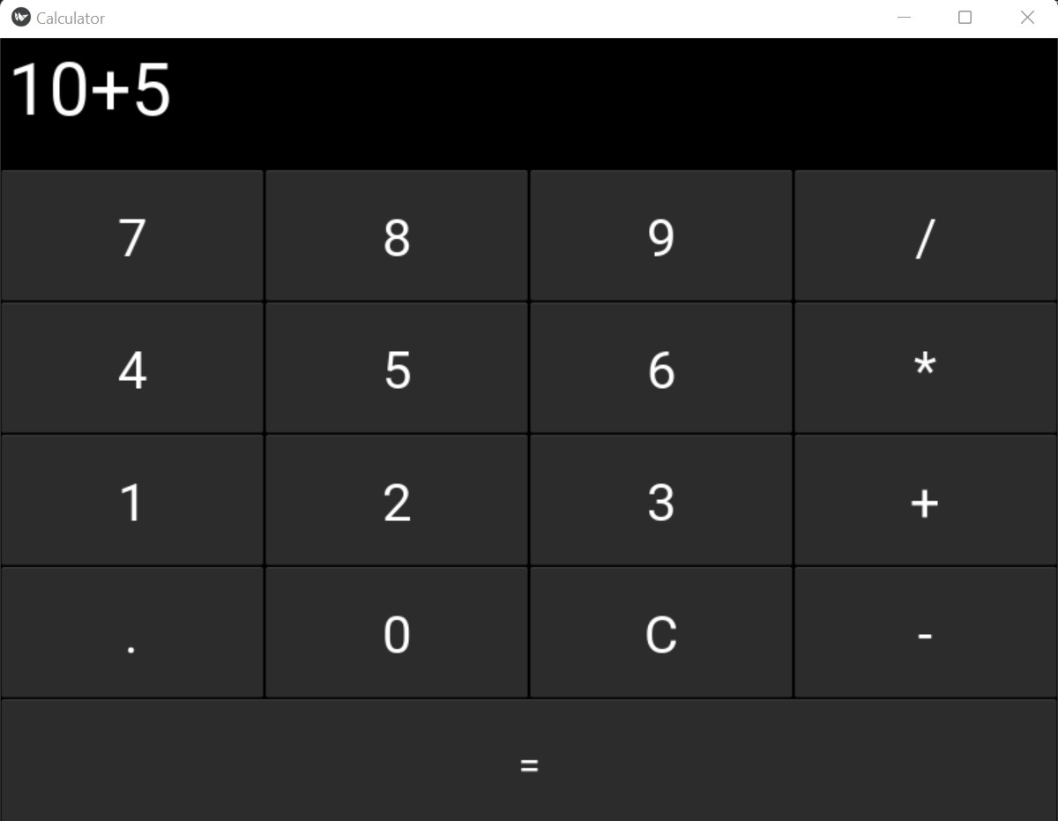

Reference :

1) <https://pypi.org/project/Kivy/>