**Mini Project**

**Shutdown Application Using tkinter Module**

**TASK**  : Create a Python GUI App which can operate following options for

Windows :

* Restart
* Restart Time
* Log out
* Shutdown

**Tools** : 1) Python 3.9.7

2) Pycharm

**Library** : tkinter , os

**Theory**  :

* Tkinter is the standard GUI library for Python. Python when combined with Tkinter provides a fast and easy way to create GUI applications. Tkinter provides a powerful object-oriented interface to the Tk GUI toolkit.
* Tkinter is a standard library in Python which is used for GUI application. Tkinter has various controls which are used to build a GUI-based application.
* To install Tkinter, we need Python pre-installed. Tkinter actually comes along when we install Python. It is built-in module/library. While installing Python, we need to check the td/tk and IDLE checkbox. This will install the tkinter and we need not install it separately.
* However, if we missed installing Tkinter while installing Python, we can do it later using the pip command.

**Installation** :

1. Step 1 : Open up a terminal or command prompt and run - **pip install tk**

**Steps :**

Creating a GUI application using Tkinter is an easy task. All you need to do is perform the following steps −

* Import the *Tkinter* & os module.
* Create the GUI application main window.
* Add one or more widgets to the GUI application.
* Enter the main event loop to take action against each event triggered by the user.

**Conclusion**

User can use this GUI application to restart , shutdown , log out windows. Application comes with four different options.

**Snapshot :**

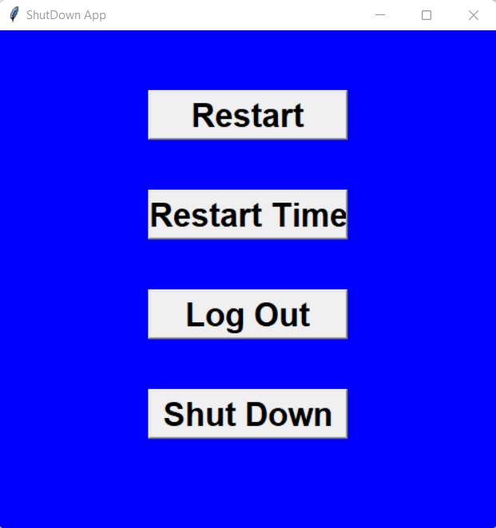

Reference : 1) [https://www.tutorialspoint.com/python/python_gui_programming.htm#](https://www.tutorialspoint.com/python/python_gui_programming.htm)

2) <https://docs.python.org/3/library/tkinter.html>