| **Name:** | BARI ANKIT VINOD |
| --- | --- |
| **Roll No:** | 65 |
| **Class/Sem:** | SE/IV |
| **Experiment No.:** | 2A |
| **Title:** | Program to perform multiplication without using MUL instruction |
| **Date of Performance:** |  |
| **Date of Submission:** |  |
| **Marks:** |  |
| **Sign of Faculty:** |  |

**Aim:** Program for multiplication without using the multiplication instruction.

**Theory:**

In the multiplication program, we multiply the two numbers without using the direct instructions MUL. Here we can successive addition methods to get the product of two numbers. For that, in one register we will take multiplicand so that we can add multiplicand itself till the multiplier stored in another register becomes zero.

**ORG 100H:**

It is a compiler directive. It tells the compiler how to handle source code. It tells the compiler that the executable file will be loaded at the offset of 100H (256 bytes.)

**INT 21H:**

The instruction INT 21H transfers control to the operating system, to a subprogram that handles I/O operations.

**MUL:** MUL Source.

This instruction multiplies an unsigned byte from some source times an unsigned byte in the AL register or an unsigned word from some source times an unsigned word in the AX register.

Source: Register, Memory Location.

When a byte is multiplied by the content of AL, the result (product) is put in AX. A 16-bit destination is required because the result of multiplying an 8-bit number by an 8-bit number can be as large as 16-bits. The MSB of the result is put in AH and the LSB of the result is put in AL.

When a word is multiplied by the contents of AX, the product can be as large as 32 bits. The MSB of the result is put in the DX register and the LSB of the result is put in the AX register.

MUL BH; multiply AL with BH; result in AX.

Algorithm:

1. Start.
2. Set AX=00H, BX= Multiplicand, CX=Multiplier 3 Add the content of AX and BX.
3. Decrement content of CX.
4. Repeat steps 3 and 4 till CX=0.
5. Stop.

Flowchart:

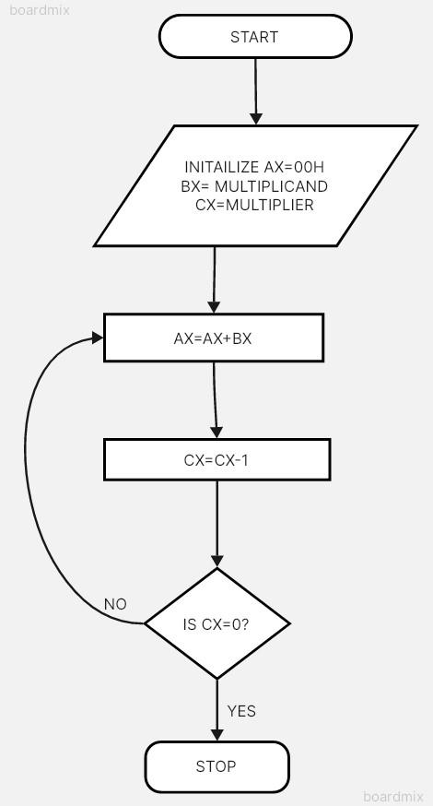

Code :

Output :

Conclusion:

1. Explain data transfer instructions.
2. Explain Arithmetic instructions.