| **Name:** | BARI ANKIT VINOD |
| --- | --- |
| **Roll No:** | 65 |
| **Class/Sem:** | SE/IV |
| **Experiment No.:** | 2B |
| **Title:** | Program for calculating factorial using assembly language |
| **Date of Performance:** |  |
| **Date of Submission:** |  |
| **Marks:** |  |
| **Sign of Faculty:** |  |

**Aim:** Program to calculate the Factorial of a number.

**Theory:**

To calculate the factorial of any number, we use MUL instruction. Here, initially, we initialize the first register by value 1. The second register is initialized by the value of the second register. After multiplication, decrement the value of the second register and repeat the multiplying step till the second register value becomes zero. The result is stored in the first register.

Algorithm:

1. Start.
2. Set AX=01H, and BX with the value whose factorial we want to find.
3. Multiply AX and BX.
4. Decrement BX=BX-1.
5. Repeat steps 3 and 4 till BX=0.
6. Stop.

Flowchart:

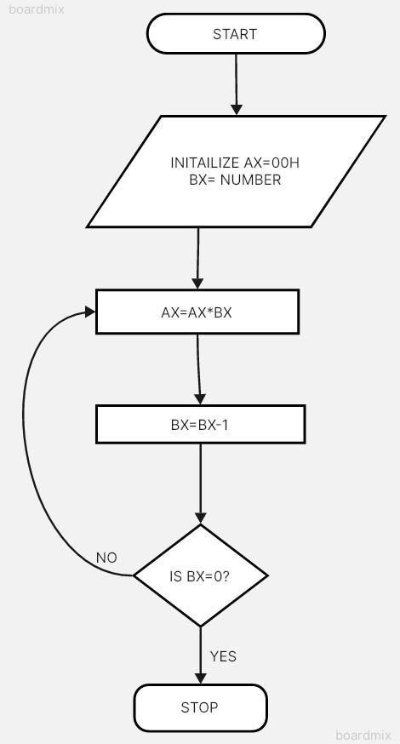

Code :

Output :

Conclusion:

1. Explain shift instructions.
2. Explain rotate instructions.