

| **Name:** | BARI ANKIT VINOD |
| --- | --- |
| **Roll No:** | 65 |
| **Class/Sem:** | SE/IV |
| **Experiment No.:** | 4 |
| **Title:** | Program to display character in uppercase and lowercase. |
| **Date of Performance:** |  |
| **Date of Submission:** |  |
| **Marks:** |  |
| **Sign of Faculty:** |  |

**Aim:** Assembly Language Program to display character A to z in both uppercase and lowercase

**Theory:**

DOS provide various interrupt services that are used by the system programmer. The most commonly used interrupt is INT 21H. It invokes inbuilt DOS functions which can be used to perform various tasks. The most common tasks are reading a user input character from the screen, displaying result on the exiding program etc.

In this program, we display the characters A to Z on the DOS prompt. DOS interrupt function 02 displays the contents of DL (ASCII code) on the screen. By loading the ASCII code of 'A' in the DL register, loading AH register with 02h and calling INT 21h it is possible to display character from A to Z on the screen.

INT 21h/AH = 2 - write character to standard output.

Entry: DL = character to write, after execution AL = DL.

**Example :-**

mov ah , 2

mov dl , 'a'

int 21h



**Flowchart:**

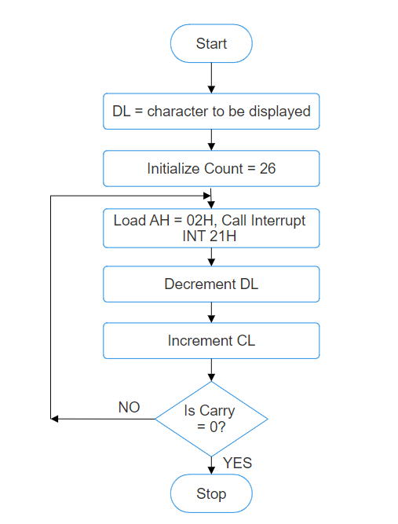

**Algorithm:**

1. Start.

2. Initialize DL with 'A'.

3. Load CL with count = 26.

4. Load AH = 02H and call INT 21H.

5. Increment DL, to next character.

6. Decrement the count.

7. Repeat steps 4,5,6 till CL is not zero.

8. To end the program use DOS interrupt:

1) Load AH = 41H.

2) Call INT 21 H.

9. Stop.

Code ;

Output :

**Conclusion:**

1. Explain INT 21H.
2. Explain working of increment and decrement instructions.