| **Name:** | BARI ANKIT VINOD |
| --- | --- |
| **Roll No:** | 65 |
| **Class/Sem:** | SE/IV |
| **Experiment No.:** | 6 |
| **Title:** | To perform program to reverse the word in string |
| **Date of Performance:** |  |
| **Date of Submission:** |  |
| **Marks:** |  |
| **Sign of Faculty:** |  |

**Aim:** Assembly Language Program to reverse the word in string.

**Theory:**

This program will read the string entered by the user and then reverse it. Reverse a string is the technique that reverses or changes the order of a given string so that the last character of the string becomes the first character of the string and so on.

**Algorithm:**

1. Start
2. Initialize the data segment
3. Display the message -1
4. Input the string
5. Display the message 2
6. Take characters count in DI
7. Point to the end character and read it
8. Display the character
9. Decrement the count
10. Repeat until the count is zero
11. To terminate the program using DOS interrupt
12. Initialize AH with 4ch
13. Call interrupt INT 21h
14. Stop

**Flowchart:**

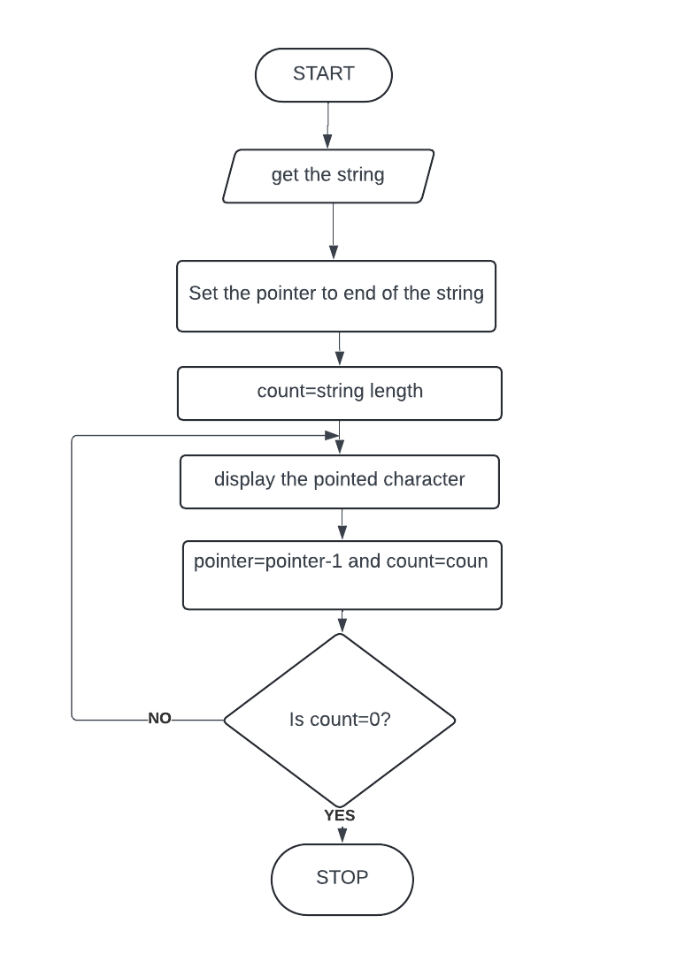

Code :

Output :

Conclusion:

1. Explain the difference between XLAT and XLATB
2. Explain the instruction LAHF.