| **Name:** | BARI ANKIT VINOD |
| --- | --- |
| **Roll No:** | 65 |
| **Class/Sem:** | SE/IV |
| **Experiment No.:** | 7 |
| **Title:** | Program to find whether given string is palindrome or not |
| **Date of Performance:** |  |
| **Date of Submission:** |  |
| **Marks:** |  |
| **Sign of Faculty:** |  |

**Aim:** Assembly Language Program to find given string is Palindrome or not.

**Theory:**

A palindrome string is a string when read in a forward or backward direction remains the same. One of the approach to check this is iterate through the string till middle of the string and compare the character from back and forth.

**Algorithm:**

1. Initialize the data segment.
2. Display the message M1
3. Input the string
4. Get the string address of the string
5. Get the right most character
6. Get the left most character
7. Check for palindrome.
8. If not Goto step 14
9. Decrement the end pointer
10. Increment the starting pointer.
11. Decrement the counter
12. If count not equal to zero go to step 5
13. Display the message m2
14. Display the message m3
15. To terminate the program using DOS interrupt
16. Initialize AH with 4ch
17. Call interrupt INT 21h
18. Stop

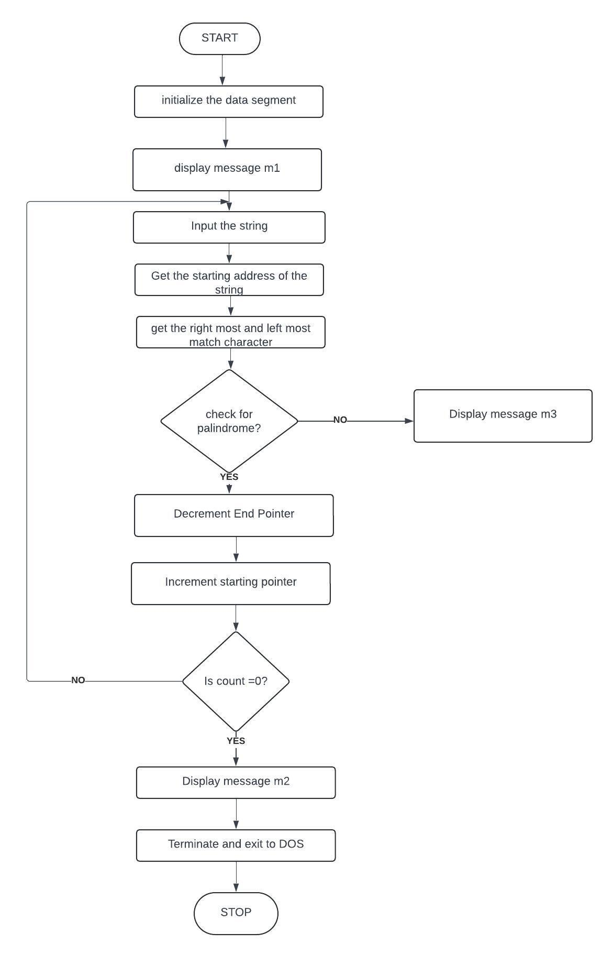

Flowchart:

Code :

Output :

Conclusion:

1. Explain SAR INSTRUCTION
2. Explain DAA instruction.

