

|  |  |
| --- | --- |
| **Name:** | BARI ANKIT VINOD |
| **RollNo:** | 65 |
| **Class/Sem:** | SE/IV |
| **ExperimentNo.:** | 10 |
| **Title:** | Programforprintingthestringusingprocedureandmacro. |
| **DateofPerformance:** | 05/04/24 |
| **DateofSubmission:** | 12/04/24 |
| **Marks:** |  |
| **SignofFaculty:** |  |



**Aim:**Programforprintingthestringusingprocedureandmacro.

**Theory:**

**Procedures:-**

•Proceduresareusedforlargegroupofinstructionstoberepeated.

•Objectcodegeneratedonlyonce.Lengthoftheobjectfileislessthememory

•CALLandRETinstructionsareusedtocallprocedureandreturnfromprocedure.

•Moretimerequiredforitsexecution.

•ProcedureCanbedefinedas:

Procedure_namePROC ……

…… Procedure_nameENDP

Example:

AdditionPROCnear ……

…… AdditionENDP

**Macro:-**

•Macroisusedforsmallgroupofinstructionstoberepeated.

•Objectcodeisgeneratedeverytimethemacroiscalled.

•Objectfilebecomesverylengthy.



•Macrocanbecalledjustbywriting.

•DirectivesMACROandENDMareusedfordefiningmacro.

•Lesstimerequiredforitsexecution.

•Macrocanbedefinedas:

Macro_nameMACRO[Argument,....,ArgumentN] ......

...... ENDM

Example:-

DisplayMACROmsg .....

..... ENDM

**Code :**

org 100h

.data

msg1 db 10, 13, 'Procedures$'

.code

lea dx, msg1

call print

mov ah, 4ch

int 21h

print proc

mov ah, 09h

int 21h

ret

print endp

ret

org 100h

print macro p1

lea dx, p1

mov ah, 09h

int 21h

endm

.data

m1 db 10, 13, 'Macos$'

.code

print m1

ret

**Output :**

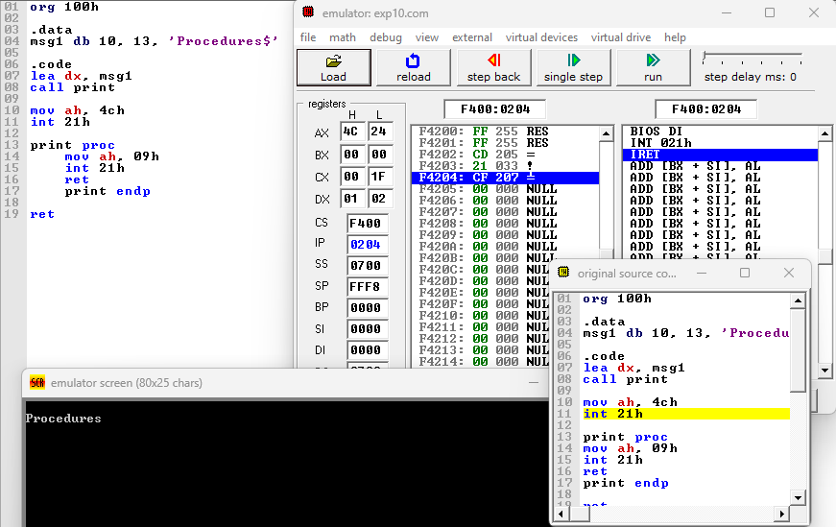

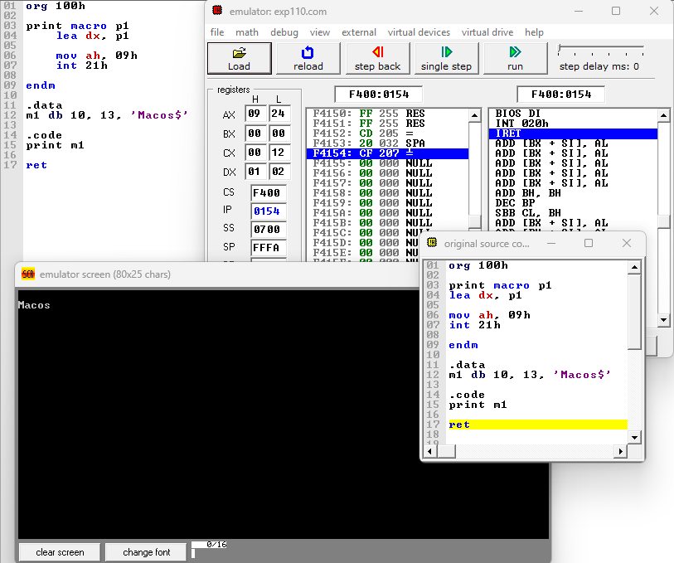

**Conclusion :**

In conclusion, the utilization of both procedures and macros in the program for printing strings enhances code readability, reusability, and efficiency. Procedures allow for the encapsulation of repetitive tasks, promoting modular design and easing maintenance. On the other hand, macros enable the generation of code snippets at compile time, reducing runtime overhead and potentially optimizing performance. By combining these two programming constructs, developers can create robust and flexible solutions for string manipulation tasks, thereby improving the overall quality and maintainability of the codebase.