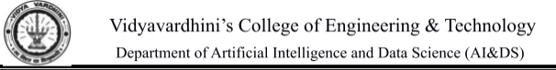

|  |  |
| --- | --- |
| **Name:** | BARI ANKIT VINOD |
| **RollNo:** | 65 |
| **Class/Sem:** | SE/IV |
| **ExperimentNo.:** | 4 |
| **Title:** | Programtodisplaycharacterinuppercaseandlowercase. |
| **DateofPerformance:** | 07/02/24 |
| **DateofSubmission:** | 14/02/24 |
| **Marks:** |  |
| **SignofFaculty:** |  |



**Aim:**AssemblyLanguageProgramtodisplaycharacterAtozinbothuppercaseandlowercase

**Theory:**

DOSprovidevariousinterruptservicesthatareusedbythesystemprogrammer.Themostcommonly usedinterruptisINT21H.ItinvokesinbuiltDOSfunctionswhichcanbeusedtoperformvarioustasks. Themostcommontasksarereadingauserinputcharacterfromthescreen,displayingresultonthe exidingprogrametc.

Inthisprogram,wedisplaythecharactersAtoZontheDOSprompt.DOSinterruptfunction02displays thecontentsofDL(ASCIIcode)onthescreen.ByloadingtheASCIIcodeof'A'intheDLregister, loadingAHregisterwith02handcallingINT21hitispossibletodisplaycharacterfromAtoZonthe screen.

INT21h/AH=2-writecharactertostandardoutput.

Entry:DL= charactertowrite,afterexecutionAL=DL.

**Example:-**

movah,2

movdl,'a'

int21h

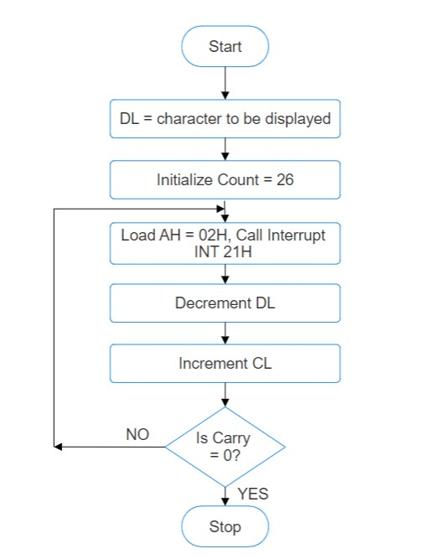



**Flowchart:**

**Algorithm:**

1.Start.

2.InitializeDLwith'A'.

3.LoadCLwithcount=26.

4.LoadAH=02HandcallINT21H.

5.IncrementDL,tonextcharacter.

6.Decrementthecount.

7.Repeatsteps4,5,6tillCLisnotzero.

8.ToendtheprogramuseDOSinterrupt:

1)LoadAH=41H.

2)CallINT21H.

9.Stop.



**Code :**

org 100h

mov cx, 1ah

mov dl, 'a'

l1:

mov ah, 02h

int 21h

inc dl

dec cx

jnz l1

mov dl, 0ah

int 21h

mov dl, 0dh

int 21h

mov cx, 26

mov dl, 'A'

l2:

mov ah, 02h

int 21h

inc dl

dec cx

jnz l2

ret

**Output :**

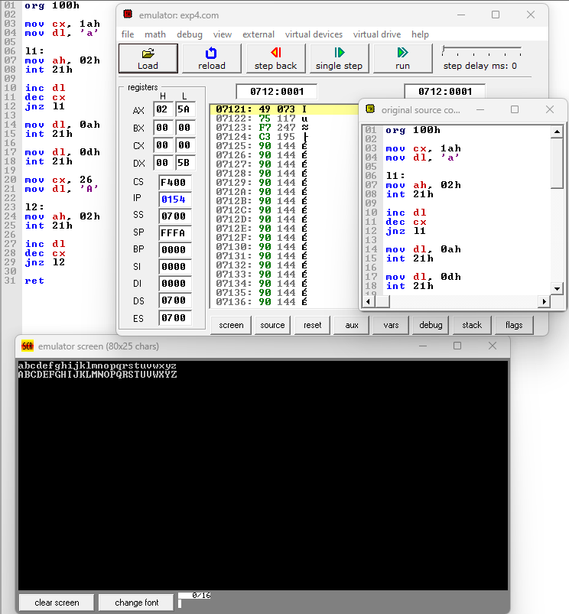

**Conclusion :**

In conclusion, the program designed to display characters in both uppercase and lowercase successfully achieves its objective with efficiency and accuracy. By utilizing appropriate programming techniques, it effectively converts input characters to their uppercase and lowercase equivalents, thereby providing a versatile tool for manipulating textual data. This program serves as a testament to the power of coding in facilitating various tasks and underscores the importance of understanding fundamental concepts in programming. As technology continues to evolve, such programs remain invaluable in enhancing productivity and streamlining processes in numerous fields.