

|  |  |
| --- | --- |
| **Name:** | BARI ANKIT VINOD |
| **RollNo:** | 65 |
| **Class/Sem:** | SE/IV |
| **ExperimentNo.:** | 5 |
| **Title:** | ProgramtodisplaystringinLowercase. |
| **DateofPerformance:** | 07/02/24 |
| **DateofSubmission:** | 14/02/24 |
| **Marks:** |  |
| **SignofFaculty:** |  |



**Aim:**ProgramtodisplaystringinLowercase.

**Theory:**

TheprogramwilltakeUppercasestringasinputandconvertittolowercasestring.Int21hisaDOS interrupt.TousetheDOSinterrupt21hloadwiththedesiredsub-function.Loadotherrequiredparameters inotherregistersandmakeacalltoINT21h.

INT21h/AH=9

outputofstringatDS:٠Stringmestbeterminatedby'"$"

example:

org100h

movdx,offsetmsg

movah,9

int21h

ret

msgdb"helloworld$"

INT21h/AH=0AH–inputofstringtoDS:DX,firstbyteisbuffersize,secondbyteisnumberofchars actuallyreadthisfunctiondoesnotadd‘$’intheendofstringtoprintusingINT21h/AH=9youmustset dollarcharacterattheendofitandstartprintingfromaddressDS:DX+2.Thefunctiondoesnotallowto entermorecharactersthanthespecifiedbuffersize.



**Algorithm:**

1.Start.

2.InitializetheDataSegment.

3.Displaymessage-1.

4.Inputthestring.

5.Displaymessage-2.

6TakethecharactercountinCX.

7.Pointtothefirstcharacter.

8.ConvertittoLowercase.

9.Displaythecharacter.

10.Decrementthecharactercoun.

11.IfnotZero,repeatfromstep6.

12.Toterminatetheprogram,usingtheDOSinterrupt:

1)InitializeAHwith4CH

2)CallinterruptINT21H.

13.Stop.

**Code :**

org 100h

.data

m1 db 10, 13, 'Enter the string in uppercase :$'

m2 db 10, 13, 'The lowercase string is :$'

buff db 80

.code

lea dx, m1

mov ah, 09h

int 21h

lea dx, buff

mov ah, 0ah

int 21h

lea dx, m2

mov ah, 09h

int 21h

mov cl, [buff+1]

lea bx, buff+2

l1:

mov dx, [bx]

add dx, 20h

mov ah, 02h

int 21h

inc bx

loop l1

ret

**Output :**

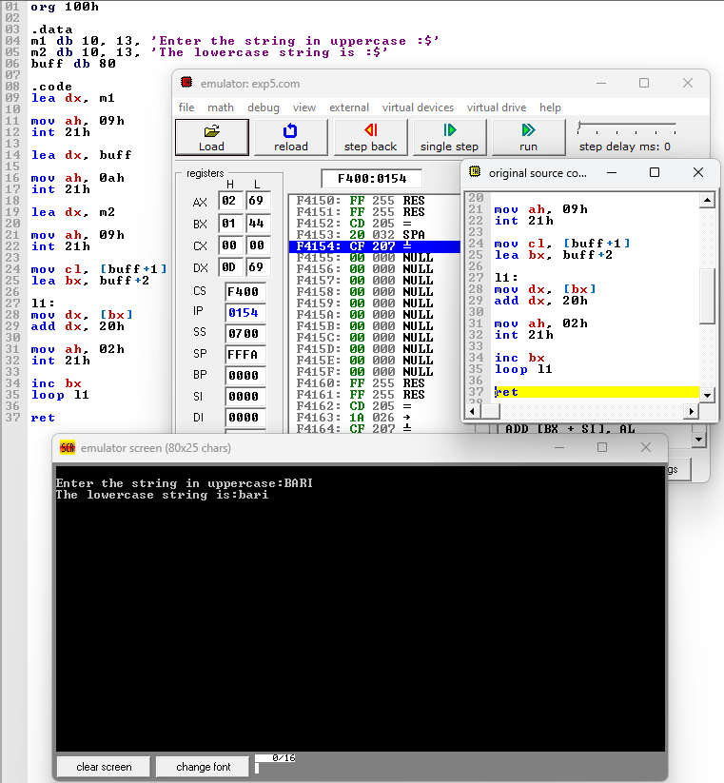

**Conclusion :**



In conclusion, the program designed to display strings in lowercase effectively demonstrates the fundamental concepts of string manipulation and programming logic. By transforming inputted strings into lowercase, the program enhances readability and standardizes data for various applications. Through this project, we've gained valuable insights into the implementation of string functions and the importance of user-friendly interfaces. As we continue to refine our coding skills, this program serves as a foundational step towards tackling more complex challenges in software development.