

|  |  |
| --- | --- |
| **Name:** | BARI ANKIT VINOD |
| **RollNo:** | 65 |
| **Class/Sem:** | SE/IV |
| **ExperimentNo.:** | 9 |
| **Title:** | Programforinterfacing8086with8255PPI. |
| **DateofPerformance:** | 22/03/24 |
| **DateofSubmission:** | 05/04/24 |
| **Marks:** |  |
| **SignofFaculty:** |  |



**Aim:**8255isconfiguredinmodeOissimpleInuput/OutputMode.PortsA,B,Careinmode0.Allthe postsareinoutputmodeanddataistransmittedtotherespectiveports.

**Apparatus:**Microprocessor8086and8255PPIexperimentalsetupkit

**Theory:**

TheprogrammablePeripheralInterfacechip8255hasthree8-bitInput/Outputportsi.e.PortA,PortB, PortCupper(PCU)andPortClower(PCL).Directbitset/resetcapabilityisavailableforportC.8255is averypowerfultoolforinterfacingperipheralequipmenttothemicroprocessor.Itisflexibleenoughto interfacewithanyI/odevicewithouttheneedofexternallogic.

**Procedure:**

1. Connect8086kitto8255PPIkitusing50pinFRUcable.

2. DefaultI/Oaddressrangesare:

SELECTION

PortA

PortB

PortC

CommandPort

ADDRESS

30H

31H

32H

33H

3. 80Histhecontrolwordfor8255.ItissetinsimpleI/Omodeandalltheportsareinoutputmode0

|  |  |  |  |  |  |  |  |
| --- | --- | --- | --- | --- | --- | --- | --- |
| **D7** | **D6** | **D5** | **D4** | **D3** | **D2** | **D1** | **D0** |
| 1 | 0 | 0 | 0 | 0 | 0 | 0 | 0 |



Always1

forI/O

GroupA PortA

mode0 (output)

PortC1

(output)

GroupB

(output)

PortB

(output)

PortC2

(output)

4. TheLED’sconnectedtothepinsatPortAglowaccordingtothedatatransmittedonportA. 5. TheLED’sconnectedtothepinsofportBglowaccordingtothedatatransmittedonPortB. 6. TheLED’sconnectedtothepinsofportCglowaccordingtothedatatransmittedonPortC.



**Program:**

Segment: C000 Offset: C000

|  |  |  |  |
| --- | --- | --- | --- |
| **Memory** | **Opcode** | **Instructions** | **Comments** |
| C000 | B0 | MOVAL,80H | Mode0,Allportsin outputmode |
| C001 | 80 |  |  |
| C002 | E6 | OUTCWR,AL |  |
| C003 | 33 |  |  |
| C004 | B0 | MOVAL,55H | DataforPortA |
| C005 | 55 |  |  |
| C006 | E6 | OUTPORTA,AL |  |
| C007 | 30 |  |  |
| C008 | B0 | MOVAL,AAH | DataforportB |
| C009 | AA |  |  |
| C00A | E6 | OUTPORTB,AL |  |
| C00B | 31 |  |  |
| C00C | B0 | MOVAL,0FH | DataforportC |
| C00D | 0F |  |  |
| C00E | E6 | OUTPORTC,AL |  |
| C00F | 32 |  |  |
| C010 | CC | INT3 | Stop |



**Code :**

org 100h

.data

arr db 05h, 10h, 03h, 09h, 02h

.code

lea si, arr

mov cx, 05h

mov al, 00h

l1:

cmp al, [si]

jnc l2

mov al, [si]

l2:

inc si

loop l1

**Output :**

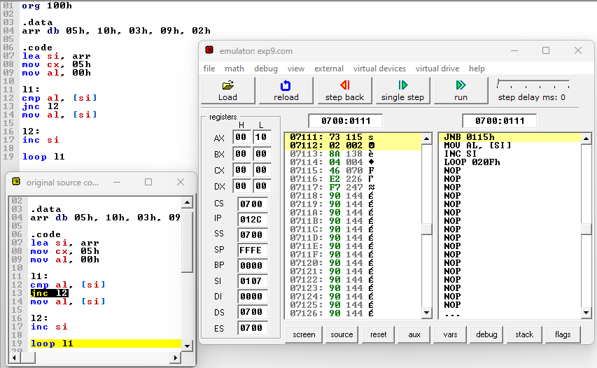

**Conclusion :**

In conclusion, the program for interfacing the 8086 microprocessor with the 8255 Programmable Peripheral Interface (PPI) serves as a crucial bridge between the computational power of the processor and the external world of peripherals. By effectively managing input and output operations through the 8255 PPI, this program enables seamless communication and control of various devices connected to the microprocessor.