Vidyavardhini’sCollegeofEngineering&Technology DepartmentofArtificialIntelligenceandDataScience(AI&DS)

|  |  |
| --- | --- |
| **Name:** | BARI ANKIT VINOD |
| **RollNo:** | 65 |
| **Class/Sem:** | SE/IV |
| **ExperimentNo.:** | 1 |
| **Title:** | Toperformbasicarithmeticoperationson16-bitdata. |
| **DateofPerformance:** | 24/01/24 |
| **DateofSubmission:** | 24/01/24 |
| **Marks:** |  |
| **SignofFaculty:** |  |

Vidyavardhini’sCollegeofEngineering&Technology DepartmentofArtificialIntelligenceandDataScience(AI&DS)

**Aim:**AssemblyLanguageProgramtoperformbasicarithmeticoperations(addition,subtraction, multiplication,anddivision)on16-bitdata.

**Theory:**

**MOV:**MOVDestination,Source. TheMOVinstructioncopiesdatafromaspecifieddestination.wordorbyteofdatafromaspecified

destination. Source:Register,MemoryLocation,ImmediateNumber Destination:Register,MemoryLocation

MOVCX,037AH;Putimmediatenumber037AHtoCX. **ADD:**ADDDestination,Source.

Theseinstructionsaddanumbersourcetoanumberfromsomedestinationandputtheresultinthe specifieddestination.

Source:Register,MemoryLocation,ImmediateNumber Destination:Register,MemoryLocation Thesourceandthedestinationinaninstructioncannotbothbememorylocations. ADDAL,74H;addtheimmediatenumberto74HtothecontentofAL.ResultinAL. **SUB:**SUBDestination,Source.

Theseinstructionssubtractthenumberinsomesourcefromthenumberinsomedestinationandput theresultinthedestination.

Source:ImmediateNumber,Register,orMemoryLocation. Destination:RegisteroraMemoryLocation. Thesourceandthedestinationinaninstructioncannotbothbememorylocations. SUBAX,3427H;Subtractimmediatenumber3427HfromAX. **MUL:**MULSource.

ThisinstructionmultipliesanunsignedbytefromsomesourcetimesanunsignedbyteintheAL registeroranunsignedwordfromsomesourcetimesanunsignedwordintheAXregister.

Source:Register,MemoryLocation. MULCX;MultiplyAXwithCX;resultinhighwordinDX,lowwordinAX. **DIV:**DIVSource.

Thisinstructionisusedtodivideanunsignedwordbyabyteortodivideanunsigneddoubleword (32bits)byaword.

Source:Register,MemoryLocation.

Ifthedivisoris8-bit,thenthedividendisinAXregister.Afterdivision,thequotientisinALand theremainderinAH.

Ifthedivisoris16-bit,thenthedividendisinDX-AXregister.Afterdivision,thequotientisinAX andtheremainderinDX.

DIVCX;dividedoublewordinDXandAXbywordinCX;QuotientinAX;andremainderinDX.

Vidyavardhini’sCollegeofEngineering&Technology DepartmentofArtificialIntelligenceandDataScience(AI&DS)

Algorithmtoaddtwo16-bitnumbers 1.LoadthefirstnumberinAX 2.LoadthesecondnumberinBX

3AddthesecondnumbertoAX 4.StoretheresultinAX. Algorithmtosubtracttwo16-bitnumbers

1.LoadthefirstnumberinAX. 2.Loadthesecondnumber.inBX3.Subtractthesecondnumberto

AX 4.StoretheresultinAX.

Algorithmtomultiplya16-bitnumberbyan8-bitnumber 1.LoadthefirstnumberinAX. 2.Loadthesecondnumber.inBL

3.MultiplyDXandAX. 4.TheresultisinDXandAX.

Algorithmtodividea16-bitnumberbyan8-bitnumber 1.LoadthefirstnumberinAX. 2.Loadthesecondnumber.inBL

3.DivideAXbyBL. 4.Afterdivision,thequotientisinALandtheremainderisinAH.

**Code :**

.org 100h

.data

num1 dw 1234h

num2 dw 4567h

result dw ?

.code

main proc

mov ax, @data

mov ds, ax

mov ax, num1

add ax, num2

mov result, ax

mov ax, num1

sub ax, num2

mov result, ax

mov ax, num1

mov bx, num2

mul bx

mov result, ax

mov ax, num1

mov bx, num2

div bx

mov result, ax

mov ax, 4ch

int 21h

main endp

end main

**Output :**

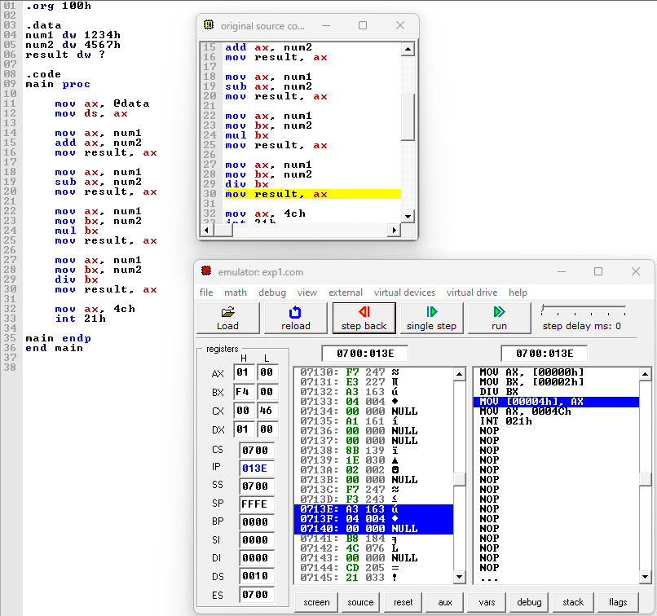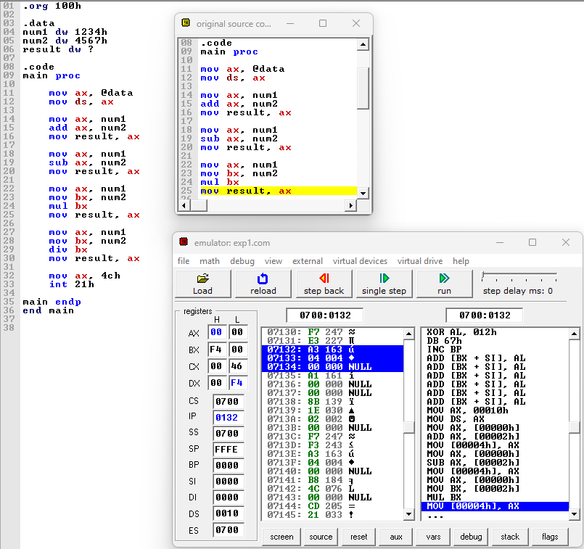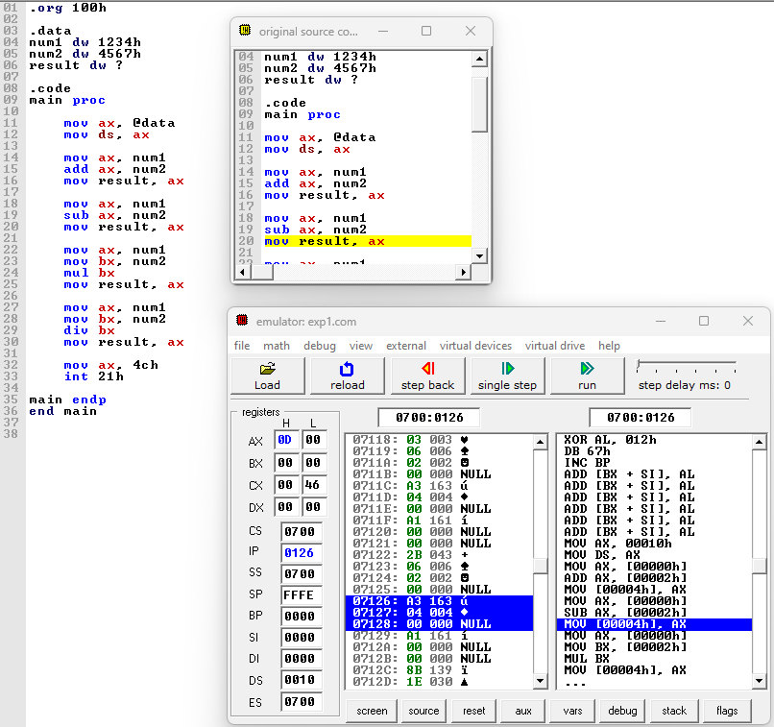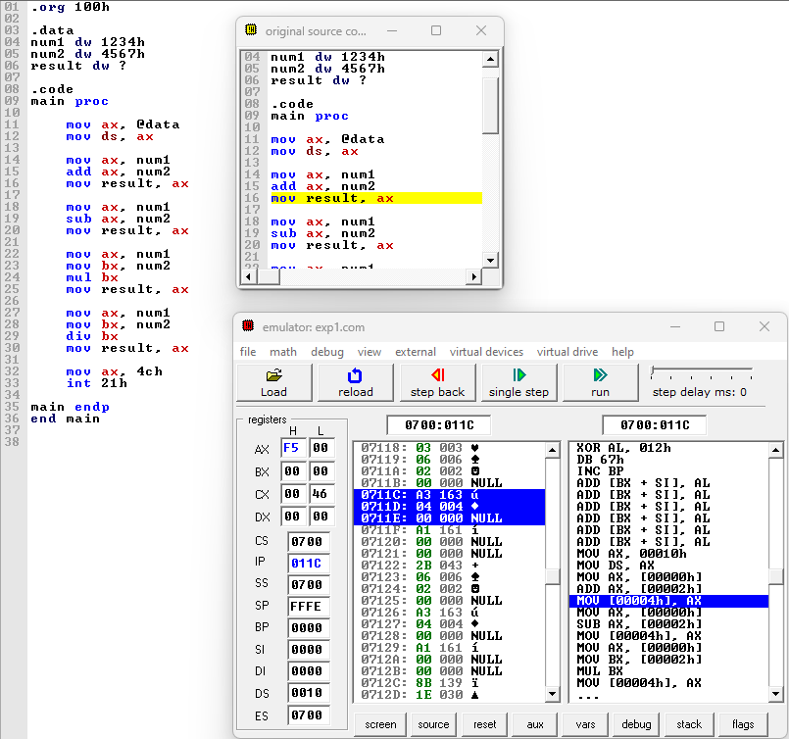

**Conclusion:**

In conclusion, the ability to perform basic arithmetic operations on 16-bit data is fundamental in various fields such as computer science, engineering, and mathematics. By efficiently manipulating 16-bit data, we can solve complex problems, process large datasets, and design intricate algorithms. Whether it's addition, subtraction, multiplication, or division, mastering these operations enables us to build robust systems, develop advanced technologies, and push the boundaries of innovation. As we continue to advance in the digital age, a solid understanding of arithmetic operations on 16-bit data remains an indispensable skill for professionals across diverse disciplines.