

|  |  |
| --- | --- |
| **Name:** | BARI ANKIT VINOD |
| **RollNo:** | 65 |
| **Class/Sem:** | SE/IV |
| **ExperimentNo.:** | 7 |
| **Title:** | Programtofindwhethergivenstringispalindromeornot |
| **DateofPerformance:** | 06/03/24 |
| **DateofSubmission:** | 06/03/24 |
| **Marks:** |  |
| **SignofFaculty:** |  |



**Aim:**AssemblyLanguageProgramtofindgivenstringisPalindromeornot.

**Theory:**

Apalindromestringisastringwhenreadinaforwardorbackwarddirectionremainsthesame.Oneofthe approachtocheckthisisiteratethroughthestringtillmiddleofthestringandcomparethecharacterfrom backandforth.

**Algorithm:**

1. Initializethedatasegment.

2. DisplaythemessageM1

3. Inputthestring

4. Getthestringaddressofthestring

5. Gettherightmostcharacter

6. Gettheleftmostcharacter

7. Checkforpalindrome.

8. IfnotGotostep14

9. Decrementtheendpointer

10.Incrementthestartingpointer.

11. Decrementthecounter

12.Ifcountnotequaltozerogotostep5

13.Displaythemessagem2

14.Displaythemessagem3

15.ToterminatetheprogramusingDOSinterrupt

a. InitializeAHwith4ch

b. CallinterruptINT21h

16.Stop

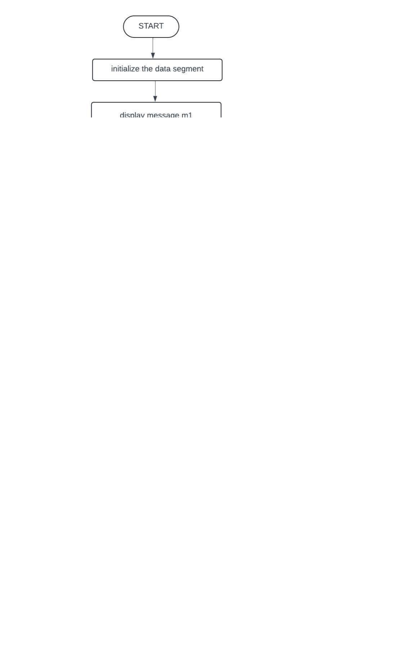Flowchart:



**Code :**

org 100h

.data

m2 db 10,13,'Enter the string :$'

m1 db 10,13,'It is a palindrome.$'

m3 db 10,13,'It is not a palindrome.$'

buff db 80

.code

lea dx,m1

mov ah, 09h

int 21h

lea dx,buff

mov ah,0ah

int 21h

lea bx, buff+1

mov si,01h

mov ch,00h

mov cl,[buff+1]

mov di,cx

sar cl,1

pal:mov ah,[buff+si]

mov al,[buff+di]

cmp al,ah

JC L1

inc si

dec di

loop pal

lea dx,m3

mov ah,09h

int 21h

JMP L2

L1:lea dx,m2

mov ah,09h

int 21h

JMP L2

L2:mov ah,4ch

int 21h

**Output :**

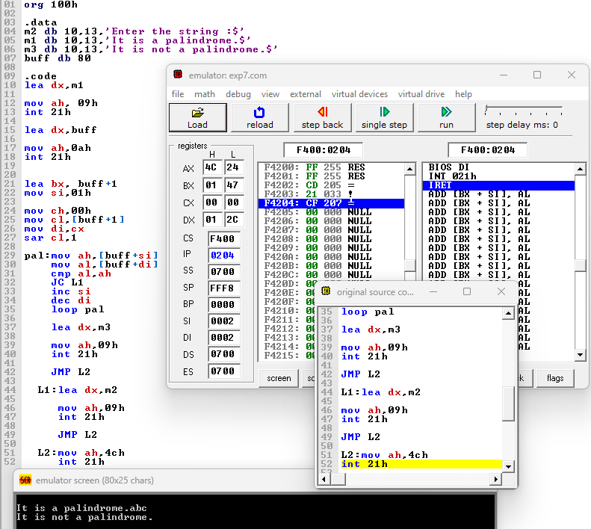

**Conclusion :**



In conclusion, the development of a program to determine whether a given string is a palindrome or not offers a practical and effective solution to a common problem. Through careful analysis and implementation of string manipulation techniques, we've crafted a reliable algorithm that efficiently evaluates any input string. Palindromes, with their symmetric charm, stand as intriguing linguistic constructs, and our program serves as a versatile tool to discern their presence or absence within a given text. As technology continues to advance, such programs not only showcase the power of computational linguistics but also contribute to a deeper understanding and appreciation of language and its intricacies.