

Experiment No 3:
Aim: To implement File Handling in Python. Theory:
The key function for working with files in Python is the open() function. The open() function takes two parameters; filename, and mode.
There are four different methods (modes) for opening a file:

" r" - Read - Default value. Opens a file for reading, error if the file does not exist "a" - Append - Opens a file for appending, creates the file if it does not exist "w" - Write - Opens a file for writing, creates the file if it does not exist "x"
- Create - Creates the specified file, returns an error if the file exists In addition you can specify if the file should be handled as binary or text mode "t" - Text -
Default value. Text mode

"b" - Binary - Binary mode (e.g. images)

Python has a set of methods available for the file object.
Method Description
close() Closes the file
detach() Returns the separated raw stream from the buffer
fileno() Returns a number that represents the stream, from the operating system's perspective flush() Flushes the internal buffer
isatty()Returns whether the file stream is interactive or not read() Returns the file content
readable() Returns whether the file stream can be read or not readline() Returns one line from the file
readlines() Returns a list of lines from the file

seek() Change the file position
seekable() Returns whether the file allows us to change the file position tell() Returns the current file position
truncate() Resizes the file to a specified size
writable() Returns whether the file can be written to or not write() Writes the specified string to the file
writelines() Writes a list of strings to the file

PROGRAM:
Program 3.1: Python program to copy odd noline from one file to other

# open file in read mode

fn = open('myfile.txt', 'r')

# open other file in write mode

fn1 = open('myfile.txt', 'w')

# read the content of the file line by line

cont = fn.readlines()

print(len(cont)) # Print the number of lines in the file

print(type(cont)) # Print the type of cont variable

# Loop through each line in the file

for i in range(0, len(cont)):

# Check if the line number is odd

if i % 2 != 0:

# Write the line to the new file

fn1.write(cont[i])

else:

pass

# close the file

fn1.close()

# open file in read mode

fn1 = open('myfile.txt', 'r')

# read the content of the file

cont1 = fn1.read()

# print the content of the file

print(cont1)

# close all files

fn.close()

fn1.close()

OUTPUT:

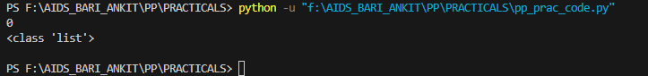

Program 3.2:

# Function to count number
# of characters, words, spaces, and lines in a file
def counter(fname):
# Variables to store total counts
num_words = 0
num_lines = 0
num_charc = 0
num_spaces = 0

# Opening file using with statement to automatically close the file
with open(fname, 'r') as f:
# Loop to iterate file line by line
for line in f:
# Incrementing total line count
num_lines += 1

# Flag to track word presence in the line
word = 'Y'

# Loop to iterate every character in the line
for letter in line:
# Condition to check if the character is not a white space and a word
if letter != ' ' and word == 'Y':
# Incrementing the word count
num_words += 1
word = 'N'
# Condition to check if the character is a white space
elif letter == ' ':
# Incrementing the space count
num_spaces += 1
word = 'Y'

# Incrementing character count for every character except space and newline
if letter != " " and letter != "\n":
num_charc += 1

# Printing total counts
print("Number of words in text file:", num_words)
print("Number of lines in text file:", num_lines)
print('Number of characters in text file:', num_charc)
print('Number of spaces in text file:', num_spaces)

# Driver Code
if __name__ == '__main__':
fname = 'myfile.txt'
try:
counter(fname)
except FileNotFoundError:
print('File not found')

OUTPUT

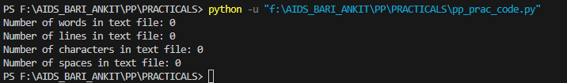

Conclusion:
The experiment successfully demonstrated the implementation of File Handling in Python, showcasing its versatility in reading, writing, and manipulating various file formats.

