

Experiment No.4
Apply DML commands for the specified system
Date of Performance:
Date of Submission:



Aim :- Write insert query to insert rows for each table created of your database management system. Use update and delete commands to manipulate the inserted values in the table.

Objective :- To learn commands of Data Manipulation Language(DML) to insert, update or delete the values in the database system.

Theory:

Data Manipulation Language (DML) is a subset of SQL (Structured Query Language) used for managing data within relational database management systems (RDBMS). DML commands are used to perform operations such as inserting, updating, and deleting data from database tables.

1. Inserting Data

The INSERT statement is used to add new rows of data into a table. It specifies the table to insert data into and provides values or expressions for each column in the new row. If a column list is not specified, values must be provided for all columns in the table in the order they were defined.

Syntax:-

INSERT INTO table_name (column1, column2, column3) VALUES (value1, value2,

value3); 2. Updating Data

The UPDATE statement is used to modify existing data within a table. It allows you to change the values of one or more columns in one or more rows based on specified conditions. If no condition is specified, all rows in the table will be updated.

Syntax:

UPDATE table_name SET column1 = value1, column2 = value2 WHERE

condition; 3. Deleting Data

The DELETE statement is used to remove one or more rows from a table based on specified conditions. If no condition is specified, all rows in the table will be deleted.

Syntax:

DELETE FROM table_name WHERE condition;
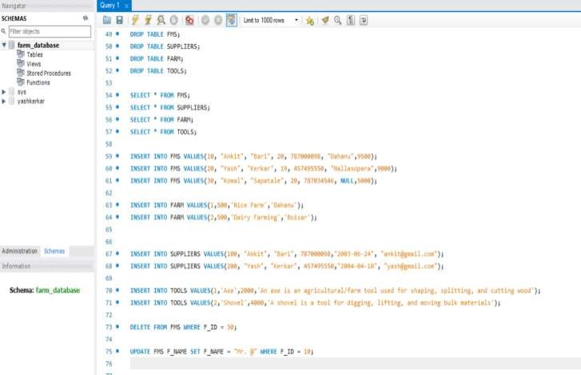


Implementation:

Program:

Output:-

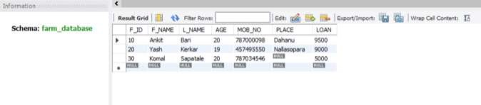
Insert into tables:
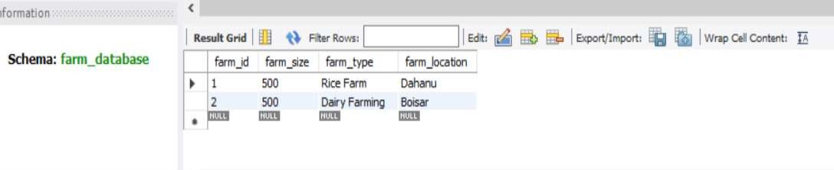
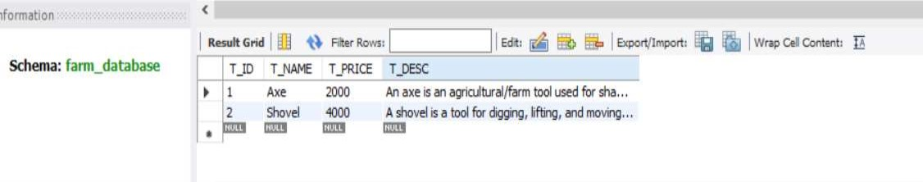
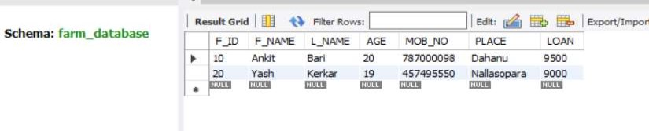

Delete record from Table:

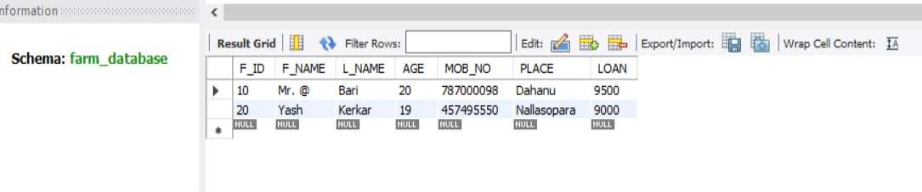
Update record in table:

Conclusion:

The completion of the practical exercise involving Data Manipulation Language (DML) commands on the Farmers Management System provides valuable insights into the operational aspects of managing agricultural data within a relational database. Through the application of various DML commands, including INSERT, UPDATE, DELETE, and SELECT, we gained practical experience in performing essential data manipulation tasks to interact with the database.

1. Explain the role of database constraints in enforcing data integrity during DML operations.

Ans. Primary Key Constraint: The primary key constraint ensures that each row in a table is uniquely identifiable by a primary key attribute or combination of attributes. During INSERT operations, the primary key constraint prevents the insertion of duplicate primary key values, thereby enforcing entity integrity and ensuring that each record is uniquely identifiable. Similarly, during UPDATE and DELETE operations, the primary key constraint ensures that only existing records can be modified or deleted, preventing unintended changes or deletions.

Unique Constraint: The unique constraint ensures that the values in one or more columns of a table are unique across all rows. During INSERT operations, the unique constraint prevents the insertion of duplicate values in specified columns, maintaining data integrity by avoiding redundancy and ensuring uniqueness. Similarly, during UPDATE operations, the unique constraint ensures that modifications do not result in duplicate values, preserving the uniqueness of data. During DELETE operations, the unique constraint ensures that records with unique values are not inadvertently removed, maintaining consistency.

Foreign Key Constraint: Foreign key constraints establish relationships between tables by enforcing referential integrity. During INSERT operations, the foreign key constraint ensures that the values inserted into a foreign key column match existing values in the referenced table's primary key column, preventing orphaned or dangling records. Similarly, during UPDATE operations, the foreign key constraint ensures that modifications do not violate referential integrity by maintaining consistency between related tables. During DELETE operations, the foreign key constraint enforces cascading deletes or restricts deletion if related records exist, preventing data inconsistencies.

Check Constraint: Check constraints define conditions that must be true for every row in a table. They allow you to specify rules that restrict the values allowed in certain columns. During INSERT and UPDATE operations, the check constraint ensures that the values inserted or modified comply with predefined conditions, preventing the insertion or modification of invalid or incompatible data. This ensures data integrity by enforcing domain constraints and business rules.

2. How do you update multiple columns in a table using a single UPDATE statement?
Ans. You can update multiple columns in a table using a single UPDATE statement in SQL by specifying each column and its corresponding new value in the SET clause. Here's the general syntax:

UPDATE table_name
SET column1 = value1, column2 = value2, ..., columnN = valueN WHERE condition;

In this syntax:
• table_name: Specifies the name of the table you want to update.
• column1, column2, ..., columnN: Specifies the columns you want to update.
• value1, value2, ..., valueN: Specifies the new values you want to assign to each column.
• condition: Specifies the condition that determines which rows will be updated. If omitted, all rows in the table will be updated.

