Experiment No. 1
Explore the internal commands of Linux.
Date of Performance:
Date of Submission:
Marks:
Sign:

Aim:Explore the internal commands of Linux.
Objective:
Execute various internal commands of linux

Theory:
ps - report a snapshot of the current processes. ps displays information about a selection of the active processes.
cal — displays a calendar and the date of Easter

date - print or set the system date and time ,Display the current time in the given FORMAT, or set the system date.
rm - remove files or directories

mkdir - make directories , Create the DIRECTORY(ies), if they do not already exist. rmdir - remove empty directories
cat - concatenate files and print on the standard output

wc - print newline, word, and byte counts for each file, Print newline, word, and byte counts for each FILE, and a total line if more than one FILE is specified.
ls - list directory contents ls [OPTION]... [FILE]...
List information about the FILEs (the current directory by default). Sort entries alphabetically.
-l: use a long listing format chmod - change file mode bits
chmod changes the file mode bits of each given file according to mode, which can be either a symbolic representation of changes to make, or an octal number
representing the bit pattern for the new mode bits. chown - change file owner and group
chown changes the user and/or group ownership of each given file. If only an owner (a user name or numeric user ID) is given, that user is made the owner of each given file, and the files' group is not changed. If the owner is followed by a colon and a group name (or numeric group ID), with no spaces between them, the group ownership of the files is changed as well.
pwd - print name of current/working directory.

Print the full filename of the current working directory.

umask - set file mode creation mask , umask() sets the calling process's file mode creation mask (umask) to mask & 0777 (i.e., only the file permission bits of mask are used), and returns the previous value of the mask.
Commands :
File Management:
ls: List directory contents.
Example: ls -l
cp: Copy files and directories.
Example: cp file1.txt file2.txt
mv: Move or rename files and directories.
Example: mv file1.txt new_directory/
rm: Remove files or directories.
Example: rm file1.txt
cat: Concatenate and display file content.
Example: cat file1.txt
head: Display the beginning of a file.
Example: head file1.txt
tail: Display the end of a file.
Example: tail file1.txt
touch: Create an empty file or update file timestamp.
Example: touch new_file.txt
Directory Management:
mkdir: Create directories.
Example: mkdir new_directory
rmdir: Remove empty directories.
Example: rmdir empty_directory
cd: Change the current working directory.
Example: cd new_directory
pwd: Print the current working directory.
Example: pwd
Process Management:
ps: Display information about active processes.
Example: ps aux
top: Display real-time system resource usage.
Example: top
kill: Terminate processes by PID (Process ID).
Example: kill <PID>
killall: Terminate processes by name.
Example: killall firefox
bg: Put a process in the background.
Example: bg <PID>
fg: Bring a background process to the foreground.
Example: fg <PID>
System Calls:
open: Opens or creates a file.
Example: open("filename.txt", O_RDWR);
read: Reads data from an open file.
Example: read(fd, buffer, sizeof(buffer));
write: Writes data to an open file.
Example: write(fd, buffer, strlen(buffer));
close: Closes an open file descriptor.
Example: close(fd);
fork: Creates a new process by duplicating the calling process.
Example: pid = fork();
exec: Replaces the current process image with a new process image.
Example: execvp("ls", argv);
wait: Suspends execution of the calling process until one of its children terminates
Example: wait(&status);
exit: Terminates the calling process.
Example: exit(0);
These are some basic Linux commands and system calls for file, directory, and process management. They are essential for navigating and manipulating files, directories, and processes in a Linux environment.

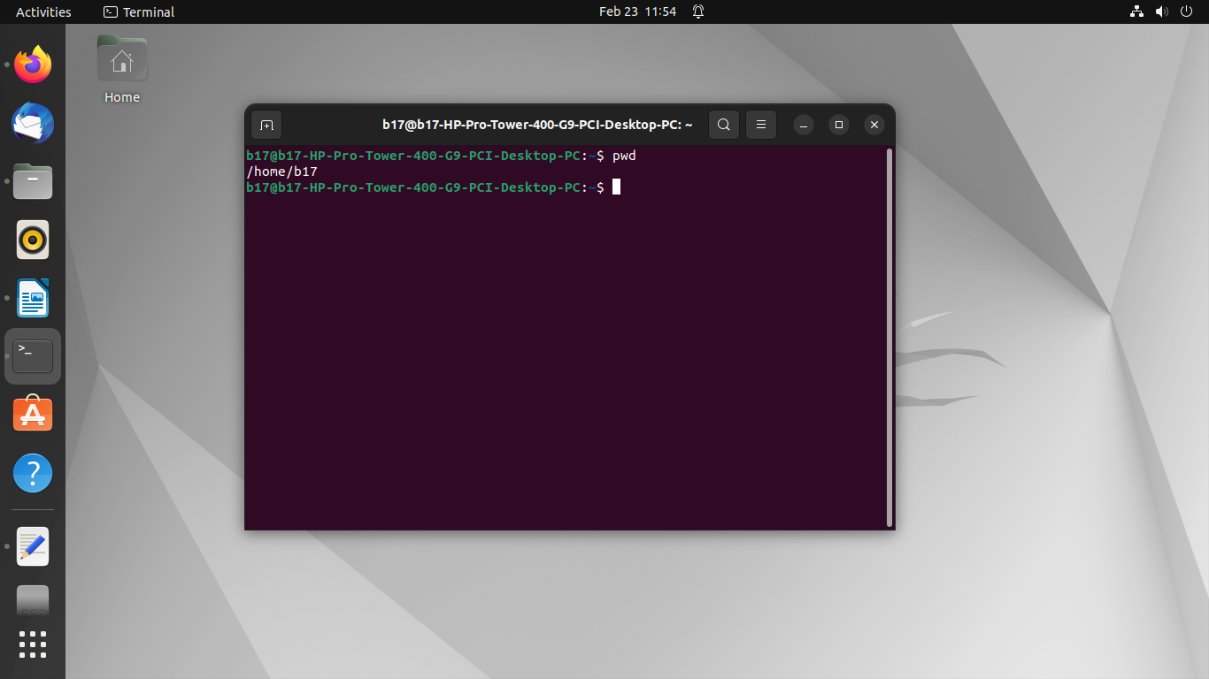
Output:
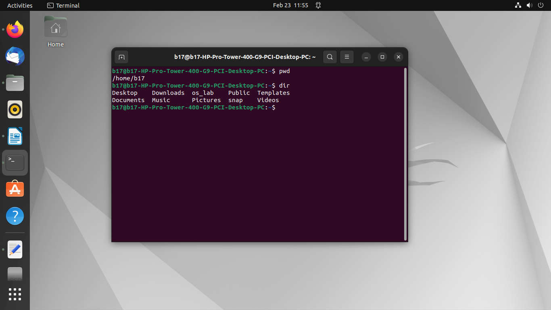
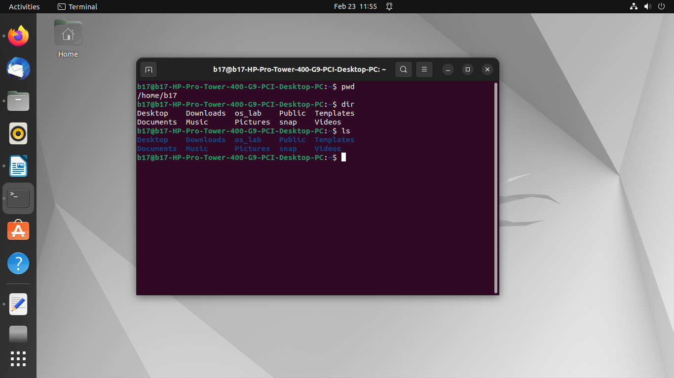
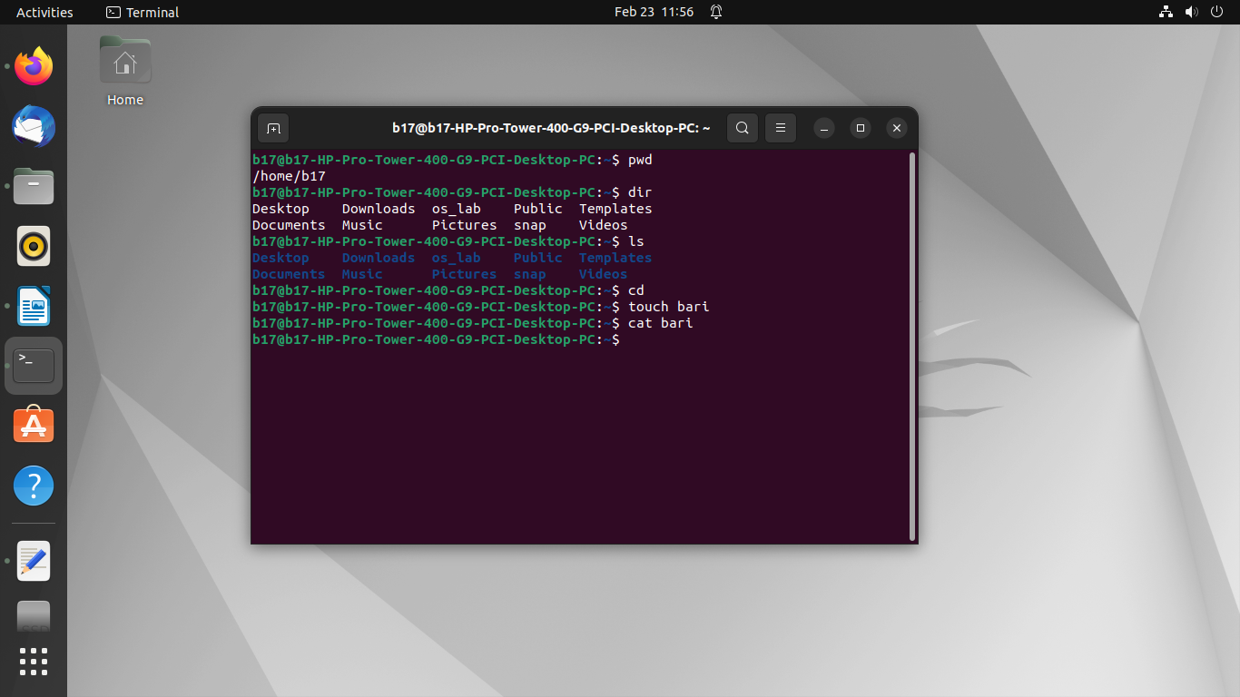
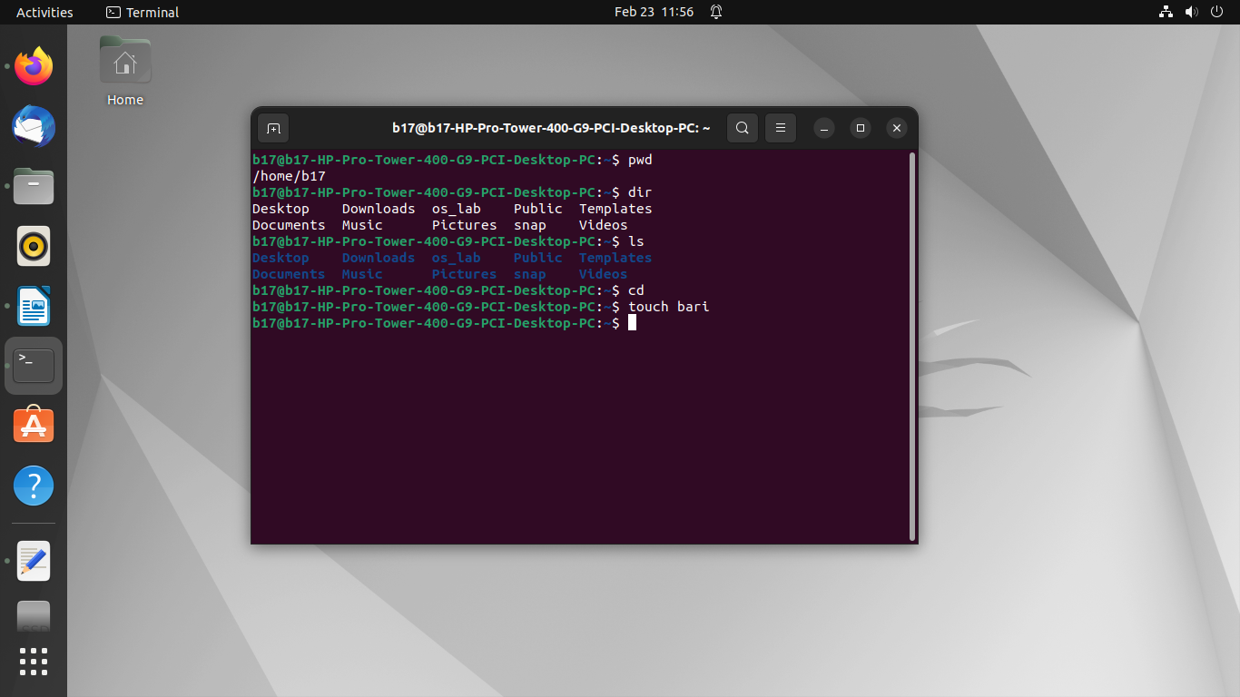
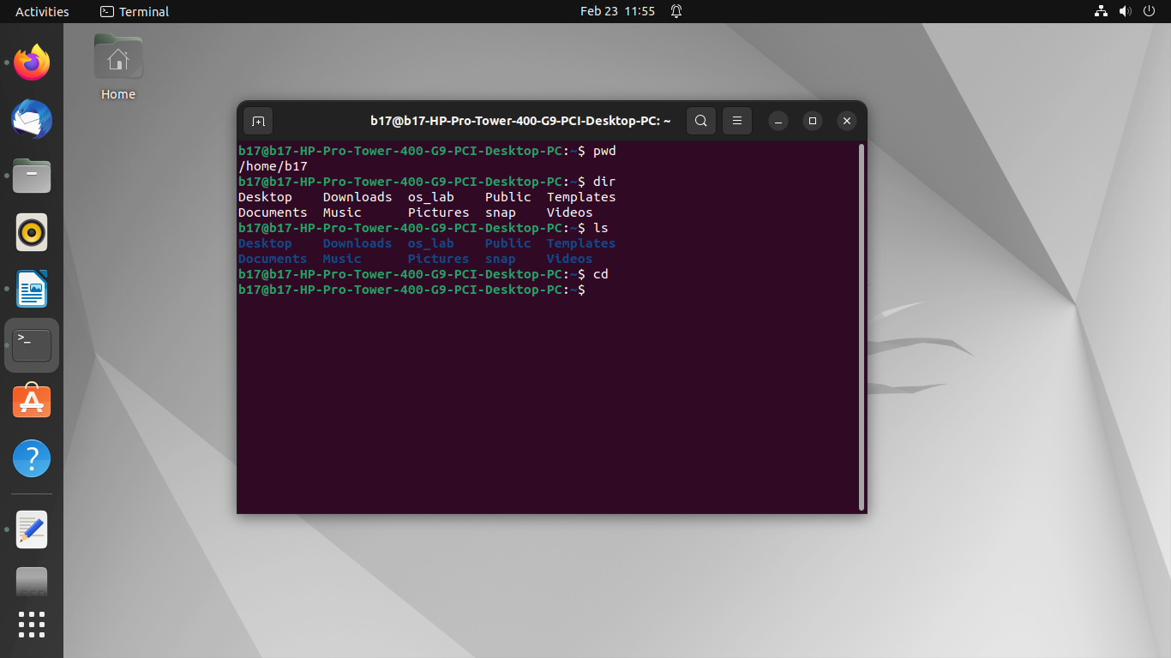

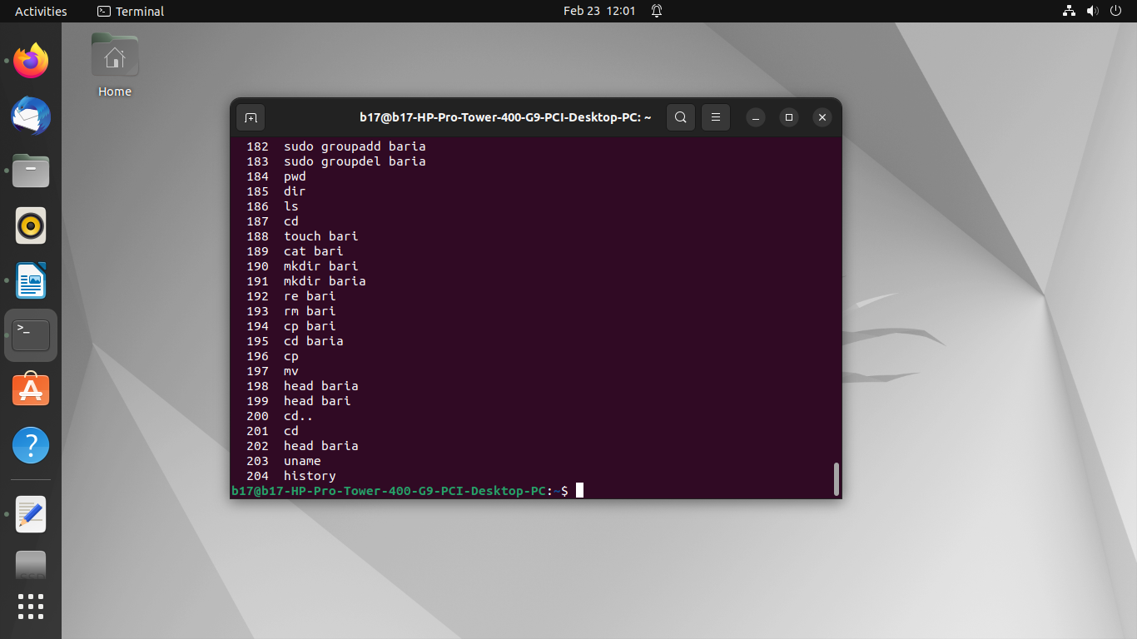
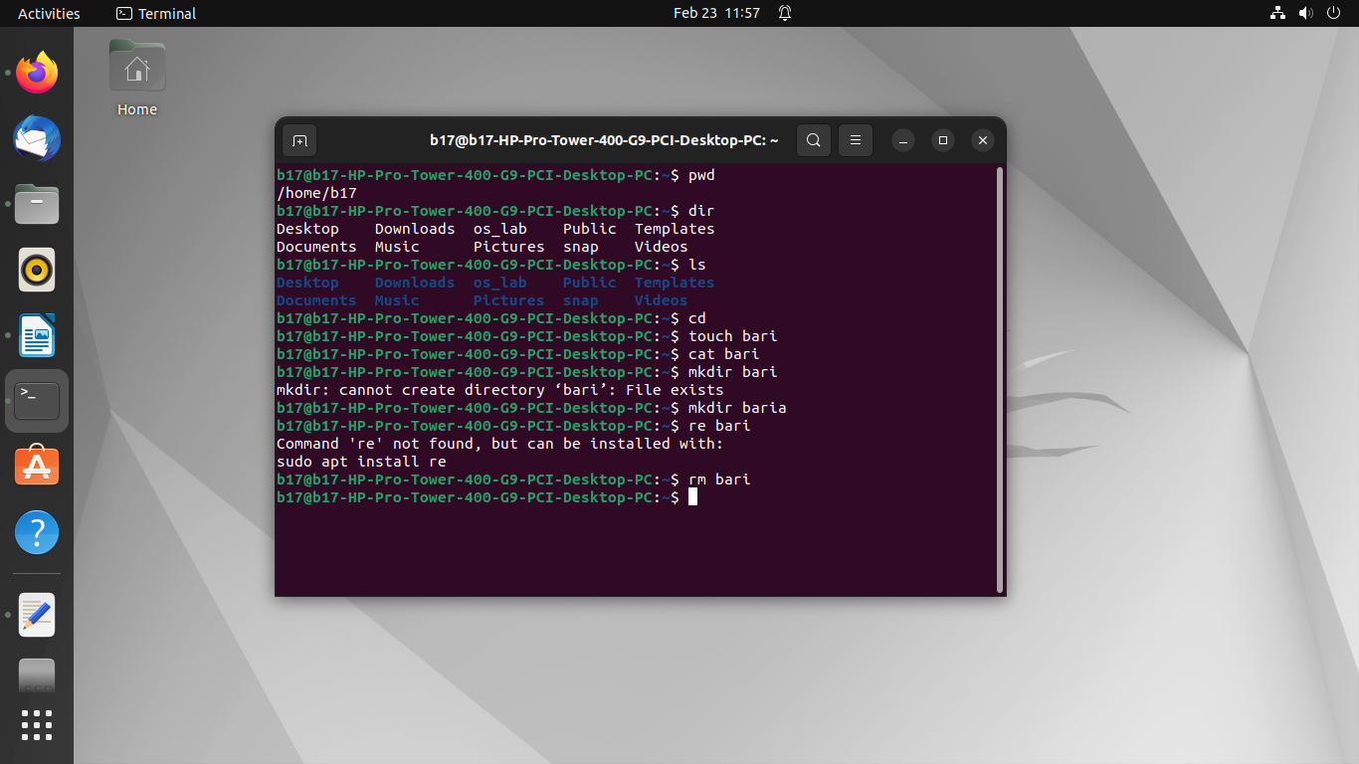
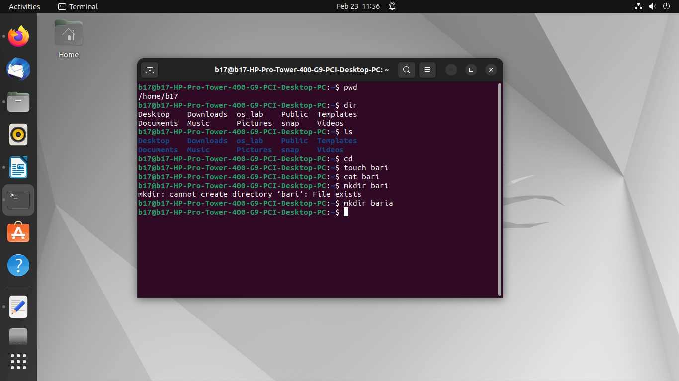
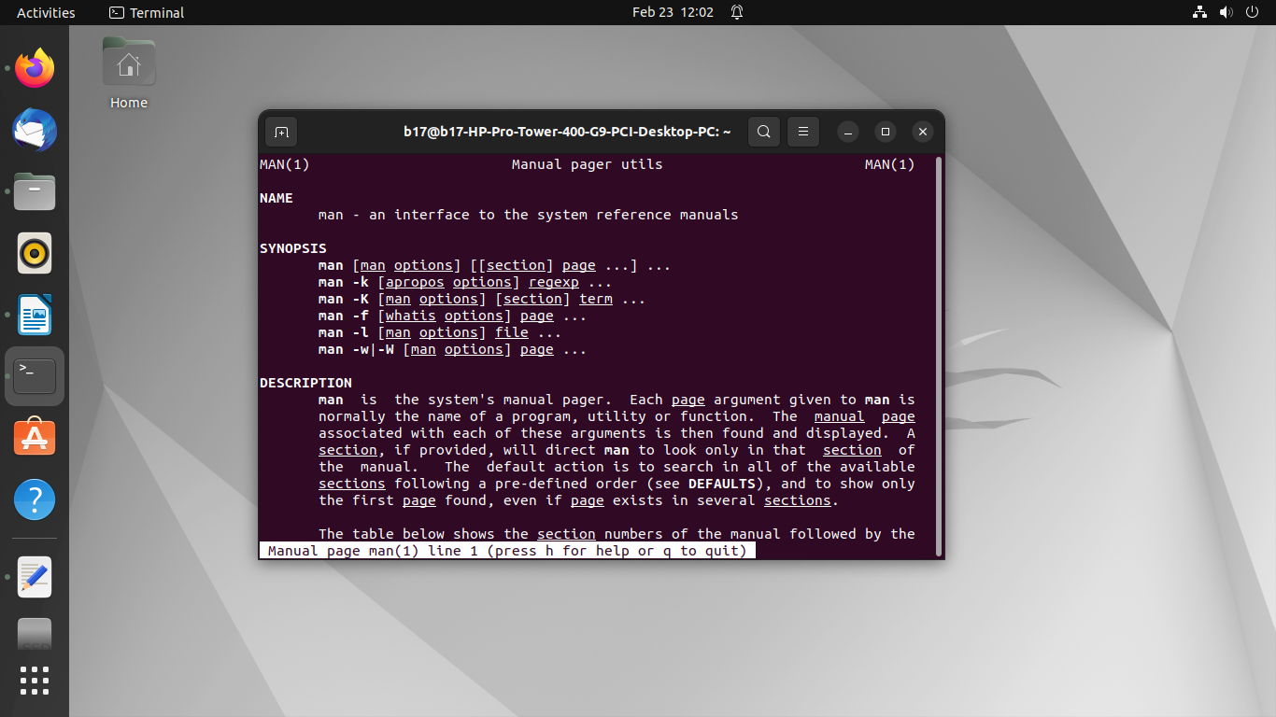
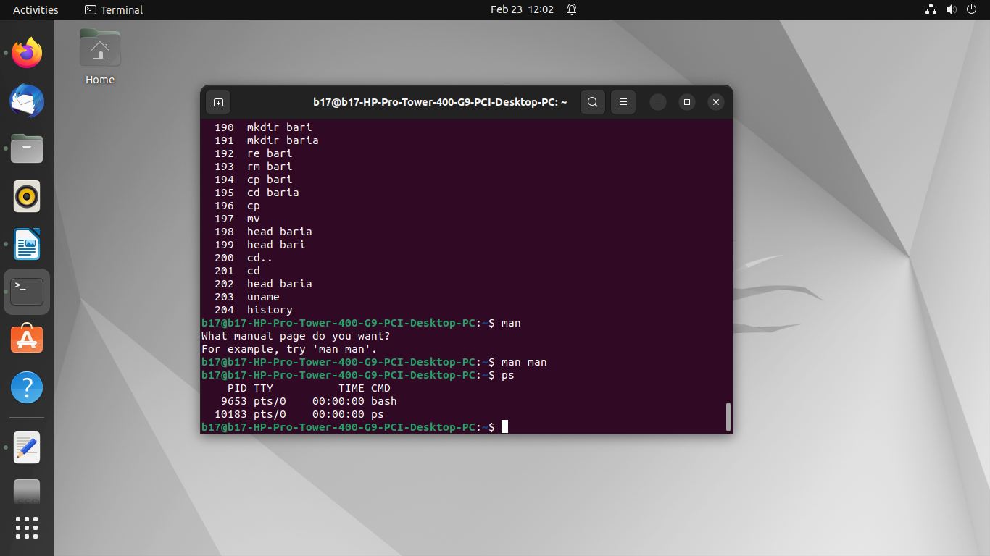

Conclusion:
In conclusion, Linux internal commands are fundamental building blocks for interacting with the operating system from the command line. They provide essential functionality, integrate closely with the shell environment, and contribute to the efficiency and flexibility of Linux system administration and usage. Understanding these commands and their usage is key for becoming proficient in Linux command-line operations.

