

Experiment No.2

Linux shell script

2.1 Write shell scripts to do the following:

a. Display OS version, release number, kernel version

b. Display top 10 processes in descending order

c. Display processes with highest memory usage.

d. Display current logged in user and log name. Display current shell, home directory, operating system type, current path setting, current working directory

Date of Performance:
Date of Submission:
Marks:
Sign:

Aim: Write shell scripts to: a. Display OS version, release number, and kernel version b. Display top 10 processes in descending order c. Display processes with highest memory usage d. Display current logged in user and log name e. Display current shell, home directory, operating system type, current path setting, current working directory
Objective: Perform some operation on os.
Theory:

Shell is a user program, or its environment is provided for user interaction. It is a command prompt within Linux where you can type commands. It is a program that takes your commands from the keyboard and gives them to the OS to perform. Shell is not part of system KERNAL but it uses system KERNAL to execute programs, create files,etc. A Shell Script is a text file that contains a sequence of commands for a UNIX based OS. It is called a Shell Script because it combines into a "Script" in a single file a sequence of commands, that would otherwise have to be presented to the system from a keyboard one at a time. A Shell Script is usually created for command sequences for which a user has a repeated need. You initiate the sequence of commands in Shell Script by simply entering the name of the Shell Script on a command line.
Types of Shell Script :-1. sh - Simple Shell
2. bash - Bourne Again Shell 3. ksh - Korne Shell
4. csh - C Shell

5. ssh - Secure Shell

To use a particular Shell type the Shell name at the command prompt. Eg:- $csh - It will switch the current Shell to C Shell. To view the current Shell that is being used, type echo $ SHELL at the command prompt.
Code :
a. Display OS version, release number, and kernel version:
bash
Copy code
#!/bin/bash
# Display OS version
echo "OS Version:"
cat /etc/os-release | grep PRETTY_NAME
# Display release number
echo "Release Number:"
cat /etc/os-release | grep VERSION_ID
# Display kernel version
echo "Kernel Version:"
uname -r
b. Display top 10 processes in descending order:
bash
Copy code
#!/bin/bash
# Display top 10 processes
echo "Top 10 Processes:"
ps aux --sort=-%cpu | head -n 11
c. Display processes with highest memory usage:
bash
Copy code
#!/bin/bash
# Display processes with highest memory usage
echo "Processes with Highest Memory Usage:"
ps aux --sort=-%mem | head -n 11
d. Display current logged in user and log name:
bash
Copy code
#!/bin/bash
# Display current logged in user
echo "Current Logged in User:"
whoami
# Display log name
echo "Log Name:"
who
e. Display current shell, home directory, operating system type, current path setting, current working directory:
bash
Copy code
#!/bin/bash
# Display current shell
echo "Current Shell:"
echo $SHELL
# Display home directory
echo "Home Directory:"
echo $HOME
# Display operating system type
echo "Operating System Type:"
uname -o
# Display current path setting
echo "Current Path Setting:"
echo $PATH
# Display current working directory
echo "Current Working Directory:"
pwd
You can save each script in a separate file with a .sh extension, make it executable using chmod +x script_name.sh, and then execute it using ./script_name.sh. These scripts will provide the requested information on a Linux system.
Output :
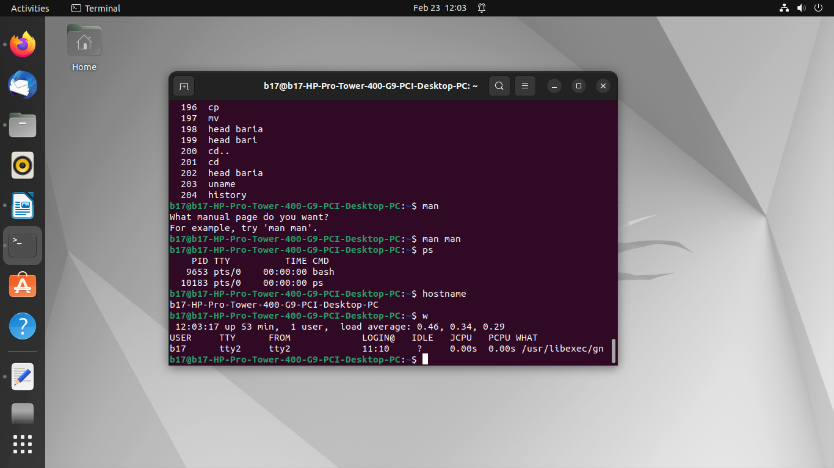
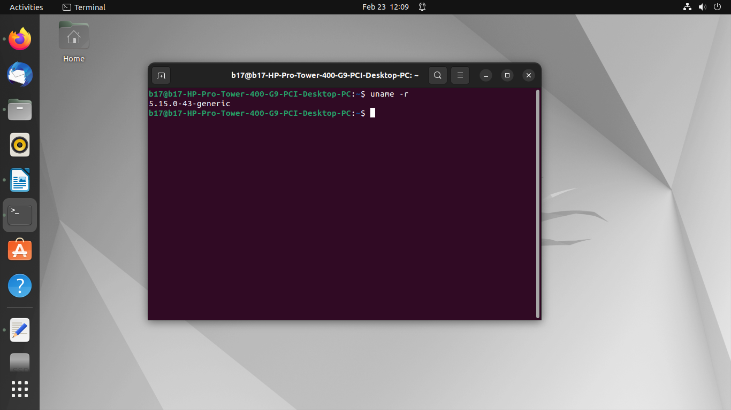
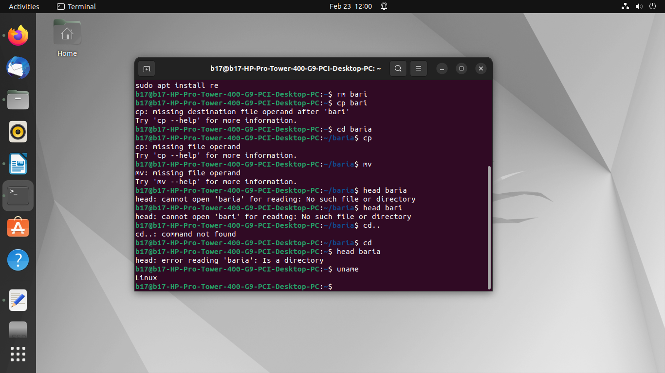
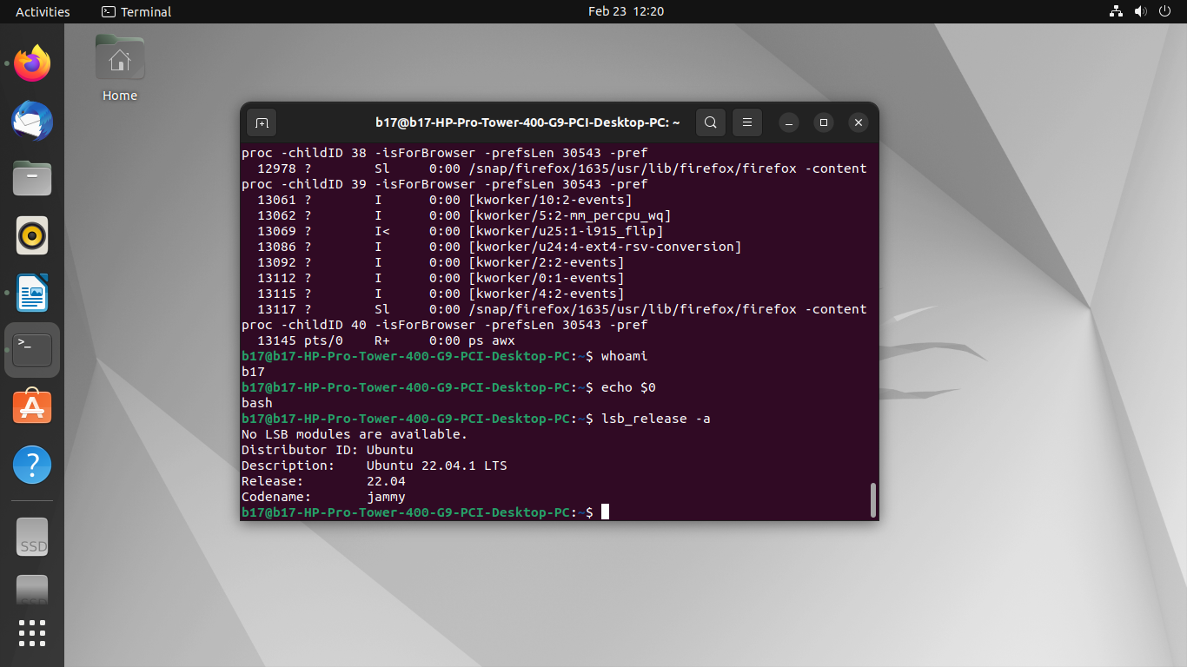
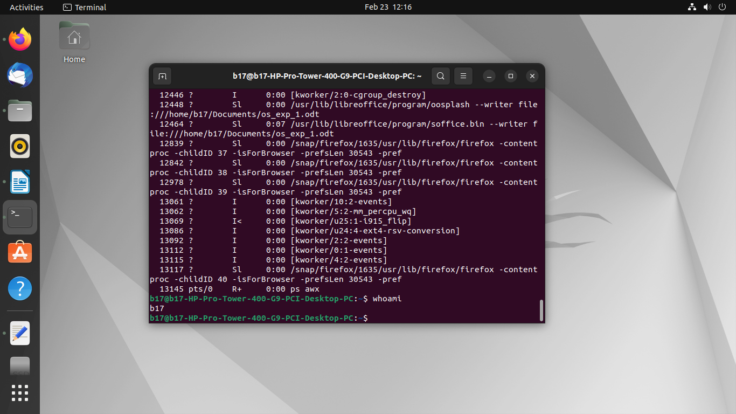
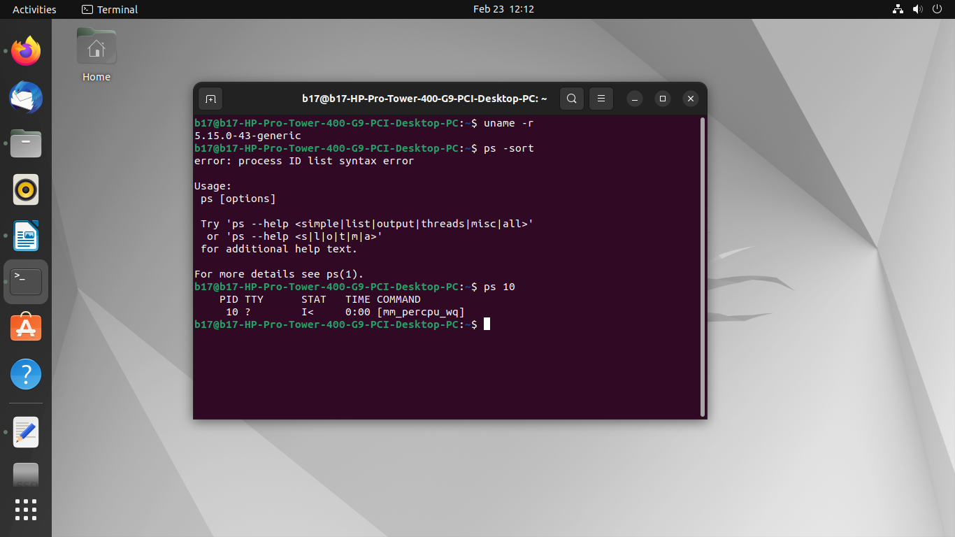

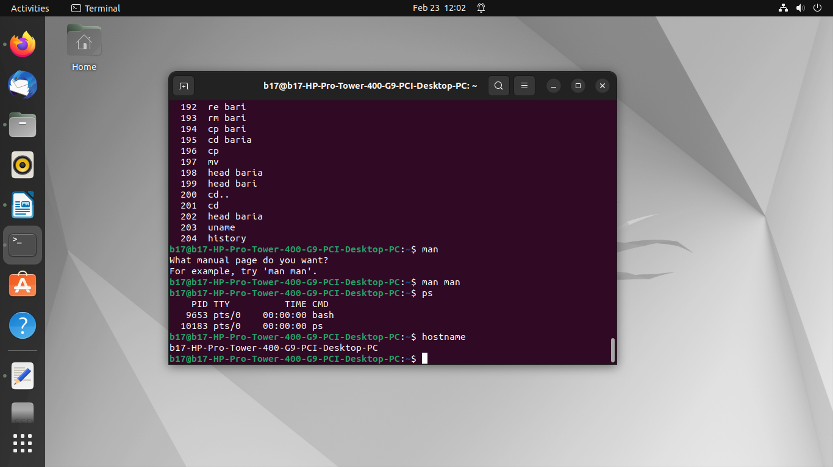
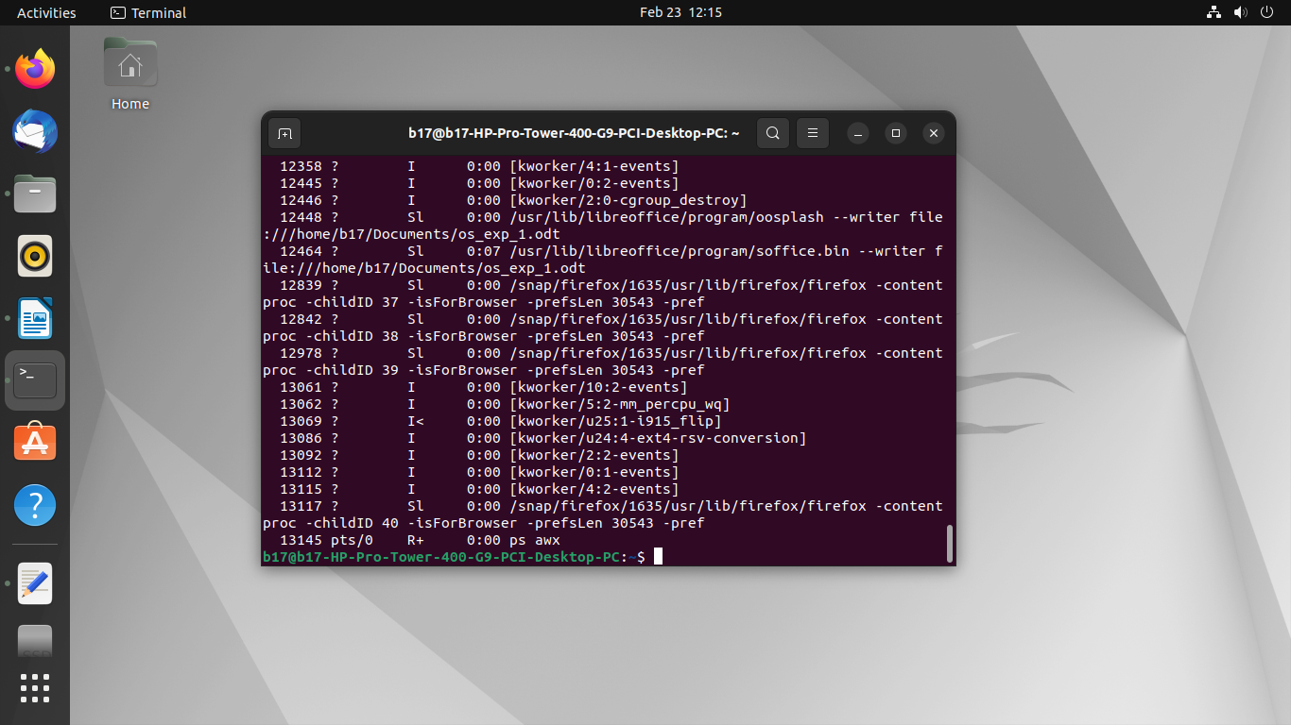
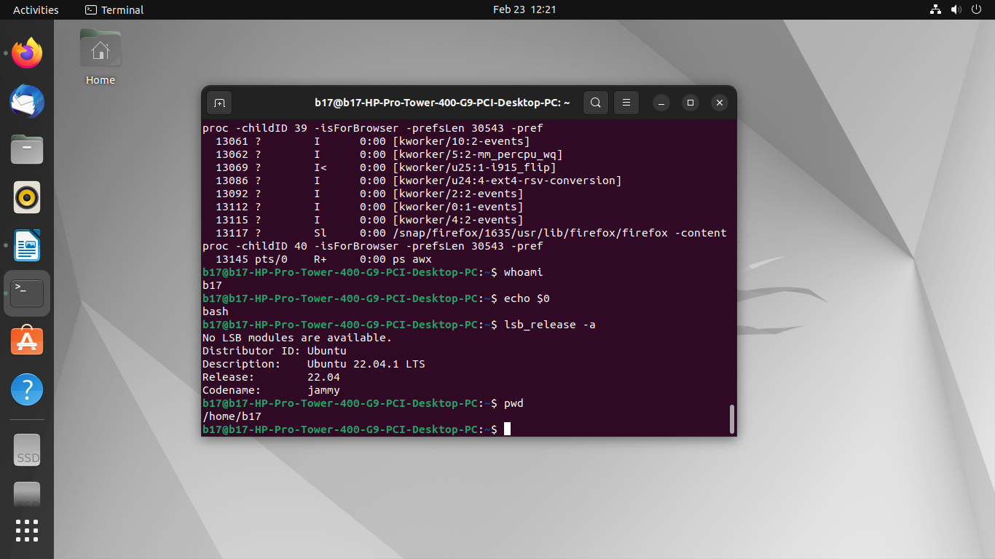

Conclusion:
In conclusion, the shell scripts provided offer a comprehensive toolkit for system administrators and users alike to efficiently manage and monitor their operating environment.
a. By displaying crucial system information such as OS version, release number, and kernel version, users can quickly assess the configuration of their system.
b. The script showcasing the top 10 processes in descending order aids in identifying resource-intensive tasks, facilitating smoother system operation.
c. Identifying processes with the highest memory usage enables users to optimize memory utilization and address potential bottlenecks effectively.
d. Displaying the current logged-in user and log name provides essential user context, enhancing security and accountability measures.
e. Lastly, presenting details such as the current shell, home directory, operating system type, path settings, and working directory offers users a comprehensive snapshot of their shell environment, aiding in navigation and customization efforts.

