Experiment No. 3
Explore Linux Commands
Date of Performance:
Date of Submission:
Marks:
Sign:

Aim:Explore user management commands of linux.
Objective:
Explore basic commands of linux
Theory:
A user is an entity, in a Linux operating system, that can manipulate files and perform several other operations. Each user is assigned an ID that is unique for each user in the operating system. In this post, we will learn about users and commands which are used to get information about the users. After installation of the operating system, the ID 0 is assigned to the root user and the IDs 1 to 999 (both inclusive) are assigned to the system users and hence the ids for local user begins from 1000 onwards.
In a single directory, we can create 60,000 users. Now we will discuss the important commands to manage users in Linux.

● useradd - create a new user or update default new user information ,useradd is a low

level utility for adding users.

● userdel - delete a user account and related files

● groupadd - create a new group , The groupadd command creates a new group account

using the values specified on the command line plus the default values from the system. The new group will be entered into the system files as needed.
● groupdel - delete a group , The groupdel command modifies the system account files, deleting all
● entries that refer to GROUP. The named group must exist

● who - show who is logged on , Print information about users who are currently logged in.
● whoami - print effective userid
● passwd - change user password
The passwd command changes passwords for user accounts. A normal user may only change the password for his/her own account, while the superuser may change the password for any account. passwd also changes the account or associated password validity period. 1.toenterinrootsudosuthenpassword 2.toaddnewusertypeuseraddcsds11(username) 3.tocheckanewlyaddeduseryouhavetotypecatetc/passwod 4setapasswordtonewuser:sudopasswdcsds11 5.createanewgroup:groupaddcsds12
6.Checkgroupcat/etc/group
7.addnewuserinnewlycreatedgroupuseradd-Gcsds12piya1(groupnameandnew username)
8.tocheck:cat/etc/group 9.toenterinnewuser:su-csds11(username)
10.todeleteusertype:userdelcsds(usernamethatyouhavetodelete) 11.Againcheckwhetheritisdeletedornotcat/etc/passwd 10.todeleteusertype:groupdelcsds12(groupthatyouhavetodelete) 12.Againcheckwhetheritisdeletedornotcat/etc/passwd
13.who-showwhoisloggedonPrintinformationaboutuserswhoarecurrentlylogged in.
14.whoami-printeffectiveuserid

Code :
#include <stdio.h>
#include <unistd.h>
#include <sys/types.h>
#include <dirent.h>

int main(int argc, char *argv[]) {
// Check if directory path is provided as argument
const char *dir_path;
if (argc > 1) {
dir_path = argv[1];
} else {
dir_path = ".";
}

// Open the directory
DIR *dir = opendir(dir_path);
if (dir == NULL) {
perror("opendir");
return 1;
}

// Read directory entries
struct dirent *entry;
while ((entry = readdir(dir)) != NULL) {
printf("%s\n", entry->d_name);
}

// Close the directory
closedir(dir);

return 0;
}

Compile this program using gcc:
gcc -o myls myls.c
Now you can run it like a regular ls command, providing an optional directory path as an argument:
./myls # Lists current directory contents
./myls /path/to/directory # Lists contents of specified directory
This program uses the opendir(), readdir(), and closedir() functions from the <dirent.h> header to open, read, and close directories, respectively. It prints the names of all directory entries to the standard output.

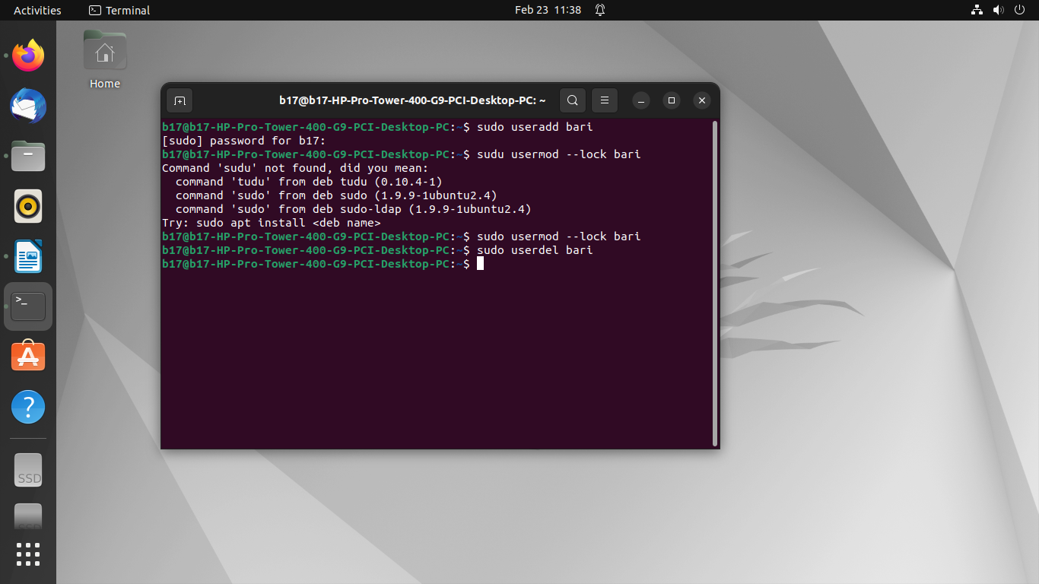

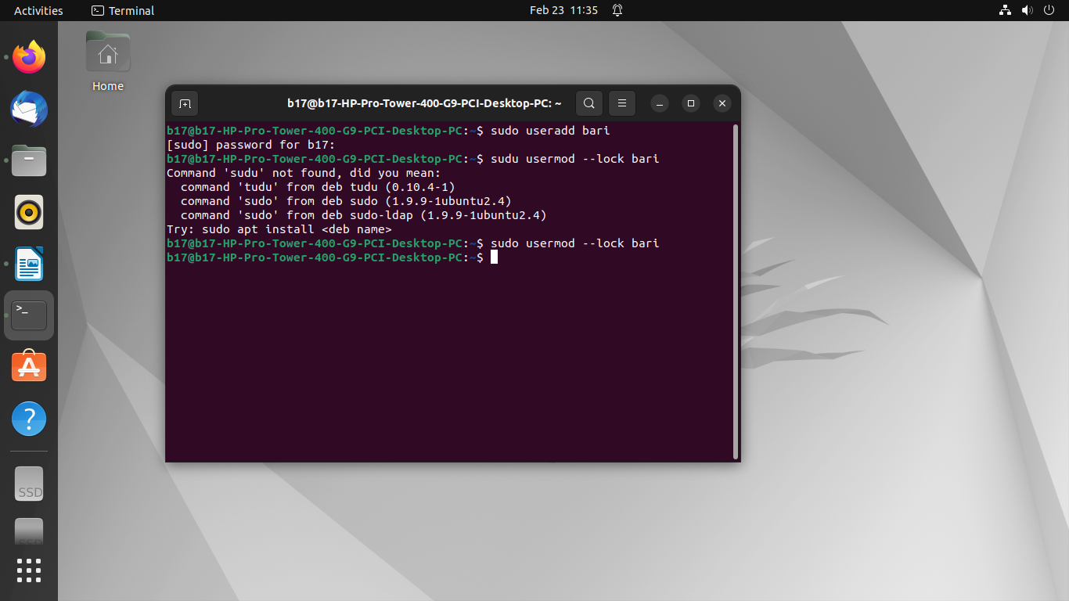
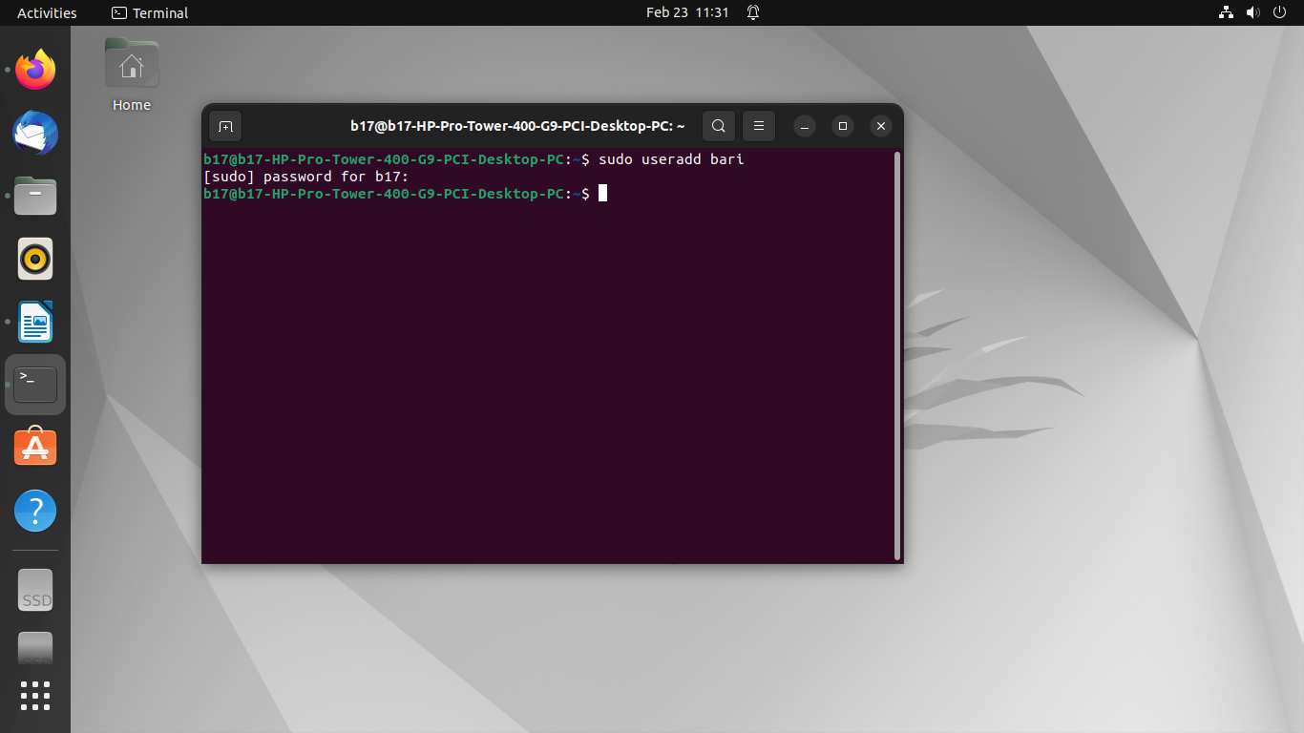
Output :
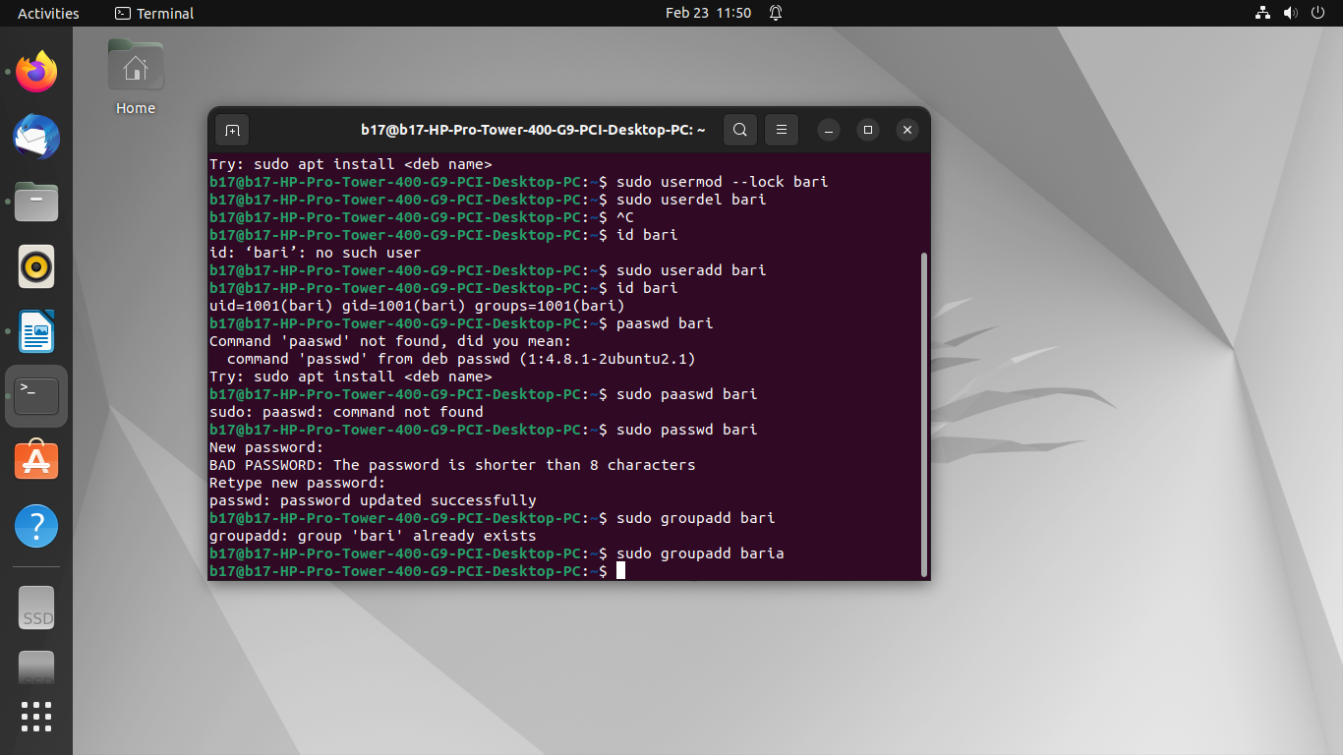
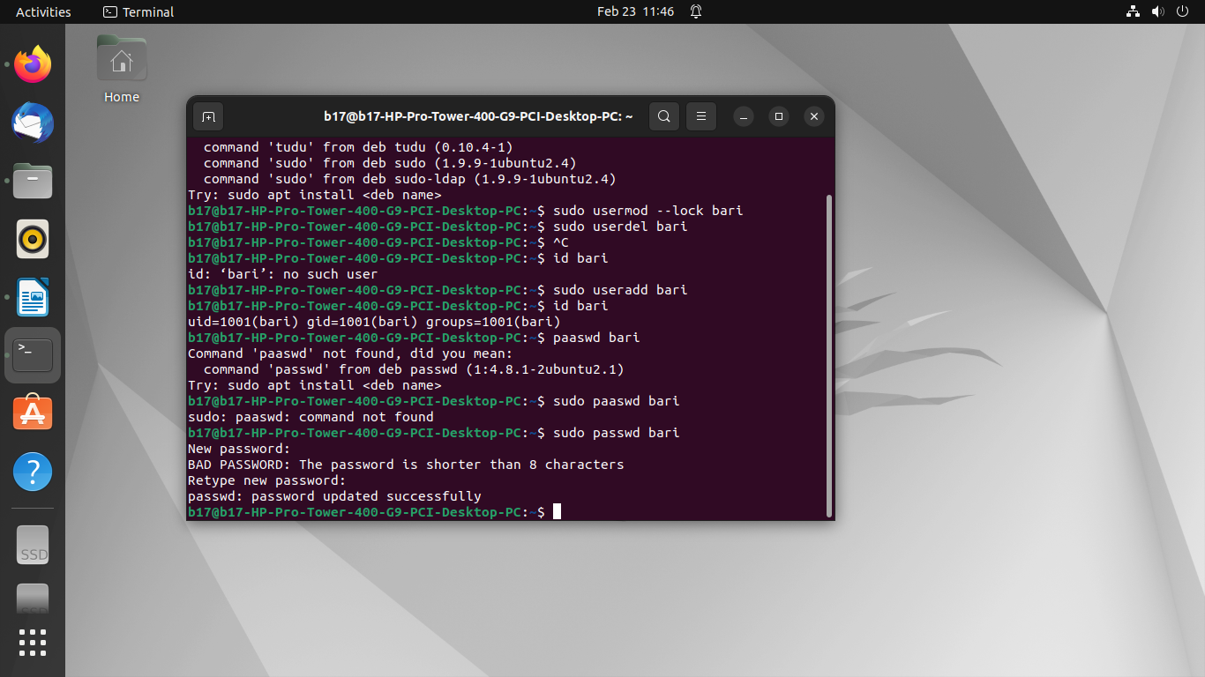
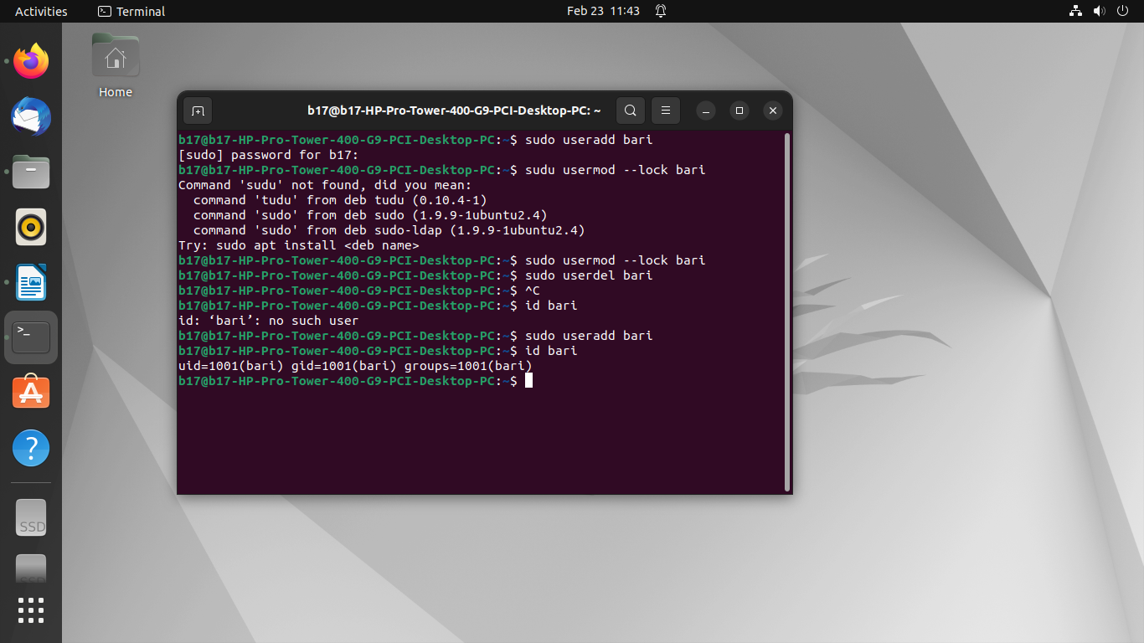
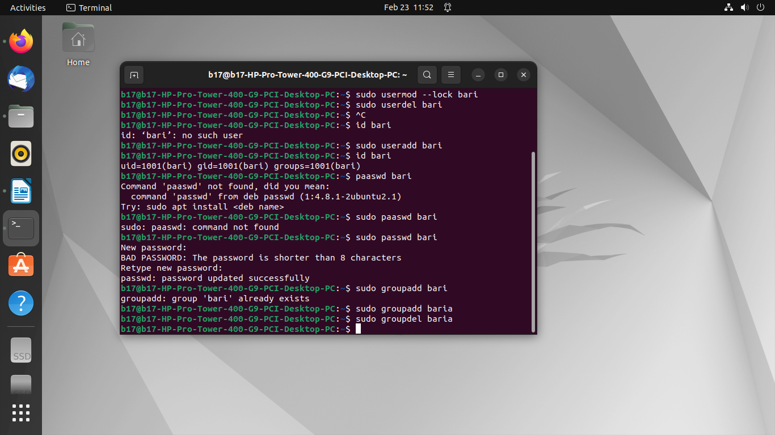

Conclusion:
In conclusion, delving into the user management commands of Linux unveils a versatile toolkit essential for system administrators and users alike. Through commands like useradd, userdel, passwd, and others, Linux empowers users to efficiently manage accounts, access permissions, and security settings. This exploration underscores the robustness and flexibility of Linux in tailoring user environments to specific needs, whether for individual users or across organizational networks. By mastering these commands, users gain greater control over their Linux systems, enhancing both security and productivity.

