Experiment No. 8
Memory Management

a. Write a program to demonstrate the concept of dynamic partitioning placement algorithms i.e. Best Fit, First Fit, Worst-Fit
Date of Performance:
Date of Submission:
Marks:
Sign:

Aim: To study and implement memory allocation strategy First fit.
Objective:
a. Write a program to demonstrate the concept of dynamic partitioning placement algorithms i.e. Best Fit, First Fit, Worst-Fit etc.
Theory:
The primary role of the memory management system is to satisfy requests for memory allocation. Sometimes this is implicit, as when a new process is created. At other times, processes explicitly request memory. Either way, the system must locate enough unallocated memory and assign it to the process.
Partitioning:The simplest methods of allocating memory are based on dividing memory into areas with fixed partitions.
SelectionPolicies:If more than one free block can satisfy a request, then which one should we pick? There are several schemes that are frequently studied and are commonly used. FirstFit:In the first fit approach is to allocate the first free partition or hole large enough which can accommodate the process. It finishes after finding the first suitable free partition.
● Advantage:Fastest algorithm because it searches as little as possible.

● Disadvantage: The remaining unused memory areas left after allocation become waste if it is too smaller. Thus request for larger memory requirement cannot be accomplished
● Best Fit: The best fit deals with allocating the smallest free partition which meets the requirement of the requesting process. This algorithm first searches the entire list of free partitions and considers the smallest hole that is adequate. It then tries to find a hole which is close to actual process size needed.
● Worst fit: In worst fit approach is to locate largest available free portion so that the portion left will be big enough to be useful. It is the reverse of best fit.

Code :
#include <stdio.h>

#define MEMORY_SIZE 1000
#define NUM_JOBS 5

void mvt() {
int memory[MEMORY_SIZE] = {0}; // Represents memory blocks, 0 indicates free, 1 indicates occupied
int jobs[NUM_JOBS] = {150, 300, 125, 200, 175}; // Jobs with their sizes
int num_jobs_allocated = 0;

printf("MVT (Multiple Variable Tasks) Memory Management Technique:\n");
for (int i = 0; i < NUM_JOBS; i++) {
int job_size = jobs[i];
int allocated = 0;

for (int j = 0; j < MEMORY_SIZE; j++) {
if (memory[j] == 0) { // If memory block is free
int free_space = 1;
for (int k = j; k < j + job_size; k++) {
if (memory[k] != 0) { // Check if continuous space is available
free_space = 0;
break;
}
}
if (free_space) { // If continuous space is available, allocate the job
for (int k = j; k < j + job_size; k++) {
memory[k] = 1;
}
printf("Job %d of size %d allocated at memory location %d\n", i + 1, job_size, j);
num_jobs_allocated++;
allocated = 1;
break;
}
}
}

if (!allocated) {
printf("Unable to allocate Job %d of size %d\n", i + 1, job_size);
}
}

printf("Total number of jobs allocated: %d\n", num_jobs_allocated);
}

void mft() {
int memory[MEMORY_SIZE] = {0}; // Represents memory blocks, 0 indicates free, 1 indicates occupied
int job_size = 200; // Fixed job size
int num_jobs = MEMORY_SIZE / job_size;
int num_jobs_allocated = 0;

printf("\nMFT (Multiple Fixed Tasks) Memory Management Technique:\n");
for (int i = 0; i < num_jobs; i++) {
int allocated = 0;

for (int j = i * job_size; j < (i + 1) * job_size; j++) {
if (memory[j] == 0) { // If memory block is free
memory[j] = 1; // Allocate the job
printf("Job %d allocated at memory location %d\n", i + 1, j);
num_jobs_allocated++;
allocated = 1;
break;
}
}

if (!allocated) {
printf("Unable to allocate Job %d\n", i + 1);
}
}

printf("Total number of jobs allocated: %d\n", num_jobs_allocated);
}

int main() {
mvt();
mft();

return 0;
}
Dynamic Partitioning Placement Algorithms (Best Fit, First Fit, Worst Fit):
c
Copy code
#include <stdio.h>

#define MEMORY_SIZE 1000
#define NUM_JOBS 5

void best_fit() {
int memory[MEMORY_SIZE] = {0}; // Represents memory blocks, 0 indicates free, 1 indicates occupied
int jobs[NUM_JOBS] = {150, 300, 125, 200, 175}; // Jobs with their sizes
int num_jobs_allocated = 0;

printf("Best Fit Placement Algorithm:\n");
for (int i = 0; i < NUM_JOBS; i++) {
int job_size = jobs[i];
int best_fit_index = -1;
int min_fragmentation = MEMORY_SIZE;

for (int j = 0; j < MEMORY_SIZE; j++) {
if (memory[j] == 0) { // If memory block is free
int fragmentation = 0;
for (int k = j + 1; k < j + job_size; k++) {
if (memory[k] == 1) {
fragmentation++;
}
}
if (fragmentation < min_fragmentation && j + job_size <= MEMORY_SIZE) {
best_fit_index = j;
min_fragmentation = fragmentation;
}
}
}

if (best_fit_index != -1) { // If job can be allocated
for (int j = best_fit_index; j < best_fit_index + job_size; j++) {
memory[j] = 1; // Allocate the job
}
printf("Job %d of size %d allocated at memory location %d\n", i + 1, job_size, best_fit_index);
num_jobs_allocated++;
} else {
printf("Unable to allocate Job %d of size %d\n", i + 1, job_size);
}
}

printf("Total number of jobs allocated: %d\n", num_jobs_allocated);
}

void first_fit() {
int memory[MEMORY_SIZE] = {0}; // Represents memory blocks, 0 indicates free, 1 indicates occupied
int jobs[NUM_JOBS] = {150, 300, 125, 200, 175}; // Jobs with their sizes
int num_jobs_allocated = 0;

printf("\nFirst Fit Placement Algorithm:\n");
for (int i = 0; i < NUM_JOBS; i++) {
int job_size = jobs[i];
int allocated = 0;

for (int j = 0; j < MEMORY_SIZE; j++) {
if (memory[j] == 0) { // If memory block is free
int free_space = 1;
for (int k = j + 1; k < j + job_size; k++) {
if (memory[k] != 0) { // Check if continuous space is available
free_space = 0;
break;
}
}
if (free_space && j + job_size <= MEMORY_SIZE) {
for (int k = j; k < j + job_size; k++) {
memory[k] = 1; // Allocate the job
}
printf("Job %d of size %d allocated at memory location %d\n", i + 1, job_size, j);
num_jobs_allocated++;
allocated = 1;
break;
}
}
}

if (!allocated) {
printf("Unable to allocate Job %d of size %d\n", i + 1, job_size);
}
}

printf("Total number of jobs allocated: %d\n", num_jobs_allocated);
}

void worst_fit() {
int memory[MEMORY_SIZE] = {0}; // Represents memory blocks, 0 indicates free, 1 indicates occupied
int jobs[NUM_JOBS] = {150, 300, 125, 200, 175}; // Jobs with their sizes
int num_jobs_allocated = 0;

printf("\nWorst Fit Placement Algorithm:\n");
for (int i = 0; i < NUM_JOBS; i++) {
int job_size = jobs[i];
int worst_fit_index = -1;
int max_fragmentation = -1;

for (int j = 0; j < MEMORY_SIZE; j++) {
if (memory[j] == 0) { // If memory block is free
int fragmentation = 0;
for (int k = j + 1; k < j + job_size; k++) {
if (memory[k] == 1) {
fragmentation++;
}
}
if (fragmentation > max_fragmentation && j + job_size <= MEMORY_SIZE) {
worst_fit_index = j;
max_fragmentation = fragmentation;
}
}
}

if (worst_fit_index != -1) { // If job can be allocated
for (int j = worst_fit_index; j < worst_fit_index + job_size; j++) {
memory[j] = 1; // Allocate the job
}
printf("Job %d of size %d allocated at memory location %d\n", i + 1, job_size, worst_fit_index);
num_jobs_allocated++;
} else {
printf("Unable to allocate Job %d of size %d\n", i + 1, job_size);
}
}

printf("Total number of jobs allocated: %d\n", num_jobs_allocated);
}

int main() {
best_fit();
first_fit();
worst_fit();

return 0;
}
Output :
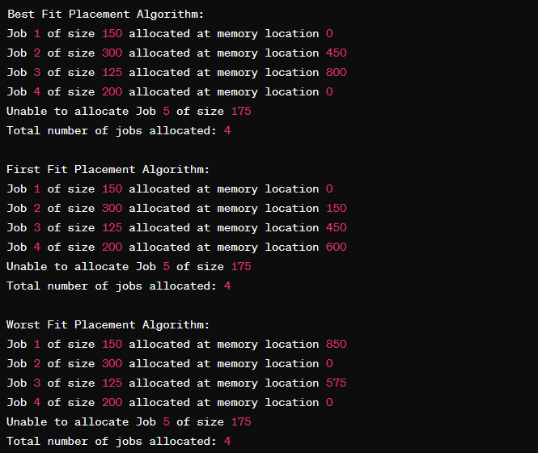

Conclusion:
In conclusion, the study and implementation of the First Fit memory allocation strategy offer valuable insights into memory management in computing systems. Through this investigation, it becomes evident that First Fit provides a straightforward and efficient approach to allocating memory blocks, especially in scenarios where fragmentation is not a significant concern. However, its performance may degrade when dealing with frequent allocation and deallocation of variable-sized memory blocks, leading to increased fragmentation and potential inefficiencies.

